Rx Investigator – Prescribed fire personnel have been lacking basic tools to see if/when the weather conditions they need are or have been occurring in combination, be it in the past, present or future. Straightforward questions such as:

When do these conditions occur in a typical year, and for how long each day?
What were the past conditions during the time we were successfully burning?
What are the conditions like this year/season and how do we track them, including forecasts?
- Select Station(s)
- Select Months (slider bar?)
- Select Max/Min for 3+ elements (i.e. prescription)
Ideas: T, RH, WS, WD, PCPN, Solar Rad?

Chart Builder Component
-Like the current Chart Builder, except it would only show the colored line plots for conditions within the set Rx prescription (and maybe the rest of the line could be dashed or grayed out)?
-Could be used to assess past years as well as current
-Might need to be able to shrink to a window (analysis period) of 5-7 days

Rx Burn Period Component
-I envision something like the BPT station plot, except relative to the count of hours meeting the Rx parameters. There could be:
- Current/selected year (with forecast!)
- Max count
- Average count (when in a typical year do my Rx parameters come together?)

NEW! Fine Dead Fuel Moisture Calculator
See following pages. An important tool for supporting fire behavior calculations in the field. This is a specific request from the PFTC.

1-hr Fuel Moisture Calculation
Inputs are (Rh, slope, aspect, time of day and year, % shading from clouds or fuels)…Tables are on following pages.

Daytime Estimation Procedure
- Using Table A, determine Reference Fuel Moisture (RFM). Percentage from intersection of temperature and relative humidity. Record this RFM percentage.
- Select Table B, C, or D to adjust RFM for local conditions by finding current month in table title.
- Is the fine fuel more than 50% shaded by canopies and clouds? If yes, use bottom shade portion of table. If no, use top exposed portion of table.
- Determine the appropriate row based on aspect and slope.
- Determine the appropriate column based on time of day and elevation of area of concern when compared to the wx site elevation. Use (A)bove if the fire is 1-2000’ above your location, (B)elow if the fire is 1-2000’ below you, and (L)evel if the fire is within 1,000’ above or below you.
- Obtain the 1-hr Moisture Content Correction (%) from the intersection of row and column.
- Add the resulting 1-hr Moisture Content Correction (%) to the RFM (%).

Nighttime Estimates of 1-hr Fuel Moisture
Published RFM and Correction Tables for Nighttime Conditions are not included here based on recommendation from Pat Andrews at the Missoula Fire Lab. She recommends:
- Estimate Dry Bulb Temperature and relative humidity (RH) for the location of interest.
Use Table A to estimate the RFM.
Use the appropriate 1-hr Moisture Content Correction Table based on the time of the year.
Obtain the correction for 0800, shaded conditions, and appropriate aspect from that table and add it to the RFM to estimate 1-hr moisture content for nighttime conditions.

Table A. Reference Fuel Moisture
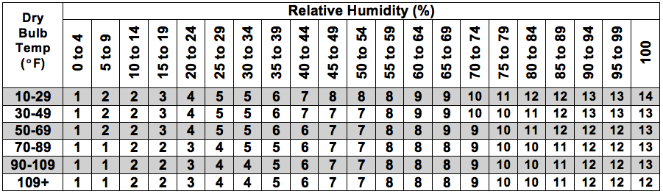
Table B. 1-hr Fuel Moisture Corrections-May-June-July
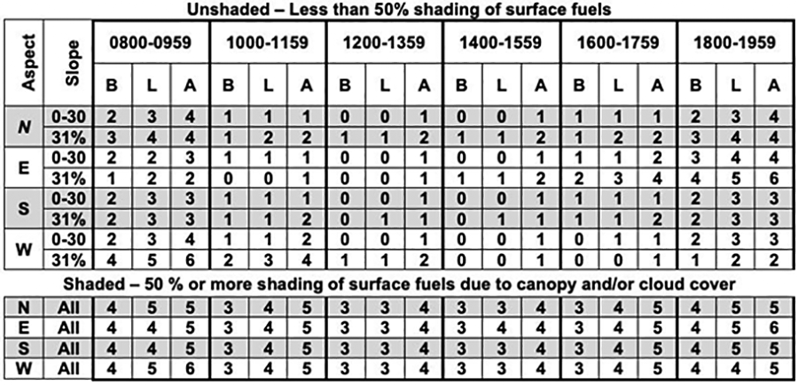
Table C. 1-hr Fuel Moisture Corrections-Feb-Mar-Apr and Aug-Sep-Oct
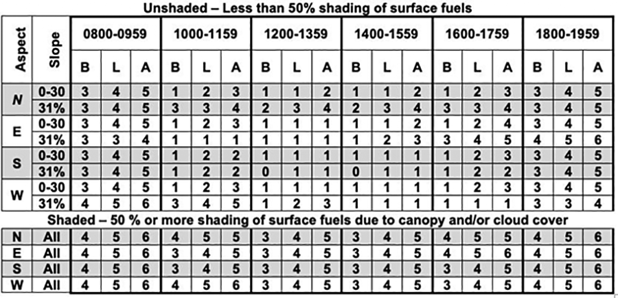
Table D. 1-hr Fuel Moisture Corrections-Nov-Dec-Jan


