image: http://www.yourdictionary.com/index.php/image/articles/15505.PhysicalCharacteristics.jpg

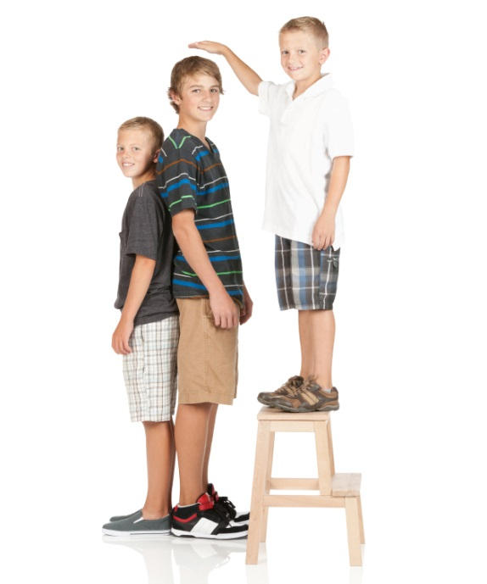

Physical [characteristics](http://www.yourdictionary.com/characteristic) can include a variety of things. Hairstyles and facial features play a big role, but aren’t the main ones. Physical characteristics are what you see with the naked eye. They encompass anything you can describe about a person or group of people, just on sight.

Physical Characteristics: What You Notice First

Physical characteristics are defining traits or features about your body.

The first thing you see when you look at someone could be their hair, clothes, nose, or figure. These are all examples of physical characteristics.

To get good examples of physical characteristics you should look at a person's face, how tall they are, and what they are wearing.

For example:

Build Characteristics

* Plump
* Stocky
* Overweight
* Fat
* Slim
* Trim
* Skinny
* Buff
* Well built

Height Characteristics

* Short
* Tall
* Petite
* Average height

Complexion Characteristics

* Dark
* Light
* Fair
* Olive
* Pale
* Tan
* Pimply
* Freckles
* Spots
* Pimples

Hair Characteristics

* Blond
* Fair
* Red
* Brown
* Black
* Grey
* White
* Long
* Short
* Curly
* Frizzy
* Straight
* Bald
* Receding

Read more at <http://examples.yourdictionary.com/examples-of-physical-characteristics.html#1vjVWTlCswZs4rVs.99>

