ELEC 475 Lab 4

Colin Gould – 20263713

Michael Cronin – 20265475

Introduction
In this lab, we implemented and trained a CLIP (Contrastive Language-Image Pre-training) model to learn a joint embedding space between images and text captions. CLIP is a vision-language model that learns to associate images with their corresponding text descriptions through contrastive learning, enabling zero-shot image classification and cross-modal retrieval tasks. The implementation used a ResNet50 backbone pretrained on ImageNet, fine-tuned on a subset of the COCO dataset to align image embeddings with CLIP’s text embeddings. The model learns to map images and captions into a shared 512-dimensional embedding space where semantically similar pairs have high cosine similarity. We evaluated the model’s performance using Recall@K metrics for both image-to-text and text-to-image retrieval, demonstrating that the model successfully learned meaningful cross-modal alignments despite training on a limited subset of data and showing signs of overfitting.

Methodology

Model Architecture
Backbone: ResNet50 (pretrained on ImageNet)
Projection Head: We used a projection head to map ResNet50’s 2048-dimensional feature space to CLIP’s 512-dimensional embedding space. The structure of the projection head was:
- ResNet50 (2048-dim)
- Dense Layer (1024-dim)
- GELU activation function
  - The Gaussian Error Linear Unit activation function is commonly used with transformer architectures due to its smooth gradients and probabilistic interpretation. We use it in the projection head to match CLIP, which is transformer based
- Dropout (p=0.3)*
  - *This was added as a modification, but we trained the baseline model without it. Dropout sets a certain percent of the activations (30% in our case) to zero on each forward pass, which reduces overfitting and increases robustness.
- Dense Layer (512-dim)
- L2 Normalize
  - L2 normalization normalizes all vectors to magnitude 1, which collapses the dot product to cosine similarity. Removing the magnitude prevents the model from using vector magnitude to hack the similarity metric.
Overall, this model had 26,131,008 trainable parameters.

Hyperparameters:

Dimensions Hyperparameters
- ResNet50 Input Dimensions: DxWxH = 3x224×224
- ResNet50 Output Dimension: 2048
- Projection Head Output Dimension: 512 (to match the CLIP embedding space)

Dataset Hyperparameters
- Training Subset Size: 400,000 image-caption pairs
- Validation Subset Size: 80,000 image-caption pairs

Training Hyperparameters
- Batch Size: 64
- Learning Rate: 1e-4
- Learning Rate Scheduler: Cosine Annealing
  - T_max: 10 (number of epochs)
  - eta_min: 1e-6 (minimum learning rate)
- Optimizer: AdamW
- Weight Decay: 0.01
- Number of Epochs: 10
- Label Smoothing: 0.1*
  - * This was only introduced as a modification, the baseline was not trained with label smoothing.

Loss Function Hyperparameters:
- Loss: InfoNCE (Normalized Temperature-scaled Cross Entropy Loss)
- Temperature: 0.07
- Type: Symmetric (image-to-text + text-to-image)

Data Preparation/Augmentation
- Random horizontal flip (p=0.5)
  - Only applied for training data
- Resize to 224×224
- CLIP normalization (mean=[0.482, 0.458, 0.408], std=[0.269, 0.261, 0.276])

Text Preprocessing
For the text encoder we used CLIP ViT-B/32 (openai/clip-vit-base-patch32). This model was frozen, only the ResNet50 model was actually trained. The tokenizer used for the text captions was the CLIP tokenizer, with a max length of 77. These captions were embedded to the 512-dimension CLIP embedding space and the vectors were L2 normalized. We prepared all these embeddings in advance (in the file Kaggle_preprocessing.ipynb) so they could be loaded as needed during training, rather than having to process them during training.

Hardware Configuration and Training Time
We trained this model using the free GPUs provided by Kaggle. We developed the notebooks in our IDE and uploaded them to Kaggle for training. Kaggle provided dual GPU access, on NVIDIA Tesla T4 GPUs, which have 16GB of VRAM.
We trained for 10 epochs, which took ~7.75 hours, or 46.5 minutes per epoch. As seen in Figure 1, over these 10 epochs our validation loss fell from over 0.8 to 0.7, while we saw our train loss fall significantly further to ~0.35. This indicates that the model was overfitting on the training data. We expect with more time and resources, we could have trained on more data and used a larger batch size. Since InfoNCE loss allows embeddings to train on both the positive match (the caption that actually corresponds to the image) and the negative matches (the other captions in the batch that do not correspond to the image), a larger batch size allows it to see more negatives and thus provides a richer training signal.
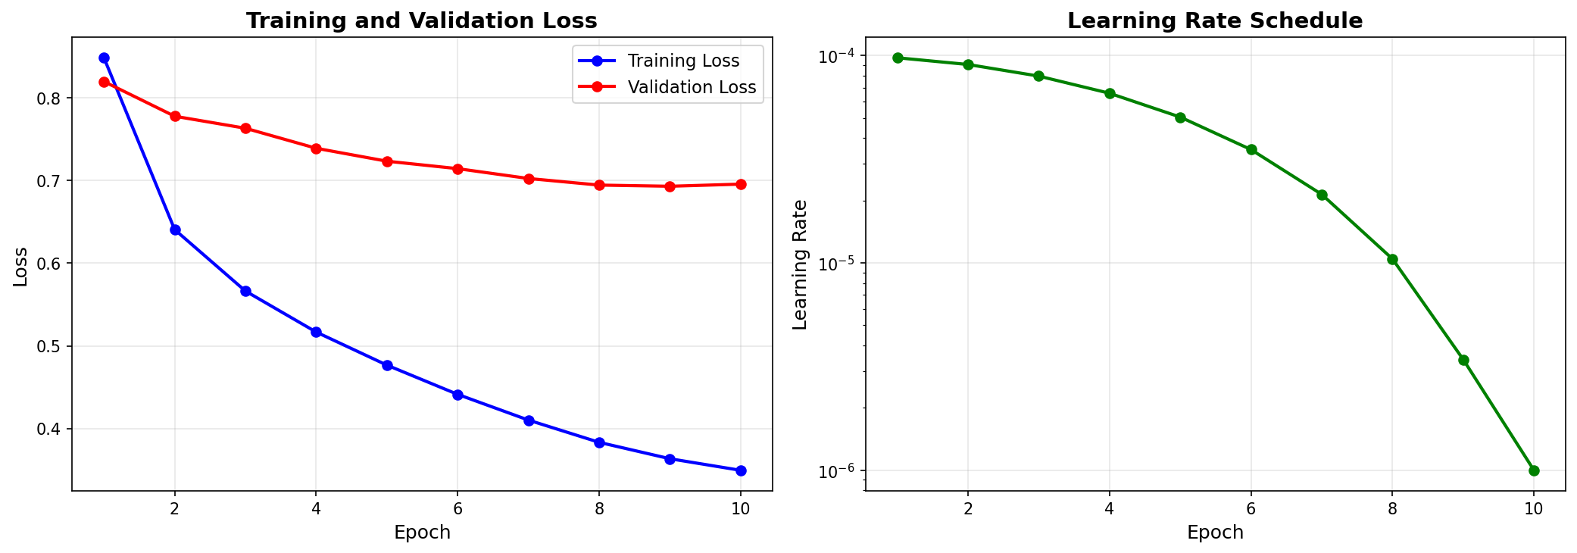
Figure 1: Loss Plot and Learning Rate Schedule

CLIP Loss
CLIP uses InfoNCE (Normalized Temperature-scaled Cross-Entropy) loss. This is a contrastive learning objective that trains the model to match correct pairs while pushing it away from incorrect matches.
In contrastive learning, we deal with anchors, positives and negatives. Anchors are the actual query samples, in this case our images. Positives are the value samples that are correct, in this case the caption that corresponds to the image. Finally, negatives are the value samples that do not correspond to the image, in this case these are all the captions of the other images in the batch. Obviously, the goal is to have the anchor representations be very similar to the positives and not very similar to the negatives.
In mathematical terms, given a batch of N (in our case N=64) image-caption pairs $\{\left(x_{1},y_{1}\right),\left(x_{2},y_{2}\right), …(x_{N},y_{N})\}$, we embed the images using our ResNet50 model and the captions using the CLIP text encoder, i.e., ${\hat{x}}_{i}=f_{ResNet}\left(x_{i}\right)$ and $\hat{y_{i}}=f_{CLIP}(y_{i})$ for each $0<i≤N$. Then we L2 normalize them each to make each $\left\|{\hat{x}}_{i}\right\|=\left\|{\hat{y}}_{i}\right\|=1$.
With these normalized embeddings, we can compute the similarity matrix $S_{ij}$:
$$S_{ij}=\frac{{\hat{x}}_{i}∙{\hat{y}}_{i}}{τ}$$
Which is the dot product of the embeddings divided by a temperature parameter (we used 0.07).
Now, we calculate loss using a combination of image-to-text loss (I2T) and text-to-image loss (T2I). For I2T, we want to identify the correct caption for each image $x_{i}$ among N options:
$$L_{I2T}\text{=}\frac{-1}{N}\sum_{i}{\frac{e^{S_{ii}}}{\sum_{j}{e^{S_{ij}}}}}$$
For T2I, we want to identify the correct image for each caption $y_{j}$ among N options:
$$L_{T2I}\text{=}\frac{-1}{N}\sum_{j}{\frac{e^{S_{jj}}}{\sum_{i}{e^{S_{ij}}}}}$$
The final loss is the average of these two:
$$L = \frac{L_{I2T} + L_{T2I}}{2}$$

As you can see, large values for the matches (i,i) and low values for the mismatches (i,j) create high scores. This pushes the matches towards each other and away from the mismatches.

Results

Baseline Results

Quantitative Evaluation
We evaluated our model on 5000 image-caption pairs from the COCO 2014 validation set using Recall@K metrics, which measure the percentage of queries where the correct match appears in the top K retrieved results. For recall @1, @5 and @10 the model had a score of around 20%, 50% and 60%, respectively. Text-to-Image performed notably better, with a 5%+ higher recall for 1, 5, and 10. The results are below in Figure 2.
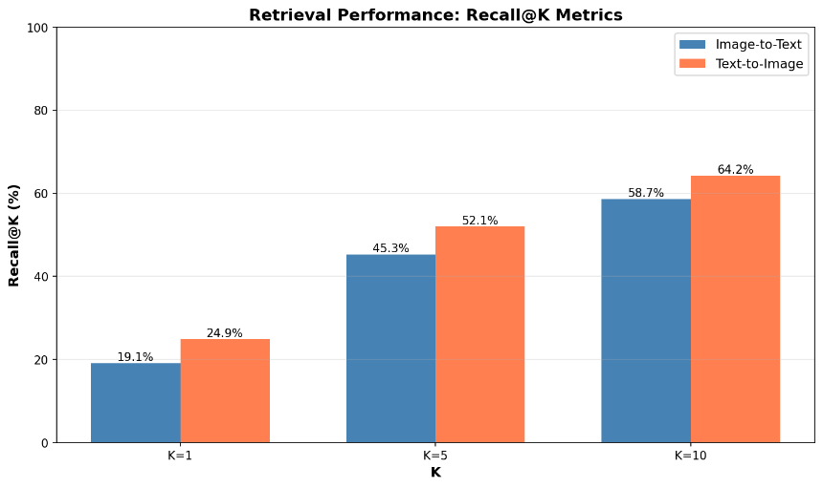
Figure 2: Baseline Model Recall @1, @5, and @10

Analysis of the similarity matrix reveals how well the model separates correct pairs from incorrect ones in Figure 3.

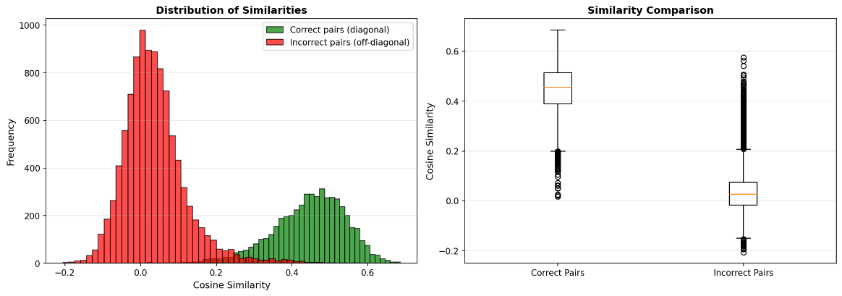
Figure 3: Baseline Results Similarity Distribution

The positive separation margin indicates that the model successfully learned to assign higher similarity scores to matching image-caption pairs than to mismatched pairs. However, the relatively low Recall@1 and overlap in similarity distributions suggest room for improvement. The model’s performance is stronger for text-to-image retrieval than image-to-text retrieval, which may reflect differences in how visual and textual information are encoded or the relative difficulty between the two tasks.
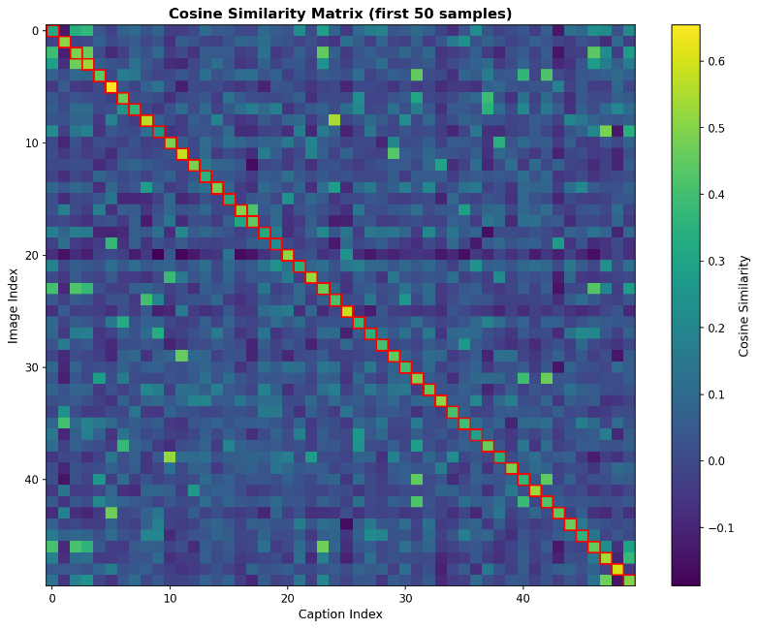
Figure 4: Heat Map of Baseline Model Image-Caption Similarities

This heat map, in Figure 4, shows that for the majority of image-caption pairs, the most similar results are the corresponding match, with only a small number of higher-similarity scores outside of the main diagonal.

Qualitative Evaluation
We conducted further evaluation through image-to-text retrieval and text-to-image retrieval over arbitrary natural language queries.
For text-to-image retrieval, we used five single-word queries, each representing a semantic category: "sport," "animal," "food," "landscape," and "person." For each query, we encoded the text using the CLIP text encoder and retrieved the five images with the highest cosine similarity to the query embedding. The retrieved images were then manually inspected to determine whether they corresponded meaningfully to the query term. We found that there were usually a couple of good matches in the top five images, as seen in Figure 5, but also some irrelevant images. The rest of the examples are in the Appendix, under Baseline Results.
Next, for image-to-text retrieval, which is essentially zero-shot image classification, we selected random images from the validation set and classified them against sets of candidate labels. Three test configurations were used: (1) high-level categories including "a person," "an animal," and "a landscape"; (2) animal subcategories including "a dog," "a cat," "a bird," and "a fish"; and (3) scene categories including "sports," "food," "nature," and "architecture." The classification was performed by computing cosine similarity scores between the image embedding and the text embeddings of each candidate class, then selecting the class with the highest similarity. The model performed poorly on these retrieval tasks. Notably, not even one of the ten zero-shot image-to-text classifications returned the correct category label.
We hypothesize that this poor qualitative performance stems from a fundamental mismatch between the embedding distributions of the query terms and the training data. The model was trained exclusively on COCO 2014 captions, which are full, descriptive sentences such as "A group of people playing soccer on a grass field." These captions provide rich contextual information and follow consistent grammatical patterns. In contrast, the evaluation queries were single words like "sports".
For improved zero-shot classification performance, future work could explore training with a more diverse set of caption styles, including both descriptive sentences and plain labels.
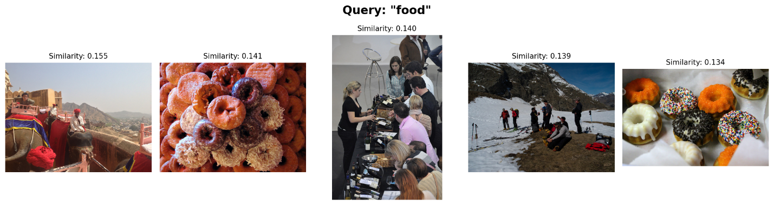
Figure 5: Example of a Text-to-Image Retrieval

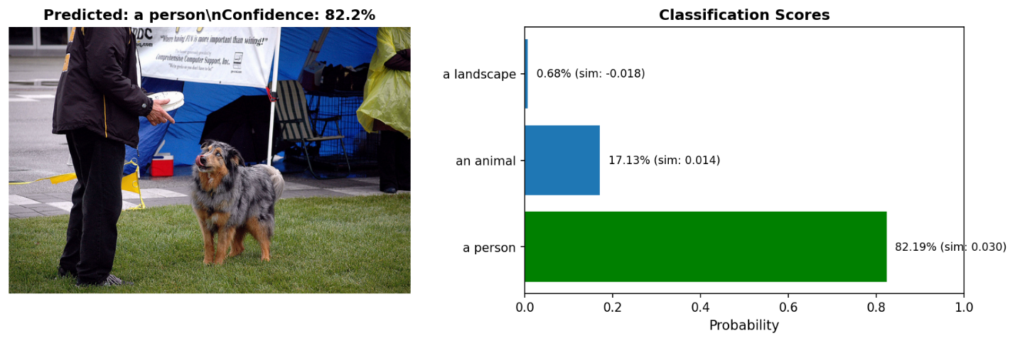
Figure 6: An example of an Image-to-Text Retrieval

Modification 1: Dropout and Label Smoothing

Quantitative Evaluation
For the first modification, we introduced regularization techniques such as dropout and label smoothing. Dropout was applied to the projection layers to reduce overfitting, while label smoothing was used during contrastive loss computation to prevent the model from becoming overly confident in its assignments.
We evaluated our model on the same 5000 image-caption pairs. As shown in Figure 7, the recall is slightly worse than baseline model.

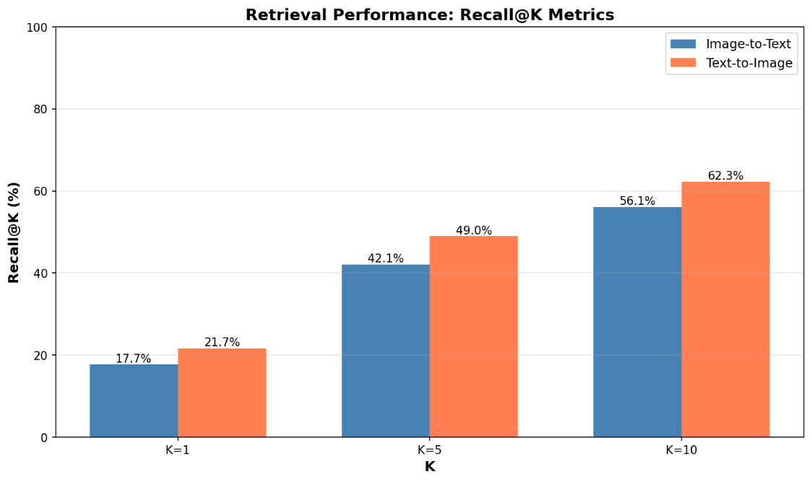
Figure 7. Recall@K evaluation for dropout and label smoothing model.
Figure 8 shows the distribution of similarity ranking, which also shows the majority of the correct image-caption pairs are ranked more similar than most incorrect pairs.
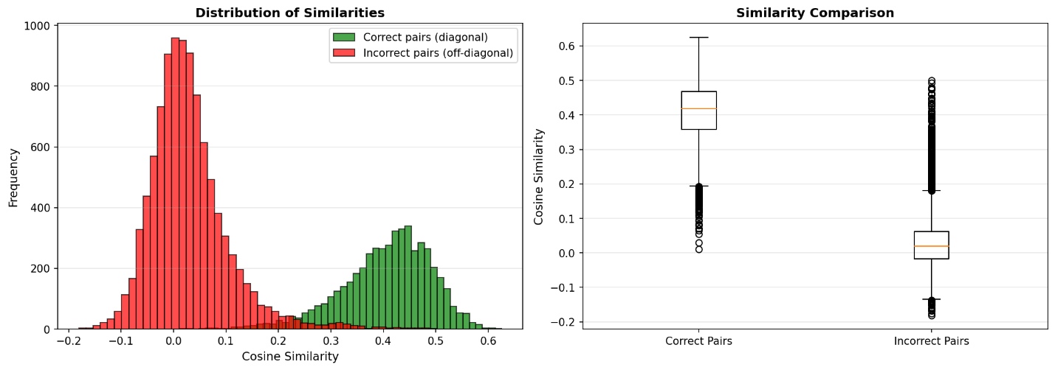
Figure 8. The distribution of similarity rankings for the dropout and smoothing model.
Additionally, the similarity heat map in Figure 9 again shows the highest similarity scores concentrated along the diagonal, indicating that the model continues to correctly align corresponding image-text embeddings.
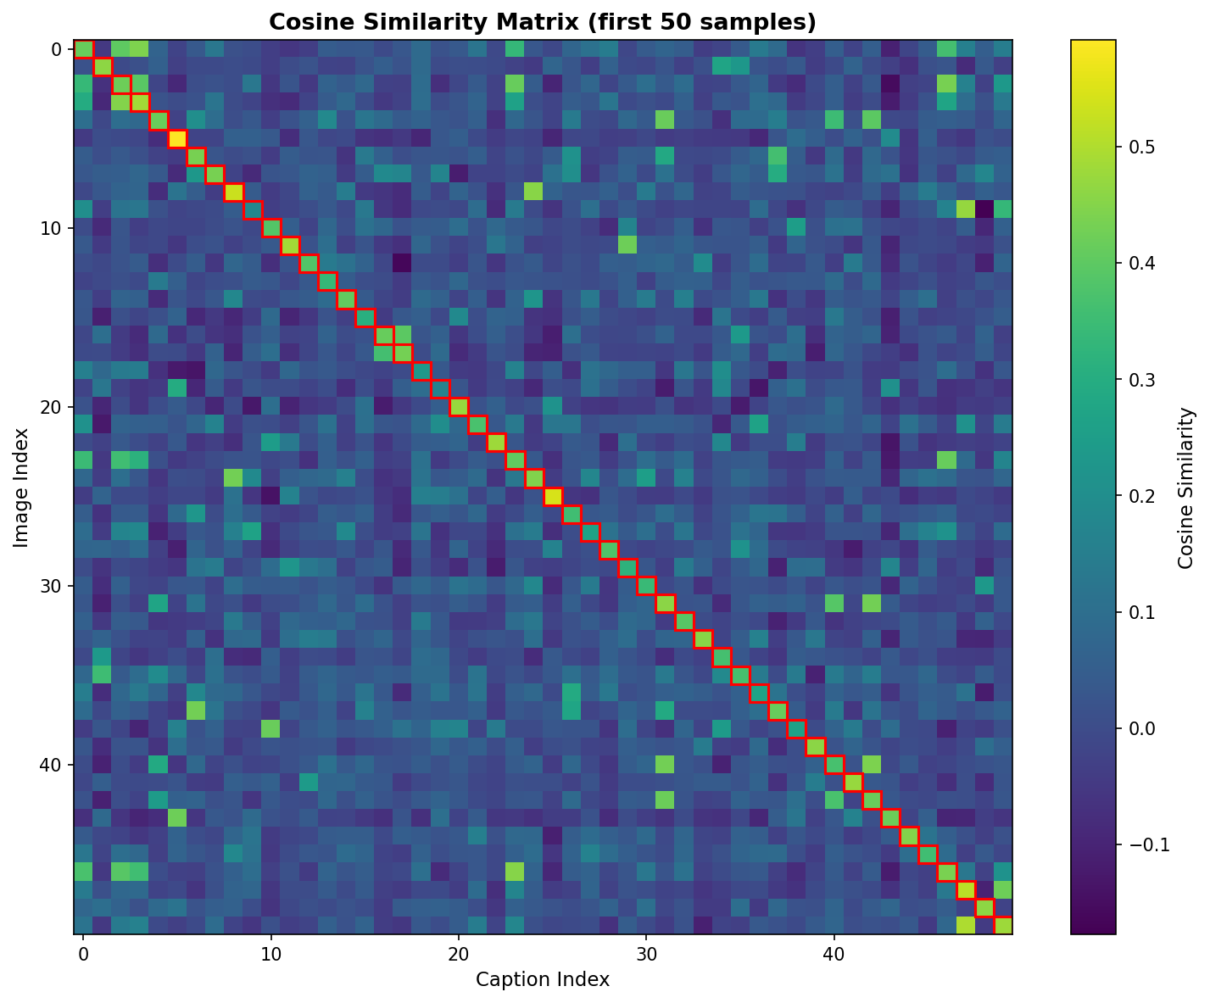
Figure 9. The similarity heat map for the dropout and smoothing model.
Overall, these results suggest that adding dropout and label smoothing did not meaningfully improve retrieval performance, and in some cases, worsened it. One possible reason is that the baseline CLIP-style setup already benefits from significant implicit regularization through the contrastive objective and large batch interactions. As a result, additional regularization may offer limited gains.

Qualitative Evaluation
We repeated the same open-ended language retrieval tests to qualitatively assess the model. Its outputs were very similar to the baseline across all prompts, and it continued to exhibit the pattern where image-to-text retrieval underperformed relative to text-to-image retrieval. Several examples are shown below in Figure 10, with the remaining cases included in the Appendix under Dropout + Label Smoothing Results.
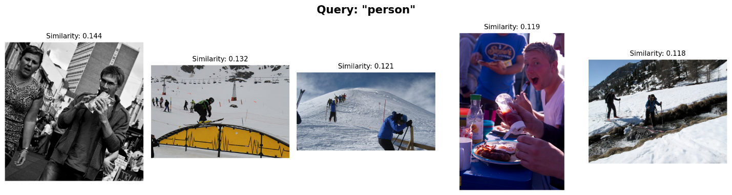
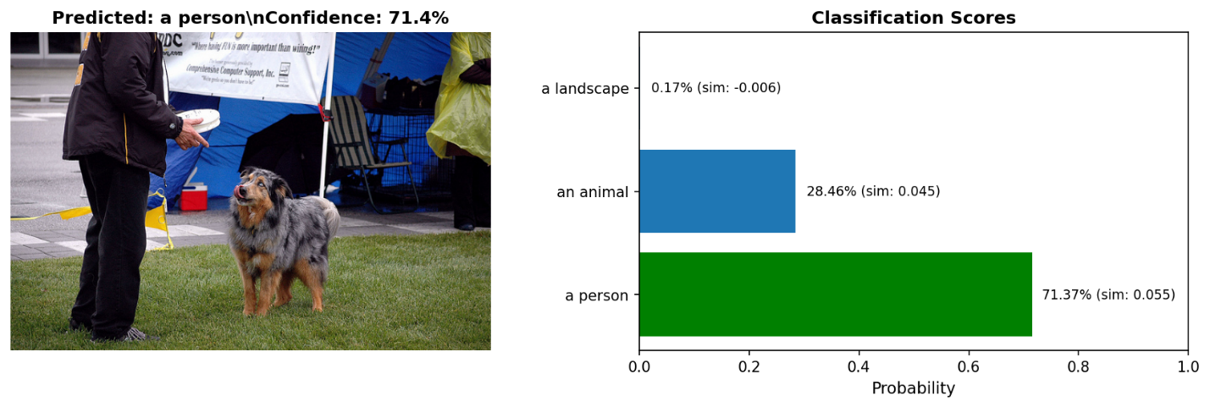
Figure 10. Examples of image-to-text and text-to-image retrievals.

Modification 2: Stronger Data Augmentation

Quantitative Evaluation
For our second modification, we introduced stronger data augmentation. This stronger augmentation applied during training, including random resized crops, horizontal flips, brightness/contrast adjustments, and slight rotations.
We evaluated our model on the same 5000 image-caption pairs. As shown in Figure 11, the recall is nearly identical to the baseline model.
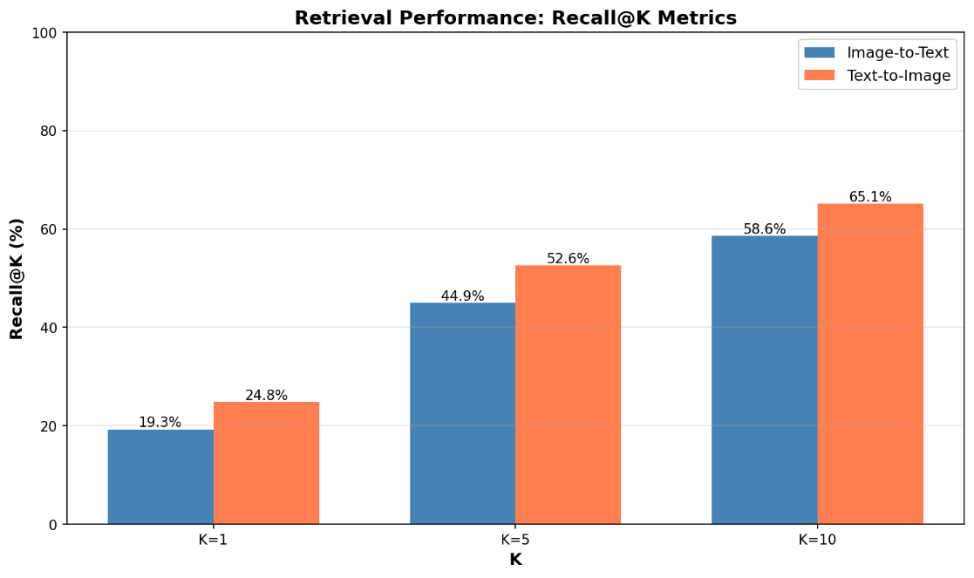
Figure 11. Recall@K evaluation the augmentation model.
Figure 12 shows the distribution, which similarly to the baseline, shows that the majority of correct pairs were ranked more similar than the majority of the incorrect pairs.
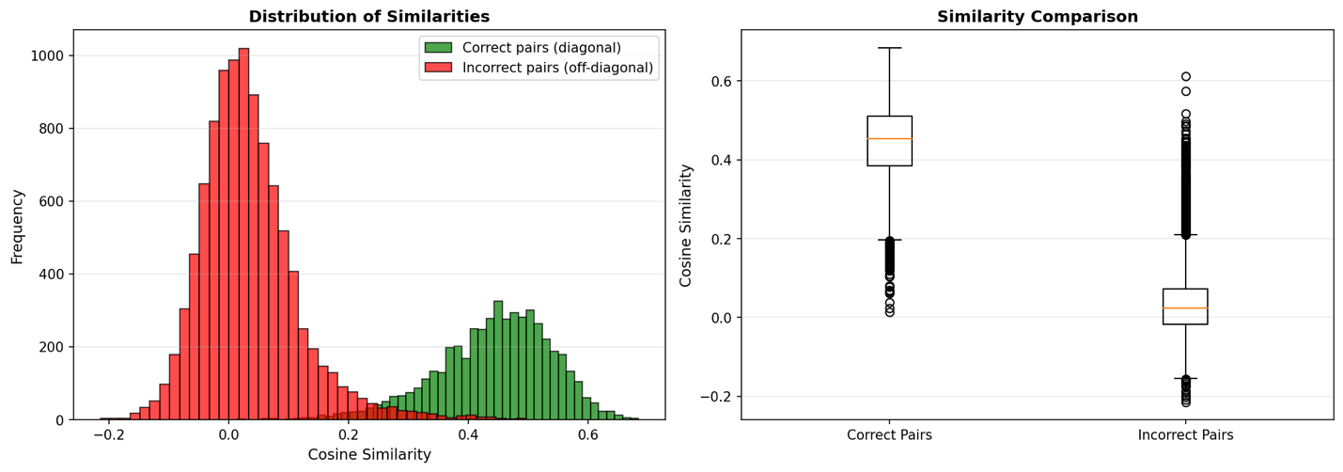
Figure 12. The distribution of similarity rankings for the augmentation model.
Lastly, the similarity heat map in Figure 13 once again shows the most similar scores tending to be on the diagonal.
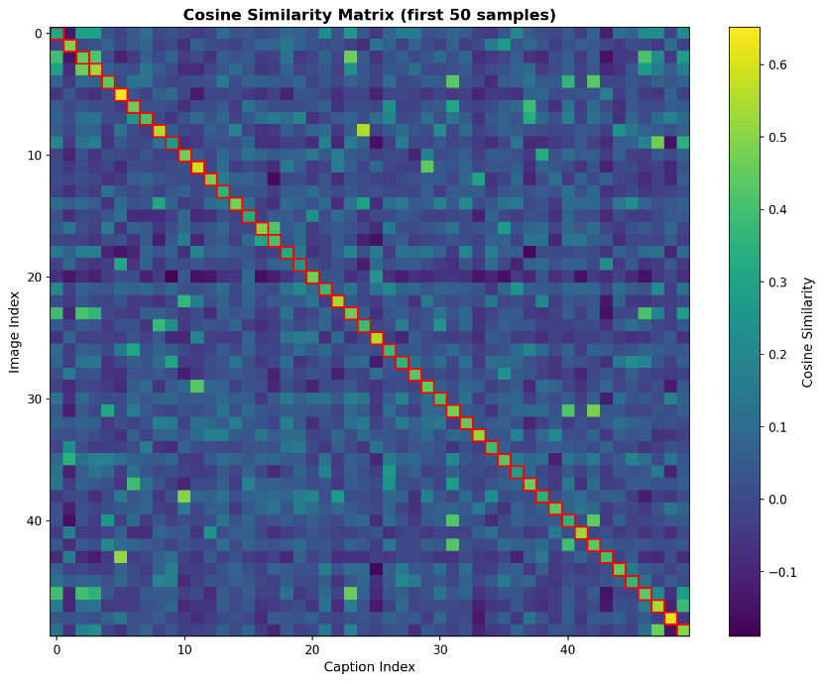
Figure 13. The similarity heat map for the augmentation model.
These results suggest that the strong data augmentation strategy did not meaningfully improve retrieval performance. This could be because we avoided some forms of augmentation that could otherwise be used, such as more aggressive cropping or color alterations. We did this to ensure we didn’t create a mismatch between the image and the caption, i.e., if the caption describes a “blue car” and we make the car red or crop it out of the photo, it could confuse the training. However, seeing as this is an uncommon scenario, even stronger augmentation may have been helpful.

Qualitative Evaluation
We performed the same arbitrary language retrieval tasks to further evaluate the model. It showed similar results to the baseline for all metrics, and was consistent with the image-to-text performing worse. Some examples are shown below in Figure 14, with the rest in the Appendix, under Stronger Augmentation Results.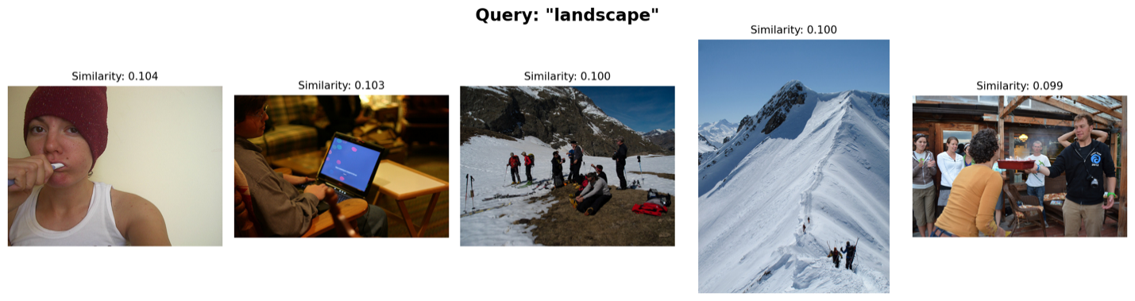
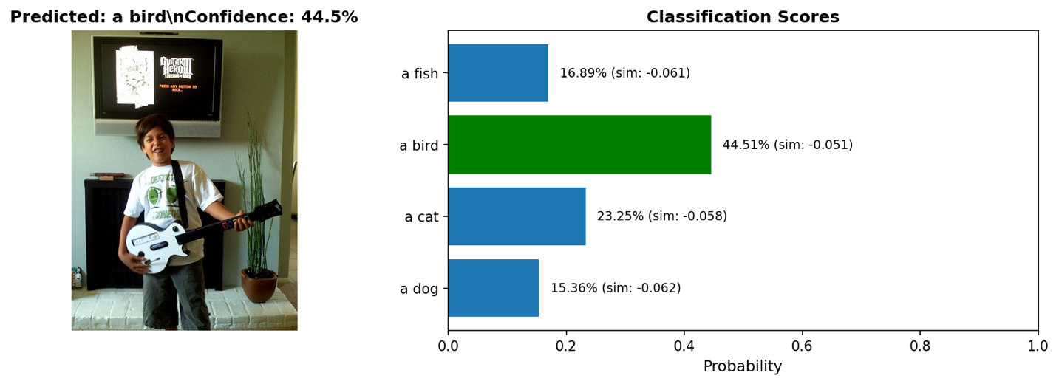
Figure 14. Examples of image-to-text and text-to-image retrievals.

Comparison of Baseline to Modifications

Similarity Metrics
Metric | Baseline | Mod1: Dropout + Label Smoothing | Mod2: Augment
Mean Similarity | 0.4463 | 0.4061 | 0.4436
Min Similarity | 0.0179 | 0.0112 | 0.0144
Max Similarity | 0.6865 | 0.6256 | 0.6847

Image-to-Text Retrieval
Metric | Baseline | Mod1: Dropout + Label Smoothing | Mod2: Augment
Recall@1 | 19.14% | 17.72% | 19.26%
Recall@5 | 45.30% | 42.08% | 44.94%
Recall@10 | 58.68% | 56.14% | 58.60%

Text-to-Image Retrieval
Metric | Baseline | Mod1: Dropout + Label Smoothing | Mod2: Augment
Recall@1 | 24.94% | 21.70% | 24.78%
Recall@5 | 52.06% | 49.00% | 52.58%
Recall@10 | 64.24% | 62.26% | 65.10%

From these results, we see that the modifications did not have much impact on the performance of the model. We suspect that dropout and label smoothing could be beneficial but needs further tuning in terms of batch size and number of epochs in order to get positive effects. Further, the augmentation modification was not significant enough to impact the results.

Discussion

Baseline Discussion
Our results demonstrate that the CLIP model successfully learned meaningful cross-modal alignments between images and text, though several limitations and areas for improvement are evident.
The model achieved moderate retrieval performance with Recall@1 scores of 19.14% (image-to-text) and 24.94% (text-to-image). While these scores are below SOTA CLIP models (which typically achieve Recall@1 > 30%), they represent meaningful progress given constraints. The Recall@5 and Recall@10 scores indicate that the model often places correct matches near the top of rankings, even if not first. This suggests the embedding space captures semantic relationships, but fine-grained distinctions need improvement.
A significant concern is the clear overfitting observed during training. The training loss decreased from 0.85 to 0.35 over 10 epochs, but validation loss plateaued around 0.70 after epoch 7. This large gap between training and validation loss indicates the model memorized training patterns rather than generalizing robustly. Factors such as limited training data, small batch size, and a short training duration of 10 epochs likely contributed to overfitting.
Using ResNet50 as the backbone provided a reasonable starting point but may limit performance compared to vision transformers used in the original CLIP. ResNet50’s inductive biases may be less suited for global semantic understanding than vision transformer’s self-attention mechanism. Alternative designs such as deeper networks, residual connections, or different normalization strategies might improve performance.

Modification Discussion
The dropout and label smoothing modification resulted in a measurable decline in performance relative to the baseline model. This is a very curious result, as these techniques are commonly used to reduce overfitting and improve generalization. In this case, it is possible the dropout injected too much noise into the projection space, weakening the consistency across batches. The label smoothing may have softened the contrastive signal that drives the model to separate positive and negative pairs. The combined effect was a reduction in the model’s ability to rank true image-caption pairs higher than mismatched ones, suggesting the baseline model was already sufficiently regularized.
The augmentation modification did not materially affect performance in either direction. This indicates the model was already robust to the forms of augmentation we applied, or that our augmentations were not aggressive enough to meaningfully alter the image representations. Combined with the first modification, these results suggest that neither regularization or augmentation strategies provided additional gains beyond the baseline, highlighting that improvements may require deeper architectural changes or more targeted domain-specific augmentations rather than general-purpose techniques.

LLM Use
Before writing any code, we invested substantial time in planning and understanding the theoretical foundations of CLIP and contrastive learning. LLM’s were instrumental in understanding the math behind the loss function, as well as the intuition behind the model. Rather than jumping straight to implementation, we had long conversations with the LLM of choice to plan and ensure all design decisions were clear. This was important as it allowed us to scope out the entire implementation and fix any contextual misunderstandings before building.
Despite this, we still encountered numerous bugs during implementation and training that required debugging. For these, we used LLM to suggest bug fixes, but we did not blindly accept LLM suggestions. We carefully traced through the code logic, verified mathematical correctness, and tested fixes. This iterative process was crucial for developing a robust implementation.
Progress was tracked in Github: https://github.com/mcronin4/elec_475_labs. We made iterative commits after each substantive LLM usage session.

Conclusion
In this lab, we successfully implemented and trained a CLIP-style model using ResNet50 and contrastive learning to align image and text embeddings. Despite training on a limited dataset and computational constraints, the model learned meaningful cross-modal representations, achieving Recall@1 scores of 19.14% (image-to-text) and 24.94% (text-to-image) on the COCO validation set.

Appendix

Baseline Results

Text to Image Results
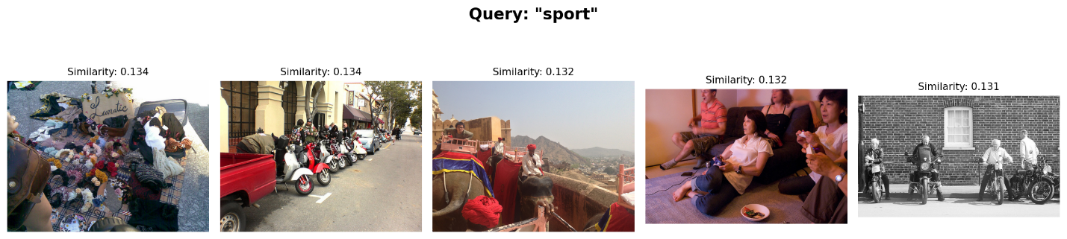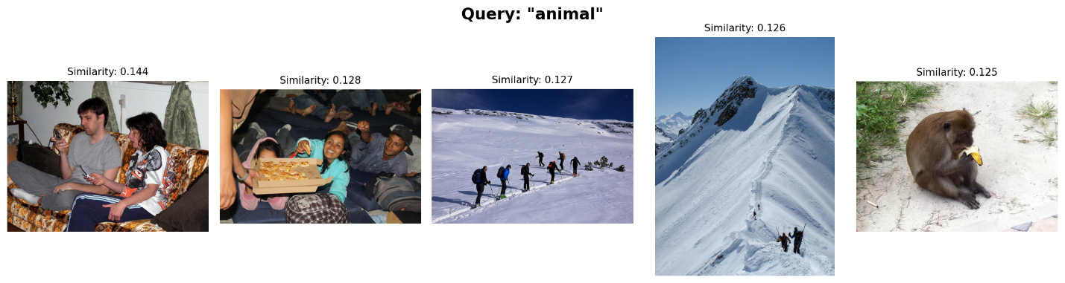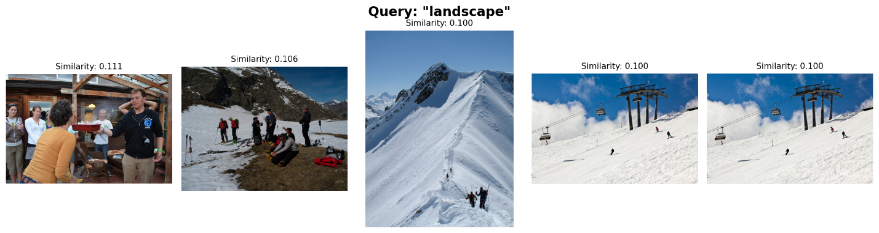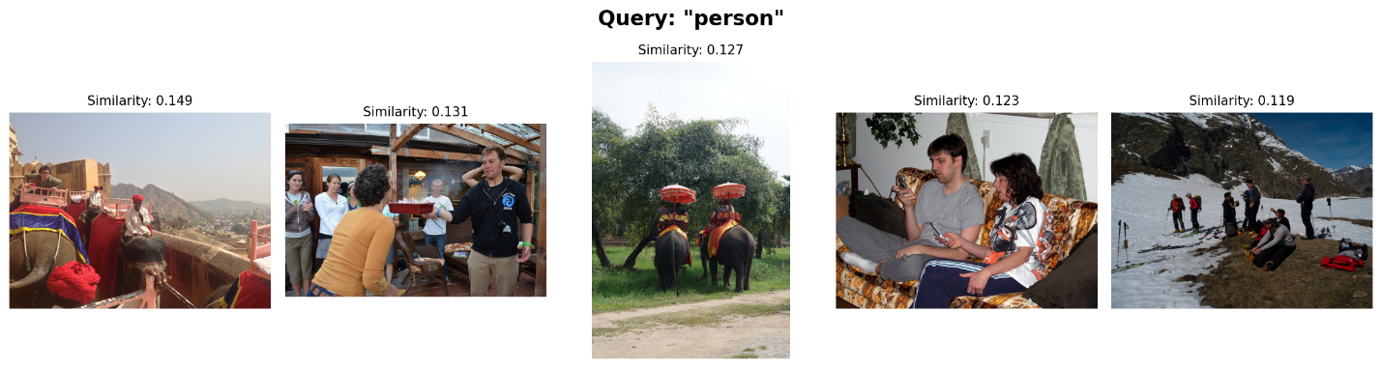

Image to Text Results
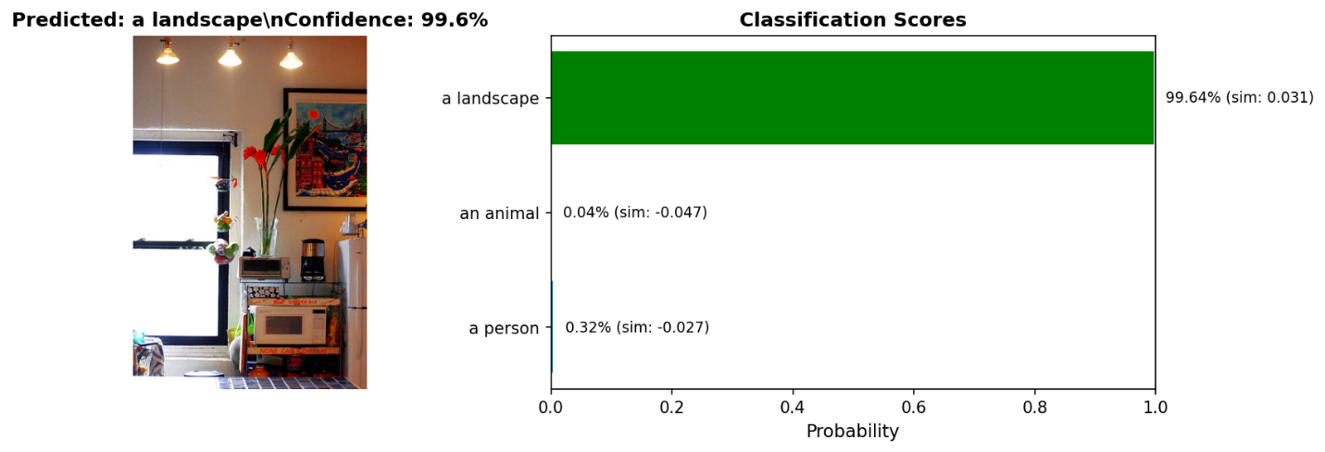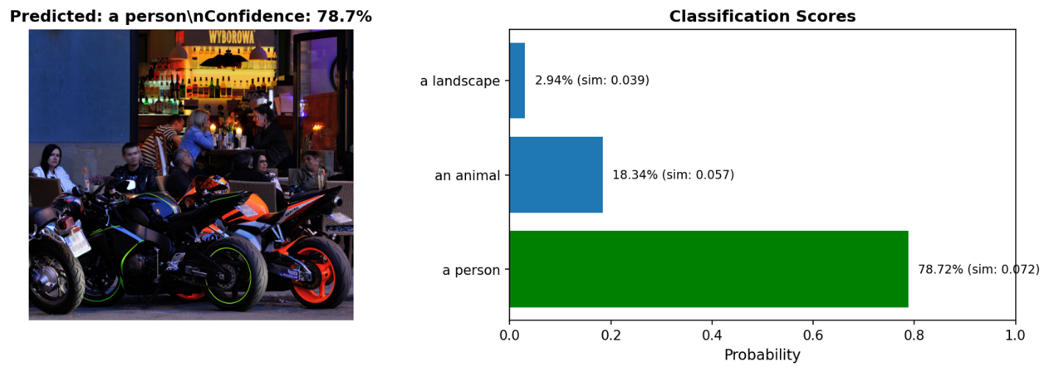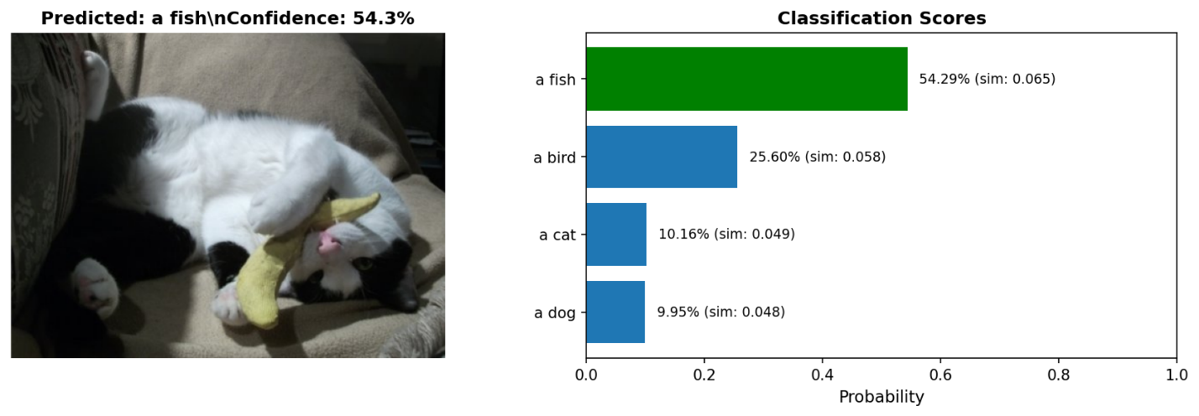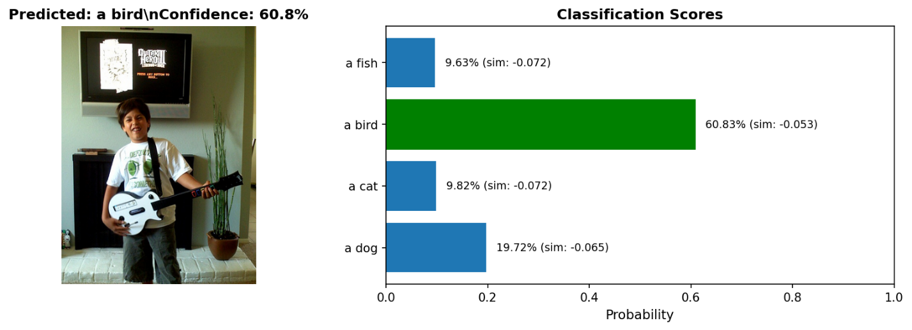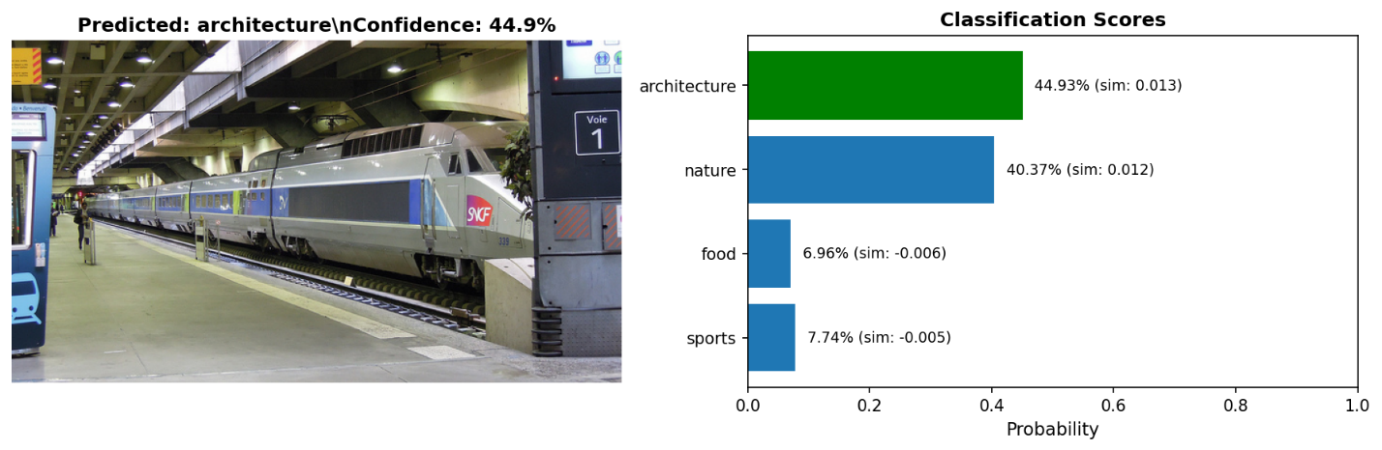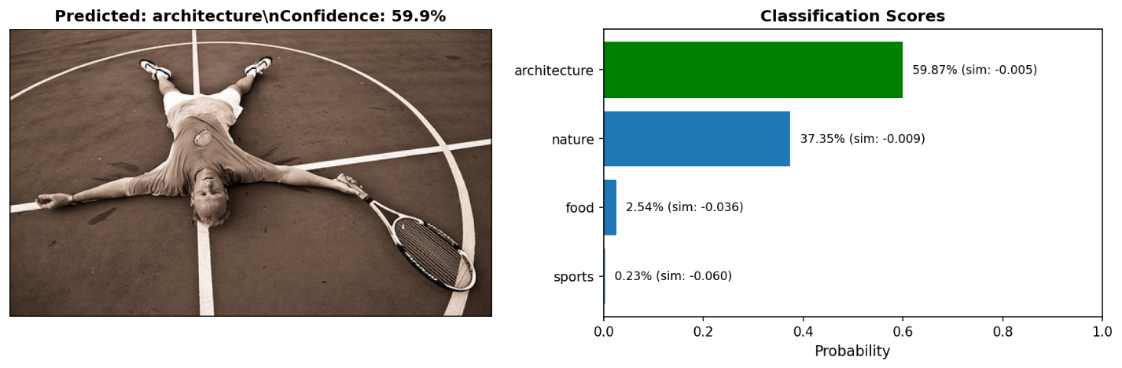

Dropout + Smoothing Results

Text to Image Results
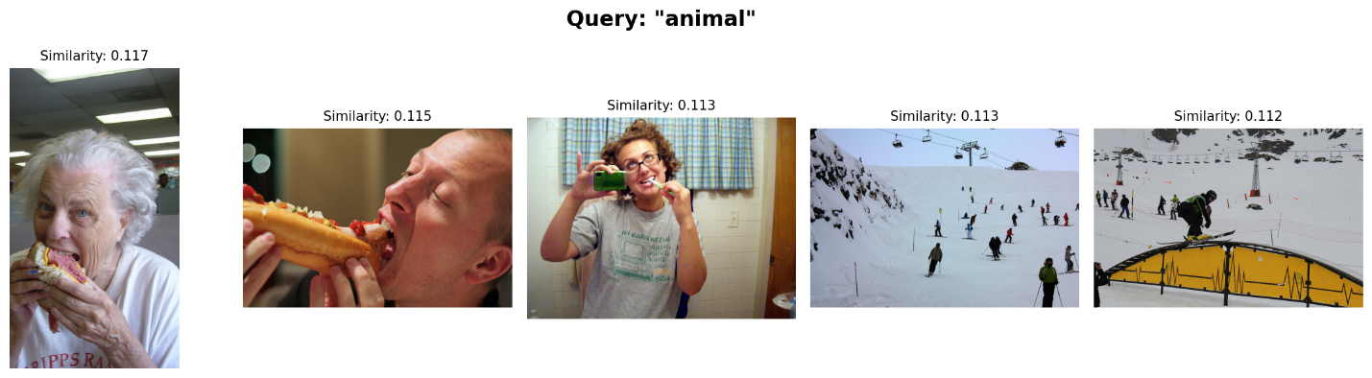
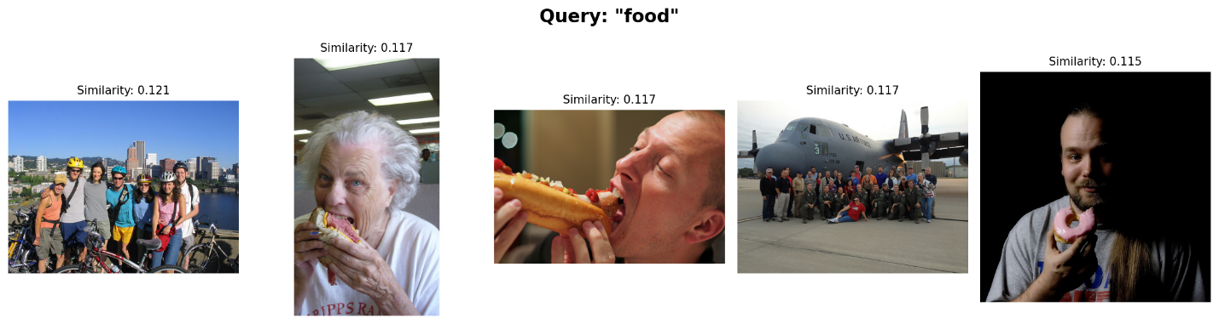
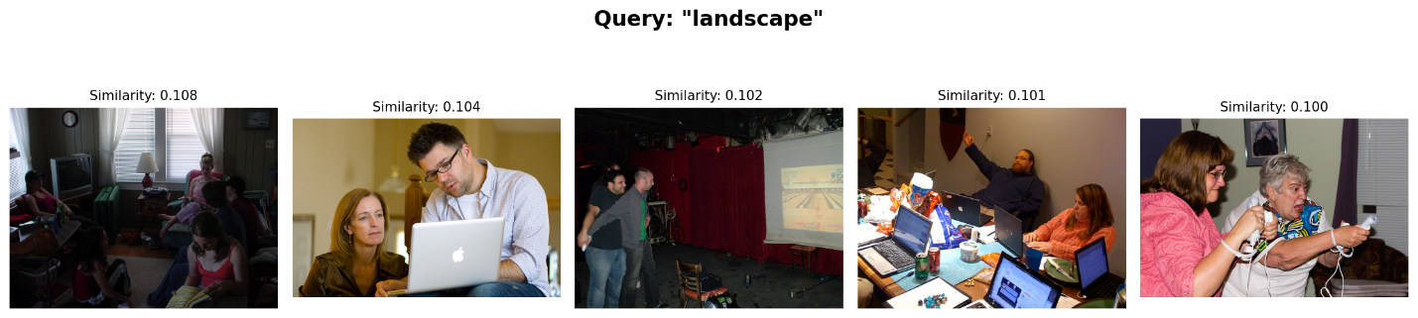

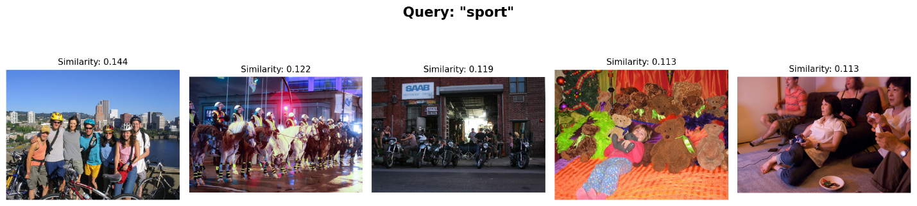

Image to Text Results
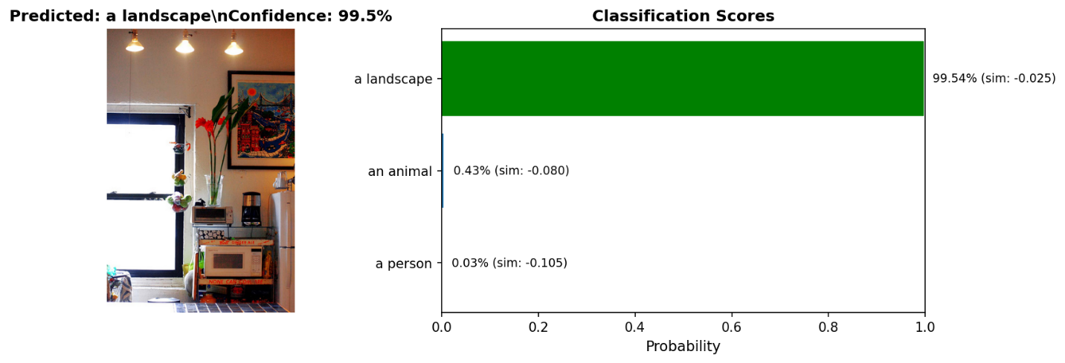
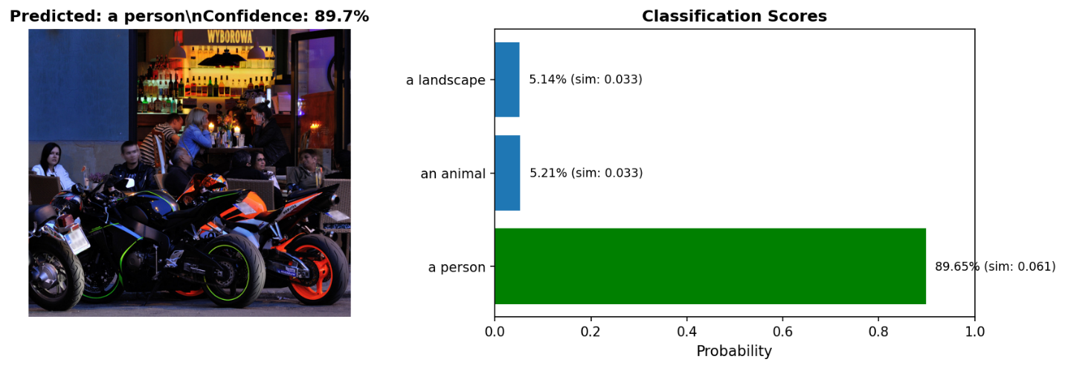

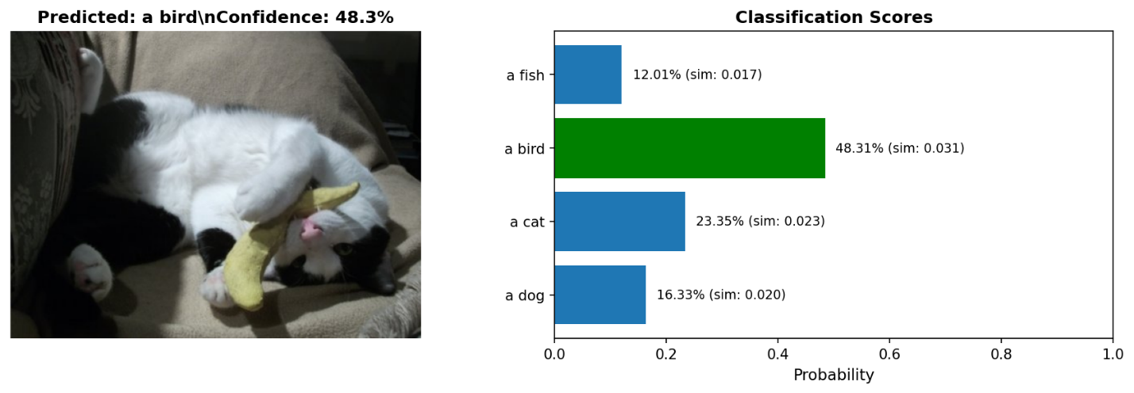
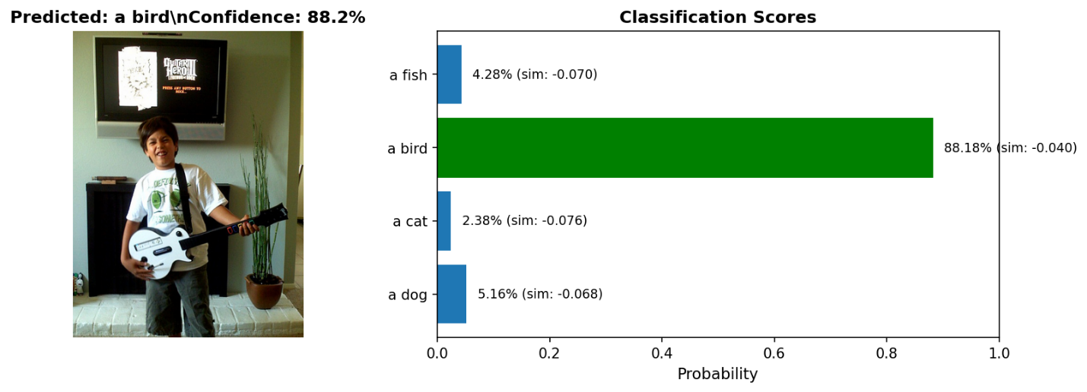
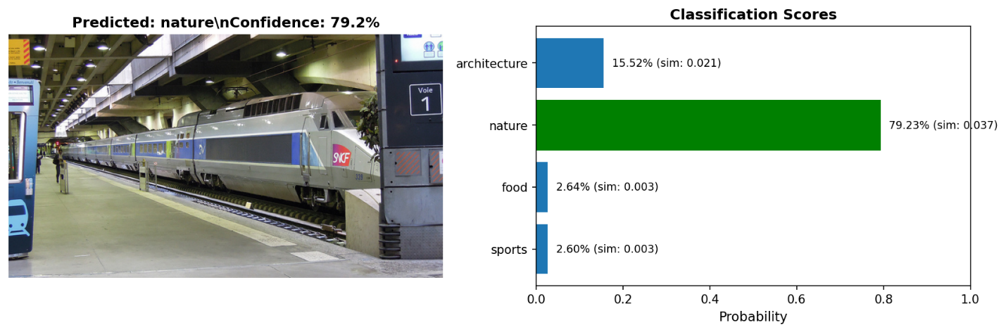
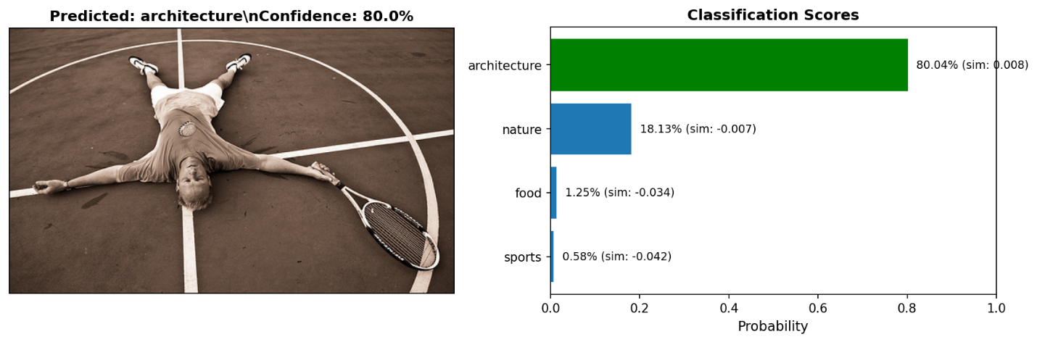

Stronger Augmentation Results

Text to Image Results
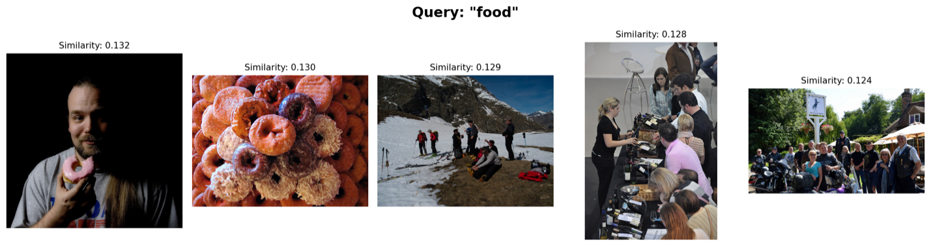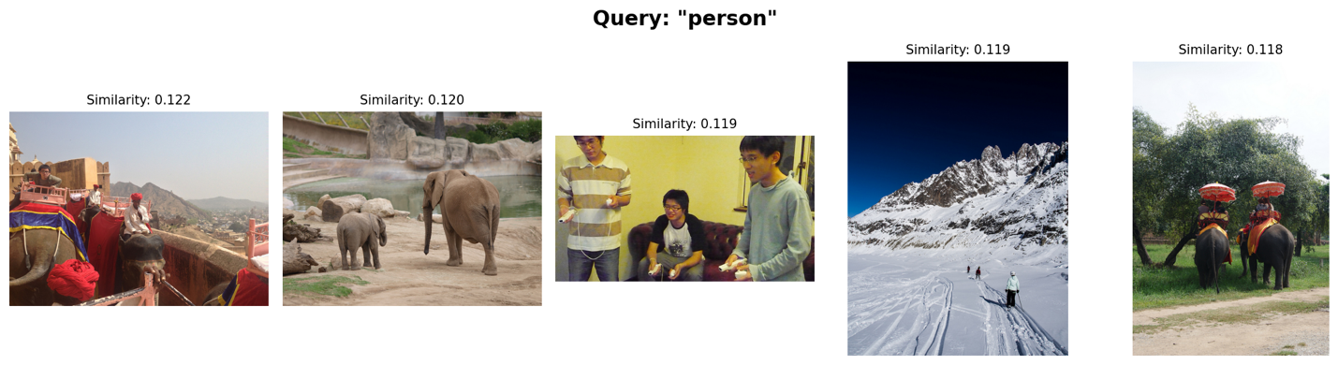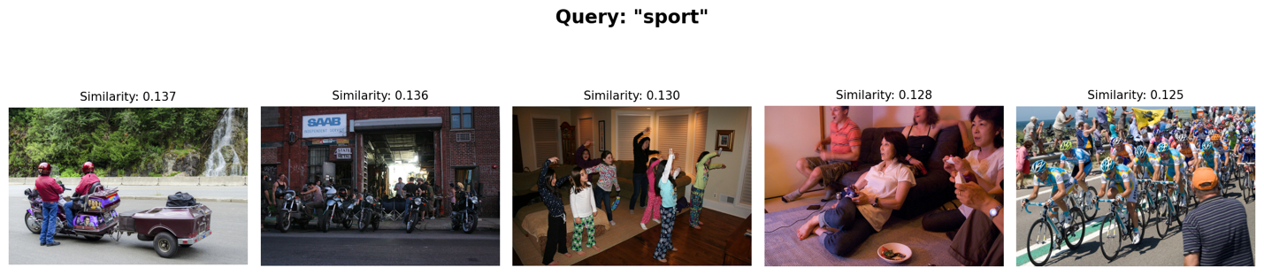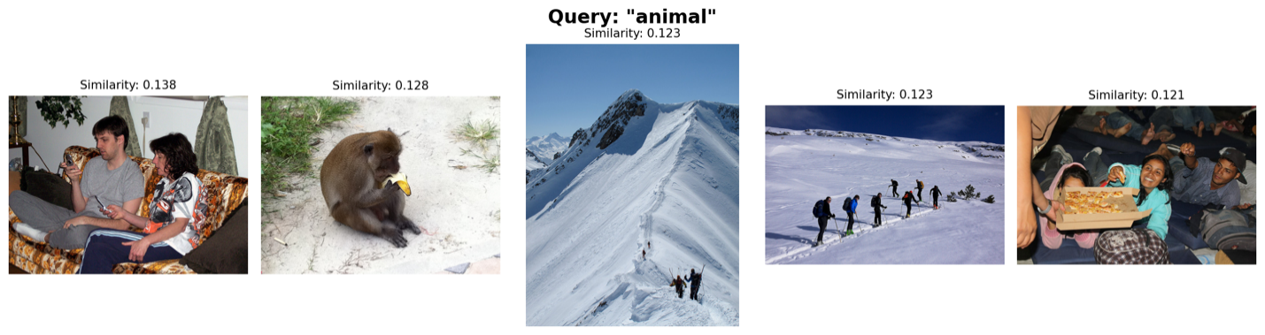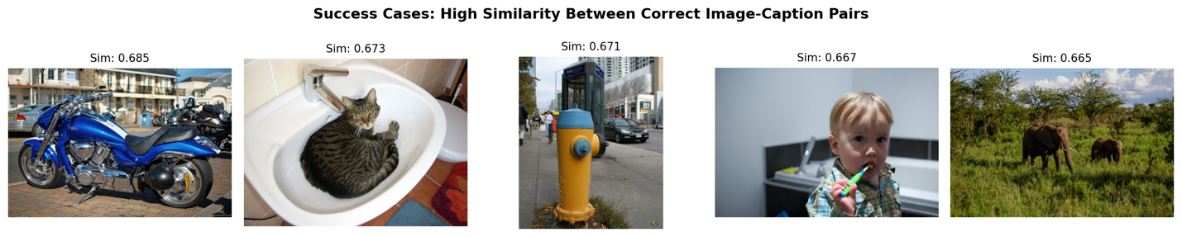

Image to Text Results
