**OsteoSense – A Right Step OÜ Experiment**

**ESA 8th Parabolic Flight Campaign**

In collaboration with;

|  |  |
| --- | --- |
| Tallinn University Of Technology | Jeff Tuhtan |
| University of West London | Dr Jin Luo |
| Université Jean Monnet | Dr Laurence Vico |

Supported by:

|  |  |
| --- | --- |
| ESA BIC Estonia | Sven Lilla |
| European Space Agency | ESA Life Science |
| Novespace | Tihbault Paris |

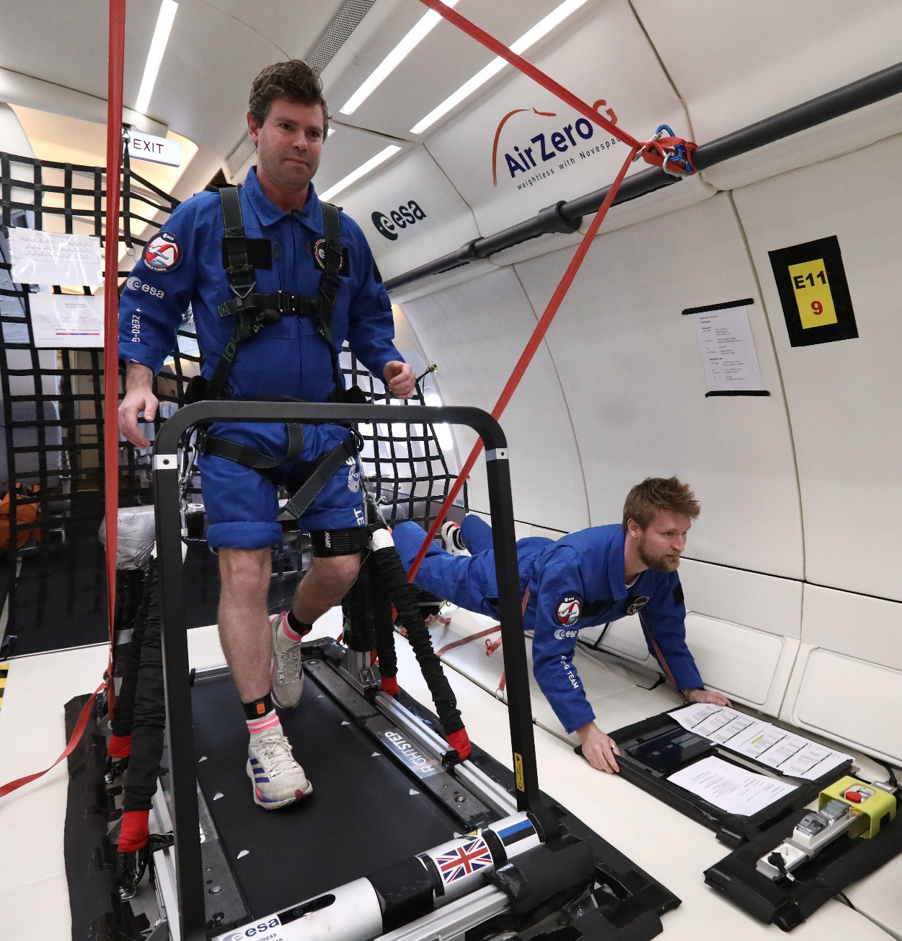

**Title**: Assessing exercise on bone loading from a novel perspective on earth and in microgravity

**Parabolic Flight Overview**

**What is parabolic flight?**

Parabolic Flight is a trajectory taken by an aircraft in order to reproduce various gravity levels, in particular hyper g (1.8g) and zero g (microgravity). It is achieved by flying the aircraft in upward and downward arcs that are interspersed with level flight. A parabolic flight creates environments for researchers to conduct experiments without needing to go to space. They provide an environment for the “normal” person to experience what an astronaut experiences in space and thus be able to design appropriate experiments for space. Weightlessness is achieved for approximately 22 seconds with 20 seconds of hyper gravity on either side of the parabola. The aircraft pulls up initially reaching around 50 degrees of nose up before “injection” which guides the plane over the top of the parabola. This is achieved by reducing the engine speed allowing the aircraft to follow a ballistic trajectory, essentially free fall. The parabola peak is exited at approximately 42 degrees nose down and 20 seconds later pulls out to level flight.

The aircraft travels at a speed of 810 km/h at an altitude of 6000m before the manoeuvre is carried out.

**Parabola Timings**

**Flight procedure**

**Hypotheses**

The following hypotheses are taken directly from the original proposal.

**Original Scientific Hypotheses**

The scientific hypotheses are considered to provide a foundation to further research in space.

* There is a difference in loading intensity and frequency content of signals generated on the ground vs microgravity in parabolic flight
* Exercise performed in footwear vs barefoot elicit an increase in loading intensity both on the ground and in parabolic flight
* Generated frequency response in microgravity can be replicated on the ground and vice versa

**Original Technical Hypotheses**

The technical hypotheses aim to address the need to measure and monitor musculoskeletal loading.

* The proposed technology can measure and monitor loading parameters in real time and in a micro gravity environment
* The proposed technology can capture required accelerometery data over the duration of a parabolic flight (3-4 hours)
* Activities performed with and without footwear result in observable loading profile alterations

**Alterations**

The first two scientific hypotheses were considered to be biomedical in nature and thus required ethical approval. These were removed as time would not allow approval to be obtained. It was deemed that the experiment would only provide an indication rather than a true scientific outcome since there are only two participants. Given that the data required would be collected anyway in order to achieve the other hypotheses the analysis can still be performed.

The second technical hypothesis was removed completely as it would involve a third sensor. This was deemed a practical issue in fixing an additional sensor, extra data analysis work and in favor of the newly developed high data rate sensor that could provide more insight into the skeletal loading aspects.

**Objectives:**

**Scientific objectives**

The scientific objectives provide a new insight and perspective to the quantification of skeletal loading and will form the foundation of future research.

1. What is the measurable difference between activities performed on the ground vs microgravity?
2. What are the measurable differences in the frequency response of the test battery on the ground vs microgravity?
3. What activities induced greater loading potential for bone adaptation?
4. Do certain activities in the battery produce similar loading potential when performed on earth and in microgravity?

**Technical Objectives**

The technical objectives assess the feasibility for real time measurement and monitoring of musculoskeletal loading in micro gravity as a pre requisite for leveraging such a solution on the International Space Station.

* Ability of the technology to capture and process “loading” data in real time
* Ability to effectively use the solution in a micro gravity environment
* Ability to collect loading data over the course of a flight
* Ability to use such a solution on the ISS

**Scientific Background**:

Bone loss in astronauts is a well documented challenge and there are currently no accepted solutions to improving astronauts preparation, maintenance and recovery.  The recent paper "Musculoskeletal research in human space flight – unmet needs for the success of crewed deep space exploration" (4) highlights the importance of understanding the loads acting on the musculoskeletal system during a mission.  It also suggests that research should be conducted not only in flight but also pre and post making a strong reference to the "forgotten period" of post flight.  **The simple message is that exercise countermeasures have been studied extensively, but the optimal program has yet to be found.**

Therefore, the aim is to improve the prevention and treatment of bone de-conditioning in astronauts on long-duration flights. It is assumed that if the level of physical activity during a space mission is much lower than before the mission, bone loss could be greater (2). We know that recovery time after a flight lasting several months is very long and even uncertain (9). The aim is to monitor astronauts before/during/after flight in order to re-establish the right levels of exercise when necessary.

Previous research has developed a novel method that can objectively assess mechanical loading of physical activity using acceleration data recorded in daily life (3). This method is underpinned by previous experimental findings on bone adaptation to mechanical loading (7,8) . Using this method it was found that loading dose of moderate-to-vigorous activities was associated with bone density at the calcaneus bone in middle-aged men and women (1,6). Furthermore, by analysing data from 3,000 participants from UK Biobank, it was also found that loading dose of moderate-to-vigorous physical activity was positively associated with bone mineral density (BMD) and bone mineral content (BMC) at lumbar spine and femur in a cohort of middle-aged and elderly UK adults (5), suggesting that there is a dose-response relationship between mechanical loading of physical activity and bone health in the human body.

Bone adaptation to mechanical loading is dependent on three parameters, namely, magnitude, frequency and duration. The analysis method considers all three of these by sensing the accelerative magnitude in the three planes of motion and the frequency response in a pre-defined time window. This means that musculoskeletal loading and thus bone adaptation may favour high frequency signals. However, effective loading responses could also be elicited it at low frequency coupled with higher acceleration. In addition, the duration component may be misleading in that bone adaption saturates as osteocytes become less effective at sensing continuous load. Whilst there is no means to measure bone biomarkers or take bone images in the parabolic flight analogue this would be useful in further research efforts should this stage be successful.

**Additions since time of submission**

The musculoskeletal system is essential for the maintenance of physical health during exploration missions, and consequently mission success. The known effects of reduced gravitational forces and mechanical loads on bone and muscle comprise overall loss of mass, resulting in site-dependent deterioration of bone integrity and bone strength. ESA’s SciSpace White Paper 12: Human Physiology outlines the need to quantify the musculoskeletal load during space flights to investigate interindividual variability comprising of appropriate biomarkers, individualisation of countermeasures and an ability to anticipate dangerous alterations to the musculoskeletal system. The ESA Explore2040 strategy explicitly prioritising support for the claims. Exploration-enabled and exploration-focussed research activities will be underpinned by the technologies required to realise these activities along with the potential to address global challenges in health and wellness.

This therefore demands an ability to quantify musculoskeletal loading to meet the need to measure and monitor individual changes, profile exercise-based counter measures and provide individualisation in near real time.

Biomechanical parameters are often used as biomarkers to quantify musculoskeletal load. Among them, loading rate is an important biomarker that measures how fast a load changes with time. Previous research found that loading rate was directly linked to biological responses of musculoskeletal tissues. Animal experiments showed that bone formation rate was proportional to strain rate of dynamic loading (Turner et al., 1995), while observational studies on human indicated that higher loading rate was associated with tibia stress fracture (Milner et al., 2006) and knee osteoarthritis (Mundermann et al., 2005).

To date, loading rate is mainly assessed in time domain based on the measurement of ground reaction force. However, time domain analysis may not provide comprehensive information as the biological effect of loading rate varies at different frequency ranges. For example, the relationship between applied strain rate and osteogenic response of cortical bone changes over a frequency range between 1 and 10 Hz (Hsieh and Turner, 2001) . Damage of articular cartilage induced by compressive load increases with frequency from 1 Hz to 100 Hz (Sadeghi et al., 2015). These findings suggest that the analysis of loading rate in frequency domain may be able to provide more insight into the effect of load on musculoskeletal system.

**Author Additions**

It may be suggested that the problem facing astronauts is a reverse problem to here on earth. On earth there are challenges with over loading of muscles and bones resulting in injury. The running shoe industry has made a conscience effort to reduce the shock essentially absorbing loading experienced by the human body. In space the loading is required due to the lack of gravity yet astronauts exercise with the same type of footwear used on earth. This observation suggests that either the systems used in space are the equivalent of earth or that there has been an oversight.

During anecdotal conversations it was been articulated that the systems on the International Space Station are not adequate for astronaut exercise due to reported discomfort, accuracy in providing the appropriate forces to stimulate earth (65-75% body weight) and that future iterations of the space station will be further constrained in terms of available space.

Given that moderate to vigorous activity is a prerequisite for bone adaptation and thus perhaps the maintenance of the skeletal system there is a definitive need to be able to perform such activities whilst on space missions whether this be in the space station or subsequently on the moon or mars.

There must be an agreed way to quantify skeletal loading that has some correlation with bone processes and then a range activities must be profiled. Physiological responses are likely to be individual and thus exercise programs must be adapted to suit. There is also a need to consider the exercise equipment and its ability to deliver the desired outcome as if not, the comparison of activity cannot be accurately achieved.

Other impact related exercise has been reported such as single leg hopping that on earth are considered a plyometric exercise. This makes sense but there are practical considerations as to the delivery of such exercises onboard the space station.

In the capture of human movement sensors are used with a data rate of up to 100Hz (60Hz in the case of Movella Dot) and then subsequently filtered to below 10Hz. This captures the movement of a limb or body segment as a whole and is used to analyse the actual movement of the body in question. Since skeletal loading is previously defined is a combination of magnitude and frequency the signals generated by impacts can be viewed as vibrations. Bones are active structures, but at lower data rates the analysis may only consider its movement rather than the signals that it is experiencing. Therefore, it may be useful to consider the underlying structure as a material that undergoes vibration, similar to perhaps a bridge. To explore this a much higher data rate is required and hence a specific sensor has been developed for this purpose.

**System Design:**

**Treadmill Primary Structure**

Figure 1: Basic Treadmill CAD

The primary structure consisted of a commercially available treadmill (Kingsmith MC2v) secured to an aluminium (EN-AW-5083). The base plate has a tensile strength of 317 MPa to comply with the requirements set out by Novespace.

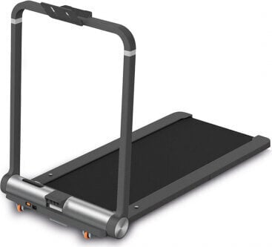

Figure 2: MCv2 Treadmill

The treadmill’s 8 feet were removed to allow the centre 4 to be directly secured to the baseplate via M10 counter sunk screws. The other 4 feet holes located at each end of the treadmill were also secured via M10 counter sunk screws but were bolted from the top. All counter sunk screws that attached the treadmill were inserted from the underside of the base plate, were torqued to 25Nm with Loctite applied.

Surrounding the treadmill on all sides were Bosch Rexroth profiles secured to the baseplate via associated brackets. At the end where the power supply resided the profiles were cut to allow access and the power cable secured via an adhesive cable support and cable tie.

Secured to along the length of the baseplate were 4 anchor rings that allowed a bungee system to be clipped in. 4 additional rings, 2 at each end of the plate were placed to allow for easier lifting of the structure. All bolts were torqued to 25Nm with Loctite applied.

**Hyper G Seat**

A seat was constructed from Bosch Profiles and positioned to allow the experimenter to be comfortably seated during hyper gravity phases of flight. This requirement is due to the experimenter experiencing close to 2x body weight with the addition of the bungee system.

**Structure Protection**

Sharp corners and edges including the complete seat and the baseplate were covered with an appropriate grade of foam. The treadmills safety cord is required for operation and safety of the experimenter and was thus attached to the experimenters harnessed during flight.

**Plane Fixation**

The base plate comprises of 4 fixation holes that allow the plate to be securely attached to the seat track of the plane. Two additional spacers were placed along the seat tracks at the midpoint of the base plate to prevent bending of the plate whilst performing activities on the treadmill.

**Cabin Layout**

**Final Treadmill System**

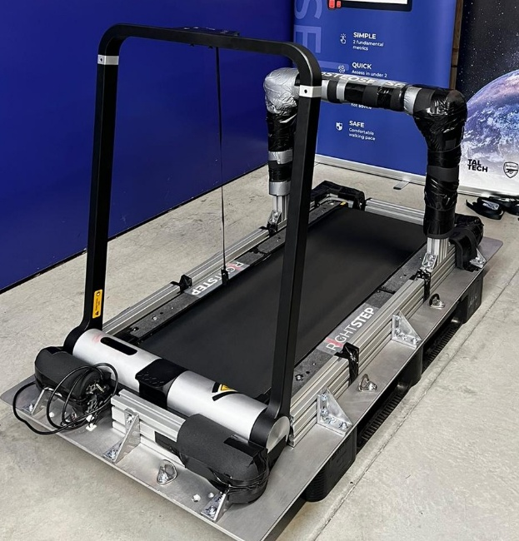

Figure 3: Treadmill On Ground Figure 4: Treadmill On Plane

**Harness and Bungee System**

In Zero G or micro gravity there is weightlessness meaning that the experimenter would be unable to perform activities on the treadmill without the assistance of a tethering system. To enable the experimenter to perform activities a bungee system was devised consisting of a harness, 2 bungee ropes clipped either side of the experimenter and a set of carabiners to allow for adjustment.

The harness was a COVERGUARD ALIOTH Full Body Harness with Positioning Belt that has a breaking strength of >15kN, a user capacity of 140Kg and a weight of 2.3 kg. It has 2 rings positioned at the hip to allow the bungee system to be clipped in.

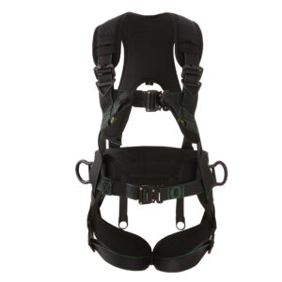

The bungee cords were sourced from an Arial Yoga provider and are used primarily to anchor a yoga participant from the ceiling. A medium strength yoga bungee was selected to accommodate the weight of the experimenters.

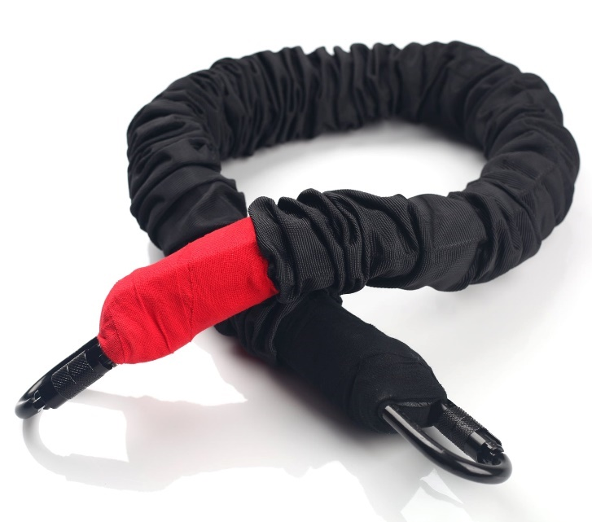

**Treadmill and Bungee System**

**<insert image>**

**Tablet Application**

A tablet application was developed to stream the process of data acquisition and to reduce the cognitive load required to execute the experiment.

The application is designed to manage the Movella Dots sensors that were worn on each limb at the ankle. The application consists of 3 sub parts that allow setup of the sensor, data acquisition and near real time processing and uploading of raw data files.

Sensors are discovered via a low energy Bluetooth scan and connected to by pressing the toggle button. A button on the sensor itself allows the sensor to be assigned to a limb. The experimenters were pre-loaded into the application at build time, and one is appropriately selected.

The start measurement button is pressed that brings up a dialog box to enter a tag for the activity (see parabola protocol for codes). The start button present in the dialog box initiates the sensor data stream. The activity is stopped via the stop button.

On completion of an activity the data is stored to the device and an upload button is available to upload the data post flight. This is required as there is no connectivity during flight. On upload data is stored in blob storage in Azure and available for download.

**Sensors**

There were two sensor types used in the experiment. Two Movella Dots worn at the ankle of each limb and a custom sensor developed in collaboration with TalTech.

**Movella Dot**

The Movella Dot has a data rate of 60Hz and a low energy Bluetooth interface. Dedicated sensor holders and straps are provided.

**TalTech Sensor**

The Taltech Sensor is an accelerometer that has a data rate of 6.6Khz. The accelerometer is on a short wire and is fixed directly to the tibia via medical tape. The sensor is controlled by a dedicated control box that is strapped to the thigh. The sensor is turned on and off via a switch located on the control box and is powered by 2 standard AAA batteries.

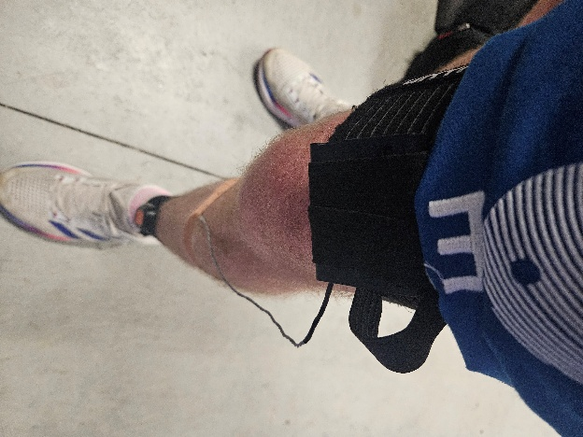

Figure 5: Sensors

**Methods**

**System Preparation**

Prior to each flight the experimenter was weighed on the treadmill whilst wearing the harness. The bungee cords were attached, and the experimenter was weighed again. The aim was to realise 2x body weight. For example, if the experimenter weighed 82kg with the harness on then the scales should read ~164kg with the bungees attached. Due to the flexible nature of a bungee the experimenter was asked to push onto tip toes to obtain a range of values.

The bungee system can be adjusted by adding or removing carabiners. Both experimenters weighed roughly the same but differed in height by a few centimetres. Therefore, the settled upon configuration consisted of the main carabiner plus 2.5 carabiners for experimenter 1 and plus 1.5 carabiners for experimenter 2.

With this step complete the experiment equipment was double checked and sensors attached to the experimenter.

**Pre Parabola 0 Procedure**

Prior to the first parabola (parabola 0) there was 10-20 minutes to setup the experiment. The following procedure was followed.

|  |
| --- |
| Fix sensors in place. (actually done pre flight) |
| Remove long straps securing the treadmill and place in main pocket of bag |
| Remove short straps securing the treadmill and place in front pocket of bag |
| Attach bungees to the primary structure and clip to safety straps |
| Turn on power (Red / red / red) |
| Turn on treadmill power |
| Turn on camera |
| Turn on Tablet |
| Get into position for parabola 0 |
| Turn on and setup Movella Dot sensors (including assignment) |

**Post Parabola 30 Procedure**

With the parabola’s complete the following procedure was followed to secure the experiment and prepare for landing.

|  |
| --- |
| Disconnect sensors from tablet |
| Turn off tablet |
| Turn off sensors |
| Turn off treadmill |
| Turn of camera |
| Turn off aircraft power supply |
| Remove bungees and place in bag |
| Secure treadmill with short straps |
| Secure treadmill with long straps |

**Parabola Protocol**

A parabolic flight is segmented into blocks of 5/6 parabolas with a level flight break in between. The protocol is designed for ease of execution giving appropriate time for adjustment to the environment. Appropriate contingency parabolas were built into the protocol to allow for errors and difficulties.

Flight 1 and Flight 2 reversed the operator and experimenter to obtain two data sets. Flight 3 was a complete contingency flight.

**Block 1**

|  |  |  |  |
| --- | --- | --- | --- |
| **Parabola** | **Code** | **Activity** | **Footwear** |
| **0** |  | **Sit** | **Shoes** |
| **1** |  | **Practice** | **Shoes** |
| **2** | **SW2** | **Walk – speed 5** | **Shoes** |
| **3** | **SW3** | **Walk – speed 5** | **Shoes** |
| **4** | **SW4** | **Walk – speed 5** | **Shoes** |
| **5** | **SW5** | **Walk – speed 5** | **Shoes** |

**5 Min break**

**Block 2**

|  |  |  |  |
| --- | --- | --- | --- |
| **Parabola** | **Code** | **Activity** | **Footwear** |
| **6** | **SR6** | **Run – Speed 8** | **Shoes** |
| **7** | **SR7** | **Run – Speed 8** | **Shoes** |
| **8** | **SR8** | **Run – Speed 8** | **Shoes** |
| **9** | **SR9** | **Run – Speed 8** | **Shoes** |
| **10** | **SJ10** | **Jump – speed 0** | **Shoes** |

**5 Min break**

**Block 3**

|  |  |  |  |
| --- | --- | --- | --- |
| **Parabola** | **Code** | **Activity** | **Footwear** |
| **11** | **SJ11** | **Jump – speed 0** | **Shoes** |
| **12** | **SJ12** | **Jump – speed 0** | **Shoes** |
| **13** | **??13** | **Contingency / walk** | **Shoes** |
| **14** | **??14** | **Contingency / walk** | **Shoes** |
| **15** | **??15** | **Contingency / walk** | **Shoes** |

**8 Minute Break - REMOVE SHOES**

**Block 4**

|  |  |  |  |
| --- | --- | --- | --- |
| **Parabola** | **Code** | **Activity** | **Footwear** |
| **16** | **BW16** | **Walk – speed 5** | **Barefoot** |
| **17** | **BW17** | **Walk – speed 5** | **Barefoot** |
| **18** | **BW18** | **Walk – speed 5** | **Barefoot** |
| **19** | **BW19** | **Walk – speed 5** | **Barefoot** |
| **20** | **BR20** | **Run – speed 8** | **Barefoot** |

**5 Min break**

**Block 5**

|  |  |  |  |
| --- | --- | --- | --- |
| **Parabola** | **Code** | **Activity** | **Footwear** |
| **21** | **BR21** | **Run – speed 8** | **Barefoot** |
| **22** | **BR22** | **Run – speed 8** | **Barefoot** |
| **23** | **BR23** | **Run – speed 8** | **Barefoot** |
| **24** | **BJ24** | **Jump – speed 0** | **Barefoot** |
| **25** | **BJ25** | **Jump – speed 0** | **Barefoot** |

**5 Min break**

**Block 6**

|  |  |  |  |
| --- | --- | --- | --- |
| **Parabola** | **Code** | **Activity** | **Footwear** |
| **26** | **BJ26** | **Jump – speed 0** | **Barefoot** |
| **27** | **??27** | **Contingency / walk** | **Barefoot** |
| **28** | **??28** | **Contingency / walk** | **Barefoot** |
| **29** | **??29** | **Contingency / walk** | **Barefoot** |
| **30** | **??20** | **Contingency / walk** | **Barefoot** |

**Experimenter procedures**

The experimenter is the role performing the activities. The following procedure was practiced repeatedly and followed during flight. Parabola 0 is not experimented in, parabola 1 is used to acclimate and 2-30 are experiment parabolas.

|  |  |  |
| --- | --- | --- |
| **Parabola** | **Phase** | **Task** |
| 0 | - | - |
| 1 | Level Flight | Get on treadmill  Attach bungees  Attach safety cord |
|  | Injection | Practice sitting / standing  Flex bungees  Assess bungee pull in zero g |
|  | 20 | Sit down |
|  | Level Flight | Set treadmill to speed  Assign sensors if not done |
| 2-30 | Level Flight | Confirm Next protocol  Adjust treadmill if required |
|  | 40 | Turn on Taltech sensor |
|  | Injection | Perform activity |
|  | 20 / 30 | Sit down  Turn off taltech sensor |

**Operator Procedures**

The operator is the role managing the protocol and data collection. The following procedure was practiced repeatedly and followed during flight. Parabola 0 is not experimented in, parabola 1 is used to acclimate and 2-30 are experiment parabolas.

|  |  |  |
| --- | --- | --- |
| **Parabola** | **Phase** | **Task** |
| 0 | - | - |
| 1 | Level Flight | Assist attaching bungees |
|  | Injection | - |
|  | 20 | - |
|  | Level Flight | Assign sensors if not done |
| 2-30 | Level Flight | Confirm application setup:   * Correct experiment assigned * Sensors connected * Right and left assigned   Go to measure tab   * Select start measuring * Confirm next protocol * Type in parabola code |
|  | 40 | Press START |
|  | Injection | Perform activity |
|  | 20 / 30 | Press stop measuring when experimenter is sitting |

**Activities Performed**

The experiment consists of walking at 5 km/h, running at 8 km/h and micro jumping in place. These activities are performed with and without shoes. The speeds were selected primarily for safety reasons due to the team being first time flyers.

It should be noted that adaptation to the environment was quick and that it was possible to run at 10 km/h. This was done and some additional data collected, however, is not used in the analysis as it was not part of the original experiment design.

**Baseline data**

Baseline data was collected for each experimenter on the Friday of preparation week. The complete structure had been installed in the aircraft and the protocol was followed for each parabola disregarding contingencies.

**Initial Experiment Observations**

**Aircraft Suspension**

During the baseline data collection, it was observed that the aircraft was subjected to vibrations that could be felt further down the aircraft by other experimenters. This was an initial concern, but it was reasoned that this may be due to the aircraft being on the ground and be due to its suspension. There is suggestion that this may also act as load dampener resulting in lower experience skeletal loading of the experimenter. Should this vibration not be present in flight the aircraft may be more rigid and thus induce a higher skeletal loading in zero g.

**Bungee System Properties**

It was observed in preflight preparation that the bungee cords were stiffer. Stretching the bungee cords whilst on the ground seemed to loosen them up and provide lower values when the experimenter was weighed. It was also felt that the bungee cords tension reduced over time (i.e became slacker) and thus later parabolas may induce less load. In the first walking parabolas of flight 2 the experimenter reported feeling overloaded suggesting that the bungee cords were pulling at a value greater than 2x body weight. This reduced over time (or the experimenter became accustomed to the pull).

**Effect on the Experiment**

It is possible that the bungee system could influence the results. The activities where the experimenter wore shoes were performed in the first half of the flight and thus the load induced in the latter half of the flight may be lower regardless of the removal of shoes.

The possible dampening by the aircraft on ground may influence the loading achieved which may result in similar if not higher loading being achieved in zero g.

The bungee system is affected by height and no adjustments were made when shoes were removed. This could lead to a lower tension in the bungee being applied when shoes are removed which would lead to lower than anticipated loading.

The treadmill has a shock absorption system built into it which may reduce the available frequency signals reaching the body.

**Data Analysis Methods**

**Analysis of loading rate in frequency domain**

A time-domain load signal  satisfying Dirichlet conditions can be expressed by discrete Fourier transformation as the sum of a finite number of sine and cosine components:

where is the total number of points for , represents the *nth* harmonic; and are harmonic coefficients, represents the fundamental frequency of the signal, and is the time. The magnitude of each harmonic for is defined as

(2)

The rate of change of the load signal can be obtained by differentiation of equation (1) with respect to ,

where represents the rate of change. The magnitude of each harmonic for can be expressed as

(4)

where is the magnitude of *nth* harmonic of , which equals the magnitude of the harmonic of multiplied by its frequency . This provides a way to analyse loading rate over a particular frequency range, as represented by the following equation.

where  (*BW/s*) is termed loading intensity that represents the loading rate over a frequency range from *ith* to *jth* harmonics, is the acceleration (*g*) at the *nth* harmonic, and is the *nth* harmonic frequency (*Hz*).

**Algorithm Usage**

Typically, equation 5 is implemented by capturing a 5 second window of data and bandpass filtering the data between 0.1 and 6Hz. This is to remove effects of gravity and low frequency noise and remove muscle and skin artifacts. 5 seconds is used to ensure that at least one complete movement cycle is captured and provides enough data for the Fast Fourier Transform to be computed with sufficient resolution.

Using the Movella Dot the time window equates to 300 samples at 60Hz. The Taltech sensor has a data rate of 6 KHz and thus 30,000 samples are captured per 5 second window. This may result in a more accurate result yet imposes challenges in data streaming, data capture size and processing times. Therefore the Taltech sensor was developed as a data logger and not directly implemented into the tablet application. The primary purpose of the Taltech sensor in this experiment is to observe the frequency response over a greater range (up to 3kHz) compared to 30Hz that can be observed by a 60Hz sensor.

**Data Preparation**

Collected data was placed in a consistent directory hierarchy.

*../data/raw_data/<environment>/<experiment>/<sensor>/<footwear>/<parabola_code>*

An example data path for parabola 2, walk, experimenter 1 would be

*../data/raw_data/flight/exp1/dot/shoes/sw2*

**Movella Dot Initial Data Exploration**

A single parabola was visualised to observe the data points collected. For a given parabola, sw2, the associated left and right ankle csv file was read in and the x,y,z acceleration extracted. The magnitude vector was computed and subsequently plotted. This was done for a select number of parabolas for each experimenter.

The raw data collected on the ground clearly depicts gravity as 1g where as the raw data collected in zero g does not.

Inconsistencies were observed in the starting and stopping of the tablet application between operators. However, data was collected consistently up to 1400 data samples.

Data capture commences when the 40 announcement is made. When the injection announcement was made the experimenter gets onto the treadmill and begins the activity. The time from 40 to injection is roughly 3 seconds and 2 seconds is allowed for the experimenter to stabilise the activity. Thus it makes sense to remove the first 5 seconds (300 data samples) to accommodate for this.

As previously stated loading is computed in 5 second windows. Due to the nature of parabolic flight and the time available in zero g the data was trimmed to find a stable 15 seconds of data to work with and then the loading computed for the duration of the activity. This would also correspond to a loading dose achieved as dose requires a duration that load is applied for and in this case would be 15 seconds.

Therefore a data set for a given parabola and activity would compromise of the first 900 samples post activity stabilisation (post 5 seconds from starting the data capture).

**Movella Dot Dataset Creation**

The objective of this procedure is to obtain data sets that are of the same length and capturing the same portion of time associated to each activity.

Notebook: <https://github.com/mcrooks83/ESA_85th_pbf_campaign_os/blob/main/data_preparation/2.%20data%20cleaning.ipynb>

The output of this notebook is a replica of the raw_data directory hierarchy with each data file reduced to 900 samples as outline above.

Data acquisition of Parabola 23 (barefoot run) for experimenter 2 was started late and thus does not conform to the above cleaning procedure. Visualising this data shows that between 1200 and 2100 samples is the equivalent and shall be used.

**TalTech Sensor**

The sensor was worn on the dominant limb of the experimenter with the sensing component attached to the tibia.

Data collected from the TalTech sensor must be converted from its binary representation to readable values. The stored file consists of 10 data bytes and 1 row ending byte resulting in an 11 byte row. The first 4 bytes are an index which can be ignored. X, Y, Z acceleration values are 2 bytes each in big endian format. Conversion requires reading in each row and unpacking the bytes and multiplying by a given conversion factor. In this case the sensor was configured to 16g and thus the conversion factor (as per the data sheet) is 0.000488.

Each data file was converted, trimmed to 15 seconds and stored as a csv file for ease of future use and to cut down on processing time.

NoteBook: <https://github.com/mcrooks83/ESA_85th_pbf_campaign_os/blob/main/data_preparation/TalTech/1.%20hig_conversion.ipynb>

**Raw Data Validation**

To validate the data raw data was visualised. Differences between the activities were clearly observed however, high acceleration spikes were observed in experimenter 1, particularly in running. These spikes were observed to a lesser extent in baseline data and lesser again in experimenter 2.

**<insert typical signals of each activity>**

**Data Processing**

**Computations**

**Statistics**

**Results:**

**Learnings**:

**System Improvements**

**Discussion**

**Future**

**References**

1. CHAHAL, J., LEE, R. and LUO, J., 2014. Loading dose of physical activity is related to muscle strength and bone density in middle-aged women. Bone, 67, pp. 41-45.
2. GABEL, L., LIPHARDT, A.M., HULME, P.A. *et al.* Incomplete recovery of bone strength and trabecular microarchitecture at the distal tibia 1 year after return from long duration spaceflight. *Sci Rep* **12**, 9446 (2022).
3. KELLEY, S., HOPKINSON, G., STRIKE, S., LUO, J. and LEE, R., 2014. An accelerometery-based approach to assess loading intensity of physical activity on bone. Research quarterly for exercise and sport, 85(2), pp. 245-250.
4. LIPHARDT, A.M., FERNANDEZ-GONZALO, R., ALBRACHT, K. *et al.* Musculoskeletal research in human space flight – unmet needs for the success of crewed deep space exploration. *npj Microgravity* **9**, 9 (2023).
5. LUO, J. and Lee, R. 2021. Dose-response relationship between free-living physical activity and bone health in the middle-aged and elderly. JBMR Plus 5(S2), pp. 49
6. LUO, J., RATCLIFFE, A., CHAHAL, J., BRENNAN, R. and LEE, R., 2018. Pattern of physical activity can influence its efficacy on muscle and bone health in middle-aged men and women. Sport Sciences for Health, 14(3), pp. 503-509
7. RUBIN, C.T. and LANYON, L.E., 1984. Regulation of bone formation by applied dynamic loads. The Journal of bone and joint surgery. American volume, 66(3), pp. 397-402.
8. TURNER, C.H., 2002. Biomechanics of bone: determinants of skeletal fragility and bone quality. 13(2), pp. 97-104.
9. TURNER, C.H., 1998. Three rules for bone adaptation to mechanical stimuli. 23(5), pp. 399-407
10. VICO, L., COLLET P., GUIGNANDON, A., LAFAGE-PROUST, M.H., et al. Effects of long-term microgravity exposure on cancellous and cortical weight-bearing bones of cosmonauts. Lancet. 2000 May 6;355(9215):1607-11. doi: 10.1016/s0140-6736(00)02217-0. PMID: 10821365.
11. VICO, L., VAN RIETBERGEN, B., VILAYPHIOU, N., et al. Cortical and Trabecular Bone Microstructure Did Not Recover at Weight-Bearing Skeletal Sites and Progressively Deteriorated at Non-Weight-Bearing Sites During the Year Following International Space Station Missions. J Bone Miner Res. 2017 Oct;32(10):2010-2021. doi: 10.1002/jbmr.3188. Epub 2017 Jun 28. PMID: 28574653.