**Architect**

A Grand Design

**Let’s talk, ever wonder… is evolution real?**

The answer is no, evolution is not real. We were all created, all created independently, each race independently in order to create a unique World, a World that could not be created with one race. Like ingredients to an ultimate recipe, we each group or race of people are designed to part of a master design… a design so Grand so Unique no one person can fathom.

… This includes architecture, music, culinary arts, spirits, dance and movement how we interact, anything and everything, we are going to create a unique and different World, it’s going to happen so long as every human being is allowed to live freely without judgement. Change will happen organically.

I believe our goals to be:

1. Create Heaven on Earth or Utopia

2. In addition, a unique World, something one race or culture could not create alone… a blend upon blend upon blend upon blend of original thinking, and I believe it will happen organically as long as we don’t interfere with natural instincts or preferences.

**Are we really Original Designs?**

There are distinct differences between all the cultures here on Earth. All is needed is about 10 minutes of time mix with critical thinking while observing images. Observe a few cultures some of which are neighboring and ask how did they come to be? Were they created independently or originate from one group? There are people who want to keep things the way they are.. Observe below, was each created independently? O rwas there one with adaption and evolution? The answer independently.

Brazil

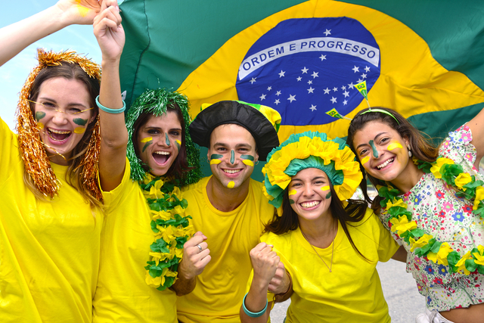

Russia

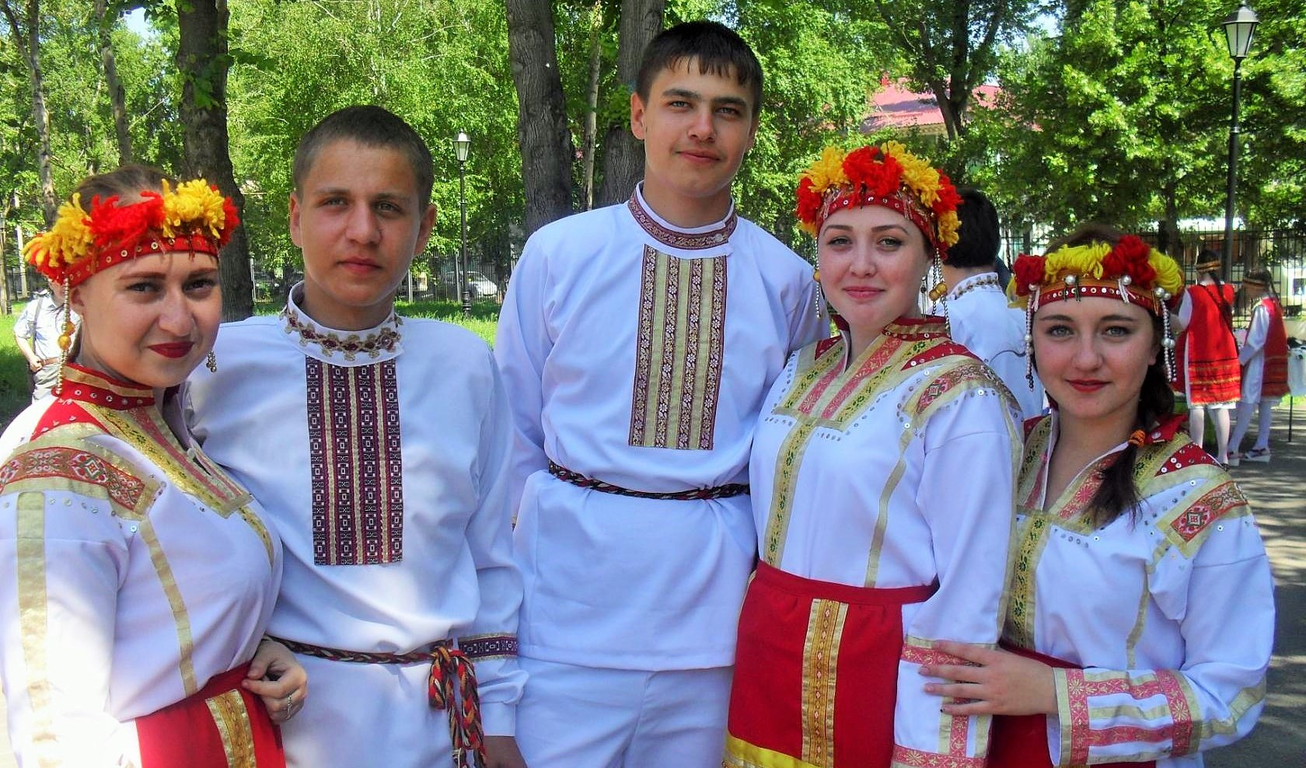

China

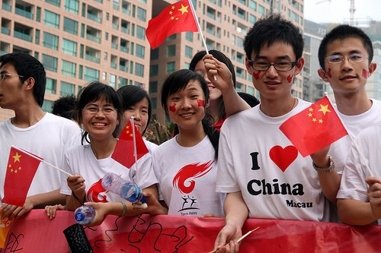

India

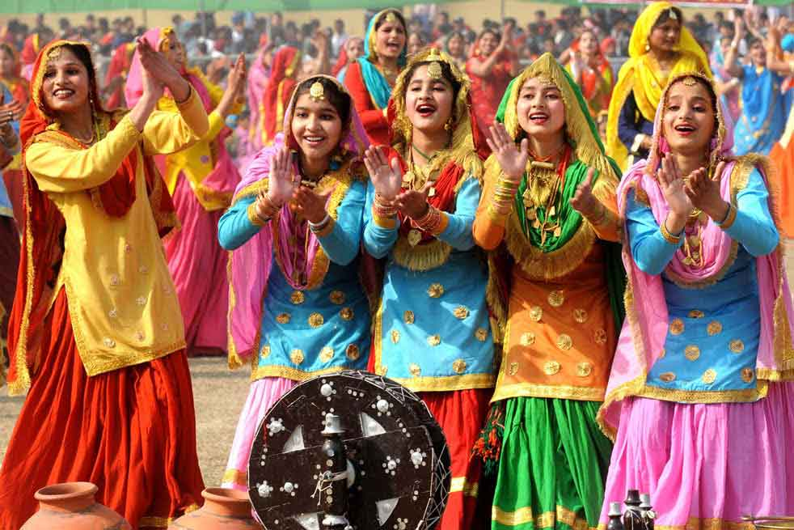

Africa

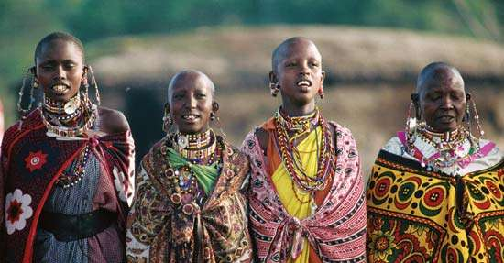

Saudi Arabia

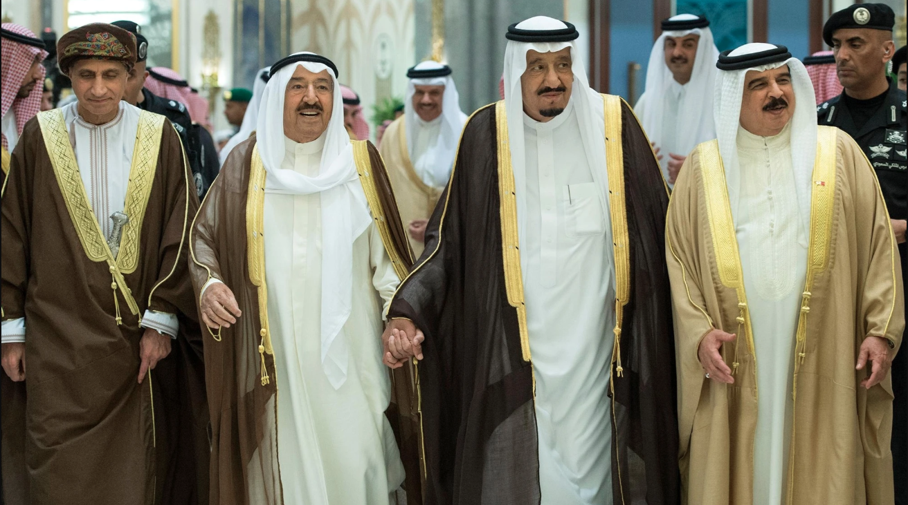

U.S.

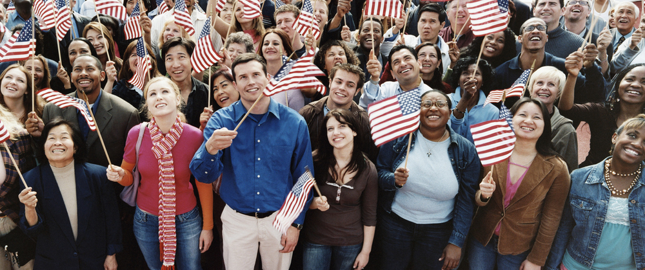

We are all different There is no environment component, weather pattern or diet that shapes an individual people over time.

So what is the goal?The goal is to create a unique world that cannot be created with one race of people. Looking at the images above, you can start to think about the cultures, architecture, food and lives of the people. Each are different in their own way. Start to combine the cultures and people and you have something unique, something different, something new that the our Grand Architect or God could not create with one.

**The Existence of God**

It can be proven within the definitive design in nature, and advanced mathematics within the design.

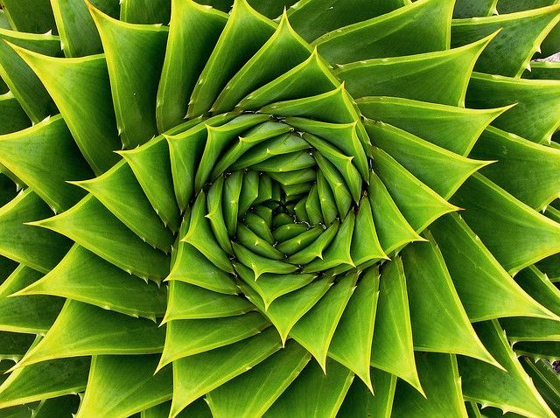

Let’s look at the aloe plant above. Do you see uniformity and the math within the design? The point of this, we were all created, all life on Earth created, no evolutions.

**Proof that we were created. Lets do an exercise…**

I want you to take a look at your hand. There is an Architect at play. Look at your hand from the side, start to wiggle your fingers and move your hand back and forth. Do this in front of a plant.

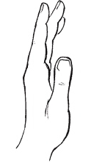

It’s important that you perform this exercise next to or in front of a plant. Spend at least 15 seconds performing this exercise and ask the question while performing this, “Does the hand belong? Is the human hand foreign?”

The hand is foreign, the human existence is foreign, we all together everything human is foreign. We did not grow or originate from Earth. We were created by God, an Architect. To support the case, let’s consider the single celled organism theory, that we all originated including animal life from a single celled organism, it is a harsh reality that the amount of data that would need to reside within the starting single celled organism would be very large. It cannot be stressed enough that life on Earth would be very very strange if this were true. Evolution does not exist, we did not originate from a single celled organism. We were created by God, an Architect.

**The**

**Solar System...**

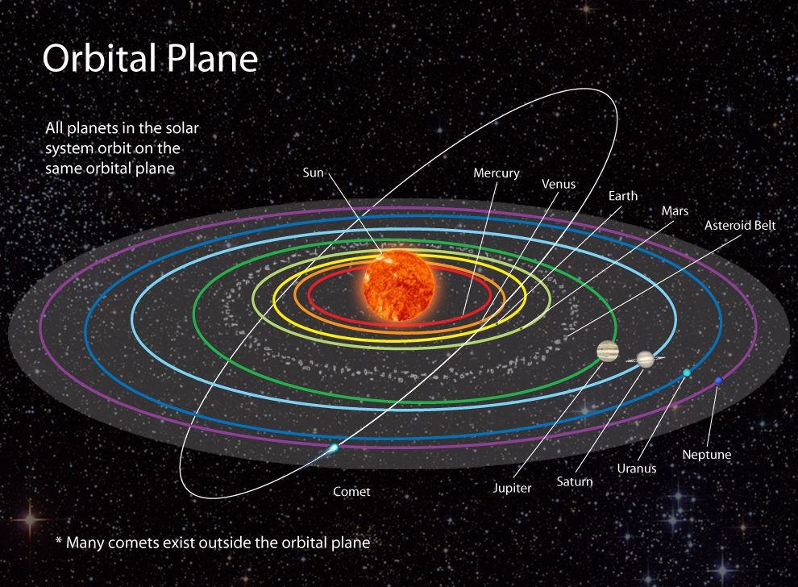The solar system consists of 8 planets that orbit the Sun. These planets orbit in a horizontal fashion. While orbiting these planets tilt and rotate… its systematic, uniform in design. An Architect is at play, God.

**What is the goal of human existence** with so many different groups or organizations of people? The goal is to create Utopia, a unique and different world that no one individual group of people could create without others.

**Lets go into detail…**

One last time, there are differences in preferences between different races or organizations of people. If two different races were to bare a child, the preferences for that child would be unique… a blend. He or she would have preferences from both cultures and may in turn prefer something new… again a blend. In turn, you don’t even have to believe in interracial relationships in order to believe in our Grand design, again blends can be something as simple as food or drink, something like Cherry Sprite or Ginger Ale with Lemonade, both can be seen as blends.

There is only so much preference data that can be stored within DNA…

Again, you don’t have to believe in inter-cultural relationships, it needs to be allowed to happen naturally but not forced.

Again, blends would influence architecture, music, food, wine, beer, dance, sports, entertainment… etc. A new culture could establish, something that our grand designer could not create independently.

**The goal summarized is to create a unique world, a world that would not be created with one culture…**

before I continue, its important you know that I am not mad

so…….if……...you……………..are….racist…………………………………………………………………………………………………………πˆ…………….... God would want something different.

And, if you don’t mind me saying… its only

color

and preferencemate, compadre,

amigo,

friend,

buddy,

love

**!ඔබට ස්තුතියි**

This is “Thank you!” in Sinhala, language of Sri Lanka. It is probably the most interesting language of all.

Blacks before women → buy plants

Whites before women → buy plants

Thou shall protect innocence  
Thou shall not lie if self serving  
Thou shall embrace ones culture  
Thou shall foster disaggregated love  
Thou shall embrace, cherish and worship femininity  
Thou shall promote masculinity  
Thou shall adore  
°Δ Ξ

www.vocebonita.xyz