YDM3 — YDM3 Task 1: Version Control Using Git for GitLab

**A: Creating Repository and Working Branch**

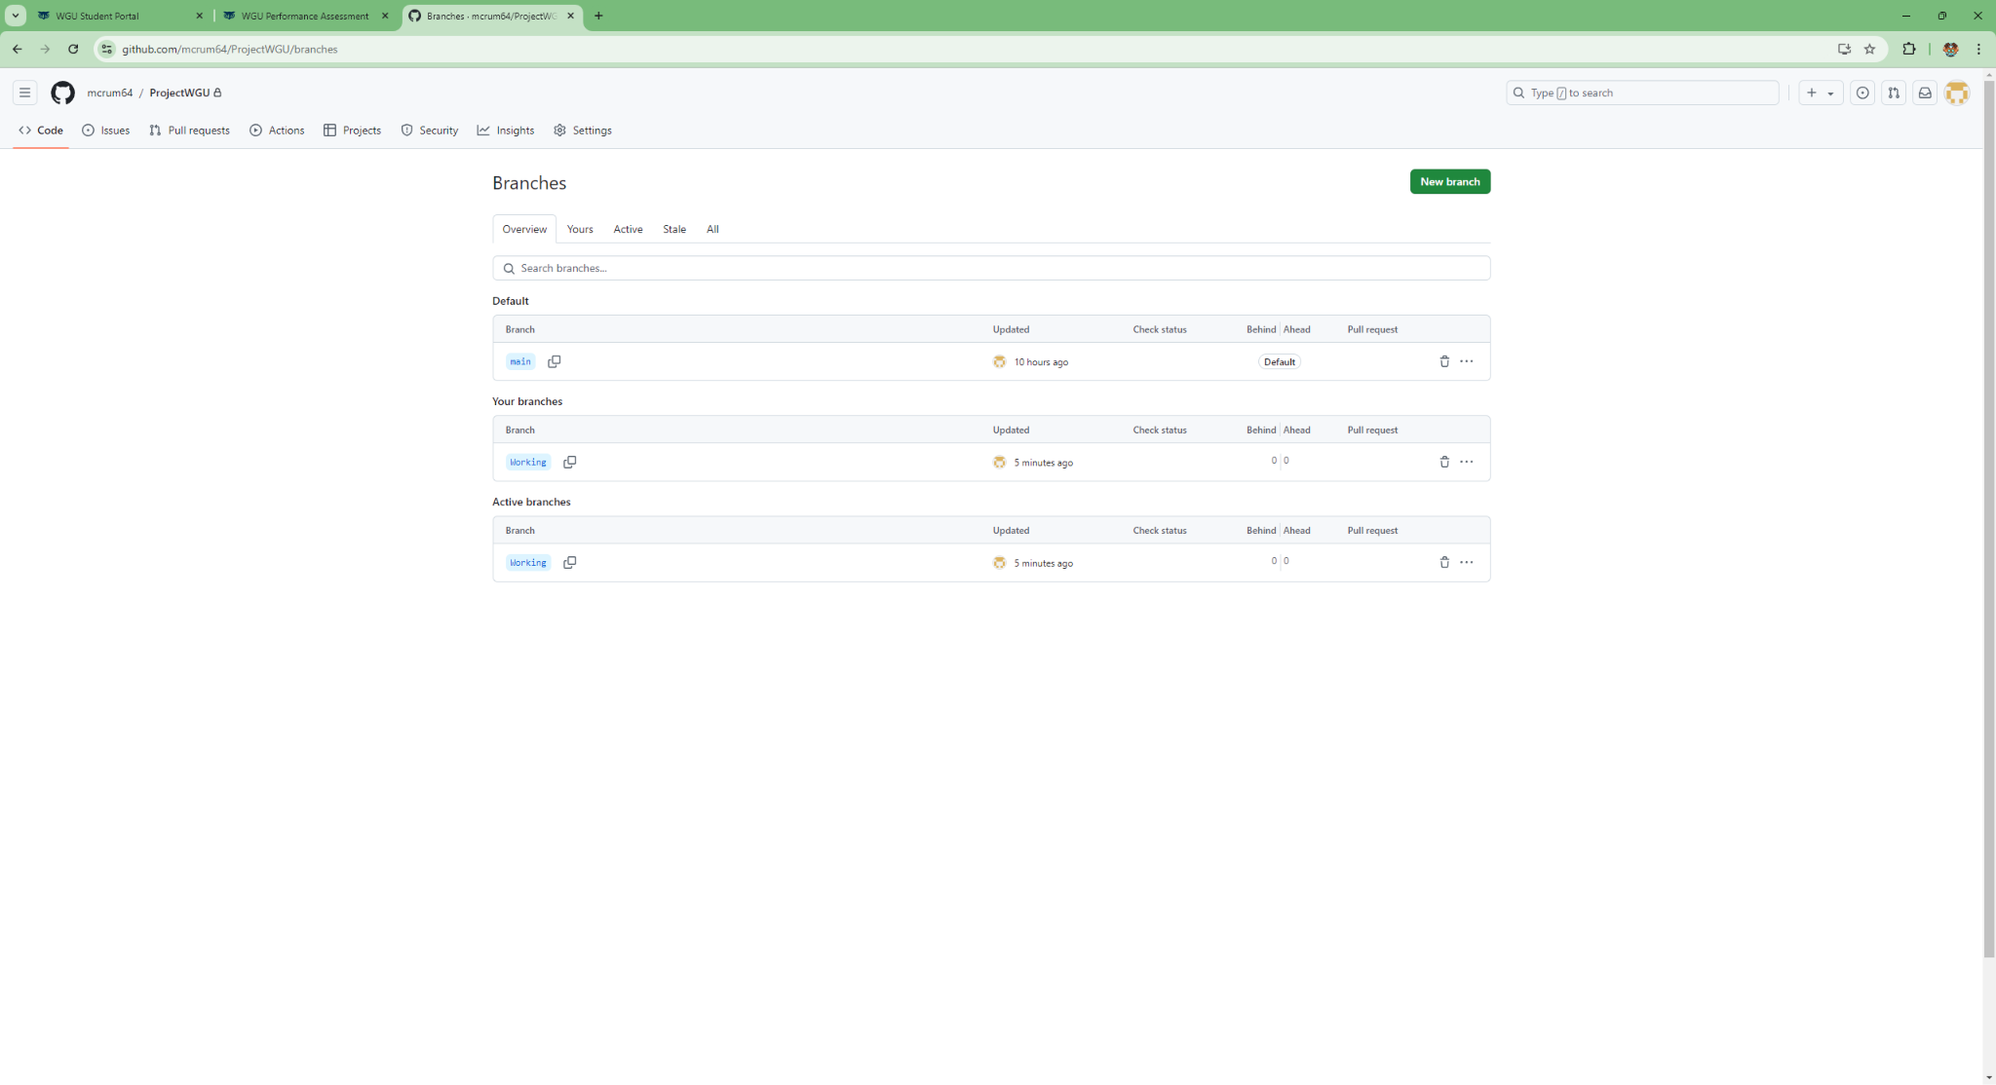

**B: Cloning repository to my machine**

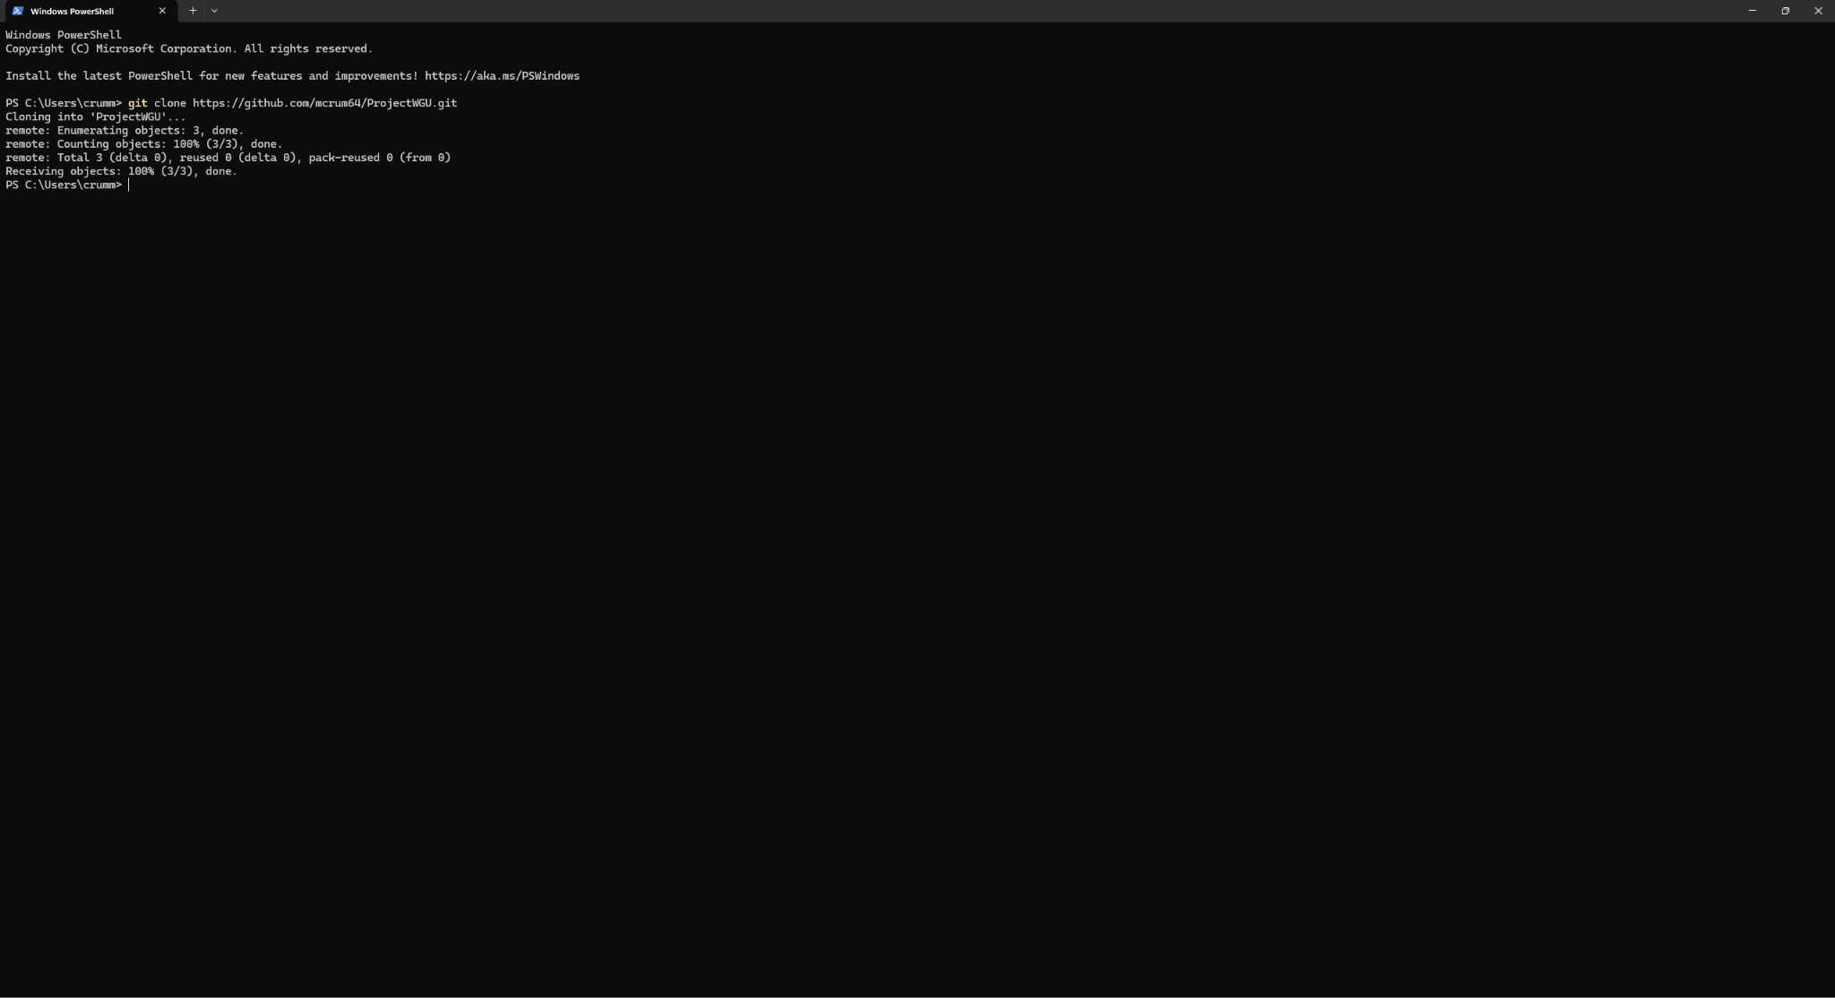

**C.1: Committing changes to three html files**

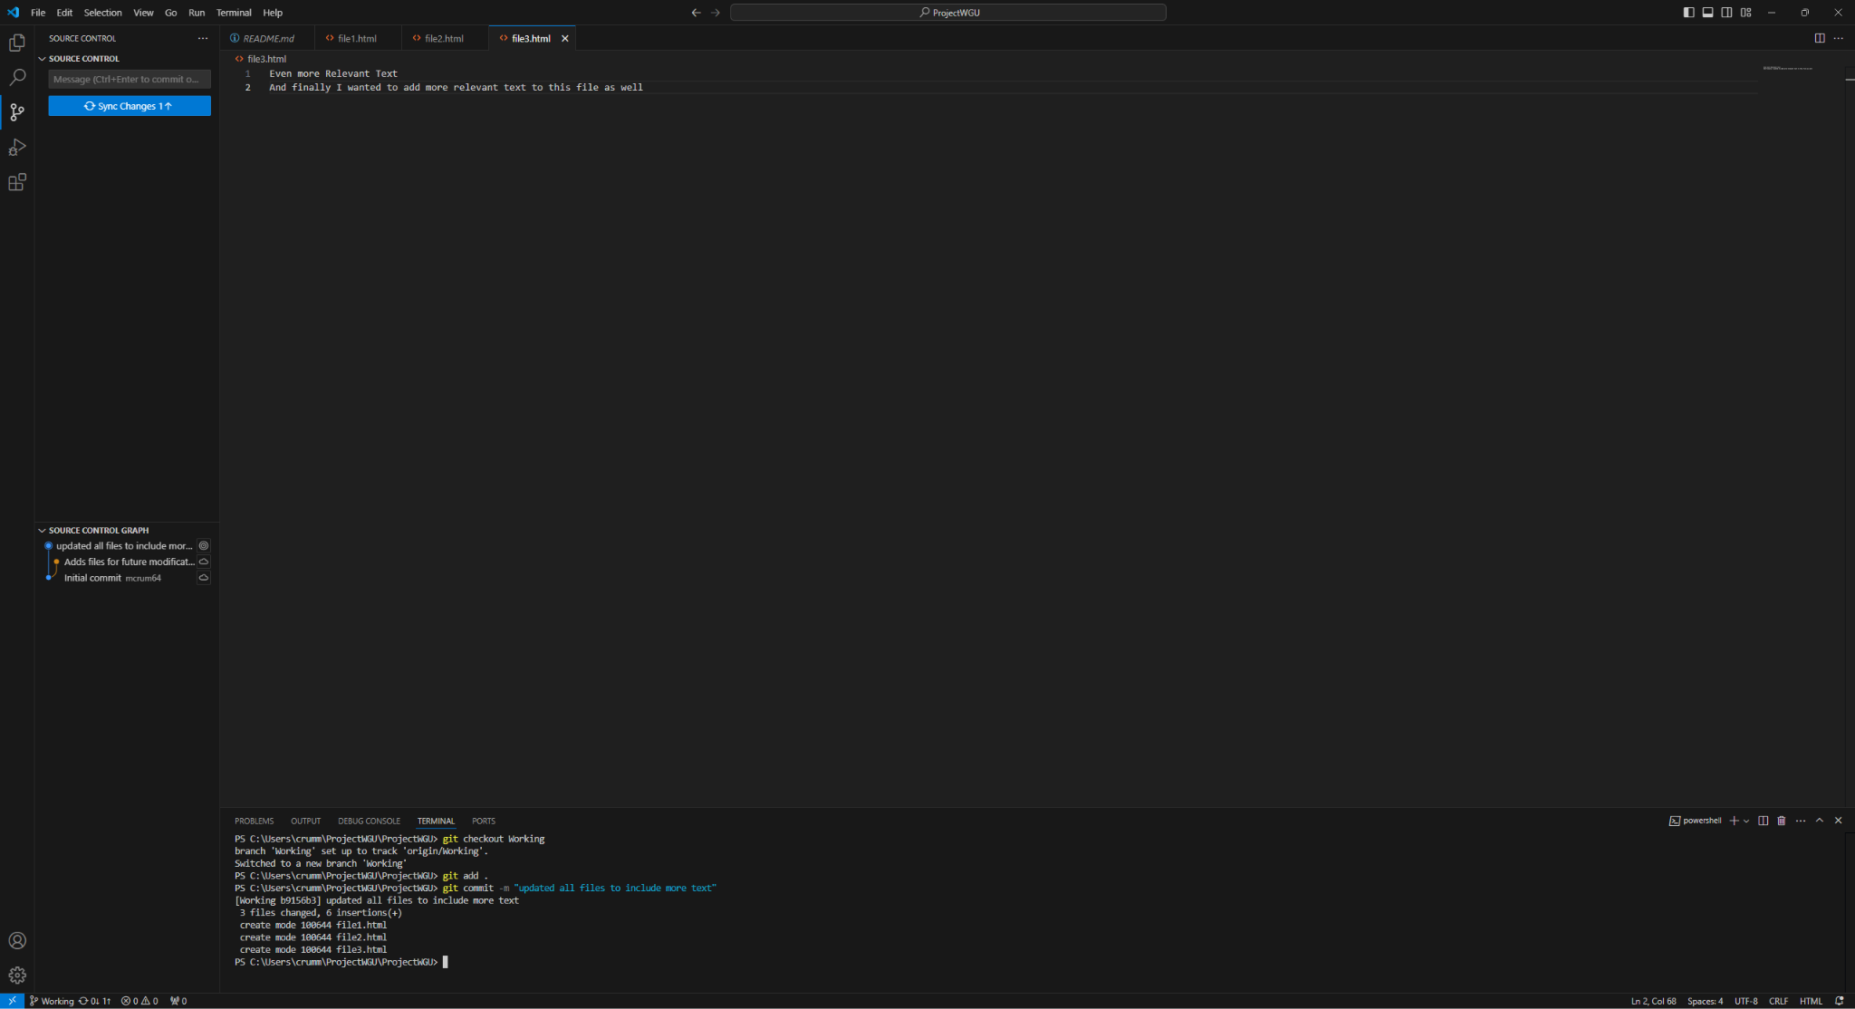

**C.2: Pushing changes**

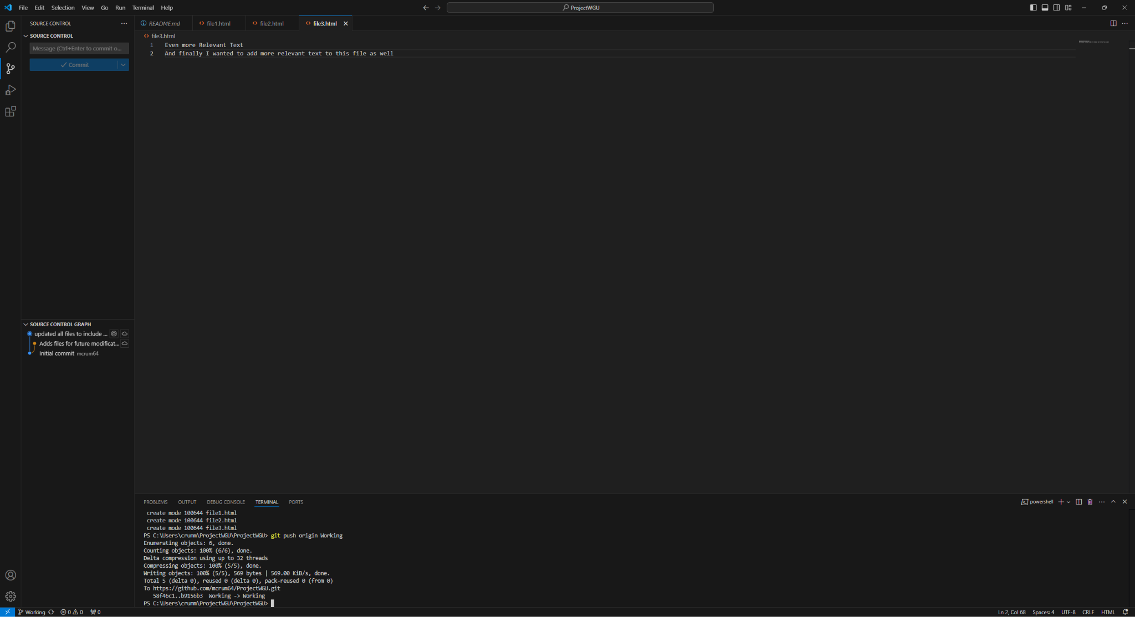

**D.1: creating a test branch using the command line interface**

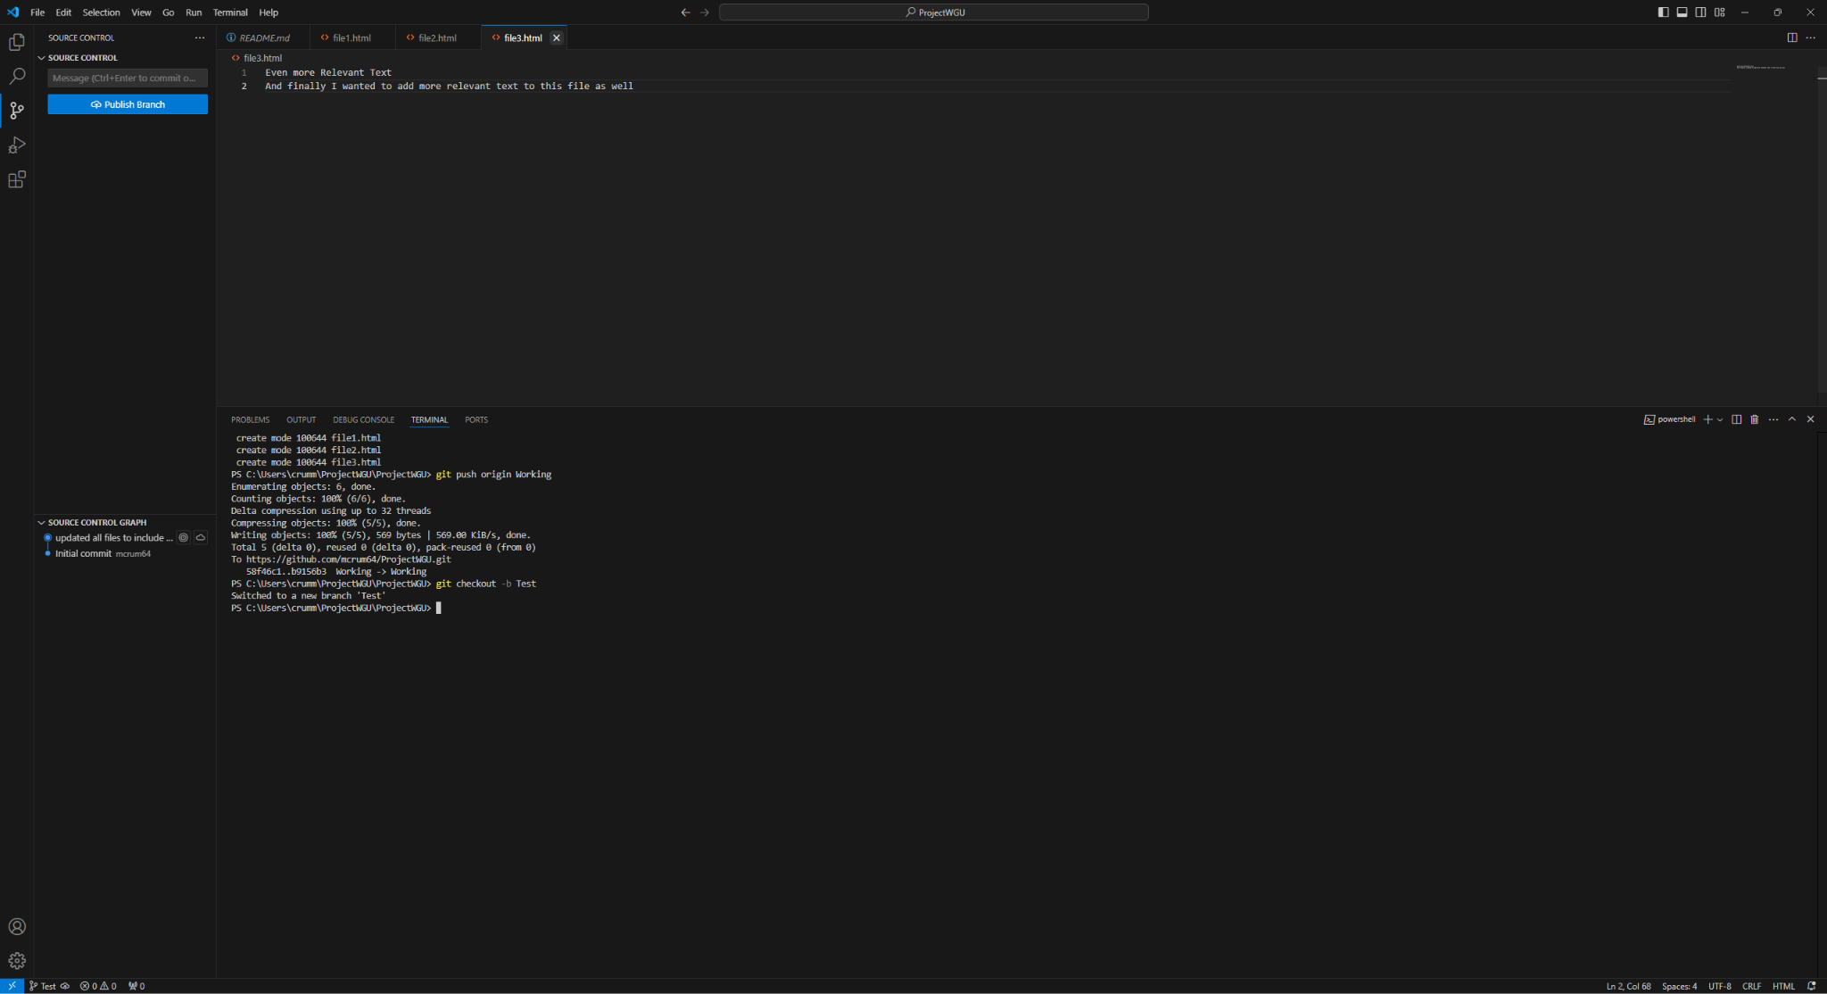

**D.2: Add student ID and commit changes**

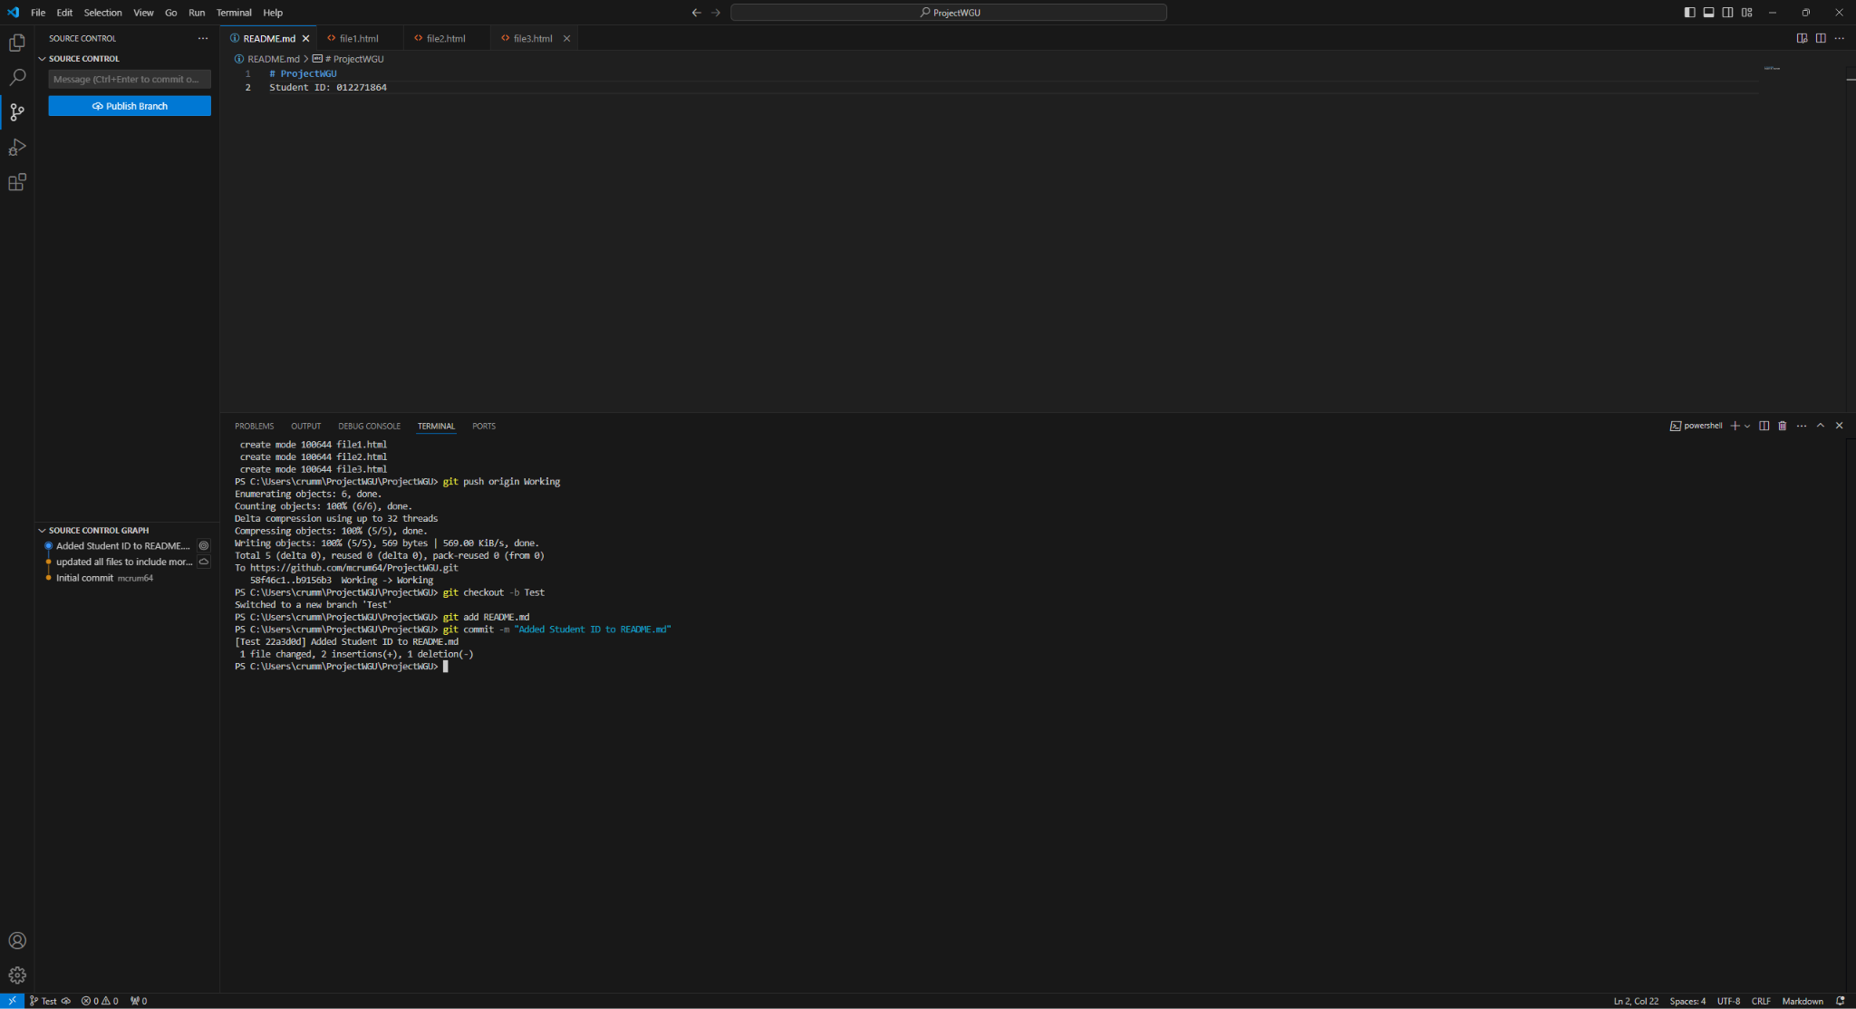

**D.3: push changes to remote repository (Test branch)**

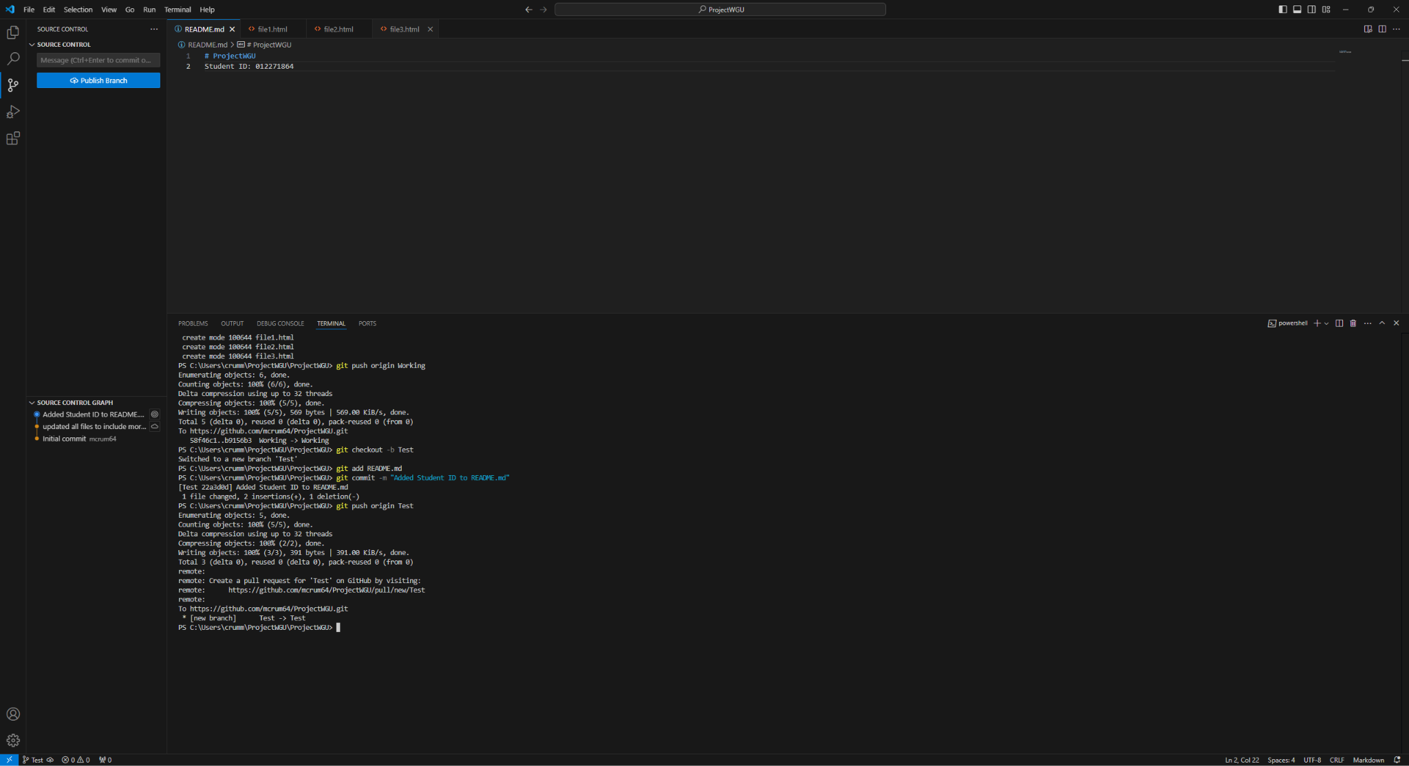

**D.4: Show repository graph**

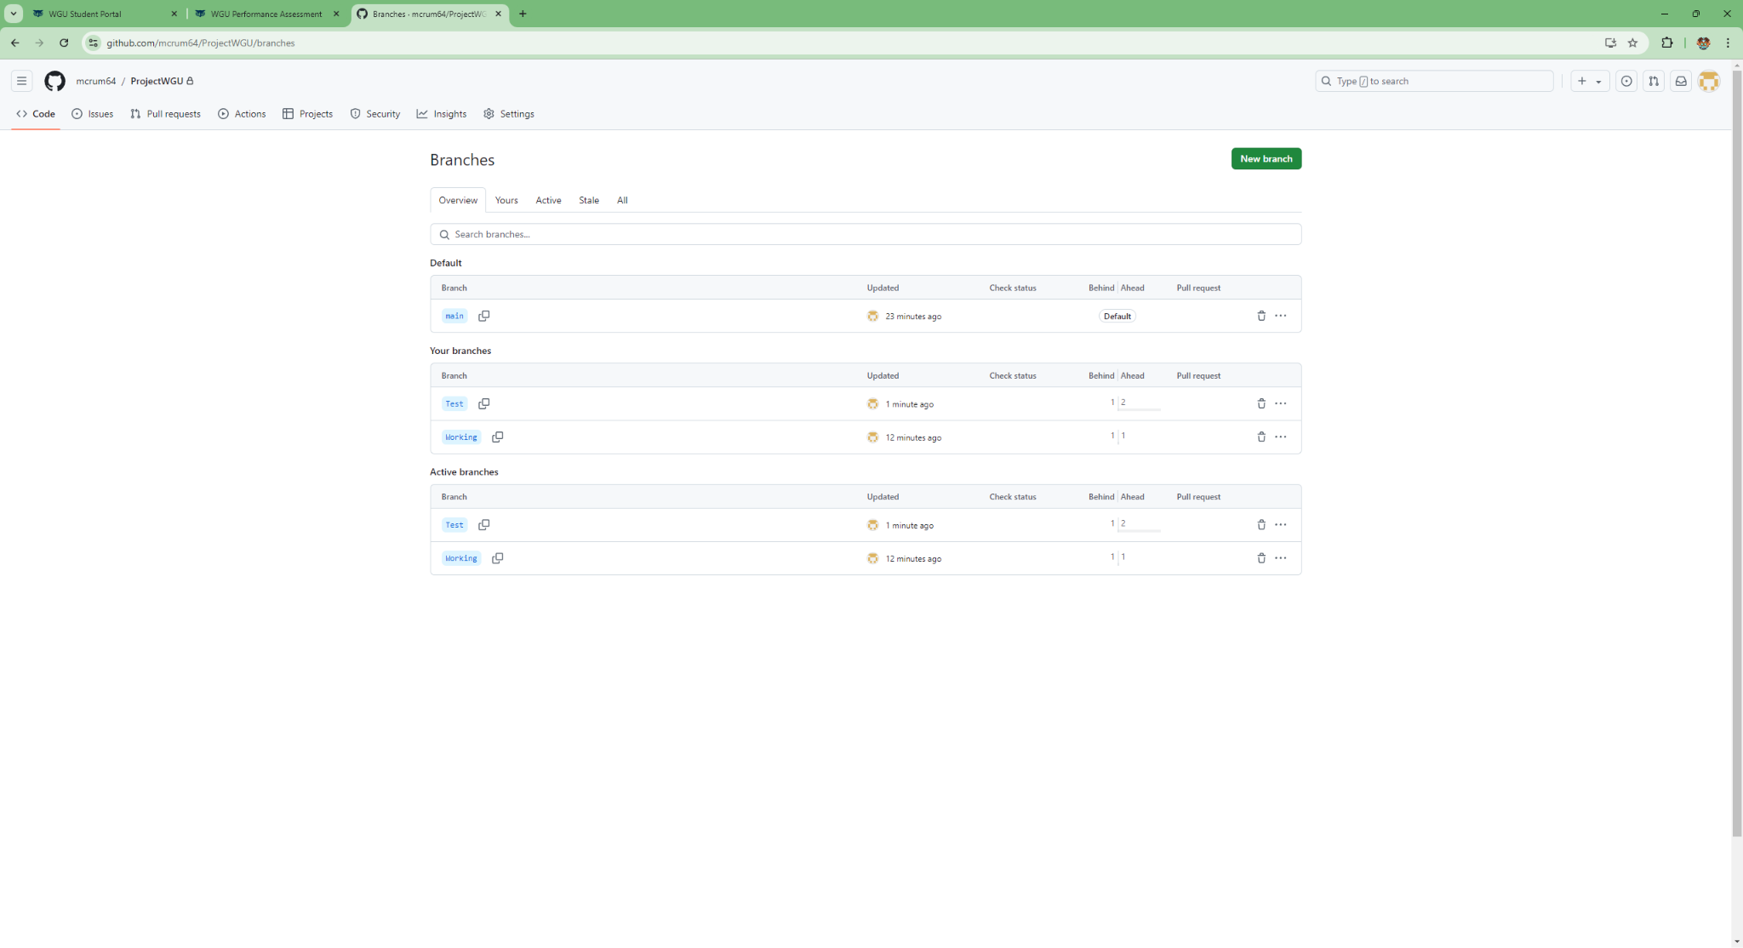

**D.5: Contents of branch**

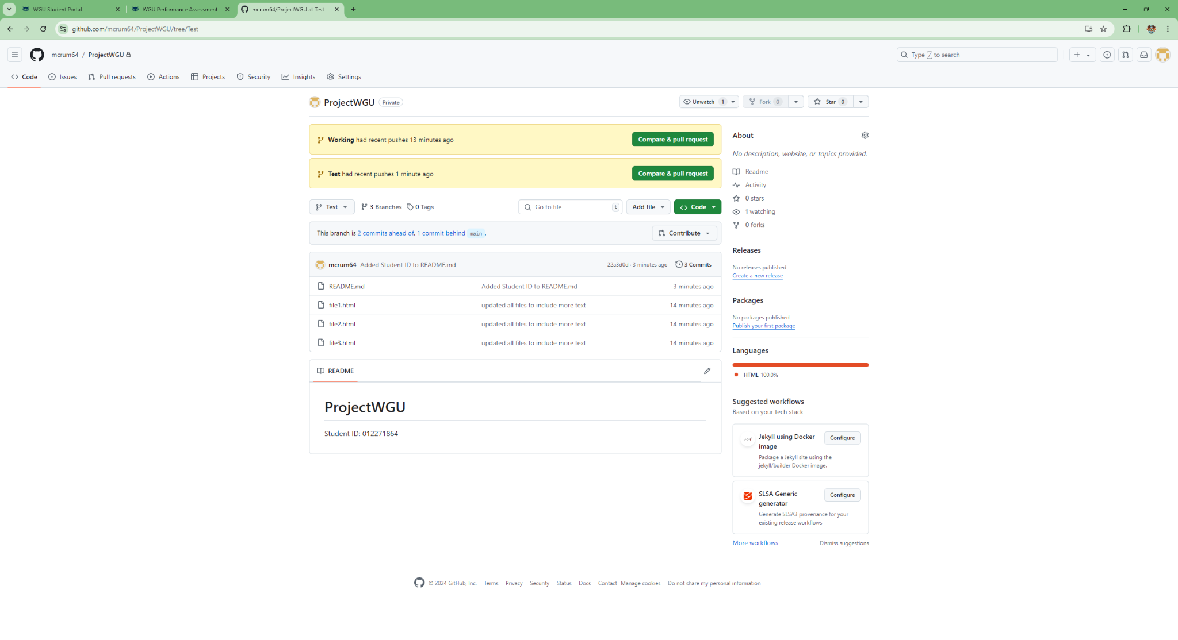

**E.1: Creating Merge Conflict**

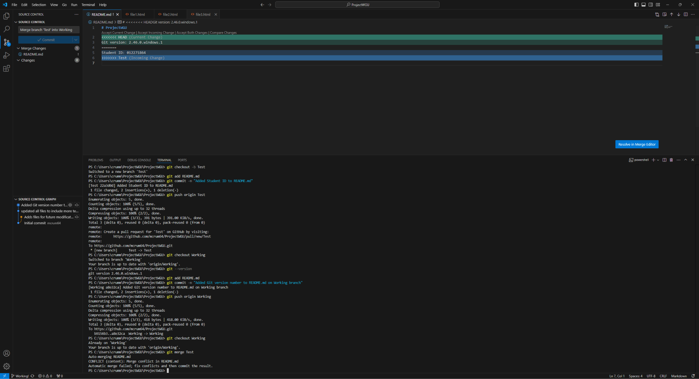

**E.2: Solving Merge Conflict and Pushing Changes**

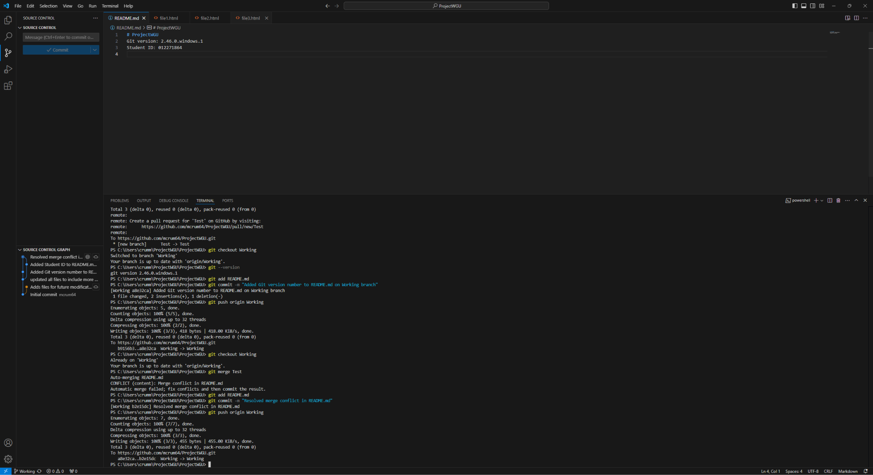

**E.3: Showing Repository Graph**

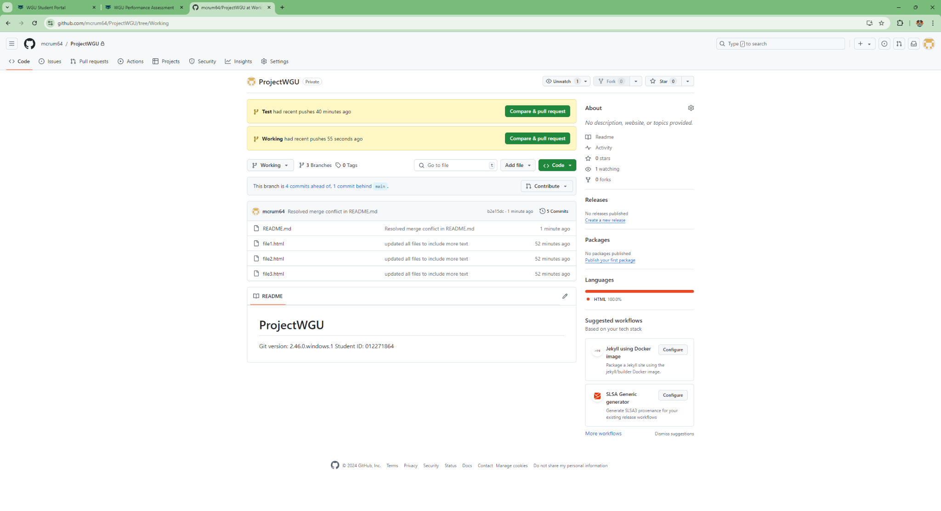

**F.1: Tagging Branch**

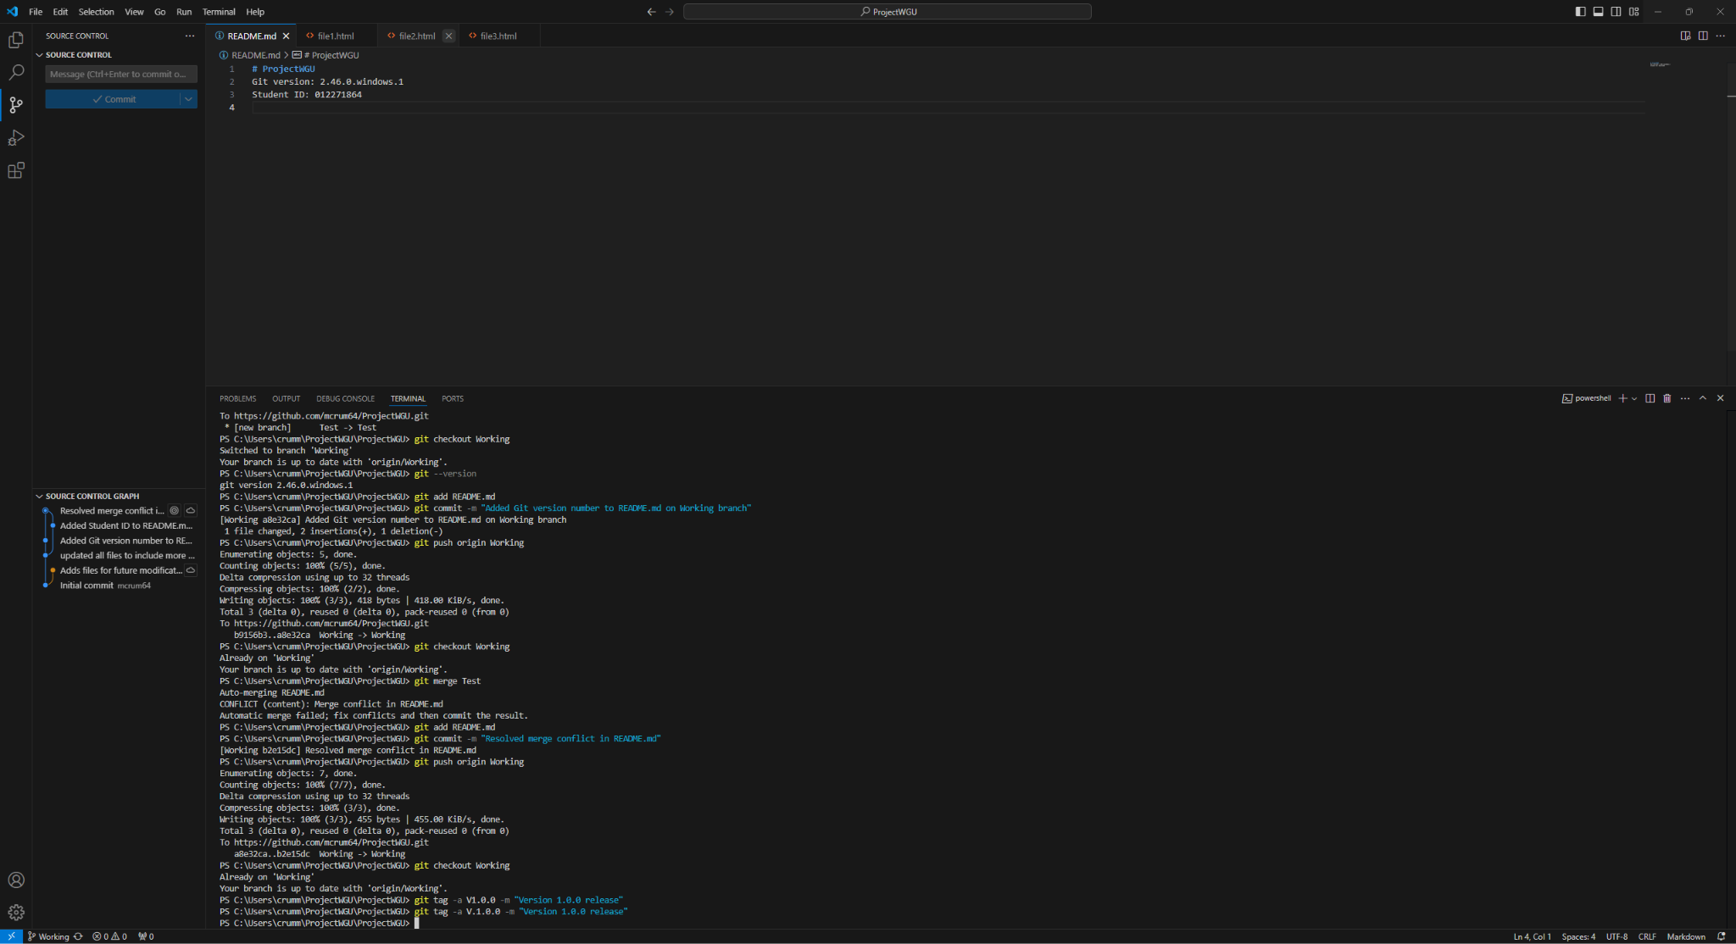

**F.2: Pushing tag**

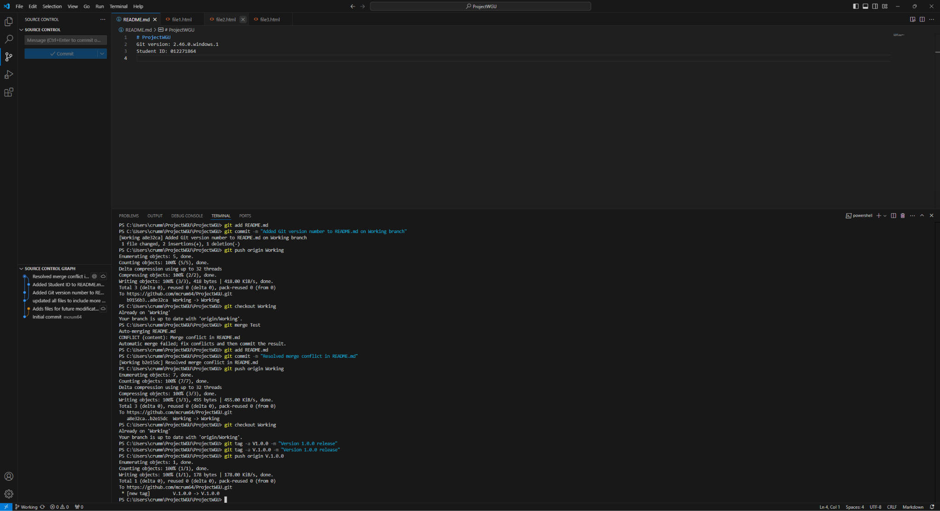

**F.3: Repository Graph**

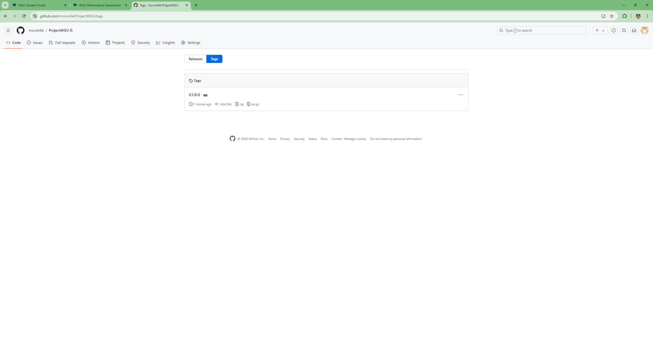

**G.1: Adding retrospective information and pushing changes**

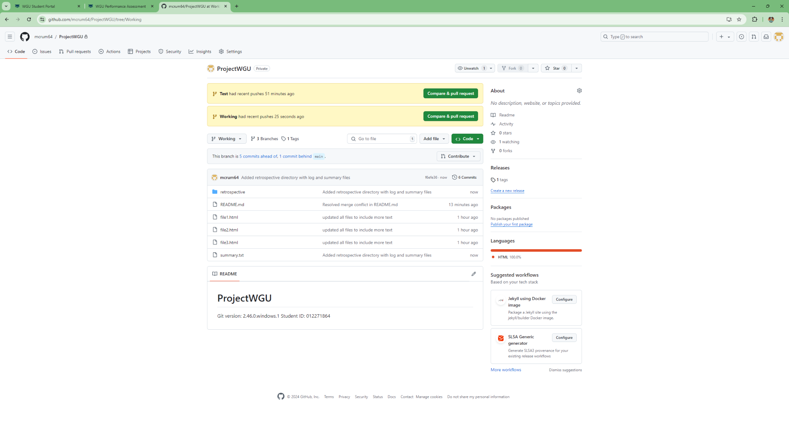

**G.2: Showing contents of log.txt**

