Coin Spot — VARA Journey Playbook
Customer Journeys · Technical Architecture · Security & Integrations
Third-Party Providers: Zand Bank PJSC · Liminal Custody · VerifiX · goAML (UAE FIU)

Contents

- 1. Journey 1: Customer Registration & KYC Onboarding
- 2. Journey 2: Authentication & Session Management
- 3. Journey 3: OTC Trade Execution
- 4. Journey 4: AED & Crypto Deposits
- 5. Journey 5: AED & Crypto Withdrawals
- 6. Journey 6: KYC / EDD Admin Review
- 7. Journey 7: Sanctions & AML Screening
- 8. Journey 8: Treasury & Client Asset Safeguarding
- 9. Journey 9: Customer Account Management
- 10. Journey 10: Compliance Reporting & MLRO Dashboard
- 11. Journey 11: Cross-Journey Data Flow
- 12. Diagram 12: Technical Architecture
- 13. Diagram 13: Network & Security Architecture
- 14. Diagram 14: Redundancy, Failover & Disaster Recovery
- 15. Diagram 15: External Integrations

Journey 1: Customer Registration & KYC Onboarding

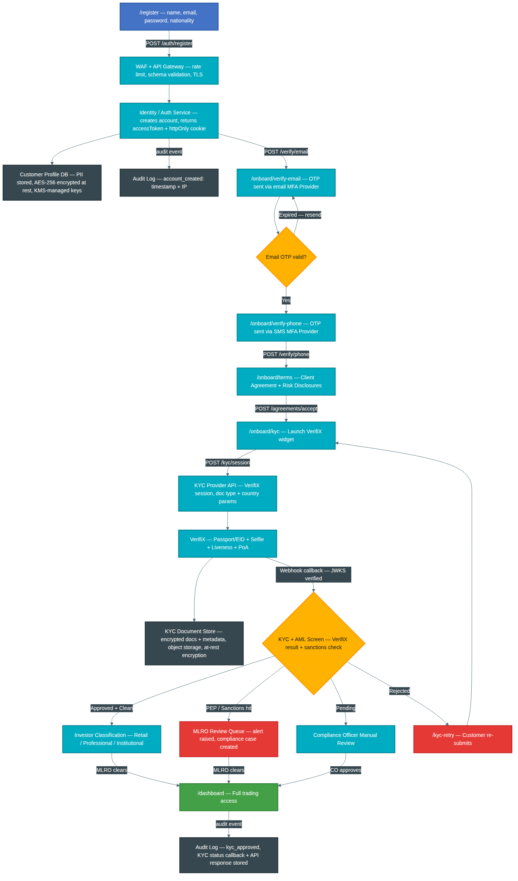
Added: Added (minimal, append-only): WAF + API Gateway (TLS, rate limit, schema validation); Identity/Auth Service layer; Customer Profile DB (AES-256/KMS at-rest encryption); KYC Provider API node (VerifiX session parameters); KYC Document Store (object storage, encrypted); MFA Provider references for email + SMS OTP; Audit Log nodes (account_created, kyc_approved); KYC status callback / API response stored in Audit Log.

Journey 2: Authentication & Session Management

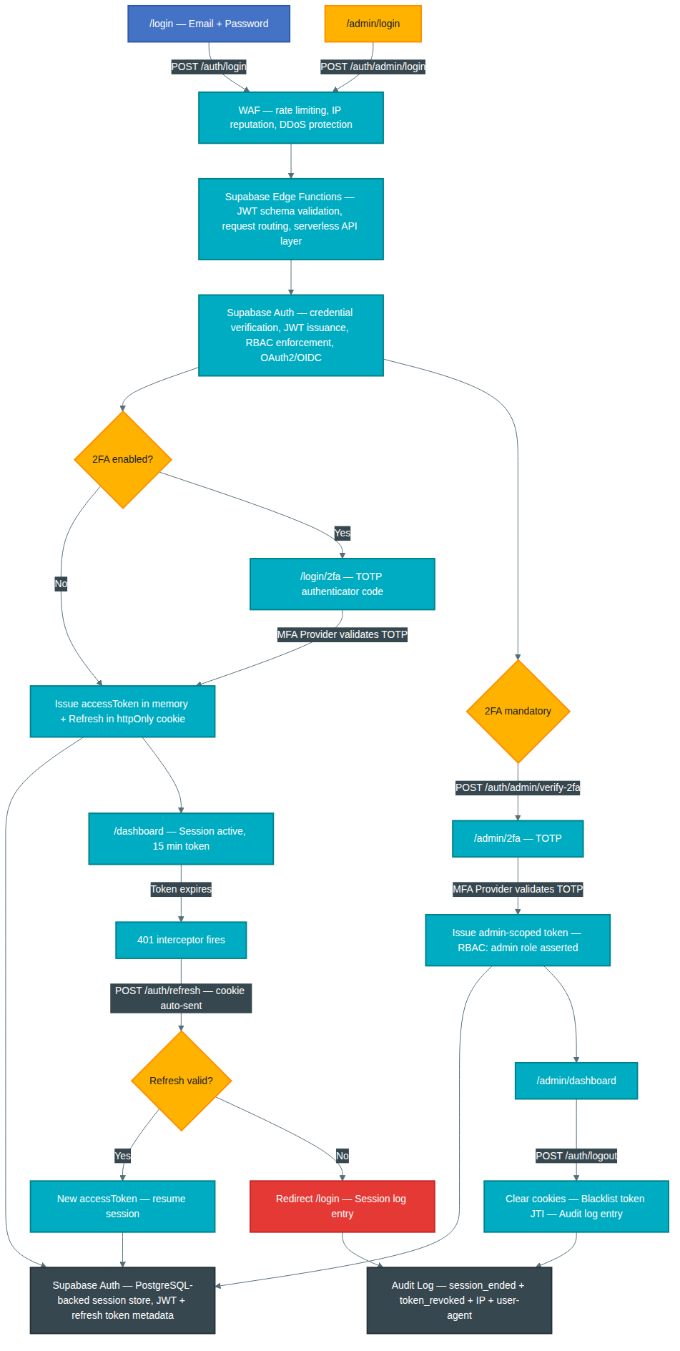
Added: Added (minimal, append-only): WAF layer (rate limiting, IP reputation, DDoS); Supabase Edge Functions as API / serverless routing layer; Supabase Auth (OAuth2/OIDC, JWT, RBAC enforcement); Supabase Auth PostgreSQL-backed session store replacing generic Redis token store reference; MFA Provider references for TOTP validation; RBAC admin-role assertion on admin token issuance; Audit Log node (session_ended, token_revoked, IP, user-agent).

Journey 3: OTC Trade Execution

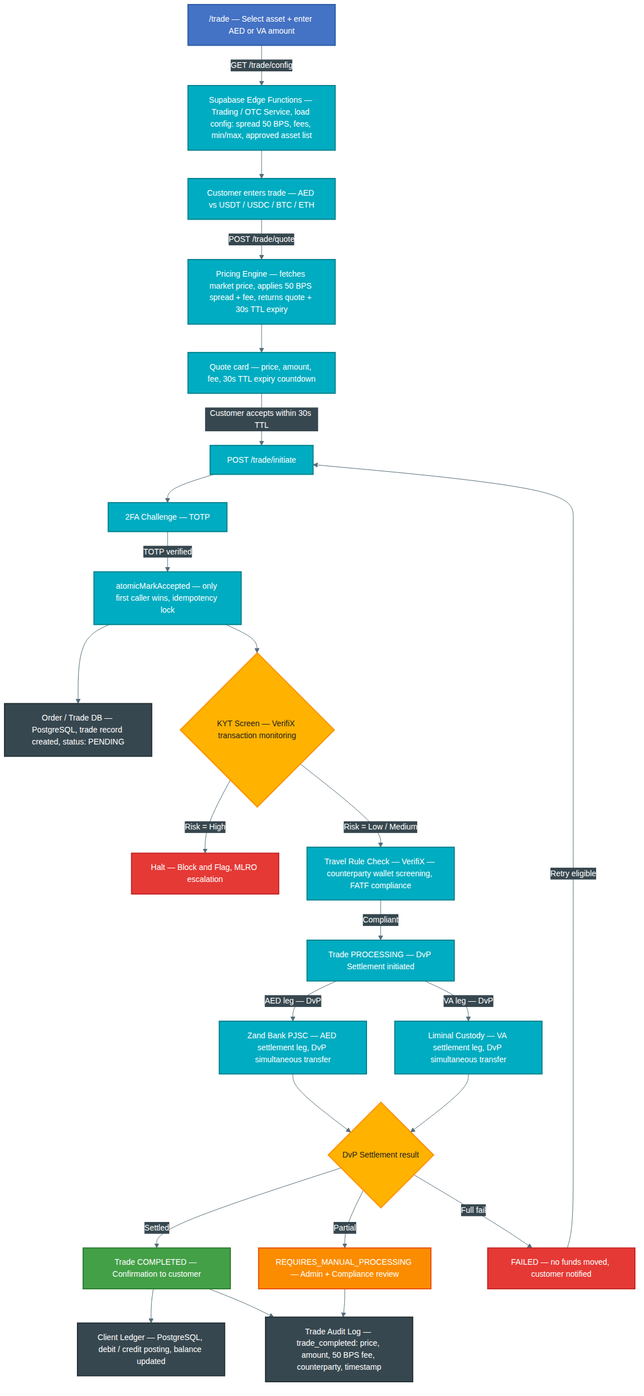
Added: Added (minimal, append-only): Supabase Edge Functions as backend Trading / OTC Service layer; Pricing Engine node (market price fetch, 50 BPS spread applied); 30s TTL on quote card; Travel Rule Check via VerifiX inserted between KYT screen and settlement; DvP (Delivery vs Payment) settlement model on both AED and VA legs; Order / Trade DB updated to Supabase PostgreSQL; Client Ledger (PostgreSQL) posting node; Trade Audit Log with 50 BPS fee recorded; Failure / Retry path.

Journey 4: AED & Crypto Deposits

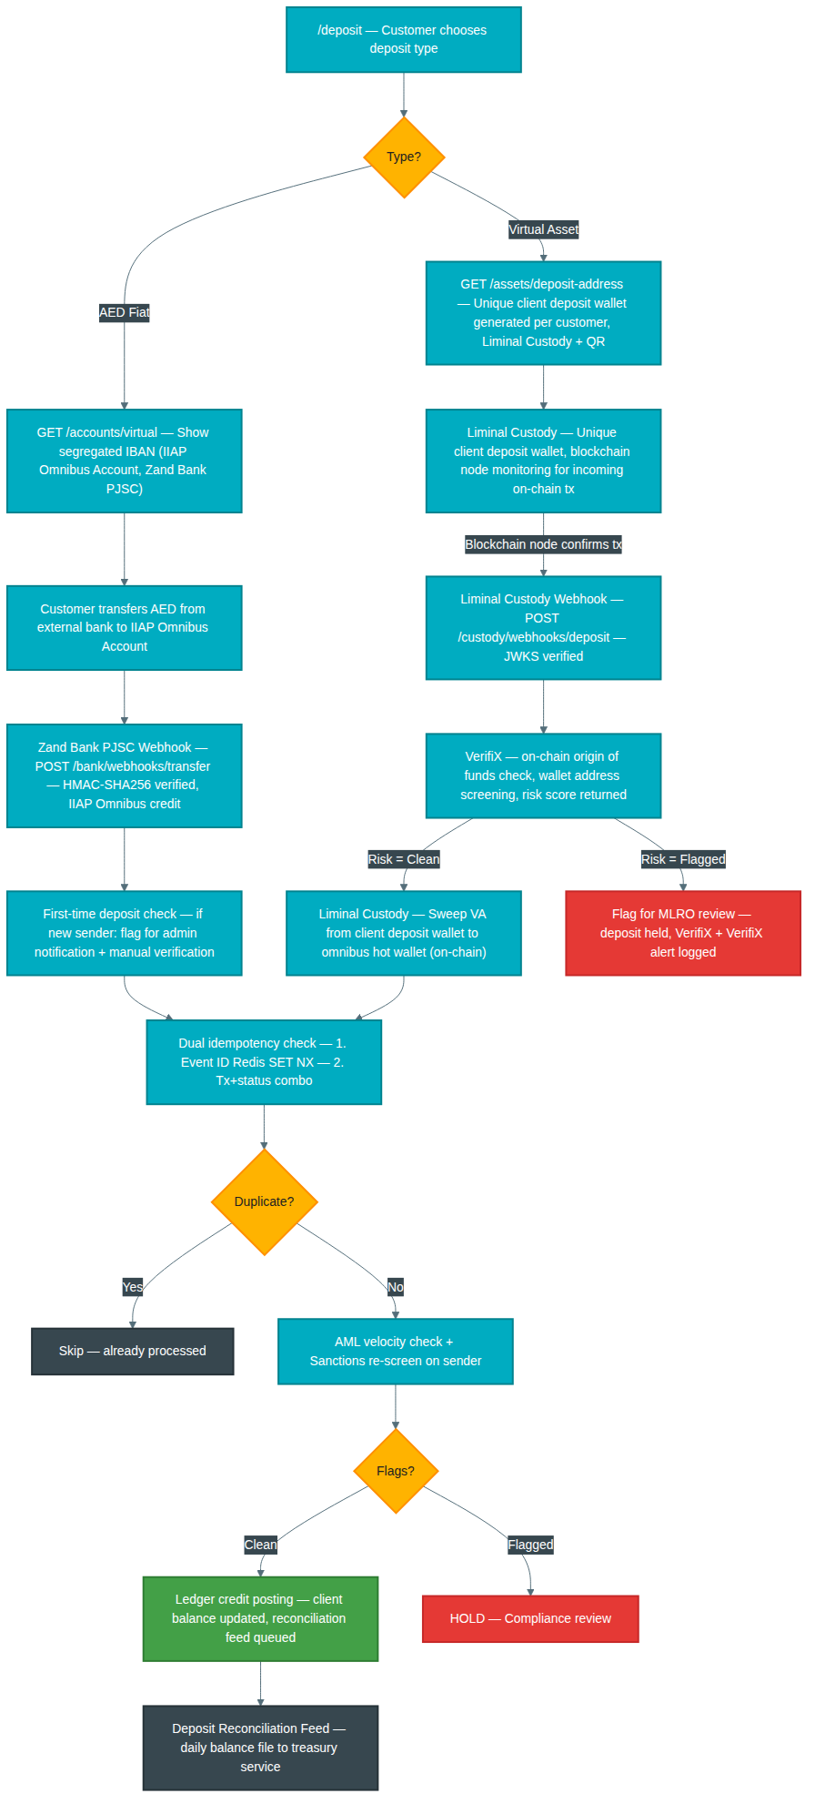
Added: Added (minimal, append-only): AED path: IIAP Omnibus Account at Zand Bank PJSC named on IBAN node; HMAC-SHA256 verified webhook; first-time deposit admin notification check node. VA path: unique client deposit wallet generated per customer via Liminal Custody; VerifiX on-chain screening with risk score; sweep from client deposit wallet to omnibus hot wallet (on-chain) on clean result; flagged path to MLRO review.

Journey 5: AED & Crypto Withdrawals

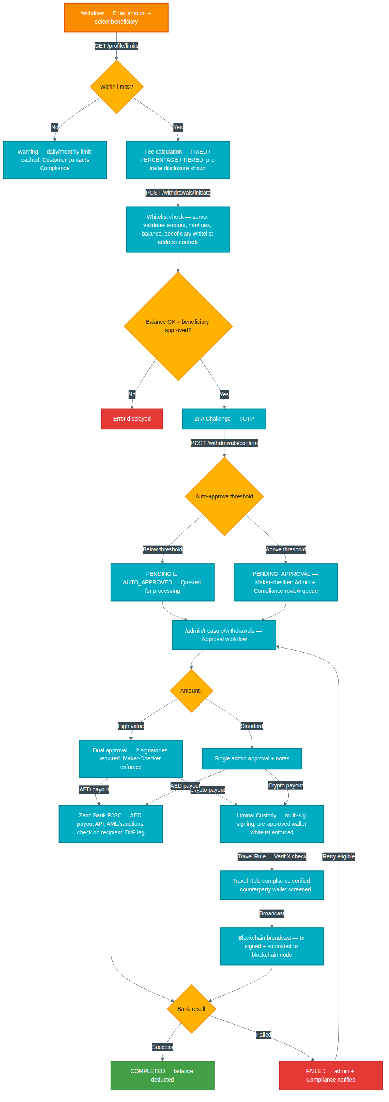
Added: Added (minimal, append-only): Whitelist check node (pre-approved beneficiary addresses); Maker-Checker on PENDING_APPROVAL; Zand Bank PJSC payout API (AML/sanctions check on recipient, DvP label); Liminal Custody multi-sig signing with pre-approved wallet whitelist enforced; Travel Rule Check via VerifiX before blockchain broadcast for crypto withdrawals; Failure / Retry path.

Journey 6: KYC / EDD Admin Review

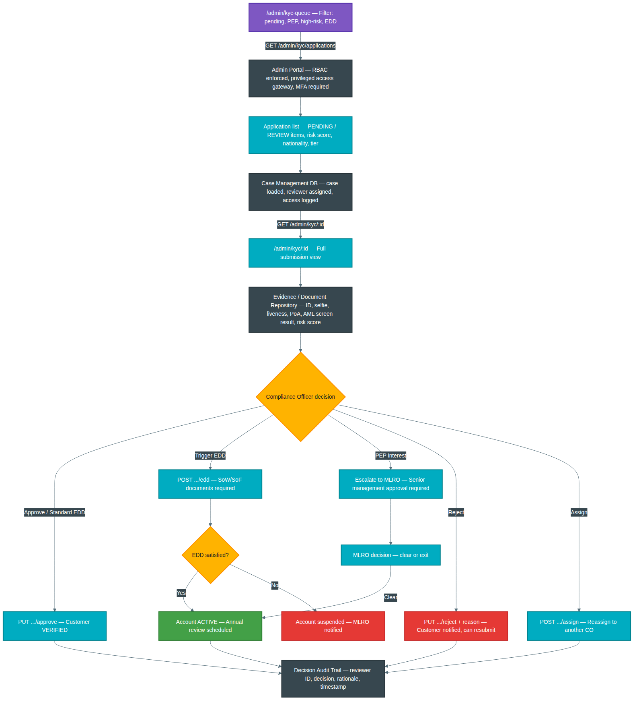
Added: Added (minimal, append-only): Admin Portal node (RBAC enforced, privileged access gateway, MFA required); Case Management DB node (case loaded, reviewer assigned, access logged); Evidence / Document Repository node (full document set accessible to reviewer); Decision Audit Trail node (reviewer ID, decision, rationale, timestamp written for all outcomes); Escalation to MLRO label clarified on PEP interest path.

Journey 7: Sanctions & AML Screening

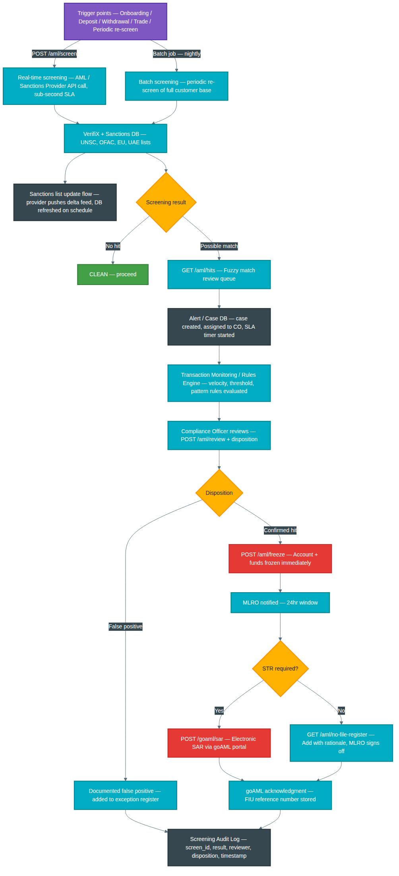
Added: Added (minimal, append-only): Real-time screening node (AML/Sanctions Provider API, sub-second SLA label); Batch screening node (nightly periodic re-screen of full customer base); Sanctions list update flow node (provider delta feed, DB refresh schedule); Alert / Case DB node (case creation, CO assignment, SLA timer); Transaction Monitoring / Rules Engine node (velocity, threshold, pattern rules); Screening Audit Log node (screen_id, result, reviewer, disposition, timestamp).

Journey 8: Treasury & Client Asset Safeguarding

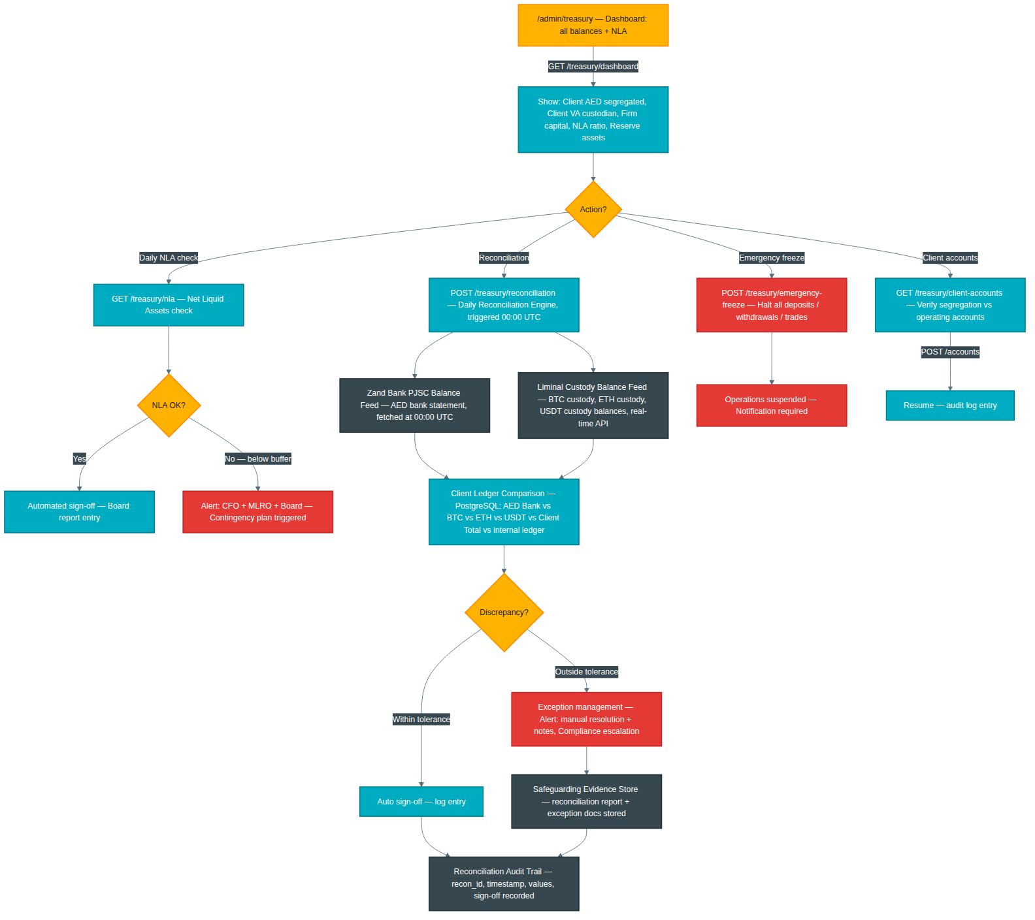
Added: Added (minimal, append-only): 00:00 UTC daily reconciliation trigger; Zand Bank PJSC Balance Feed (AED bank statement); Liminal Custody Balance Feed broken out as BTC, ETH, USDT custody balances; Client Ledger Comparison updated to show all asset types (AED Bank, BTC, ETH, USDT, Client Total) vs internal PostgreSQL ledger; Exception management, Safeguarding Evidence Store, and Reconciliation Audit Trail nodes retained. All provider names generic.

Journey 9: Customer Account Management

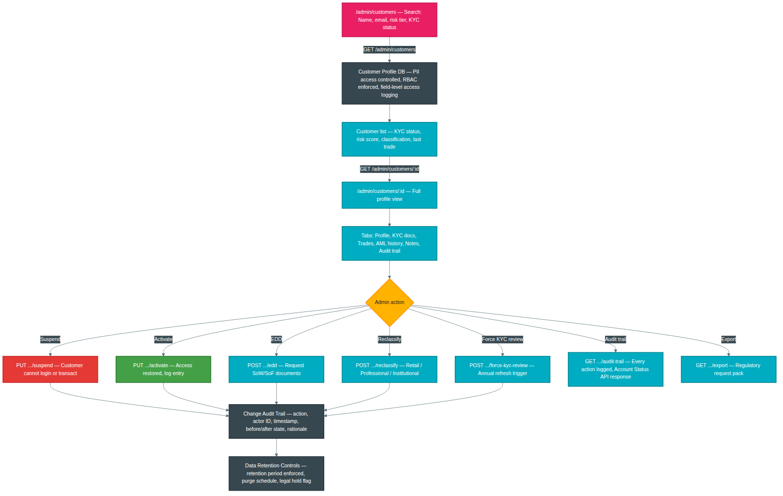
Added: Added (minimal, append-only): Customer Profile DB node (PII access controlled, RBAC enforced, field-level access logging); Account Status API reference in audit trail node label; Change Audit Trail node (action, actor ID, timestamp, before/after state, rationale — applied to all mutating actions); Data Retention Controls node (retention period enforcement, purge schedule, legal hold flag).

Journey 10: Compliance Reporting & MLRO Dashboard

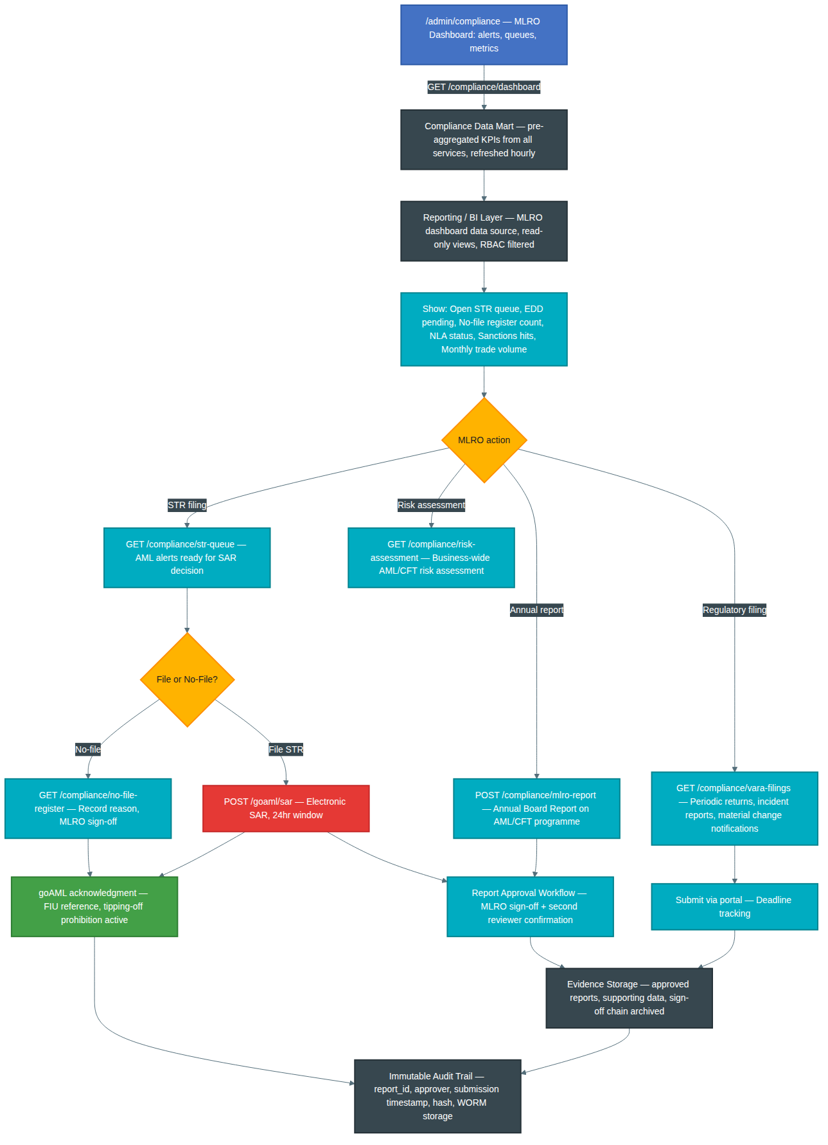
Added: Added (minimal, append-only): Compliance Data Mart node (pre-aggregated KPIs from all services, hourly refresh); Reporting / BI Layer node (MLRO dashboard data source, read-only views, RBAC filtered); Report Approval Workflow node (MLRO sign-off + second reviewer confirmation, applied to SAR and annual report); Evidence Storage node (approved reports, supporting data, sign-off chain archived); Immutable Audit Trail node (report_id, approver, submission timestamp, hash, WORM storage).

Journey 11: Cross-Journey Data Flow NEW

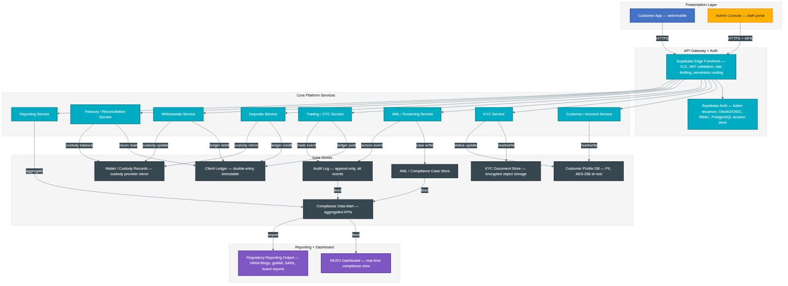
New diagram: New diagram — Journey 11: Shows cross-journey data flow across the full platform. Includes Customer App and Admin Console (presentation layer), API Gateway and Auth Service (gateway layer), all eight core platform services (customer, KYC, AML, trading, deposits, withdrawals, treasury, reporting), all data stores (Customer Profile DB, KYC Document Store, Compliance Case Store, Client Ledger, Custody Records, Audit Log, Compliance Data Mart), and the MLRO Dashboard and Regulatory Reporting output layer. Data flow edges are labelled with the operation type (read/write, ledger post, aggregate, export, etc.).

Diagram 12: Technical Architecture NEW

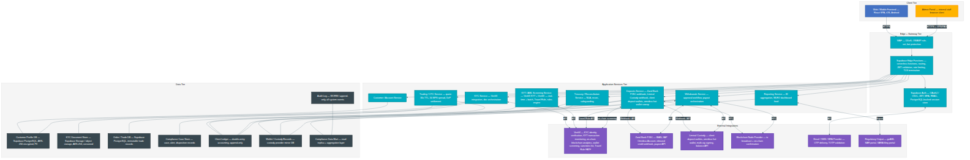
New diagram: New diagram — Technical Architecture: Layered system architecture across five tiers: Client (web/mobile frontend, admin portal), Edge/Gateway (WAF, API Gateway, Auth/Session Service), Application Services (8 microservices), Data Tier (8 stores including audit log and compliance data mart), and External Integrations (KYC provider, AML provider, bank/payment partner, custody/wallet provider, blockchain node, email/SMS/MFA, regulatory output). All service-to-data and service-to-external connections shown with protocol labels.

Diagram 13: Network & Security Architecture NEW

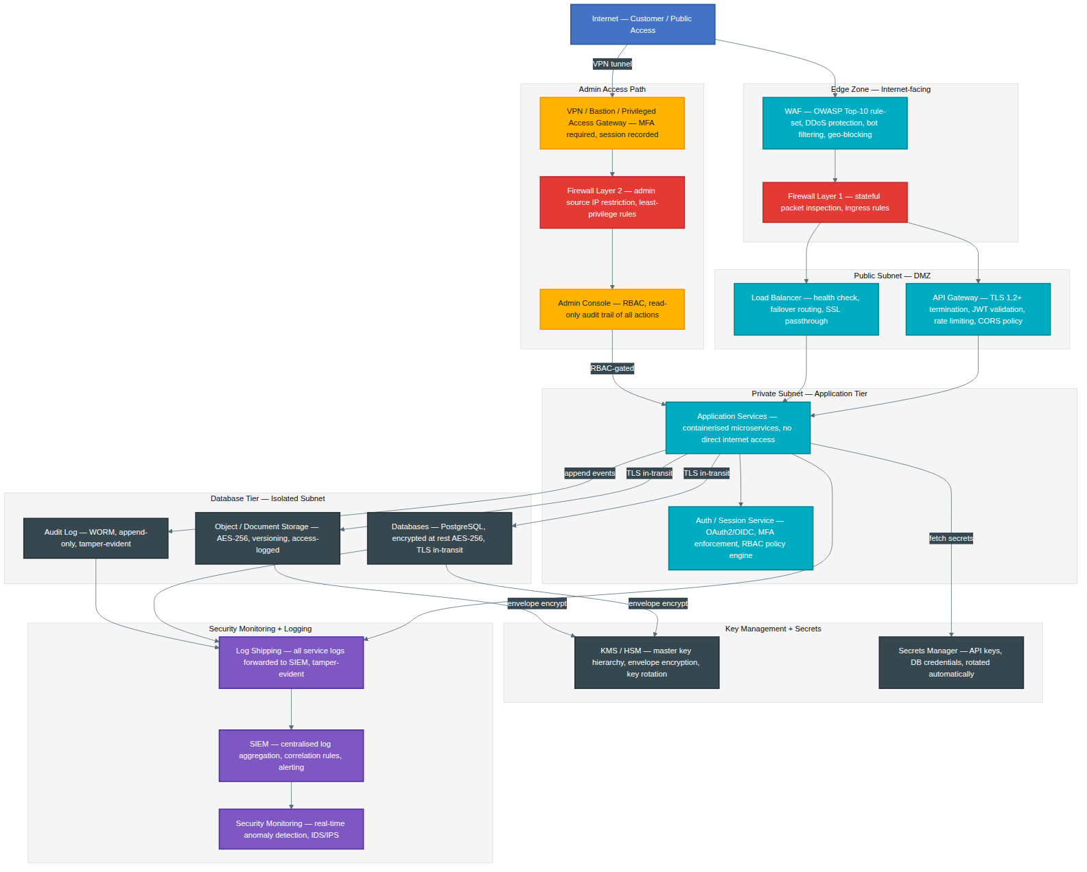
New diagram: New diagram — Network & Security Architecture: Covers internet/customer access → WAF → Firewall Layer 1 → Public Subnet (API Gateway, Load Balancer with TLS termination) → Private Subnet (application services, auth/session service with RBAC) → Database Tier (isolated subnet, AES-256 at rest, TLS in-transit) → Key Management (KMS/HSM, envelope encryption, key rotation) → Secrets Management → Admin access path (VPN/Bastion/Privileged Access Gateway with MFA, Firewall Layer 2, Admin Console with RBAC) → Security Monitoring (SIEM, IDS/IPS, log shipping to tamper-evident store). Encryption in transit (TLS) and at rest (AES-256/KMS) labelled on all relevant edges.

Diagram 14: Redundancy, Failover & Disaster Recovery NEW

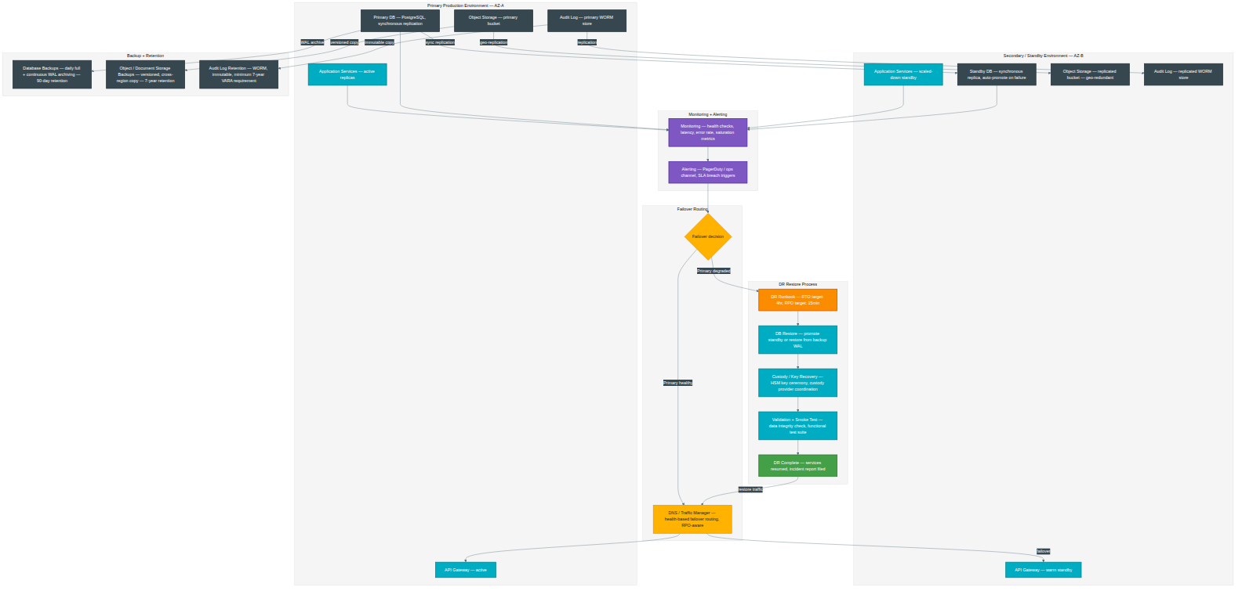
New diagram: New diagram — Redundancy, Failover & DR: Shows Primary Production Environment (AZ-A) and Secondary/Standby Environment (AZ-B) with synchronous DB replication and geo-replicated object storage and audit log. Backup tier covers database (daily full + continuous WAL, 90-day retention), object storage (versioned cross-region, 7-year retention), and audit log (WORM immutable, 7-year VARA requirement). Monitoring and alerting feed into failover decision. DNS/Traffic Manager provides health-based failover routing. DR Restore Process includes runbook (RTO 4hr / RPO 15min placeholders), DB restore path, Custody/Key Recovery (HSM key ceremony), validation, and smoke test before traffic restoration.

Diagram 15: External Integrations NEW

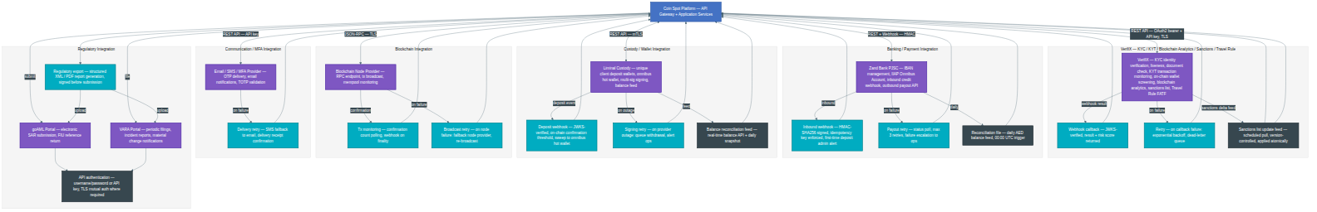
New diagram: New diagram — External Integrations: Shows all third-party and platform integration points grouped by domain: KYC Provider (VerifiX — OAuth2/REST, JWKS-verified webhook callback, exponential backoff retry); AML/Sanctions Provider (real-time API + list delta feed, queue-and-replay retry); Bank/Payment Partner (HMAC-signed webhooks, idempotency enforcement, payout retry, daily reconciliation file); Custody/Wallet Provider (mTLS REST API, JWKS-verified deposit webhook, signing retry, real-time balance feed); Blockchain Node Provider (JSON-RPC/TLS, tx monitoring, fallback node retry); Email/SMS/MFA Provider (API key, SMS fallback retry); Regulatory output (goAML SAR submission, VARA portal filings, API authentication methods, signed report export). All retry and failure-handling paths shown per integration.

Appendix: Third-Party Provider Register

# | Provider | Category | Role | Status
1 | Zand Bank PJSC | Banking | Client fiat account banking; AED settlement; IIAP Omnibus Account | Confirmed
2 | Liminal Custody | VA Custody | Third-party custody of client virtual assets (BTC, ETH, USDT); client deposit wallets; omnibus hot wallet; multi-sig | Confirmed
3 | VerifiX | KYC / KYT / Blockchain Analytics | Customer identity verification; KYT transaction monitoring; on-chain wallet screening; blockchain analytics; sanctions list; Travel Rule FATF | Confirmed
4 | [Blockchain Analytics Provider] | Blockchain Analytics | Placeholder — on-chain transaction screening; wallet address screening; Travel Rule support (VerifiX confirmed for this role) | Confirmed — VerifiX
5 | goAML (UAE FIU) | Regulatory Reporting | STR/SAR electronic filing platform | Confirmed (regulatory obligation)

