Just a small piece of code in order to get a list of movies from TMDb depending on some string parameters you will pick (language, release date, genres, popularity)

I am using the discover request from TMDb API. This is more “friendly” than the API because you do not have to input language and genre ID as filters but “real life parameters”.

Here’s an example that shows how to use the code:

First, you will need to get a TMDb API key. You can request one after registering your account on TMDb. (it will takes literally 2 minutes): <https://developers.themoviedb.org/3/getting-started/introduction>

After you get your API Key, you are all set! If you want to watch a North Korean drama movie tonight but you want it relatively short, not too old, and not too popular, here is what you can input in the **parameters.py**

INPUT

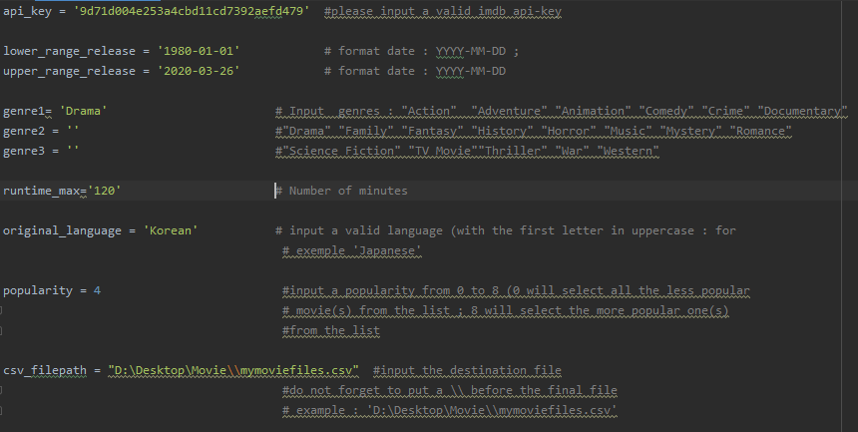

You can now run the **Main.py** (do not forget to install the requirements**)**. As an output, you will have a csv spreadsheet (under your csv_filepath) with all the matching movies classifying from the best to the worst rating.

OUTPUT

