CS 4341 Project 3 Report
A01- 2017
Jon Berry
Mathew Schwartzman
Nicolette Vere

Abstract
The purpose of project 3 was to review our basic understanding of machine learning concepts and in particular, neural networks. We used a Keras-based tensorflow neural net written in Python to learn from a subset of the MNIST handwritten digit database. This system gets to upwards of 90% in fewer than 20 epochs and maintains a steady accuracy as shown by the results graphs.

Graphs
The following graph shows the progression of Acc, Loss, and Val_acc over epochs. These values indicate our model’s improvement over time, maintaining what appears to be a logarithmic progression to an asymptote of ~91% accuracy.

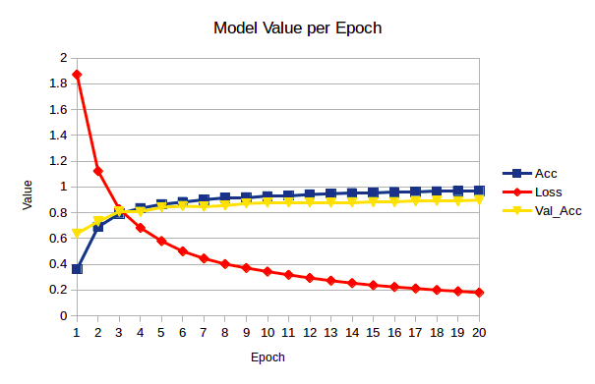

This next graph shows the same data series over 50 epochs.

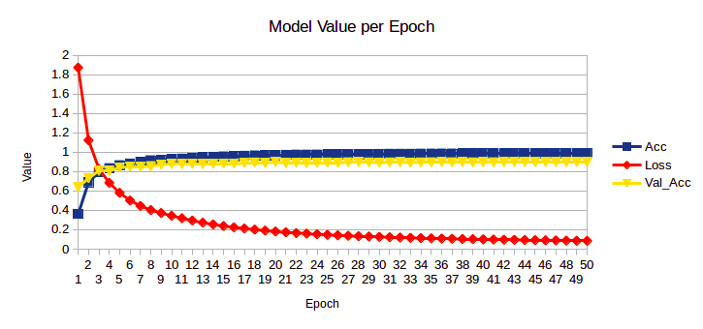

Training Procedure
We started by changing the type of initializer that was used. Below are all of the different outputs for each of the initializers we tried.

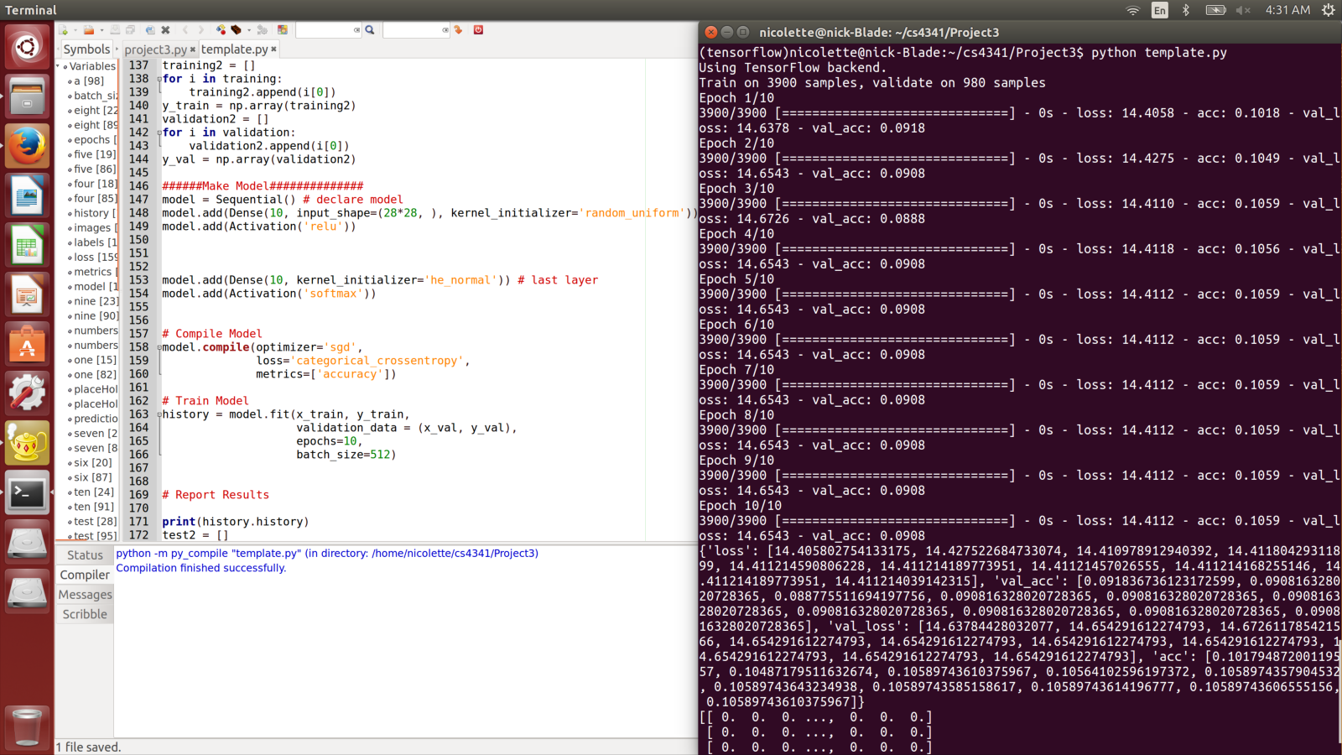
Random Uniform Initializer for first layer
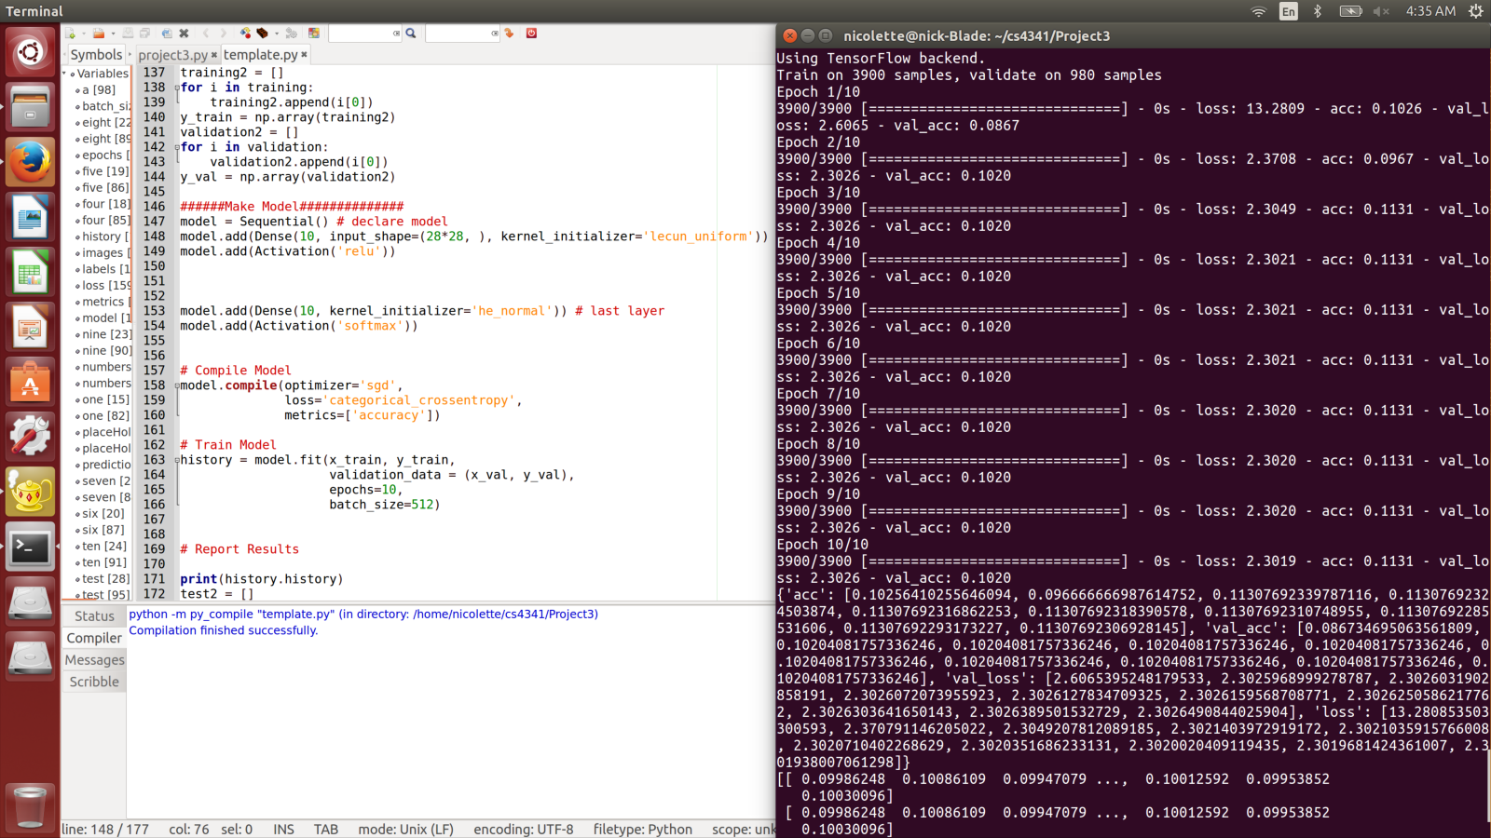
Lecun Uniform Initializer for first layer
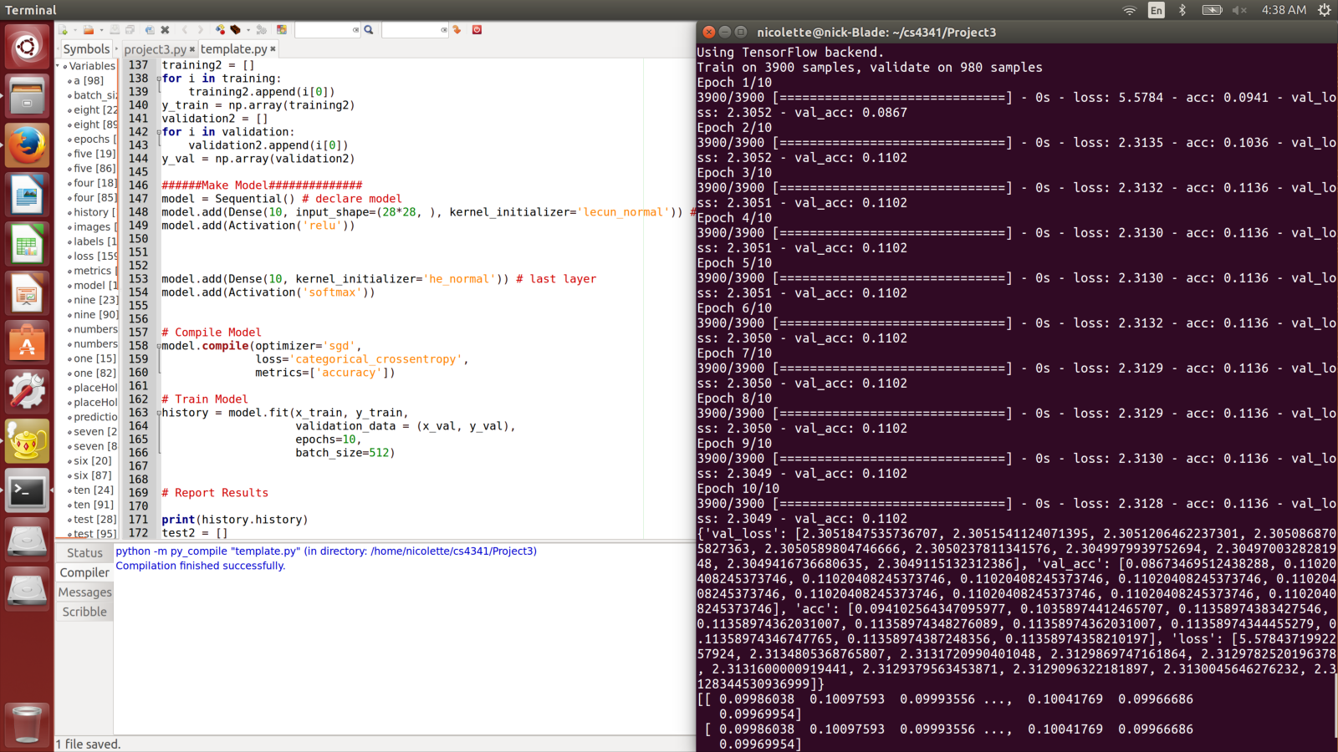
Lecun Normal Initializer for first layer
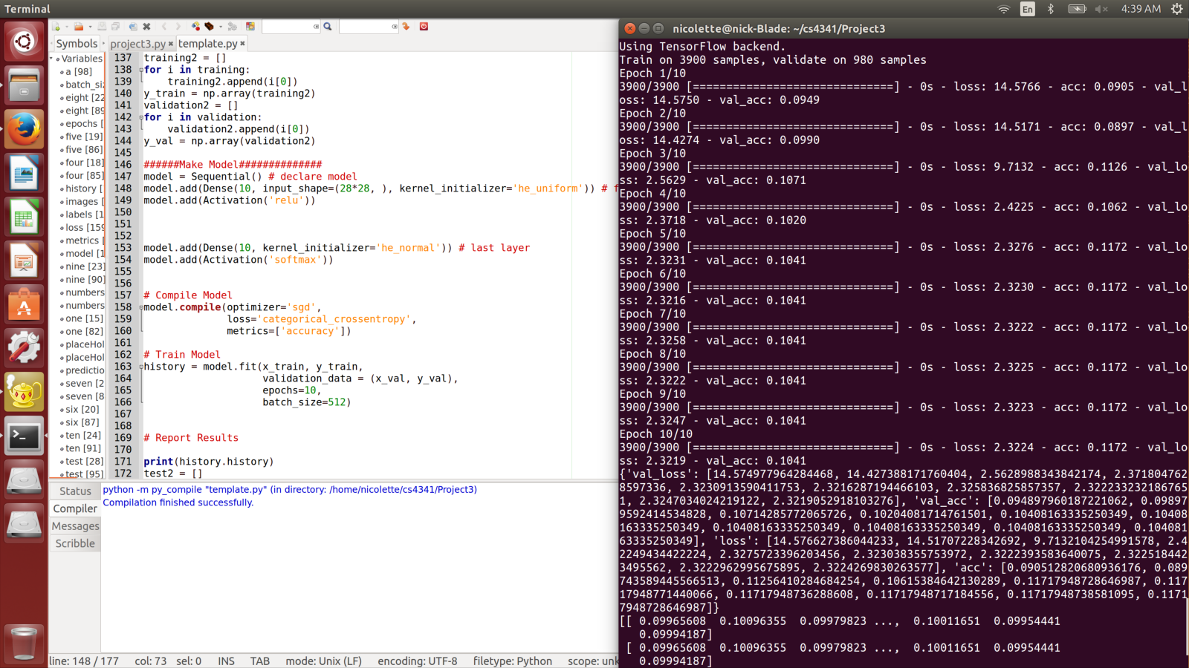
He Uniform Initializer for first layer

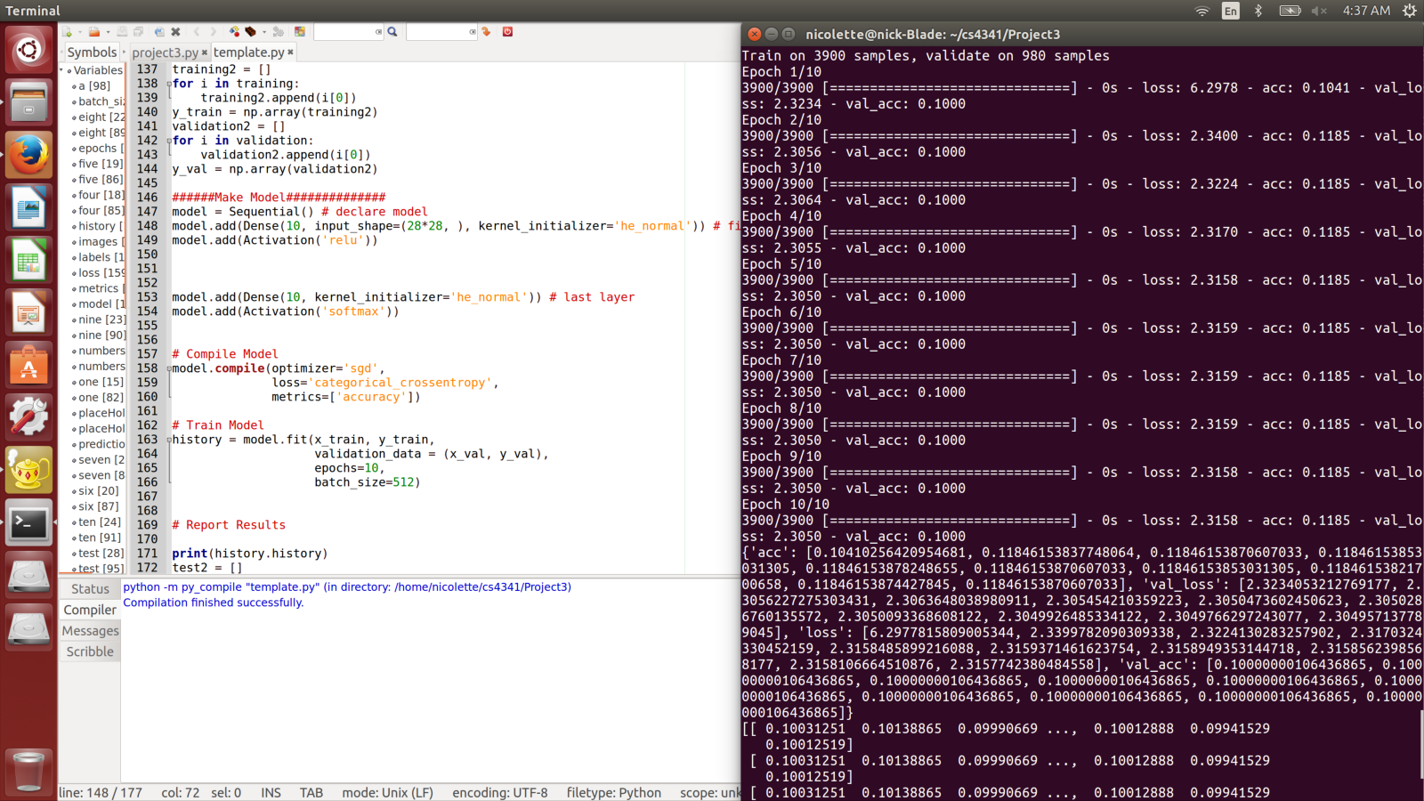
He Normal Initializer for first layer

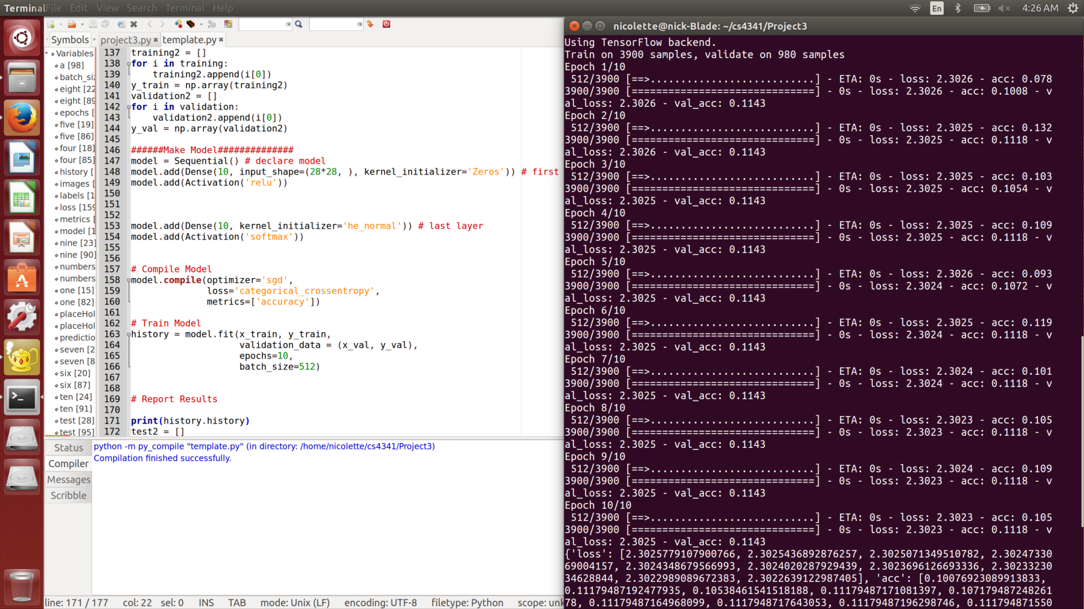
Zeros initializer for first layer
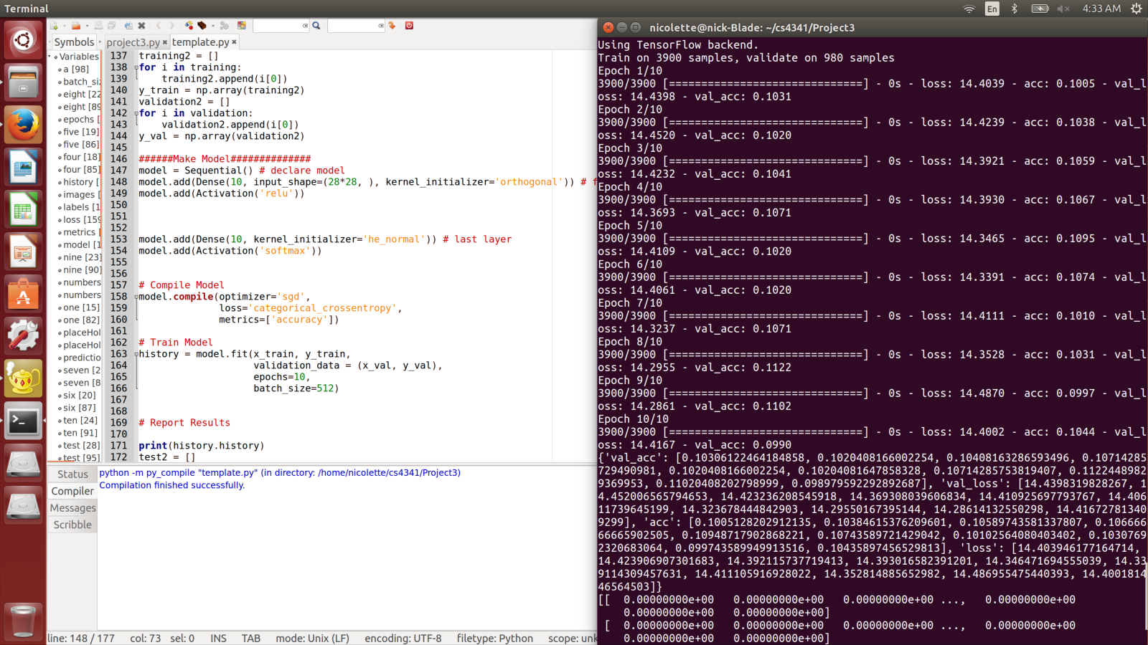
Orthogonal Initializer for first layer
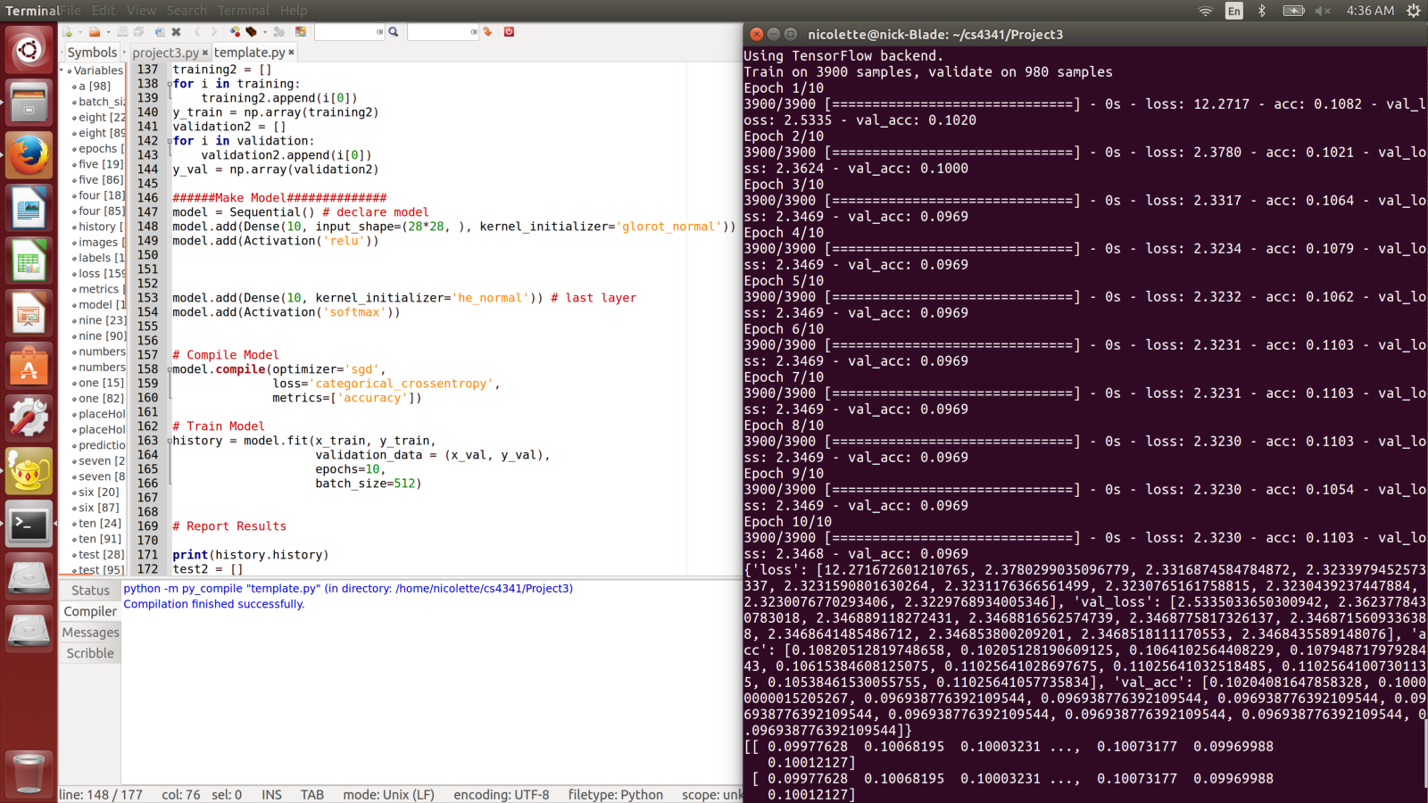
Glorot Normal Initializer for first layer

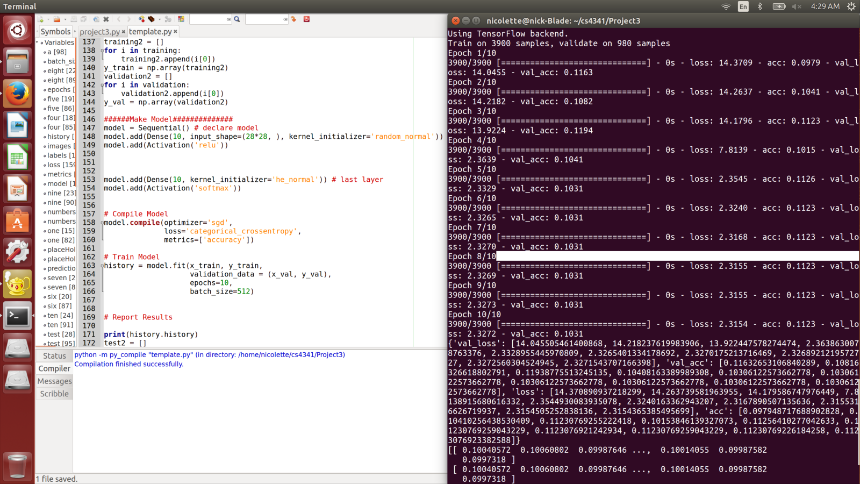
Random Normal Initializer for first layer.
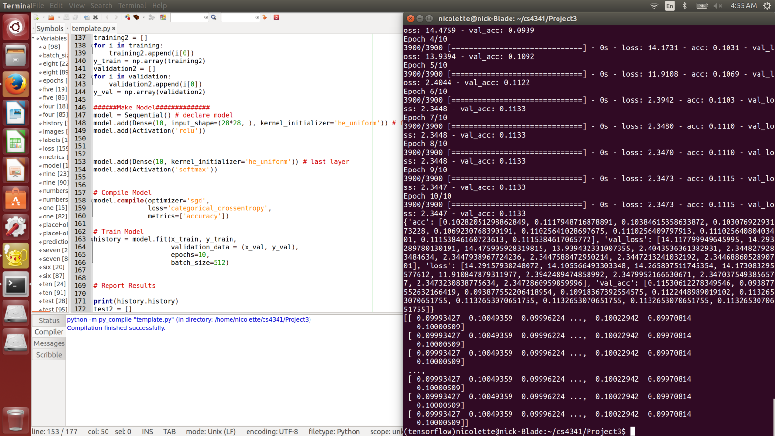
First and last layer initializer as he_normal
He_uniforma had the largest impact on accuracy. It made accuracy go up to about 0.1172 which was higher than any of the others. But random normal was also pretty good with 0.1123 so that was tested with for a bit.
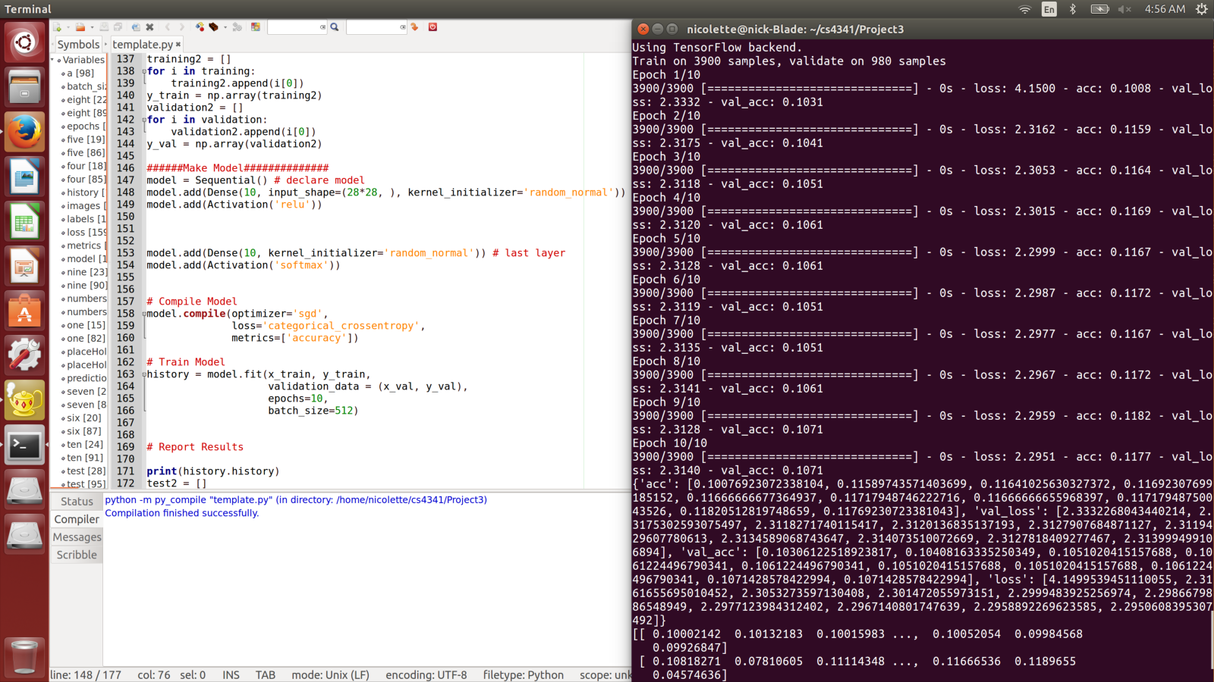
First and last layer initializer as random_normal with relu.

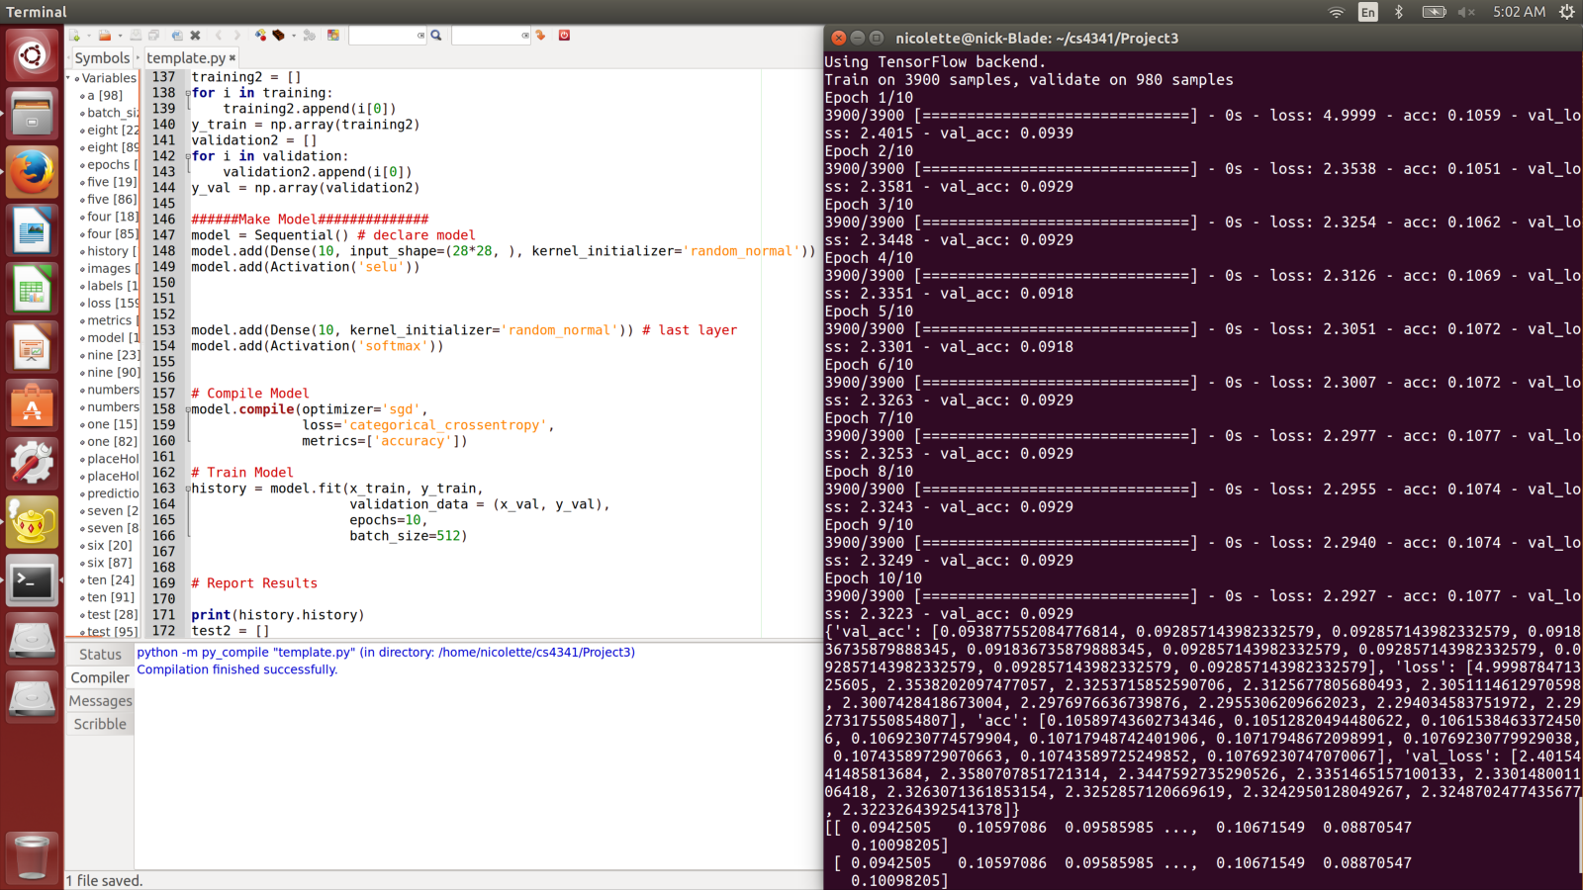
First and last layer initializer as random_normal with selu.
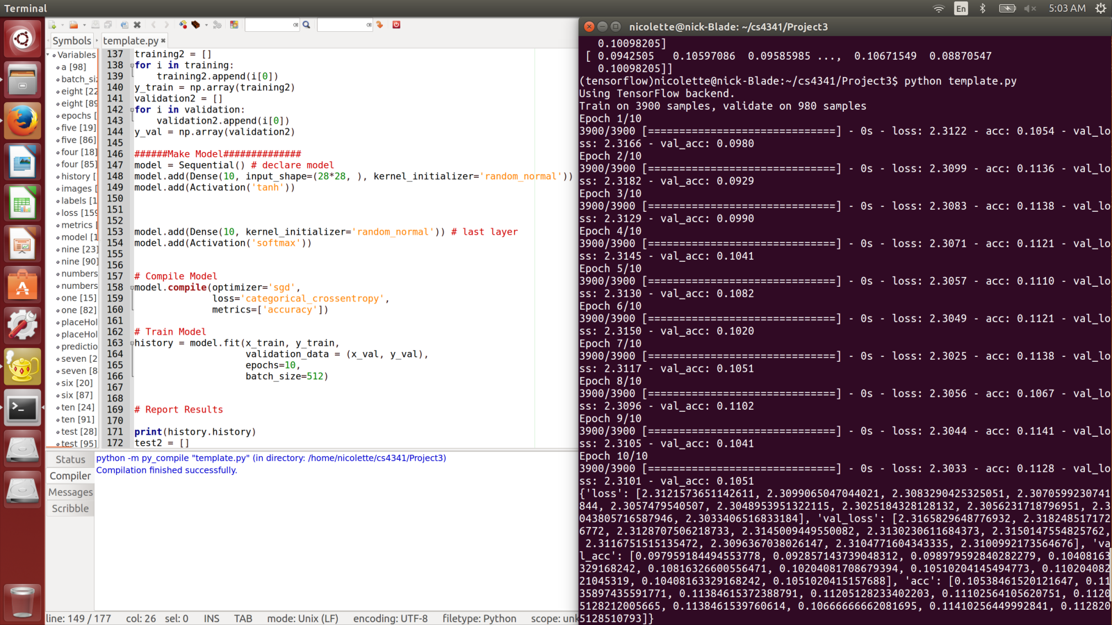
First and last layer initializer as random_normal with tanh.
After testing all of the activation options tanh was the most consistent and still had a high value. Selu had higher values but there was more variation. Testing was done with both moving forward.
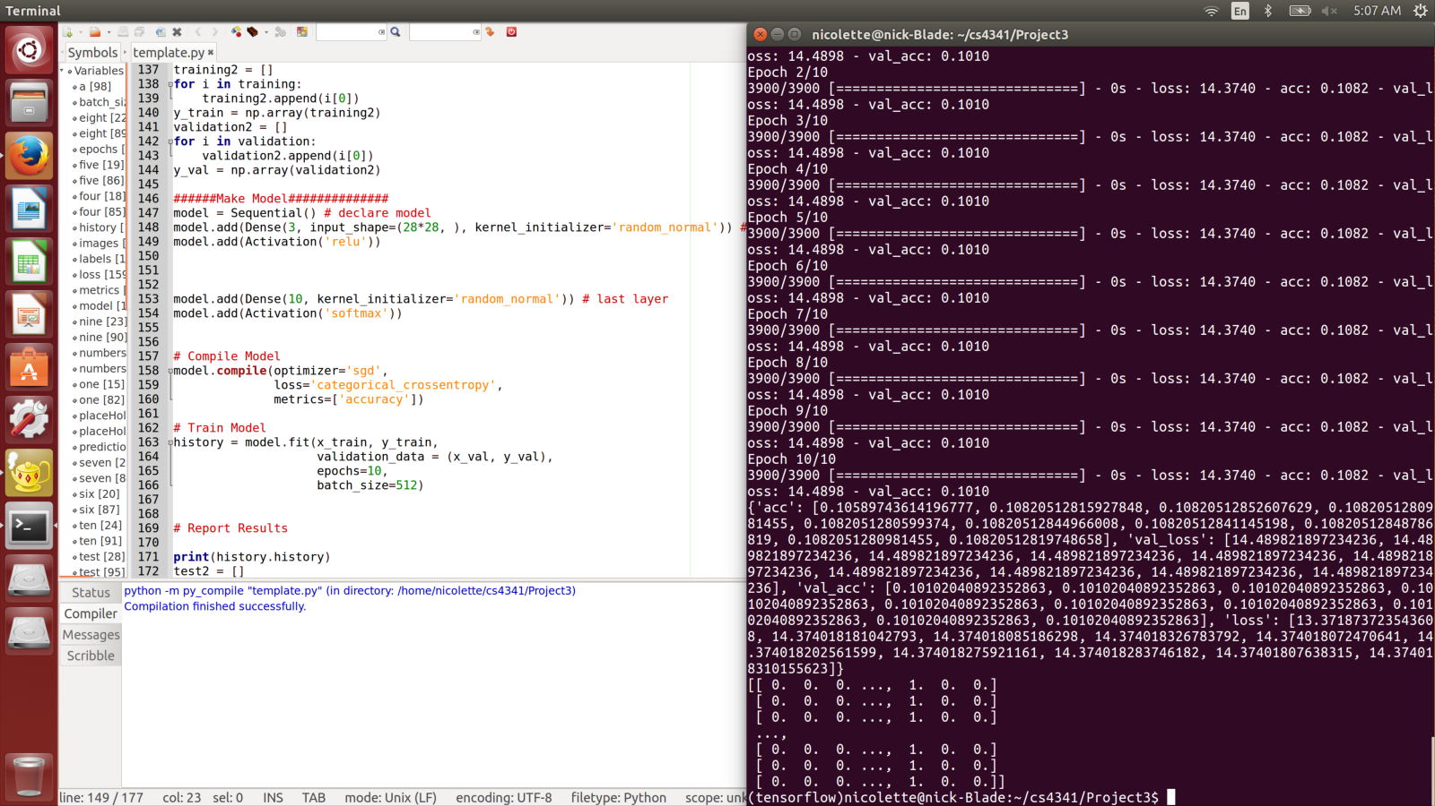
First layer 3 neurons with random_normal initializer and relu activation.
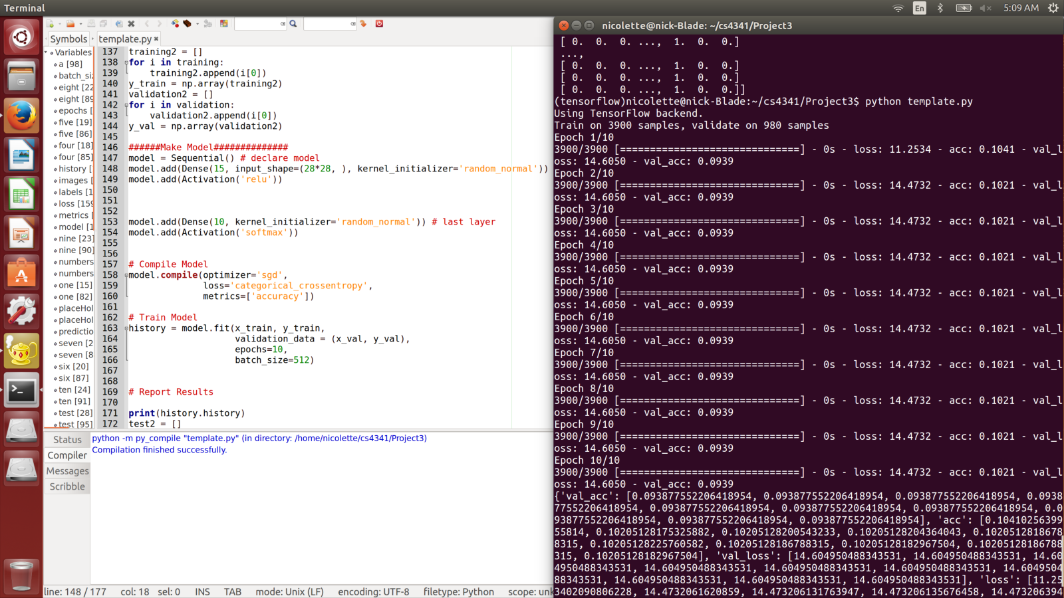
First layer 15 neurons with random_normal initializers and relu activation.
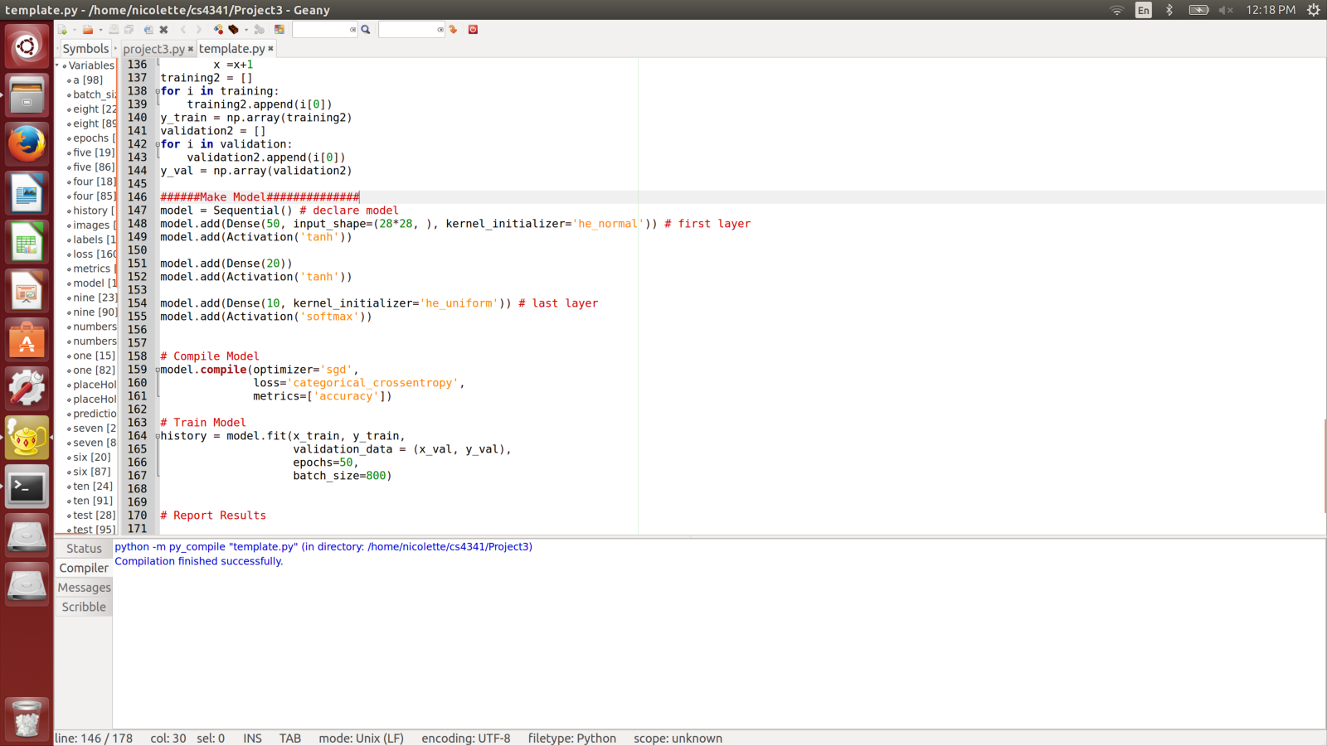
Changed to he_normal initializer and tanh activation added dense layer with 20 neurons. Also changed epochs to 50 and batch size to 800 since previous attempts did not have a large enough
change. The other good options previously found were tried. So instead of the initializer being random_normal he_uniform was tried. For activation instead of relu the other good option tanh was tried.

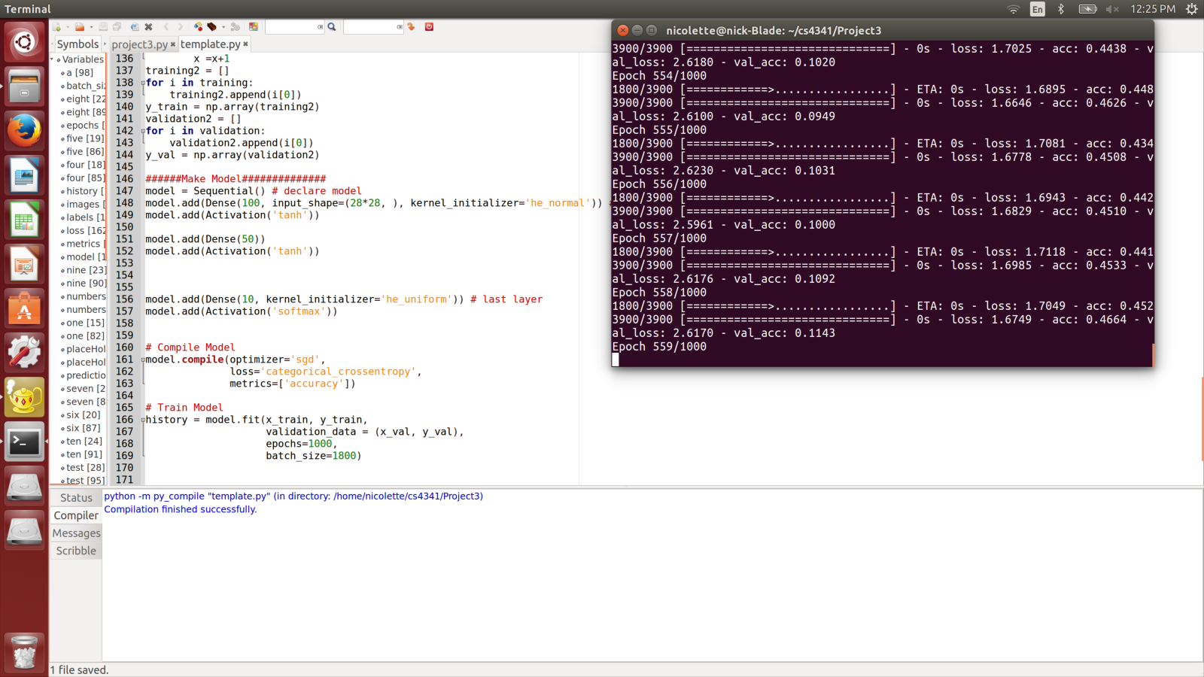

Changed middle layer to 50 neurons and first layer to 100 neurons and epochs 1000 and batch size 1000 since increasing everything had improved acc.

After this we were concerned why val_acc was acting seemingly randomly. We found that images and labels were not lining up as well as they should have been. After here we realized that the images and labels were not lined up from the start so only the acc was being tracked correctly.
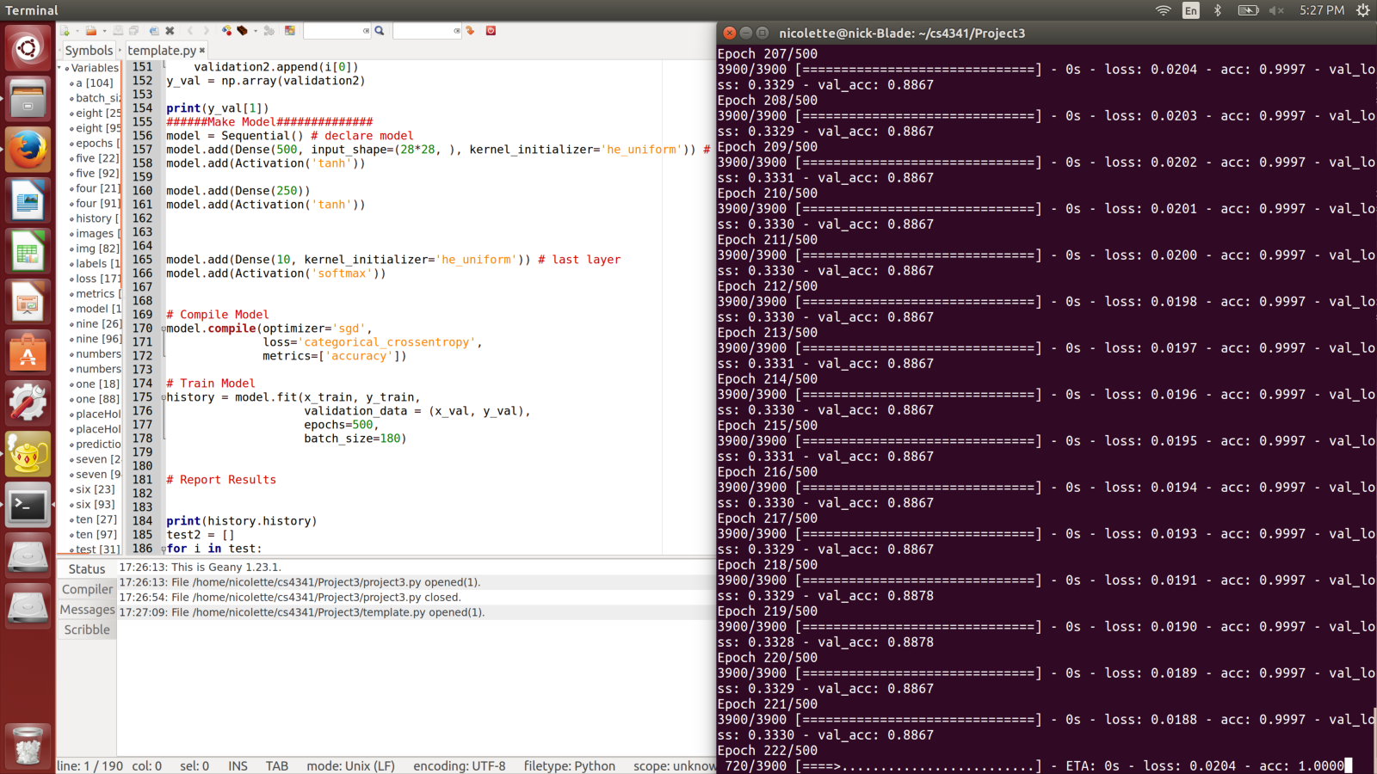
First layer was changed to have 500 neurons with middle layer 250. All activation were tanh and all initializers were he_normal. This caused val_acc to be similar to acc and over 0.7. After this the amount of epochs was reduced to 50 since 500 seemed to be taking a while and after about 50 it would be over 0.7.

Model Training Description
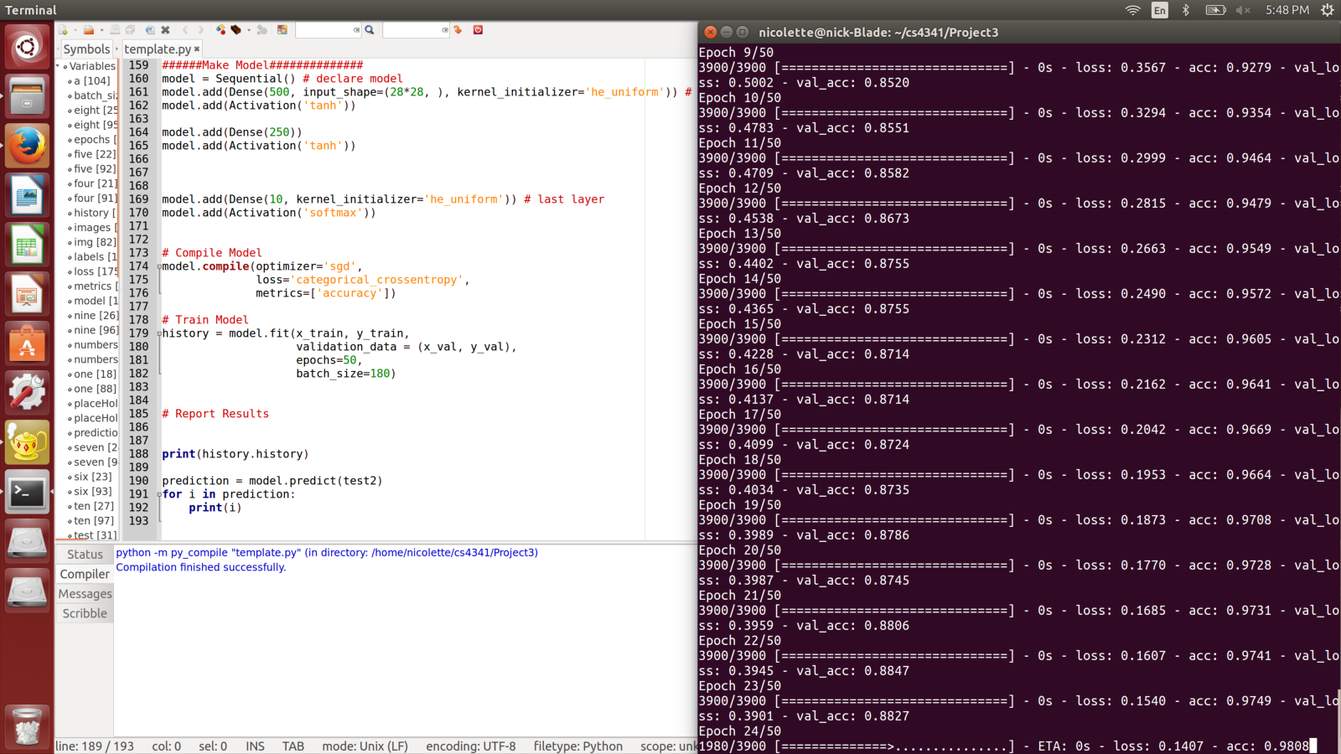
After all of the training even after 10 epochs val_acc was over 0.7. We decided to keep batch size of 100 because it worked for the previous testing. This was the final model used since it had a combination of the best initializer found, activation method and combination of middle layer neurons and first neurons. The 50 epochs allowed for enough data to be collected to make an accurate confusion matrix and get up way above 0.7 for val_acc. The screenshot can be seen above. Experimenting had shown that the best initializer was he_uniform and activation was tanh. The best starting neuron configuration was 500 and middle was 250 out of the ones we tried.

Confusion Matrix and Model Performance
The table below shows a 10X10 confusion matrix. It displays the model’s performance on a selection of ten instances with probabilities representing how certain the model is of a value’s true label. The x-axis shows the predicted label and the y-axis shows the true value.
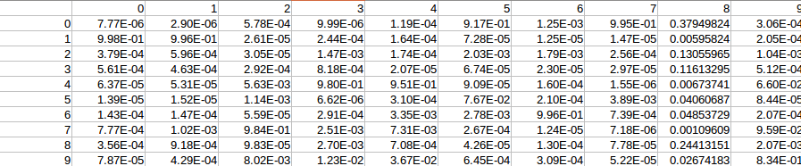

Visualization
These are three images that were classified incorrectly by the neural network. The 5 has an extra line at the bottom, which is different from most standard handwritings. The 7 has a curly top and could look like a nine or possibly a four. The three, though rotated from the standard for threes, was most likely erred due to an imperfection in the training or an insufficient training set.

