**To-do task 1**

**Name:** Shoaib Sabir

**Roll No:** Mcsf19a019

1. **Create repository private repo and name it first_repo.** 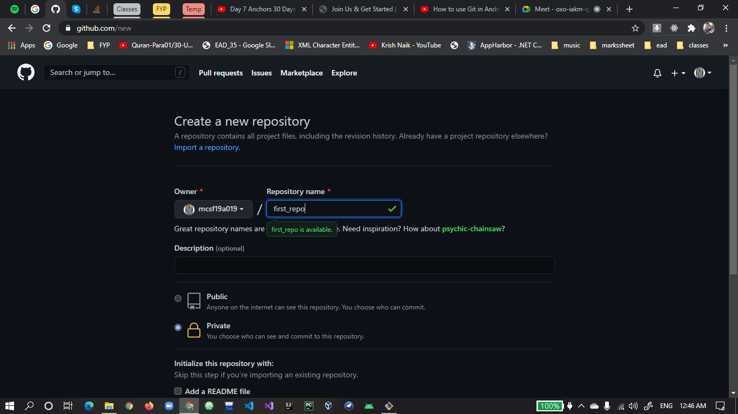
2. **Repository is created and link is provided to connect with local repository.** 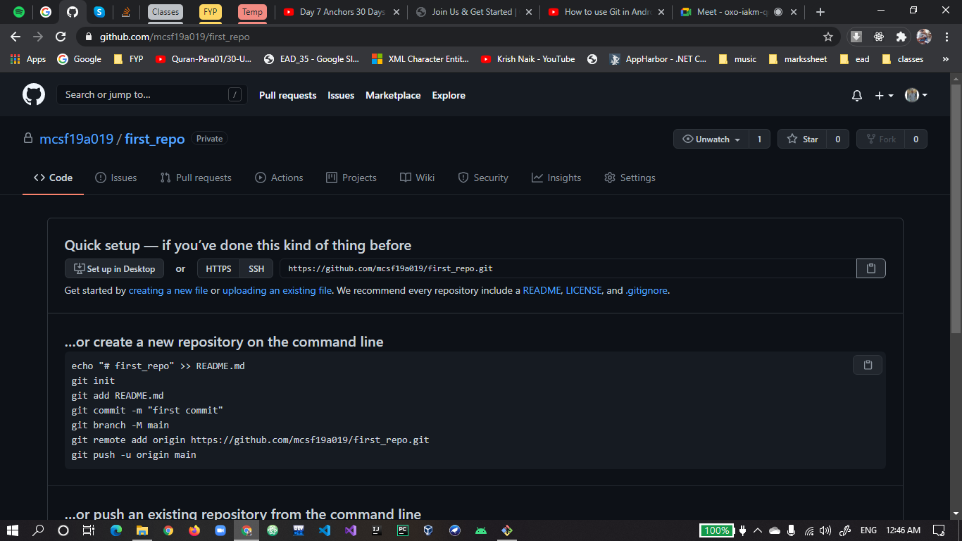
3. **git clone is use to connect local and online repository.** 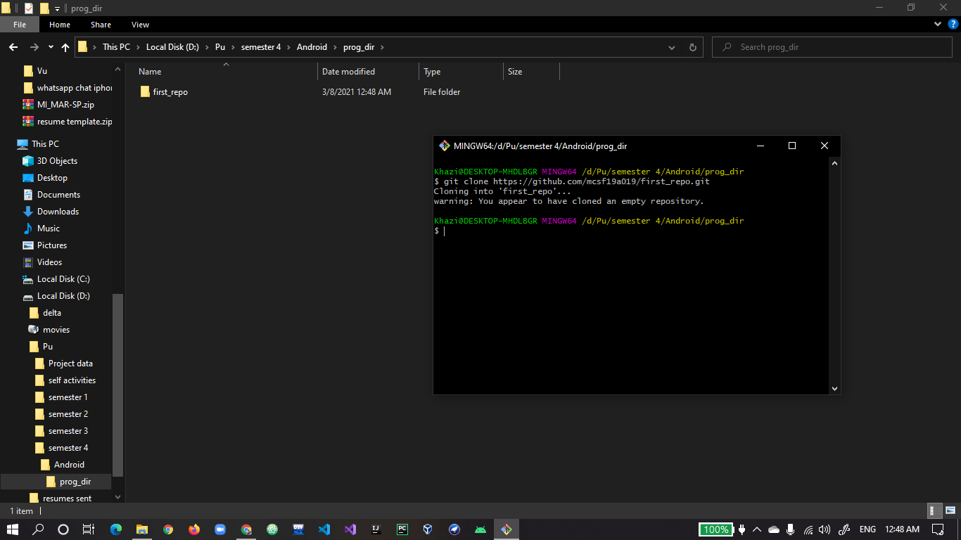
4. **cd to move from one directory to another windows command.** 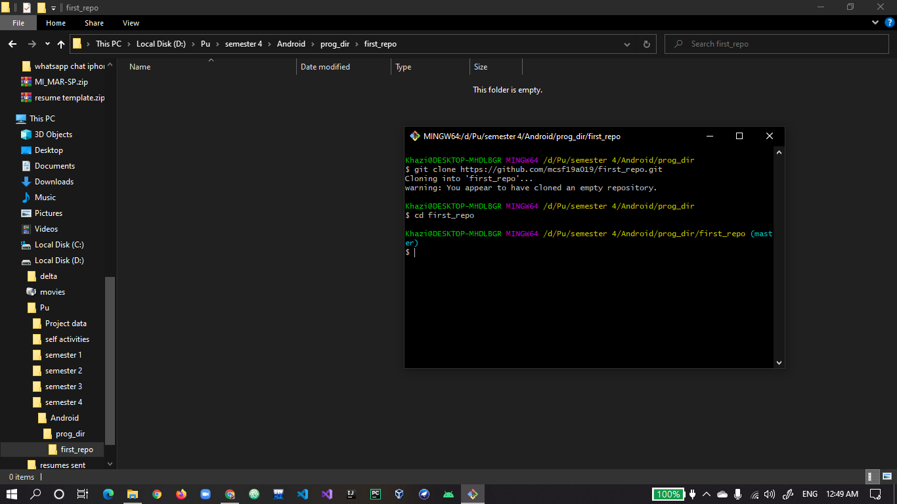
5. **git add to start tracking the file for changes.** 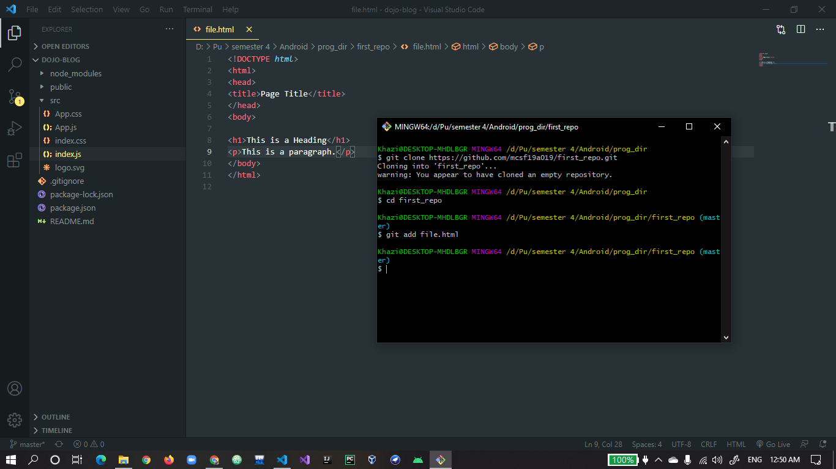
6. **git commit -m “message” is use to save stable version on git.** 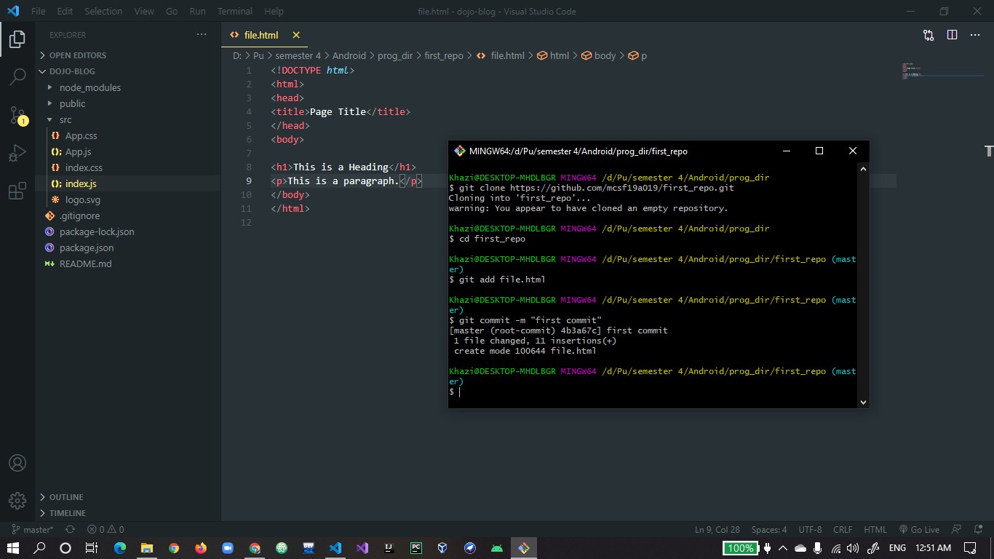
7. **git push is use to sync online repository with local.** 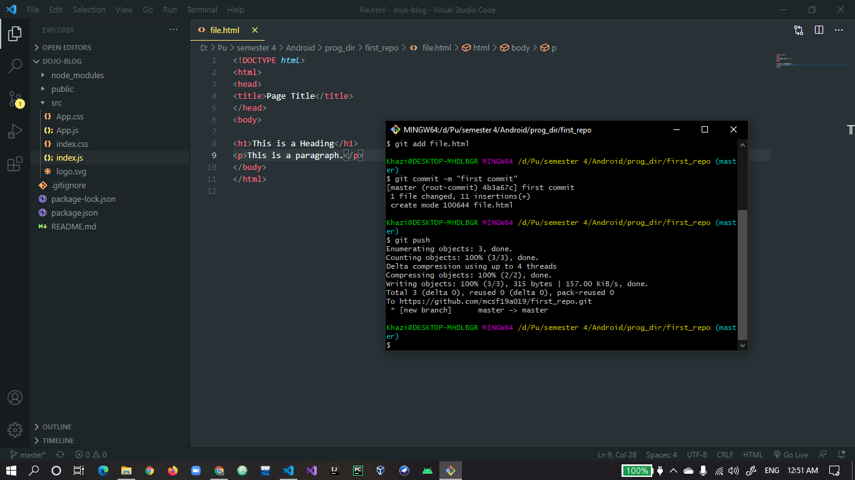
8. **You can see file is uploaded on online repository.** 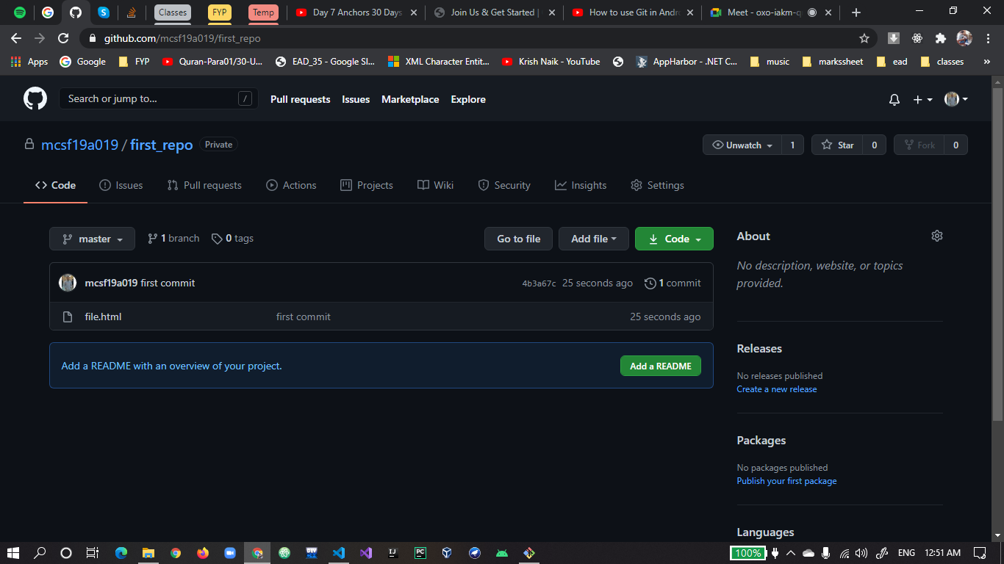
9. **Changes in file online.** 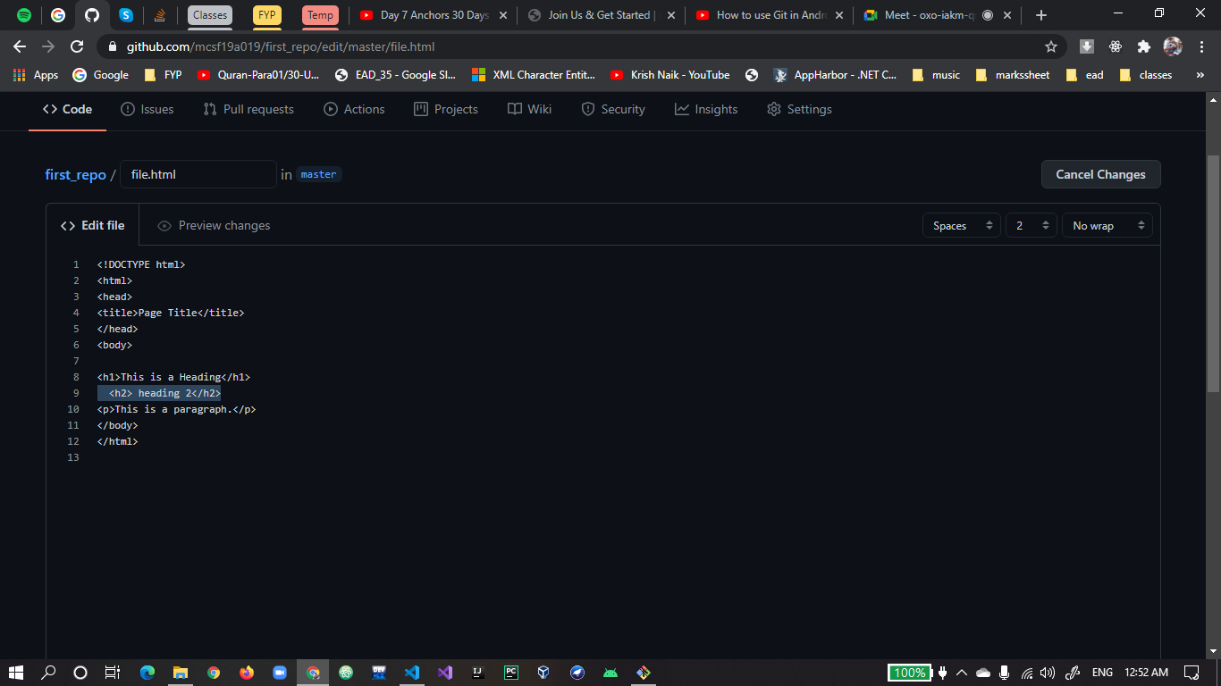
10. **Doing commit on changes online file.** 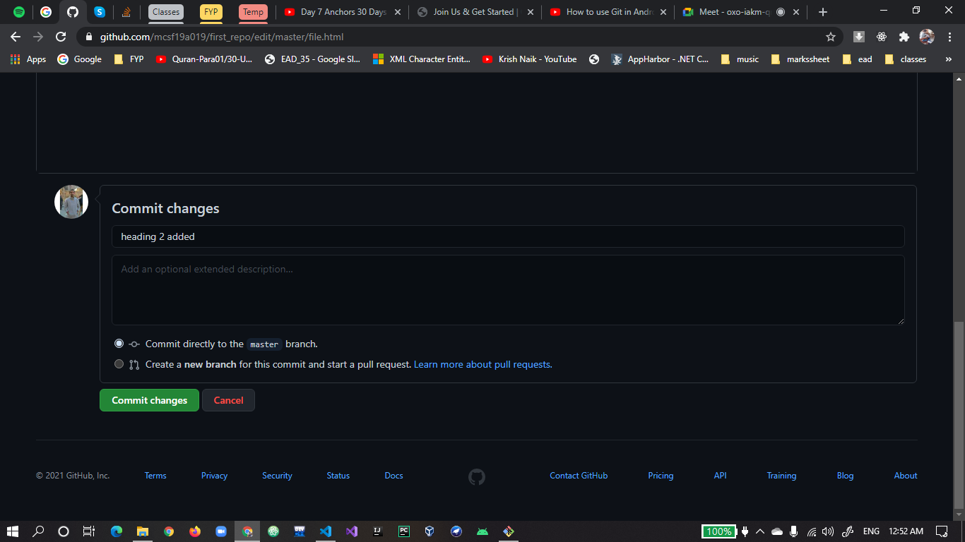
11. **Now changing in the file offline.** 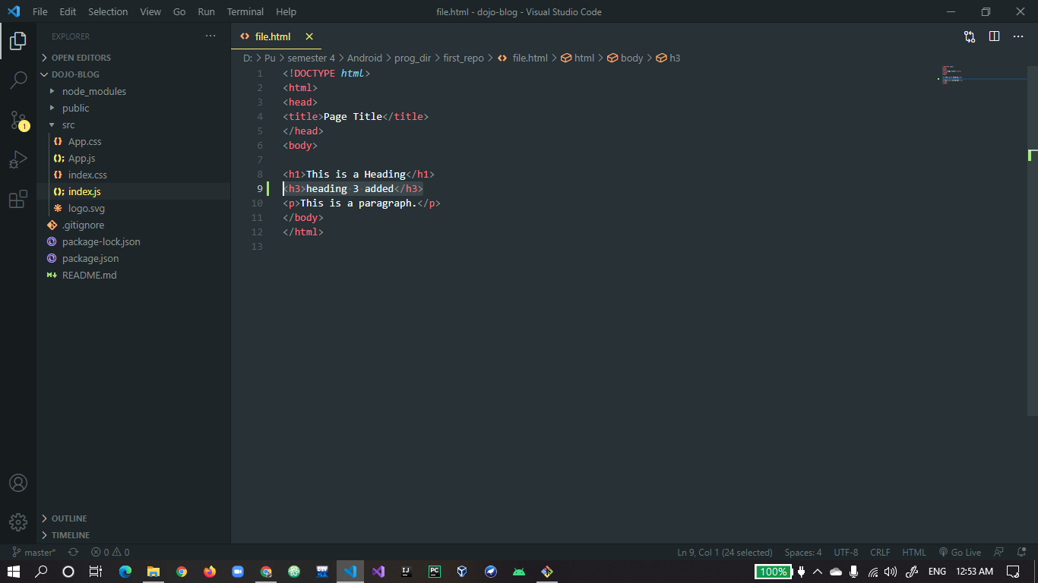
12. **git commit -am “message” is use to do commit and add in the same command.** 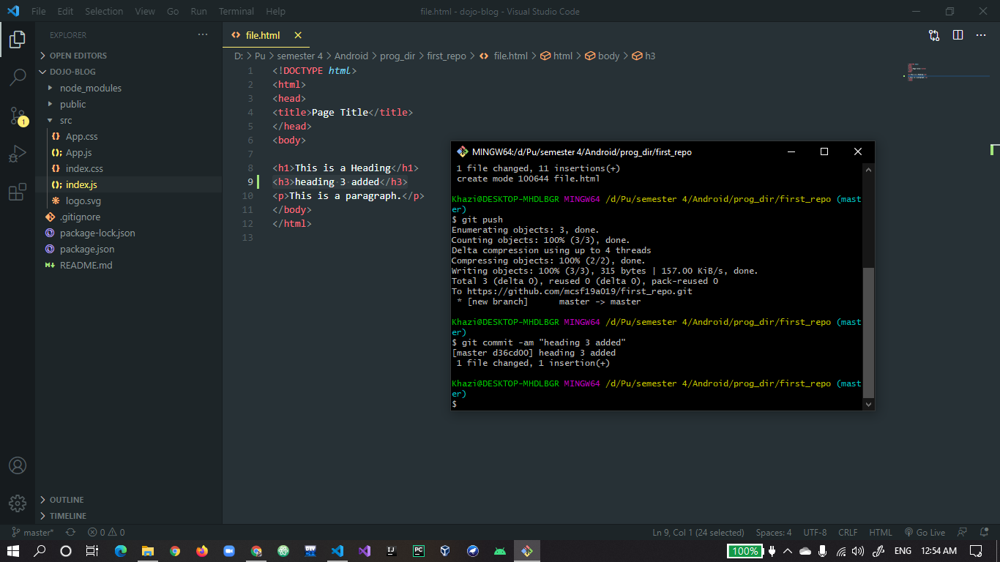
13. **Now git push gives error because another commit submited by another user git is confused which version it has to save this is called conflict.** 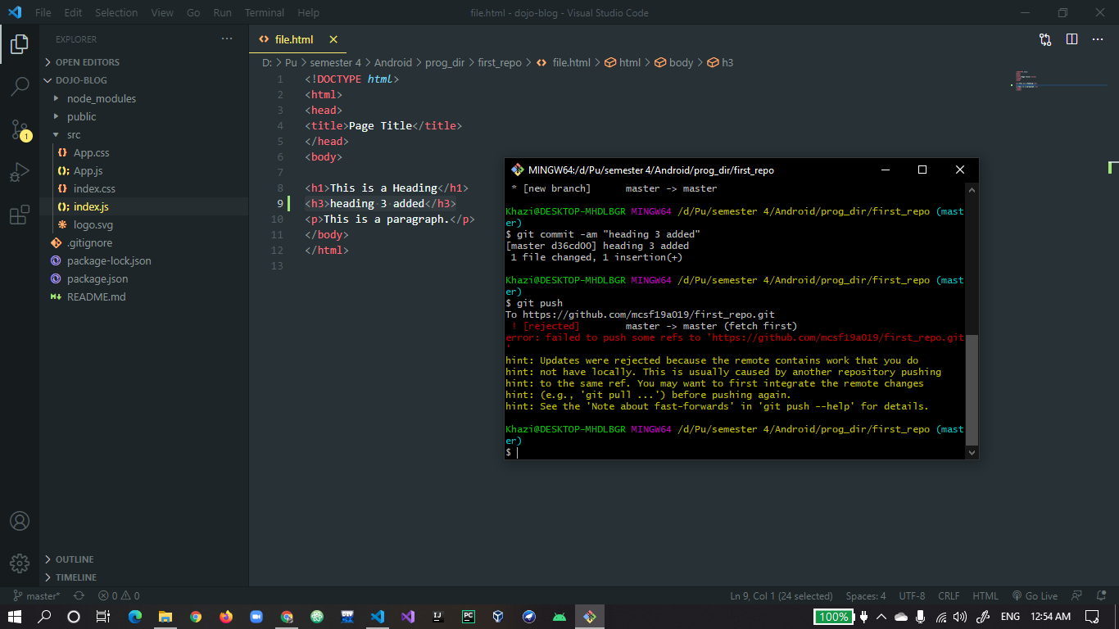
14. **Now to resolve the conflict use git pull command to see local and online changes in offline editor.** 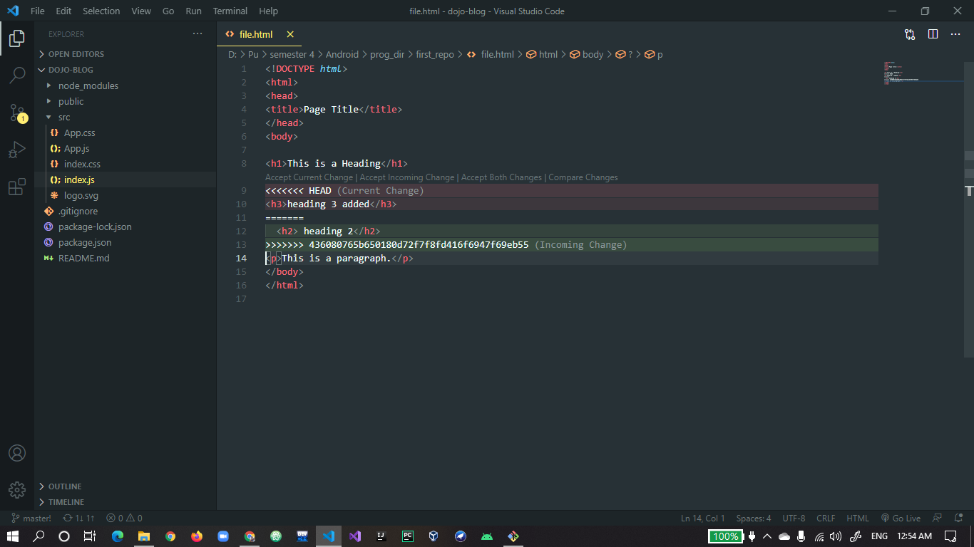
15. **Accept changes which suits best.** 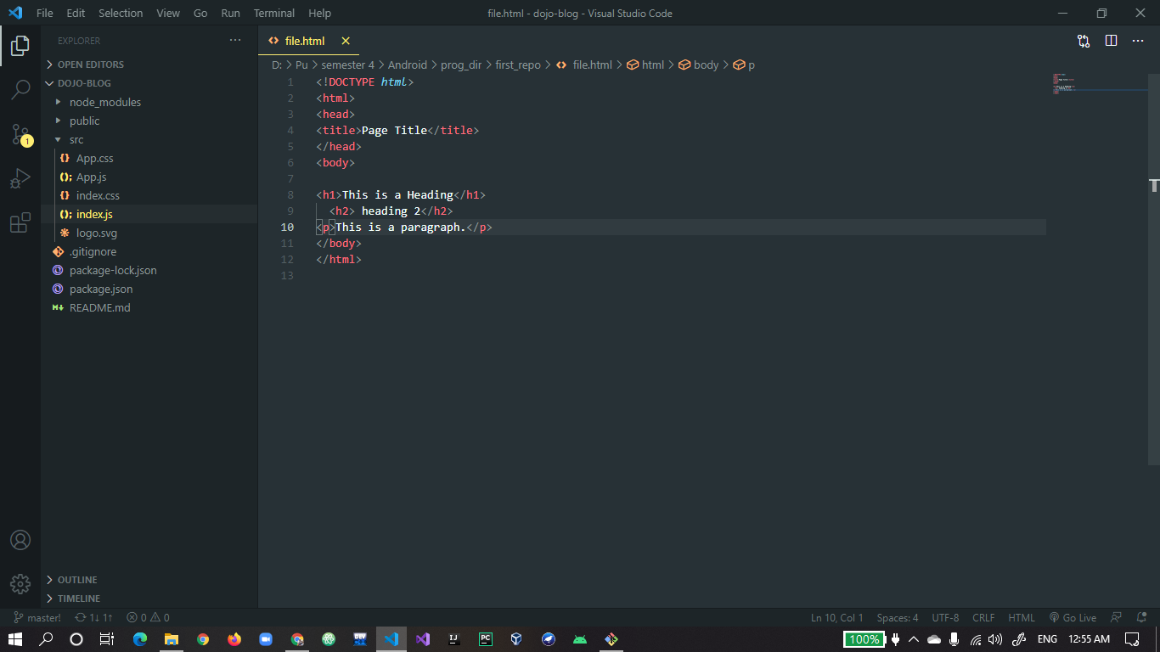
16. **git commit again after resolve the conflict.** 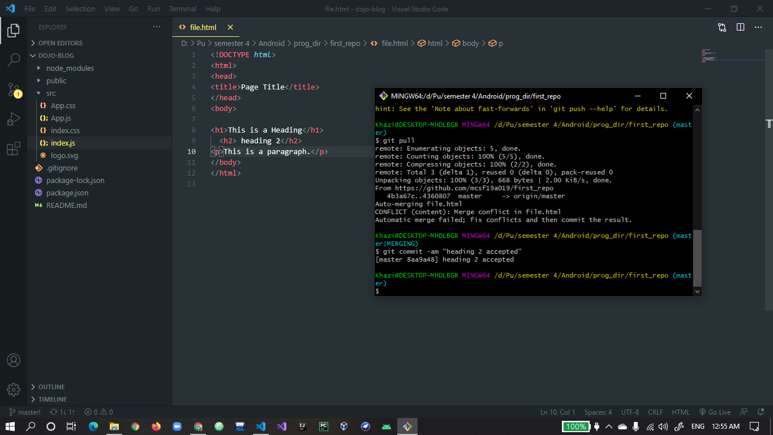
17. **git push again after resolve conflict.** 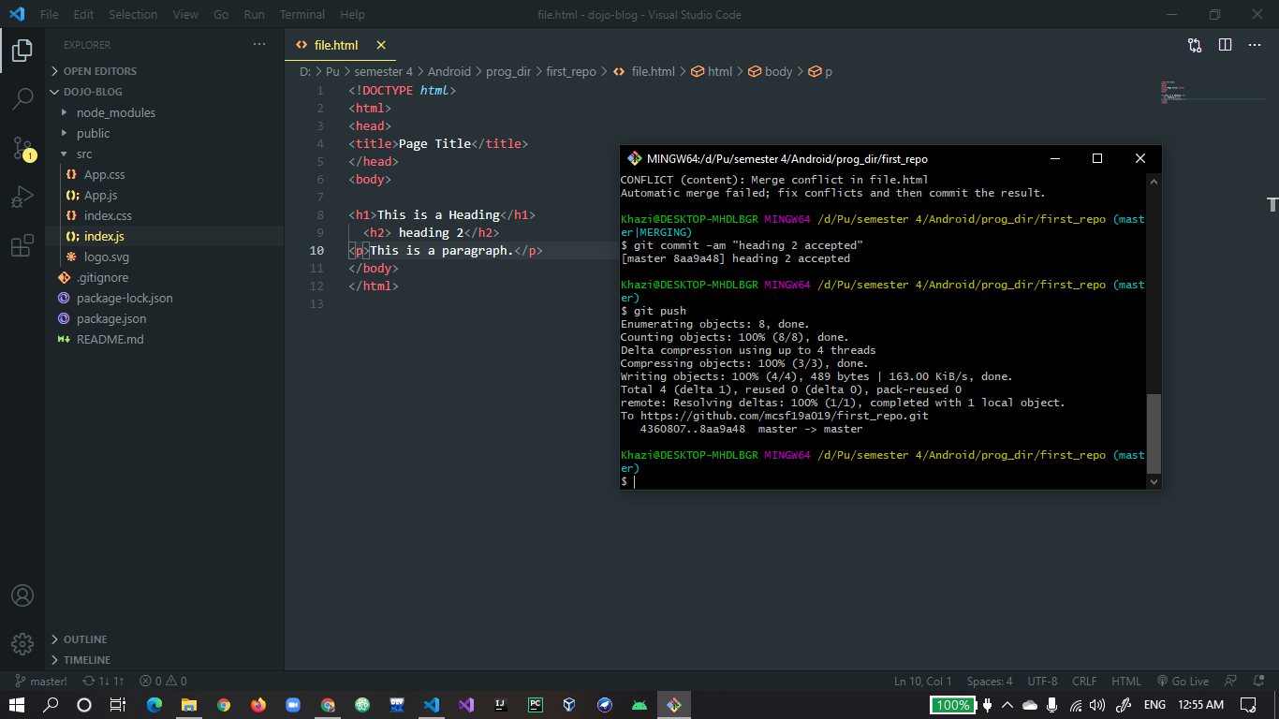
18. **Changes are synced after resloving conflict.** 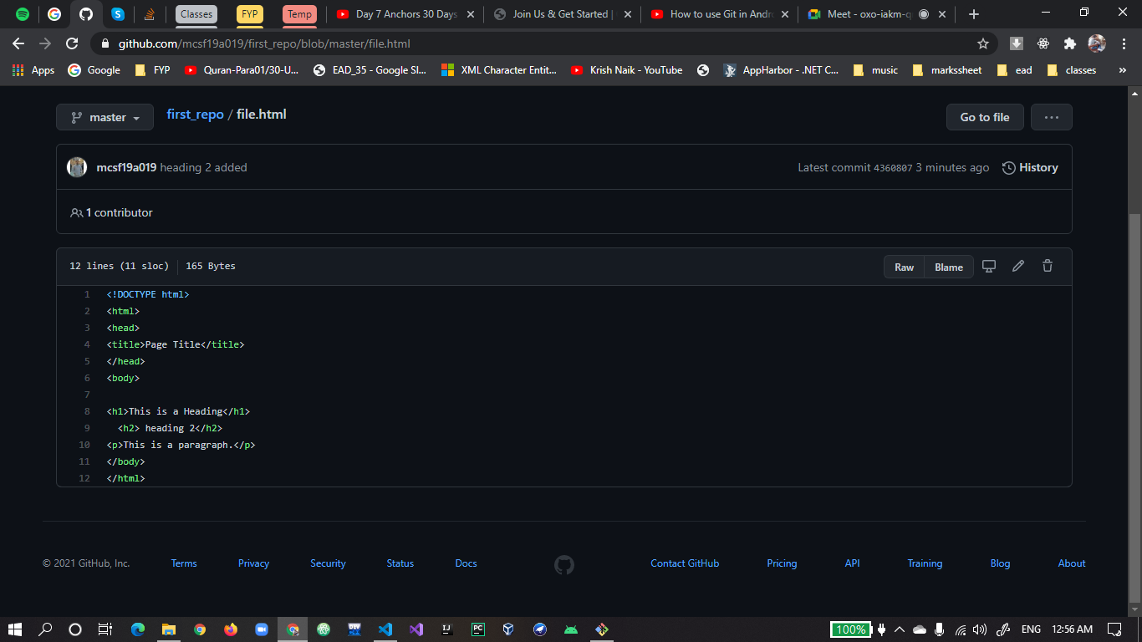
19. **git checkout -b “newbr” to create new branch.** 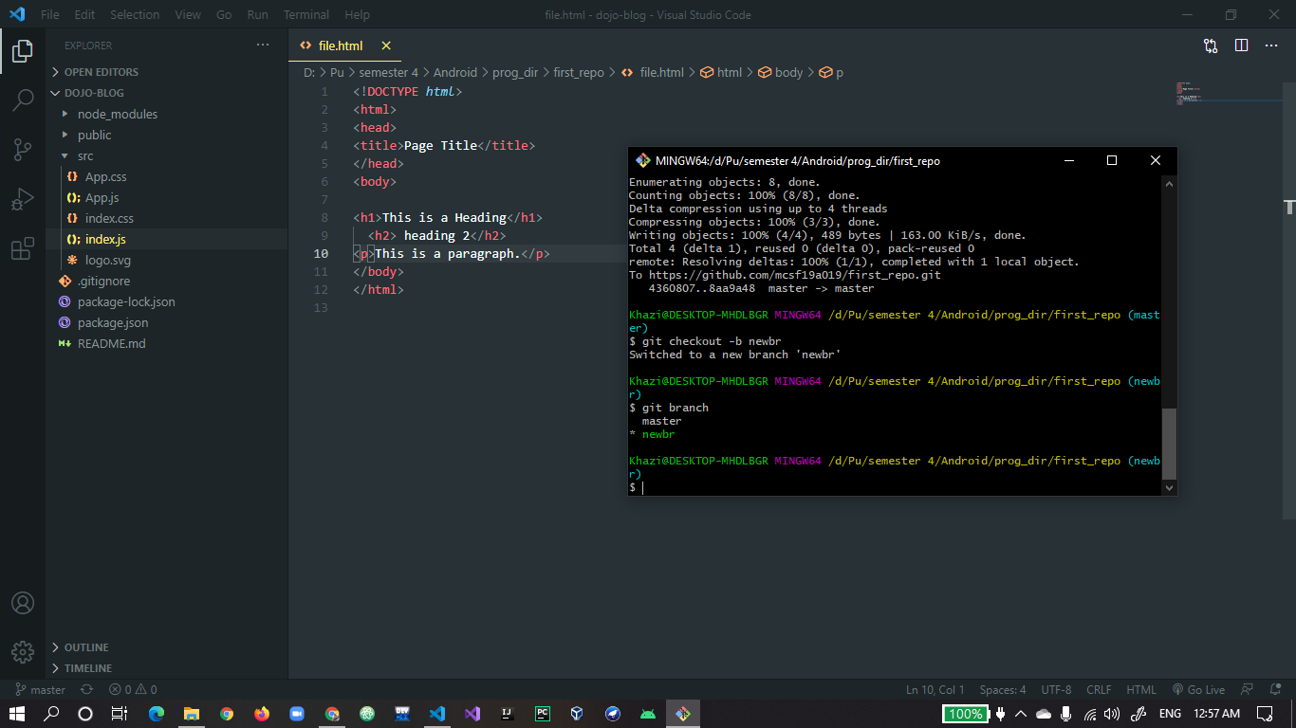
20. **git checkout “newbr” to change branch from master.**
21. **git commit in new branch.** 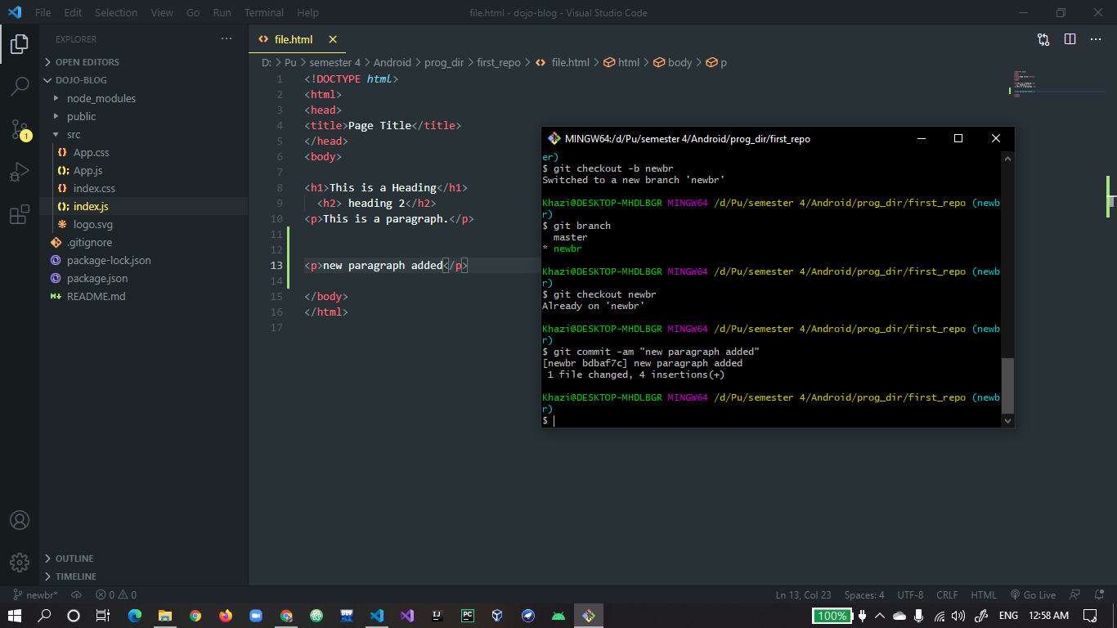
22. **git checkout master to go back to master branch.** 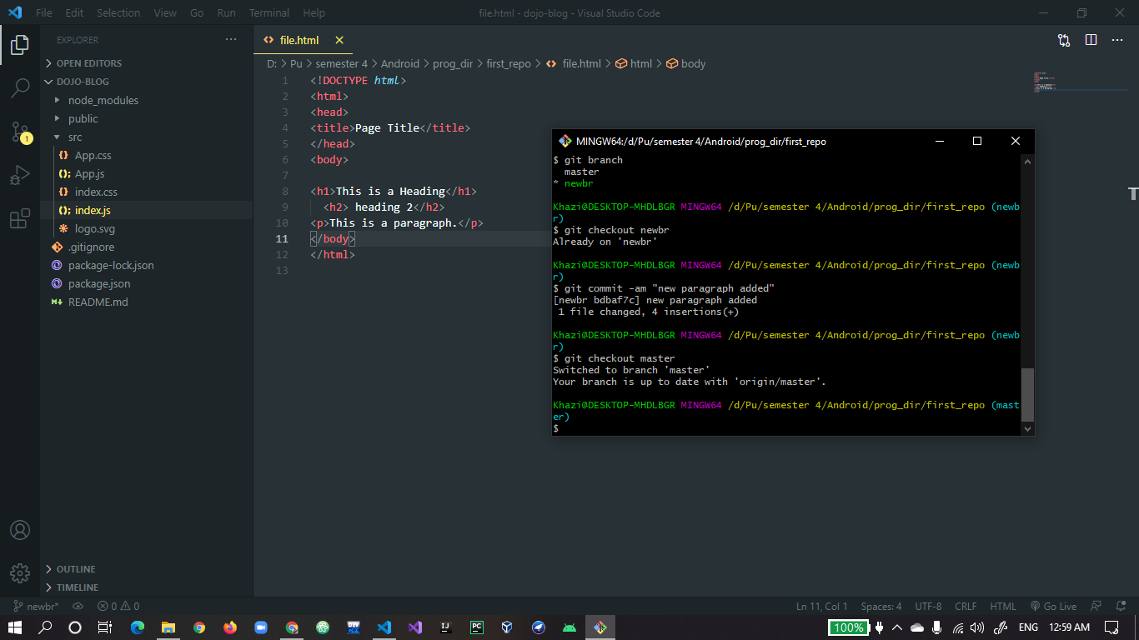
23. **git merge “newbr” to merge branch with master.** 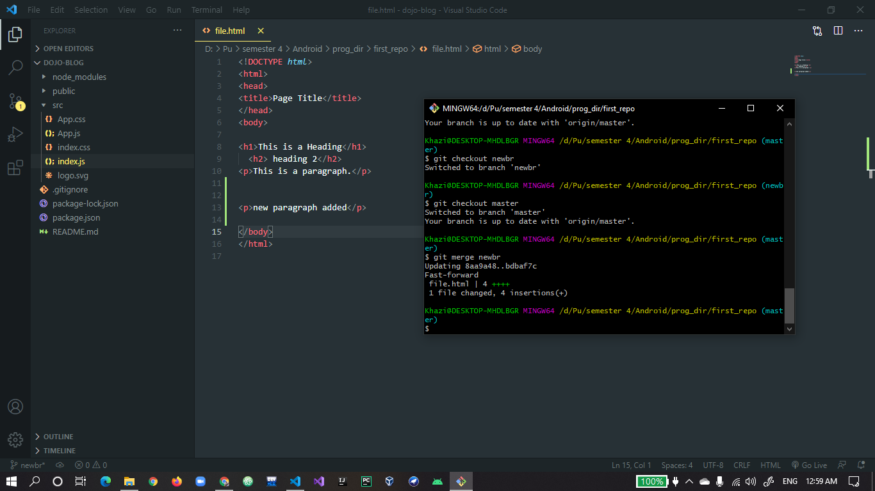
24. **git branch -D “newbr” to delete branch**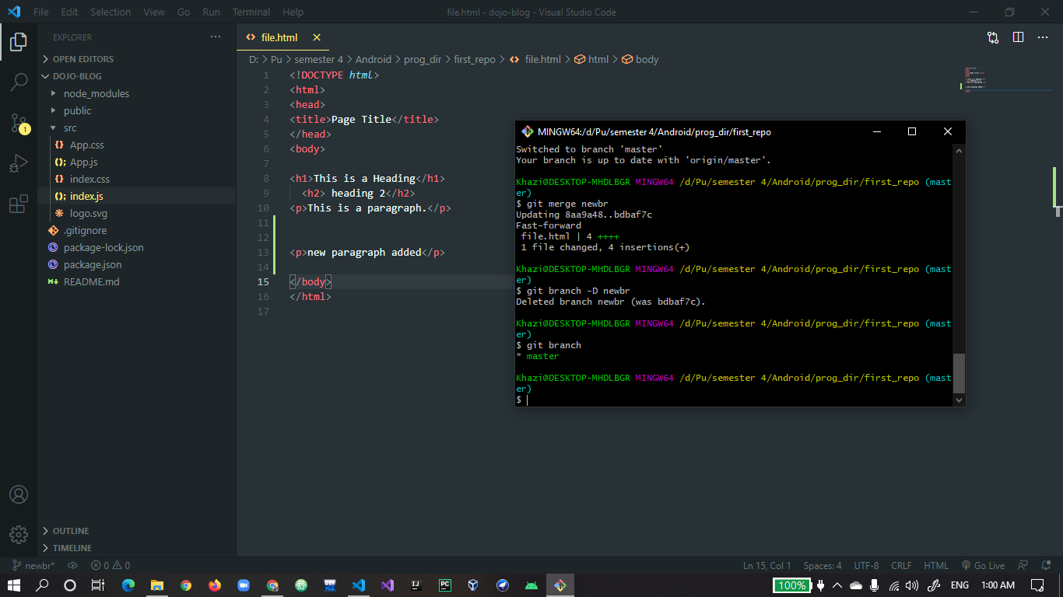
25. **again, push to submit changes to online repository**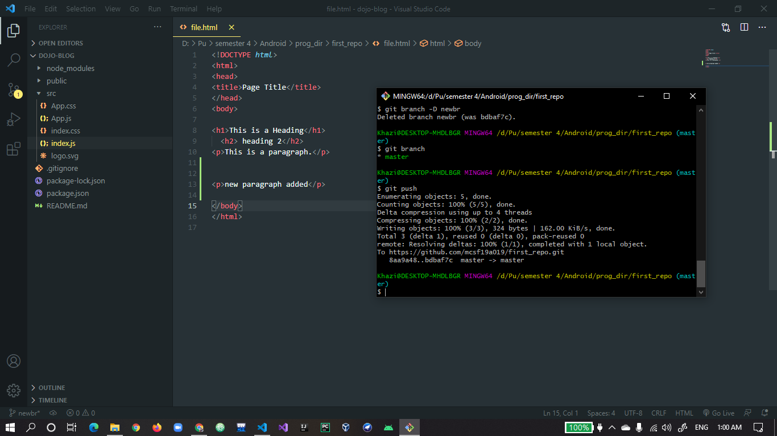
26. **merging can be seen in online after push.** 