**To-do task 10 Lec:** *SQLite 1 and SQLite 2*

**Name:** Shoaib Sabir

**Roll No:** Mcsf19a019

1. **App design.**

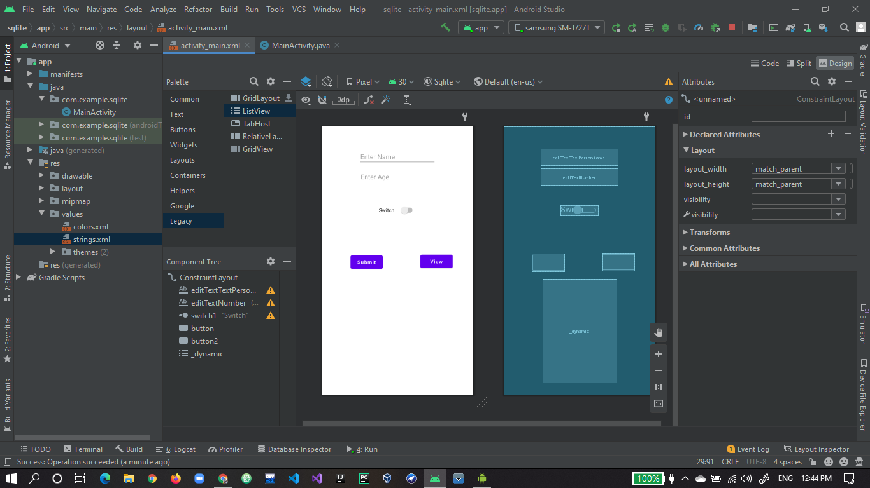

1. **Toast code for both buttons.**

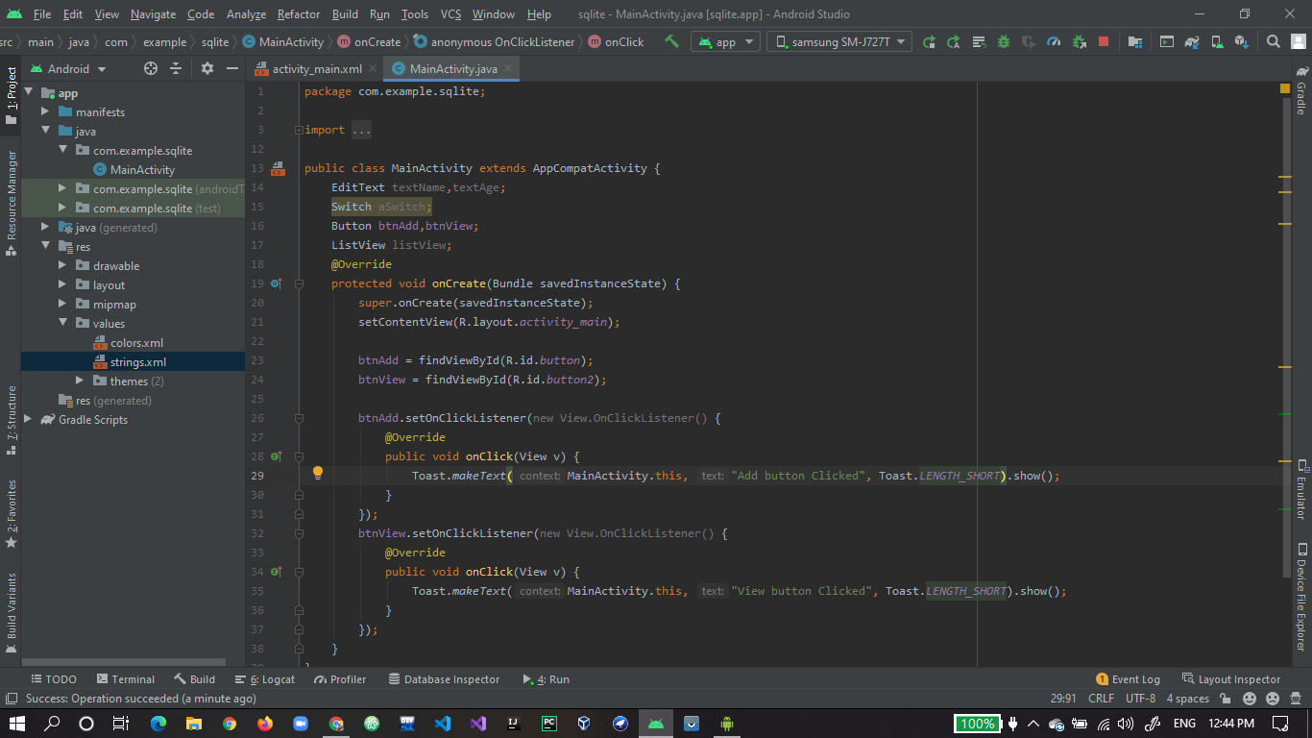

1. **App in running state.**

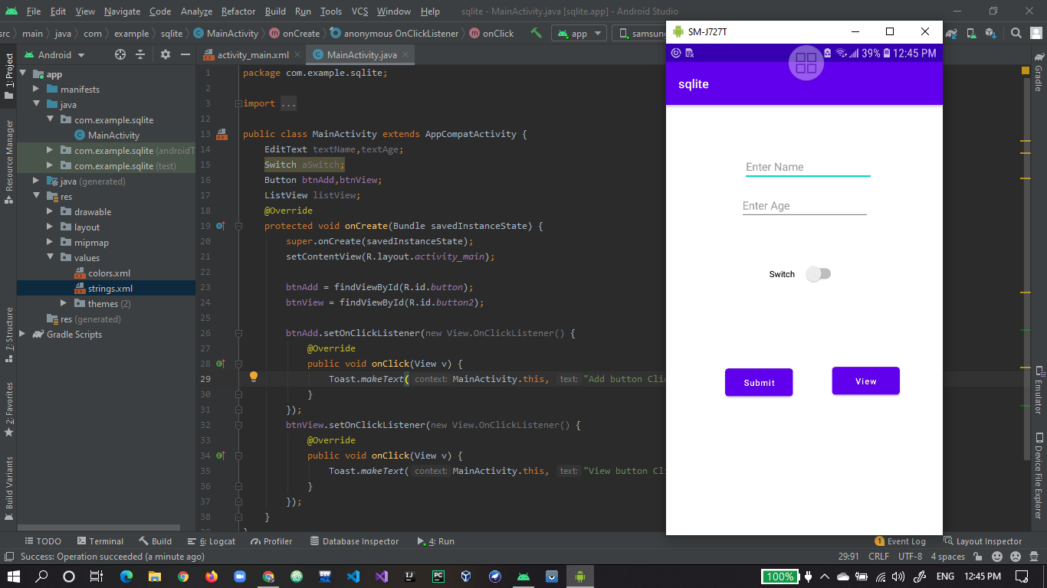

1. **Add button Toast is working fine.**

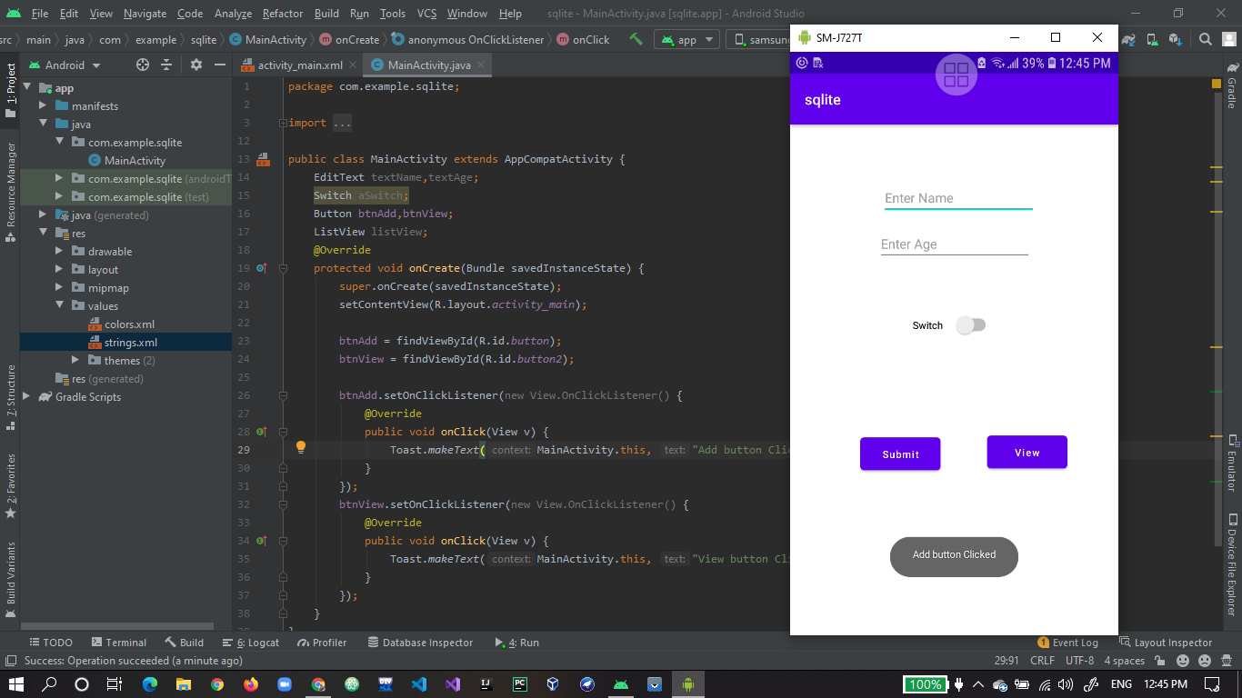

1. **View button Toast working fine.**

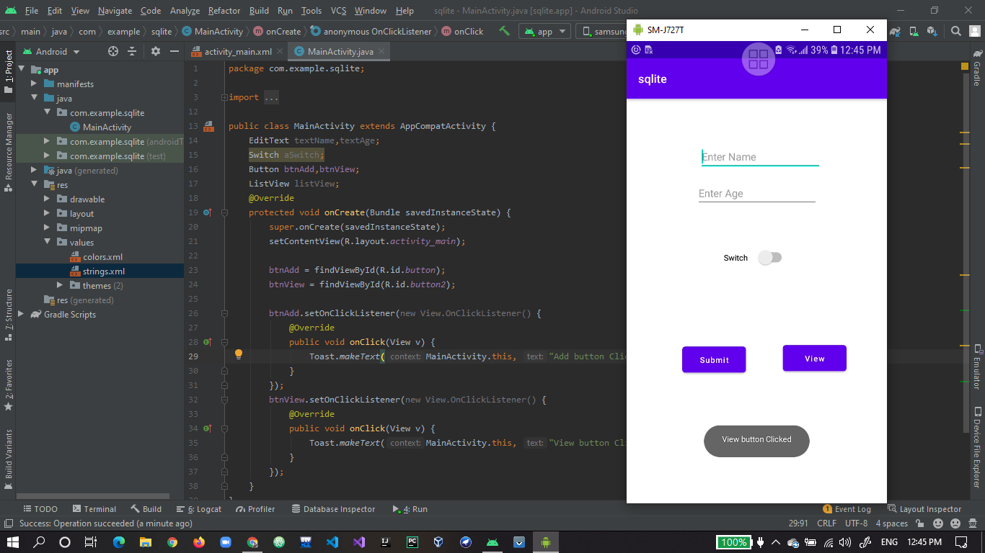

1. **Making Student class with basic properties and getter setters.**

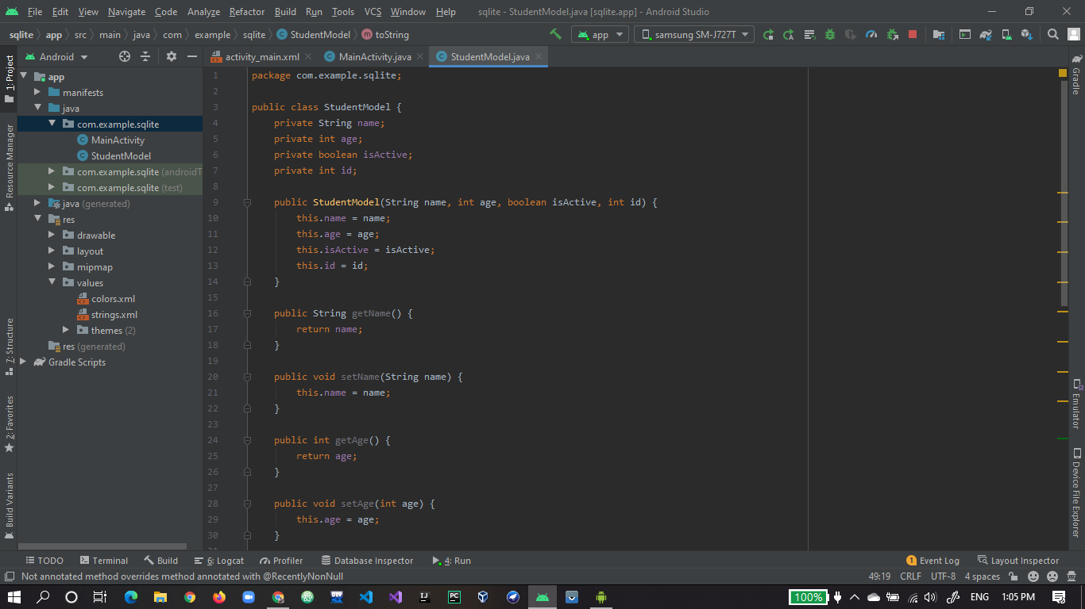

1. **Overloading to string function for class.**

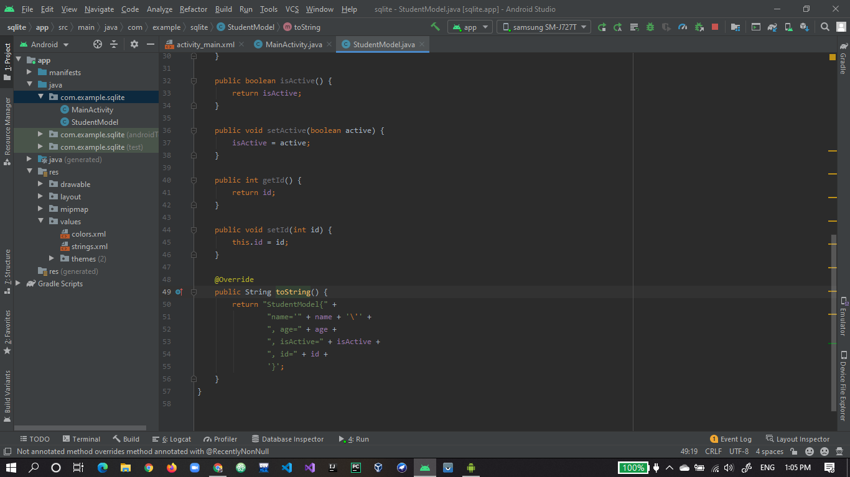

1. **Overloading onclickListener() for and setting values through constructor in student object.**

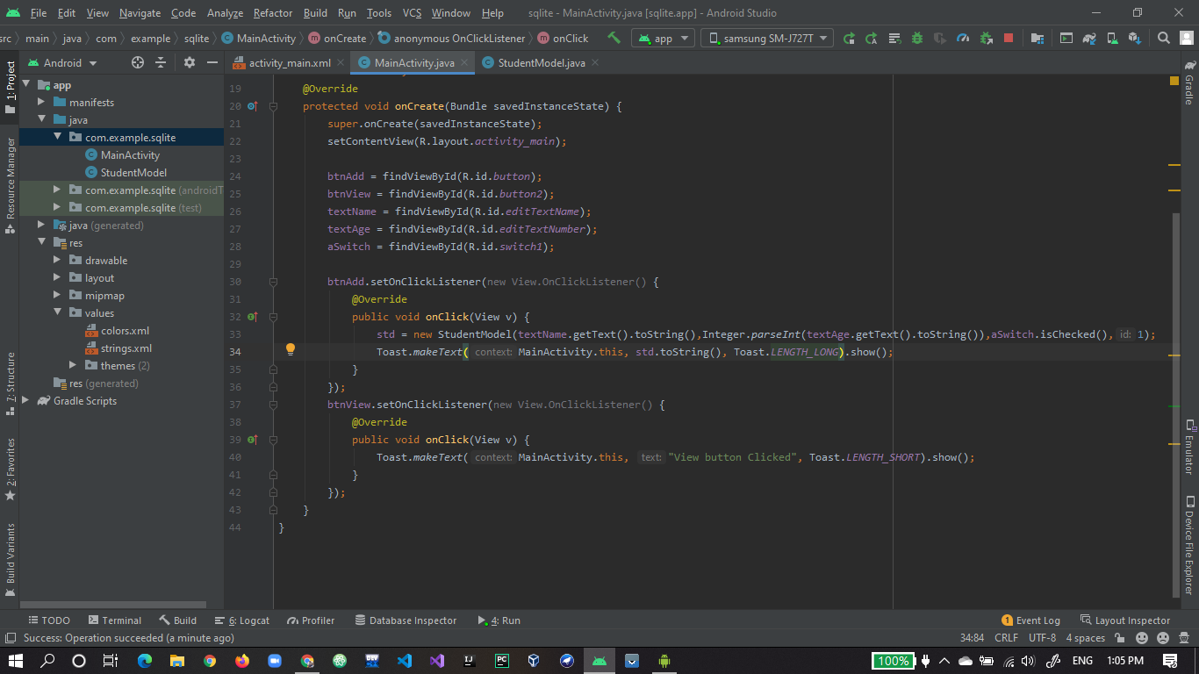

1. **Final output toast showing object data.**

