**To-do task 9 Lec:** *SQLite 3*

**Name:** Shoaib Sabir

**Roll No:** Mcsf19a019

1. Design layout to add student in DB and show in list.

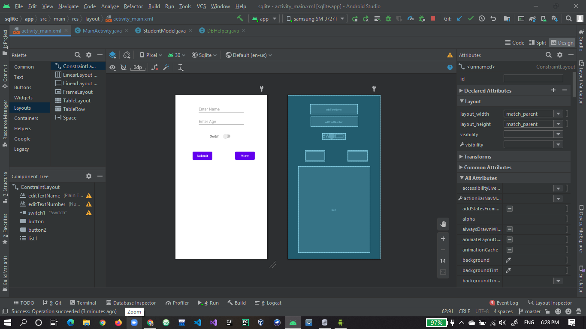

1. Declaration and binding of layout items.

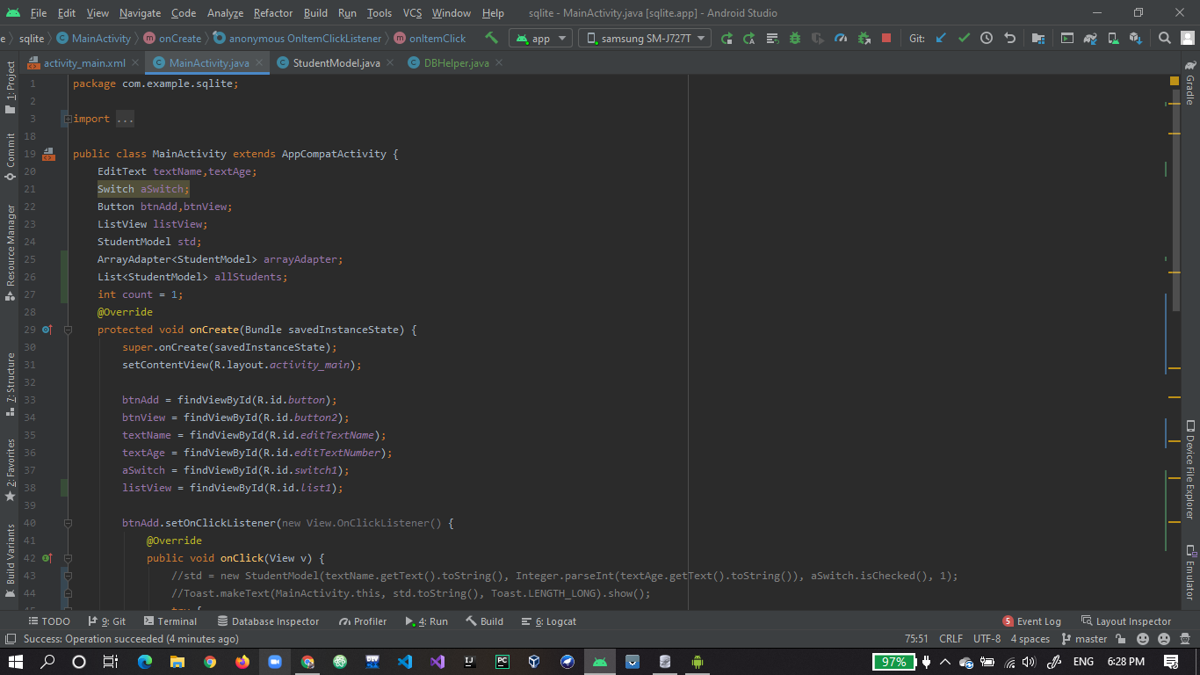

1. Code for submit button to call function to add student in database and code for view button to fetch data from DB and put into list using adapter.

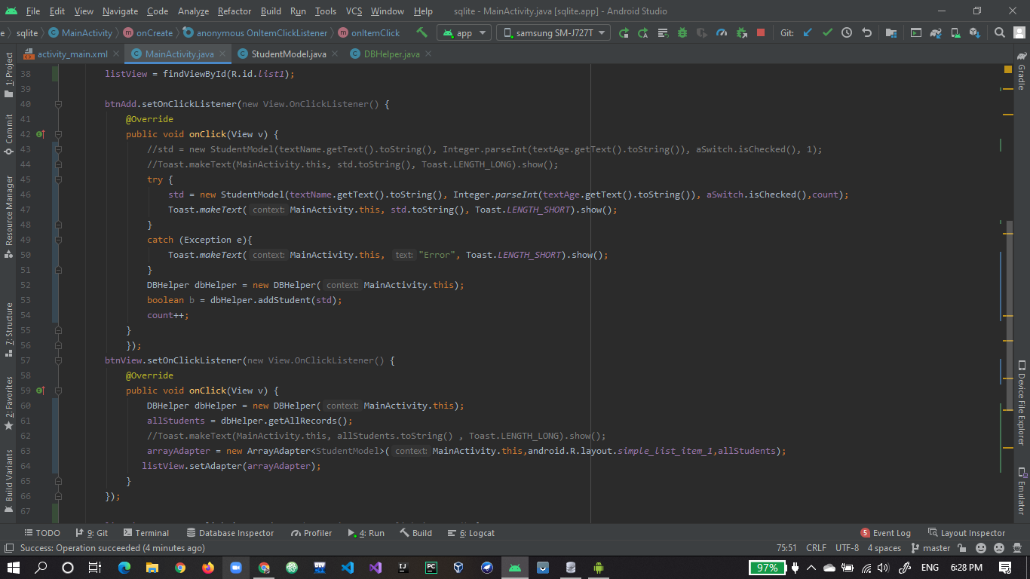

1. Code for delete record from DB when click on item in list.

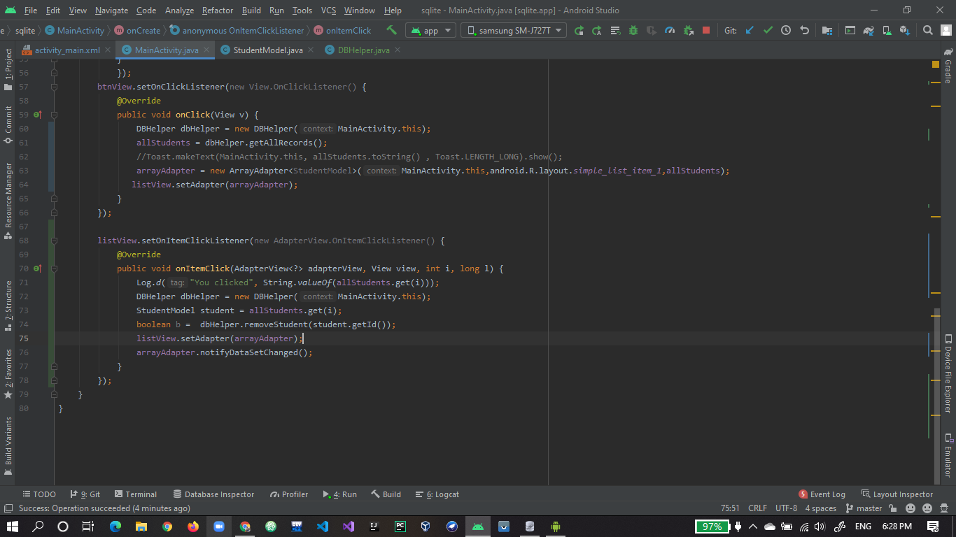

1. Student Class with basic properties and getter and setters.

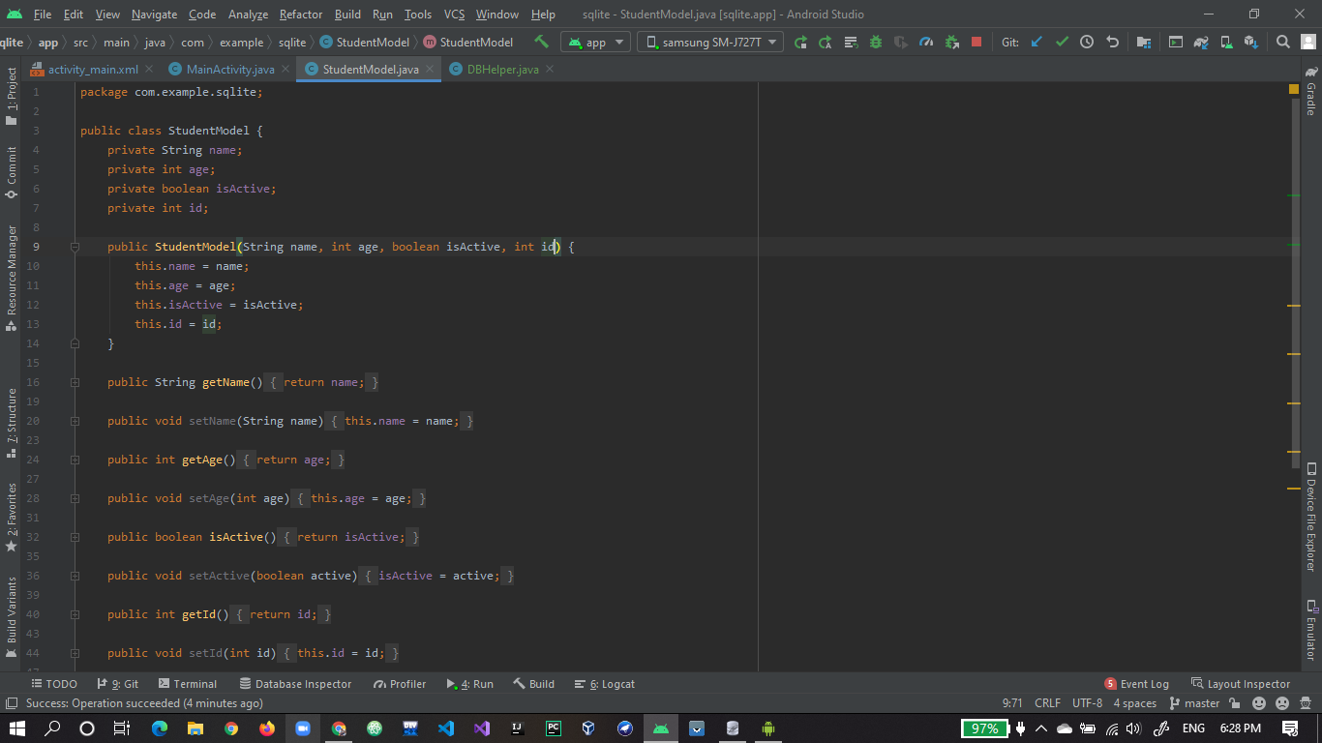

1. To string method overloaded for student class.

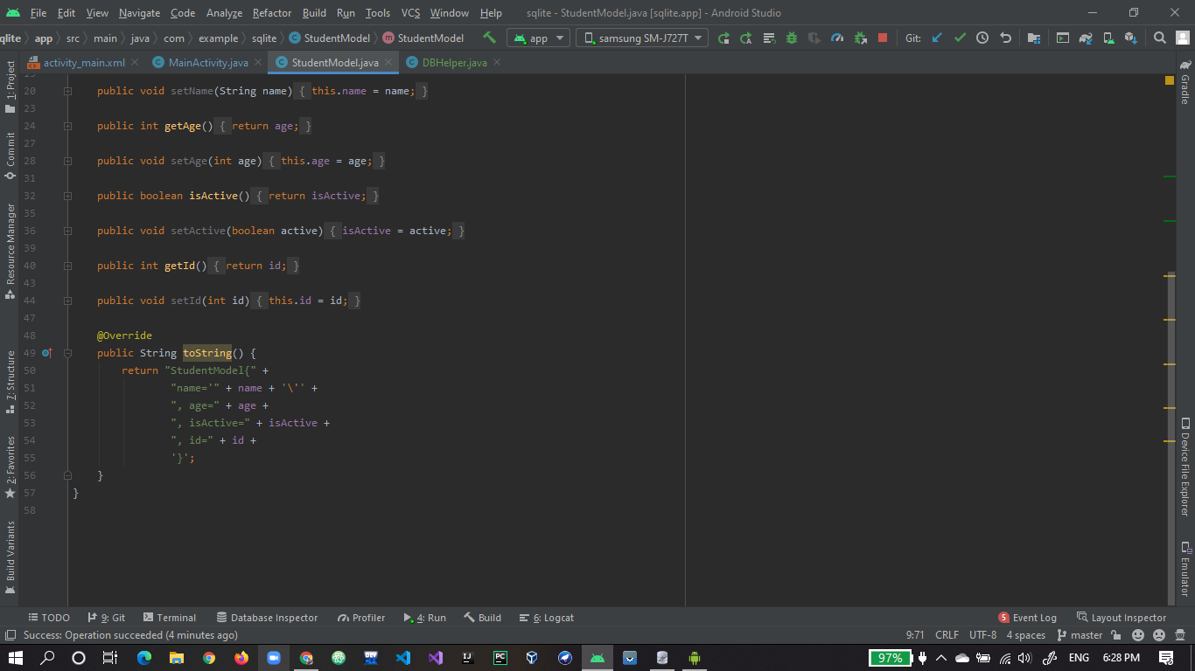

1. DBHehpler class where DB created and manipulated.

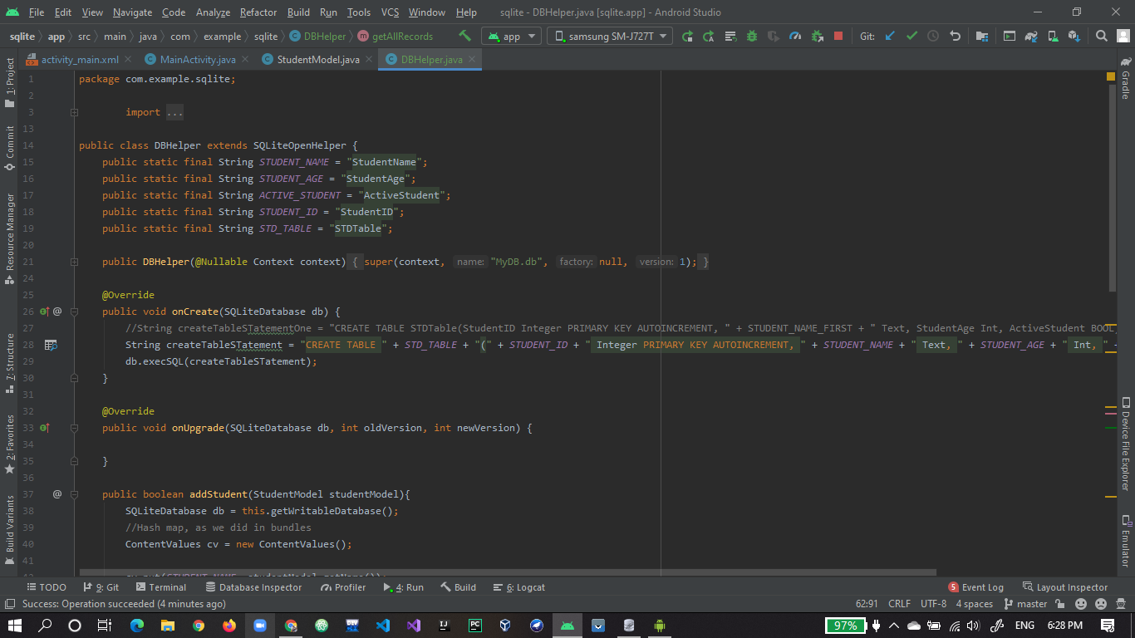

1. addStudent function to add student in DB and getAllRecords to show DB Data in list.

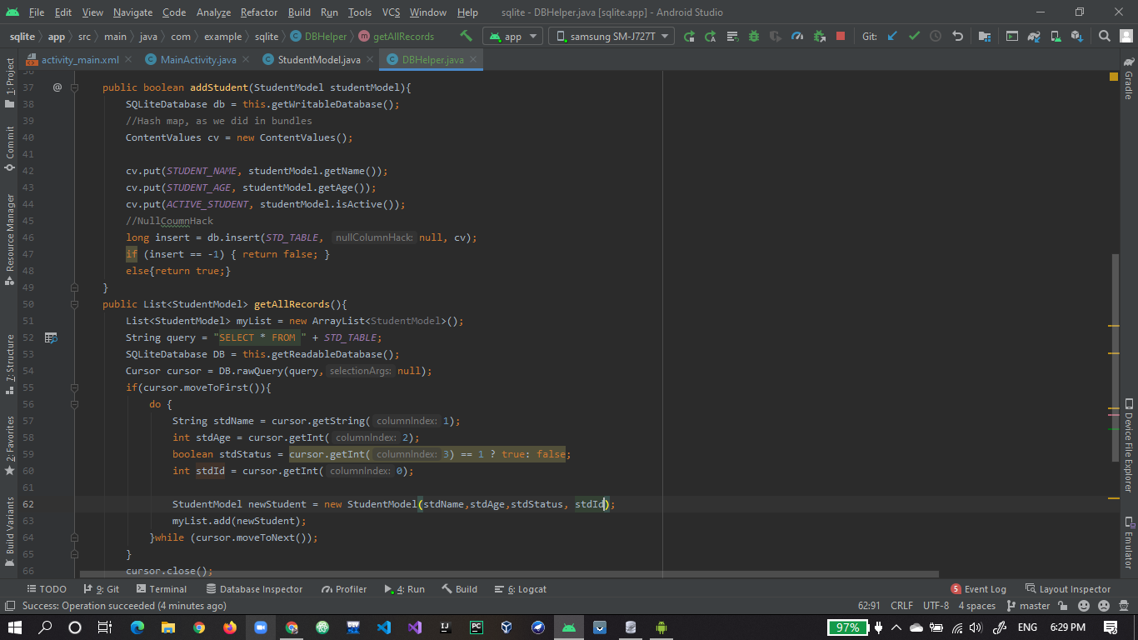

1. removeStudent function to delete particular student record from DB.

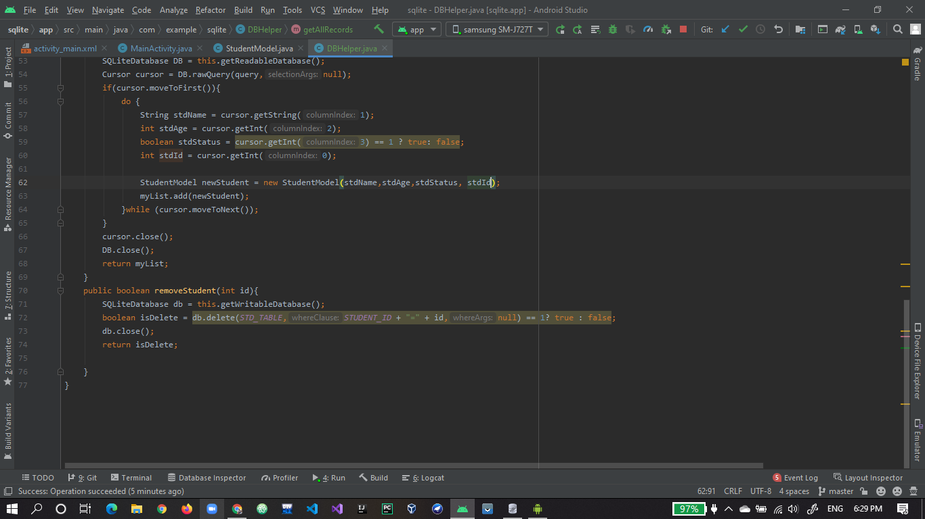

1. final output one student is added into DB and showing in list.

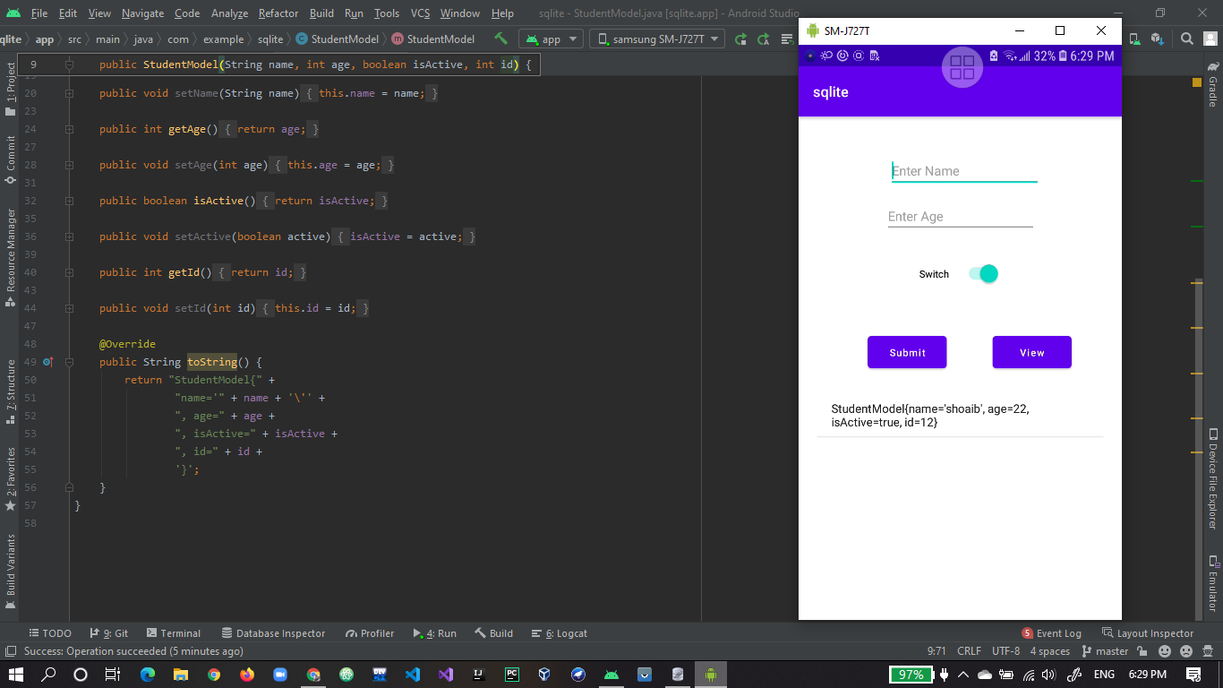

1. added several records.

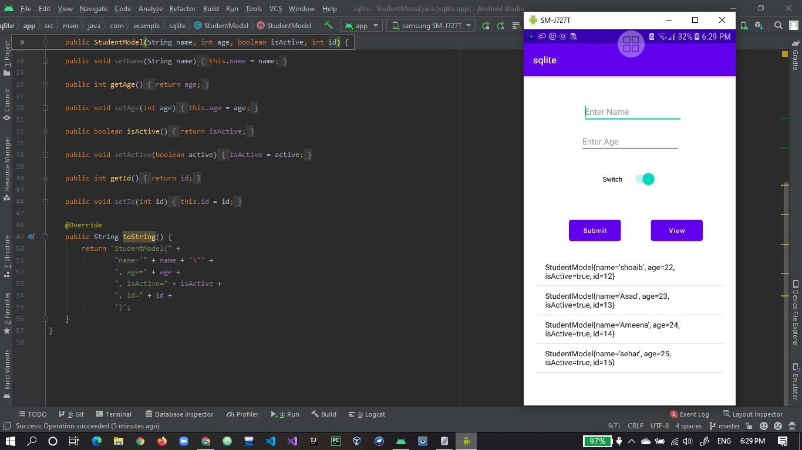

1. No delete button just need to click on student item from list to delete here you can see one student record is deleted as compare to above picture.

