**To-do task 12 Lec:**  *Dialogs*

**Name:** Shoaib Sabir

**Roll No:** Mcsf19a019

1. Code against button when click on button dialog will appear up.

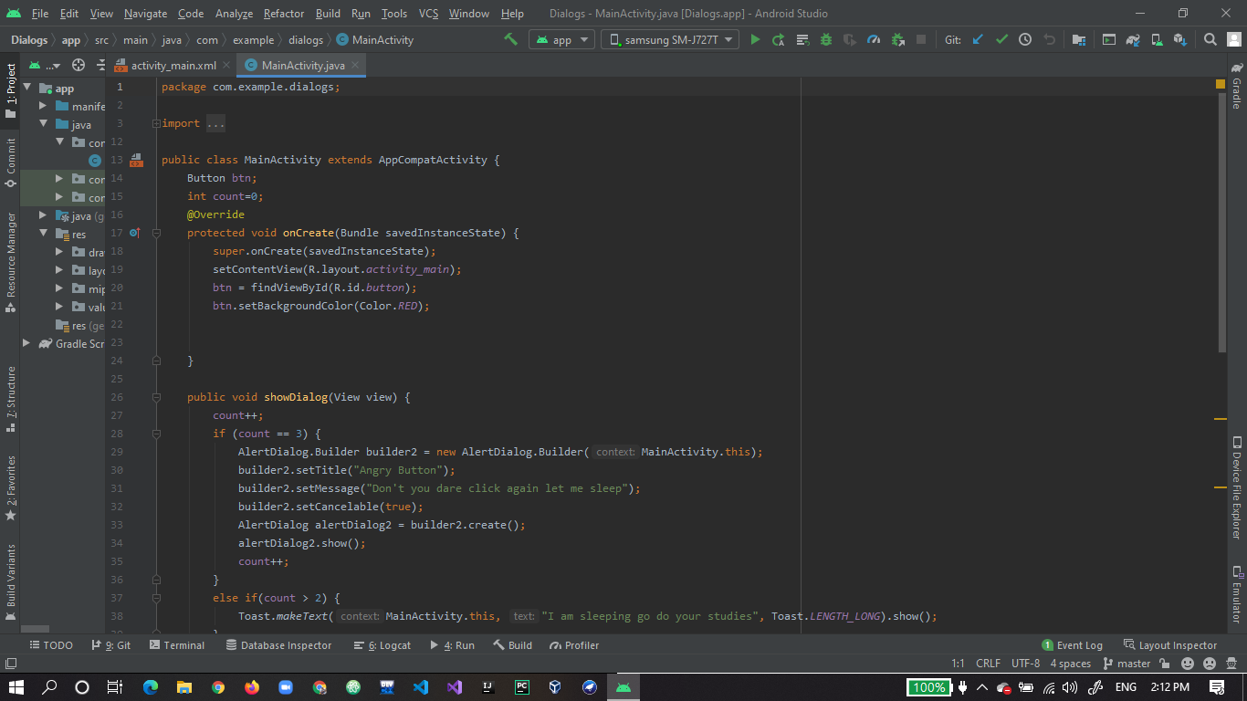

1. To make it fun I added counter with if conditions.

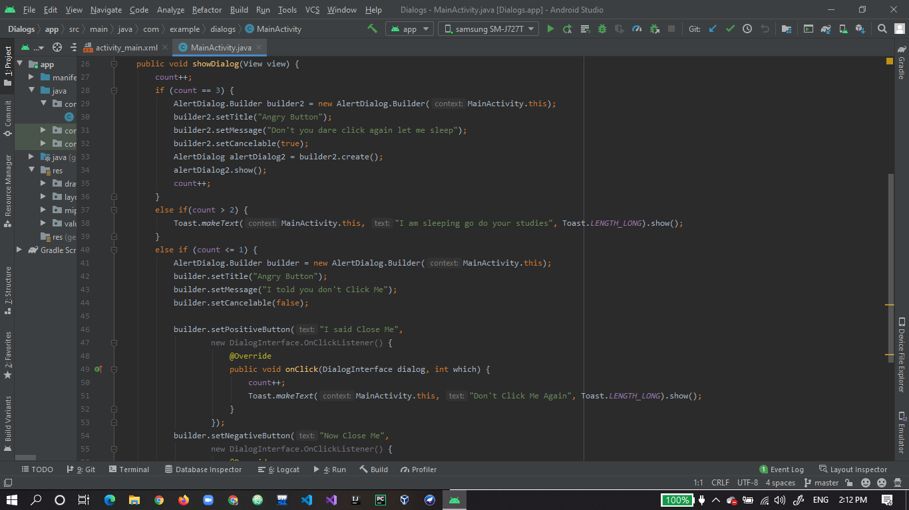

1. Here is the code when dialog appears then what user will see

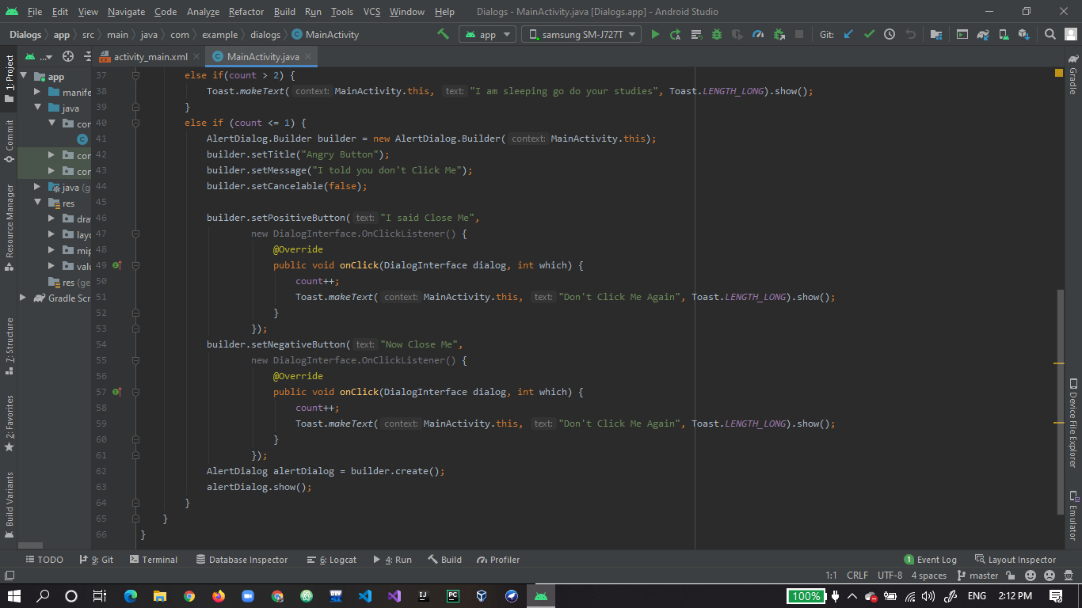

1. Home screen when user open app.

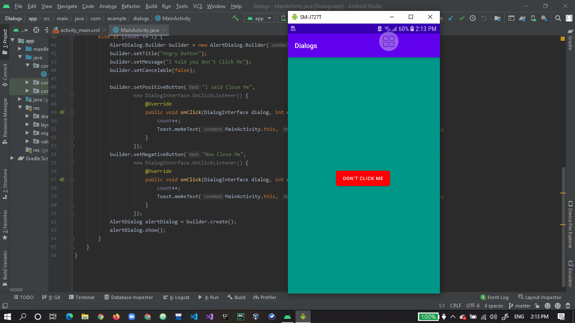

1. When user click on button first time following dialog will apear.

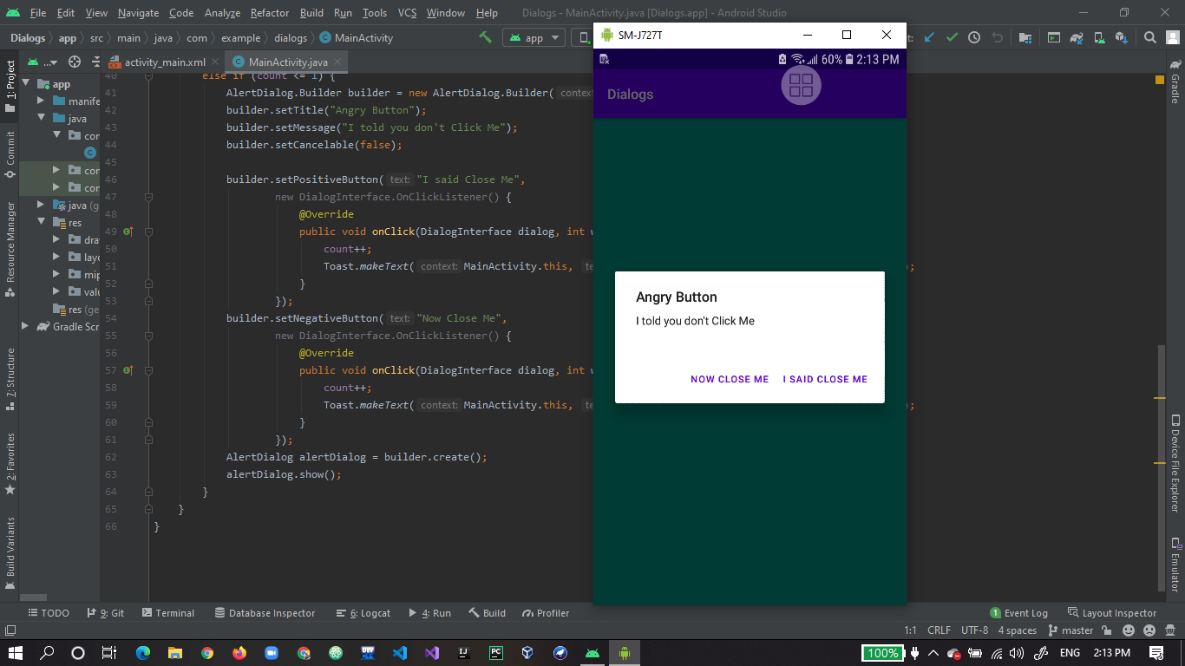

1. On close the dialog following toast will appear on screen.

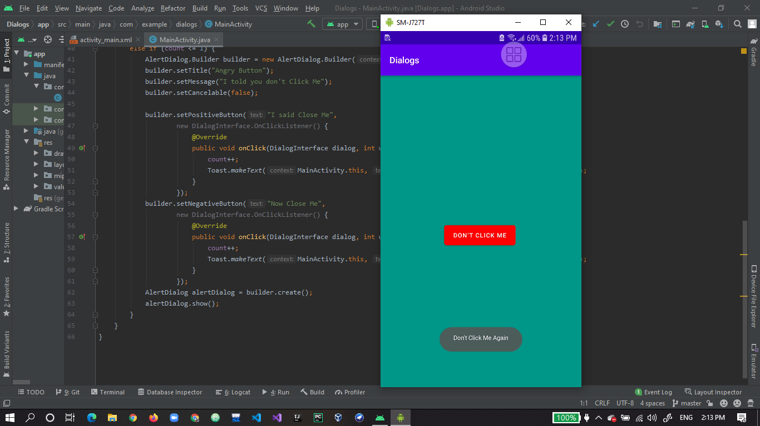

1. When user click on button 2nd time following dialog will appear.

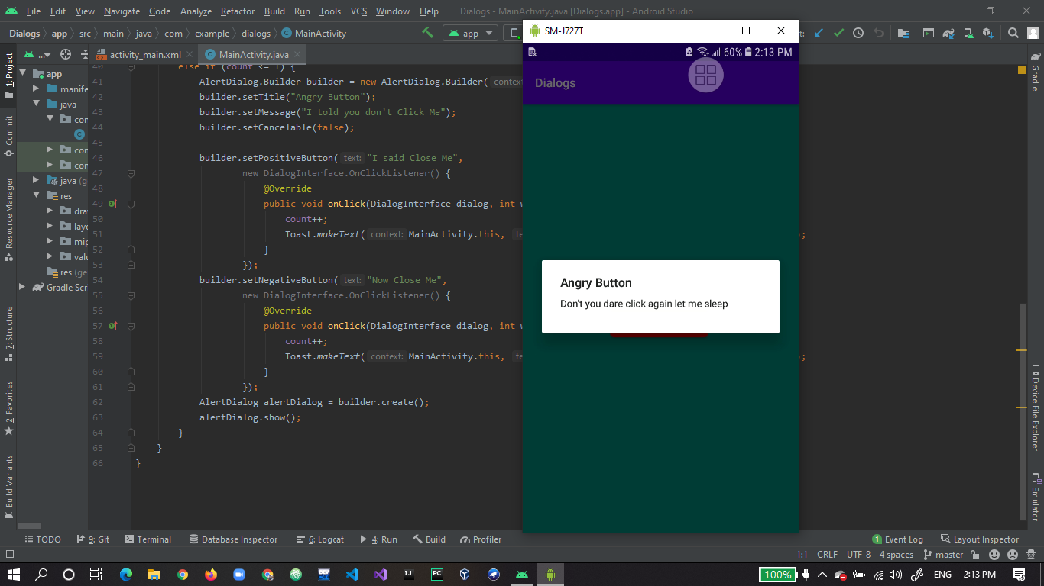

1. At the end now after 2 times click following toast will appear always when user click on button.

