**To-do task 3 Lec:** *layout*

**Name:** Shoaib Sabir

**Roll No:** Mcsf19a019

1. Code only contain TODO just as demo.

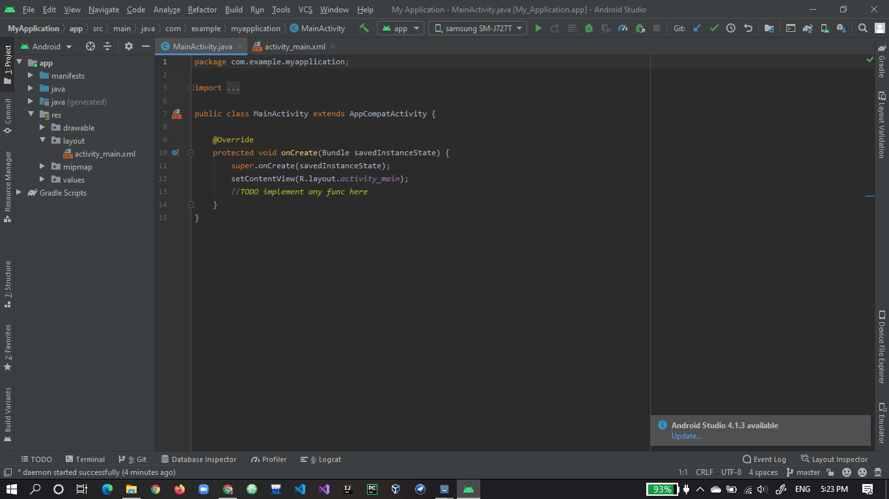

1. The xml file contains three text views.

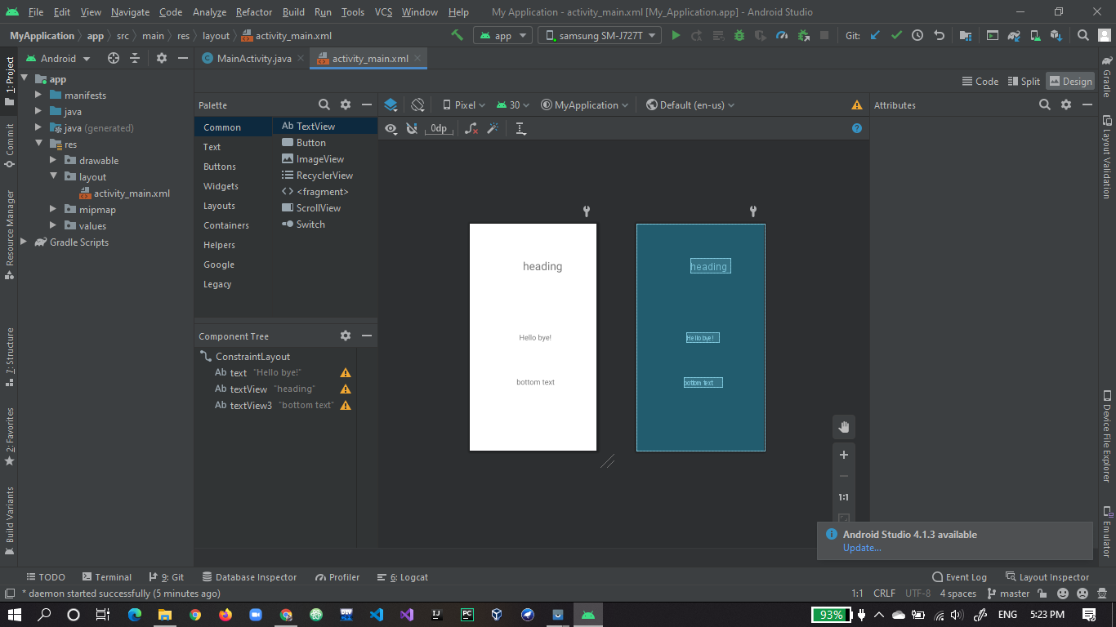

1. Here is the output.

