**To-do task 4 Lec:** *Intent and Activity Life Cycle*

**Name:** Shoaib Sabir

**Roll No:** Mcsf19a019

1. Main activity code.

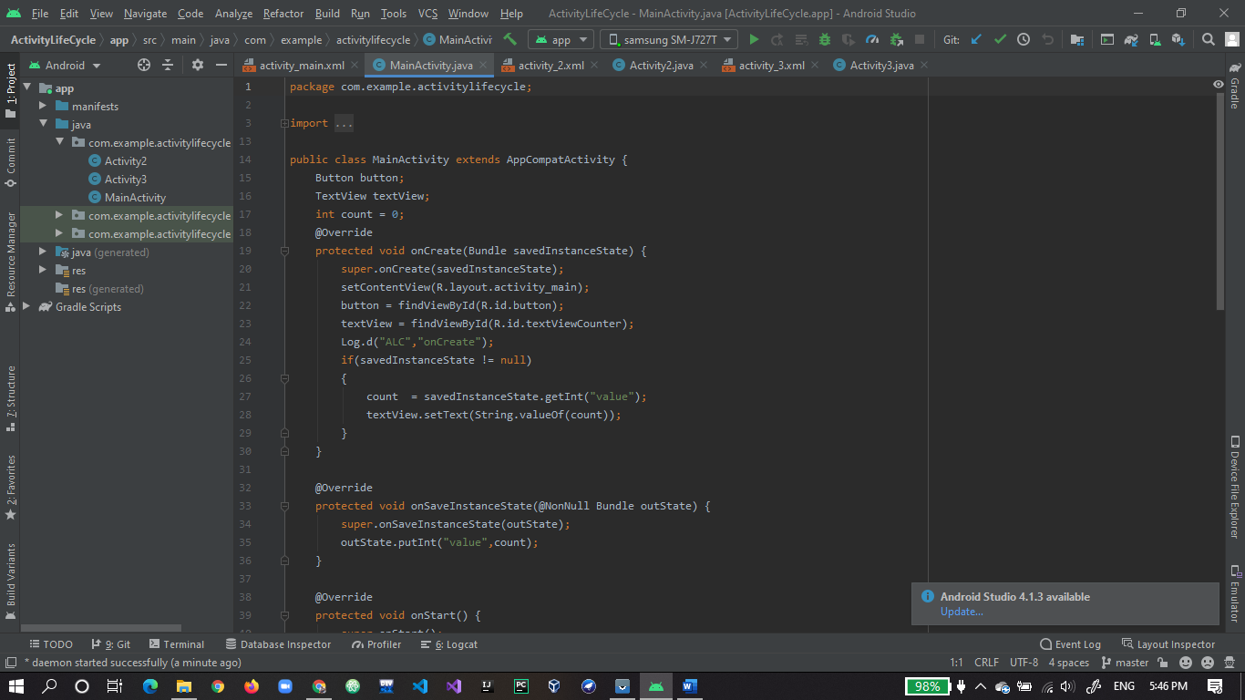

1. Code to go activity 2 and activity 3.

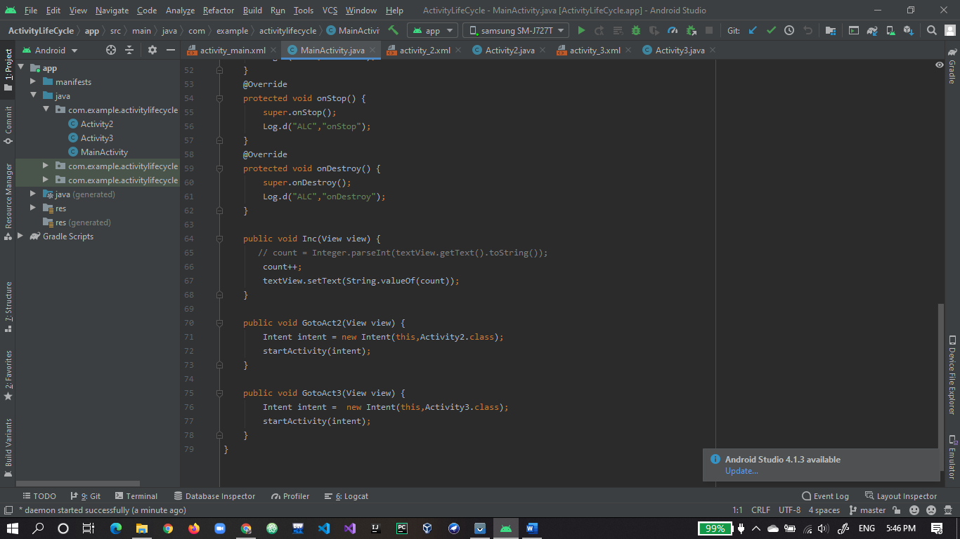

1. Xml design of app.

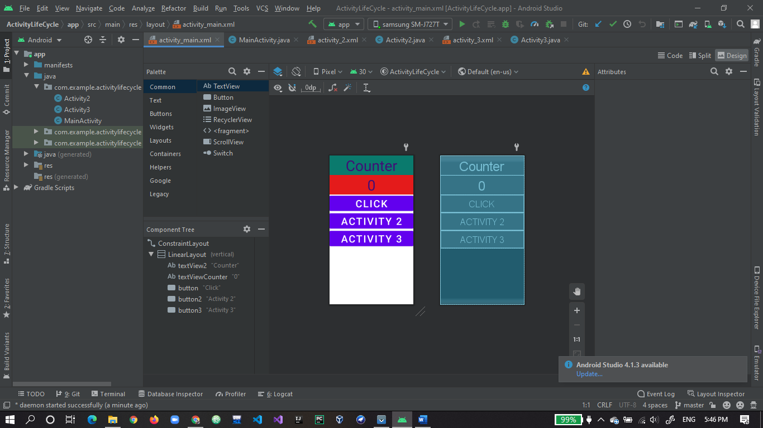

1. Activity 2 code.

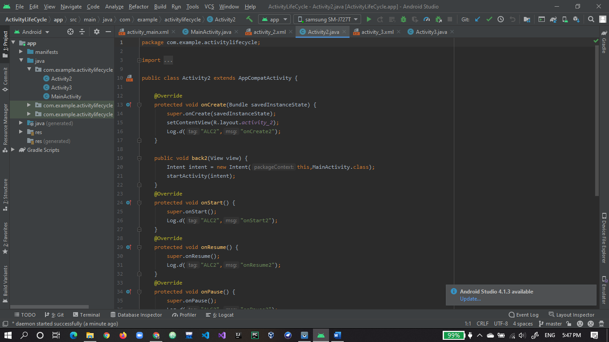

1. Code to go main activity or go to activity 3.

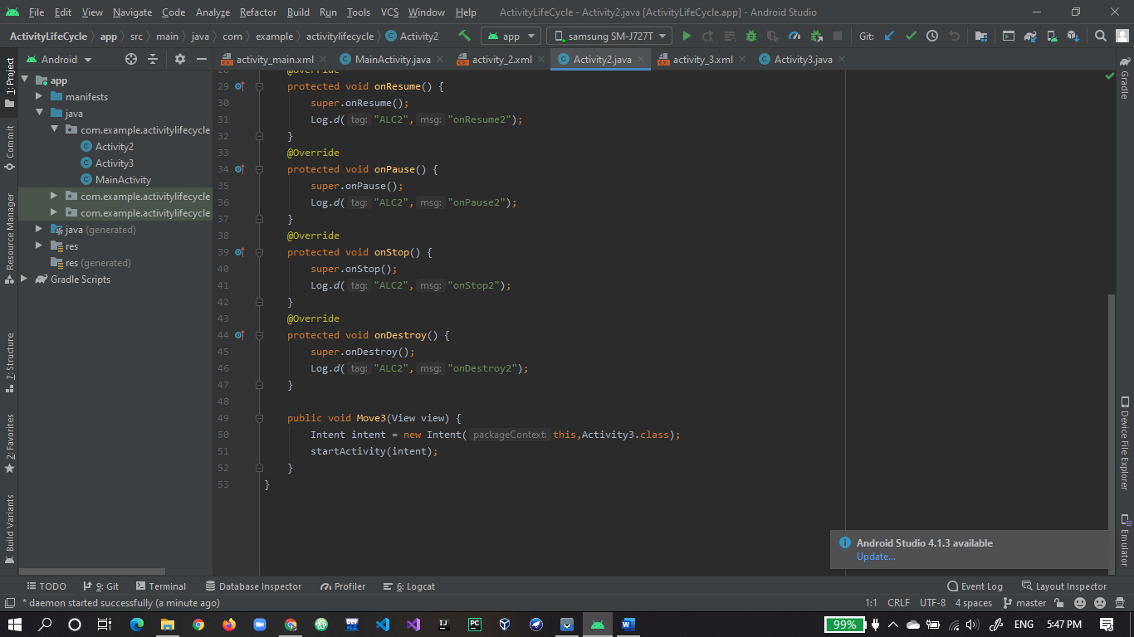

1. Activity 2 xml design.

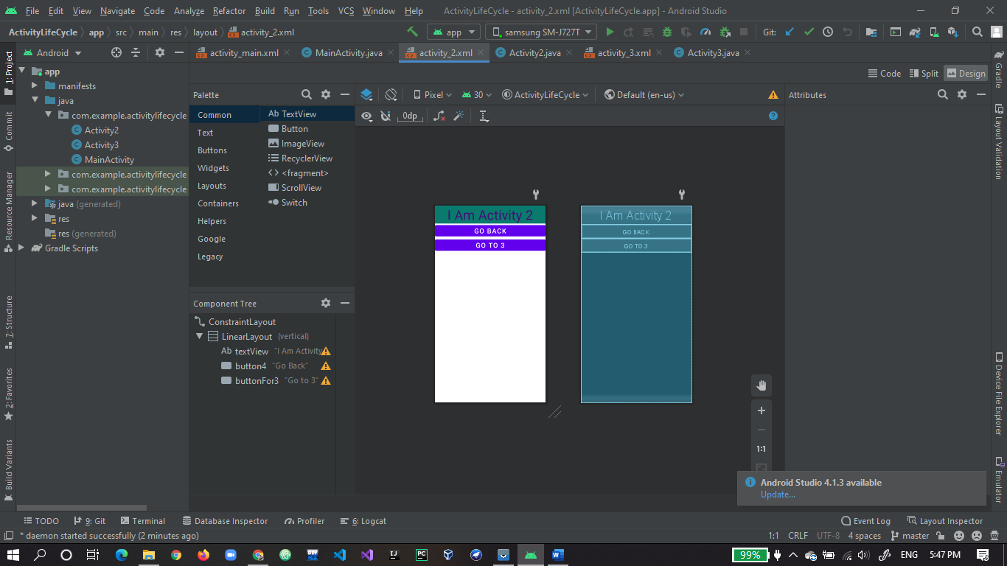

1. Activity 3 code.

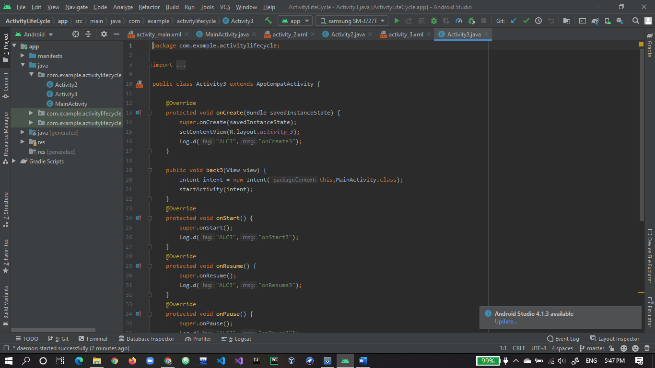

1. Code to go main activity or to go activity 2.

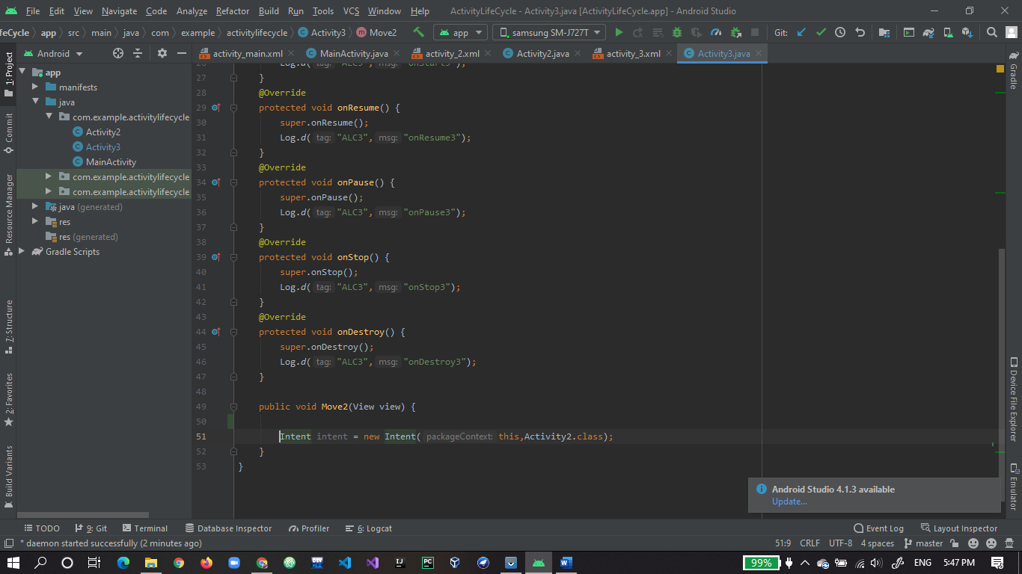

1. Xml of Activity 3.

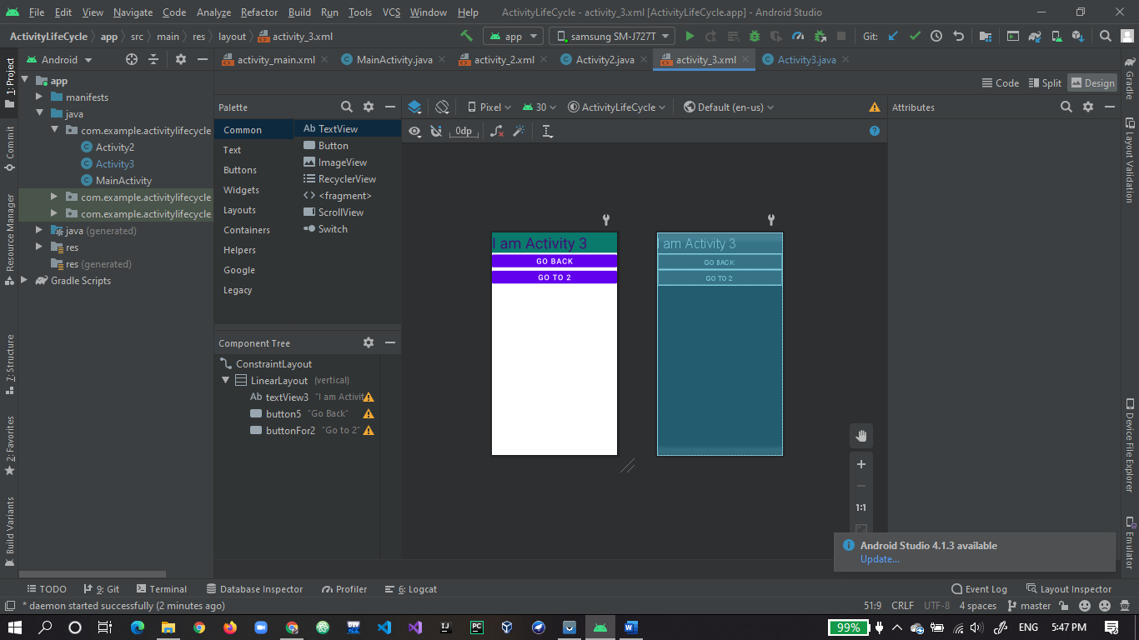

1. Final output of app.

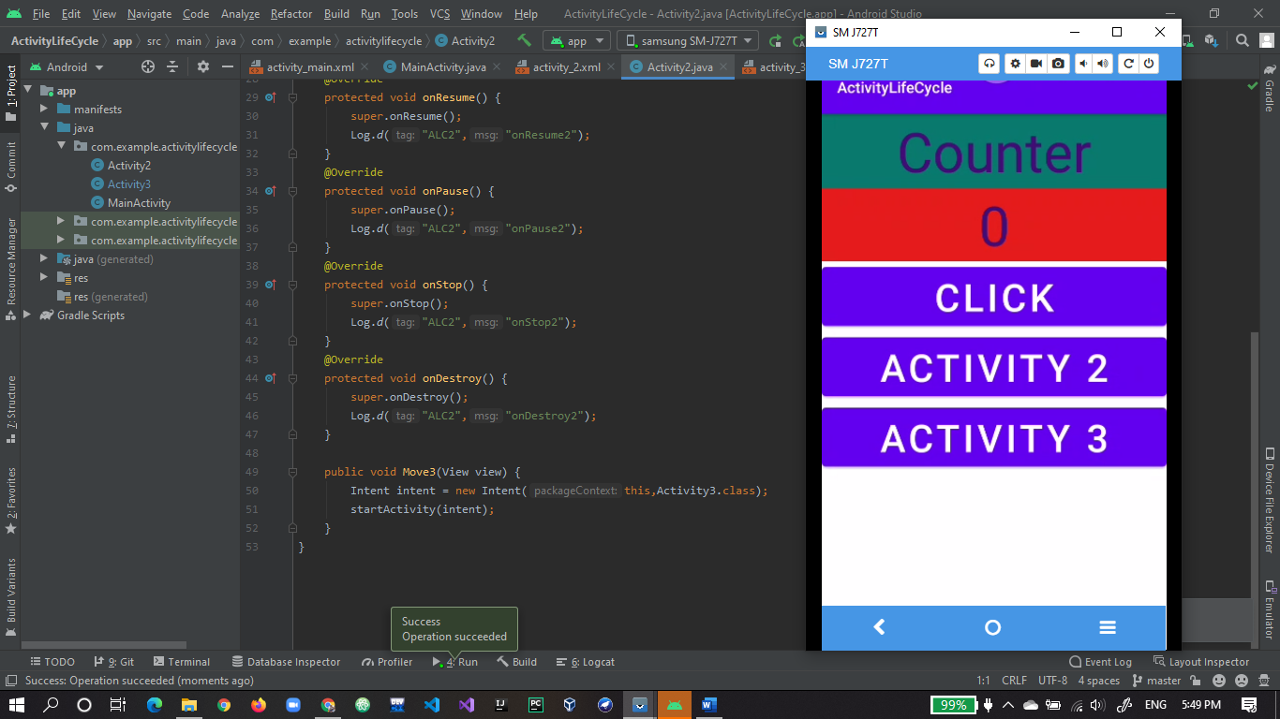

1. Counter is working fine.

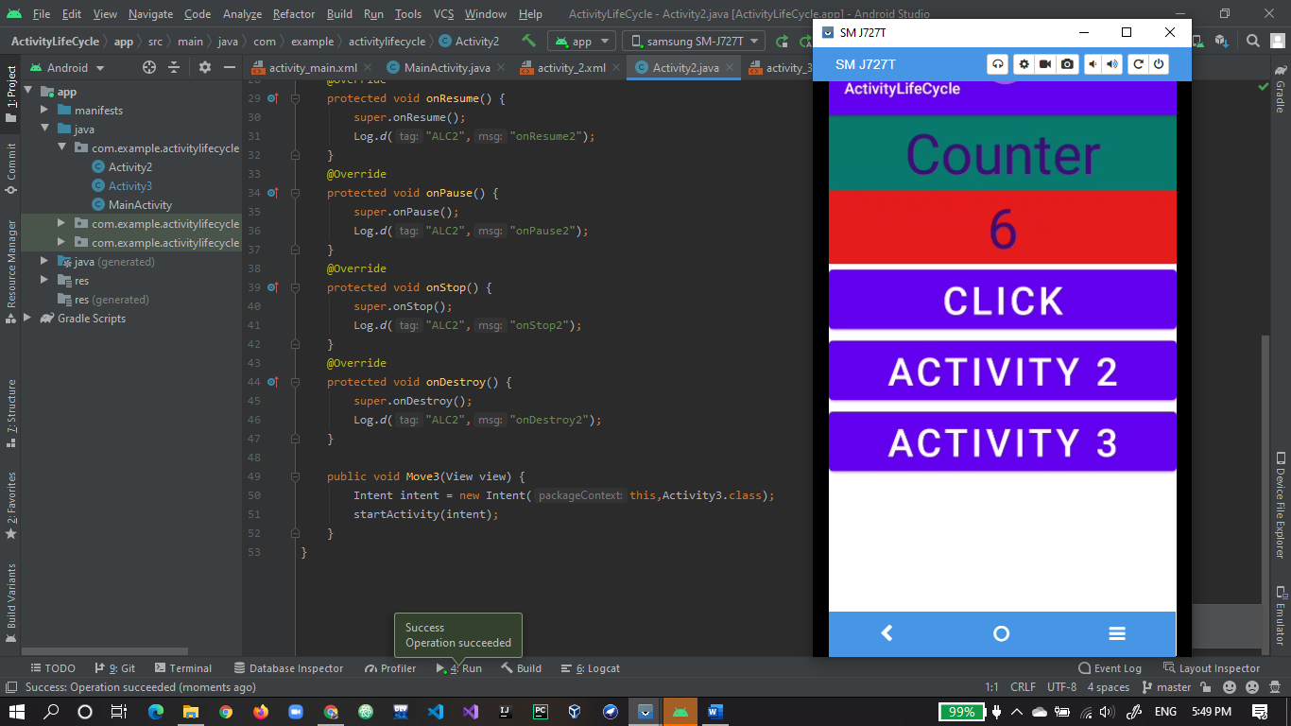

1. Moved to activity 2.

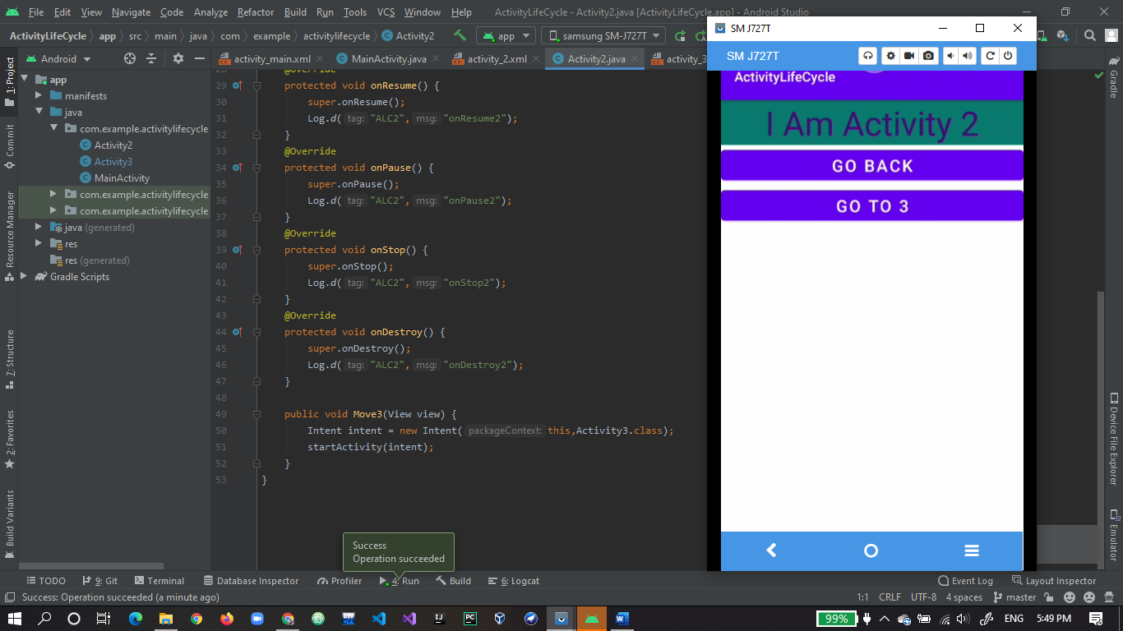

1. Moved to activity 3.

