**To-do task 5**

**Name:** Shoaib Sabir

**Roll No:** Mcsf19a019

1. Making ArrayList and adding data into it.

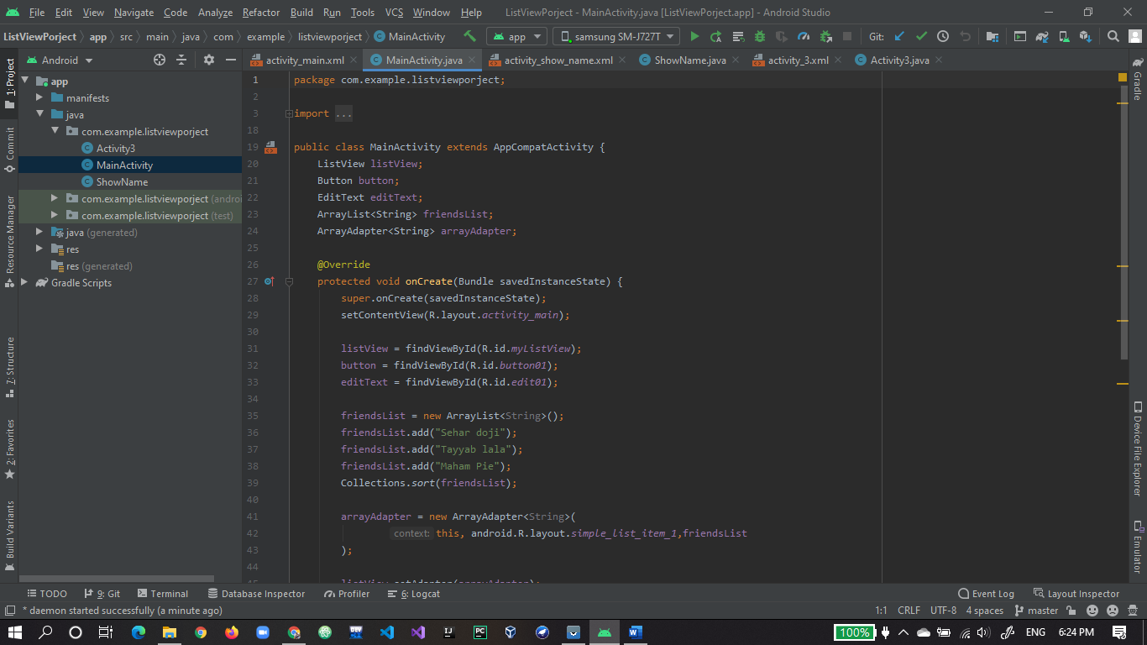

1. Setting adapter for arraylist and addfriend() function code.

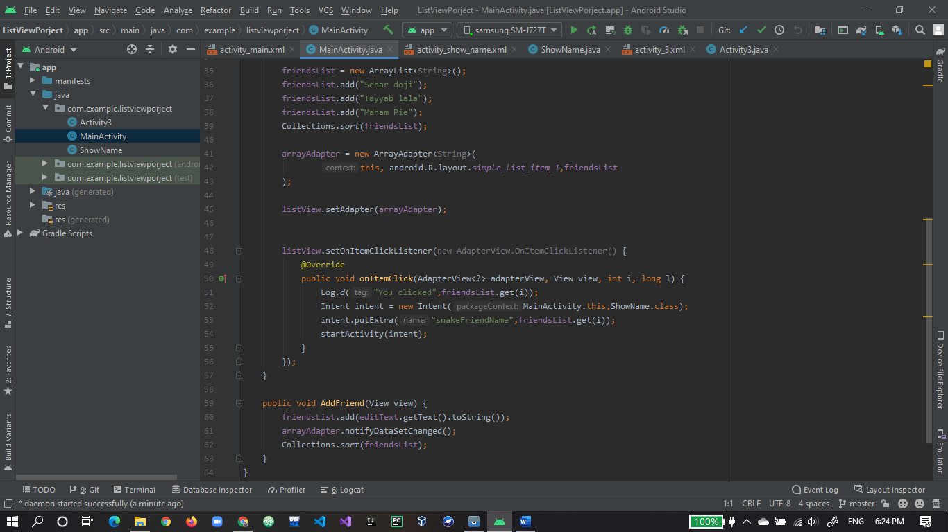

1. Xml design to show and add friends in arraylist.

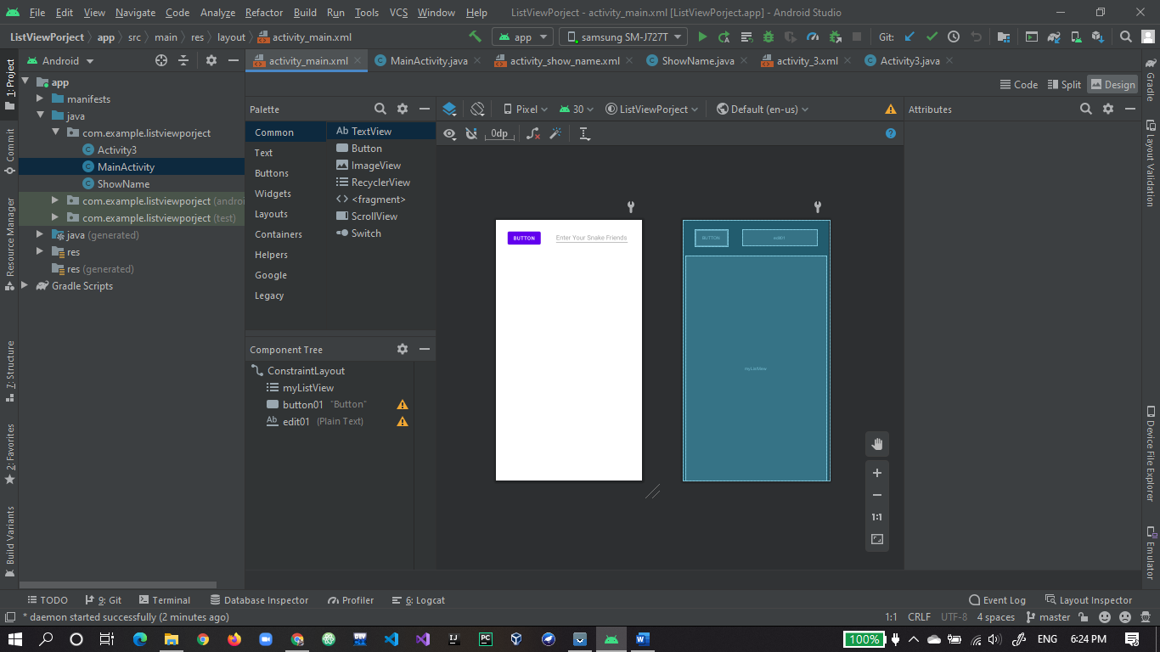

1. Output of app showing list of friends.

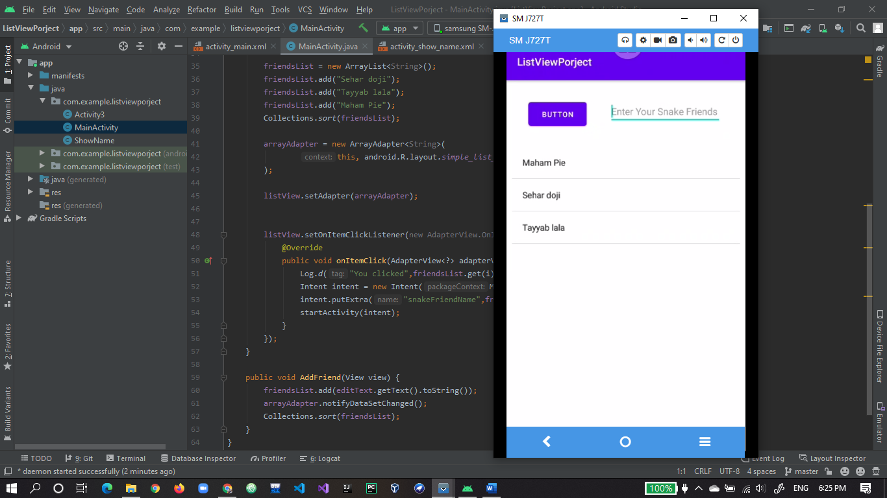

1. Adding new friend.

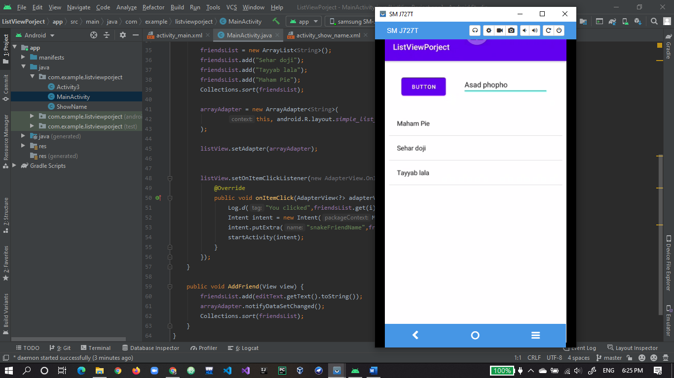

1. Friend added and showing in list.

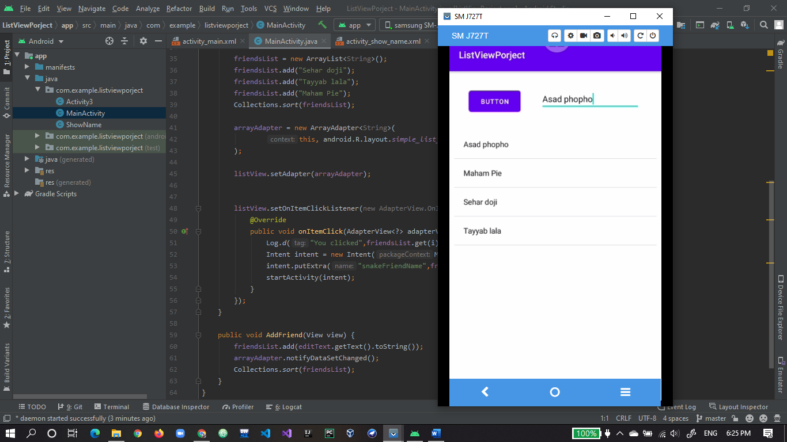

1. Getting data from on activity to other using intent.

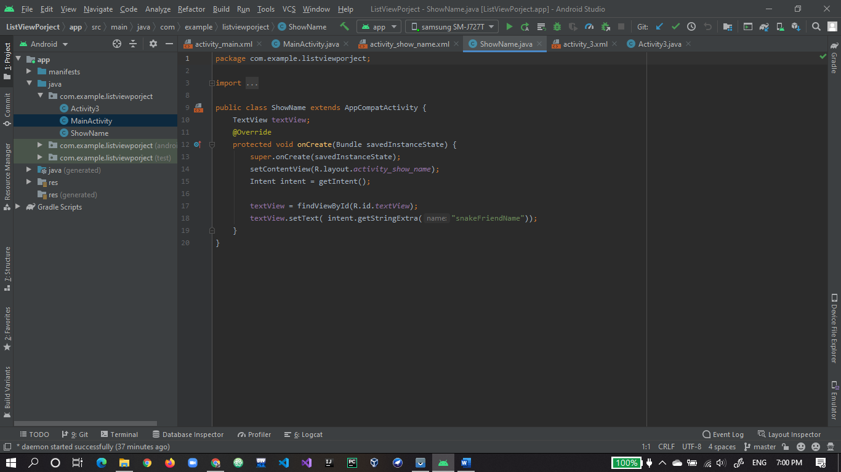

1. Here the name of friend will be shown which will be clicked by using intent sent to this activity from mainActivity.

