**To-do task 7 Lec:** *Animation 1*

**Name:** Shoaib Sabir

**Roll No:** Mcsf19a019

1. Code to manipulate the picture.

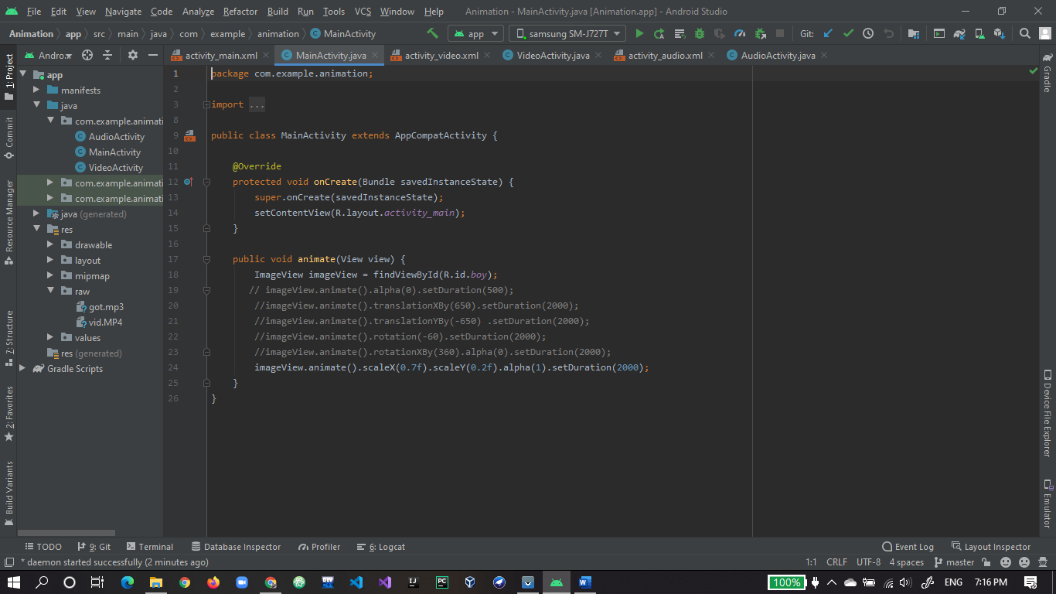

1. Xml of animation project.

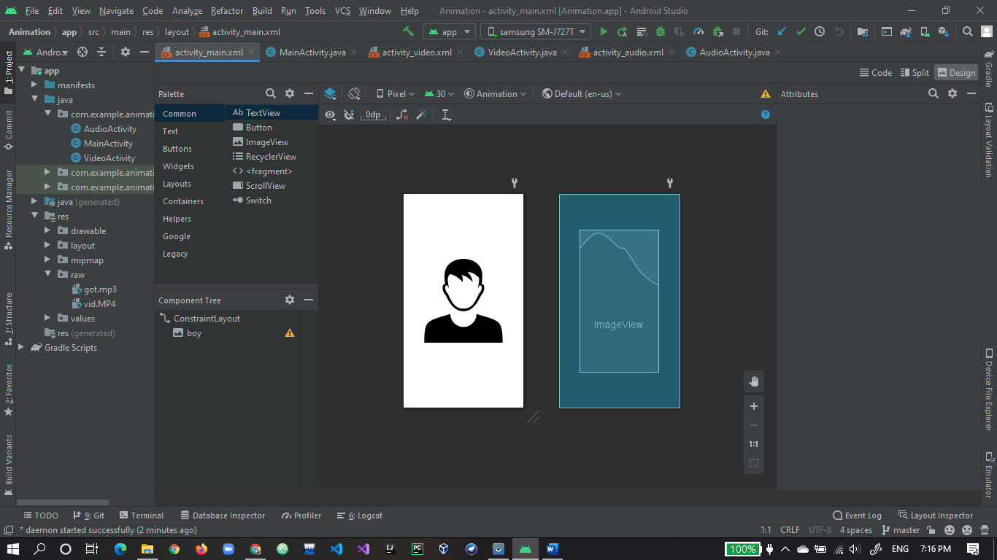

1. App run first time output.

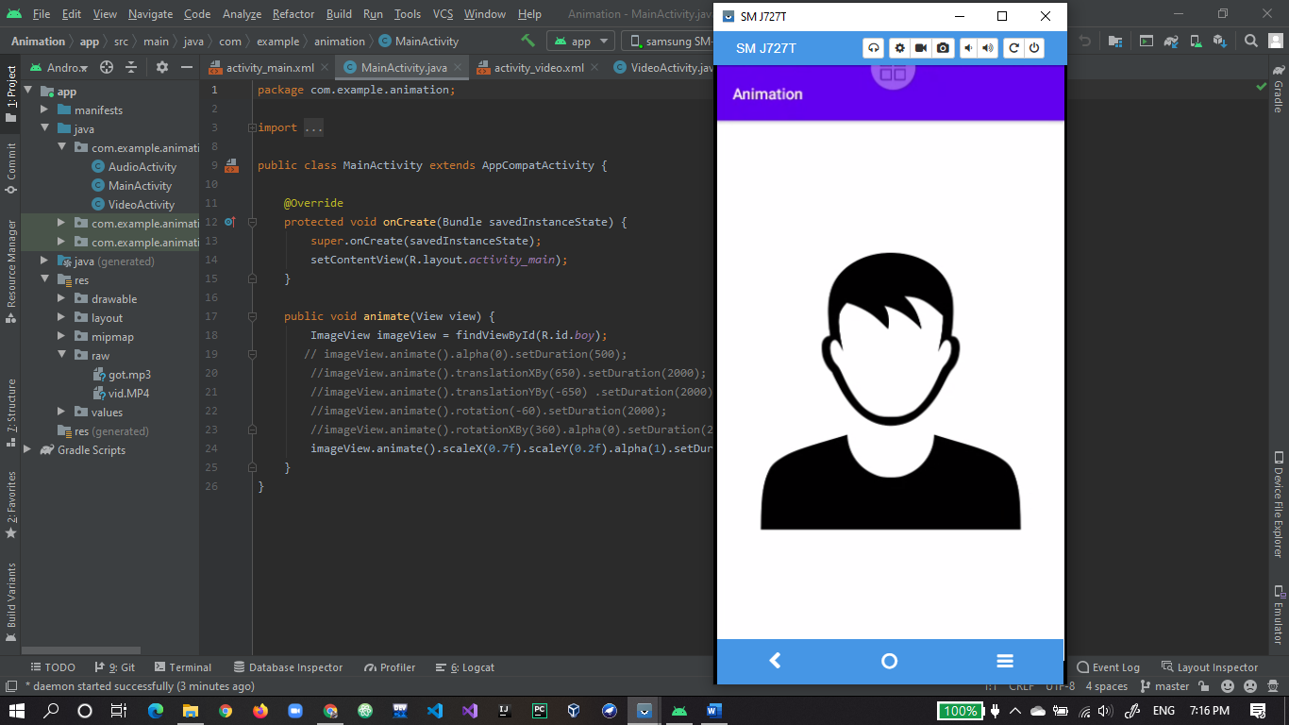

1. After clicking on picture animation code works fine.

