**To-do task 8 Lec:** *Animation 1*

**Name:** Shoaib Sabir

**Roll No:** Mcsf19a019

1. Adding video and media controls using code.

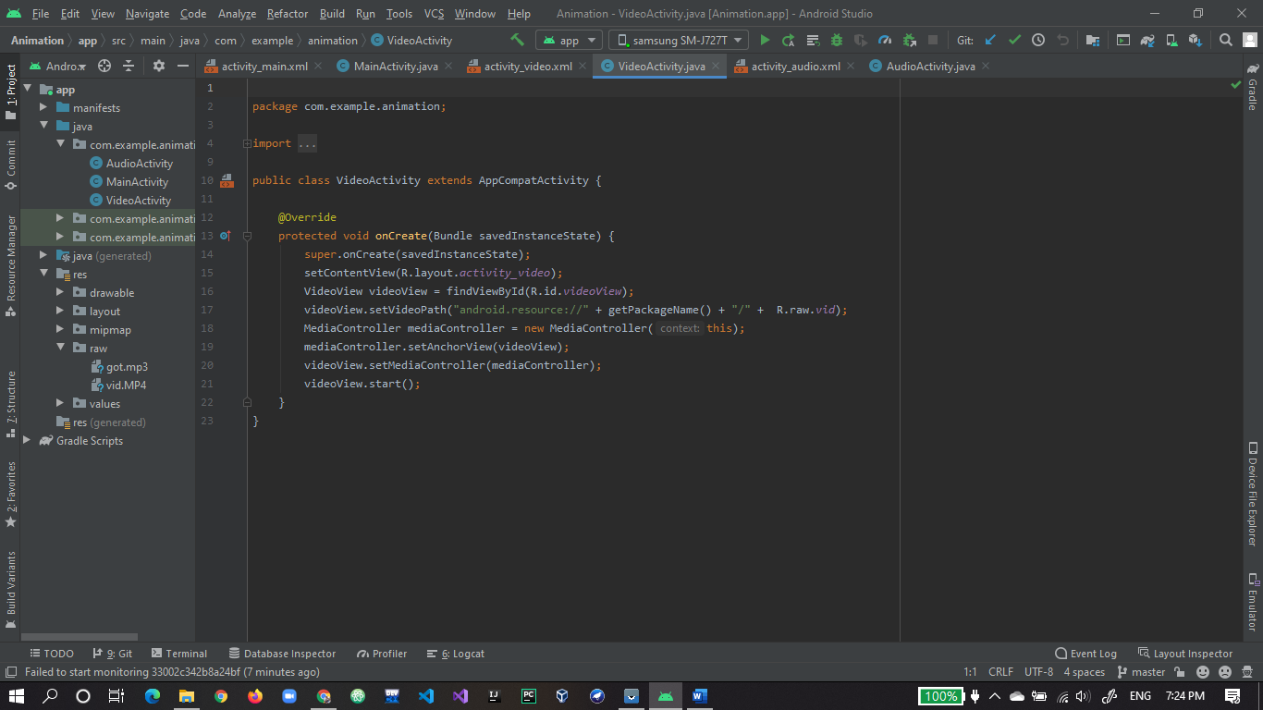

1. Video widget on xml.

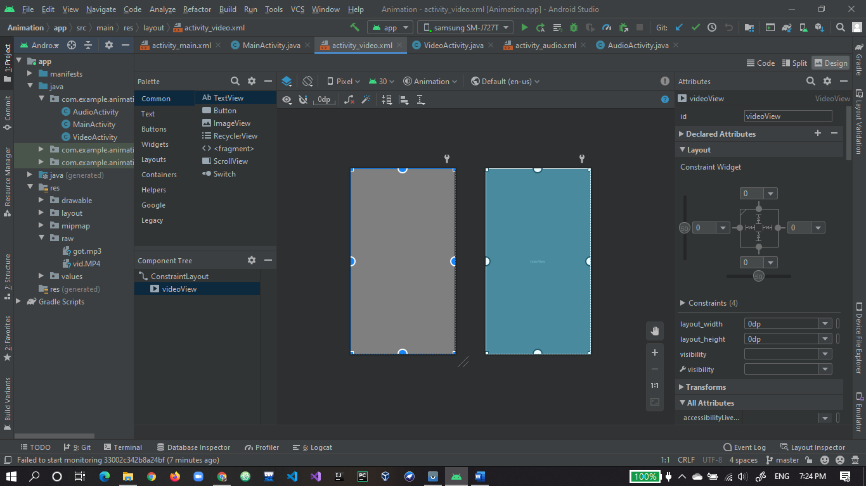

1. Video is working fine.

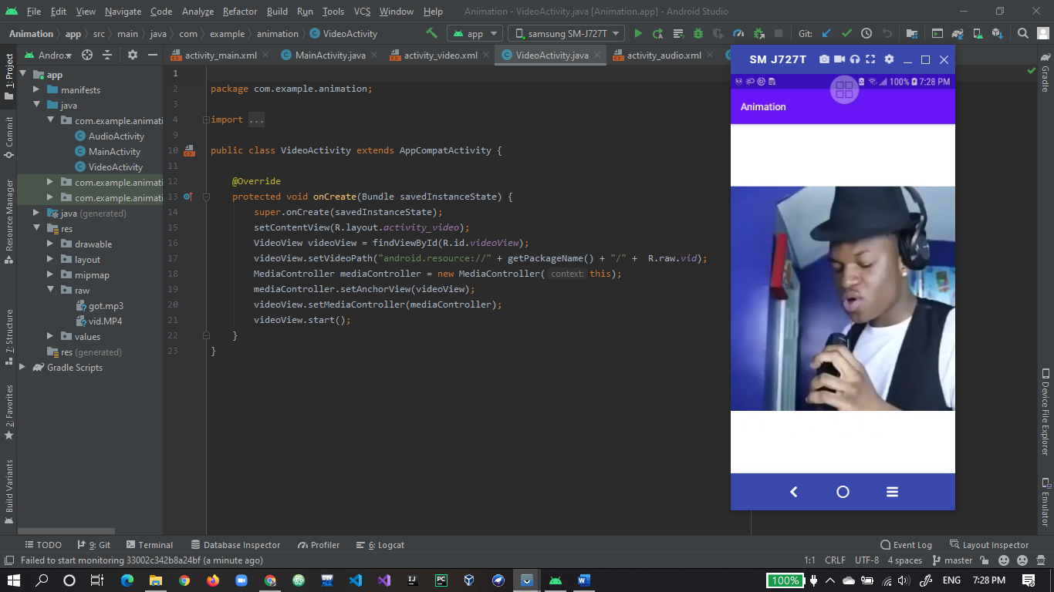

1. Media controller also working fine.

