* First of all **GIT CLONE:**



* Now initialize an empty repository using



* Now to find **Git Status:**

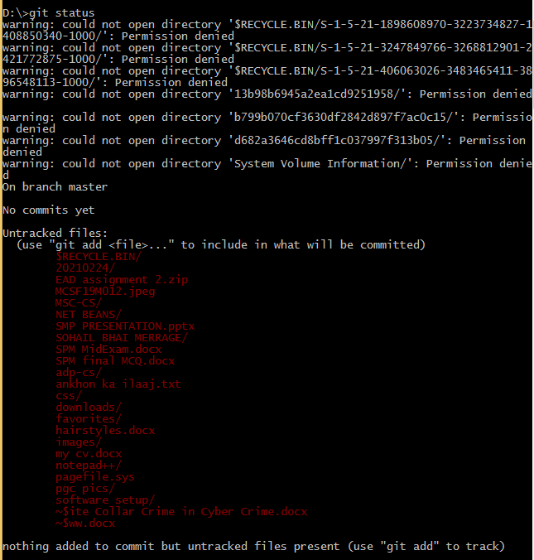

* Now to **folder:**

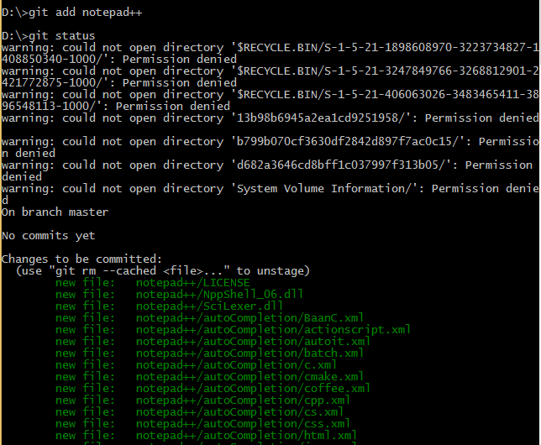

After this when we run **GIT STATUS** selected file and folder will be shown with green color

* Now , we will **commit it:**

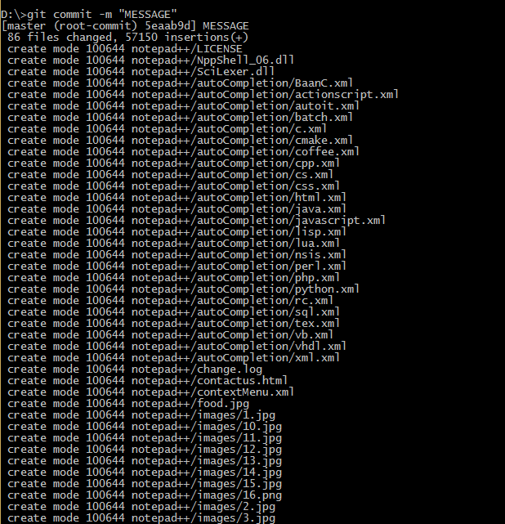

* now we will add **remote origin:**



* Now we will push it using



after this a window will appear

here you need to select **ACCESS USING BROWSER**

then you need to type your repository password

after that **refresh your repository**

**Now your folder is uploaded on git:**

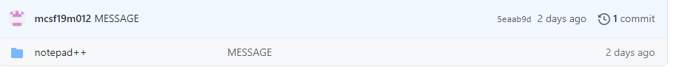

**And command will show following information**

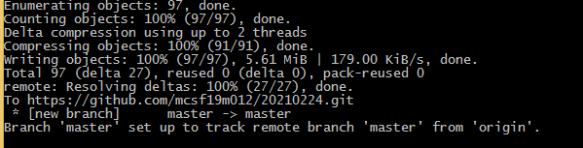

* **Commiting changes to file:**

This is my change in my file

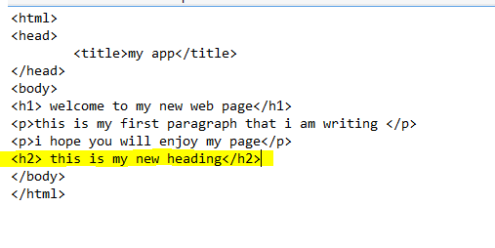

1)git add

2) git commit

3)git push

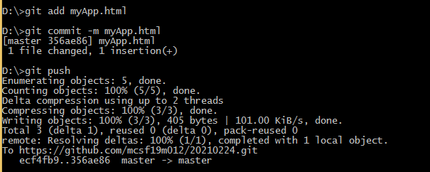

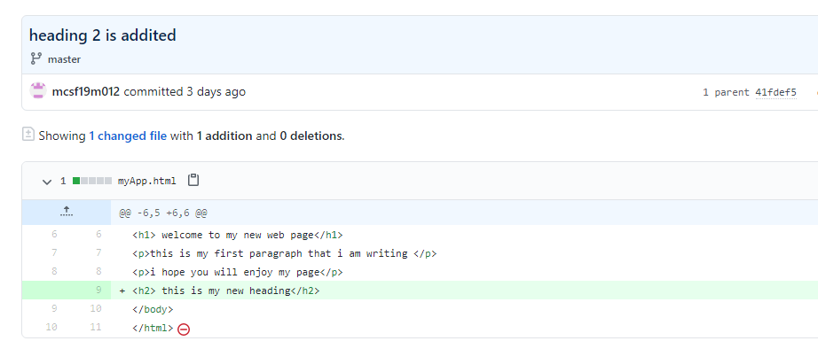

After following above three command my heading 2 is added on my github repository

This is my new line that I have edited in my repository save it then I follow above three commands then my git hub will have edited file.

* **Edit file online:**

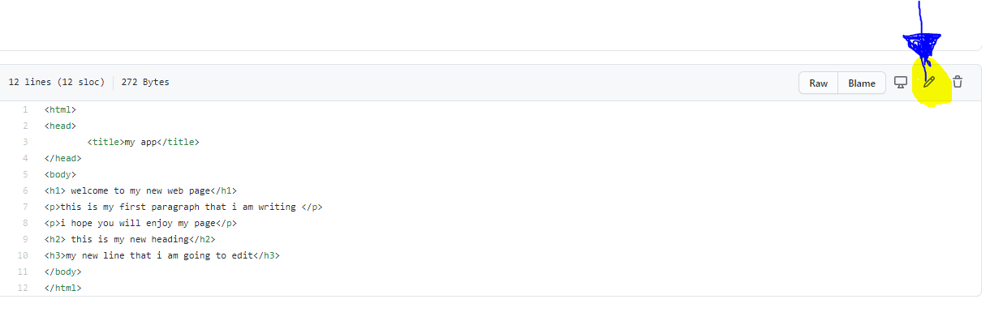

Heading 1 edited online:

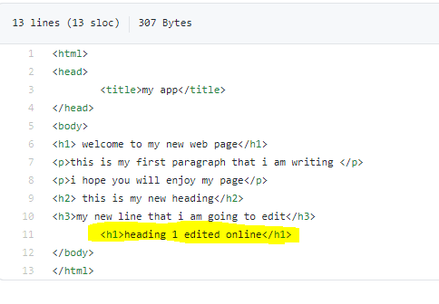

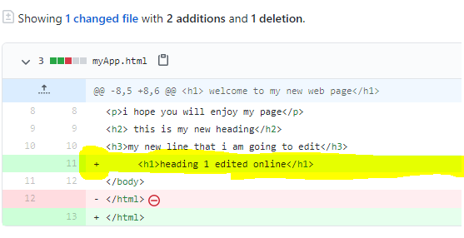

Show changes in central repository

* To view changes at your local repository we use **git pull** command

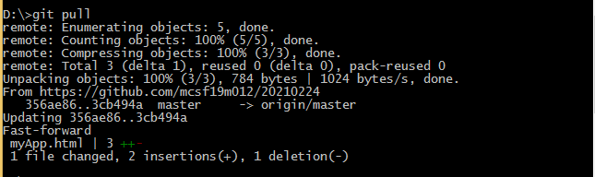

Now your local repository file will have changes

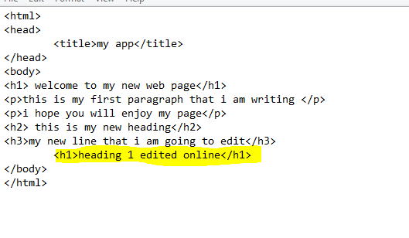

**Merge conflict**

Merge conflict rises when two user change same line of code at same time.

**Change in github repository:**

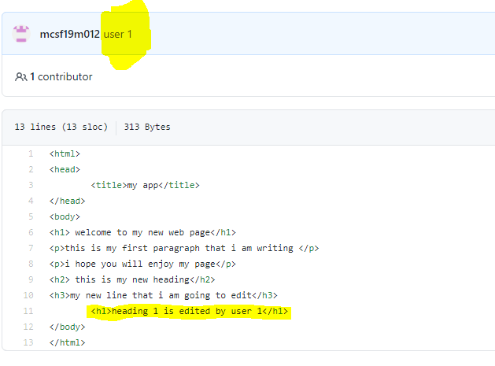

**Change in local repository:**

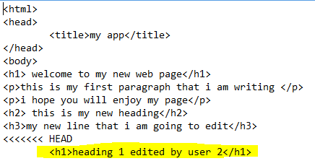



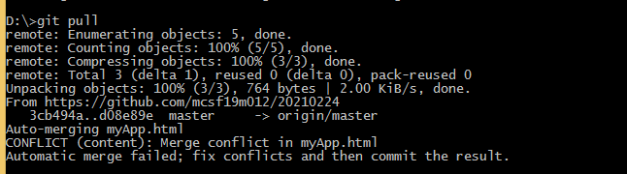

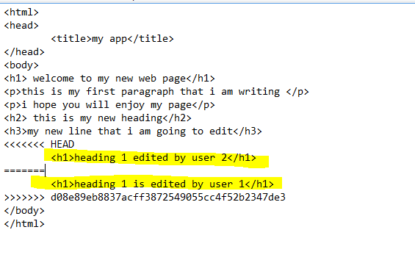

**Git conflict issue resolved:**

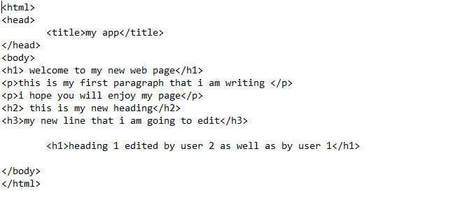

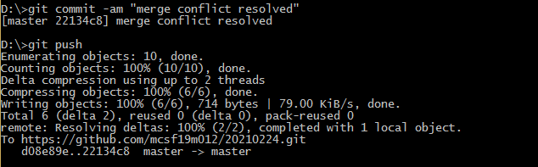

**Same data at github.com:**

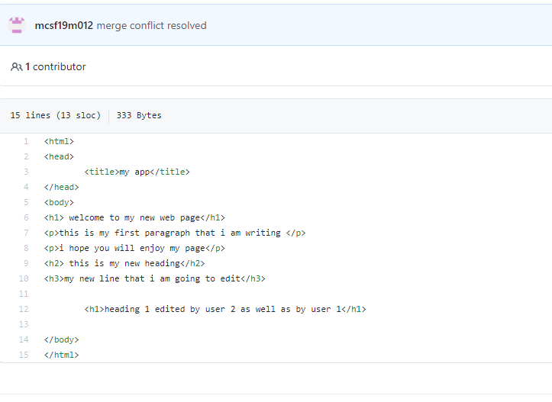

**Git log:**

Give details of commit.

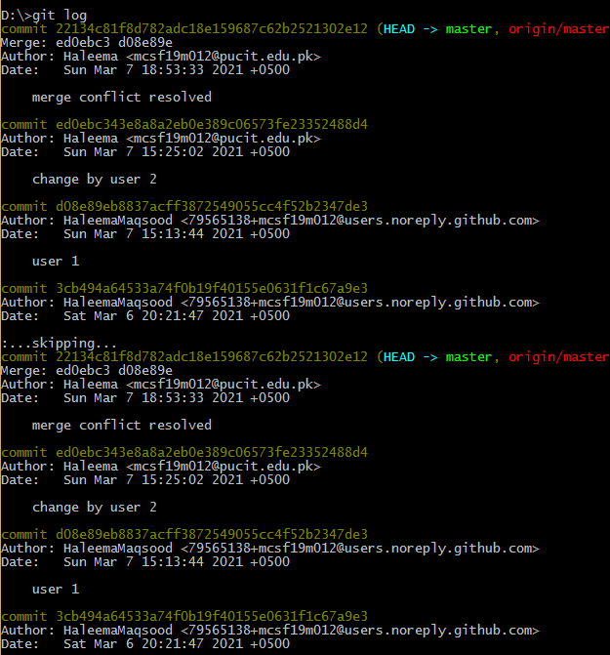

**Video lecture 4:**

**Remove a file from github:**

This is my current github repository:

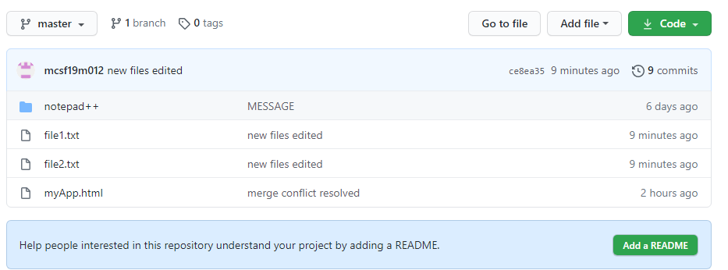

Now I want to remove file 2.txt from my github repository:

Then I will use following command:



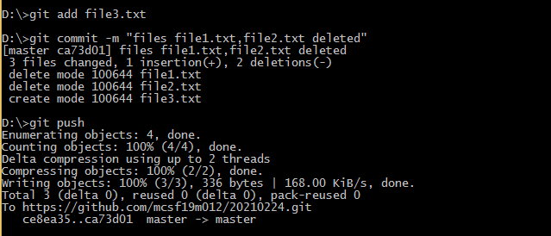

Now we can see file1.txt,file2.txt has been removed:

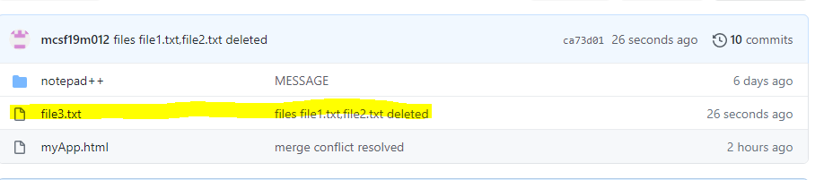

**Branching:**

**Create a branch:**

1. **Git branch (**to check branches)



By default branching class in **master.**

1. **Create a new branch:**



**3.Now check list of branches:**

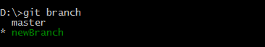

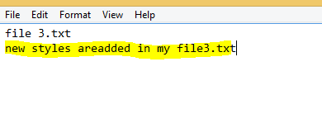



**This is master branch of file3.txt:**

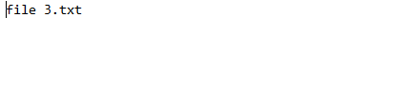

**This is my newBranch**

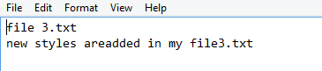

**Merge different branches:**

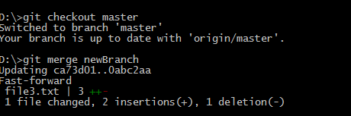

this is merged file:

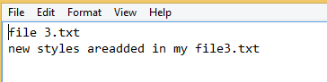

**Now master branch will have merged changes:**

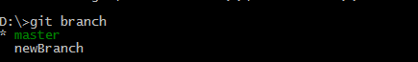

Now we need to delete newBranch:

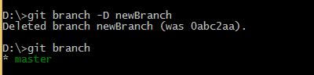

Now we have just onlu master branch.

**5-Android IDE Introduction:**

* **Start a new project:**

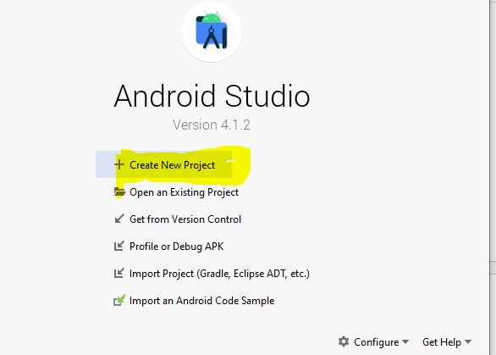

**Start of project:**

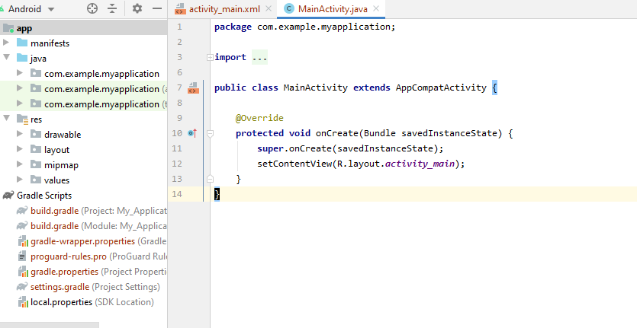

**CODE and GUI FILE:**

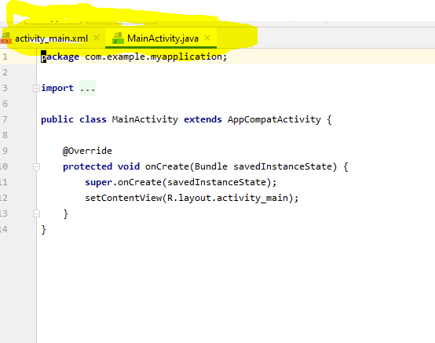

Here activity main.xaml is GUI file, whereas MainActivity.java is java code file

**BUILD PROJECT:**

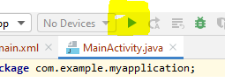

Here yello heighligted buttion is to build project.

**At bottom:**

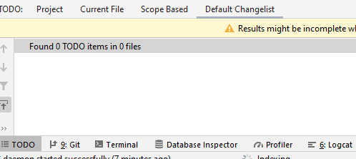

Bottom of android studio contain bar that include **todo, terminal, and logcat.**

**ACTIVITY MAIN.xaml:**

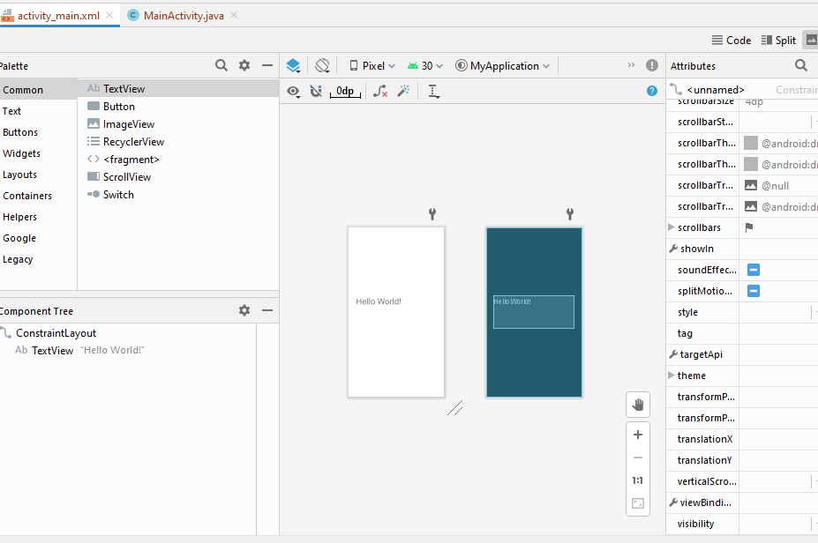

**Build.gradle project:**

**Contain all dependencies and third party tools.**

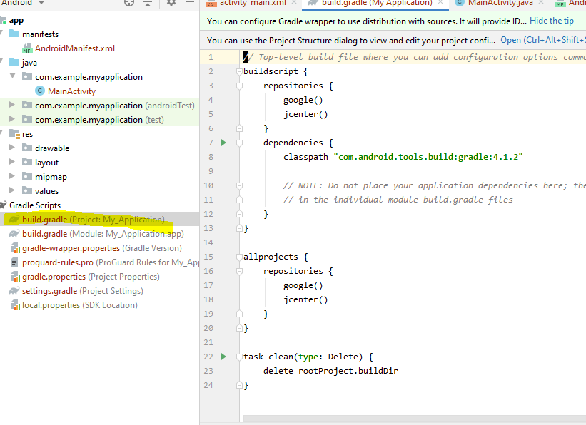

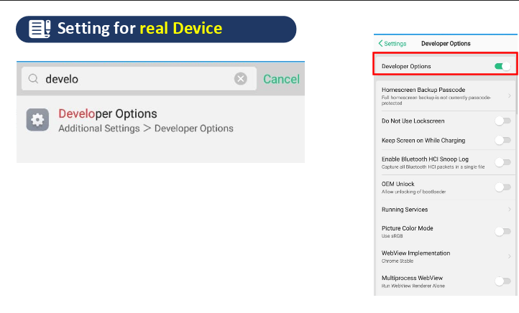

**To connect your phone**

**Search in setting “developer option” turn on it.**

**Switch on “usb debugging”.**

**My virtual device:**



**Android profiler:**

**Views>>tool window>>profiler**

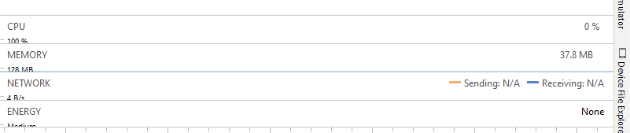

**Design and blueprint**

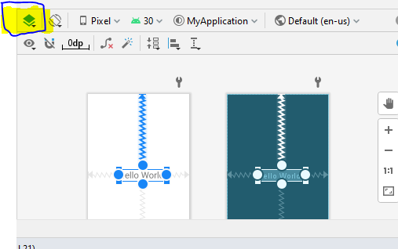

**Constraint layout:**

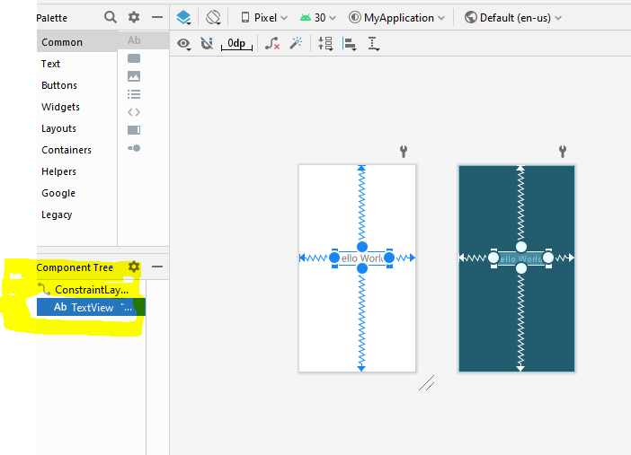

**XML TEXT VIEW:**

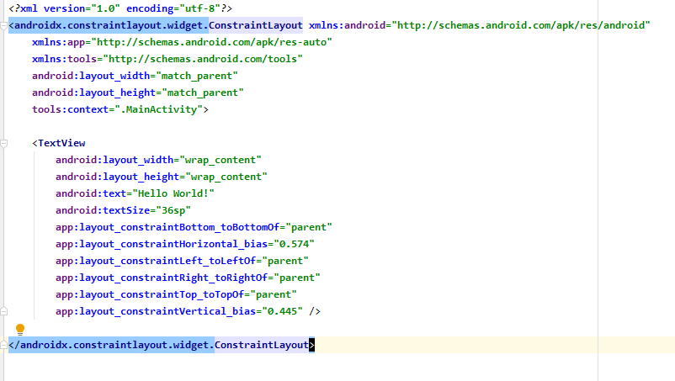

**My android**

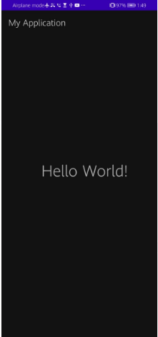

**Video lecture 6-Android IDE introduction:**

**HOW TO CREATE TODO**

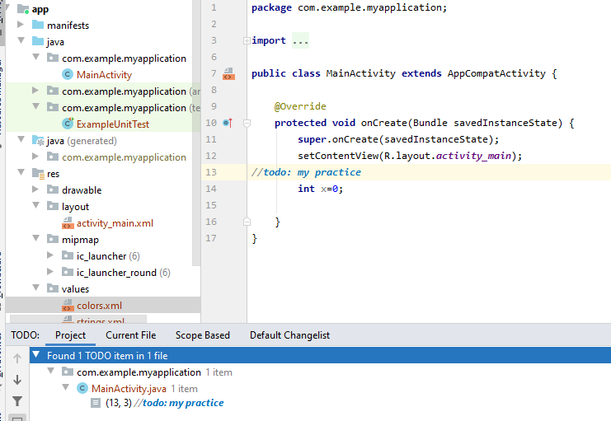

**BUILD:**

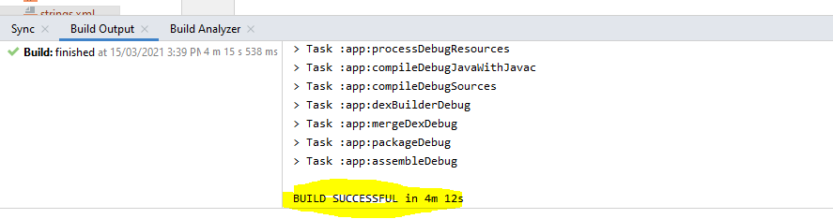

**Constraint layout:**

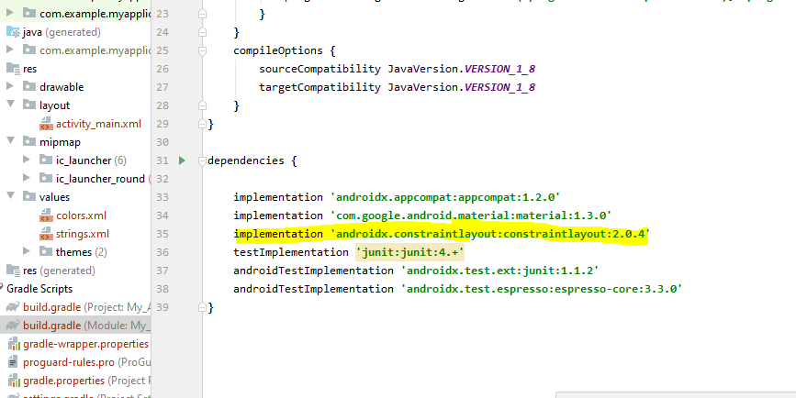

**Week 3:**

**Lecture 5 :**

**Layouts:**