**Introduction**

In this project we wanted to ascertain whether it rains more in Seattle or another city. I chose to compare Seattle to Boston since it is on the opposite coast, and I genuinely did not have any inclination of whether it rains more in one city than the other. To do this, we analyzed data collected from the National Oceanic and Atmospheric Administration. This government agency works to provide reliable weather, water, and climate data across the nation so we can have confidence that the data we are analyzing will produce accurate results.

**Analysis and Modeling**

In the analysis phase, we explore precipitation patterns in both cities through visualizations. We begin by calculating and summarizing daily mean precipitation for each city, followed by creating bar graphs and boxplots to compare rainfall distributions across months. We grouped the data by month to visualize trends in average precipitation over time. In addition to average rainfall, the analysis also examines how frequently it rains by calculating and plotting the proportion of days with any precipitation, both over the full five-year period and for each month.

We begin our analysis by examining the mean daily precipitation over the five-year period. As seen in the bar graphs below, Boston has a slightly higher average daily precipitation whereas Seattle has the higher proportion of days with precipitation.

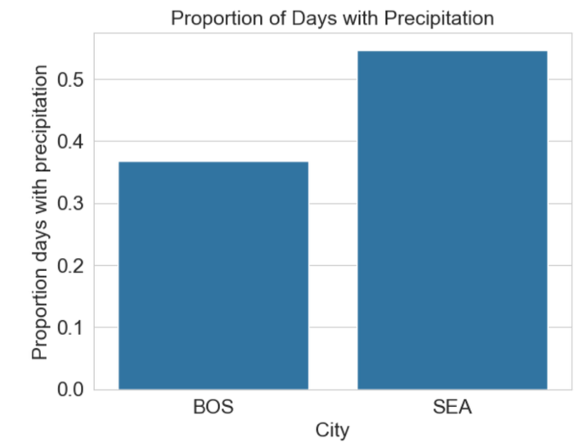

The difference in mean daily precipitation of the two cities seems to be close so we will conduct a test for each month to determine if there are statistically significant differences. In the modeling stage, statistical tests are applied to determine whether the observed differences between Seattle and Boston are significant. A two-sided t-test is used to compare the average monthly rainfall between the two cities, and the results are visualized with markers indicating months with statistically significant differences. Similarly, a two-sided z-test is performed to analyze whether the proportion of days with any rain differs significantly between the cities each month, with plots highlighting the months showing notable variations.

The graph shows that in January, July, August, September, and December, there’s strong evidence that Seattle and Boston get **different average amounts of rain** — meaning the difference in rainfall between the two cities during those months is **not just due to chance.**

In January, February, March, April, July, November, and December, the results show a clear difference in how often it rains in Seattle compared to Boston — one city gets rain on more days during those months. For the other months, the difference isn’t strong enough to say that one city is rainier than the other.

**Conclusion**

From the results of our analysis, I am confident in saying that you can expect one city to have more rain than the other depending on the season. Seattle has more rain in the Fall/Winter while Boston has more rain in the Spring/Summer. It should also be noted that while Seattle has a greater proportion of days rain occurs, Boston has a higher average daily rainfall. This aligns with my prior belief about Seattle rainfall from living here for a few years: it rains more often but it is usually a drizzle or does not rain for prolonged periods of time. This does not seem to be the case for Boston suggesting that when it rains, it rains either more intensely or for a longer period of time. When it comes to answering the question of whether it rain more in Seattle or Boston: Seattle probably *feels* like it rains more because it rains more frequently throughout the year despite Boston having the slightly higher total precipitation.