Clinical Governance and Risk Management Handbook

SGMC is dedicated to upholding the highest standards of clinical governance and systematic risk management across all hospital and provider settings. This handbook serves as a foundational operational and compliance resource, designed to guide staff, leaders, and committees in safeguarding patient safety, ensuring care quality, and maintaining regulatory compliance. Through clear policies, procedures, and practical tools, SGMC fosters a culture of accountability, continuous learning, and improvement. The handbook is intended for daily reference, onboarding, audits, and accreditation surveys, supporting SGMC’s mission to deliver safe, effective, and patient-centered care.

# Clinical Governance: Principles and Foundations

Clinical governance is a systematic approach to maintaining and improving the quality of patient care within healthcare organizations. At SGMC, clinical governance serves as the foundation for all activities aimed at safeguarding patient safety, ensuring compliance with regulatory requirements, and fostering a culture of continuous improvement. By establishing clear policies, procedures, and accountability structures, clinical governance enables SGMC to deliver care that is safe, effective, patient-centered, and aligned with best practices.

Clinical governance is deeply integrated into SGMC’s mission to provide exceptional patient care while upholding the highest standards of safety and quality. The principles that underpin clinical governance are reflected in SGMC’s strategic objectives, which emphasize not only compliance with external regulations but also internal accountability, transparency, and ongoing professional development. This alignment ensures that every department, team, and individual at SGMC understands their role in promoting quality and safety, and that organizational goals are consistently supported by robust governance practices.

### Key Principles of Clinical Governance

* **Patient Safety:** Ensuring all care processes prioritize the safety and well-being of patients.
* **Quality Assurance:** Maintaining high standards of clinical care through regular monitoring and improvement.
* **Accountability:** Defining clear roles and responsibilities for all staff involved in patient care.
* **Transparency:** Promoting open communication and reporting of incidents, outcomes, and risks.
* **Continuous Improvement:** Using data, feedback, and audits to drive ongoing enhancements in care delivery.
* **Compliance:** Adhering to relevant laws, regulations, and accreditation standards.
* **Learning Culture:** Encouraging education, training, and knowledge sharing among staff.

# Governance Structure & Roles

SGMC’s approach to clinical governance is grounded in a clearly defined hierarchy and robust reporting relationships. The governance structure ensures that accountability for clinical quality and risk management is distributed across dedicated roles, each with explicit responsibilities and oversight mechanisms. This structure supports transparent decision-making, effective communication, and seamless escalation of issues from frontline teams to executive leadership.

At the apex of the clinical governance framework is the Chief Medical Officer (CMO), who holds ultimate responsibility for clinical oversight and reports directly to the Chief Executive Officer (CEO). Supporting the CMO are specialized roles such as the Risk Manager, Quality Director, and heads of clinical departments, each charged with distinct facets of governance—from risk assessment to quality improvement and compliance monitoring. The integration of these roles fosters a culture of shared responsibility, enabling SGMC to maintain high standards of patient safety while meeting regulatory and accreditation requirements.

The following table details the key governance roles, their core responsibilities, and reporting lines within SGMC.

## Governance Roles, Responsibilities, and Reporting Lines

|  |  |  |
| --- | --- | --- |
| **Role** | **Key Responsibility** | **Reporting To** |
| Chief Medical Officer | Overall clinical governance oversight | CEO |
| Risk Manager | Oversees risk assessment processes | Chief Medical Officer |
| Quality Director | Implements quality improvement initiatives | Chief Medical Officer |
| Department Heads | Ensures compliance and quality within departments | Quality Director |
| Clinical Audit Lead | Coordinates audit schedules and reporting | Quality Director |
| Compliance Officer | Monitors regulatory compliance and documentation | Chief Medical Officer |
| Patient Safety Officer | Manages incident reporting and safety programs | Risk Manager |
| Training Coordinator | Embeds governance principles in staff education | Quality Director |
| Data Analyst | Collates and analyzes governance-related metrics | Quality Director |
| Accreditation Manager | Prepares for external surveys and inspections | Compliance Officer |

# Risk Management Framework

Risk management is a cornerstone of clinical governance, designed to proactively identify, assess, and mitigate risks that threaten patient safety, care quality, and operational integrity within SGMC’s healthcare settings. In clinical environments, risk management encompasses both strategic and day-to-day activities, ensuring that hazards—whether clinical, operational, or regulatory—are systematically addressed. Effective risk management not only safeguards patients and staff but also supports organizational resilience, regulatory compliance, and continuous quality improvement.

## Risk Identification & Assessment

Identifying and assessing risks in clinical and operational contexts is a structured process involving multiple methodologies. Risks may arise from a variety of sources, including clinical procedures, equipment failures, staff competency gaps, environmental hazards, and systemic process weaknesses. The identification phase relies on incident reporting, direct observation, audit findings, and stakeholder feedback. Once risks are identified, they must be systematically assessed to determine their potential impact and likelihood, enabling prioritization and targeted mitigation.

The following table presents a comprehensive Risk Assessment Matrix, which is used to evaluate the severity and likelihood of identified risks, facilitating evidence-based decision-making:

### Risk Assessment Matrix

|  |  |  |  |  |  |  |  |
| --- | --- | --- | --- | --- | --- | --- | --- |
| **Risk Description** | **Likelihood (1-5)** | **Severity (1-5)** | **Risk Score (L x S)** | **Category** | **Existing Controls** | **Action Required** | **Responsible Person** |
| Medication error | 4 | 5 | 20 | Critical | Double-checking | Enhanced training | Nurse Manager |
| Patient falls | 3 | 4 | 12 | High | Bed rails, signage | Review protocols | Safety Officer |
| Equipment malfunction | 2 | 5 | 10 | High | Maintenance logs | Upgrade equipment | Biomedical Engineer |
| Infection control breach | 3 | 5 | 15 | Critical | Hand hygiene | Audit compliance | Infection Control Lead |
| Documentation errors | 4 | 3 | 12 | High | EMR checks | Staff refresher | Dept. Supervisor |
| Data security breach | 1 | 5 | 5 | Moderate | Firewalls | IT review | IT Manager |

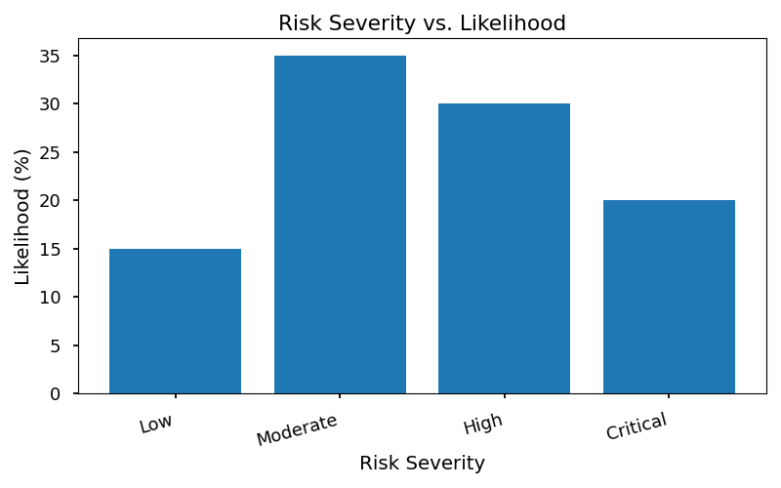

The chart above visually represents the relationship between risk severity and likelihood, enabling SGMC teams to prioritize risks that require immediate intervention.

## Risk Mitigation Strategies

Mitigating identified risks requires a multifaceted approach. SGMC employs a range of interventions tailored to the nature and priority of each risk. Risk mitigation strategies may include process redesign, staff training, technology upgrades, enhanced monitoring, and policy enforcement. All mitigation actions are documented, tracked, and reviewed for effectiveness as part of the continuous improvement cycle.

### Risk Mitigation Strategies and Interventions

* **Process Standardization:** Implementing standardized protocols and checklists to reduce variability in clinical practice.
* **Staff Training and Competency Assessment:** Regular education sessions, simulation exercises, and competency evaluations to ensure staff are equipped to manage risks.
* **Technology and Equipment Upgrade** Investing in advanced medical devices and IT systems to minimize equipment-related risks.
* **Enhanced Surveillance and Monitoring:** Continuous monitoring of key risk indicators, such as infection rates and incident reports.
* **Policy Enforcement:** Strict adherence to SGMC policies regarding patient safety, data protection, and incident reporting.
* **Environmental Control** Regular safety audits of clinical areas, maintenance of equipment, and optimization of facility design to prevent falls and other hazards.
* **Root Cause Analysi** Conducting thorough investigations of adverse events to identify underlying causes and prevent recurrence.
* **Communication and Feedback Loop** Establishing clear channels for staff to report risks and receive timely feedback on action taken.
* **Contingency Planning:** Developing and rehearsing emergency response plans for critical incidents (e.g., equipment failure, fire, mass casualty events).
* **Audit and Review:** Periodic audits to assess risk management effectiveness and inform ongoing improvements.

Each of these strategies is aligned with SGMC’s commitment to maintaining a safe, high-quality clinical environment, and is subject to regular review by the Risk Management Department and Clinical Governance Committees.

# Incident Reporting & Learning Systems

Incident reporting is a cornerstone of patient safety and organizational learning within SGMC. By systematically capturing and analyzing adverse events, near misses, and other safety incidents, the organization fosters a proactive culture of transparency, accountability, and continuous improvement. Effective incident reporting enables timely identification of risks, supports evidence-based corrective actions, and ensures compliance with regulatory standards such as those set by the Joint Commission and CMS. Furthermore, incident data provides valuable insights for leadership, guiding strategic decisions and resource allocation to areas of greatest need. Ultimately, robust incident reporting systems contribute to safer care environments and reinforce SGMC’s commitment to excellence.

## Incident Capture & Documentation

Documenting adverse events and near misses is a critical first step in the incident management process. SGMC requires all staff to promptly report any event that may compromise patient safety, including errors, omissions, and unexpected outcomes. Standardized incident reporting forms are utilized to ensure consistency and completeness of data. Key elements to document include the date and time of occurrence, individuals involved, a detailed description of the event, immediate actions taken, and any contributing factors identified at the time. Reports should be submitted through SGMC’s electronic incident management system, which maintains confidentiality and facilitates timely review by the Risk Management Department.

### Incident Response Steps Checklist

1. **Ensure Immediate Patient Safety**

* Assess and stabilize the patient as needed.

2. **Notify Appropriate Personnel**

* Inform supervisor and Risk Manager.

3. **Document the Incident**

* Complete incident report form with factual details.

4. **Preserve Evidence**

* Secure any relevant materials (e.g., medications, equipment).

5. **Initiate Preliminary Review**

* Conduct initial assessment to determine required follow-up.

## Analysis & Response

Once an incident is reported, SGMC employs a structured root cause analysis (RCA) workflow to identify underlying factors and prevent recurrence. The RCA process begins with forming a multidisciplinary review team, gathering all pertinent information, and mapping out the sequence of events. The team utilizes evidence-based tools such as the “Five Whys” and fishbone diagrams to systematically explore contributing causes. Based on the findings, corrective action plans are developed, specifying responsible parties, timelines, and measurable outcomes. All corrective actions are tracked until completion, and lessons learned are disseminated organization-wide to reinforce safe practices and drive continuous improvement.

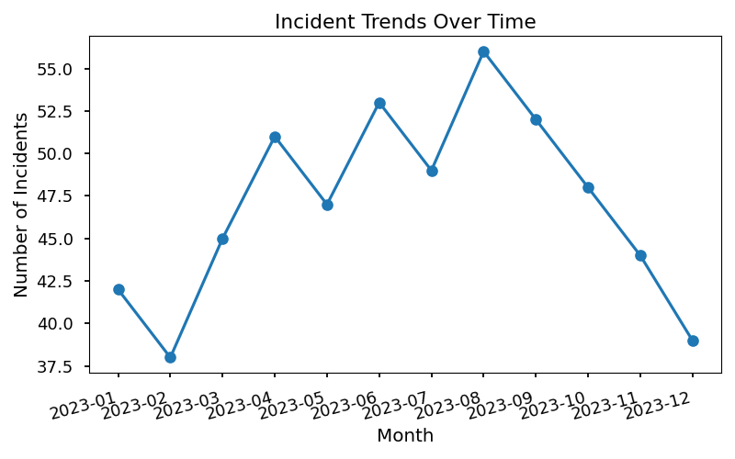

### Incident Reporting Summary Table

|  |  |  |  |
| --- | --- | --- | --- |
| **Incident Type** | **Number Reported** | **% of Total Incidents** | **Actions Taken** |
| Medication Error | 24 | 30% | RCA, staff training |
| Patient Fall | 18 | 22% | Environmental audit |
| Equipment Failure | 12 | 15% | Maintenance review |
| Diagnostic Delay | 8 | 10% | Process improvement |
| Other | 18 | 23% | Case-by-case review |

* 1: World Health Organization. “Patient Safety Incident Reporting and Learning Systems.” WHO Guidelines, 2020.
* 2: Joint Commission. “Sentinel Event Policy and Procedures.” Joint Commission Manual, 2023.

# Clinical Audit & Compliance Monitoring

Clinical audits are a cornerstone of SGMC’s approach to clinical governance and risk management. They provide a systematic, objective means of evaluating whether clinical processes, outcomes, and documentation meet established standards, regulatory requirements, and best practices. Audits serve dual purpose ensuring compliance with internal and external policies, and driving continuous improvement in patient care quality and safety. By routinely assessing clinical activities, SGMC can identify gaps, implement corrective actions, and foster a culture of accountability and excellence across all departments.

## Audit Planning & Execution

Effective audit planning and execution are essential for achieving meaningful results and ensuring that compliance objectives are met. Clinical audits at SGMC are scheduled according to a risk-based calendar, with high-priority areas (such as infection control, medication safety, and patient documentation) reviewed more frequently. Methodologies include retrospective chart reviews, direct observation, staff interviews, and process mapping. Audit teams are multidisciplinary, ensuring diverse perspectives and expertise. Each audit cycle begins with clear objectives, defined criteria, and a standardized protocol to ensure consistency and reliability in findings.

### Checklist: Clinical Audit Preparation

* Define audit objectives, scope, and criteria based on SGMC policy and regulatory standards.
* Assemble a multidisciplinary audit team; assign roles and responsibilities.
* Notify relevant department leaders and staff of upcoming audit dates and requirements.
* Review previous audit findings, corrective actions, and outstanding issues.
* Prepare audit tools (e.g., checklists, data collection forms, interview guides).
* Ensure secure access to necessary documentation, records, and systems.
* Schedule stakeholder interviews and direct observation sessions.
* Communicate confidentiality protocols and data handling requirements to all audit participants.
* Confirm logistic meeting rooms, IT support, and resource availability.
* Finalize audit timeline and reporting deadlines.

### Table: Compliance Audit Tracker

|  |  |  |  |  |  |  |
| --- | --- | --- | --- | --- | --- | --- |
| **Audit Area** | **Frequency** | **Lead Auditor** | **Last Audit Date** | **Findings Summary** | **Corrective Actions** | **Status** |
| Infection Control | Quarterly | Dr. S. Patel | 2024-03-15 | 2 minor non-compliance | Staff retraining | Closed |
| Medication Safety | Monthly | J. Lee, PharmD | 2024-05-01 | 1 major deviation | Policy revision | In Progress |
| Patient Documentation | Biannual | M. Gomez, RN | 2023-12-10 | 3 incomplete records | Template update | Closed |
| Surgical Procedures | Annual | Dr. A. Kumar | 2023-11-20 | No issues | N/A | Closed |
| Falls Prevention | Quarterly | L. Chen, PT | 2024-04-12 | 1 process gap | Workflow adjustment | In Progress |

## Documentation & Reporting

Comprehensive documentation and transparent reporting are critical components of the clinical audit process. All audit activities must be thoroughly recorded, including audit plans, methodologies, findings, and corrective actions. Reports should be clear, actionable, and distributed to relevant stakeholders, including department heads, governance committees, and the risk management team. Documentation must comply with SGMC’s internal policies, Joint Commission standards, and applicable legal requirements. Audit findings are tracked over time to monitor improvements, identify recurring issues, and ensure accountability for corrective measures. All reports are securely stored and readily accessible for accreditation surveys, regulatory inspections, and internal review.

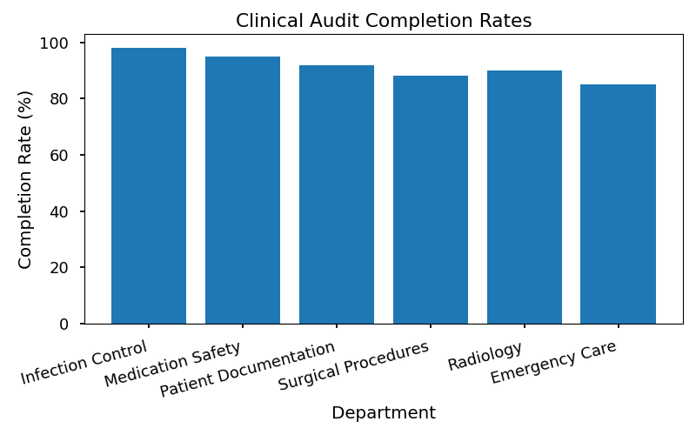

# Regulatory Standards & Accreditation

## Overview of Key Regulatory Bodies

Ensuring clinical excellence and patient safety at SGMC requires strict adherence to regulatory standards set by recognized bodies. The Joint Commission and the Centers for Medicare & Medicaid Services (CMS) are two primary organizations that establish and enforce healthcare quality benchmarks in the United States. The Joint Commission focuses on continuous improvement in patient care, safety, and organizational management through its accreditation programs. CMS, meanwhile, administers federal standards for healthcare providers participating in Medicare and Medicaid, emphasizing evidence-based protocols, reporting requirements, and patient outcomes.

Compliance with these standards is not only essential for maintaining accreditation but also for safeguarding SGMC’s reputation, minimizing legal risks, and securing reimbursement. These regulatory frameworks demand systematic documentation, robust reporting mechanisms, and ongoing staff education. SGMC integrates these requirements into daily operations, ensuring that every department is audit-ready and that best practices are embedded into clinical workflows.

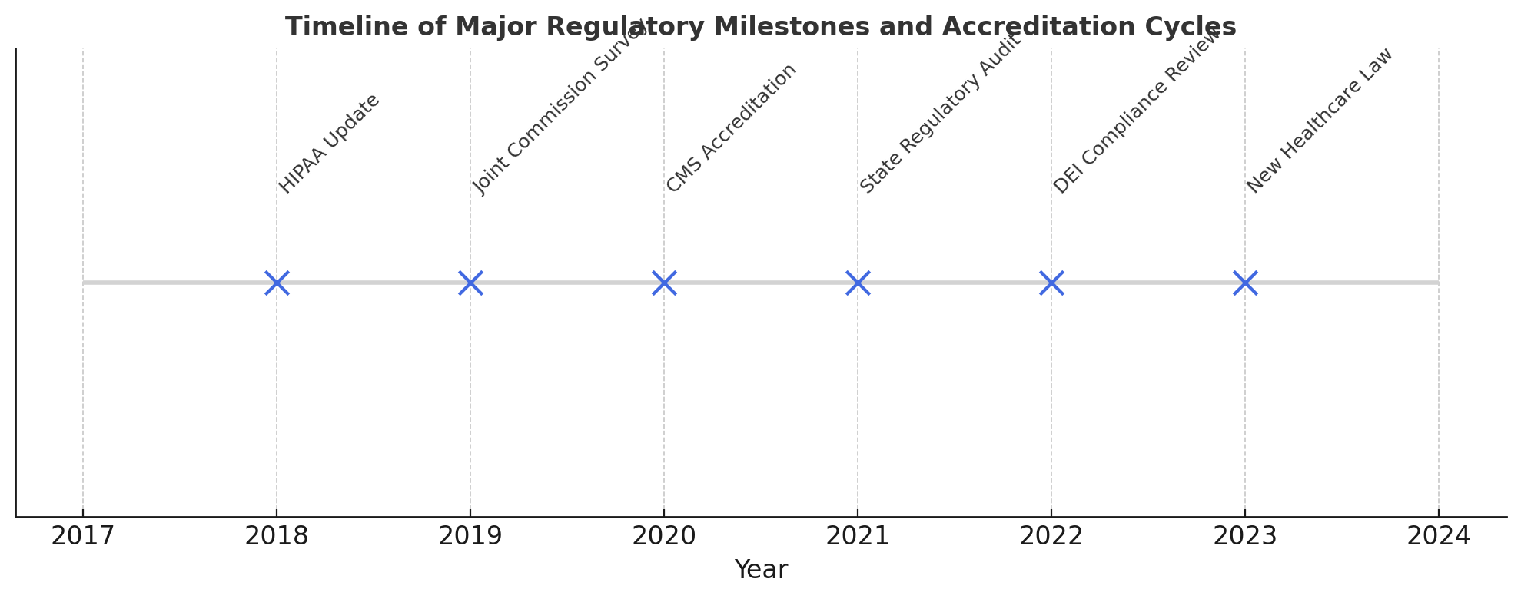

## Accreditation and Compliance Documentation Requirements

* Maintain up-to-date policies and procedures reflecting current regulatory standards.
* Document all clinical audits and compliance checks.
* Record and analyze incident reports and corrective actions.
* Track staff training and competency assessments.
* Ensure accessibility of compliance documentation for surveyors and auditors.

## Regulatory Standards Crosswalk

|  |  |  |
| --- | --- | --- |
| **Regulatory Body** | **Key Requirements** | **SGMC Policy Reference** |
| Joint Commission | Patient safety goals, incident reporting, | SGMC-CLIN-001, SGMC-RISK-01 |
|  | continuous improvement, staff training |  |
| CMS | Conditions of Participation, quality metrics, | SGMC-CLIN-003, SGMC-COMP-02 |
|  | clinical documentation, infection control |  |
| ISO 9001 | Quality management systems, risk assessment | SGMC-QUAL-005 |

* 1: The Joint Commission. Comprehensive Accreditation Manual for Hospitals. 2023 Edition.
* 2: Centers for Medicare & Medicaid Services. State Operations Manual Appendix A - Hospital. Current Version.
* 3: ISO 9001:2015 Quality Management Systems – Requirements.
* 4: SGMC Internal Policy Manual, CLIN-001.
* 5: SGMC Internal Policy Manual, RISK-01.

# Continuous Improvement & Quality Initiatives

SGMC is committed to fostering a culture of continuous improvement and quality enhancement across all clinical and operational domains. Continuous improvement is achieved through systematic methodologies that empower teams to identify areas for development, implement evidence-based changes, and monitor outcomes. By embedding these principles into daily practice, SGMC ensures that patient safety, care effectiveness, and organizational efficiency are consistently elevated. The approach is data-driven, encourages staff engagement, and is aligned with national and international healthcare standards, including those set by the Joint Commission and WHO. This outlines SGMC’s framework for ongoing quality improvement, with a particular focus on the Plan-Do-Study-Act (PDSA) cycle and real-world success metrics.

## PDSA Cycle Application

The Plan-Do-Study-Act (PDSA) cycle is a cornerstone of SGMC’s continuous improvement methodology. It provides a structured, iterative approach to testing and implementing changes in clinical practice. The following step-by-step guide illustrates how SGMC applies the PDSA cycle within its clinical setting

1. **Plan**: Identify an area for improvement, define objectives, and develop a change strategy. Gather baseline data and set measurable targets.

2. **Do**: Implement the proposed change on a small scale. Ensure that all relevant staff are informed and trained as needed.

3. **Study**: Collect data post-implementation. Analyze the results to determine whether the change led to the desired improvement.

4. **Act**: Based on findings, standardize the successful change or revise the approach and begin another cycle as necessary.

This methodology enables SGMC teams to adapt quickly, learn from each cycle, and promote sustainable improvements in patient care and operational processes.

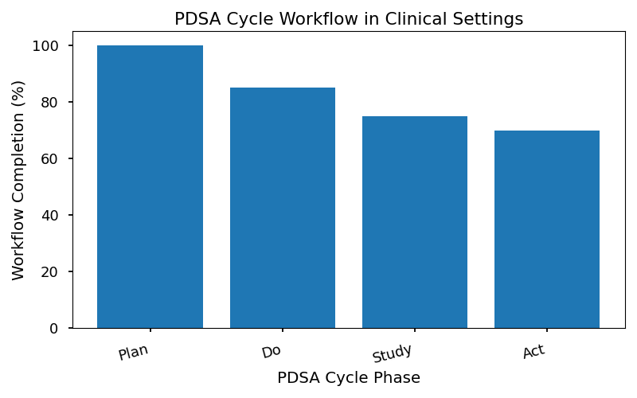

## Success Stories & Metrics

A recent example of SGMC’s commitment to quality improvement involved the reduction of medication administration errors in the inpatient medical unit. Through a targeted PDSA cycle, the team implemented barcode medication administration technology and enhanced staff training. The intervention was monitored over a three-month period, with clear metrics established to evaluate its effectiveness. As a result, medication errors decreased significantly, staff reported increased confidence in the process, and patient satisfaction scores improved.

The table below summarizes the key metrics and outcomes from this improvement project:

|  |  |  |  |
| --- | --- | --- | --- |
| **Metric** | **Baseline (Pre-intervention)** | **Post-intervention** | **Change (%)** |
| Medication Errors (monthly) | 12 | 3 | -75% |
| Staff Training Completion (%) | 65 | 100 | +35% |
| Patient Satisfaction Score | 82 | 90 | +10% |

World Health Organization. (2021). Quality of care: A process for making strategic choices in health systems. Geneva: WHO.

# Training, Education & Culture of Safety

Embedding clinical governance principles and risk management protocols into staff education is fundamental to SGMC’s commitment to patient safety and continuous quality improvement. This outlines the strategies, requirements, and activities aimed at cultivating a robust culture of safety throughout all clinical and operational areas.

## Strategies for Embedding Governance Principles into Staff Education and Onboarding

SGMC recognizes that effective clinical governance begins with comprehensive education for all staff, especially those in leadership and clinical management roles. The organization’s training approach is designed to ensure that every new and existing team member understands their responsibilities regarding patient safety, risk identification, and adherence to regulatory standards.

Onboarding programs for clinical managers include structured modules on SGMC’s governance framework, incident reporting procedures, and compliance monitoring. These modules are delivered via a combination of interactive workshops, e-learning platforms, and mentorship programs. Continuous professional development is supported through scheduled refresher courses, scenario-based learning, and access to updated policy manuals.

To reinforce these principles, SGMC integrates governance topics into mandatory annual training for all staff. This training covers the latest regulatory changes, case studies on adverse events, and lessons learned from internal audits and external accreditation reviews. Department leaders are responsible for facilitating regular safety briefings and encouraging open dialogue about risk management and quality improvement.

SGMC also utilizes feedback from staff surveys and incident debriefs to refine educational content, ensuring that training remains relevant and responsive to emerging challenges. Through these strategies, SGMC fosters an environment where governance is not only a policy requirement but a shared value among all employees.

## Governance Training Requirements for New Clinical Managers

### Checklist: Governance Training Requirements for New Clinical Managers

1. **Orientation Session**

* Attend introductory seminar on SGMC’s clinical governance framework.
* Review organization-wide safety and risk management policies.

2. **Policy Manual Review**

* Study SGMC’s internal policy manuals, including incident reporting and audit procedures.
* Complete comprehension assessment.

3. **Incident Reporting System Training**

* Participate in hands-on training for electronic incident reporting tools.
* Demonstrate proficiency in submitting and tracking incidents.

4. **Risk Assessment Workshop**

* Engage in scenario-based exercises covering risk identification and scoring.
* Collaborate with Risk Management Department on mock assessments.

5. **Compliance Documentation**

* Learn procedures for maintaining and archiving compliance records.
* Review checklist for required documentation during audits.

6. **Root Cause Analysis (RCA) Simulation**

* Complete a guided RCA exercise using a sample adverse event.
* Present findings to Quality Director and receive feedback.

7. **Quality Improvement Methodologies**

* Attend workshop on Plan-Do-Study-Act (PDSA) cycles.
* Participate in a departmental improvement project.

8. **Regulatory Standards Overview**

* Review key requirements from Joint Commission, CMS, and ISO 9001.
* Complete online quiz on regulatory compliance.

9. **Mentorship Assignment**

* Pair with experienced clinical manager for first 90 days.
* Schedule bi-weekly check-ins to discuss governance challenges.

10. **Annual Refresher Enrollment**

* Register for mandatory annual governance and risk management refresher course.
* Track participation in SGMC’s learning management system.

## Culture of Safety Promotion Activities

* Conduct regular safety huddles at the start of each shift.
* Display safety awareness posters in clinical areas.
* Organize quarterly patient safety workshops.
* Recognize staff contributions to safety through awards and incentives.
* Facilitate open forums for discussing safety concerns and near misses.
* Distribute monthly safety bulletins summarizing incident trends.
* Encourage anonymous reporting of safety issues.
* Integrate safety topics into departmental meetings.
* Provide access to online safety resources and training modules.
* Celebrate annual “Patient Safety Week” with special events and guest speakers.

# Communication & Reporting Protocols

Effective communication and reporting protocols are foundational to SGMC’s approach to clinical governance and risk management. Clear, structured communication ensures that critical governance and risk issues are identified, escalated, and addressed in a timely manner, both within the organization and with external stakeholders. These protocols support transparency, accountability, and regulatory compliance, and are designed to safeguard patient safety, protect organizational reputation, and facilitate learning from incidents.

SGMC’s communication guidelines encompass both internal and external channels. Internally, departments must follow established pathways for reporting adverse events, near misses, and compliance gaps, ensuring that information reaches the appropriate oversight bodies (such as the Clinical Governance Committee and Risk Management Department). Externally, SGMC adheres to statutory requirements for notifying regulatory agencies, accreditation bodies, and, where appropriate, patients and families. All communications must be documented in accordance with SGMC’s policy, ensuring traceability and confidentiality.

The following protocol outlines the steps for incident escalation, providing a standardized process for reporting, assessment, and response:

## Communication Protocol Steps for Incident Escalation

1. **Immediate Notification**

* Staff member identifies a governance or risk-related incident.
* Incident is reported immediately to the direct supervisor using the SGMC Incident Reporting System.
* Urgent events (e.g., patient harm, data breach) require verbal notification in addition to electronic submission.

2. **Initial Assessment**

* Supervisor conducts a preliminary review to determine severity and potential impact.
* Incident is classified (e.g., minor, moderate, severe) according to SGMC’s Risk Scoring Matrix.
* Documentation is completed in the Incident Reporting System.

3. **Escalation to Department Leadership**

* For moderate or severe incidents, supervisor notifies the Department Leader and Risk Manager within two hours.
* Department Leader reviews incident details and confirms classification.
* Risk Manager initiates formal risk assessment and mitigation planning.

4. **Notification of Governance Oversight**

* For incidents with organizational impact, Department Leader escalates to the Clinical Governance Committee and Chief Medical Officer (CMO).
* Governance Committee reviews incident and determines if external notification is required.

5. **External Communication (if applicable)**

* If incident meets regulatory reporting thresholds, Risk Manager prepares external notification for relevant agencies (e.g., Joint Commission, CMS).
* Communications team coordinates messaging for patients, families, and media as per SGMC policy.

6. **Follow-Up and Documentation**

* All communications and actions are documented in the Incident Reporting System and maintained for audit purposes.
* Feedback is provided to staff involved, and lessons learned are disseminated through internal channels.

7. **Continuous Review**

* Protocol effectiveness is reviewed quarterly by the Clinical Governance Committee.
* Updates are made to reflect regulatory changes and internal process improvements.
* **Checklist: Communication Protocol Compliance**
* [ ] Incident reported immediately via SGMC system.
* [ ] Preliminary assessment completed and documented.
* [ ] Appropriate escalation to department leadership.
* [ ] Notification to governance oversight (if required).
* [ ] External agencies notified (if applicable).
* [ ] All actions documented for audit trail.
* [ ] Protocol reviewed and updated quarterly.

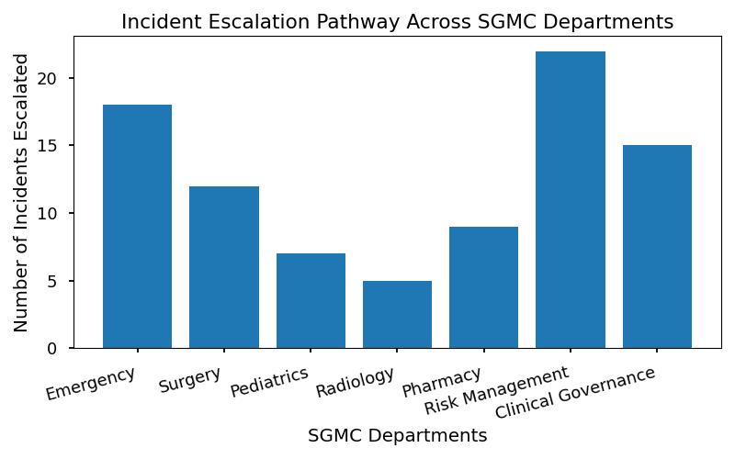

* **1:** World Health Organization. "Patient Safety Incident Reporting and Learning Systems." WHO, 2020.
* **2:** Joint Commission. "Sentinel Event Policy and Procedures." Joint Commission Resources, 2022.
* **3:** ISO 9001:2015. "Quality Management Systems – Requirements." ISO, 2015.
* **4:** SGMC Internal Policy Manual: Incident Management , 2023.
* **5:** SGMC Internal Policy Manual: Communication Protocols, 2023.

# Technology & Data Management

## Role of Technology in Supporting Clinical Governance and Risk Management

Technology plays a pivotal role in modern clinical governance and risk management, serving as the backbone for data-driven decision making, operational efficiency, and regulatory compliance. Digital solutions enable real-time monitoring of patient safety indicators, automate complex audit processes, and facilitate seamless incident reporting across hospital and provider settings. By leveraging electronic health records (EHRs), risk management software, and analytics platforms, SGMC ensures that critical information is accessible, actionable, and secure. These systems not only enhance transparency and accountability but also support continuous improvement by providing actionable insights from aggregated data. Furthermore, technology fosters multidisciplinary collaboration, enabling departments to share best practices and lessons learned, and ensuring that risk mitigation strategies are consistently applied throughout the organization.

## Overview of Risk Management Software Tools and Features

|  |  |  |  |
| --- | --- | --- | --- |
| **Software Tool** | **Key Features** | **Integration Capability** | **User Role Access** |
| SGMC Risk Tracker | Incident logging, risk scoring, dashboard alerts | EHR, HR Systems | All staff, managers |
| AuditPro | Audit scheduling, compliance tracking, reporting | Financial, EHR | Auditors, leaders |
| SafeGuard Analytics | Trend analysis, root cause analysis workflows | Incident systems | QI teams, executives |
| Compliance Monitor | Policy updates, regulatory alerts, documentation | Policy database | Compliance officers |

## Data Flow for Incident Reporting and Audit Tracking

# Legal, Ethical & Confidentiality Considerations

Clinical governance and risk management are underpinned by robust legal and ethical obligations that safeguard both patient rights and organizational integrity. SGMC adheres to national and international statutes, such as HIPAA, the Joint Commission standards, and WHO guidelines, ensuring that all clinical activities and risk management processes comply with legal mandates and ethical norms. These requirements are critical for protecting patient privacy, promoting transparency, and maintaining trust within the healthcare environment. Staff are expected to uphold these standards at all times, with breaches subject to disciplinary action and potential legal ramifications. Regular training and policy reviews help ensure that all team members remain vigilant and informed about their responsibilities regarding legal compliance and ethical conduct.

## Confidentiality Requirements and Best Practices

* Patient information must only be accessed by authorized personnel involved in care delivery.
* All clinical documentation should be stored securely, both physically and digitally, per SGMC policy.
* Staff must not discuss patient details in public areas or with unauthorized individuals.
* Electronic communications containing patient data must be encrypted and transmitted via approved channels.
* Breaches of confidentiality must be reported immediately through SGMC’s incident reporting system.

# Monitoring, Evaluation & Review

## Overview

Ensuring the effectiveness of clinical governance and risk management frameworks at SGMC requires robust, ongoing monitoring and evaluation processes. These processes are designed to systematically assess the implementation of policies, procedures, and initiatives, ensuring that standards are consistently met and areas for improvement are identified proactively. Continuous monitoring supports compliance with regulatory requirements and accreditation standards, while evaluation enables informed decision-making and the refinement of risk mitigation strategies.

Regular reviews of governance activities—such as incident reporting, clinical audits, and risk assessments—are conducted by designated committees and department leaders. These reviews utilize quantitative and qualitative metrics to measure performance, track progress against objectives, and verify adherence to internal and external standards. Feedback from these evaluations is used to update policies, inform training programs, and guide resource allocation.

Evaluation outcomes are disseminated through quarterly governance meetings, annual quality reports, and compliance dashboards. The monitoring process incorporates both retrospective analysis of incidents and prospective audits of ongoing practices. In addition, SGMC employs benchmarking against industry best practices and regulatory guidelines to ensure continual advancement in patient safety and care quality.

## Risk Mitigation Plan Review Checklist

The following checklist is used by Risk Management Departments and Clinical Governance Committees to systematically review the effectiveness and completeness of risk mitigation plans. This ensures that all identified risks are addressed adequately, and that mitigation strategies are both actionable and measurable.

|  |  |  |  |  |
| --- | --- | --- | --- | --- |
| **Step** | **Description** | **Responsible Party** | **Status (Complete/Incomplete)** | **Comments** |
| 1 | Verify all identified risks are listed in the plan. | Risk Manager |  |  |
| 2 | Confirm each risk has an assigned mitigation strategy. | Department Leader |  |  |
| 3 | Assess if mitigation strategies are SMART (Specific, Measurable, Achievable, Relevant, Time-bound). | Quality Director |  |  |
| 4 | Ensure responsible individuals are assigned for each action item. | Risk Manager |  |  |
| 5 | Review timelines for implementation and completion. | Department Leader |  |  |
| 6 | Check for necessary resources (staff, equipment, training) allocated. | Quality Director |  |  |
| 7 | Validate monitoring metrics for each mitigation strategy. | Risk Manager |  |  |
| 8 | Confirm documentation and reporting protocols are in place. | Department Leader |  |  |
| 9 | Schedule follow-up review dates and responsible parties. | Quality Director |  |  |
| 10 | Document lessons learned and update plan accordingly. | Risk Manager |  |  |

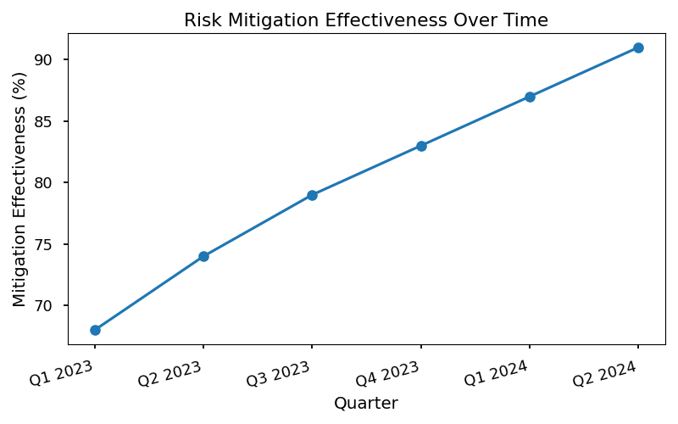

1. World Health Organization. Patient Safety and Risk Management Guidelines.

2. Joint Commission. Standards for Hospital Accreditation.

3. ISO 9001:2015 Quality Management Systems.

4. SGMC Internal Policy Manual: Risk Management Procedures.

5. SGMC Clinical Governance Annual Report, 2024.

# Appendices

## Glossary of Terms

The following glossary provides definitions for key terms utilized throughout the Clinical Governance and Risk Management Handbook. These terms are foundational to understanding the principles, procedures, and policies described within this document.

Clinical Governance:

A systematic approach to maintaining and improving the quality of patient care within a health system. It encompasses leadership, accountability, policies, and continuous improvement activities.

Risk Management:

A coordinated set of activities and methods used to direct an organization and control risks to its objectives, particularly those affecting patient safety and care quality.

Incident Reporting:

A formal process for documenting adverse events, near misses, or any occurrence that could compromise patient safety or care standards.

Root Cause Analysis (RCA):

A structured method used to analyze serious adverse events by identifying underlying problems that increase the likelihood of errors while avoiding focusing on individual mistakes.

Compliance Audit:

A comprehensive review of clinical and operational practices to ensure adherence to established standards, regulations, and policies.

PDSA Cycle (Plan-Do-Study-Act):

An iterative four-step model for carrying out change and continuous improvement in clinical processes.

Corrective Action Plan:

A documented strategy outlining the steps to address identified deficiencies or risks, assigning responsibilities and timelines for resolution.

Quality Improvement:

Ongoing efforts to enhance patient outcomes, system performance, and professional development within healthcare settings.

Accreditation:

A formal recognition by an authoritative body that an organization meets predetermined standards of quality and safety.

Below is a list of key references and s that have informed the development of this handbook. These materials provide authoritative guidance on clinical governance, risk management, and compliance.

1. World Health Organization (WHO). "Patient Safety: Making Healthcare Safer." WHO Guidelines, 2021.

2. Joint Commission. "Comprehensive Accreditation Manual for Hospitals." Joint Commission Resources, 2023.

3. International Organization for Standardization. "ISO 9001:2015 Quality Management Systems—Requirements." ISO, 2015.

4. SGMC Internal Policy Manual. "Clinical Governance and Risk Management Policies." SGMC, 2024.

5. Joint Commission International. "Root Cause Analysis in Health Care: Tools and Techniques." JCI, 2022.

Additional references and supporting materials are available upon request from the SGMC Quality and Risk Management Department.

## Forms & Templates

The following tables provide examples of forms and templates used in clinical governance and risk management processes. These resources are designed for adaptation and use across SGMC departments.

### Incident Report Form

|  |  |  |
| --- | --- | --- |
| **Field** | **Description** | **Example Entry** |
| Date of Incident | Date when event occurred | 2024-05-15 |
| Location | Department/Unit | ICU |
| Description of Event | Brief summary of incident | Medication error |
| Persons Involved | Names/roles of involved individuals | Nurse, Pharmacist |
| Immediate Actions Taken | Steps taken post-incident | Patient monitored, report filed |
| Follow-Up Required | Further investigation or actions | RCA scheduled |

### Clinical Audit Checklist

|  |  |  |  |
| --- | --- | --- | --- |
| **Audit Area** | **Compliance Criteria** | **Status** | **Comments** |
| Hand Hygiene | 100% staff compliance | Met |  |
| Medication Storage | Secured, temperature control | Not Met | Fridge temp issue |
| Documentation | Timely, complete records | Met |  |
| Equipment Checks | Daily safety checks logged | Not Met | Log missing |

### Corrective Action Plan Template

|  |  |  |  |  |
| --- | --- | --- | --- | --- |
| **Deficiency Identified** | **Responsible Person** | **Action Steps** | **Target Date** | **Status** |
| Incomplete audits | Audit Lead | Train staff, revise logs | 2024-07-01 | Pending |
| Medication errors | Pharmacy Manager | Review protocols, re-educate staff | 2024-06-15 | In Progress |
| Equipment failures | Facilities Lead | Schedule maintenance, update checklist | 2024-06-30 | Completed |

# 1 – Foundations of Clinical Governance

Clinical governance forms the cornerstone of SGMC’s commitment to delivering safe, high-quality patient care. It encompasses the systems, processes, and leadership behaviors that ensure clinical standards are met and continuously improved. SGMC’s approach integrates governance principles into strategic planning, daily operations, and staff development, creating a culture of transparency and accountability.

## Definitions and Principles

Clinical governance is defined by the World Health Organization as “a system through which healthcare organizations are accountable for continuously improving the quality of their services and safeguarding high standards of care.” At SGMC, clinical governance is built on the following pillar

* **Patient Safety:** Proactively preventing harm and responding to adverse events.
* **Quality Assurance:** Systematic monitoring and evaluation of clinical practices.
* **Accountability:** Clear roles, responsibilities, and escalation pathways.
* **Continuous Improvement:** Commitment to learning, innovation, and evidence-based change.
* **Compliance:** Adherence to regulatory, accreditation, and internal standards.

## Relationship to Organizational Strategy

SGMC’s strategic plan is tightly interwoven with clinical governance objectives. Governance priorities inform resource allocation, risk management, and performance measurement at every organizational level. By aligning governance initiatives with broader strategic goals, SGMC ensures that patient safety and quality are central to all decision-making processes.

# 2 – Governance Structure & Roles

A clearly defined governance structure is essential for effective oversight and coordination of clinical quality and risk management activities. SGMC’s governance framework assigns specific responsibilities to key leadership roles, ensuring accountability and streamlined communication.

## Governance Roles Table

|  |  |  |
| --- | --- | --- |
| **Role** | **Key Responsibility** | **Reporting To** |
| Chief Medical Officer | Overall clinical governance | CEO |
| Risk Manager | Oversees risk assessment processes | CMO |
| Quality Director | Implements quality improvement | CMO |
| Department Heads | Daily compliance within clinical units | Quality Director |
| Clinical Audit Lead | Manages audit schedules and execution | Quality Director |
| Compliance Officer | Prepares for surveys and inspections | CMO |

* Table 1: SGMC Clinical Governance Roles and Responsibilities

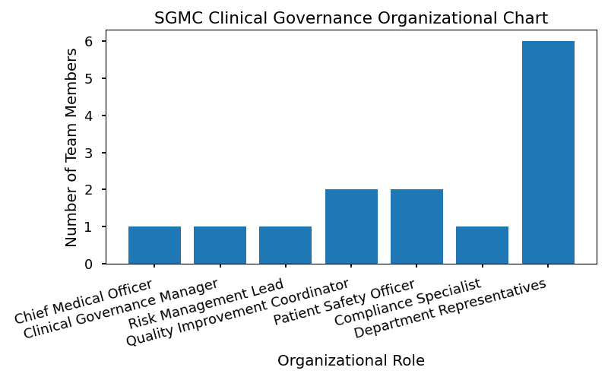

# 3 – Risk Management Framework

SGMC’s risk management framework provides a systematic approach for identifying, assessing, and mitigating risks that could impact patient safety, clinical outcomes, or organizational compliance. The framework is grounded in ISO 9001 standards and Joint Commission requirements, ensuring alignment with best practices.

## Step-by-Step Guide to Risk Identification, Assessment, and Mitigation

1. **Risk Identification:**

* Source Incident reports, audits, staff feedback, regulatory updates.
* Tool Risk registers, brainstorming sessions, process mapping.

2. **Risk Assessment:**

* Severity and likelihood scoring using standardized criteria.
* Prioritization of risks based on impact and probability.

3. **Risk Mitigation:**

* Development of action plans to address high-priority risks.
* Assignment of responsibilities and timelines.

4. **Monitoring and Review:**

* Regular evaluation of mitigation effectiveness.
* Updating risk registers and communicating outcomes.

## Risk Scoring Matrix

|  |  |  |  |  |
| --- | --- | --- | --- | --- |
| **Risk Category** | **Likelihood (1–5)** | **Severity (1–5)** | **Risk Score (L x S)** | **Priority Level** |
| Patient Safety | 4 | 5 | 20 | High |
| Compliance | 2 | 3 | 6 | Moderate |
| Operational | 3 | 2 | 6 | Moderate |
| Financial | 1 | 4 | 4 | Low |

* Table 2: Risk Assessment Matrix

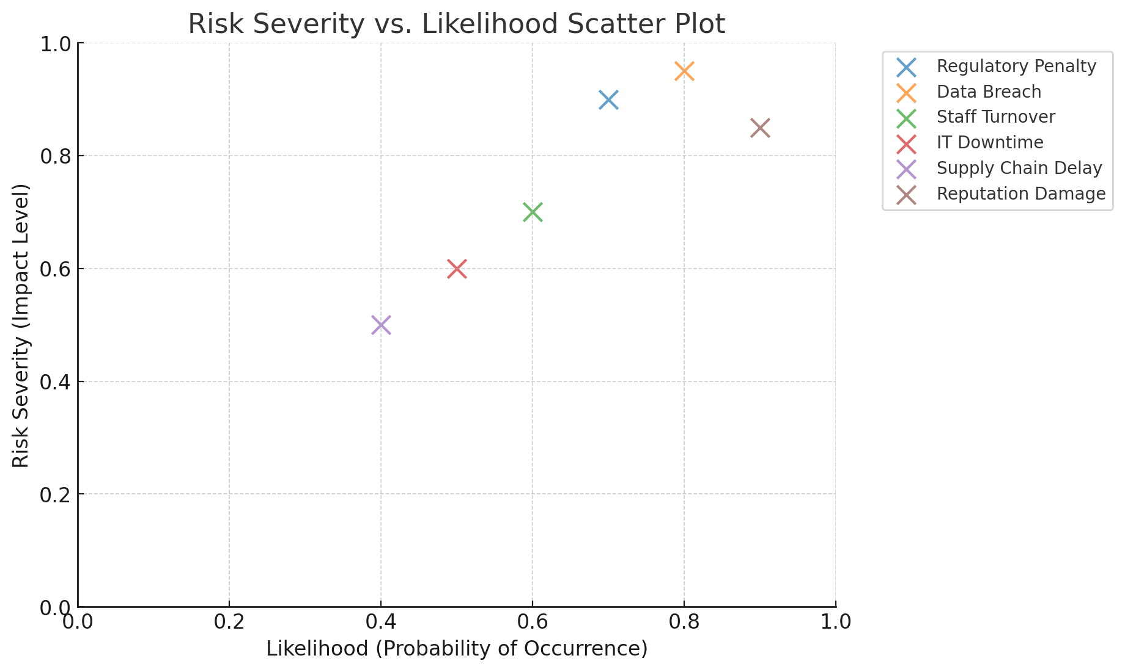

# 4 – Incident Reporting & Learning

Robust incident reporting is fundamental to SGMC’s learning culture and risk mitigation efforts. The organization encourages transparent reporting of adverse events, near misses, and unsafe conditions, followed by thorough analysis and corrective action.

## Capturing, Analyzing, and Responding to Adverse Events

* **Reporting:**
* Accessible electronic incident reporting system.
* Anonymous option available for staff.
* **Analysis**
* Immediate triage of reported incidents.
* Multidisciplinary incident review meetings.
* **Response:**
* Implementation of corrective actions.
* Feedback provided to reporting staff.

## Root Cause Analysis Workflow

1. Assemble review team.

2. Collect and analyze incident data.

3. Map contributing factors.

4. Identify root causes using tools (e.g., fishbone diagram).

5. Develop and implement corrective actions.

6. Monitor effectiveness and close the loop.

## Incident Reporting Summary Table

|  |  |  |  |  |  |
| --- | --- | --- | --- | --- | --- |
| **Incident Type** | **Q1 Count** | **Q2 Count** | **Q3 Count** | **Q4 Count** | **Yearly Total** |
| Medication Error | 12 | 9 | 15 | 11 | 47 |
| Falls | 7 | 10 | 8 | 6 | 31 |
| Infection | 5 | 6 | 7 | 5 | 23 |
| Equipment | 3 | 2 | 4 | 3 | 12 |

* Table 3: SGMC Incident Reporting Summary

# 5 – Clinical Audit & Compliance Monitoring

Clinical audits are a core element of SGMC’s quality assurance program, supporting compliance with internal policies and external standards. Audits are conducted regularly, using standardized methodologies, and findings drive targeted improvement efforts.

## Audit Schedules, Methodologies, and Documentation Requirements

* **Audit Schedule**
* Annual, quarterly, and ad hoc audits based on risk and regulatory requirements.
* **Methodologies**
* Retrospective chart reviews, observational studies, process audits.
* **Documentation Requirement**
* Detailed audit plans, checklists, and evidence logs.
* Secure storage of audit reports and corrective action documentation.

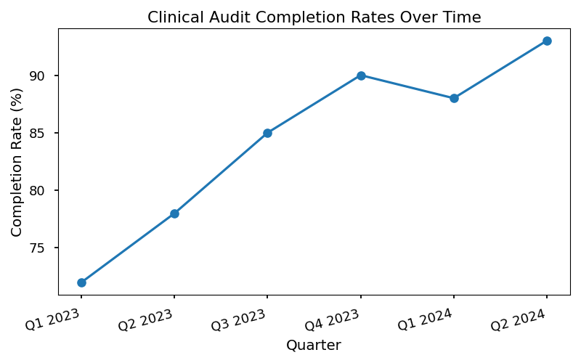

## Compliance Audit Tracker Table

|  |  |  |  |  |
| --- | --- | --- | --- | --- |
| **Audit Area** | **Scheduled Date** | **Completion Status** | **Findings Summary** | **Responsible Lead** |
| Medication Safety | 01/15/2024 | Complete | 2 minor issues | Audit Lead |
| Infection Control | 03/20/2024 | In Progress | Pending | Dept. Head |
| Documentation | 06/10/2024 | Scheduled | N/A | Compliance Off. |
| Equipment Safety | 09/05/2024 | Scheduled | N/A | Risk Manager |

* Table 4: SGMC Compliance Audit Tracker

# 6 – Continuous Improvement & Quality Initiatives

SGMC fosters a culture of continuous improvement through the application of structured methodologies, such as the Plan-Do-Study-Act (PDSA) cycle. Quality initiatives are data-driven and focused on measurable outcomes.

## PDSA Cycle Application in Clinical Contexts

1. **Plan:**

* Define the improvement objective (e.g., reduce medication errors by 20%).
* Develop a detailed intervention plan.

2. **Do:**

* Implement the intervention on a small scale.
* Collect relevant data.

3. **Study:**

* Analyze results and compare against targets.
* Identify lessons learned.

4. **Act:**

* Refine the intervention and expand implementation.
* Monitor ongoing performance.

### Example: Successful Improvement Project

* **Objective:** Reduce post-operative infection rates by 15% in surgical unit.
* Intervention: Enhanced hand hygiene protocol.
* Metric
* Baseline infection rate: 6.2%
* Post-intervention rate: 4.8%
* Reduction: 22.6%

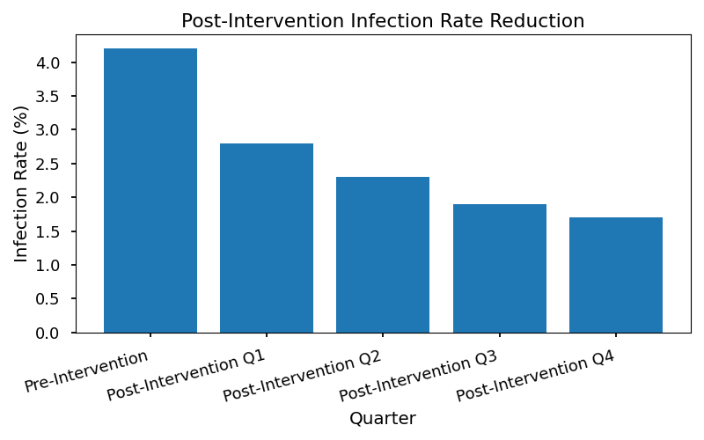

# 7 – Training & Culture of Safety

Embedding clinical governance principles into staff education is a strategic priority for SGMC. Training programs are designed to reinforce safety behaviors, regulatory compliance, and continuous improvement mindsets.

## Embedding Governance Principles into Staff Education

* **Mandatory Onboarding:**
* All new clinical managers complete governance and risk management training.
* **Ongoing Education:**
* Quarterly workshops on incident reporting, audit preparation, and risk mitigation.
* **Culture of Safety:**
* Regular communication of safety lessons learned.
* Recognition programs for exemplary safety practices.

# Checklists

## Clinical Audit Preparation Checklist

* [ ] Confirm audit schedule and scope.
* [ ] Review audit methodology and tools.
* [ ] Assemble audit team.
* [ ] Notify relevant departments.
* [ ] Prepare documentation templates.

## Incident Response Steps Checklist

* [ ] Receive and triage incident report.
* [ ] Notify appropriate leadership.
* [ ] Conduct preliminary investigation.
* [ ] Assemble review team.
* [ ] Complete root cause analysis.
* [ ] Implement corrective actions.

## Compliance Documentation Requirements Checklist

* [ ] Maintain up-to-date policy manuals.
* [ ] Secure storage of audit reports.
* [ ] Evidence of staff training.
* [ ] Incident reporting logs.
* [ ] Regulatory correspondence files.

## Risk Mitigation Plan Review Checklist

* [ ] Review latest risk register.
* [ ] Assess effectiveness of mitigation actions.
* [ ] Update action plans as needed.
* [ ] Communicate changes to stakeholders.
* [ ] Schedule next review.

1. World Health Organization (WHO). “Quality of Care: A Process for Making Strategic Choices in Health Systems.” Geneva: WHO, 2006.

2. Joint Commission. “Comprehensive Accreditation Manual for Hospitals.” Oakbrook Terrace, IL: Joint Commission Resources, 2023.

3. International Organization for Standardization (ISO). “ISO 9001: Quality Management Systems.” Geneva: ISO, 2015.

4. SGMC Internal Policy Manual, 4.2 – Risk Management Procedures, 2023.

5. SGMC Internal Policy Manual, 7.1 – Clinical Governance Framework, 2023.

# 1 – Foundations of Clinical Governance

## Definitions and Principles

Clinical governance is defined as the framework through which SGMC ensures accountability for continuously improving the quality of clinical care and safeguarding high standards of patient safety. It encompasses the systems, processes, and leadership required to deliver safe, effective, and person-centered healthcare.

Key principles include:

* **Accountability:** Clear responsibilities for quality and safety at every organizational level.
* **Transparency:** Open reporting and sharing of performance data and adverse events.
* **Patient-Centerednes** Care designed around the needs and preferences of patients.
* **Continuous Improvement:** Systematic approaches to learning and quality enhancement.
* **Risk Management:** Proactive identification and mitigation of clinical and operational risks.

## Relationship to Organizational Strategy

Clinical governance is integral to SGMC’s strategic objectives. It aligns with the hospital’s mission to deliver exceptional patient outcomes and comply with regulatory standards. Governance structures and processes are embedded within operational plans, ensuring that every department actively contributes to the organization’s quality and safety goals.

# 2 – Governance Structure & Roles

## Governance Structure Overview

SGMC’s clinical governance model is designed to provide clear oversight, accountability, and support for all quality and risk management activities. The structure ensures that key roles and committees are integrated into decision-making processes.

### Governance Roles Table

|  |  |  |
| --- | --- | --- |
| **Role** | **Key Responsibility** | **Reporting To** |
| Chief Medical Officer | Overall clinical governance | CEO |
| Risk Manager | Oversees risk assessment processes | CMO |
| Quality Director | Implements quality improvement | CMO |
| Department Leaders | Daily compliance within units | Quality Dir. |
| Compliance Officer | Regulatory adherence | CEO |
| Governance Committee | Policy oversight & strategic review | CEO |

# 3 – Risk Management Framework

## Step-by-Step Guide to Risk Identification, Assessment, and Mitigation

SGMC’s risk management framework is a systematic process designed to identify, evaluate, and address risks that could impact patient safety or care quality.

* **Step 1: Risk Identification**
* Review incident reports, audit findings, and regulatory updates.
* Engage frontline staff in hazard identification exercises.
* Use checklists and observational tools during rounds.
* **Step 2: Risk Assessment**
* Score risks using standardized criteria for severity and likelihood.
* Document risks in the centralized Risk Register.
* **Step 3: Risk Mitigation**
* Develop targeted action plans for high-priority risks.
* Assign responsibilities and monitor progress.
* Review effectiveness through follow-up audits.

### Risk Assessment Matrix Table

|  |  |  |  |
| --- | --- | --- | --- |
| **Severity** | **Likelihood** | **Risk Score** | **Mitigation Priority** |
| Catastrophic | Likely | 5 | Immediate |
| Major | Possible | 4 | High |
| Moderate | Unlikely | 3 | Medium |
| Minor | Rare | 2 | Low |
| Negligible | Rare | 1 | Monitor |

# 4 – Incident Reporting & Learning

## Capturing, Analyzing, and Responding to Adverse Events

Incident reporting is a cornerstone of SGMC’s learning culture. All staff are encouraged to report adverse events, near misses, and unsafe conditions using the electronic Incident Reporting System.

* **Reporting Step**

1. Complete the online incident form within 24 hours of event occurrence.

2. Notify department leadership and Risk Manager.

3. Initiate preliminary review for immediate patient safety concerns.

### Incident Reporting Summary Table

|  |  |  |  |
| --- | --- | --- | --- |
| **Incident Type** | **Number Reported** | **Actions Taken** | **Status** |
| Medication Error | 12 | RCA, staff retraining | Closed |
| Falls | 8 | Environmental review | Open |
| Infection Control | 5 | Policy update | Closed |
| Equipment Failure | 3 | Maintenance scheduled | Open |

### Root Cause Analysis Workflow

1. Assemble RCA team within 48 hours.

2. Gather relevant documentation and interviews.

3. Map out the event timeline and contributing factors.

4. Identify root causes and recommend corrective actions.

5. Document findings and share lessons learned.

# 5 – Clinical Audit & Compliance Monitoring

## Audit Schedules, Methodologies, and Documentation Requirements

Clinical audits are conducted regularly to ensure compliance with internal policies and external standards (Joint Commission, CMS, ISO 9001). Each department follows a defined audit schedule and methodology.

* **Audit Methodology:**
* Select audit topic based on risk and regulatory priorities.
* Use standardized audit tools and checklists.
* Document findings, corrective actions, and follow-up dates.

### Compliance Audit Tracker Table

|  |  |  |  |  |
| --- | --- | --- | --- | --- |
| **Audit Topic** | **Date Completed** | **Compliance Rate** | **Corrective Actions** | **Next Review** |
| Hand Hygiene | 2024-01-15 | 98% | Re-education | 2024-04-15 |
| Medication Storage | 2024-02-10 | 95% | Equipment update | 2024-05-10 |
| Documentation | 2024-03-05 | 92% | Process review | 2024-06-05 |
| Infection Control | 2024-04-01 | 97% | Policy revision | 2024-07-01 |

# 6 – Continuous Improvement & Quality Initiatives

## PDSA Cycle Application in Clinical Contexts

The Plan-Do-Study-Act (PDSA) cycle is used to drive continuous improvement in care delivery.

* **PDSA Step**

1. **Plan:** Identify an area for improvement and set objectives.

2. **Do:** Implement the change on a small scale.

3. **Study:** Analyze data and evaluate results.

4. **Act:** Standardize successful changes or revise the plan.

### Example: Reducing Patient Falls

* **Plan:** Implement hourly rounding protocol.
* **Do:** Pilot in orthopedic ward for 3 months.
* **Study:** Monitor fall rates, patient feedback, and staff adherence.
* **Act:** Expand protocol hospital-wide after positive results.

### Corrective Action Plan Tracker Table

|  |  |  |  |  |
| --- | --- | --- | --- | --- |
| **Issue Identified** | **Action Plan** | **Responsible Party** | **Due Date** | **Status** |
| High fall rates | Hourly rounding | Nurse Manager | 2024-03-31 | Complete |
| Documentation gaps | Staff training | Educator | 2024-04-15 | Ongoing |
| Infection spikes | Protocol review | IPC Lead | 2024-05-01 | Pending |
| Medication errors | Double-check process | Pharmacy Dir. | 2024-06-01 | Ongoing |

# 7 – Training & Culture of Safety

## Embedding Governance Principles into Staff Education

SGMC is committed to fostering a culture of safety through comprehensive education and training programs. All new clinical managers complete onboarding modules covering clinical governance, risk management, and incident reporting.

* **Training Component**
* Mandatory governance orientation for new staff.
* Annual refresher courses on risk management and compliance.
* Simulation-based learning for incident response.
* Departmental workshops on audit preparation and PDSA cycles.

# Checklists

## Clinical Audit Preparation Checklist

1. Review audit schedule and assigned topics.

2. Gather relevant policies and procedures.

3. Prepare audit tools and documentation templates.

4. Notify department staff of upcoming audit.

5. Confirm audit logistics and timing.

## Incident Response Steps Checklist

1. Ensure immediate patient safety.

2. Report the incident in the electronic system.

3. Notify department leadership.

4. Initiate preliminary review.

5. Document actions taken.

## Compliance Documentation Requirements Checklist

1. Maintain up-to-date policy manuals.

2. Store completed audit reports securely.

3. Track corrective actions and follow-up dates.

4. Archive incident reports as per retention policy.

5. Verify regulatory submissions.

## Risk Mitigation Plan Review Checklist

1. Assess effectiveness of implemented actions.

2. Update risk register with current status.

3. Re-score residual risk.

4. Schedule follow-up audit.

5. Communicate results to relevant stakeholders.

# Stakeholder Engagement & Collaboration

Effective stakeholder engagement is a cornerstone of robust clinical governance and risk management within SGMC. Involving diverse stakeholders ensures that policies and procedures are well-informed, practical, and reflective of real-world challenges faced by clinical teams. Engaged stakeholders foster transparency, accountability, and a culture of continuous improvement, which are essential for safeguarding patient safety and care quality. By actively collaborating with both internal and external parties, SGMC can more effectively identify risks, implement best practices, and comply with regulatory requirements.

## Internal Stakeholder Roles

Internal stakeholders play crucial and varied roles in the governance and risk management processes. Their responsibilities span strategic oversight, operational implementation, compliance monitoring, and frontline feedback. The following are key internal stakeholders and their primary responsibilitie

* **Executive Leadership (CEO, COO, CFO):** Sets organizational strategy, allocates resources, and ensures alignment with governance objectives.
* **Chief Medical Officer (CMO):** Provides clinical oversight, ensures compliance with medical standards, and leads quality improvement initiatives.
* **Risk Manager:** Identifies, assesses, and mitigates clinical and operational risks; oversees incident reporting and analysis.
* **Quality Director:** Develops and implements quality assurance programs, monitors audit outcomes, and drives continuous improvement.
* **Department Leaders (Nursing, Pharmacy, Laboratory, etc.):** Ensures daily compliance with policies, manages staff training, and reports incidents.
* **Clinical Governance Committee** Reviews governance metrics, monitors risk trends, and recommends corrective actions.
* **Frontline Staff (Physicians, Nurses, Allied Health Professionals):** Adheres to protocols, reports adverse events, and participates in improvement initiatives.
* **Information Technology (IT) Team:** Maintains secure data systems for incident reporting and audit tracking.
* **Human Resources (HR):** Coordinates staff training, onboarding, and competency assessments related to governance.

### Stakeholder Engagement Activities and Frequency

|  |  |  |
| --- | --- | --- |
| **Stakeholder Group** | **Engagement Activity** | **Frequency** |
| Executive Leadership | Strategic review meetings | Quarterly |
| Chief Medical Officer | Clinical governance committee | Monthly |
| Risk Manager | Risk assessment workshops | Bi-monthly |
| Quality Director | Audit result presentations | Monthly |
| Department Leaders | Unit-level compliance huddles | Weekly |
| Clinical Governance Committees | Governance dashboard review | Quarterly |
| Frontline Staff | Incident reporting feedback sessions | Bi-monthly |
| IT Team | System security audits | Annually |
| Human Resources | Staff training seminars | Quarterly |

## External Partnerships

SGMC recognizes that collaboration with external agencies, patient advocacy groups, and regulatory bodies is vital for maintaining best practices in clinical governance and risk management. These partnerships provide access to the latest guidelines, benchmarking opportunities, and support for accreditation processes. Engaging with external stakeholders ensures that SGMC remains compliant with national and international standards, incorporates patient perspectives into care delivery, and participates in broader health system improvement initiatives. Through regular communication, joint projects, and shared learning, SGMC strengthens its governance framework and enhances the quality and safety of patient care.

# Patient & Family Involvement

### Strategies for Incorporating Patient and Family Perspectives into Governance and Risk Management

SGMC recognizes that the involvement of patients and their families is central to effective clinical governance and robust risk management. By integrating patient voices into decision-making processes, the organization ensures that care delivery remains patient-centered, responsive, and aligned with actual needs and expectations. Patient and family perspectives are systematically gathered and analyzed to inform policy development, risk mitigation strategies, and service improvement initiatives. This approach not only enhances the quality and safety of care but also fosters trust, transparency, and shared accountability between healthcare providers and the community they serve. SGMC’s governance framework mandates regular engagement with patients and families at multiple levels, from bedside care to strategic planning, ensuring their feedback directly shapes organizational priorities and actions.

### Methods for Soliciting Patient Feedback and Participation

* Conducting regular patient satisfaction surveys.
* Hosting patient and family advisory councils.
* Implementing suggestion boxes throughout clinical areas.
* Facilitating focus groups on specific clinical topics.
* Offering opportunities for patients to participate in quality improvement projects.
* Inviting patient representatives to governance committee meetings.
* Providing accessible channels for complaints and compliments.

# Risk Communication & Transparency

Transparent and effective risk communication is a cornerstone of SGMC’s clinical governance and risk management framework. Ensuring that risk-related information is clearly conveyed both within SGMC and to external stakeholders—including regulatory bodies, patients, and partner organizations—supports a culture of accountability and continuous improvement. Best practices dictate that risk communication should be timely, accurate, and actionable, empowering all parties to understand the nature and implications of identified risks, as well as the steps being taken to mitigate them. This transparency not only facilitates regulatory compliance but also strengthens trust in SGMC’s commitment to patient safety and organizational integrity.

## Steps for Communicating Risk Findings and Mitigation Plans

1. **Risk Identification and Documentation**

* Collect and document risk data through incident reports, audits, and staff feedback.
* Validate findings with relevant department leaders and risk management teams.

2. **Initial Internal Notification**

* Notify key internal stakeholders (e.g., Chief Medical Officer, Risk Manager, Quality Director) of significant risks.
* Use established communication channels such as governance committee meetings and secure digital platforms.

3. **Risk Assessment and Prioritization**

* Assess the severity and likelihood of each risk using the SGMC risk scoring matrix.
* Prioritize risks based on potential impact on patient safety and regulatory compliance.

4. **Development of Mitigation Plans**

* Collaborate with responsible departments to design actionable mitigation strategies.
* Assign clear responsibilities and timelines for implementation.

5. **Formal Communication to Wider Internal Audience**

* Disseminate risk findings and mitigation plans to all affected units via email bulletins, intranet updates, and staff briefings.
* Include summary reports and visual aids (e.g., charts, infographics) for clarity.

6. **External Communication (if applicable)**

* Prepare formal communications for external parties such as regulatory agencies, accreditation bodies, and—where appropriate—patients and families.
* Ensure messaging is consistent with SGMC policies and regulatory requirements.

7. **Follow-Up and Feedback**

* Monitor the implementation of mitigation plans.
* Solicit feedback from stakeholders to assess understanding and effectiveness.
* Update communication as required based on outcomes and ongoing risk evaluation.

## Risk Communication Channels and Responsible Parties

|  |  |  |  |
| --- | --- | --- | --- |
| **Communication Channel** | **Responsible Party** | **Audience** | **Frequency** |
| Governance Committee Mtg. | Chief Medical Officer | Committee Members | Quarterly |
| Email Bulletins | Risk Manager | Department Leaders | As needed |
| Intranet Updates | Quality Director | All Staff | Monthly |
| Incident Debrief Sessions | Department Leaders | Unit Staff | Post-incident |
| Regulatory Reports | Compliance Officer | External Regulators | Per requirement |
| Patient Notifications | Patient Safety Officer | Patients/Families | Case-by-case |

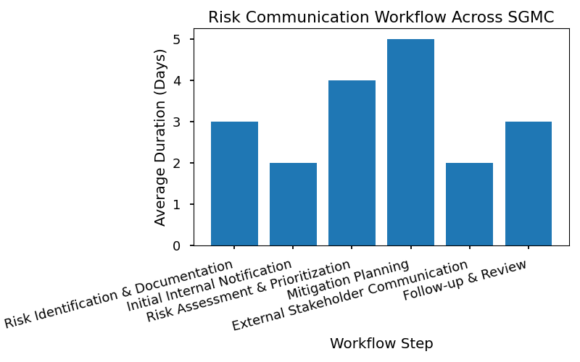

# Emergency Preparedness & Response

Effective emergency preparedness is a critical component of clinical governance and risk management within SGMC. By integrating risk management principles into emergency planning, the organization ensures rapid, coordinated responses to incidents that threaten patient safety, operational continuity, and regulatory compliance. This proactive approach minimizes harm, supports legal defensibility, and maintains public trust during crises.

SGMC's emergency preparedness framework aligns with national and international standards, including those set forth by the Joint Commission and WHO, and is designed to address a diverse range of emergencies—such as natural disasters, infectious disease outbreaks, mass casualty events, and internal system failures. The protocols and tools outlined in this enable staff to identify risks, respond effectively, and recover operations swiftly, supporting both patient care and organizational resilience.

## Emergency Protocols

Below are the key emergency response protocols and responsibilities that underpin SGMC’s preparedness strategy:

* **Activation of Incident Command System (ICS):**
* Initiate ICS upon notification of an emergency event.
* Assign roles based on pre-established command structure.
* **Risk Assessment and Triage:**
* Conduct immediate risk assessment using the SGMC Risk Scoring Matrix.
* Prioritize patient care and resource allocation according to severity.
* **Communication Protocol**
* Notify internal stakeholders (clinical teams, leadership) and external agencies (local authorities, regulatory bodies).
* Use standardized communication templates for rapid information dissemination.
* **Resource Mobilization:**
* Deploy emergency supplies and equipment from designated storage areas.
* Assign staff to critical functions, ensuring adequate coverage.
* **Evacuation and Shelter-in-Place Procedure**
* Follow established evacuation routes and protocols for safe patient transfer.
* Implement shelter-in-place measures when external evacuation is not feasible.
* **Documentation and Incident Reporting:**
* Record all actions and decisions in the emergency log.
* Complete initial incident report within two hours of event onset.
* **Post-Incident Review and Debrief:**
* Conduct root cause analysis and debrief with involved teams.
* Update protocols based on lessons learned.

### Emergency Preparedness Checklist

|  |  |  |  |
| --- | --- | --- | --- |
| **Task** | **Responsible Party** | **Frequency** | **Status** |
| Review and update emergency protocols | Risk Manager | Quarterly | [ ] Complete |
| Conduct emergency drills | Department Leaders | Biannually | [ ] Complete |
| Inventory emergency supplies | Facilities Supervisor | Monthly | [ ] Complete |
| Verify staff emergency training records | HR Coordinator | Annually | [ ] Complete |
| Test communication systems | IT Lead | Quarterly | [ ] Complete |

### Emergency Response Workflow

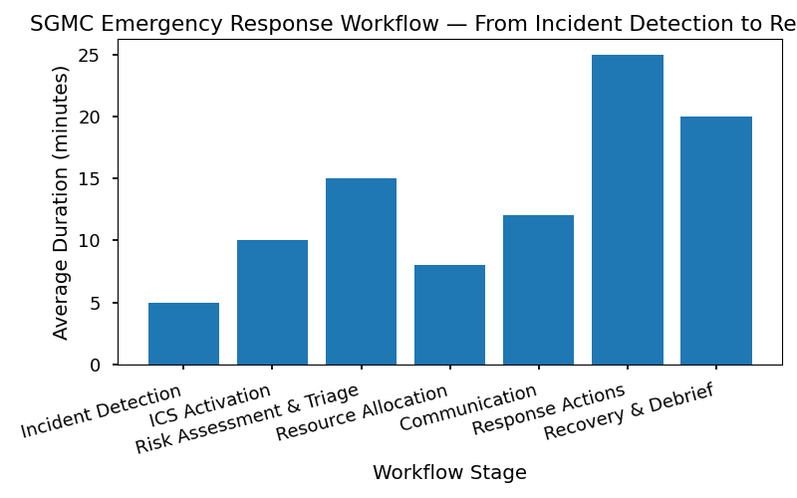

This workflow chart illustrates the sequential steps SGMC staff should follow during an emergency event, beginning with incident detection, activation of the incident command system, assessment and triage, resource mobilization, communication, documentation, and concluding with post-incident review and continuous improvement.

# Data Privacy & Security in Clinical Governance

Ensuring the privacy and security of patient data is a foundational element of clinical governance at SGMC. Safeguarding sensitive health information is not only a legal and ethical obligation but also critical to maintaining patient trust and organizational integrity. SGMC adheres to national and international privacy regulations, including HIPAA and GDPR, and follows best practices outlined by the World Health Organization (WHO) and Joint Commission recommendations. All clinical staff, administrators, and third-party partners are required to comply with established data protection protocols, participate in regular training, and report any suspected breaches promptly. The organization leverages robust technical controls, clear policies, and continuous monitoring to minimize risks and ensure swift, coordinated responses to any data security incidents.

## Data Protection Measures and Responsibilities

* **Use of Secure Electronic Health Records (EHR):** All patient records must be stored and accessed through approved, encrypted EHR systems.
* **Role-Based Access Control** Staff access to patient data is limited to only what is necessary for their clinical or administrative duties.
* **Regular Staff Training:** Mandatory annual training sessions on data privacy, phishing awareness, and breach protocols.
* **Physical Security Measure** Secure workstations, locked file cabinets, and restricted access to sensitive areas.
* **Incident Reporting:** Immediate reporting of any suspected data breaches or unauthorized access to the Risk Manager.
* **Audit Trail** All access to patient data is logged and reviewed regularly for unusual activity.

## Data Breach Response Plan

|  |  |  |  |  |
| --- | --- | --- | --- | --- |
| **Step** | **Responsibility** | **Timeline** | **Key Actions** | **Documentation Required** |
| Detection & Initial Reporting | All Staff | Immediate | Identify breach, notify Risk Manager | Incident Report Form |
| Containment | IT Security Team | Within 2 hours | Isolate affected systems, prevent further unauthorized access | System Logs, Access Records |
| Assessment & Classification | Risk Manager | Within 4 hours | Determine scope, classify severity | Breach Assessment Checklist |
| Notification | Compliance Officer | Within 24 hours | Notify affected individuals, regulatory authorities | Notification Letters, Regulatory Forms |
| Investigation | Risk Manager & IT Team | 1–3 days | Conduct root cause analysis, document findings | Investigation Report |
| Remediation | Department Leaders | 1–7 days | Implement corrective actions, update policies | Remediation Plan, Updated Procedures |
| Review & Learning | Clinical Governance Committee | Within 2 weeks | Review incident, share lessons learned, update training | Meeting Minutes, Training Materials |

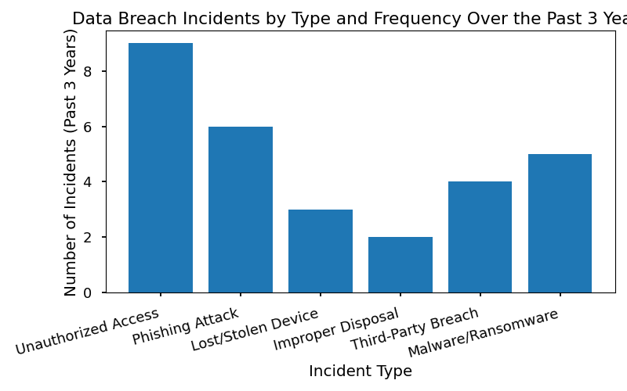

* 1: Data privacy protocols are established in accordance with WHO’s “Guidance on Health Data Security” (WHO, 2021).
* 2: SGMC internal policy manual, 4.2, “Data Protection and Privacy.”

# Performance Measurement & Benchmarking

Performance measurement is a critical component of effective clinical governance and risk management, providing objective data to guide decision-making, support continuous improvement, and demonstrate compliance with regulatory requirements. SGMC employs a systematic approach to measuring performance, integrating both quantitative and qualitative metrics to evaluate the effectiveness of its governance structures, risk mitigation strategies, and overall care quality. Benchmarking against national standards ensures that SGMC remains aligned with best practices and regulatory expectations, while ongoing monitoring of key indicators enables timely identification of areas for improvement.

Regular performance reviews are conducted at multiple organizational levels, including department meetings, governance committee sessions, and executive oversight. Data sources include incident reporting systems, audit results, patient feedback, and compliance documentation. These reviews not only support accreditation and external audits but also foster a culture of transparency and accountability. By leveraging robust measurement frameworks, SGMC ensures that clinical governance and risk management remain dynamic, evidence-based, and responsive to evolving challenges.

## Key Performance Indicators (KPIs)

SGMC utilizes a comprehensive set of Key Performance Indicators (KPIs) to assess and monitor the effectiveness of its clinical governance and risk management processes. These KPIs are selected to reflect both regulatory requirements and internal priorities for patient safety, quality improvement, and operational excellence. Core KPIs include:

* **Incident Rate per 1,000 Patient Day** Tracks the frequency of reported adverse events and near-misses, enabling targeted interventions.
* **Compliance Audit Completion Rate:** Measures the percentage of scheduled audits completed within the designated timeframe.
* **Corrective Action Implementation Rate:** Assesses the timeliness and effectiveness of actions taken in response to identified risks or audit findings.
* **Staff Training Compliance:** Monitors the proportion of clinical staff who have completed mandatory governance and risk management training modules.
* **Patient Satisfaction Score** Evaluates patient-reported outcomes related to safety and quality of care.
* **Root Cause Analysis (RCA) Turnaround Time:** Measures the average time taken to complete RCA for reported incidents.
* **Risk Mitigation Plan Review Frequency:** Tracks how often risk mitigation plans are reviewed and updated.
* **Documentation Accuracy in Incident Report** Assesses the completeness and reliability of incident reporting data.
* **Benchmark Achievement Rate:** Compares SGMC’s performance against established national or international benchmarks.
* **Regulatory Compliance Rate:** Monitors adherence to external standards such as Joint Commission, CMS, and ISO 9001.

These KPIs are reviewed quarterly, with results disseminated to relevant committees and department leaders to inform strategic planning and operational adjustments.

### Benchmarking SGMC Performance Against National Standards

|  |  |  |  |
| --- | --- | --- | --- |
| **Indicator** | **SGMC Performance** | **National Standard** | **Benchmark Status** |
| Incident Rate (per 1,000 pt days) | 2.1 | ≤2.5 | Met |
| Audit Completion Rate (%) | 96 | ≥95 | Exceeded |
| RCA Turnaround Time (days) | 7 | ≤10 | Met |
| Staff Training Compliance (%) | 99 | ≥98 | Exceeded |
| Patient Satisfaction Score (%) | 93 | ≥90 | Exceeded |
| Regulatory Compliance Rate (%) | 100 | 100 | Met |

# Financial Risk & Resource Management

Clinical governance is not solely concerned with clinical quality and safety—it also encompasses the prudent management of financial risks associated with healthcare delivery. Effective financial risk management ensures that SGMC’s clinical operations remain sustainable, compliant, and responsive to changing regulatory and market conditions. By integrating financial stewardship into clinical governance, SGMC can safeguard resources, optimize cost-effectiveness, and support ongoing quality improvement initiatives. The following outlines key financial risk factors, mitigation strategies, and resource allocation principles vital to robust governance.

## Financial Risk Factors and Mitigation Strategies

The following are the principal financial risks encountered in clinical governance and the corresponding mitigation strategies adopted by SGMC:

* **Revenue Cycle Disruption:** Billing errors, coding inaccuracies, and delayed claims can result in lost revenue and compliance penalties.
* Mitigation: Regular audit of billing processes, staff training on coding standards, and implementation of automated claim tracking systems.
* **Compliance Fines and Legal Cost** Non-compliance with regulatory requirements (e.g., CMS, Joint Commission) can lead to substantial fines and legal expenses.
* Mitigation: Routine compliance audits, continuous staff education, and proactive policy updates aligned with regulatory changes.
* **Cost Overruns in Quality Initiative** Quality improvement projects may exceed budget due to poor planning or scope creep.
* Mitigation: Detailed project budgeting, milestone-based funding releases, and periodic financial reviews.
* **Resource Misallocation:** Inefficient allocation of funds and personnel can hinder risk management efforts and clinical operations.
* Mitigation: Data-driven resource planning, prioritization of high-impact risk areas, and regular evaluation of resource utilization.
* **Insurance Gaps and Claims Risk:** Inadequate insurance coverage or poor claims management can expose SGMC to financial loss.
* Mitigation: Comprehensive insurance review, claims management system upgrades, and staff training on incident documentation.
* **Investment in Technology:** Failure to invest in modern risk management and clinical governance technologies may result in competitive disadvantage and inefficiencies.
* Mitigation: Strategic technology investment planning, ROI analysis, and phased implementation of new systems.
* **Fraud and Financial Abuse:** Instances of fraud, theft, or misuse of funds threaten organizational integrity and financial stability.
* Mitigation: Strong internal controls, whistleblower protection policies, and regular forensic audits.

## Resource Allocation for Risk Management Initiatives

The following table provides a simplified overview of how SGMC allocates resources to support risk management and clinical governance initiative

|  |  |  |  |
| --- | --- | --- | --- |
| **Initiative** | **Budget Allocation (%)** | **Personnel Assigned** | **Technology Investment** |
| Compliance Audits | 20% | 3 FTEs | Audit software |
| Incident Reporting System Upgrade | 15% | 2 FTEs | Reporting platform |
| Staff Training & Education | 25% | 5 FTEs | E-learning modules |
| Quality Improvement Projects | 30% | 4 FTEs | Analytics tools |
| Insurance Review & Management | 10% | 1 FTE | Claims management |

By systematically identifying financial risks and strategically allocating resources, SGMC ensures that clinical governance remains both effective and sustainable. This approach supports compliance, mitigates operational risks, and promotes a culture of fiscal responsibility across all clinical departments.

# Innovation & Change Management

Innovation is a cornerstone of continuous improvement in clinical practice, enabling healthcare organizations such as SGMC to adapt to evolving patient needs, regulatory requirements, and technological advancements. While fostering innovation is essential for driving better outcomes, it must be balanced with robust risk management strategies to safeguard patient safety and maintain compliance. This outlines SGMC’s approach to supporting innovation, emphasizing the integration of clinical governance principles to ensure that new practices, technologies, and processes are systematically evaluated, implemented, and monitored for effectiveness and safety.

SGMC encourages staff at all levels to propose and pilot innovative solutions, with oversight from clinical governance committees to assess potential risks and benefits. The organization’s structured framework ensures that change is managed responsibly, with clear accountability, stakeholder involvement, and alignment with strategic objectives. By embedding risk management into the innovation process, SGMC aims to create a culture where creative problem-solving is both encouraged and regulated, minimizing unintended consequences and maximizing value for patients and providers.

## Change Implementation

Implementing change within clinical governance is a complex, multi-step process that requires careful planning, stakeholder engagement, and ongoing evaluation. The following steps detail SGMC’s recommended approach for introducing changes in clinical governance processe

1. **Needs Assessment and Opportunity Identification**

* Conduct a thorough analysis to identify areas for improvement or innovation.
* Gather input from frontline staff, patients, and leadership to ensure alignment with organizational goals.

2. **Risk Assessment and Feasibility Analysis**

* Evaluate potential risks and benefits associated with the proposed change.
* Utilize established risk scoring matrices to quantify and prioritize risks.
* Assess resource requirements and operational feasibility.

3. **Stakeholder Engagement and Communication**

* Involve relevant stakeholders early in the process, including clinical teams, risk managers, and patient representatives.
* Develop a communication plan to articulate the rationale, expected outcomes, and impact of the change.

4. **Development of Implementation Plan**

* Outline specific actions, timelines, and responsibilities.
* Define key performance indicators (KPIs) and success metrics.
* Ensure compliance with regulatory standards and SGMC policies.

5. **Pilot Testing and Evaluation**

* Implement the change on a small scale to assess effectiveness and identify unforeseen issues.
* Collect and analyze data to inform necessary adjustments.

6. **Full-scale Rollout and Monitoring**

* Expand implementation across relevant departments or units.
* Monitor outcomes continuously, using established audit and reporting mechanisms.
* Provide training and support to staff to facilitate adoption.

7. **Review, Feedback, and Continuous Improvement**

* Solicit feedback from all stakeholders.
* Review results against KPIs and regulatory requirements.
* Refine processes based on lessons learned and integrate successful changes into standard practice.

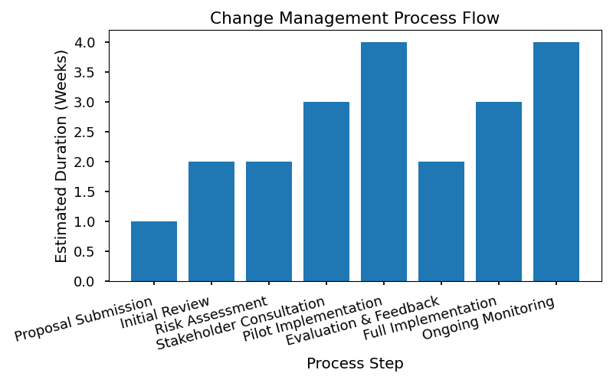

# Supplier & Contractor Risk Management

Ensuring robust governance and risk management standards with external suppliers and contractors is critical to SGMC’s overall clinical safety and operational resilience. Suppliers and contractors, ranging from medical device vendors to outsourced service providers, must comply with SGMC’s clinical governance policies, regulatory mandates, and risk mitigation protocols. By proactively managing these relationships, SGMC minimizes exposure to supply chain disruptions, regulatory non-compliance, and patient safety risks. The following outlines the essential criteria for supplier risk assessment and provides a detailed schedule for monitoring contractor compliance.

## Supplier Risk Assessment Criteria

To safeguard clinical and operational integrity, SGMC evaluates suppliers using the following risk assessment criteria:

* Regulatory compliance status (e.g., FDA, ISO 9001 certification)
* Past performance and incident history
* Financial stability and business continuity planning
* Data security and patient confidentiality protocols
* Ability to meet SGMC’s quality standards and delivery timelines

## Contractor Compliance Monitoring Schedule

The table below provides a comprehensive schedule for monitoring contractor compliance across critical domains. This schedule ensures that all contractors are regularly evaluated against SGMC’s standards, with clear accountability and escalation pathways for non-compliance.

|  |  |  |  |  |  |  |  |
| --- | --- | --- | --- | --- | --- | --- | --- |
| **Contractor Name** | **Service Provided** | **Compliance Domain** | **Frequency of Review** | **Responsible Department** | **Last Audit Date** | **Next Scheduled Audit** | **Escalation Procedure** |
| MedSupply Co. | Surgical Instruments | Regulatory | Quarterly | Procurement | 2024-04-10 | 2024-07-10 | Notify CMO; Suspend contract |
| CleanCare Services | Facility Cleaning | Infection Control | Monthly | Environmental Health | 2024-05-01 | 2024-06-01 | Issue corrective action |
| TechHealth IT | EHR System Maintenance | Data Security | Biannual | IT Security | 2023-12-15 | 2024-06-15 | Report to CIO |
| PharmaDirect | Medication Supply | Quality Assurance | Quarterly | Pharmacy | 2024-03-20 | 2024-06-20 | Review with Quality Director |
| SafeTrans Logistics | Patient Transport | Staff Credentialing | Monthly | HR Compliance | 2024-05-05 | 2024-06-05 | Immediate suspension |

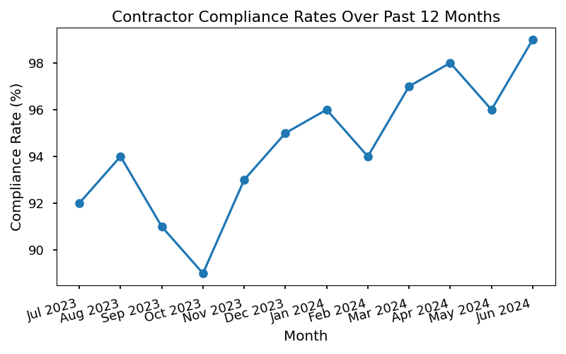

* 1: SGMC Supplier Management Policy Manual, 3.2
* 2: Joint Commission Standard LD.04.03.09
* 3: ISO 9001:2015, Clause 8.4
* 4: WHO Guidelines on Health Care Supplier Risk Management
* 5: SGMC Annual Compliance Audit Report, 2023

# Sustainability & Environmental Risk Considerations

### Addressing Environmental Risks and Promoting Sustainability in Clinical Governance

In modern healthcare, sustainability and environmental risk management are integral components of effective clinical governance. SGMC recognizes that clinical operations have a significant impact on the environment, both directly through resource consumption and waste generation, and indirectly through procurement and supply chain activities. Addressing these risks is essential not only for regulatory compliance but also for safeguarding patient health and community well-being. By integrating environmental considerations into clinical governance, SGMC aims to minimize its ecological footprint, ensure responsible resource stewardship, and foster a culture of sustainability throughout the organization.

Environmental risk management involves identifying, assessing, and mitigating factors that may negatively impact the environment or compromise patient safety due to environmental hazards. Promoting sustainability within clinical governance requires collaboration across departments, the adoption of best practices in energy and waste management, and ongoing education for staff. These efforts contribute to enhanced operational resilience, reduced costs, and improved public perception, aligning with SGMC’s commitment to continuous improvement and excellence in care.

### Environmental Risk Factors in Healthcare Settings

* Improper disposal of hazardous medical waste
* Excessive energy consumption in clinical facilities
* Water usage inefficiencies
* Use of non-renewable or toxic materials
* Air quality concerns from facility operations
* Inefficient procurement and supply chain practices

### Sustainability Initiatives and Outcomes

|  |  |  |
| --- | --- | --- |
| **Initiative** | **Description** | **Outcome/Metric** |
| Medical Waste Segregation | Separation of hazardous and non-hazardous waste | 25% reduction in landfill waste |
| Energy-Efficient Lighting | Installation of LED fixtures in all wards | 18% decrease in energy costs |
| Water Conservation Program | Low-flow faucets and leak monitoring | 12% reduction in water usage |
| Green Procurement Policy | Sourcing eco-friendly supplies | 30% of supplies certified green |
| Staff Sustainability Training | Workshops on environmental best practices | 85% staff participation rate |

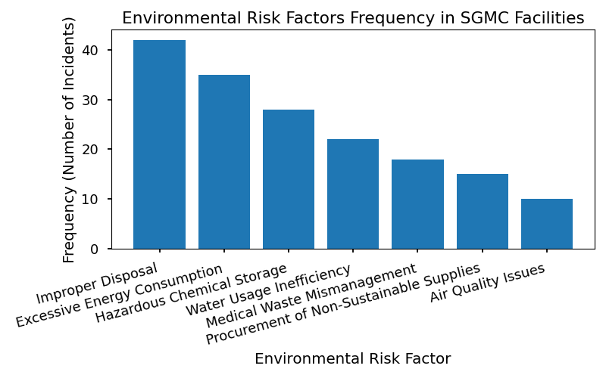

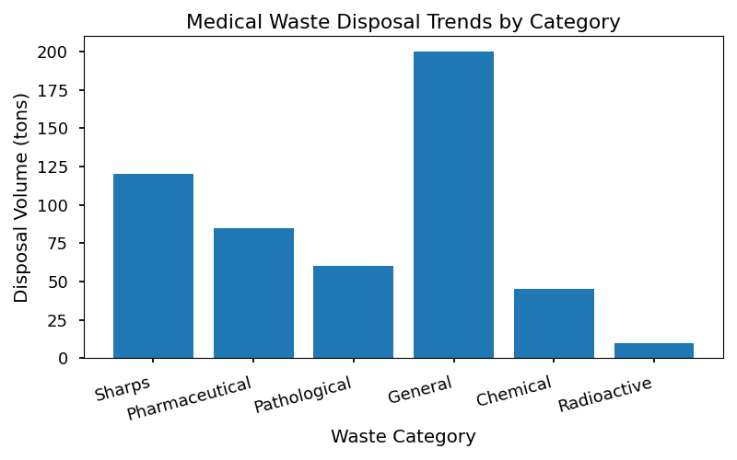

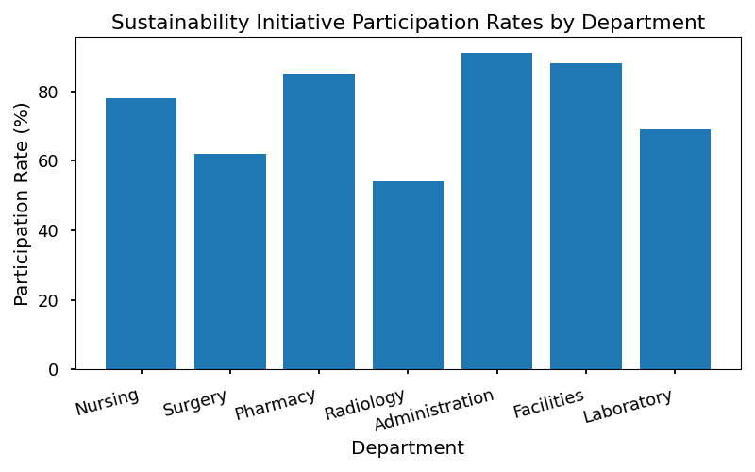

1. World Health Organization (WHO), "Safe management of wastes from health-care activities," 2014.

2. Joint Commission, "Environment of Care Standards," 2022.

3. ISO 14001:2015, "Environmental management systems — Requirements with guidance for use."

4. SGMC Internal Policy Manual, 8: Environmental Stewardship, 2023.

5. SGMC Sustainability Report, 2022.1

* SGMC branding and metadata included in document properties.