SGMC Hospital Sustainable Growth and Performance Report

# Executive Summary

SGMC Hospital stands at a pivotal juncture in its strategic growth trajectory, driven by our unwavering commitment to clinical excellence, patient-centered care, and community health. As a leading regional healthcare provider, SGMC’s mission is to deliver high-value, compassionate services while advancing innovation and operational integrity. Our vision for sustainable growth is rooted in expanding access, optimizing service lines, and reinforcing our reputation as a trusted healthcare partner.

The healthcare market presents both significant challenges and promising opportunities. Rising demand for specialty services, evolving population health needs, and rapid technological advancements are reshaping our competitive landscape. Concurrently, margin pressures, regulatory changes, and workforce dynamics require disciplined resource management. SGMC recognizes that sustainable expansion is essential to remain resilient, improve patient outcomes, and maintain community trust in an increasingly dynamic environment.

This Strategic Operations and Performance Report outlines SGMC’s short- and mid-term growth strategies, integrating market expansion, operational efficiency, service optimization, and financial sustainability. Designed as an executive-level playbook, the report equips our board, leadership, and department heads with actionable insights and directives to guide decision-making, prioritize investments, and ensure SGMC’s continued leadership in healthcare delivery.

# Growth Drivers

The following key growth drivers have been identified as central to SGMC’s sustainable expansion strategy:

* **Market demand for specialty services:** Increased patient volume and referrals in cardiology, oncology, and orthopedics.
* **Population health trends:** Aging demographics and rising chronic disease prevalence within our service area.
* **Technological advancements:** Adoption of telehealth, AI-driven diagnostics, and digital patient engagement platforms.
* **Strategic partnerships and affiliations:** Collaborations with regional providers, academic institutions, and payers to extend reach and capabilities.

# Priority Initiatives Table

The table below summarizes SGMC’s highest-priority initiatives for near-term execution, providing estimated costs, timelines, expected ROI, and accountable owners.

|  |  |  |  |  |
| --- | --- | --- | --- | --- |
| **Initiative** | **Est. Cost** | **Timeline** | **Expected ROI** | **Owner** |
| Cardiology Service Expansion | $2.4M | 12 mo | 15% | COO |
| Telehealth Market Entry | $1.1M | 9 mo | 12% | CIO |
| Population Health Analytics | $750K | 8 mo | 9% | CMO |
| Community Oncology Partnership | $1.8M | 14 mo | 13% | CSO |

# Financial Sustainability

SGMC is committed to robust financial stewardship to support strategic growth while safeguarding fiscal health. The following approaches underpin our financial sustainability framework:

* **Revenue diversification strategies:** Expanding outpatient services, specialty clinics, and value-based care contracts to broaden income streams.
* **Cost containment measures:** Lean process redesign, supply chain optimization, and workforce productivity initiatives to reduce operating expenses.
* **Risk mitigation planning:** Enhanced payer mix analysis, scenario modeling for reimbursement changes, and contingency reserves to manage financial volatility.

# Implementation Timeline Chart

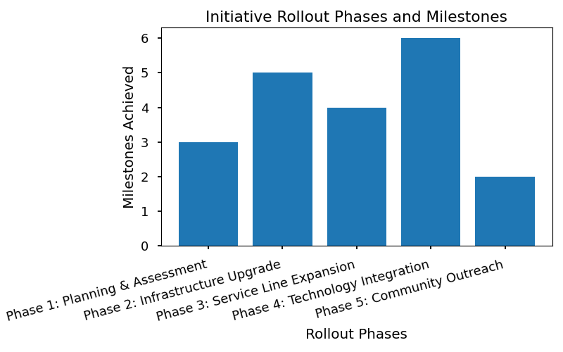

The chart above illustrates the phased implementation schedule for SGMC’s priority growth initiatives, mapping key milestones and interdependencies over the next 18 months. This visual guide supports cross-departmental alignment and resource allocation, ensuring timely execution and measurable impact.

1. Based on findings from the American Hospital Association’s “Strategies for Sustainable Growth in Healthcare Systems,” 2023.

# Growth Drivers

SGMC Hospital’s sustainable growth strategy is underpinned by a rigorous analysis of market forces and internal capabilities. Our approach is informed by comprehensive market research, patient utilization data, and ongoing stakeholder engagement. The primary factors influencing our growth trajectory are selected for their direct impact on patient care quality, operational performance, and our ability to meet evolving community health needs. By focusing on these drivers, SGMC positions itself to expand strategically while maintaining the highest standards of clinical excellence and fiscal responsibility.

* **Market demand for specialty services**
* **Population health trends**
* **Technological advancements**
* **Strategic partnerships and affiliations**

Each growth driver plays a critical role in shaping SGMC’s future. The increasing market demand for specialty services reflects both demographic shifts and the rising prevalence of chronic conditions within our service area. Population health trends, including aging populations and social determinants of health, necessitate adaptive care models and targeted outreach. Technological advancements—such as telehealth, digital diagnostics, and data analytics—enable SGMC to deliver care more efficiently and extend our reach. Strategic partnerships and affiliations foster resource sharing, innovation, and expanded access to care. Together, these drivers align with SGMC’s long-term vision: to be the region’s most trusted healthcare provider, advancing patient outcomes and community well-being through sustainable growth and operational excellence.

# Strategic Initiatives & Prioritization

## Priority Initiatives Overview

SGMC Hospital is committed to advancing its mission and sustaining long-term growth by executing a focused set of strategic initiatives over the coming 24 months. These initiatives are designed to optimize service lines, enhance operational efficiency, and position SGMC as a leader in patient-centered care within our region. Each priority has been selected based on rigorous market analysis, financial modeling, and alignment with SGMC’s core values of quality, safety, and community trust. The following table summarizes the key initiatives, associated investment, anticipated timeline, projected return on investment (ROI), and accountable leadership for each project.

|  |  |  |  |  |
| --- | --- | --- | --- | --- |
| **Initiative** | **Est. Cost** | **Timeline** | **Expected ROI** | **Owner** |
| Cardiology Service Expansion | $2.4M | 12 mo | 15% | COO |
| Telehealth Market Entry | $1.1M | 9 mo | 12% | CIO |
| Outpatient Surgery Center | $3.7M | 18 mo | 18% | CMO |
| Behavioral Health Integration | $950K | 10 mo | 9% | VP, Clinical Ops |
| Strategic Community Partnership | $600K | 8 mo | 7% | CEO |

## Implementation Timeline

SGMC’s approach to the rollout of these strategic initiatives is structured in clearly defined phases to ensure optimal resource allocation, continuous alignment with operational objectives, and preservation of our high standards of patient care. Initiative launches are sequenced to minimize disruption, with cross-functional teams assigned to oversee each phase and to monitor key performance indicators. This phased strategy will allow SGMC to adapt responsively to market feedback and operational learnings, while maintaining momentum across all priority projects.

* Phase 1 (Months 1–6): Launch Telehealth Market Entry and Strategic Community Partnership.
* Phase 2 (Months 7–12): Initiate Cardiology Service Expansion and Behavioral Health Integration.
* Phase 3 (Months 13–24): Complete Outpatient Surgery Center build-out and optimize service integration across all new lines.

Key milestones include project kick-offs, mid-phase reviews, and post-launch performance assessments, each mapped to specific dates to facilitate executive oversight and timely decision-making. This timeline ensures SGMC’s strategic priorities are executed with precision and accountability, supporting our vision for sustainable growth and excellence in patient care.

# Financial Sustainability

Sustaining SGMC Hospital’s long-term mission requires a rigorous assessment of our financial health and a forward-looking approach to revenue diversification. Current analyses indicate that while SGMC maintains a stable fiscal position, evolving market pressures and regulatory environments necessitate ongoing vigilance. Our commitment to financial sustainability is foundational to supporting high-quality patient care, strategic growth, and community trust. Diversifying revenue streams and implementing robust cost controls are essential to ensure resilience against market fluctuations and to enable strategic investments in future capabilities.

## Revenue & Cost Strategies

SGMC is actively pursuing a multifaceted approach to revenue expansion, focusing on the introduction of new service lines aligned with market demand and the optimization of our payer mix. This includes targeted investments in specialty care, ambulatory services, and digital health platforms, which are projected to increase both patient volume and reimbursement rates. Additionally, strategic partnerships and affiliations are being evaluated to further broaden our service offerings and enhance market reach.

1. **Cost Containment Measures**

* Conduct comprehensive supply chain reviews to identify and eliminate inefficiencies.
* Implement Lean Six Sigma methodologies across clinical and administrative departments.
* Standardize procurement processes to leverage volume discounts and reduce waste.

2. **Risk Mitigation Plans**

* Diversify revenue sources to reduce dependency on single payers or service lines.
* Strengthen compliance and audit functions to minimize regulatory and reimbursement risks.
* Develop contingency plans for market disruptions, including telehealth and remote care expansion.

3. **Investment Priorities**

* Prioritize capital allocation for high-growth service lines such as cardiology and oncology.
* Invest in advanced health IT infrastructure to support data-driven decision-making.
* Allocate resources to workforce development and training to enhance operational agility.

Financial modeling and scenario planning are integral to SGMC’s sustainable growth strategy. Detailed projections, incorporating variable market conditions and regulatory changes, guide our investment decisions and ensure that expansion initiatives remain fiscally responsible. Regular reviews of performance metrics and risk assessments enable agile adjustments to our strategic plan, safeguarding both profitability and care standards.

* Financial projections and strategic recommendations are informed by findings from the “2023 Healthcare Market Growth and Sustainability Report” published by Kaufman Hall, which highlights best practices in revenue diversification and cost management for hospital systems.

# Operational Directives & Performance Monitoring

In alignment with SGMC Hospital’s mission to deliver exceptional patient care while advancing organizational growth, the following operational directives are established for department heads. These directives are designed to ensure the consistent execution of strategic initiatives outlined in our Sustainable Growth Plan. Department leaders are expected to integrate these directives into daily operations, maintain adherence to established protocols, and foster a culture of accountability and continuous improvement. Clear communication of objectives, resource allocation, and collaborative engagement across departments will be essential to achieving the hospital’s long-term vision and maintaining community trust.

## Performance Metrics & Accountability

To monitor the effectiveness of our strategic initiatives and uphold the highest standards of operational excellence, SGMC Hospital has identified key performance indicators (KPIs) that will serve as benchmarks for progress. These KPIs are tailored to each department’s functional responsibilities and are critical for tracking outcomes related to patient care, financial health, service expansion, and operational efficiency. Department heads are required to report on these metrics according to the specified frequency, enabling executive leadership to make informed decisions and adjust strategies as needed. Transparent reporting and data-driven reviews will underpin our commitment to accountability and performance improvement.

|  |  |  |
| --- | --- | --- |
| **KPI** | **Responsible Department** | **Reporting Frequency** |
| Patient Satisfaction Score | Patient Experience | Monthly |
| Service Line Volume Growth (%) | Clinical Operations | Quarterly |
| Operating Margin (%) | Finance | Monthly |
| Telehealth Utilization Rate | IT / Digital Health | Monthly |
| Staff Turnover Rate (%) | Human Resources | Quarterly |
| Readmission Rate (%) | Quality & Safety | Monthly |

A robust feedback mechanism is in place to support ongoing performance evaluation and continuous improvement. Department heads will participate in regular review sessions, during which performance data and operational challenges are discussed openly. Actionable feedback from these sessions will be incorporated into process adjustments and staff training programs. Additionally, an internal dashboard will provide real-time visibility into key metrics, empowering teams to respond proactively to emerging trends and operational needs. This iterative approach ensures that SGMC Hospital remains agile, responsive, and steadfast in pursuing sustainable growth and excellence in patient care.

* Performance monitoring framework informed by “Strategic Growth and Accountability in Healthcare Systems,” Becker’s Hospital Review, 2023.1