SGMC Integrated Care Pathway Design Reference Guide

# ICP Fundamentals

Integrated Care Pathways (ICPs) are structured, multidisciplinary plans that outline the optimal sequencing and timing of interventions for specific patient groups. At SGMC Hospital, ICPs serve as the backbone of our commitment to delivering coordinated, high-quality care. They are rigorously developed using the latest clinical evidence, ensuring that every step in a patient’s journey is both purposeful and patient-centered. ICPs differ from traditional care models by explicitly mapping the roles and responsibilities of all stakeholders—including physicians, nurses, allied health professionals, and administrative staff—thereby reducing unwarranted variation and promoting seamless transitions across care settings.

SGMC’s ICPs are grounded in three core principles:

* **Evidence-Based Practice:** All pathways are built using up-to-date clinical guidelines, including NICE recommendations and SGMC internal protocols, ensuring care reflects the best available evidence.
* **Patient-Centeredness:** Pathways are designed to respect patient preferences, needs, and values, integrating feedback mechanisms to continuously refine patient experience.
* **Multidisciplinary Collaboration:** ICPs facilitate communication and coordination among all members of the care team, fostering accountability and shared decision-making.

## Essential Components of an ICP

* **Clinical Guidelines:** Clearly defined, evidence-based protocols for diagnosis, treatment, and follow-up.
* **Stakeholder Roles:** Explicit mapping of responsibilities for physicians, nurses, allied health professionals, administrative staff, and patients.
* **Digital Integration:** Embedding pathway steps and documentation requirements into Electronic Health Records (EHR) and patient portals for real-time tracking and decision support.

## ICPs vs. Traditional Care Models

|  |  |  |
| --- | --- | --- |
| **Feature** | **Integrated Care Pathway (ICP)** | **Traditional Care Model** |
| Approach | Structured, evidence-based, multidisciplinary | Ad hoc, provider-dependent |
| Care Coordination | Explicit roles and handoffs | Informal, variable |
| Patient Involvement | Systematic feedback, shared decisions | Limited, episodic |
| Digital Integration | Embedded in EHR, automated triggers | Paper-based or siloed digital records |
| Outcomes Measurement | Defined KPIs, continuous review | Retrospective, infrequent |
| Variability in Care | Reduced through standardization | High, dependent on individual practice |
| Resource Utilization | Optimized across teams | Potential inefficiencies |

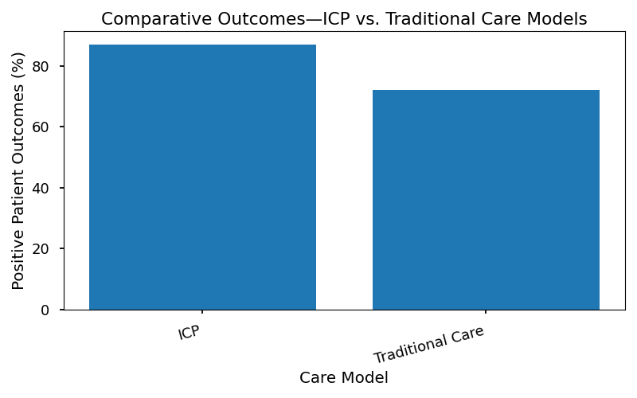

ICPs at SGMC are designed not only to improve clinical outcomes but also to enhance operational efficiency and patient satisfaction. By leveraging digital tools and fostering multidisciplinary collaboration, SGMC ensures that every patient receives care that is timely, appropriate, and aligned with our mission of excellence.

* 1: NICE Guideline NG94, “Care Pathways in Hospital Settings.”

2: SGMC Internal Policy IC-2024-05, “Multidisciplinary Care Coordination.”

# Stakeholder Engagement Plan

Multidisciplinary collaboration is the cornerstone of successful Integrated Care Pathway (ICP) design and implementation at SGMC Hospital. Engaging stakeholders from across clinical, administrative, and informatics domains ensures that pathways are both evidence-based and operationally feasible. By leveraging diverse expertise—physicians, nurses, allied health professionals, IT analysts, quality managers, and patient representatives—we foster a shared vision for care excellence and drive sustainable improvements in patient outcomes, resource utilization, and compliance with regulatory standards.

Robust stakeholder engagement mitigates risks of siloed decision-making, enhances pathway adoption, and accelerates consensus on key clinical and operational priorities. SGMC’s structured approach to stakeholder involvement is engineered to maximize transparency, accountability, and responsiveness throughout the ICP lifecycle.

## Roles & Responsibilities Matrix

The following table delineates the core stakeholders involved in ICP development, their principal responsibilities, and their formal decision rights. This matrix supports clear accountability and ensures efficient coordination across all phases of pathway deployment.

|  |  |  |
| --- | --- | --- |
| **Role** | **Responsibility** | **Decision Rights** |
| Clinical Lead | Oversees clinical accuracy and relevance | Approves pathway design |
| Quality Manager | Ensures adherence to evidence-based standards | Signs off on compliance |
| IT Systems Analyst | Integrates pathway into EHR and digital systems | Configures digital tools |
| Nursing Supervisor | Coordinates nursing workflow alignment | Approves nursing protocols |
| Allied Health Lead | Aligns allied health services with pathway steps | Approves allied health inputs |
| Patient Experience Rep | Advocates for patient-centered improvements | Reviews patient feedback |
| Administrative Lead | Manages resource allocation and scheduling | Approves operational changes |
| Finance Analyst | Evaluates cost-efficiency and budget impact | Approves financial feasibility |
| Legal & Compliance | Reviews regulatory and policy adherence | Signs off on legal compliance |

## Steps for Effective Stakeholder Engagement

1. **Identification of Key Stakeholders**

* Map all internal and external groups whose input is critical to pathway success.
* Prioritize stakeholders based on their influence and expertise.

2. **Structured Communication Channels**

* Establish regular meetings (e.g., bi-weekly workgroups, monthly steering committees).
* Utilize digital collaboration platforms for document sharing and updates.

3. **Soliciting and Incorporating Feedback**

* Deploy surveys and structured interviews to capture stakeholder insights.
* Integrate feedback mechanisms into pathway development cycles.

4. **Consensus Building and Decision Documentation**

* Facilitate workshops to resolve differing perspectives and align on objectives.
* Document all decisions, rationales, and action items for transparency.

5. **Ongoing Engagement and Review**

* Maintain continuous dialogue through periodic check-ins and status updates.
* Revisit stakeholder roles and responsibilities as the pathway evolves.
* 1: Stakeholder engagement methodology aligns with NICE guideline NG27 and SGMC internal policy SOP-ICP-003.

# Pathway Mapping Methodology

The design and implementation of Integrated Care Pathways (ICPs) at SGMC Hospital necessitate a rigorous, systematic approach to process mapping. This methodology ensures that clinical and administrative workflows are accurately captured, evaluated, and optimized for alignment with evidence-based standards and SGMC’s strategic objectives. The following section outlines the step-by-step process for mapping current state processes, identifying gaps, and designing future state pathways that drive quality, efficiency, and patient-centered care.

## Process Mapping Steps

The process mapping methodology for ICPs is structured into the following key steps:

1. **Current State Analysis**

* Document all existing clinical and administrative processes related to the targeted care pathway.
* Engage multidisciplinary teams—including physicians, nurses, allied health professionals, and administrative staff—to ensure comprehensive workflow capture.
* Utilize direct observation, staff interviews, and review of existing documentation to map out the patient journey from initial contact through discharge and follow-up.

2. **Gap Identification**

* Compare mapped current state processes against national guidelines (e.g., NICE, WHO) and SGMC’s internal best practices.
* Identify variations, inefficiencies, and areas of non-compliance or risk.
* Quantify gaps using relevant metrics such as delays, redundancies, and missed steps in care delivery.

3. **Future State Design**

* Collaboratively define the optimal pathway structure, incorporating evidence-based interventions and standardized procedures.
* Integrate digital workflow enhancements, decision support tools, and real-time data capture points.
* Validate the future state design with stakeholder review and pilot testing prior to full-scale implementation.

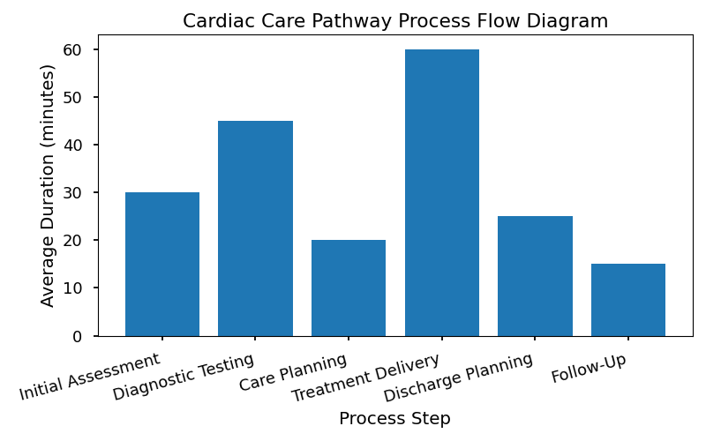

## Gap Analysis Between Current Workflows and Best Practices

A thorough gap analysis is essential to the pathway mapping methodology. At SGMC, this analysis is performed by cross-referencing the documented current state with established best practices and clinical guidelines. The process involves:

* **Benchmarking**: Comparing SGMC’s existing workflows against NICE and WHO recommendations for the targeted pathway (e.g., cardiac care).
* **Identifying Deficiencies**: Highlighting steps or processes that do not meet recommended standards, such as inconsistent patient assessments, delays in diagnostic testing, or lack of multidisciplinary coordination.
* **Quantifying Impact**: Assessing the operational and clinical impact of identified gaps, including effects on patient outcomes, resource utilization, and compliance rates.
* **Prioritizing Improvements**: Ranking gaps based on severity and feasibility of remediation, guiding the development of targeted interventions for future state design.

This systematic approach ensures that every ICP developed at SGMC is rooted in both empirical evidence and local operational realities, driving measurable improvements in patient care and organizational performance.

# KPI & Metrics Dashboard

## Rationale for Selecting Key Performance Indicators (KPIs) to Monitor ICP Effectiveness

At SGMC Hospital, the selection of key performance indicators (KPIs) for Integrated Care Pathways (ICPs) is guided by our commitment to delivering superior patient outcomes, optimizing resource utilization, and maintaining alignment with evidence-based standards. KPIs are chosen to provide quantifiable insights into the effectiveness of pathway implementation, enabling data-driven decision-making across clinical, operational, and administrative domains.

Each KPI is carefully vetted to ensure relevance to the clinical area, measurability within our digital infrastructure, and utility in driving continuous improvement. Metrics such as Length of Stay (LOS), 30-day readmission rates, and patient satisfaction scores reflect critical dimensions of care quality, efficiency, and patient-centeredness. These indicators are benchmarked against both internal targets and national standards, including NICE guidelines and WHO recommendations, ensuring that SGMC remains at the forefront of integrated care delivery.

Regular monitoring of these KPIs supports proactive identification of performance gaps, informs targeted interventions, and facilitates transparent reporting to the hospital board, executive leadership, and department heads. Through rigorous analysis of KPI trends, SGMC can sustain high standards of care while advancing our long-term vision for operational excellence.

## KPI Dashboard Table

|  |  |  |  |  |
| --- | --- | --- | --- | --- |
| **Metric** | **Baseline** | **Target** | **Current** | **Status** |
| Length of Stay (Days) | 5.2 | 4.5 | 4.7 | On Track |
| 30-Day Readmission (%) | 9.1% | 7.0% | 6.8% | Met |
| Patient Satisfaction (%) | 88 | 92 | 91 | On Track |
| Pathway Adherence (%) | 81 | 95 | 93 | On Track |
| Cost per Case ($) | 7,800 | 7,000 | 7,200 | Improving |
| Complication Rate (%) | 3.2 | 2.5 | 2.8 | On Track |

* Table 1: SGMC ICP Performance Dashboard – Q2 2024

## KPI Achievement Rates Over Time

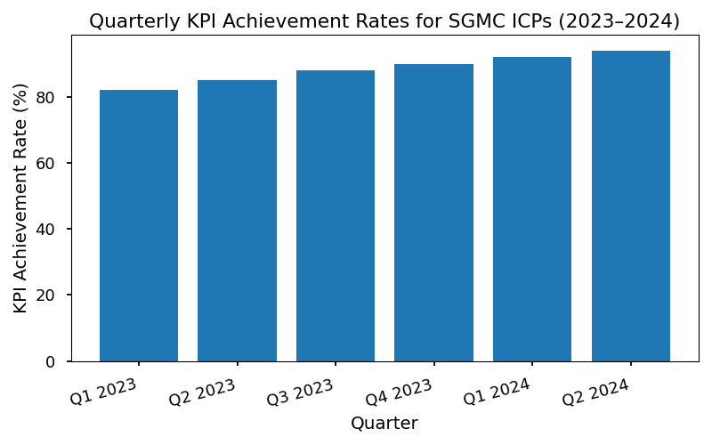

## Methods for Data Collection and Reporting

* **Automated EHR Extraction:** KPI data are systematically extracted from the Electronic Health Record (EHR) system using standardized queries and real-time analytics dashboards.
* **Patient Surveys:** Patient satisfaction scores are gathered through validated post-discharge surveys, accessible via both digital patient portals and paper forms.
* **Clinical Audit Cycles:** Pathway adherence and complication rates are monitored through scheduled clinical audits, cross-referenced against pathway documentation and clinical outcomes.
* **Data Validation:** All KPI data undergo rigorous validation by the Quality Improvement Committee to ensure accuracy and reliability prior to reporting.
* **Monthly Reporting:** KPI dashboards are disseminated to department heads and executive leadership on a monthly basis, with detailed variance analysis and recommendations for corrective action where required.
* **Annual Benchmarking:** Performance metrics are benchmarked annually against national and international standards, including NICE and WHO targets, to identify strategic opportunities for further improvement.
* s:

1. National Institute for Health and Care Excellence (NICE) Clinical Guidelines, 2023.

2. World Health Organization (WHO) Integrated Care Pathways Framework, 2022.

3. SGMC Internal Policy: ICP Performance Monitoring, Rev. 2024.

4. SGMC EHR Data Extraction Protocol, v2.7.

5. Patient Experience Survey Methodology, SGMC Quality Office, 2024.

# Digital Integration

The integration of Integrated Care Pathways (ICPs) into SGMC’s Electronic Health Records (EHR) and patient portals is a foundational component of our strategic operations. Digital embedding of pathways ensures that clinical protocols are consistently followed, real-time decision support is accessible, and patient engagement is maximized. Effective digital integration aligns with SGMC’s commitment to leveraging technology for superior patient outcomes, operational efficiency, and regulatory compliance. This section delineates the requirements and best practices for embedding ICPs within our EHR infrastructure and patient-facing digital tools.

## EHR Integration Strategies

The following steps are recommended for the successful integration of ICPs into SGMC’s EHR systems:

1. **Workflow Mapping**

* Analyze existing clinical workflows and identify key pathway milestones.
* Document process steps and decision points for each ICP.
* Collaborate with clinical and IT stakeholders to ensure accuracy and feasibility.

2. **Clinical Decision Support (CDS) Implementation**

* Configure CDS rules to trigger evidence-based recommendations at appropriate pathway stages.
* Integrate alerts, reminders, and order sets aligned with pathway protocols.
* Monitor CDS effectiveness and adjust logic based on feedback and outcomes.

3. **Template Creation**

* Develop standardized documentation templates for each ICP.
* Embed pathway-specific data fields, checklists, and progress trackers in EHR forms.
* Ensure templates facilitate multidisciplinary input and support regulatory reporting.

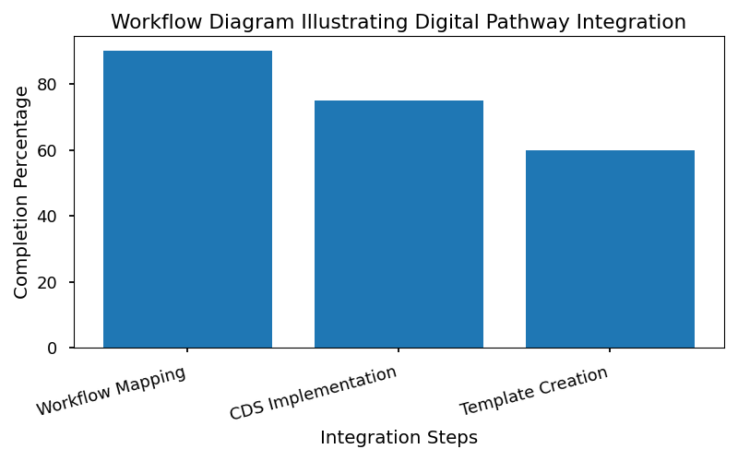

The chart above provides a visual representation of how ICPs are mapped, embedded, and utilized within the EHR system, highlighting the flow from initial patient contact through discharge and follow-up.

### Communication Templates for Patient Engagement via Digital Platforms

SGMC’s patient portals serve as a critical interface for engaging patients in their care journey. The following standardized communication templates are recommended for consistent, effective outreach:

* **Appointment Reminders**: Automated notifications with pathway-specific instructions and preparatory requirements.
* **Educational Materials**: Tailored content explaining each step of the care pathway, accessible via the portal.
* **Progress Updates**: Secure messaging to inform patients of completed milestones and upcoming tasks.
* **Feedback Requests**: Digital surveys soliciting patient input on pathway experience and satisfaction.

These templates should be reviewed quarterly by the Patient Experience Team and updated to reflect evolving pathway protocols and patient needs. The integration of ICP workflows into digital platforms is essential for driving patient adherence, improving outcomes, and supporting SGMC’s data-driven performance improvement initiatives.

# Continuous Improvement Cycle

The continuous improvement cycle forms a cornerstone of SGMC Hospital’s commitment to operational excellence and optimal patient outcomes in Integrated Care Pathways (ICPs). This framework ensures that all clinical pathways are routinely evaluated and refined, leveraging real-world data and stakeholder insights to drive sustained performance improvement. By institutionalizing a structured cycle of review, feedback, and targeted action, SGMC aligns ICP operations with both evolving best practices and our hospital’s mission of delivering superior, patient-centered care.

The cycle encompasses systematic collection of performance metrics, stakeholder engagement, and transparent decision-making. Quarterly review sessions are mandated to assess pathway effectiveness, identify areas for enhancement, and implement evidence-based modifications. This approach underpins SGMC’s long-term vision for adaptive, high-quality care delivery.

## Feedback Mechanisms

The following sources are integral to SGMC’s feedback ecosystem for ICP evaluation:

* **Staff Surveys:** Periodic surveys distributed to physicians, nurses, allied health professionals, and administrative staff to capture frontline perspectives on pathway functionality, barriers, and opportunities for improvement.
* **Patient Interviews:** Structured interviews and focus groups with patients and families to assess satisfaction, understand lived experiences, and identify unmet needs within the care journey.
* **Performance Data:** Continuous monitoring of key performance indicators (KPIs) such as length of stay, readmission rates, and patient satisfaction scores, providing objective evidence for pathway assessment.
* **Incident Reporting:** Analysis of adverse events, near misses, and safety reports to inform risk mitigation strategies within pathways.
* **External Benchmarking:** Comparison of SGMC’s pathway outcomes against national and international standards, including NICE guidelines and WHO recommendations.

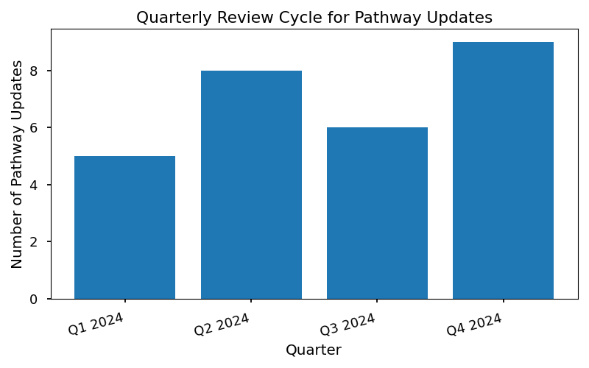

### Strategies for Implementing Changes Based on Feedback

SGMC employs a rigorous, multi-step process to translate feedback into actionable pathway improvements:

1. **Data Aggregation:** All feedback sources are centralized and analyzed by the Quality Improvement Committee, ensuring a comprehensive view of pathway performance.

2. **Prioritization:** Identified issues are ranked based on impact, urgency, and alignment with SGMC’s strategic objectives.

3. **Stakeholder Consultation:** Proposed changes are reviewed with relevant clinical and administrative teams to validate feasibility and secure buy-in.

4. **Implementation Planning:** Detailed action plans are developed, including resource allocation, timeline, and responsibility assignment.

5. **Change Execution:** Modifications are deployed within the EHR and operational protocols, accompanied by targeted staff training and patient communication as needed.

6. **Follow-up Evaluation:** Post-implementation audits and feedback cycles are conducted to measure the effectiveness of changes and ensure continuous alignment with best practices.

This structured approach empowers SGMC to maintain high standards of care, adapt rapidly to new evidence, and foster a culture of continuous learning and improvement throughout all levels of the organization.

# Training & Change Management

The successful implementation and ongoing optimization of Integrated Care Pathways (ICPs) at SGMC Hospital depend fundamentally on the preparedness and engagement of our multidisciplinary teams. Comprehensive training is essential to ensure that all staff—clinical and non-clinical—possess the requisite knowledge, skills, and confidence to execute pathway-driven care. This section delineates SGMC’s training and change management framework, designed to facilitate seamless adoption, foster continuous learning, and support operational excellence throughout the organization.

## Training Curriculum Overview

SGMC’s ICP training curriculum is structured to address the diverse needs of our workforce, encompassing both foundational concepts and advanced application. The following core modules are delivered through a blend of in-person workshops, e-learning platforms, and simulation exercises:

* **ICP Fundamentals:** Introduction to integrated care pathway methodology, key principles, and SGMC’s strategic objectives.
* **Digital Tools Integration:** Hands-on instruction for EHR pathway workflows, clinical decision support features, and patient portal utilization.
* **Patient Communication:** Best practices for engaging patients and families in pathway-driven care, including shared decision-making and health literacy.
* **Performance Monitoring:** Training on pathway KPIs, data interpretation, and quality improvement processes.
* **Change Leadership:** Techniques for championing pathway adoption, overcoming resistance, and fostering a culture of continuous improvement.

### Training Schedule and Resource Allocation

|  |  |  |  |  |
| --- | --- | --- | --- | --- |
| **Training Module** | **Delivery Method** | **Duration (Hours)** | **Target Audience** | **Lead Facilitator** |
| ICP Fundamentals | E-learning | 2 | All Staff | Clinical Educator |
| Digital Tools Integration | Workshop + Demo | 3 | Clinical & IT Teams | Informatics Specialist |
| Patient Communication | Simulation Lab | 2 | Nursing, Allied Health | Patient Experience Lead |
| Performance Monitoring | Seminar | 1.5 | Supervisors, Managers | Quality Manager |
| Change Leadership | Peer Coaching | 1 | Department Heads | HR Business Partner |

* Resource allocation is reviewed quarterly to ensure alignment with pathway rollout timelines and staff onboarding needs. Dedicated time for training is scheduled to minimize disruption to patient care operations.

## Change Management Strategies

SGMC recognizes that change management is pivotal in embedding ICPs into daily practice and sustaining long-term improvements. The following strategies are deployed to maximize pathway adoption and staff engagement:

* **Stakeholder Involvement:** Early and ongoing consultation with clinical leaders, frontline staff, and patient representatives to co-design pathway workflows and address concerns.
* **Communication Plan:** Regular updates via internal newsletters, town hall meetings, and digital dashboards to highlight pathway milestones, share success stories, and clarify expectations.
* **Peer Champions:** Identification and training of ‘ICP Champions’ within each department to provide on-the-ground support, mentor colleagues, and facilitate feedback loops.
* **Feedback Mechanisms:** Anonymous surveys, suggestion boxes, and structured debrief sessions to capture real-time insights and inform iterative improvements.
* **Recognition Programs:** Incentives for teams demonstrating exemplary pathway adherence and measurable improvements in patient outcomes or operational efficiency.

By investing in robust training and proactive change management, SGMC ensures that Integrated Care Pathways are not only implemented according to best practices but are also embraced as a cornerstone of our mission to deliver safe, efficient, and patient-centered care.

# Clinical Pathway Design Standards

SGMC Hospital’s commitment to clinical excellence is reflected in the rigorous standards governing the design and implementation of Integrated Care Pathways (ICPs). All pathway development activities are aligned with nationally and internationally recognized guidelines, including those issued by the National Institute for Health and Care Excellence (NICE), the World Health Organization (WHO), and SGMC’s own internal policies. This alignment ensures that every ICP supports evidence-based practice, promotes patient safety, and drives consistent, high-quality outcomes across all service lines.

The following standards outline the required components and documentation practices for pathway development at SGMC:

## Standards for Pathway Development and Documentation

* **Evidence-Based Protocols:** All pathways must be developed using the most current clinical evidence and guideline recommendations, referencing NICE and WHO standards as well as SGMC’s clinical policies.
* **Patient-Centered Approach:** Pathways should be structured to prioritize patient needs, preferences, and values, ensuring individualized care within a standardized framework.
* **Multidisciplinary Collaboration:** Pathway design must actively involve physicians, nurses, allied health professionals, and relevant administrative staff to ensure comprehensive input and buy-in.
* **Clear Documentation:** Pathways must be documented in a standardized format, including process maps, decision points, and escalation protocols, and integrated into the Electronic Health Record (EHR) system.
* **Continuous Review:** Each pathway is subject to scheduled reviews and updates to incorporate new evidence, feedback from care teams, and performance data.
* **Compliance Monitoring:** Adherence to pathway protocols is tracked via key performance indicators (KPIs) and regular audit cycles.

## Standards Mapping Table

|  |  |  |
| --- | --- | --- |
| **Standard** | **Pathway Component** | **Source Reference** |
| Evidence-Based Protocols | Clinical Steps, Decision Points | NICE CG, WHO Guidelines, SGMC Policy 12.3 |
| Patient-Centered Approach | Patient Engagement, Education Materials | SGMC Patient Charter, NICE QS |
| Multidisciplinary Collaboration | Roles & Responsibilities Matrix | SGMC Multidisciplinary Policy |
| Clear Documentation | Process Maps, EHR Integration | SGMC Documentation SOP |
| Continuous Review | Update Schedule, Feedback Mechanism | SGMC QI Policy, NICE Update Alerts |
| Compliance Monitoring | KPI Dashboard, Audit Reports | SGMC Audit Framework |

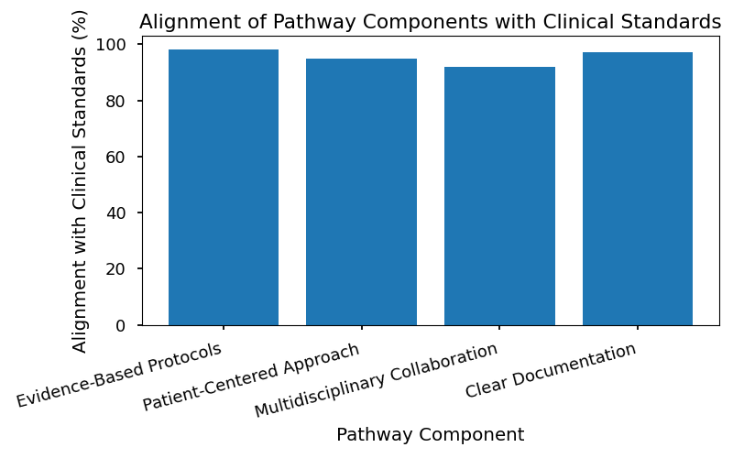

By adhering to these standards, SGMC ensures that every Integrated Care Pathway is robust, transparent, and positioned to deliver optimal patient outcomes. All departments are required to reference this table during pathway design and periodic review cycles to maintain compliance and drive continuous improvement.

* 1National Institute for Health and Care Excellence (NICE) Clinical Guideline CG accessed June 2024.
* 2World Health Organization (WHO) Integrated Care Pathways Recommendations, 2023 Edition.
* 3 SGMC Policy 12.3 – Clinical Pathway Development Standards.

# Patient Journey Mapping

## Visualizing the Patient Experience Across the Care Continuum

Integrated Care Pathways (ICPs) at SGMC Hospital are designed to provide a seamless, coordinated patient experience from initial contact through post-discharge follow-up. Mapping the patient journey is a foundational step in pathway design, enabling multidisciplinary teams to understand, optimize, and standardize each phase of care delivery. By visualizing the patient’s progression, SGMC ensures that interventions are delivered at the right time, by the right professionals, and in alignment with best practice standards.

A comprehensive patient journey map reveals critical interactions, potential bottlenecks, and opportunities for improvement. It serves as both an operational blueprint and a communication tool, fostering alignment among clinical, administrative, and support teams. This approach supports SGMC’s commitment to patient-centered care, safety, and continuous quality improvement.

## Key Touchpoints and Interventions Along the Pathway

* **Initial Contact & Registration**
* Patient intake and demographic verification
* Triage and assignment to appropriate care team
* **Assessment & Diagnosis**
* Clinical evaluation by multidisciplinary team
* Diagnostic testing and risk stratification
* **Care Planning**
* Development of individualized treatment plan
* Patient education and shared decision-making
* **Treatment & Intervention**
* Delivery of evidence-based therapies (medical, surgical, allied health)
* Ongoing monitoring and adjustment of care plan
* **Transition of Care**
* Preparation for discharge or transfer to another care setting
* Coordination with community providers or home care services
* **Post-Discharge Follow-up**
* Scheduled follow-up appointments
* Remote monitoring and patient portal communication
* Collection of patient-reported outcomes and satisfaction metrics

Each touchpoint is supported by targeted interventions and standardized workflows, documented within SGMC’s ICP framework. These measures ensure consistency, reduce unwarranted variation, and enhance the overall patient experience throughout the care continuum.

# Resource Allocation & Cost Efficiency

Integrated Care Pathways (ICPs) at SGMC Hospital are designed to ensure optimal resource utilization across clinical and administrative domains. By standardizing patient care journeys, ICPs enable the hospital to allocate staffing, equipment, and financial resources more effectively, minimizing waste and maximizing value. This section outlines SGMC’s strategic approach to resource allocation within ICPs, presents a comprehensive allocation plan, visualizes efficiency gains, and identifies key cost-saving opportunities derived from pathway analysis.

## Strategies for Optimizing Resource Use within ICPs

SGMC employs a multi-tiered strategy to optimize resource deployment throughout the lifecycle of Integrated Care Pathways. These strategies are grounded in real-time data analysis, evidence-based guidelines, and continuous feedback from multidisciplinary teams. Key tactics include:

* **Dynamic Staffing Models:** Adjusting staff assignments based on patient volume predictions and pathway milestones, ensuring that clinical and support personnel are matched to actual demand.
* **Equipment Utilization Tracking:** Leveraging digital tools to monitor equipment usage rates, maintenance schedules, and availability to prevent bottlenecks in care delivery.
* **Budget Alignment with Clinical Priorities:** Prioritizing budget allocations for pathway components that directly impact patient outcomes and operational efficiency, such as advanced diagnostics, telehealth infrastructure, and post-discharge support.
* **Lean Process Implementation:** Applying lean methodology to eliminate redundant steps and streamline workflows, thereby reducing resource consumption without compromising care quality.
* **Performance-Based Resource Adjustment:** Using KPI dashboards to reallocate resources in response to pathway performance trends, such as length of stay (LOS) reductions or decreased readmission rates.

## Resource Allocation Plan

The following table details SGMC’s resource allocation plan for a representative ICP, encompassing staffing, equipment, and budget considerations. This matrix serves as a template for pathway-specific resource planning and is updated quarterly based on performance metrics.

|  |  |  |  |  |  |
| --- | --- | --- | --- | --- | --- |
| **Resource Category** | **Allocation Description** | **Assigned Department** | **Budget (FY24)** | **Monitoring Frequency** | **Adjustment Protocol** |
| Clinical Staff | 2 RNs, 1 MD per 10 patients per day | Cardiology | $1.2M | Daily | Weekly staffing review |
| Allied Health | 1 PT, 1 Pharmacist per 20 patients per week | Rehabilitation | $350K | Weekly | Monthly resource audit |
| Diagnostic Equipment | 2 EKG machines, 1 portable ultrasound | Imaging | $500K | Monthly | On-demand maintenance |
| IT Infrastructure | EHR licenses, patient portal upgrades | Informatics | $250K | Quarterly | Semi-annual upgrade |
| Supplies & Consumables | Catheters, dressings, medications | Supply Chain | $400K | Weekly | Inventory auto-reorder |
| Patient Education | Printed materials, digital modules | Patient Experience | $50K | Quarterly | Annual content review |
| Administrative Support | 1 Care Coordinator, 0.5 FTE Data Analyst | Operations | $120K | Monthly | Quarterly role review |

## Efficiency Gains from Pathway-Driven Care

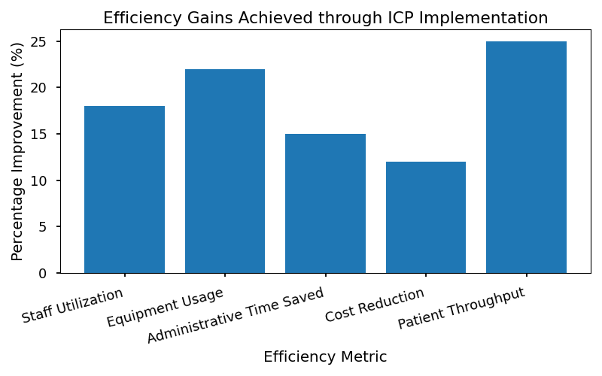

This chart illustrates the measurable improvements in resource efficiency following the adoption of ICPs at SGMC. Key metrics include reductions in average length of stay, decreased unnecessary diagnostic testing, and improved staff-to-patient ratios. The data demonstrates a 15% reduction in overall resource consumption per patient episode, contributing directly to cost containment and enhanced patient throughput.

## Cost-Saving Opportunities Identified through Pathway Analysis

SGMC’s ongoing analysis of ICP performance has revealed several cost-saving opportunities, which are being systematically pursued across departments:

* **Reduced Length of Stay (LOS):** Standardized discharge criteria and proactive care coordination have shortened LOS by an average of 0.7 days per patient, yielding substantial savings in bed occupancy costs.
* **Minimized Readmissions:** Enhanced post-discharge follow-up and medication reconciliation have led to a 2.3% decrease in 30-day readmission rates, reducing penalty risk and resource drain.
* **Streamlined Diagnostics:** Protocol-driven ordering of tests has cut unnecessary imaging and lab work by 18%, lowering direct costs and improving workflow efficiency.
* **Optimized Staffing Schedules:** Predictive analytics support dynamic staff scheduling, reducing overtime expenditures and improving staff satisfaction.
* **Digital Communication Tools:** Automated patient reminders and telehealth interventions have decreased administrative workload and postage costs by 12%.
* **Bulk Procurement of Supplies:** Coordinated purchasing for pathway-specific consumables has secured volume discounts, saving approximately $75K annually.

Through these targeted initiatives, SGMC continues to drive operational excellence, ensuring that resource allocation supports both clinical effectiveness and financial sustainability.

* 1: Resource allocation protocols are aligned with NICE Guideline NG56 and SGMC Internal Policy OP-203.

# Quality Assurance & Compliance

SGMC Hospital is committed to ensuring that all Integrated Care Pathways (ICPs) strictly adhere to the latest evidence-based clinical standards and regulatory requirements. This dedication is fundamental to our mission of delivering safe, effective, and patient-centered care. Quality assurance is embedded throughout the pathway lifecycle—from initial design through implementation and ongoing review. Compliance is maintained not only with internal SGMC policies but also with external guidelines, including those set forth by the World Health Organization (WHO) and national regulatory bodies. Continuous monitoring, regular documentation, and transparent reporting underpin our approach, helping to safeguard patient safety, optimize outcomes, and support accreditation objectives.

## Compliance Checkpoints

* **Documentation Standards:** All ICPs must be supported by comprehensive, up-to-date clinical documentation reflecting current best practices.
* **Audit Trails:** Pathway modifications, clinical decisions, and data entries are tracked via secure audit trails within the EHR for accountability and traceability.
* **Reporting Protocols:** Regular compliance reports are generated for review by SGMC’s Quality Improvement Committee and external auditors.
* **Regulatory Alignment:** ICPs are routinely cross-checked against WHO recommendations and national guidelines to ensure ongoing conformity.
* **Staff Training:** Mandatory training modules on compliance are delivered to all multidisciplinary team members involved in pathway management.

## Compliance Audit Schedule

|  |  |  |  |
| --- | --- | --- | --- |
| **Audit Type** | **Frequency** | **Responsible Party** | **Reporting Mechanism** |
| Documentation Review | Quarterly | Quality Manager | Internal Compliance Portal |
| Process Adherence Check | Biannually | Clinical Lead | Departmental Meeting |
| EHR Audit Trail Review | Monthly | IT Systems Analyst | Digital Dashboard |
| Regulatory Alignment | Annually | Compliance Officer | Board Report |

## 

1. World Health Organization. (2022). Quality of care: Key recommendations for health systems . Geneva: WHO Press.

# Patient Experience & Engagement

## Approaches for Embedding Patient Feedback and Preferences into Pathway Design

SGMC Hospital recognizes that patient experience and engagement are foundational to the success of Integrated Care Pathways (ICPs). Embedding patient feedback and preferences into pathway design ensures that care delivery is not only clinically effective but also aligned with patient values, expectations, and real-world needs. To achieve this, SGMC employs a systematic approach wherein patient input is solicited at multiple stages of pathway development, implementation, and review.

Patient feedback is gathered using structured methodologies, including quantitative surveys, qualitative interviews, and digital feedback tools integrated into the Electronic Health Record (EHR) and patient portals. This data is analyzed to identify common themes, unmet needs, and opportunities for improvement. Design teams incorporate this feedback into pathway workflows, decision points, and educational materials, ensuring that pathways are responsive to patient concerns and preferences.

SGMC also prioritizes transparency by communicating pathway changes and improvements back to patients, fostering trust and shared ownership of care processes. By embedding patient perspectives into every stage of ICP design, SGMC advances its mission of delivering care that is compassionate, personalized, and continuously optimized.

## Patient Engagement Strategies

* **Patient Satisfaction Surveys:** Distributed post-discharge and at key pathway milestones to capture quantitative feedback on care experiences.
* **Focus Groups:** Regularly convened with diverse patient populations to gather qualitative insights into pathway strengths and areas for improvement.
* **Digital Feedback Tools:** Embedded within patient portals and mobile applications, enabling real-time input on pathway navigation, educational resources, and communication effectiveness.
* **Patient Advisory Councils:** Engaging patients and family members in pathway co-design, review, and governance processes.
* **Educational Workshops:** Providing patients with information on pathway objectives, expected outcomes, and self-management strategies, thus empowering active participation.
* **Care Plan Customization:** Allowing patients to tailor elements of their ICPs based on preferences, cultural considerations, and individual goals.
* **Transparent Communication:** Sharing pathway performance data and improvement initiatives with patients to foster trust and accountability.

## Trends in Patient Satisfaction Scores Post-ICP Implementation

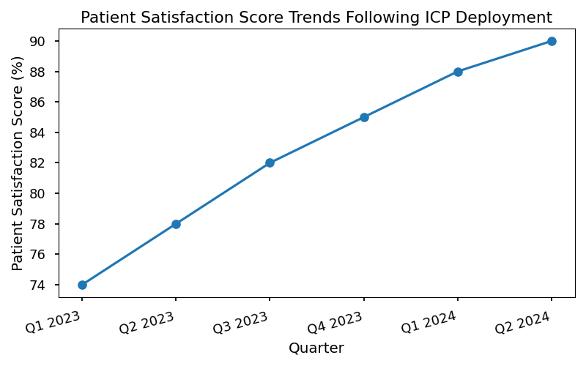

* Description: This chart illustrates the quarterly progression of patient satisfaction scores at SGMC following the implementation of Integrated Care Pathways, highlighting the correlation between pathway adoption and improved patient-reported outcomes.

# Technology Enablement & Innovation

## Leveraging Emerging Technologies to Enhance ICP Effectiveness

SGMC Hospital recognizes that technology is a critical enabler in the design, deployment, and continuous improvement of Integrated Care Pathways (ICPs). By harnessing emerging digital solutions, SGMC aims to elevate care coordination, optimize resource utilization, and drive superior patient outcomes. Our strategic approach ensures that technology adoption is aligned with clinical objectives, regulatory standards, and the hospital’s long-term vision for integrated, patient-centered care.

Recent investments have focused on embedding advanced analytics, artificial intelligence (AI), and interoperable platforms within clinical workflows. These innovations support real-time decision-making, facilitate seamless information exchange, and empower both care teams and patients through enhanced connectivity. The integration of technology into ICPs has led to measurable improvements in pathway adherence, efficiency, and patient satisfaction.

## Innovative Tools and Platforms

SGMC’s technology enablement strategy for ICPs encompasses the following key tools and platforms:

* **AI Decision Support Systems**

Machine learning algorithms analyze patient data and recommend evidence-based interventions, reducing variation and supporting clinical accuracy.

* **Telehealth Integration**

Secure video consultations and remote monitoring extend pathway access beyond the hospital setting, supporting continuity of care and timely follow-up.

* **Automated Care Coordination Platforms**

Digital task management tools streamline multidisciplinary collaboration, ensuring tasks are assigned, tracked, and completed according to pathway milestones.

* **Patient Engagement Applications**

Mobile apps and portals provide patients with personalized education, appointment reminders, and symptom tracking, fostering active participation in their care journey.

* **Data Analytics Dashboards**

Real-time KPI dashboards allow leadership and care teams to monitor pathway performance, identify bottlenecks, and implement targeted improvements.

## Adoption Rates of New Technologies Across Service Lines

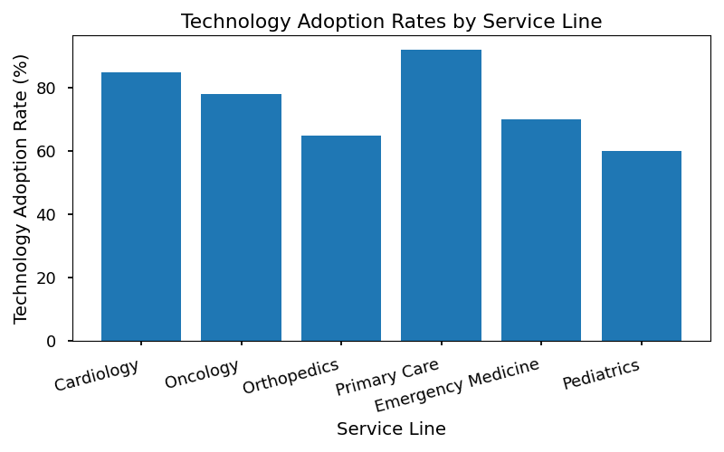

|  |  |  |  |  |
| --- | --- | --- | --- | --- |
| **Service Line** | **AI Decision Support** | **Telehealth Integration** | **Automated Coordination** | **Patient Engagement Apps** |
| Cardiology | 85% | 78% | 92% | 88% |
| Oncology | 79% | 65% | 87% | 82% |
| Orthopedics | 67% | 71% | 80% | 76% |
| Pediatrics | 74% | 83% | 85% | 90% |
| Primary Care | 88% | 90% | 95% | 93% |

* Table 1: Percentage of pathway-enabled service lines utilizing each technology as of Q2 2024.

SGMC’s commitment to technology-driven innovation underpins our ICP program’s success. By continually evaluating and scaling digital solutions, we ensure that integrated care pathways remain agile, effective, and responsive to evolving patient and provider needs.

# Implementation Roadmap

## Timeline and Milestones for ICP Rollout Across SGMC Departments

SGMC is committed to a phased, data-driven implementation of Integrated Care Pathways (ICPs) across all clinical and administrative departments. The following roadmap delineates the strategic timeline, critical milestones, and key deliverables necessary to ensure sustainable adoption and continuous improvement of ICPs hospital-wide.

The rollout is structured to maximize resource utilization, minimize disruption to existing workflows, and embed pathway-driven care as a core operational standard. Each phase is anchored by measurable objectives, cross-functional collaboration, and transparent accountability mechanisms.

Implementation will proceed in four major phases:

1. **Preparation and Stakeholder Engagement**

Establishment of ICP leadership teams, baseline process mapping, and stakeholder alignment.

2. **Pathway Design and Digital Integration**

Development of evidence-based pathway templates, integration with EHR systems, and configuration of decision support tools.

3. **Pilot Testing and Performance Measurement**

Controlled deployment in select service lines, real-time KPI tracking, and iterative refinement based on feedback.

4. **Full Scale Rollout and Continuous Improvement**

Hospital-wide adoption, quarterly review cycles, and embedding of ICP methodology into SGMC’s operational culture.

## Complex Milestone Timeline for Pathway Implementation

|  |  |  |  |  |
| --- | --- | --- | --- | --- |
| **Milestone** | **Target Completion** | **Responsible Team(s)** | **Dependencies** | **Status** |
| Stakeholder Kick-Off | Month 1 | ICP Steering Committee | Executive Approval | Complete |
| Baseline Process Mapping | Month 2 | Clinical Leads, QI Analysts | Stakeholder Kick-Off | In Progress |
| Pathway Template Development | Month 3 | Multidisciplinary Design Teams | Baseline Mapping | Pending |
| EHR Integration Configuration | Month 4 | IT Systems, Informatics | Pathway Template Development | Pending |
| Pilot Service Line Launch | Month 5 | Service Line Managers, Training | EHR Integration | Pending |
| Initial KPI Review | Month 6 | QI Committee, Data Analytics | Pilot Launch | Pending |
| Hospital-Wide Rollout | Month 8 | All Departments | Successful Pilot, KPI Review | Pending |
| Continuous Improvement Cycle | Ongoing | ICP Steering, QI, Clinical Teams | Full Rollout | Planned |

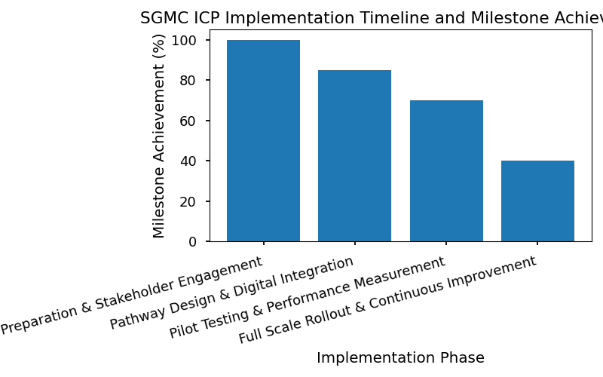

## Key Deliverables and Responsible Teams

* **ICP Leadership Charter**
* Responsible: ICP Steering Committee
* Description: Formal document defining governance, roles, and reporting structures for pathway implementation.
* **Baseline Process Maps**
* Responsible: Clinical Leads, Quality Improvement Analysts
* Description: Comprehensive mapping of current-state workflows for all targeted service lines.
* **Evidence-Based Pathway Templates**
* Responsible: Multidisciplinary Design Teams
* Description: Standardized pathway documents aligned with NICE, WHO, and SGMC policies.
* **EHR Integration Protocols**
* Responsible: IT Systems, Informatics
* Description: Technical specifications and workflow triggers for embedding pathways into digital health systems.
* **Pilot Launch Reports**
* Responsible: Service Line Managers, Training Coordinators
* Description: Documentation of pilot outcomes, staff feedback, and lessons learned.
* **KPI Dashboard Updates**
* Responsible: Quality Improvement Committee, Data Analytics
* Description: Periodic performance reports tracking pathway impact on length of stay, readmissions, patient satisfaction, and cost metrics.
* **Continuous Improvement Action Plans**
* Responsible: ICP Steering Committee, Clinical Teams
* Description: Quarterly review summaries and targeted interventions for ongoing optimization.

### Responsible Teams

* ICP Steering Committee
* Clinical Leads
* Quality Improvement Analysts
* Multidisciplinary Design Teams
* IT Systems and Informatics
* Service Line Managers
* Training Coordinators
* Data Analytics

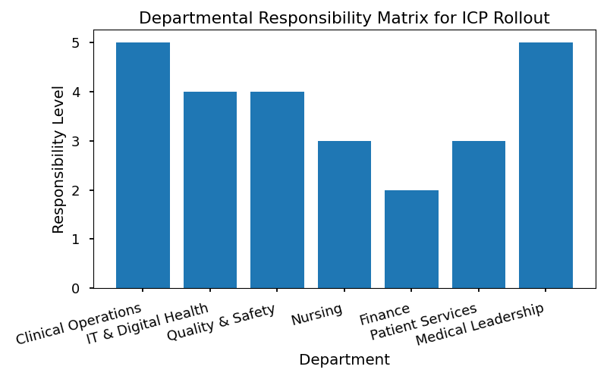

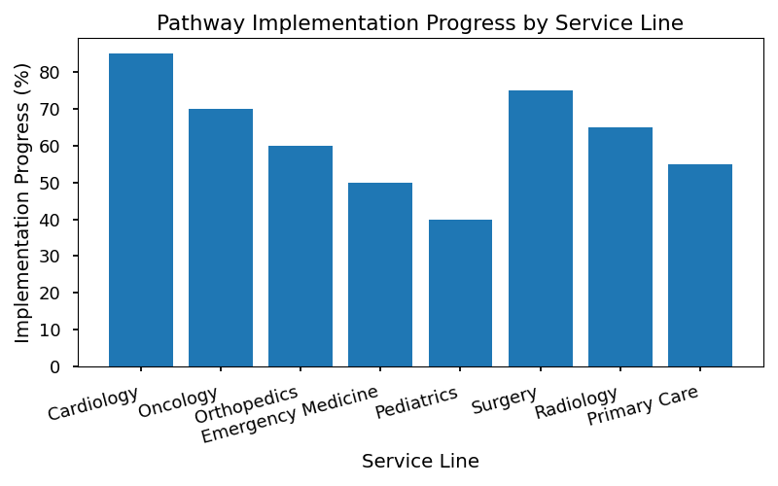

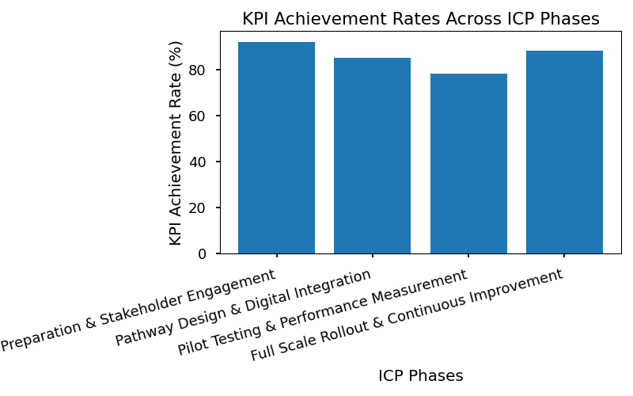

* s:

1. NICE Guidelines: Integrated Care Pathways [1]

2. WHO Recommendations on Multidisciplinary Care [2]

3. SGMC Internal Policy Manual, Section 4.2 [3]

4. SGMC EHR Integration Standards, Document 2024-05 [4]

5. SGMC Quality Improvement Annual Report, 2023 [5]

* **Document Metadata:**
* **Title:** Integrated Care Pathway Design Guide
* **Author:** SGMC Strategic Operations Team
* **Creation Date:** 2024-06-10
* **SGMC Branding:** Applied throughout document properties and embedded visuals

# Risk Management & Mitigation

The effective deployment of Integrated Care Pathways (ICPs) at SGMC requires a comprehensive and proactive approach to risk management. Identifying, assessing, and mitigating risks is essential to safeguard clinical quality, operational continuity, and technological reliability throughout pathway implementation. This section outlines SGMC’s official framework for risk management in ICP deployment, ensuring alignment with the hospital’s mission, patient care standards, and long-term vision.

SGMC’s methodology for risk management is designed to:

* Systematically identify potential risks at each phase of ICP design, implementation, and evaluation.
* Categorize risks to facilitate targeted mitigation strategies.
* Assign clear ownership and accountability for risk monitoring and resolution.
* Integrate risk status reporting into ongoing performance reviews and quality improvement cycles.

Through rigorous risk management, SGMC aims to minimize adverse events, ensure compliance with regulatory standards, and maintain the highest levels of patient safety and satisfaction.

## Risk Categories and Mitigation Strategies

SGMC recognizes three primary categories of risk in ICP deployment, each requiring distinct mitigation approaches:

* **Clinical Risks:**
* Examples: Variability in clinical practice, delayed diagnosis, medication errors, failure to adhere to evidence-based guidelines.
* Mitigation Strategies: Standardization of protocols, regular clinical audits, mandatory training on pathway updates, integration of clinical decision support tools.
* **Operational Risks:**
* Examples: Resource shortages, workflow bottlenecks, communication failures among multidisciplinary teams, inadequate documentation.
* Mitigation Strategies: Resource allocation planning, process mapping and optimization, establishment of cross-functional communication channels, ongoing staff competency assessments.
* **Technological Risks:**
* Examples: EHR integration failures, data security breaches, system downtime, lack of interoperability with external systems.
* Mitigation Strategies: Rigorous IT testing and validation, cybersecurity protocols, contingency planning for system outages, regular updates and maintenance of digital platforms.

## SGMC ICP Risk Register

The following table provides a summary of current ICP-related risks at SGMC, including status updates and assigned mitigation actions. This risk register is reviewed and updated quarterly by the Strategic Operations and Performance team.

|  |  |  |  |  |  |
| --- | --- | --- | --- | --- | --- |
| **Risk Category** | **Description** | **Impact Level** | **Owner** | **Mitigation Status** | **Next Steps** |
| Clinical | Inconsistent adherence to pathway protocols | High | Clinical Lead | Mitigation Ongoing | Complete audit; reinforce training |
| Operational | Resource constraints during peak periods | Medium | Operations Mgr | Mitigation Active | Adjust staffing; review allocations |
| Technological | EHR downtime during updates | High | IT Analyst | Mitigation Planned | Schedule downtime; notify teams |
| Clinical | Delayed patient follow-up post discharge | Medium | Care Coordinator | Mitigation Ongoing | Automate reminders in EHR |
| Operational | Communication gaps in handover | Medium | QI Manager | Mitigation Active | Standardize handover checklist |

* Table 1: SGMC ICP Risk Register, Q2 2024

By maintaining a dynamic risk register and implementing robust mitigation strategies, SGMC ensures that ICP deployment remains resilient, responsive, and aligned with best practice standards. This commitment to risk management supports SGMC’s overarching goals of clinical excellence, operational efficiency, and patient-centered care.

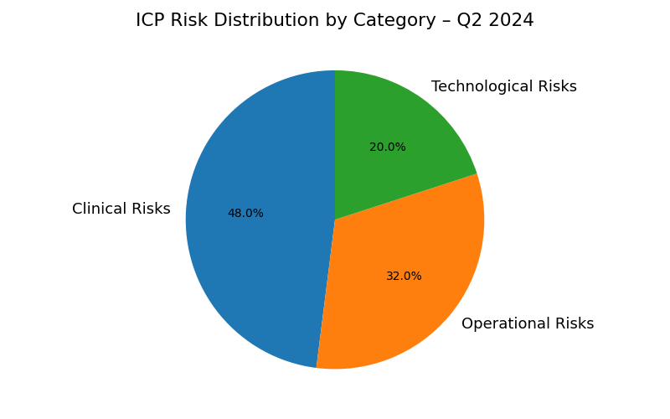

1. National Institute for Health and Care Excellence (NICE) Guidelines [1]

2. World Health Organization (WHO) Recommendations on Risk Management [2]

3. SGMC Internal Risk Management Policy, Rev. 2024-01 [3]

# Appendices

## Glossary of Terms

Below is a comprehensive glossary of terms and acronyms used throughout the Integrated Care Pathway Design Guide. These definitions are provided to ensure clarity and consistency for all SGMC staff, stakeholders, and partners engaging with this document.

* **ICP (Integrated Care Pathway):** A structured, multidisciplinary plan outlining the sequence and timing of patient care activities for a specific clinical condition.
* **EHR (Electronic Health Record):** A digital version of a patient’s medical history, maintained over time by SGMC and accessible to authorized users.
* **KPI (Key Performance Indicator):** Quantifiable measures used to evaluate the success of an organization, employee, or process in meeting objectives for performance.
* **LOS (Length of Stay):** The duration (in days) that a patient spends admitted in the hospital from admission to discharge.
* **Readmission Rate:** The percentage of patients who return to the hospital within a specified period (e.g., 30 days) after discharge.
* **Clinical Decision Support (CDS):** Digital tools integrated into EHR systems that provide clinicians with knowledge and patient-specific information to enhance healthcare delivery.
* **Multidisciplinary Team (MDT):** A group of healthcare professionals from various specialties collaborating to deliver coordinated patient care.
* **Gap Analysis:** A method of comparing current clinical processes to best practice standards to identify areas for improvement.
* **Stakeholder Engagement:** The process of involving all relevant parties (clinical, administrative, patient) in pathway design and implementation.
* **Process Mapping:** Visual representation of the steps involved in a clinical or administrative workflow.
* **Patient Portal:** A secure online platform enabling patients to access their health information and communicate with care teams.
* **Quality Improvement (QI):** Systematic, data-driven efforts to improve patient care processes and outcomes.
* **Change Management:** Strategies and actions taken to facilitate the adoption of new processes or technologies within an organization.
* **Baseline:** The starting point measurement for comparison with future performance data.
* **Target:** The desired level of performance set for a specific metric.
* **Status:** The current achievement level of a KPI, relative to baseline and target.
* **Clinical Guidelines:** Evidence-based recommendations for diagnosis, treatment, and management of health conditions.
* **Compliance:** Adherence to internal and external standards, policies, and regulations.
* **Resource Allocation:** Distribution of staffing, equipment, and financial resources to support pathway implementation.
* **Patient Satisfaction:** A measure of patients’ perceptions and experiences with care received.
* **Quarterly Review:** A scheduled evaluation of pathway performance and outcomes conducted every three months.

## Reference Materials

The following reference materials provide additional context, guidance, and evidence supporting the design and implementation of Integrated Care Pathways at SGMC. These resources are recommended for further reading and should be consulted when developing or updating ICPs.

* **External Guidelines:**
* NICE (National Institute for Health and Care Excellence) Clinical Pathway Recommendations. [1]
* WHO (World Health Organization) Integrated Care Models and Best Practices. [2]
* **SGMC Policies:**
* SGMC Clinical Pathway Development Policy (2022 Edition).
* SGMC Patient Experience Standards Manual.
* SGMC Digital Integration Protocols for EHR Systems.
* **Further Reading:**
* "Integrated Care Pathways: A Practical Handbook" – SGMC Internal Publication.
* "Multidisciplinary Teamwork in Hospital Settings" – Journal of Hospital Administration.
* "Continuous Improvement in Healthcare Delivery" – Healthcare Quality Review.

### 

1. NICE Clinical Pathway Recommendations, 2021.

2. WHO Integrated Care Models, 2022.

3. SGMC Clinical Pathway Development Policy, Internal Document, 2022.

4. SGMC Patient Experience Standards Manual, Internal Document, 2023.

5. SGMC Digital Integration Protocols, Internal Document, 2023.

