Field Manual for Measurements and Plot Establishment

Strip Cut Understory Protection Study



Version 1 July 2013 ***Table of Contents***

1 BackGround 4

1 General 4

2 Plot Cluster REMeasurement Protocols 6

2.1 Plot Re measurement 6

3 New Installation Establishment 7

3.1 Block Selection 7

2.1 Gathering Block Information 7

3.2 Locating Plot Custers 7

3.2.1 Pre-Location Method Using Aerial Photos/Detailed Harvest Maps 7

3.2.2 Field Location Method 11

3.2 Directions and Navigation 12

4.1 Access Notes 12

4.2 Directions within the Block 12

2 Plot Establishment 13

6.1 Plot Center 13

6.2 Plot Cluster Sequence 14

6.3 Plot Center Line 16

6.4 Individual Plot Boundaries 18

6.5 Plot Cluster Boundary Delineation 21

6.6 Age Plot Establishment 21

7.1 Plot Cluster Description 23

7.2 Buffer and Removal Plots 24

7.3 Extraction Plot 26

Field Measurement Quality Control Standards 27

APPENDIX I: GLOSSARY OF TERMS 29

APPENDIX II: EQUIPMENT LIST 31

APPENDIX III: Field Tally Sheets 32

Block Form Side 1 32

Block Form Side 2 33

Plot Form Page 1 Side 1 34

Plot Form Page 1 Side 2 35

Plot Form Page 2 Side 1 36

Plot Form Page 2 Side 2 37

APPENDIX IV: Tally Sheet Codes 38

APPENDIX V: DIAMETER MEASUREMENTS 42

APPENDIX VI: HEIGHT MEASUREMENT 43

***List of Tables***

Table 1. Extraction Trail lengths for Plot Cluster pre-location example. 10

Table 2. Tree numbering. 26

Table 3. Quality control standards for Plot Cluster establishment and measurement. 29

Table 4. Member company codes. 39

Table 5. Slope position descriptions. 39

Table 6. Acceptable species codes. 40

Table 7. Crown class codes. 40

Table 8. Condition codes (based on LFS PSP standards). 41

***List of Figures***

.

Figure 1. Example of selection of eligible Extraction Trails for sampling. 9

Figure 2. Plot pre-location process. Measured distances are shown in black. 11

Figure 3. Plot cluster layout when Buffer is present. 16

Figure 4. Plot cluster layout when no Buffer is present 17

Figure 5. Plot boundary markings. 20

Figure 6. Section layout and tree numbering. 26

Figure 7. Slope codes. 39

Figure 8. Diameter measurement techniques. 43

Figure 9. Coniferous and deciduous height measurement. 44

Figure 10. Measuring height on a leaning tree. 45

# 

# 1 Background

This document is intended for use by contractors engaged in 1) re-measuring the Mixedwood Management Association’s Strip Cut Understory Protection (SCUP) plots and 2) establishing new plot installations for the study. It replaces all previous versions of the *Strip Cut Understory Protection Monitoring Protocol and Field Manual* as of July 31, 2013.

This section provides a brief overview of the protocol and describes changes to procedures effective in the 2013 field season. For detailed information on study design, refer to previous version of the manual.

The protocol was originally designed to assess stand level performance following strip cut understory protection harvesting , to provide information for growth model develop and/or calibration and to provide data acceptable to Alberta Sustainable Resource Development for use in monitoring and yield curve validation. The protocol was revised in 2013 to:

* collect data suitable for both MGM model develop and initiation
* maximize efficiency of sampling, particularly reducing effort on tagging and measuring saplings.

The protocol is intended for *Single-Pass* Strip Cut Understory Protection systems only and samples three different areas within the treatment. The *Extraction Trail* is the area within which all trees have been harvested, to provide access for harvesting equipment. The *Removal Strip* is the area subjected to overstory removal (generally aspen), for the purpose of releasing understory conifers (generally white spruce). The *Buffer Strip* is a “leave” area, within which the overstory is retained to reduce windthrow effects on release trees in the Removal Strip. The SCUP protocol uses a *Plot Cluster* design. A Plot Cluster consists of a series of adjacent plots, each sampling one of the three treatment areas.

# 2 New Installation Establishment

## 2.1 Block Selection

The protocol is intended for *Single-Pass* Strip Cut Understory Protection systems only. To be considered an eligible Block, establishment and first measurement must be able to occur in the spring prior to the first growing season after harvest. Blocks must be large enough to accommodate six Plot Clusters, and must have a minimum of five eligible Extraction Trails. To be considered for eligibility, blocks should have:

* 4-8 m wide Extraction Trails
* 0 m to 20 m wide Buffer Strips
* 6-10 m wide Removal Strips. where buffer strips are present
* 12-20 m wide removal strips if there is no Buffer Strip between Removal Strips
* A total length of eligible extraction trails ≥ 720 m in order to allow for the establishment of 6 plot clusters.

An Extraction Trail is eligible if:

* it is not the first or last Extraction Trail along Block edges
* its length is ≥ 120 m
* It has a Buffer on at least one side (where treatment includes a buffer)

### 2.1.1 Gathering Block Information

Available Block information should be recorded on the **Block Form (Side 1)** (Appendix 3) prior to field sampling. Missing Block information should be treated in **one of two ways**: cross out fields where information is not available; leave these fields blank if the information was not collected prior to field sampling. An example is provided in Appendix III.

## 2.2 Locating Plot Clusters

There are two methods of determining Plot Cluster locations. If aerial photos or detailed harvest maps (which include locations of extraction trails) are available, use the Plot Cluster pre-location method (Section 3.2.1). This is the preferred method. Where this information is not available, use the alternate Plot Cluster location method (Section 4.2).

### 2.2.1 Pre-Location Method Using Aerial Photos or Detailed Harvest Maps

Where available, aerial photography (preferably 1:15,000 scale) or detailed harvest maps will be used to randomly pre-locate six Plot Cluster center points within the eligible Extraction Trails.

The selection of Extraction Trails will be systematic with a random start. An example is provided in Figure 1.

1. Number all eligible Extraction Trails 1 through X, starting from west to east or north to south depending on layout. See section 2.2 for a description of eligible extraction trails.
2. Flip a coin to determine the starting eligible Extraction Trail (Extraction Trail 1 or 2).
3. Select alternating eligible Extraction Trails for sampling. If starting with eligible Extraction Trail 2, use 2, 4, 6, 8 *etc.*; if starting with eligible Extraction Trail 1, use 1, 3, 5, 7 *etc.*

Plot Clusters will be pre-located on eligible extraction trails using a fixed distance with a random start. An example is provided in Figure 2 and Table 1, using the eligible Extraction Trails from Figure 1. Details of the example are provided in brackets at the end of each step of the process:

1. Measure the length of each selected Extraction Trail (Li) in m.
2. Sum the individual selected eligible Extraction Trail lengths (Ltotal = L1 + L2 …+ Li) in m to determine the total sampling length.
3. Determine the fixed distance between Plot Clusters by dividing the total sampling length by 6 (Dfixed = Ltotal/6) and round down to the nearest m.
4. To determine the start distance for the first Plot Cluster location, select a random number between 0 and 1, multiply it by the fixed distance between Plot Clusters (Dstart=Dfixed*random) and round down to the nearest m.
5. Locate the first Plot Cluster at Dstart m along the first selected Extraction Trail (either 1 or 2 depending on results from Step 2, Section 4.1.1) using a tie point at the intersection of the Extraction Trail with the *Haul Road* (tie point 2 in this example).
6. To locate the second plot cluster, poceed along the selected eligible Extraction Trail a distance equal to Dfixed. When the end of one selected Extraction Trail is reached, proceed to the next selected Extraction Trail and continue until Dfixed is reached (heading in the opposite direction than the first Extraction Trail). The fixed distance will be the sum of the two distances along the Extraction Trails in question; the distance between Extraction Trails is not measured.
7. Repeat step 6 until all six Plot Clusters are pre-located.
8. Once the six Plot Clusters are pre-located, determine whether any Plot Clusters within 30 m of the beginning or end of the Extraction Trails. Offset the Plot Cluster by moving it 30 m inwards; that is, away from the end of the Extraction Trail. This step must be done after all Plot Clusters are pre-located, and will not affect the location of the remaining Plot Clusters.

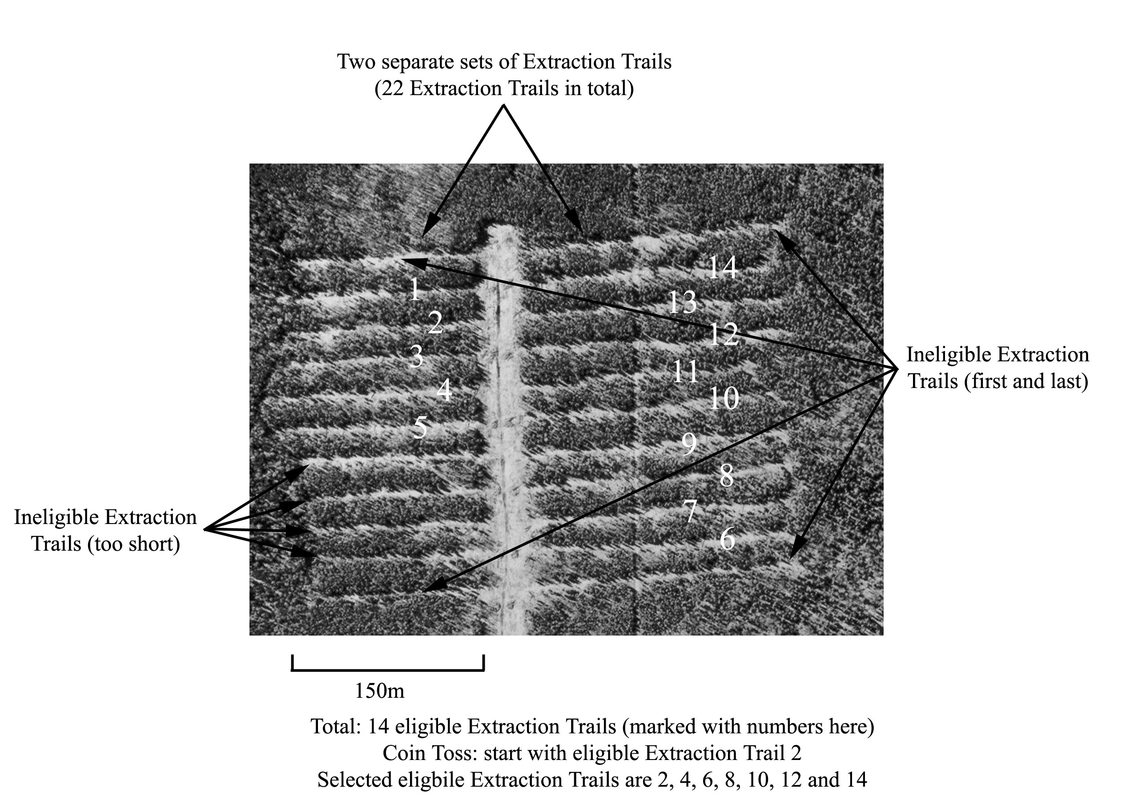

Figure 1. Example of selection of eligible Extraction Trails for sampling.

Table 1. Extraction Trail lengths for Plot Cluster pre-location example.

|  |  |
| --- | --- |
| Selected Eligible  Extraction Trail | Total Length (m) |
| 2 | 160 |
| 4 | 183 |
| 6 | 218 |
| 8 | 220 |
| 10 | 217 |
| 12 | 226 |
| 14 | 219 |
| Total | 1443 |

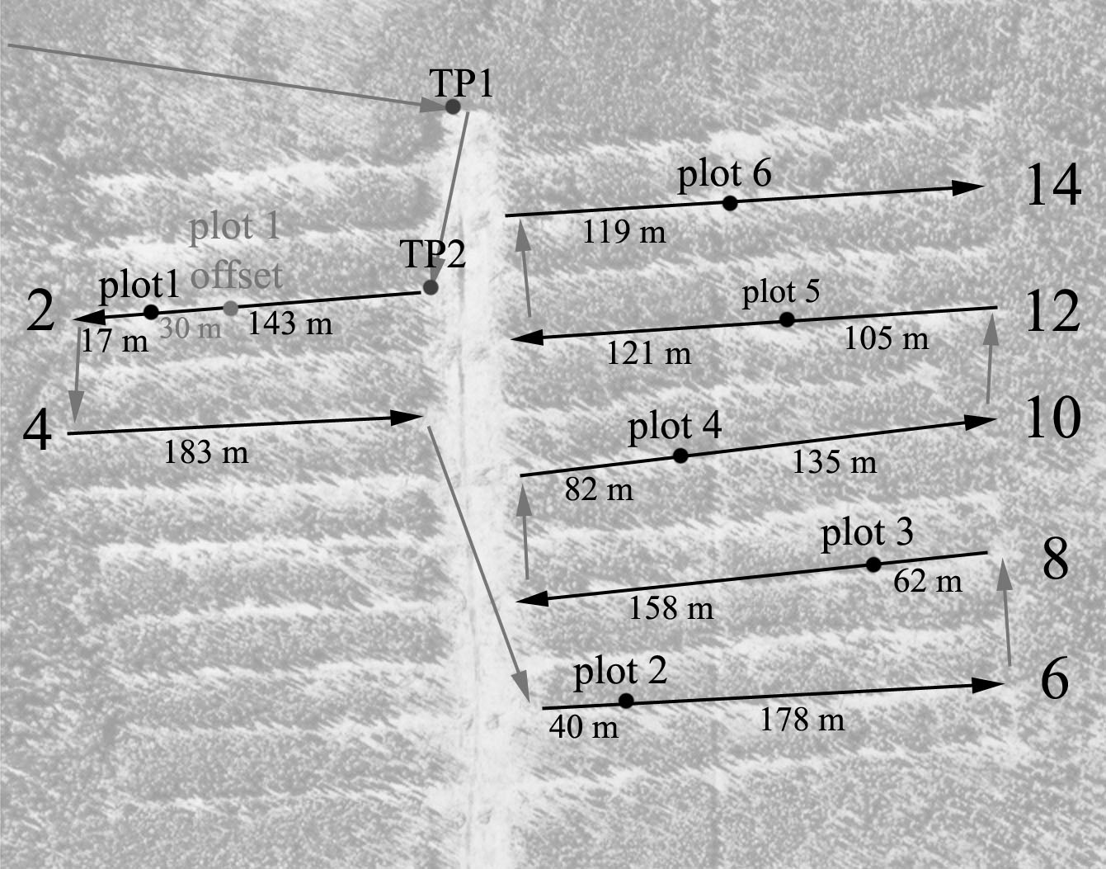

Figure 2. Plot pre-location process**. Measured distances are shown in black.**

Grey arrows indicate the path to be taken for Plot Cluster layout.

### 2.2.2 Field Location Method

If aerial photos are not available, Plot Clusters may be located in the field using this alternate method.

1. ***Determine the number of Haul Roads with eligible extraction trails:*** Either walk the Block to determine the number of Haul Roads or use harvest maps. See Section 3.1. for information on how to determine eligible extraction trails. Haul roads along the edge of the Block count as a single Haul Road.
2. ***Determine the number of Plot Clusters to be established on each Haul Road:*** The number of Plot Clusters to be established will depend on length of each Haul Road. For each Haul Road, divide the length of the Haul Road by the total length of Haul Roads and multiply by 6 (Nplots=round((Lhaul_1/ Lhaul_tot)*6)). This is the number of Plot Clusters to be established on each Haul Road. The total should be 6. If, due to rounding, the total is not 6, assign additional Plot Clusters based on fractions. For example, there are three Haul Roads with lengths of 656, 624 and 320 m. Total Haul Road length is 1600 m. Using the above formula, the number of Plot Clusters per road is calculated as 2.46, 2.34, and 1.20 Plot Clusters per road, respectively, which round to 2, 2, and 1 Plot Clusters (total of 5 Plot Clusters). Since the first Haul Road was the closest to rounding up, adjust the numbers to 3, 2 and 1, respectively.
3. ***Select a random distance for each Plot Cluster:*** For each Plot Cluster, calculate a random distance along the Haul Road (multiply a random number between 0 and 1 by the Haul Road length in m, *e.g.*, Dstart=Lhaul*random, and round to the nearest m). Walk along the Haul Road to the calculated distance, then select the extraction trail closest to the Haul Road at that point. If the extraction trail extends on both sides of the Haul Road, as in Figure 3, flip a coin to determine whether to proceed to the left or right (rather than treat these as individual Extraction Trails, as in Section 4.1).
4. ***Locate the Plot Cluster center:*** Determine the length of the selected extraction trail. Calculate a random distance along the extraction trail (multiply a random number between 0 and 1 by the extraction trail length in m). Proceed from the Haul Road along the extraction trail for that distance. Establish the center of the Plot Cluster at the center of the Extraction Trail.
5. ***Offset Plot Clusters located within buffers:*** If the Plot Cluster center is within 30 m of the beginning or end of the Extraction Trail, the Plot Cluster must be offset (to avoid edge effect). Offset the Plot Cluster center by moving it 30 m inwards; that is, away from the end of the Extraction Trail.
6. ***Locate subsequent Plot Clusters:*** repeat the previous steps until all 6 Plot Clusters are located. In the event that the same extraction trail is randomly selected to have more than one Plot Cluster, reselect a different random number (sampling without replacement). Where there less than six eligible Extraction Trails, one Extraction Trail may have two Plot Clusters; however, these must be at least 100 m apart.

## 2.3 Directions and Navigation

Good access notes and within block location information are required to allow both Quality Control crews and subsequent re-measurement crews to relocate both the Block and the Plot Clusters.

### 2.3.1 Access Notes

Record detailed access, starting along a major highway or road and ending at the first starting point. Include distances (to the nearest 0.1 km) along the main road from a recognizable road intersection or other anthropogenic or land feature to the turnoff from this road. From this point, provide directions along the road(s) leading to the main in-block Haul Road associated with the Block. Note whether or not vehicle (truck) access continues into the Block, or whether access by foot or ATV is required. Directions should be recorded on the **Block Form (Side 1)** (Appendix III). Either a map to the Block should be attached to this form or a hand drawn map should be included on the front of the **Block Form (Side 1)**.

Directions to the Block end at the Starting Point. The starting point is placed at the intersection of the primary Haul Road with the first extraction trail which occurs along this road. Flag the location on the left or right side of the road next to a well-established tree that is expected to persist for some time.

Establish a blue post at the selected starting point, place 3 blue ribbons at eye level on a tree closest to the starting point and paint a blue circle around the bole at breast height.

Place an aluminum tag on the starting post, recording:

* + MWMA - Company Code – SCUP - Harvest Block Identifier – SP
  + Azimuth and distance to first tie point

**example: MWMA-ALPA-SCUP-16751-SP**

**192 m @ 90° to TP1**

### 2.3.2 Directions within the Block

#### 2.3.2.1 Tie Points Marking Plot Clusters

A tie points must be placed at the intersection of the Haul Road with each extraction trail containing a Plot Cluster (see example Figure 5 or Appendix III). Locate the tie point on the same side of the extraction trail as the plot cluster.

Establish a **blue post** at each tie point, place 3 **blue ribbons** at eye level on a tree closest to the tie point.

Place a tag on each tie post, recording:

* + MWMA - Company Code – SCUP - Harvest Block Identifier – TP#
  + Distance and azimuth to Plot Cluster center
  + Distance and azimuth to next tie point, if applicable

**example: MWMA-ALPA-SCUP-16751-TP4**

**116 m @ 72° to PC3 / 139 m @ 322° to TP5**

#### 2.3.2.2 Tie Points for Block Navigation

Additional tie points will be used to mark any changes in direction that occur while navigating between the starting point and subsequent tie points. For example, in Figure 5 (next page) or Appendix III, TP1 marks a change in direction when moving from the primary Haul Road to a secondary Haul Road.

Establish a blue post at each tie point, place 3 blue ribbons at eye level on a tree closest to the tie point.

Place a tag on each tie post, recording

* + MWMA - Company Code – SCUP - Harvest Block Identifier – TP#
  + Distance and azimuth to next tie point(s) (generally there will be two)

**example: MWMA-ALPA-SCUP-16751-TP1**

**216 m @ 239° to TP2 / 64 m @ 325° to TP4**

Once the starting point and all tie points are established, record the following information on the **Block Form (Side 2)**.

## 2.4 Plot Establishment

### 2.4.1 Plot Center

Locations of Plot Cluster centers are determined using one of the two methods described in Section 4. Navigate to the Plot Cluster center using the prescribed distances and directions.

* Once at the first Plot Cluster center, establish a **blue** **post** in the center of the Extraction Trail, with an aluminum tag labeled with the following information separated by dashes (SCUP Plot ID):
  + MWMA - Company Code – SCUP - Harvest Block Identifier – PC#

**example: MWMA-ALPA-SCUP-16751-PC1**

### 3.4.2 Plot Cluster Sequence

This section describes the steps for establishing a Plot Cluster, which consists of a Buffer Plot, two Removal Plots (A and B) and an Extraction Plot. Appendix II lists the equipment required to establish one Plot Cluster, and Appendix III provides a sample Field Plot Establishment Form which has been filled out to illustrate the correct recording of data. Appendix IV provides a list of codes used on the form.

The Plot Cluster sequence is randomly selected (either Buffer-Removal-Extraction-Removal or Removal-Extraction-Removal-Buffer) using methods described on the next page. See Figure 6 for a sample layout. Plot “center” is the center of the Extraction Plot.

* Where the treatment includes a Buffer, there is a Removal Plot (A and B) on either side of the Extraction Plot. Only one side of the Extraction Trail will have a Buffer Plot; the sequence id determined using a coin toss;
* Where the treatment does not include a Buffer, there is a single Removal Plot, spanning the distance between two adjacent extraction trails; the sequence id, Removal – Extraction or Extraction – Removal, is determined by a coin toss.

#### 6.2.1 Plot Cluster Sequence When Treatment Includes Buffers

All layout and measurement is completed relative to the side of the Plot Cluster that contains the Buffer Plot.

1. Stand facing along the Extraction Trail (does not matter which direction). Flip a coin to select which side of the Extraction Plot will have the Buffer Plot (either left or right of the crew member and perpendicular to the extraction line).
2. The selected side will have a Buffer Plot and Removal Plot (A), with the Plot Cluster boundary occurring at the far edge of the Buffer Plot.
3. The non-selected side will have only Removal Plot (B), with the Plot Cluster boundary occurring at the far edge of Removal Plot B.
4. Figure 7 shows the Plot Cluster layout.
5. If there is only a Buffer Stratum on one side, then no coin is required; the side with the Buffer Stratum is selected for the Buffer Plot. If there is no buffer stratum on either side, this is an ineligible Extraction Trail and an alternate Plot Cluster location must be selected.

Figure 3. Plot cluster layout when Buffer is present.

#### 6.2.2 Plot Cluster Sequence When Treatment Does Not include Buffers

All measurement and layout is completed relative to the side of the Plot Cluster that contains the Removal Plot.

1. Stand facing along the Extraction Trail (does not matter which direction). Flip a coin to select which side of the Extraction Plot will have the Removal Plot (either left or right of the crew member and perpendicular to the extraction line).
2. The selected side will have the Removal Plot, with the Plot Cluster boundary occurring at the far edge of the Removal Plot.
3. The non-selected side will not have a Removal Plot, with the Plot Cluster boundary occurring at the far edge of Extraction Plot.
4. Figure 8 shows the Plot Cluster layout.



Figure 4. Plot cluster layout when no Buffer is present

### 6.3 Plot Center Line

The Plot Cluster centerline extends across all plots and intersects the Plot Cluster center point, located in the center of the Extraction Trail. This line should be perpendicular to the general orientation of Extraction Trail (blue line in Figure 6). It is important to have this line laid out as close to perpendicular to the Extraction Trail as possible, otherwise QC tolerances for Plot Cluster layout parameters may be exceeded.

#### Location

*Note: This process describes plot and center line location for treatments that include Buffer. If no Buffer is present, the steps are the same however the measurements start on the outside edge of the Removal Plot as opposed to the outside edge of the Buffer Plot.*

Determine the direction of the centerline:

1. Take a compass reading along the Extraction Trail (*i.e.* 275°).
2. Add or subtract 90° depending on which side of the Extraction Trail contains the Buffer Plot or the Removal Plot if no buffer is present (*i.e.* 5°).
3. Run a measuring tape perpendicular to the Extraction Trail (use the azimuth from step 2):
   1. From the next Extraction Trail outside the Buffer Strip (Removal Plot where no Buffer present)
   2. Across the Buffer Strip and Removal Strip A (Removal Plot where no Buffer present)
   3. Through the Plot Cluster center point on the Extraction Trail
   4. Through Removal Strip B (where Buffer present)
   5. And well into the next Buffer Strip (or next Removal Plot if no Buffer is present)
4. Leave the tape on the ground, making sure it is **straight**.

**Note:** Leave the measuring tape out along the centerline because it is needed for the duration of Plot Cluster establishment and measurement.

Mark the boundaries of the Buffer Strip:

1. Get a general feel of the width of the surrounding Removal Strips, keeping in mind the prescribed width (*i.e.* 8 m). A good way to do this:
   1. Walk around the Removal Strips on either side of the Buffer Strip
   2. Within each Removal Strip, mark stumps on either side of the centerline by laying strips of blue flagging tape on them
   3. You may have to mark stumps quite a distance from the centerline (10 or 15 m) in order to get a good idea of Buffer Strip boundary
2. Establish a **blue pigtail[1]** on the Plot Cluster centerline (with the measuring tape still in place) at the outer boundary of the Buffer Plot, based on general Removal Stratum width.
3. Establish a **blue pigtail** on the Plot Cluster centerline at the boundary between the Buffer Strip and the Removal Strip A, based on general Removal Stratum widths.

Mark the boundaries of the Removal Strips:

1. Move the measuring tape left along the centerline until the zero end of the measuring tape is located at the **blue pigtail** marking the outer edge of the Buffer Strip
2. Establish a **blue pigtail** on the Plot Cluster centerline at the boundary between Removal Strip A and the Extraction Trail.
3. Establish a **blue pigtail** on the Plot Cluster centerline at the boundary between the Extraction Trail and Removal Strip B.
4. Get a general feel for the width of Removal Strip B (use flagging to mark stumps)
5. Establish a **blue pigtail** on the Plot Cluster centerline at the outer boundary of Removal Strip B.

#### 6.3.2 Measurement

With the tape still extended across the Plot Cluster at the centerline and the zero end at the outer boundary of the Buffer Strip, measure the distance of each boundary or **blue pigtail** (Buffer, Removal A, Extraction and Removal B) from the outer boundary of the Buffer Strip[2]. The Stratum widths will be calculated based on these recorded measurements. This will ensure that the sum of the individual plot widths is equal the width of the Plot Cluster.

Record this information on the **Plot Form Page 1 (Side 1)**:

**STRIP WIDTH INFORMATION**

Starting at outer boundary of Buffer Strip:

* Outer boundary of Buffer Strip at centerline in m (always 0 m)

Moving across Plot Cluster:

* Removal Strip A boundary in m (Buffer/Removal A)
* Extraction Trail boundary in m (Removal A/Extraction)
* Removal Strip B boundary in m (Extraction/Removal B)
* Outer edge of Removal Strip B in m

**Note:** Leave the measuring tape out along the Plot Cluster centerline because it is needed for the duration of Plot Cluster establishment and measurement.

### 6.4 Individual Plot Boundaries

#### 6.4.1 Location

*Note: This process describes plot location for treatments that include Buffer. If no Buffer is present, the steps are the same however the measurements start on the outside edge of the Removal Plot as opposed to the outside edge of the Buffer Plot.*

Buffer Plot boundary markers are established 4 m on either side of the centerline for 8 m long plots. For 16 m long plots, boundary markers are established at both 4 m and 8 m on either side of the centerline.

Figure 7 illustrates the placement of Plot Cluster boundary markers based on Stratum boundary markers along the centerline (blue posts).

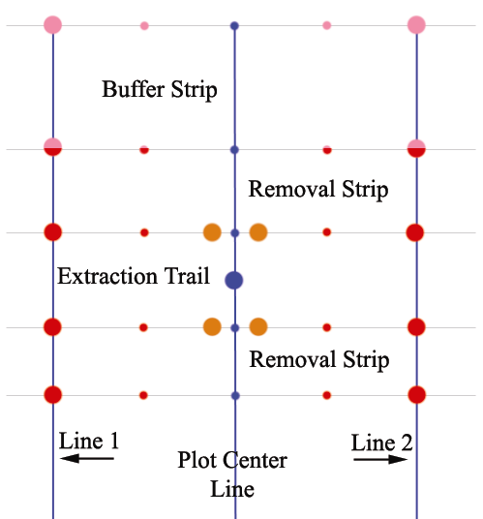

Figure 5. Plot boundary markings[3].

Mark the Buffer Plot and Removal Plot boundaries:

1. Outer Buffer Strip:
   1. For 8 m long plots, establish **pink posts[4]** perpendicular to the centerline at 4 m on either side of the **blue pigtail** markers.
   2. For 16 m long plots, place **pink pigtails** at 4 m and **pink posts** at 8 m perpendicular to the centerline on either side of the **blue pigtail** markers.
2. Buffer Strip/Removal Strip A boundary:
   1. For 8 m long plots, establish **pink/red posts** perpendicular to the centerline at 4 m on either side of the **blue pigtail** markers.
   2. For 16 m long plots, place **pink/red[5] pigtails** at 4 m and **pink/red posts** at 8 m perpendicular to the centerline on either side of the **blue pigtail** markers.
3. Removal Strip A/Extraction Trail boundary:
   1. For 8 m long plots, establish **red posts** perpendicular to the centerline at 4 m on either side of the **blue pigtail** markers.
   2. For 16 m long plots, place **red pigtails** at 4 m and **red posts** at 8 m perpendicular to the centerline on either side of the **blue pigtail** markers.
4. Removal Strip B/Extraction Trail boundary:
   1. For 8 m long plots, establish **red posts** perpendicular to the centerline at 4 m on either side of the **blue pigtail** markers.
   2. For 16 m long plots, place **red pigtails** at 4 m and **red posts** at 8 m perpendicular to the centerline on either side of the **blue pigtail** markers.
5. Outer Removal Strip B:
   1. For 8 m long plots, establish **red posts** perpendicular to the centerline at 4 m on either side of the **blue pigtail** markers.
   2. For 16 m long plots, place **red pigtails** at 4 m and **red posts** at 8 m perpendicular to the centerline on either side of the **blue pigtail** markers.

Mark the Extraction Plot boundaries:

1. At the boundary between the Extraction Trail and Removal Strip A, establish **orange posts** perpendicular to the centerline at 1 m on either side of the **blue pigtail** markers.
2. At the boundary between the Extraction Trail and Removal Strip B, establish **orange posts** perpendicular to the centerline at 1 m on either side of the **blue pigtail** markers.

#### 6.4.2 Measurement

Two additional lines will be used to measure the widths of each Stratum associated with the Plot Cluster sequence (Buffer, Removal A, Extraction, Removal B), and to ensure that the Plot Cluster layout is within quality control standards.

Place the zero end of a measurement tape at the far edge of the Buffer Plot (**pink post**) and extend the tape across the Plot Cluster sequence (Buffer Plot, Removal Plot A, Extraction Trial and Removal Plot B) to the far edge of the Removal Plot B. The tape should cross each post, and create Line 1 (Figure 7).

Record the distance from the outer edge of the Buffer Strip for each Stratum (Buffer, Removal A, Extraction and Removal B) starting at the Buffer Strip. The plot widths will be calculated based on these recorded measurements. This will ensure that the sum of the individual plot widths is equal the width of the Plot Cluster.

Record on the **Plot Form Page 1 (Side 1)**:

**STRIP WIDTH INFORMATION**

Starting at outer boundary of Buffer Strip:

* Outer boundary of Buffer Strip at centerline in m (always 0 m)

Moving across Plot Cluster:

* Removal Strip A boundary in m
* Extraction Trail boundary in m
* Removal Strip B boundary in m
* Outer boundary of Removal Strip B in m

Repeat the measurement procedure for the other side of the Plot Cluster, creating and measuring Line 2 (Figure 7).

Measure and record the two boundary widths of the Establishment Plot (between the two **orange posts**).

**For quality control purposes, the total length of the Plot Cluster sequence must be within 30 cm of the total length of the centerline for both Line 1 and Line 2. If not, the Plot Cluster layout must be rechecked and adjusted.**

### 6.5 Plot Cluster Boundary Delineation

The Plot Cluster will be revisited for future re-measurements. Therefore, trees close to, but outside the Plot Cluster must be identified. Mark the Plot Cluster boundary by spraying a **blue line** at breast height on all trees just outside the perimeter of Removal Plot A, Removal Plot B and the Buffer Plot. Spray the trees on the side facing away from the Plot Cluster.

### 6.6 Age Plot Establishment

Age information for both aspen and spruce is required for each Plot Cluster within each Block. Age at breast height will be collected in 300 m2 plots adjacent to the Plot Cluster from three aspen and three white spruce by coring the stems at breast height and counting the tree rings.

Age plots will be established as it follows.

#### 6.6.1 Age Plots where Treatment Includes Buffers

Three age plots will be established in Blocks where the treatment includes Buffers. One 300 m2 plot will be established in the Buffer, one 150 m2 plot will be established in the Removal Strip A and 150 m2 will be established in the Removal Strip B.

##### 6.6.1.1 Buffer Age Plot

A 300 m2 plot will be established in the Buffer strip adjacent to the Buffer Plot and it will be used to collect breast height age for aspen. The plot will be located left or right of the Buffer Plot so that it fits within the length of the Buffer strip. The Buffer Age Plot will have the following characteristics:

* The width of the Buffer Age Plot will be the same as the width of the Buffer Plot;
* The length of the plot will be calculated as 300/Buffer Plot width.

In each Buffer Age Plot three largest aspen by DBH will be selected and measured as described in Section 7.1

##### 6.6.1.2 Removal Age Plots

In each Removal Strip (A and B) a 150 m2 plot will be established adjacent to the Removal Plot A or B. These plots will be located left or right of the Removal Plot and they will be used to collect age information for the white spruce. The Removal Age Plots will have the following characteristics:

* The width of the Removal Age Plots (A and B) will be the same as the width of the Removal Strip (A and B); and
* The length of the plot will be calculated as 150/Removal Age Plot width.

The white spruce tree selection for age measurement will follow the steps:

* In each 150 m2 Removal Age Plot the three largest white spruce by DBH will be selected;
* The 6 white spruce selected (3 in each Removal Age Plot) will be ranked in the descending order of their DBH; and
* The top 3 largest white spruce by DBH will be selected for age measurement as described in Section 7.1.

#### 6.6.2 Age Plots where Treatment Does Not Include Buffers

For treatments that do not include a Buffer there is only one Age Plot to be established. In this case age is measured only for the white spruce.

##### 6.6.2.1 Removal Age Plot

A single 300 m2 will be established in the Removal Strip adjacent to the Removal Plot. The age plot will be located left or right of the Removal Plot and it will be used to collect age information only for white spruce.

The Removal Plot Age will have the following characteristics:

* The width of the Removal Age Plot will be the same as the width of the Removal Strip; and
* The length of the plot will be calculated as 300/Removal Age Plot width.

The white spruce tree selection for age measurement will follow the steps:

* In the 300 m2 Removal Age Plot the three largest white spruce by DBH will be selected;
* The selected white spruce will be measured as described in Section 7.1.

## 7.1 Plot Cluster Description

Once the Plot Cluster has been established, measurement of plot attributes can commence. Record the following information on the **Plot Form Page 1 (Side 1)**:

* Township
* Range
* Meridian
* SCUP Plot ID (MWMA-Company Code-SCUP-Harvest Block Number-PC#)
* Measurement date (yyyy/mm/dd)
* Crew Initials (up to three crew members)
* Measurement number (measurement number at establishment = 001)

**PLOT DESCRIPTION INFORMATION**

* Slope percent (taken from the outer boundary of the Buffer Plot across the Plot Cluster)

*Measure the slope gradient using a clinometer and record to the nearest percent.*

* Slope position

*See Appendix IV for a description of slope position codes.*

* Aspect (taken from the outer boundary of the Buffer Plot across the Plot Cluster)

*Determine the average aspect (direction the slope faces) of Plot Cluster in degrees. For Plot Clusters with no slope, the aspect is assigned a value ‘0’; a north aspect is recorded as 360 degrees.*

* Elevation in m

*Determine the average elevation of the Plot Cluster using an altimeter or a GPS unit.*

* UTM coordinates (also submit in digital format with SCUP Plot ID)
* Orientation of Extraction Trail to the nearest degree (*i.e.* 275°)
* Direction of Buffer Strip in relation to Plot Cluster center within Extraction Trail (*i.e.* 5°)
* Plot length (either 8 m or 16 m)

**ECOLOGICAL INFORMATION**

* Ecosite to ecosite phase

*Using the appropriate Field Guide to Ecosites, determine the ecosite based on vegetation within the Buffer Plot, and enough soils assessment to obtain soil moisture and nutrient regime. Ecosite should be assessed for each Plot Cluster.*

* Soil moisture regime

*Use soil codes from the Ecosite field guide.*

* Soil nutrient regime

*Use soil codes from the Ecosite field guide.*

**ASPEN AGE INFORMATION**

In the Buffer Age Plot once the three largest DBH aspen were selected, record the following for each individual tree:

* Diameter at breast height (cm)
* Height (m)
* Age at breast height (y)

Mark the selected aspen with a band of blue paint, completely encircling the bole, at breast height. Note the approximate location of the tree in the comments section, including a rough azimuth from the Buffer Plot, to help QC crews relocate the tree.

**SPRUCE AGE INFORMATION**

In the Removal Age Plots (or Removal Age Plot where no Buffer is present) after the largest DBH white spruce were selected, as described in Sections 6.6.1.2 and 6.6.2.1, record the following for each individual tree:

* Diameter at breast height (cm)
* Height (m)
* Age at breast height (y)

Mark the selected white with a band of blue paint, completely encircling the bole, at breast height. Note the approximate location of the tree in the comments section, including a rough azimuth from the Removal Plot(s), to help QC crews relocate the tree.

### 7.2 Buffer and Removal Plots

The tagging and measuring of live trees within the Buffer and Removal Plots is conducted by dividing the Plot Cluster into *Sections*. Sections are 4 m wide strips which run parallel to the Plot Cluster centerline and perpendicular to the Extraction Trail (within the Removal and Buffer Plots).

#### 7.2.1 Section Layout

For Plot Clusters that are 8 m in length there are two Sections (each 4 m wide) separated by the center line. Use the measuring tape along the centerline as the dividing line between Section 1 and Section 2.

For Plot Clusters that are 16 m in length, there are four Sections (4 m each) divided evenly across the Plot Cluster. Using the measuring tape along the centerline as the dividing line between Section 2 and Section 3. Run another measuring tape along the Plot Cluster at 4 m on either side of the centerline (line should cross all red and pink pigtail markers) to separate Sections 1 and 2, and Sections 3 and 4. All measuring tapes should be at 0 m at the outer edge of the Buffer Plot and pulled tight.

#### 7.2.2 Tree Numbering

Tree numbering begins in Section 1 at the outer boundary of the Buffer Plot. The tree numbers will correspond to the plot type and Section number as shown in Table 5. All numbers start at the thousand level and increment by 1. For example, trees in Removal Plot A and Section 1 will be numbered RA1000, RA1001, RA1002, ….*etc.* Figure 8 illustrates the Section layout and tree numbering.

Table 2. Tree numbering.

|  |  |  |  |  |
| --- | --- | --- | --- | --- |
| Plot Type | Section Number | | | |
| 1 | 2 | 3 | 4 |
| Buffer | B1000 | B2000 | B3000 | B4000 |
| Removal A | RA1000 | RA2000 | RA3000 | RA4000 |
| Removal B | RB1000 | RB2000 | RB3000 | RB4000 |

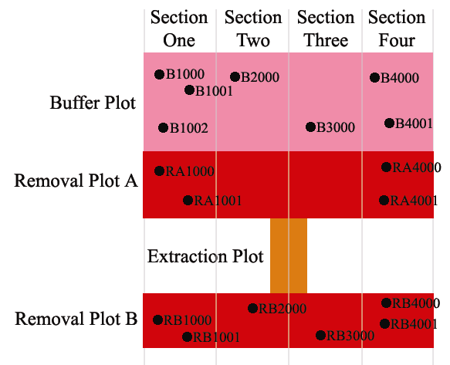

Figure 6. Section layout and tree numbering.

#### 7.2.3 Measurement

Starting with the Buffer Plot, within each Section, measure and record the following Tree Information on the **Plot Forms**:

1. Divide the work so that one cruiser acts as the tally person (standing on the centerline) and one person tags and measures the trees.
2. Number trees from the outer boundary of the Buffer Plot towards Removal Plot A working your way through each Section.
3. Tag all acceptable[6] conifer species > 1.3 m in height.
4. Tag all acceptable deciduous species > 1.3 m in height.
   1. Place nails at breast height (1.3 m from root collar) so that diameter tape is consistently placed right above nail level.
   2. If a tree is too small to nail, loosely attach a tag to the lateral branch closest to breast height.
5. For each tagged tree, measure/assess and record on the **Plot Forms[7]**:

Section number

Tree Number

Species code

Diameter at breast height (0.1 cm)

Total height (0.1 m)

Height to live crown (0.1 m)

Distance along centerline (0.1 m) from outer boundary of Buffer Plot

Crown class code

Up to 3 condition codes, in order of priority

1. Appendix IV provides the species codes, crown class codes and condition codes.
2. Appendix V provides instruction on correct diameter measurement.
3. Appendix VI provides instruction on correct height measurement.

Repeat this procedure for Removal Plot A and Removal Plot B. The measured distances along the centerline must be the cumulative distance from the outside of the Buffer Plot.

In order to estimate the basal area removed (level of release), assess recent stumps in the Removal Plots (*e.g.*, those resulting from Strip Cut Understory Protection harvesting only). On the tally sheet, record tree number as 999; measure and record on the **Plot Forms**:

Section number

Diameter at 10 cm (0.1 cm)

Distance along centerline (0.1 m) from outer boundary of Buffer Plot

Paint all sampled stumps with an ‘X’ in blue paint on the top of the stump to help relocate them during quality control assessment.

### 7.3 Extraction Plot

Trees within the Extraction Plot are tallied by species and height class until they exceed breast height for conifers, or until they reach or exceed a DBH of 7.0 cm for deciduous species. Record the following information on **Plot Form Page 2 (Side 1)**:

1. Tally all acceptable conifer regeneration > 30 cm and ≤ 130 cm tall by species
2. Tally all acceptable deciduous regeneration> 30 cm and ≤ 130 cm tall by species

If and when the trees within Extraction Plot are large enough, record:

1. Tag all acceptable conifer species > 1.3 m in height.
2. Tag all acceptable conifer species > 1.3 m in height.
   1. Place nails at breast height (1.3 m from root collar) so that diameter tape is consistently placed snugly above nail level.
   2. If a tree is too small to nail, loosely attach a tag to the lateral branch closest to breast height.
3. Number trees from E5000, E5001, etc…
4. For each tagged tree measure/assess and record:

Tree Number

Species code

Diameter at breast height (0.1 cm)

Total height (0.01 m)

Height to live crown (0.01 m)

Crown class code

Up to 3 condition codes, in order of priority

1. Appendix IV provides the species codes, crown class codes and condition codes.
2. Appendix V provides instruction on correct diameter measurement.
3. Appendix VI provides instruction on correct height measurement.

# 3 Plot Cluster Re-measurement Protocols

Removal and Extraction Plots are re-measured at five-year intervals, up to and including 20 years, after which a 10-year re measurement schedule is followed. Buffer Plots are measured every 10 years. Re-measurement should always occur prior to the commencement of the growing season.

At the next re-measurement of plots established before 2013, in addition to the regular measurements and maintenance, sapling plots will be added to the plot cluster as described in section 2.2.

## 3.1 Maintenance

When navigating to and between plots, ensure that the starting point and tie points are visible and in good condition. This includes touch-up painting of nearby trees and replacement of faded flagging tape. If access has changed since the last measurement, complete a new Block Form, including new maps with directions to and within the Block (see Section 5).

Replace or repair any posts or pigtails which show signs of damage or fading. This includes touch-up painting of metal posts and replacement of faded flagging tape. Walk the Plot Cluster boundary and touch up paint on blue-marked trees. Ensure that all tree tags remain securely fastened and legible, and that DBH markings are intact. If cables were used to attach tags, ensure that there is adequate space to allow trees to grow without being girdled by the cable.

## 3.2 Sapling Plot Establishment

The original plot protocols had two options for plot layout (Figure x). The first was for blocks where the treatment included a buffer strip, the second was for blocks where a buffer was not part of the treatment. Starting with 2012 re-measurements, sapling plots will be added to existing plot clusters as illustrated in Figure x.

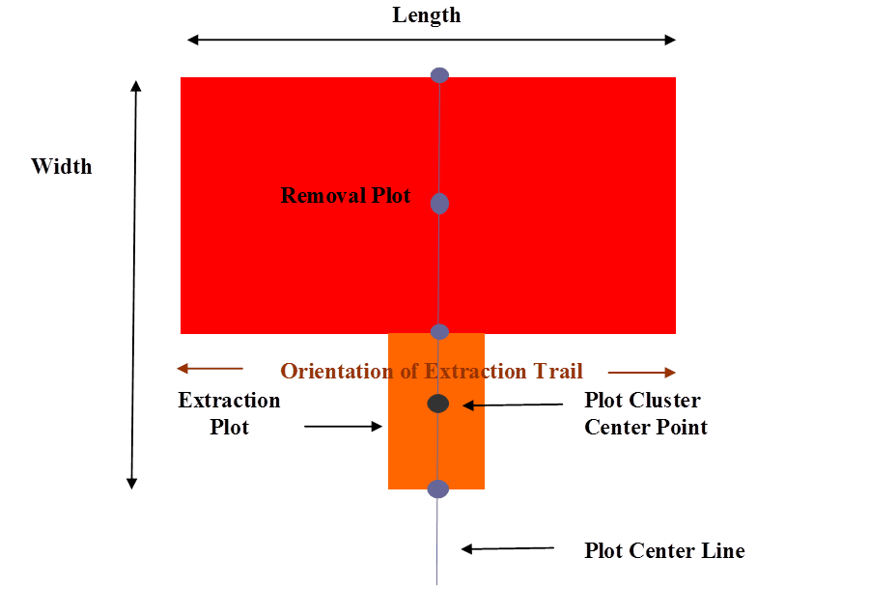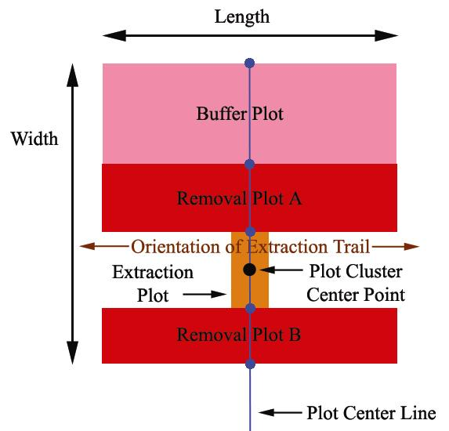

Figure x. Original SCUP plot cluster layouts for blocks with and without buffers as part of the strip cut understory protection treatment.

|  |  |  |  |  |  |  |  |  |  |  |  |  |  |  |  |  |  |  |
| --- | --- | --- | --- | --- | --- | --- | --- | --- | --- | --- | --- | --- | --- | --- | --- | --- | --- | --- |
|  |  |  |  |  |  |  |  |  | S5 |  |  |  |  |  |  |  |  |  |
|  | Buffer (B) | | | |  |  |  |  |  |  |  |  |  |  |  |  |  |
|  |  |  |  |  |  |  |  |  |  |  |  |  |  |  |  |  |  |
|  |  |  |  |  |  |  |  |  | S4 |  |  |  |  |  |  |  |  |  |
|  |  |  |  |  |  |  |  |  |  |  |  |  |  |  |  |  |  |
|  | Removal | | |  |  |  |  |  |  |  |  |  |  |  |  |  |  |
|  | Area A (RA) | | | |  |  |  |  | S3 |  |  |  |  |  |  |  |  |  |
|  |  |  |  |  |  |  |  |  |  |  |  |  |  |  |  |  |  |
|  |  |  |  |  |  |  |  |  |  |  |  |  |  |  |  |  |  |
|  |  |  |  |  |  |  |  |  | S2 |  |  |  |  |  |  |  |  |  |
|  |  |  |  |  |  |  |  |  |  |  |  |  |  |  |  |  |  |
|  | Extraction | | | |  |  |  |  |  |  |  |  |  |  |  |  |  |
|  | Trail (E) | | |  |  |  |  |  | S1 |  |  |  |  |  |  |  |  |  |
|  |  |  |  |  |  |  |  |  |  |  |  |  |  |  |  |  |  |
|  |  |  |  |  |  |  |  |  |  |  |  |  |  |  |  |  |  |
|  |  |  |  |  |  |  |  |  | |  | | --- | | S7 | | |  |  |  |  |  |  |  |  |  |
|  |  |  |  |  |  |  |  |  |  |  |  |  |  |  |  |  |  |
|  | Removal | | |  |  |  |  |  |  |  |  |  |  |  |  |  |  |
|  | Area B (RB) | | | |  |  |  |  | S6 |  |  |  |  |  |  |  |  |  |
|  |  |  |  |  |  |  |  |  |  |  |  |  |  |  |  |  |  |
|  |  |  |  |  |  |  |  |  |  |  |  |  |  |  |  |  |  |

Figure x. Sapling subplot layout for plot clusters with buffer plots.

Seven sapling subplots must be established adjacent to each other so that their centres coincide with the existing plot cluster centre line. Sapling subplots are 2 m long parallel to strip orientation. Their width is variable depending on the width of the buffer, retention and extraction trails. Their widths are determined as follows:

* Split the existing extraction plot into two subplots of equal width on extraction trail (S1 and S2)
* In the Removal Area A and Buffer area, create three subplots of equal width in removal/buffer area (S3 to S7). Because of variable buffer and retention strip widths, in some cases, the buffer may fall partially into S4. Do not vary subplot width but keep at 1/3 of the total width of removal/buffer width regardless of buffer position. In most cases, subplot 5 should contain either all or most of the buffer depending on buffer width.
* In Removal Area B, create two sapling plots of equal width (S6 and S7).

Record subplot width for each of the 7 sapling plots. Record location of subplot: E (within extraction trail), R1 or R2 (primarily in retention area 1 or 2), B (primarily in buffer area). Stem map the 4 corners of each subplot from plot centre and annotate with subplot number and direction (NE, NW, SE, SW).

Depending on the density of the saplings, some of the subplots may not be measured. To determine which subplots to measure, use the following procedure:

* Tally all saplings (≥ 1.3 m and height and < 5.1 cm DBH) by subplot and species
* Calculate the total number of saplings for 1) the extraction trail sapling plots (S3 to S7) and 2) the removal/buffer sapling plots (S1 and S2)
* For extraction Trail:
  + If < 50 trees, tag and measure both subplots (S1 and S2)
  + If ≥ 50 trees, tag and measure subplot S2
* For Extraction Retention/Buffer Areas:
  + If < 50 trees, tag and measure all subplots (S3-S7)
  + If 50-99 trees, tag and measure subplots S3, S4, and S5
  + If ≥ 100 trees, randomly select 1 subplot for tagging and measuring

## 3.3 Plot Measurements

All previously measured trees must be relocated and measured, in addition to measuring new trees. Note: DBH should not decrease on subsequent measurements. Height should not decrease unless a damage condition code is recorded. Trees that have died between measurement periods should be noted using the condition codes in Appendix IV and measured a final time.

Locate and tag any new trees that have reached the tagging limits, and measure their distance along the centerline (distance is relative to the outer Buffer boundary). Ensure that new trees are associated with the correction section. Tree numbers should follow the instructions in Section 7.2.2, with the first new tree number incrementing from the last tree number at last measurement. **DO NOT reuse tree numbers from dead or missing trees.**

### 3.3.1 Retention and Buffer Tree Plots

For each tagged tree in the retention and buffer plots, record the following on the **Plot Forms[8]**:

* Section number
* Tree Number
* Species code
* Diameter at breast height (0.1 cm)
* Total height (0.1 m)
* Height to live crown (0.1 m)
* Distance along centerline (0.1 m) from outer boundary of Buffer Plot
* Crown class code
* Up to 3 condition codes, in order of priority

Appendix IV provides the species codes, crown class codes and condition codes. Instructions for diameter and height measurements are in Appendices V and VI, respectively.

### 3.3.2. Stem Mapping

Starting in 2013, all trees in the retention and buffer tree plots must be stem mapped. All trees are to be stem mapped from plot centre. Record distance and azimuth will be recorded from plot centre (Do we have a form for this?). On subsequent measurements, only newly tagged treed will need to be stem mapped.

Sapling plots will not be stem mapped.

### 3.3.3. Sapling Plots

Tag and number all saplings in the subplots selected using the procedures in Section For each tagged tree in the sapling plots, record:

* plot (one of: S1 to S7)
* tree number
* species code
* total height (0.1 m)
* Diameter at breast height (0.1 cm)
* lean%,
* crown class
* Up to 3 condition codes, in order of priority

For newly dead saplings, record species, DBH and condition codes. Condition code 1 should be 25, 61 or 29. If possible, condition codes 2 and 3 should describe the cause of mortality.

# 4 Field Measurement Quality Control Standards

Blocks will be field checked to ensure that all establishment and measurement have been met. A minimum of one out of every five sampled Blocks, by company, will be subjected to QC protocols (default of one Block by company where less than five Blocks are sampled). Within each selected Block, all navigation information will be QC’d. In addition, two Plot Clusters will be randomly selected for QC’ing plot measurements.

Standards for quality control for Plot Clusters are provided in Table 6. Standard quality control checks involve checking approximately 50% of the measurements within the selected Plot Cluster (except for total number of trees and species, which will have a 100% check). At the discretion of the check cruiser, more than 50% of the measurements may be checked. A total Plot Cluster error of ≥ 2.0 is considered unacceptable and the Plot Cluster may have to be re sampled, at the discretion of the check cruiser. If the error ≥ 2.0, then all other Plot Clusters within the Block will be checked.

All costs associated with correcting errors are the responsibility of the field crew. Plot Clusters will be returned to the pool for quality control selection.

Table 3. Quality control standards for Plot Cluster establishment and measurement.

|  |  |  |
| --- | --- | --- |
| Attribute | Allowable Error | Points |
| Plot Cluster Length | - length of each side of the Plot Cluster must be within 0.3 m of center line length | 0.5 |
| Plot Cluster Center | - must be correctly flagged and identified - plot header information must be complete | 0.5 |
| Slope % | - must be within +10% of the slope gradient value | 0.1 per > 10% |
| Slope Position | - must be within + 1 position class | 0.25 per class |
| Aspect | - must be within + 10 degrees | 0.1 per > 10% |
| Ecosite | - no error | 0.25 |
| Number of Live Trees Tagged | - no error allowed; all acceptable stems within the Buffer and Removal Plots must be included | 0.5 per tree |
| Corner Posts | must be properly placed by color code standard  - must reasonably mark boundary of plots within Plot Cluster | 0.5 |
| Species | - no error allowed; all species must be identified correctly | 0.25 per tree |
| Breast Height Tags | - must be within + 3 cm from 1.3 m | 0.25 per tree |
| Diameter - Breast Height | - must be within + 0.2 cm of the DBH | 0.25 per tree |
| Height | - must be within + 0.5 meters of the height, | 0.25 per tree |
| Crown Class Codes | - a maximum of 10 % of the stems can be misclassified by one crown class | 0.25 > 10% |
| Condition Codes | - a maximum of 10% of the affected stems may be misclassified | 0.25 > 10% |
| Number of Dead Trees | - no error allowed; all acceptable trees within the plot boundaries must be included | 0.5 per tree |
| Tally by Height Class | - no species missed  - check tally must be within 10% of cruise tally | 0.1 per piece > 10% |

# APPENDIX I: GLOSSARY OF TERMS

*Block:* Harvest Block to which a Single Pass Strip Cut Understory Protection harvest treatment has been applied; unit area defined by a given harvest prescription.

*Buffer Strip:* an area where no overstory removal has occurred; generally used for protection of removal areas from effects of wind.

*Buffer Plot:* that component of the Plot Cluster which is located within the Buffer area.

*Extraction Plot:* that component of the Plot Cluster which is located within the Extraction trail.

*Extraction Trail:* an area where all overstory has been removed and no protection or release of understory has occurred; used for access to removal areas.

*Haul Road:* machine traffic area used for transporting wood removed from Extraction Trails.

*Plot Cluster:* a single sampling unit consisting of a series of interconnecting plots: Buffer Plot, Removal Plot A, Extraction Plot and Removal Plot B.

*Plot Width:* the dimension of the plot that is perpendicular to the orientation of the Extraction Trail.

*Plot Length:* the plot dimension parallel to the orientation of the Extraction Trail.

*Removal Strip:* the area where deciduous overstory has been removed in order to release conifer understory; understory protection is an important aspect of harvesting within this area.

*Removal Plot:* that component of the Plot Cluster which is located within the Removal area.

*Section:*  a 4 m wide strip running perpendicular to the Extraction Trail; plots are subdivided into Sections in order to obtain semi-spatial information on the distribution of stems.

*Single Pass:* a type of Strip Cut Understory Protection where harvesting treatment for conifer release is only conducted once prior to full harvest of a Block.

*Strip Cut Understory Protection:* a silvicultural system used primarily to release understory conifers from beneath deciduous overstory, while retaining some overstory in order to provide protection from windthrow; the Strip Cut process involves:

1. Removing all trees in generally parallel strips, to allow harvesting equipment to access the rest of the Block (Extraction Trails);
2. Removal of deciduous overstory by “reaching” of equipment into areas on either side of the Extraction Trail (Removal Strip); and
3. Retention of deciduous overstory beyond the “reach” zone in order to protect the conifers from effects of wind (Buffer Strip).

# APPENDIX II: EQUIPMENT LIST

The following supplies are needed for the establishment of a single Plot Cluster:

Reusable supplies:

* 3 x 50 m tapes
* mallet
* increment borer
* soil auger
* height measurement equipment – *e.g.*, range finder, Suunto or Criterion
* DBH tape
* compass
* field manual
* pencils

Non-reusable supplies:

* 16-19 rebar posts or EMT electrical conduits (minimum 90 cm long)
* 5-15 pigtail markers for Plot Cluster marking
* blue spray paint
* red spray paint
* orange spray paint
* pink spray paint
* blue flagging tape
* red flagging tape
* orange flagging tape
* pink flagging tape
* tree tags
* Plot Cluster center tag
* aluminum nails (for attaching tags)
* wire (for attaching tags)
* tally sheets

# APPENDIX III: Field Tally Sheets

### Block Form Side 1



### Block Form Side 2



### 

### Plot Form Page 1 Side 1



### Plot Form Page 1 Side 2



### Plot Form Page 2 Side 1



### 

### Plot Form Page 2 Side 2



# APPENDIX IV: Tally Sheet Codes

Table 4. Member company codes.

|  |  |
| --- | --- |
| Company Code | Company Name |
| AINS | Ainsworth Lumber Co. Ltd. |
| ALPL | Alberta Plywood Ltd. |
| ALPA | Alberta Pacific Forest Industries Ltd. |
| DMI | Daishowa Marubeni International Ltd. |
| FOOT | Footner Forest Products Ltd. |
| MWFP | Millar Western Forest Products Ltd. |
| SLP | Slave Lake Pulp Corp. |
| TOLK | Tolko Industries Ltd. |
| WEYC | Weyerhaeuser of Canada |
| VAND | Vanderwell Contractors Ltd. |

Table 5. Slope position descriptions.

|  |  |  |
| --- | --- | --- |
| Code | Topographic Position | Description |
| 1 | Crest | The uppermost portion of a slope, shape usually convex in all directions with no distinct aspect. |
| 2 | Upper Slope | The upper portion of the slope immediately below the crest, slope shape usually convex with a specific aspect. |
| 3 | Mid Slope | The area of the slope between the upper and lower slopes where the slope shape is usually straight and with a specific aspect. |
| 4 | Lower Slope | The lower portion of the slope immediately above the toe where the slope shape is usually concave and with a specific aspect. |
| 5 | Toe | The lowermost portion of the slope immediately below and adjacent to the lower slope where the slope shape is concave grading rapidly to level with no distinct aspect. |
| 6 | Depression | Any area that is concave in all directions, usually at the toe of a slope or within level topography with no distinct aspect. |
| 7 | Level | Any level area excluding toe slopes, generally horizontal, with no distinct aspect. |



Figure 7. Slope codes.

Table 6. Acceptable species codes.

|  |  |
| --- | --- |
| Species Code | Species |
| SW | white spruce |
| SB | black spruce |
| PL | lodgepole pine |
| PJ | jack pine |
| FB | balsam fir |
| LT | larch (tamarack) |
| AW | trembling aspen |
| PB | balsam poplar |
| BW | white birch |
| DD | dead deciduous |
| DC | dead coniferous |
| DU | dead unknown |

Table 7. Crown class codes.

|  |  |
| --- | --- |
| Crown Class Code | Description |
| D | Dominant - crown extends above the general level of the canopy. |
| C | Codominant - crown forms the general level of the canopy. |
| I | Intermediate - crown is below but extending into the bottom of the general level of the canopy. |
| S | Suppressed - crown is entirely below the general level of the canopy. |

Table 8. Condition codes (based on LFS PSP standards).

|  |  |  |  |
| --- | --- | --- | --- |
| Condition Code | Description | Condition Code | Description |
| 0 | Healthy | 45 | Other mammalian/avian evidence |
| 1 | Insects | 51 | Conks/Blind Conks |
| 2 | Disease | 52 | Open Scars |
| 3 | Rabbit Browsing | 53 | Burls and Galls (DBH ≥ 7.0 cm) |
| 4 | Shepherds Crook | 54 | Fork (DIB>7.0cm-2.5m past fork) |
| 5 | Browsing (other) | 55 | Pronounced Crook (DIB>7.0cm -2.5m past crook) |
| 6 | Fire | 56 | Broken Top (<=10cm DIB at break, DBH ≥ 7.0 cm; no CC) |
| 7 | Mechanical | 57 | Limby (DBH ≥ 7.0 cm) |
| 8 | Windthrow | 58 | Leaning (DBH ≥ 7.0 cm, & if severe, No CC) |
| 9 | Climate | 59 | Broken Stem (>=10cm DIB at break; No CC) |
| 10 | Flooding | 60 | Generic woodpecker feeding |
| 11 | Poor Planting | 61 | Dead and Down (No CC; DBH ≥ 7.0 cm) |
| 12 | Suppression | 62 | Stem Insects (Bark & Sawyer Beetle; DBH ≥ 7.0 cm) |
| 13 | Frost Heaving | 63 | Stem Disease (Cankers; DBH ≥ 7.0 cm) |
| 14 | Erosion | 64 | Foliar Insects (DBH ≥ 7.0 cm) |
| 15 | Missing | 65 | Foliar Disease (Needle blights & rust; DBH ≥ 7.0 cm) |
| 16 | Dead Top/Dieback | 66 | Stem Form Defect (=>7.0cm DIB where defect begins) |
| 17 | Poor Seedbed | 67 | Closed Scars |
| 18 | Herbicide | 68 | Atropellis Canker |
| 19 | Western Gall Rust | 69 | Comandra Blister Rust |
| 20 | Armillaria Root Rot | 70 | Elytroderma needle cast of pine |
| 21 | Moldy Planting Stock | 71 | Hypoxylon Canker |
| 22 | Multiple Leader | 72 | Spruce Cone Rust |
| 23 | Poor Form | 73 | Stalactiform Blister Rust |
| 24 | Broken Top (new or old) | 74 | Tomentosus Root Rot |
| 25 | Dead & Standing (No CC) | 75 | Spruce Spanworm |
| 26 | Snow Press | 76 | Cone Maggot |
| 27 | Dead Top with new leader | 77 | Coneworm |
| 28 | Sucker from old stump | 78 | Eastern Spruce Budworm |
| 29 | Cut down | 79 | Mountain Pine Beetle |
| 30 | Terminal Weevil | 80 | Spruce Beetle |
| 31 | SW Gall Aphid | 81 | Spruce Needle Rust |
| 32 | Tent Caterpiller | 82 | Yellow-headed Spruce Sawfly |
| 33 | Root Collar Weevil | 83 | Large Aspen Tortrix |
| 34 | J-Root | 84 | Excavations by woodpeckers |
| 35 | Leaning | 85 | Yellow-bellied Sapsucker feeding |
| 36 | Same Stump | 86 | Small Mammal feeding on tree bole |
| 37 | Unknown | 87 | Small Cavity |
| 38 | Pitch Moth | 88 | Large Cavity |
| 39 | DBH taken on new leader | 89 | Hollow tree/bole section |
| 40 | Nutrient Deficiency | 90 | Beaver (feeding/harvest) |
| 41 | Mouse Feeding | 91 - 96 | Hawksworth Mistletoe Rating System |
| 42 | Ungulate feeding/rubbing | 98 | Data changed by office |
| 43 | Domestic livestock (rubbing) |  |  |
| 44 | Nest |  |  |

# APPENDIX V: DIAMETER MEASUREMENTS

Measure diameter at 1.3 m above the root collar, paying attention to the following anomalies

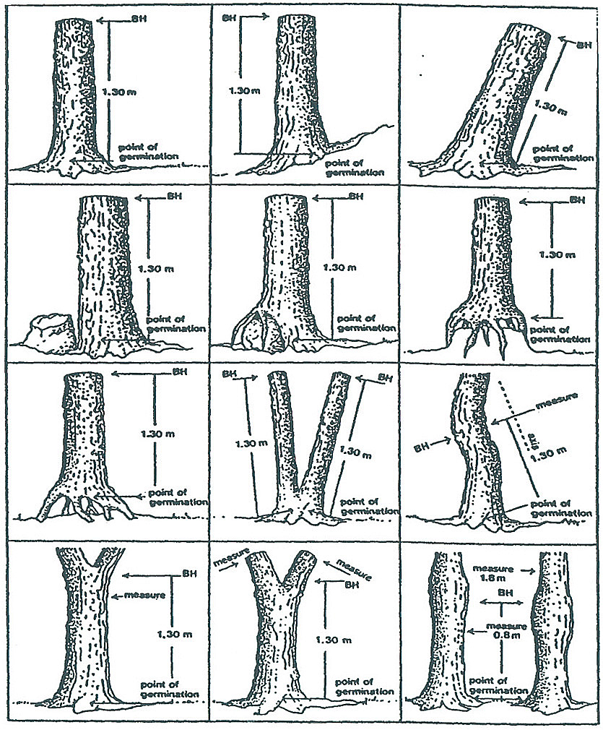

Figure 8. Diameter measurement techniques.

1. If tree is on a slope, measure at 1.3 m at midpoint.
2. If tree is leaning, measure at 1.3 m perpendicular to the lean.
3. If tree is forked below 1.3 m, measure as two separate trees at 1.3 m.
4. If tree is forked above 1.3 m, measure as one tree at 1.3 m.
5. If tree is deformed at 1.3 m or is a bottleneck tree, measure diameter above deformation or bottleneck. Record in comments field the height at which diameter was taken.

# APPENDIX VI: HEIGHT MEASUREMENT

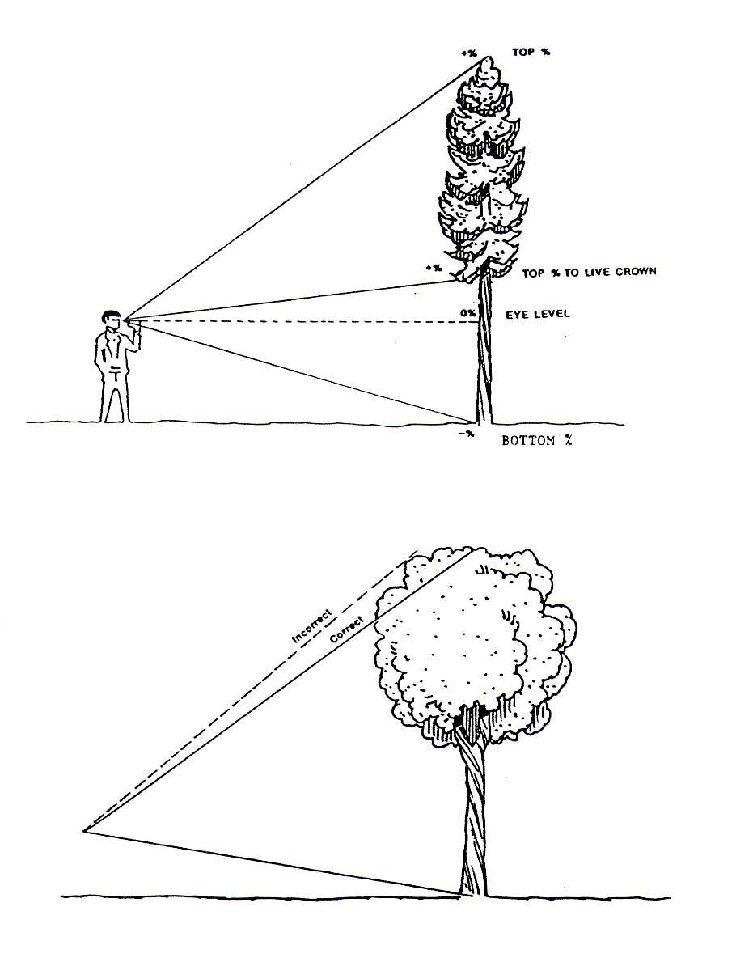

Figure 9. Coniferous and deciduous height measurement.

For leaning trees, height readings are taken while standing perpendicular to the direction of the lean (Figure 12).

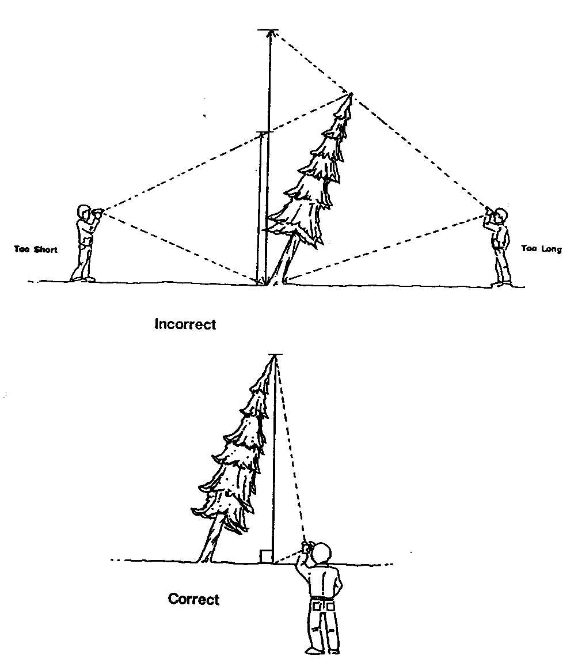

Figure 10. Measuring height on a leaning tree.

Diagrams taken from Alberta Lands and Forest Permanent Sample Plot Field Procedures Manual, 1994.

1. Metal pigtail marker with blue flagging tape.
2. Because the bearing of strips will vary, for consistency, all measurements across the Plot Cluster will begin at the outer edge of the Buffer Strip.
3. Large dots represent posts, small dots represent pigtail markers.
4. All posts and/or pigtails should be buried at least halfway into the ground.
5. For metal posts, spray with both colours; for pigtail markers, use both colours of flagging tape.
6. Acceptable species are defined in Appendix IV.
7. Plot Form Page 1 (Side 2) = Buffer Plot; Plot Form Page 2 (Side 2) = Removal Strips A and B.
8. Plot Form Page 1 (Side 2) = Buffer Plot; Plot Form Page 2 (Side 2) = Removal Strips A and B.