**Project Plan

April 19, 2017

# Background

Mixedwood stands, dominated by aspen and white spruce, are probably the most common and productive forest type in the western boreal forest. Under natural conditions these forests generally originate after fire with white spruce recruiting in the understory. Aspen reaches maturity and can be harvested at 60 to 80 years, while spruce trees are still too small to be utilized. If properly protected during overstory harvesting of the aspen, these understory spruce could be released to produce crop trees for the next rotation. A strip-cut harvesting design achieves the desired removal of aspen while maintaining some of the aspen overstory to protect the understory spruce from windthrow.

Protecting understory white spruce during removal of overstory aspen will take advantage of advanced spruce growth; this will result in a shorter rotation, reduced reforestation cost, and eventually an increase of timber production per unit land. While strip-cut methods are being increasingly adopted across Alberta, there is a lack of information on how residual spruce in removal strips respond to release and aspen regenerate on the machine corridor of extraction trails, which leaves uncertainty regarding the accuracy of growth projections for mixedwood stands harvested using strip-cut techniques. This project aims to fill the information gap required for understanding growth and yield of strip-cut aspen-dominated mixedwood stands.

The objectives of the Strip Cut Understory Protection (SCUP) trial are to:

1. Develop measurement protocols to assess block-level stand performance following understory protection harvesting;
2. Collect data to quantitatively describe stand development after understory protection harvesting. ; and
3. Provide information required for growth model development and/or calibration.

# Design

The protocol was originally designed to assess stand level performance following strip cut understory protection harvesting, to provide information for growth model development and/or calibration and to provide data acceptable to Alberta Sustainable Resource Development for use in monitoring and yield curve validation. The protocol was revised in 2013 to:

* Collect data suitable for MGM model initiation for yield estimation purposes; and
* Maximize efficiency of sampling, particularly reducing effort on tagging and measuring saplings.

The protocol is intended for *Single-Pass* Strip Cut Understory Protection systems only and samples three different areas within the treatment. The *Extraction Trail* is the area within which all trees have been harvested, to provide access for harvesting equipment. The *Removal Strip* is the area subjected to overstory removal (generally aspen), for the purpose of releasing understory conifers (generally white spruce). The *Buffer Strip* is a “leave” area, within which the overstory is retained to reduce windthrow effects on released trees in the Removal Strip. The SCUP protocol uses a *Plot Cluster* design. A Plot Cluster consists of a series of adjacent plots, each sampling one of the three treatment areas, as illustrated below. The target was to establish 6 plot clusters in each cutblock.

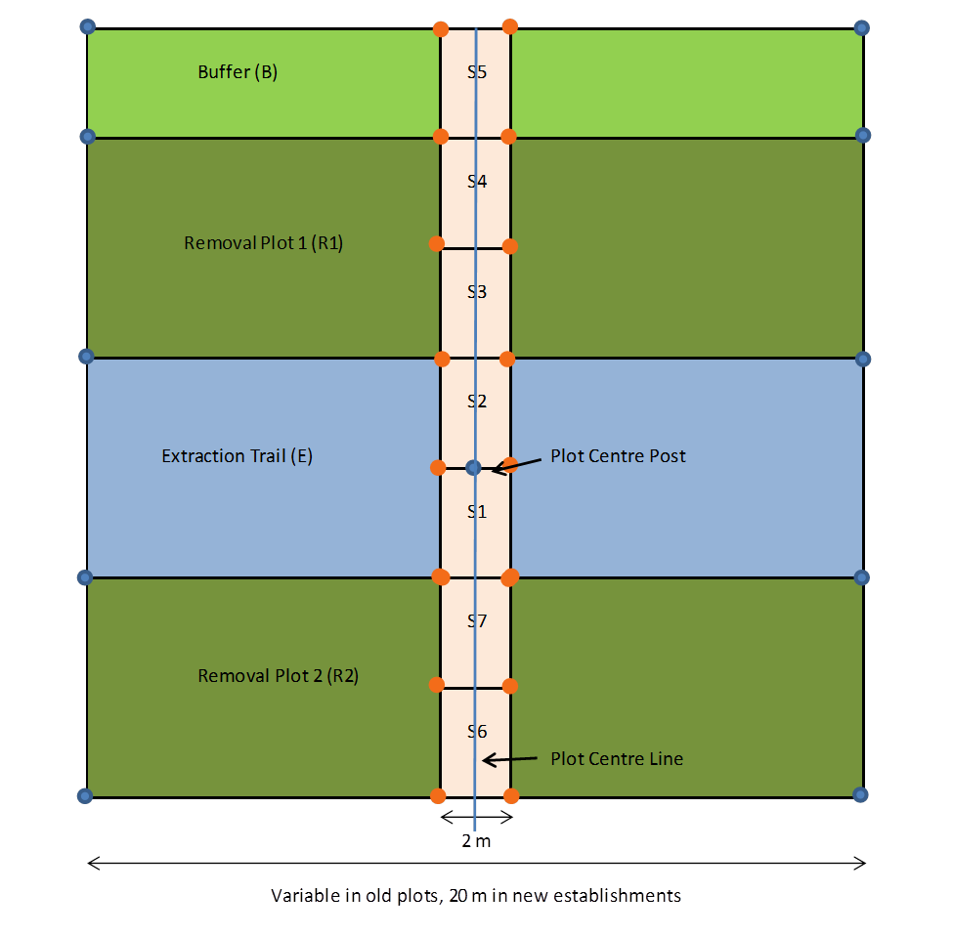

In cases where there is no buffer, plot layout is as follows:

# Data Collection

**Sapling Plots**

In the 7 sapling plots (S1-S7 in the figures), saplings ≥1. 3m height and <7. 1cm DBH are assessed. All saplings in the 7 sapling plots are tallied. The number of sapling plots that are tagged and measured depends on the number of saplings tallied, as described in the SCUP manual.

For each tagged sapling in the sapling plots, the following is recorded:

* Plot (one of: S1 to S7)
* Tree number
* Species code
* Total height (nearest 0. 01 m)
* Diameter at breast height (nearest 0. 1 cm)
* Lean (%)
* Crown class
* Up to 3 condition codes, in order of priority

**Retention and Buffer Tree Plots**

All trees ≥7. 1 cm DBH, including those falling within the sapling plots, are assessed. For each tagged tree in the retention and buffer plots the following is recorded:

* Section (one of:. . E (Extraction), B (Buffer), Removal Area (R1 or R2))
* Tree number
* Species code
* Total height (nearest 0. 1 m)
* Diameter at breast height (nearest 0. 1 cm)
* Height to live crown (nearest 0. 1 m)
* Lean (%)
* Crown class code
* Up to 3 condition codes, in order of priority

**Age Plots**

Three age plots are established as shown below. One 300 m2 plot will be established in the Buffer, one 150 m2 plot will be established in the Removal Strip A and another 150 m2 plotwill be established in the Removal Strip B.

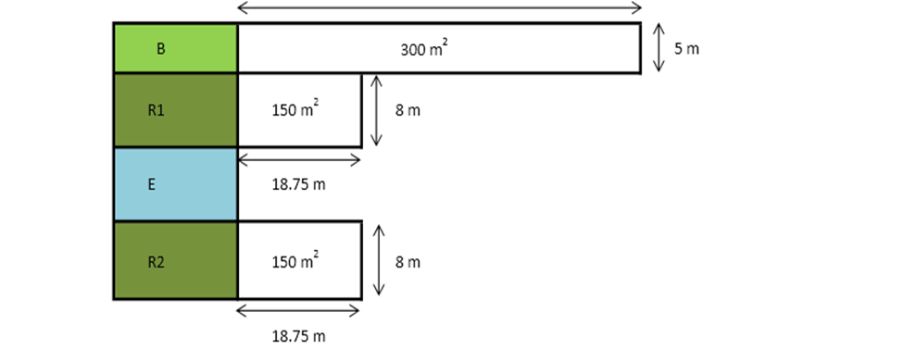

The three largest diameter aspen will be selected in the Buffer age plot. The three largest diameter spruce trees we be selected in the two Removal age plots. For each of the select trees the following measurements are recorded:

* Diameter at breast height (0. 1 cm)
* Height (0. 1m)
* Age at breast height (years)
* Crown class
* Origin

# Measurement History

Plots were established beginning in 2005 and have been on a 5-year measurement schedule. In 2012, assessment of top height trees was added to the protocol. An additional visit was made to installations where these data were not collected at the second measurement. The following table summarizes the timing of installation establishment and subsequent re-measurements.

|  |  |  |  |  |  |  |
| --- | --- | --- | --- | --- | --- | --- |
| **Company FMA** | **Installation Number** | **Number of Plots** | **Established** | **5-year Remeasure** | **Site Index Assessed** | **10-year Remeasure** |
|
| Vanderwell | 7012 | 6 | 2005 | 2010 | 2012 | 2015 |
| Al-Pac | 27131 | 6 | 2005 | 2010 | 2012 | 2015 |
| Al-Pac | 19191 | 6 | 2005 | 2010 | 2012 | 2015 |
| Al-Pac | 29691 | 6 | 2005 | 2010 | 2012 | 2015 |
| Al-Pac | 16751 | 6 | 2005 | 2010 | 2012 | 2015 |
| Al-Pac | 11911 | 6 | 2007 | 2012 | 2012 | 2016 |
| Al-Pac | 22361 | 6 | 2007 | 2012 | 2012 | 2016 |
| Al-Pac | 36551 | 6 | 2007 | 2012 | 2012 | 2016 |
| Al-Pac | 36271 | 6 | 2007 | 2014 | 2014 | - |
| Al-Pac | 36381 | 6 | 2007 | 2014 | 2014 | - |
| Al-Pac | 34591 | 6 | 2007 | 2013 | 2013 | - |
| Al-Pac | 27631 | 6 | 2007 | 2013 | 2013 | - |
| Al-Pac | 15571 | 6 | 2007 | 2013 | 2013 | - |
| Ainsworth | 572 | 2 | 2007 | 2014 | 2014 | - |
| Tolko HL | 330 | 2 | 2007 | 2014 | 2014 | - |
| Tolko HL | 2212 | 2 | 2007 | 2014 | 2014 | - |
| Al-Pac | 17781 | 6 | 2007 | 2013 | 2013 | - |
| Al-Pac | 20631 | 2 | 2007 | 2013 | 2013 | - |

# Measurement Schedule

The 5-year measurement interval will continue at a minimum until the third (15-year) re-measurement has been completed on all installations in 2024. At that time it will be evaluated and if rates of change have slowed significantly, the trial will move to a 10-year measurement interval.

The following table indicates the planned timing of the 10-year (if not already completed) and 15-year re-measurements for each installation.

|  |  |  |  |  |  |  |  |  |  |
| --- | --- | --- | --- | --- | --- | --- | --- | --- | --- |
| **Company FMA** | **Installation Number** | **Number of Plots** | **2018** | **20191** | **20201** | **2021** | **20222** | **2023** | **20241** |
| Vanderwell | 7012 | 6 |  |  | 15-yr |  |  |  |  |
| Al-Pac | 27131 | 6 |  |  | 15-yr |  |  |  |  |
| Al-Pac | 19191 | 6 |  |  | 15-yr |  |  |  |  |
| Al-Pac | 29691 | 6 |  |  | 15-yr |  |  |  |  |
| Al-Pac | 16751 | 6 |  |  | 15-yr |  |  |  |  |
| Al-Pac | 11911 | 6 |  |  |  | 15-yr |  |  |  |
| Al-Pac | 22361 | 6 |  |  |  | 15-yr |  |  |  |
| Al-Pac | 36551 | 6 |  |  |  | 15-yr |  |  |  |
| Al-Pac | 36271 | 6 |  | 10-yr |  |  |  |  | 15-yr |
| Al-Pac | 36381 | 6 |  | 10-yr |  |  |  |  | 15-yr |
| Al-Pac | 34591 | 6 | 10-yr |  |  |  |  | 15-yr |  |
| Al-Pac | 27631 | 6 | 10-yr |  |  |  |  | 15-yr |  |
| Al-Pac | 15571 | 6 | 10-yr |  |  |  |  | 15-yr |  |
| Ainsworth | 572 | 2 |  | 10-yr |  |  |  |  | 15-yr |
| Tolko HL | 330 | 2 |  | 10-yr |  |  |  |  | 15-yr |
| Tolko HL | 2212 | 2 |  | 10-yr |  |  |  |  | 15-yr |
| Al-Pac | 17781 | 6 | 10-yr |  |  |  |  | 15-yr |  |
| Al-Pac | 20631 | 2 | 10-yr |  |  |  |  | 15-yr |  |

**1**Measurements must be completed before May 31.

**2**No scheduled measurements for 2022.

# Data Sharing

Measurement data have been and will be continue to be provided to Alberta Agriculture and Forestry and the University of Alberta to support development of the GYPSY and MGM models, respectively. Other requests for access to the trial data will be considered by Mixedwood Project Team members on a case-by-case basis.

# Analysis

Due to the staggered timing of remeasurements, annual analysis of data is neither necessary nor cost-effective. The next major analysis of the data is scheduled for 2019, when the second remeasurement will have been completed on all installations. The analysis undertaken at that time will include:

* Spruce response to release;
* Rates of mortality in residual spruce and aspen;
* Rates of ingress in extraction and removal areas; and
* Comparison to modelled trajectories from GYPSY and MGM.

At a minimum, one report and one QuickNote will be prepared describing the results of the analysis. If the findings merit publication, a manuscript will be prepared for submission to a peer reviewed journal.

# Extension

All Alberta companies that are practising understory protection strip-cut techniques are encouraged to use the SCUP protocols for their government-mandated monitoring to extend the dataset.

A field tour to visit SCUP sites as well as the Dynamic Aspen Density Experiment will be held in the fall of 2019.