

**Department of Computer Engineering**

**CSE5041 Database Design & Development  
Project Report**

Language Course Database

**Due Date:** 06.12.2018

|  |  |  |
| --- | --- | --- |
|  | **ID** | **Name & Surname** |
| **1st Student :** | **1301020460** | **Mücahit TOZAL** |
| **2nd Student :** | **1301020426** | **Burak CACINA** |

**TABLE OF CONTENTS**

**1 INTRODUCTION** 4

1.1 PROJECT DESCRIPTION 4

**2 ENTITY RELATIONAL MODEL** 5

2.1 ENHANCED ER DIAGRAM 5

2.2 RELATIONAL SCHEMA & MAPPING 6

**3 NORMALIZATION** 7

3.1 FUNCTIONAL DEPENDENCIES 7

3.2 UNNORMALISED FORM 7

3.3 FIRST NORMAL FORM 7

3.4 SECOND NORMAL FORM 7

3.5 THIRD NORMAL FORM 7

**LIST OF FIGURES**

Figure 1: EER diagram of the Company Employee Administrative Database ............................... 5

Figure 2: Relational schema of the Company Employee Administrative Database with arrows indicating referential integrity....................................................................................................... 6

# INTRODUCTION

## PROJECT DESCRIPTION

The Language School Database stores information about the languages, courses, teachers and students. For designing language school database the requirements are below;

• First of all, we need teacher table for the store information about teacher id, description, name, email and phone. Each teacher has an account it contains id, teacher id, login and password and is active. Teacher should be active while they are teaching a language.

• Secondly, we need a students who take the language courses. Students table include id name, birthday, city, email, phone. Each student has an account it contains id, student id, login and password and is active. All students should be active in our database. Students shall pay for course. Each student payment stored in payment table that contains information payment date, amount , status, method how they paid. Also there is method table, it includes 3-different way to pay. 1- Cash, 2- Credit Card, 3- Debit Card. Finally, the students while register to the language school, they choose language which they are want. These are stored in class of student table.

• While designing language school database we need a course. Each course has a unique id, unique language id, unique level id, lessons, description and term. The course has relation with language table and it contains languages. Each language has different teaching level such as Elementary, Intermediate and Advanced stored in level table.

• Finally, teacher, students and course are engaged with the class table. Also it contains the information about start and end date for each class. Class table is main table which contains all information about database.

# ENTITY RELATIONAL MODEL

## ENHANCED ER DIAGRAM

(Below is an example, you should create your own EER Diagram related to your project.)

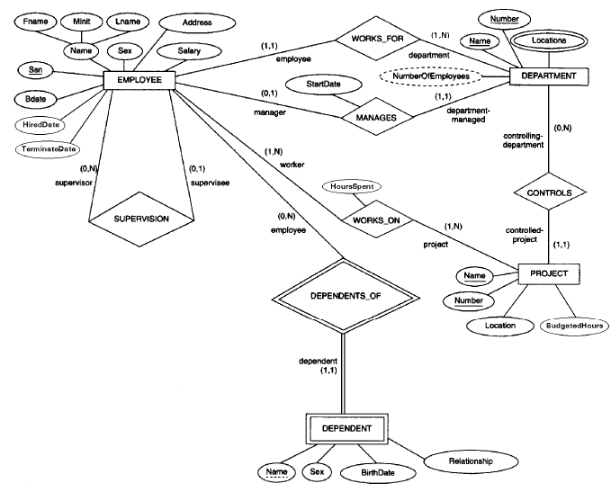

**Figure 1:** EER diagram of the Company Employee Administrative Database

## RELATIONAL SCHEMA & MAPPING

(Below is an example, you should create your own Relational Schema related to your project. Do not forget to show your PKs (underlined) and FKs (dotted).)

(Show the intermediate steps !!!

* **Mapping a regular entity**
* **Mapping a composite attribute**
* **Mapping a multivalued attribute**
* **Mapping Weak Entities**
* **Mapping Binary Relationships**
* **Mapping Unary Relationships**

)

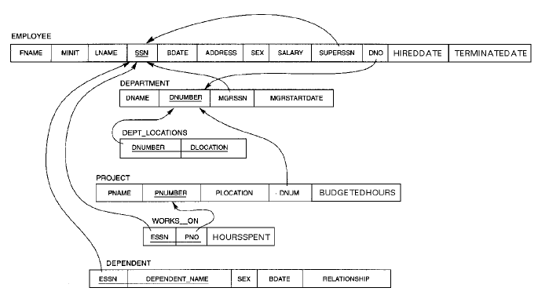

**Figure 2:** Relational schema of the Company Employee Administrative Database with arrows indicating referential integrity

# NORMALIZATION

(Apply the normalization process to the model.)

## FUNCTIONAL DEPENDENCIES

(Below is an example showing the functional dependencies, you should do your own project.)

(The following is the set of functional dependencies (FD's) of COMPANY.)

F = { FD1: SSN → FNAME, MINIT, LNAME, SSN, BDATE, ADDRESS, SEX,

SALARY, SUPERSSN, DNO, HIREDDATE, TERMINATEDATE

FD2: DNUMBER → DNAME, DNUMBER, MGRSSN, MGRSTARTDATE

FD3: DNAME → DNAME, DNUMBER, MGRSSN, MGRSTARTDATE

FD4: PNUMBER → PNAME, PNUMBER, PLOCATION, DNUM, BUDGETEDHOURS

FD5: PNAME → PNAME, PNUMBER, PLOCATION, DNUM, BUDGETEDHOURS

FD6: DNUMBER, DLOCATION → DNUMBER, DLOCATION

FD7: ESSN, PNO → ESSN, PNO, HOURSSPENT

FD8: ESSN, DEPENDENT_NAME → ESSN, DEPENDENT_NAME, SEX(dependent), BDATE(dependent), RELATIONSHIP }

## UNNORMALISED FORM

## FIRST NORMAL FORM

## SECOND NORMAL FORM

## THIRD NORMAL FORM

(You should show unnormalised form, 1st normal form, 2nd normal form and 3rd Normal Form for your projects.)