**Getting Started with Images**

**Capture Video from Camera**

**Playing Video from file**

**Saving a Video**

**Drawing Line**

Create a black image and draw a blue line on it from top-left to bottom-right corners (thickness 5px).

**Drawing Rectangle**

Need top-left to bottom-right corners (thickness 3px).



**Drawing Circle**

Need its center coordinates and radius, -1 to fill it, default thickness 1px.



**Drawing Ellipse**

Need its center location, (major-axis length, minor-axis length), angle of rotation in anti-clockwise direction, startAngle, endAngle (the starting and ending of ellipse arc, measured in clockwise direction from major axis, i.e., 0, 360 gives the full ellipse.

Below we draw a half ellipse at the center of the image.



**Drawing Polygon**

Need coordinates of vertices.

Below we draw a polygon with four vertices in yellow color.

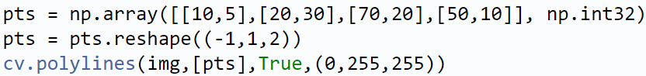

True: get a polygon with a closed shape.

False: get a polyline joining all the points.

**Adding Text to Images**

Need specify:

* Text data
* Position coordinates to put it (origin at top-left corner)
* Font (check cv.putText() for supported fonts)
* Font Scale (size of font)
* Color, thickness, lineType = cv.LINE_AA (recommended).

