# Nano image

* <https://developer.nvidia.com/zh-cn/embedded/downloads>
* 帳號：aiot
* 密碼：aiots405

# Nano 編譯器

* sudo apt-get install nano
* sudo nano ~/.bashrc

# 最後面加入以下內容：

export CUDA_HOME=/usr/local/cuda-10.2

export LD_LIBRARY_PATH=/usr/local/cuda-10.2/lib64:$LD_LIBRARY_PATH

export PATH=/usr/local/cuda-10.2/bin:$PATH

# 完成後，使其生效：

* source ~/.bashrc

# 測試是否有生效

* nvcc –V

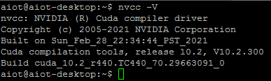

# 16G SWAP

git clone https://github.com/JetsonHacksNano/installSwapfile

./installSwapfile/installSwapfile.sh –size 16

sudo reboot #重開機

# 調整功耗模式

* sudo jetson_clocks
* sudo nvpmodel -m 0

# Jtop 監控 (略)

* sudo apt-get install python3-pip python3-dev build-essential
* sudo -H pip3 install --upgrade pip
* sudo -H pip3 install jetson-stats
* sudo systemctl restart jetson_stats.service
* sudo jtop

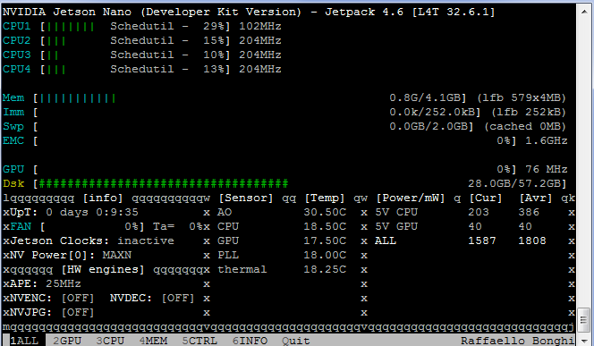

# VNC(略)

* sudo apt-get update
* sudo apt-get upgrade
* gsettings set org.gnome.Vino prompt-enabled false
* gsettings set org.gnome.Vino require-encryption false
* sudo nano /etc/gdm3/custom.conf

#將下方的#刪除，並更改自己的使用者名稱

AutomaticLoginEnable = true

AutomaticLogin = aiot

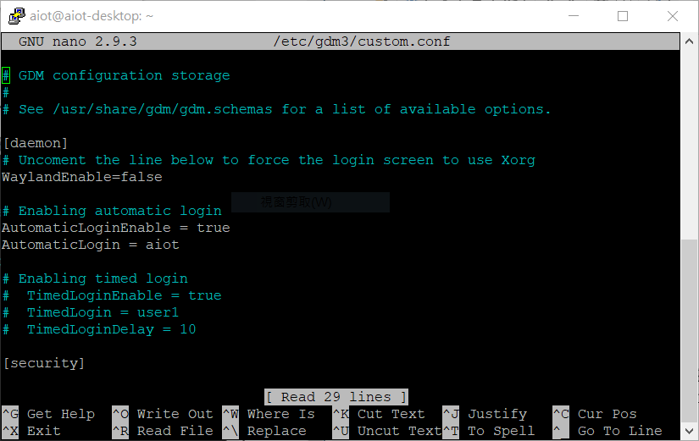

* sudo nano /etc/X11/xorg.conf #調整遠端的解析度

#新增下述內容

Section "Screen"

Identifier "Default Screen"

Monitor "Configured Monitor"

Device "Default Device"

SubSection "Display"

Depth 24

Virtual 1920 1080

EndSubSection

EndSection

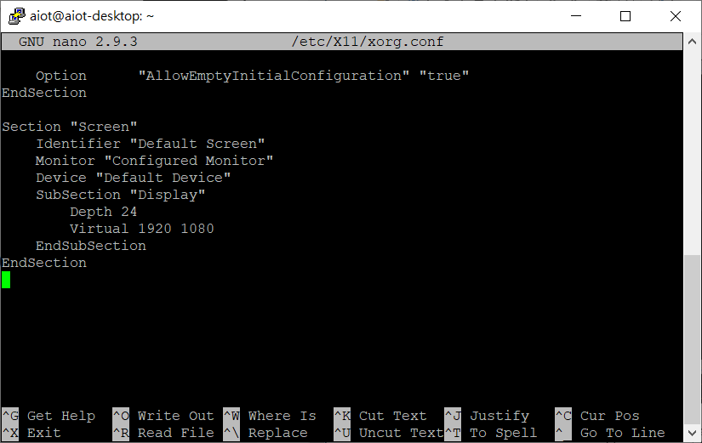

# VNC 設定為開機後自動啟動

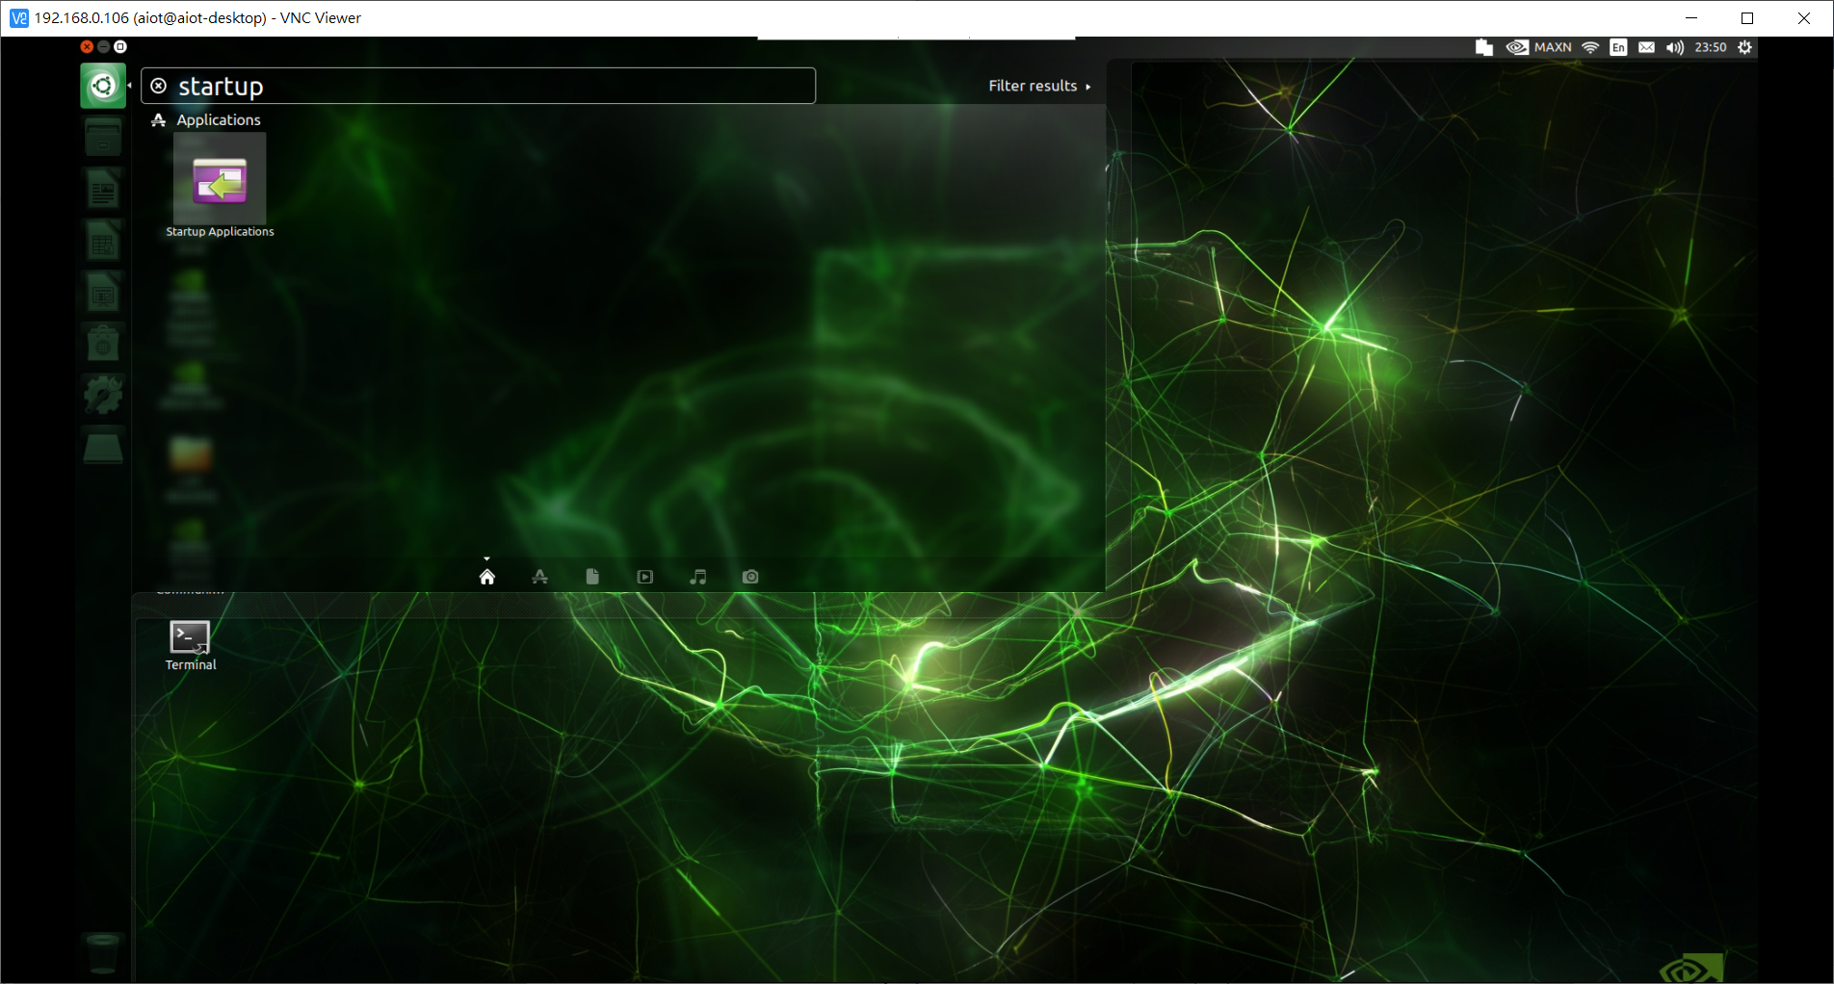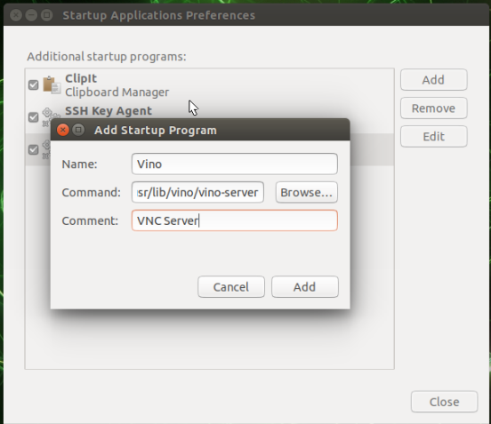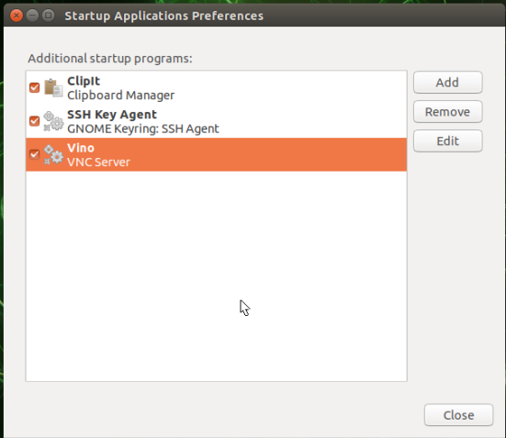

* sudo reboot
* export DISPLAY=:0

# JupyterLab (略)

* sudo -H pip3 install --upgrade pip
* pip3 install jupyter jupyterlab
* sudo reboot
* jupyter lab --generate-config
* nano -c ~/.jupyter/jupyter_lab_config.py

#修改以下內容

c.ServerApp.allow_origin = '*'

c.ServerApp.ip = '0.0.0.0'

* jupyter lab password #密碼s405

#設定開機自動啟動jupyter lab

* sudo nano /etc/systemd/system/jupyter.service

#修改以下內容

[Unit]

Description=Jupyter Notebook

[Service]

Type=simple

User=aiot

ExecStart=/home/aiot/.local/bin/jupyter-lab --port 8888 --no-browser

WorkingDirectory=/home/aiot/

[Install]

WantedBy=default.target

* sudo systemctl enable jupyter
* sudo systemctl start jupyter

#在電腦輸入下方內容即可使用

* http://ipaddress:8888 #ipaddress：Nano的ip

# OpenCV

* sudo apt-get update
* sudo apt-get upgrade
* sudo sh -c "echo '/usr/local/cuda/lib64' >> /etc/ld.so.conf.d/nvidia-tegra.conf"
* sudo ldconfig
* sudo apt-get install build-essential cmake git unzip pkg-config
* sudo apt-get install libjpeg-dev libpng-dev libtiff-dev
* sudo apt-get install libavcodec-dev libavformat-dev libswscale-dev
* sudo apt-get install libgtk2.0-dev libcanberra-gtk*
* sudo apt-get install python3-dev python3-numpy python3-pip
* sudo apt-get install libxvidcore-dev libx264-dev libgtk-3-dev
* sudo apt-get install libtbb2 libtbb-dev libdc1394-22-dev
* sudo apt-get install libv4l-dev v4l-utils
* sudo apt-get install libgstreamer1.0-dev libgstreamer-plugins-base1.0-dev
* sudo apt-get install libavresample-dev libvorbis-dev libxine2-dev
* sudo apt-get install libfaac-dev libmp3lame-dev libtheora-dev
* sudo apt-get install libopencore-amrnb-dev libopencore-amrwb-dev
* sudo apt-get install libopenblas-dev libatlas-base-dev libblas-dev
* sudo apt-get install liblapack-dev libeigen3-dev gfortran
* sudo apt-get install libhdf5-dev protobuf-compiler
* sudo apt-get install libprotobuf-dev libgoogle-glog-dev libgflags-dev
* sudo apt-get install qt5-default
* wget -O opencv.zip https://github.com/opencv/opencv/archive/4.5.0.zip
* wget -O opencv_contrib.zip https://github.com/opencv/opencv_contrib/archive/4.5.0.zip
* unzip opencv.zip
* unzip opencv_contrib.zip
* mv opencv-4.5.0 opencv
* mv opencv_contrib-4.5.0 opencv_contrib
* rm opencv.zip
* rm opencv_contrib.zip
* cd ~/opencv
* mkdir build
* cd build
* cmake -D CMAKE_BUILD_TYPE=RELEASE \

-D CMAKE_INSTALL_PREFIX=/usr \

-D OPENCV_EXTRA_MODULES_PATH=~/opencv_contrib/modules \

-D EIGEN_INCLUDE_PATH=/usr/include/eigen3 \

-D WITH_CUDA=ON \

-D CUDA_ARCH_BIN=5.3 \

-D CUDA_ARCH_PTX="" \

-D WITH_CUDNN=ON \

-D WITH_CUBLAS=ON \

-D ENABLE_FAST_MATH=ON \

-D CUDA_FAST_MATH=ON \

-D OPENCV_DNN_CUDA=ON \

-D ENABLE_NEON=ON \

-D WITH_QT=OFF \

-D WITH_OPENMP=ON \

-D WITH_OPENGL=ON \

-D BUILD_TIFF=ON \

-D WITH_FFMPEG=ON \

-D WITH_GSTREAMER=ON \

-D WITH_TBB=ON \

-D BUILD_TBB=ON \

-D BUILD_TESTS=OFF \

-D WITH_EIGEN=ON \

-D WITH_V4L=ON \

-D WITH_LIBV4L=ON \

-D OPENCV_ENABLE_NONFREE=ON \

-D INSTALL_C_EXAMPLES=OFF \

-D INSTALL_PYTHON_EXAMPLES=OFF \

-D BUILD_NEW_PYTHON_SUPPORT=ON \

-D BUILD_opencv_python3=TRUE \

-D OPENCV_GENERATE_PKGCONFIG=ON \

-D BUILD_EXAMPLES=OFF ..

* make -j4
* sudo rm -r /usr/include/opencv4/opencv2
* sudo make install
* sudo ldconfig
* make clean
* sudo apt-get update

#測試成功畫面

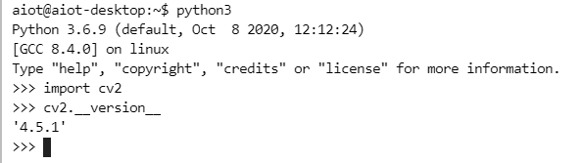

#如出現以下錯誤

Illegal instruction (core dumped)

* nano ~/.bashrc

#底下新增

export OPENBLAS_CORETYPE=ARMV8

* source ~/.bashrc

# OpenCV 2

<https://www.rs-online.com/designspark/jetson-nano-opencv-cn>

# TensorFlow

* sudo apt-get update
* sudo apt-get install libhdf5-serial-dev hdf5-tools libhdf5-dev zlib1g-dev zip libjpeg8-dev liblapack-dev libblas-dev gfortran
* sudo apt-get install python3-pip
* sudo pip3 install -U pip testresources setuptools==49.6.0
* sudo pip3 install -U numpy==1.16.1 future==0.18.2 mock==3.0.5 h5py==2.10.0 keras_preprocessing==1.1.1 keras_applications==1.0.8 gast==0.2.2 futures protobuf pybind11
* sudo pip3 install --pre --extra-index-url https://developer.download.nvidia.com/compute/redist/jp/v44 tensorflow

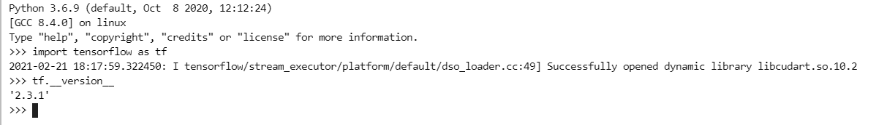

# TensorFlowLite

pip3 install <https://dl.google.com/coral/python/tflite_runtime-2.1.0.post1-cp36-cp36m-linux_aarch64.whl>

# GPIO

$ sudo apt-get install python3-pip

$ sudo pip3 install Jetson.GPIO

$ sudo apt-get install git-all

$ git clone https://github.com/NVIDIA/jetson-gpio.git

$ cd jetson-gpio

jetson-gpio$ sudo python3 setup.py install

jetson-gpio$ sudo groupadd -f -r gpio

jetson-gpio$ sudo usermod -a -G gpio aiot

參考網址:

基本安裝:

<https://d246810g2000.medium.com/nvidia-jetson-nano-for-jetpack-4-4-01-%E7%92%B0%E5%A2%83%E5%AE%89%E8%A3%9D-fd48d5658a13>

Tensorflowlite:

<https://yanwei-liu.medium.com/tflite-on-jetson-nano-c480fdf9ac2>

tensorflow:

<https://docs.nvidia.com/deeplearning/frameworks/install-tf-jetson-platform/index.html>

opencv:

<https://qengineering.eu/install-opencv-4.5-on-jetson-nano.html>