MC PS1 R Markdown
Mackenzie Cuffe, 26338157
2026-09-24
# Packages needed for this assignment.
# install.packages() only needs to be run once ever on your machine -
# it's commented out here so knitting doesn't try to reinstall every time.
# install.packages("tidyverse")
# install.packages("GGally")
library(tidyverse)
library(GGally)

Problem 1

Education
A school counselor was curious about the average IQ of the students in her school and took a random sample of 25 students’ IQ scores. The following is the data set below. We want to find a 90% confidence interval for the average student IQ in the school.
y <- c(105, 69, 86, 100, 82, 111, 104, 110, 87, 108, 87, 90, 94, 113, 112,
98, 80, 97, 95, 111, 114, 89, 95, 126, 98)
To find the confidence interval you must find the mean, variance, standard deviation, standard error, and margin of error.

Step 1: Find the mean
sum_y <- sum(y)
print(sum_y)
## [1] 2461
length_y <- length(y)
print(length_y)
## [1] 25
# mean = sum_y / length_y
mean_y <- sum_y / length_y
print(mean_y)
## [1] 98.44
Alternatively you can find the mean by going mean(y), as seen below:
mean(y)
## [1] 98.44

Step 2: Find the standard deviation
First you need to get the sum of every individual data value minus the mean, squared. To find this we can use a loop to go through each data value, subtract the mean, then square the result.
data_minus_mean <- 0
for (i in 1:length(y)) {
data_minus_mean[i] <- y[i] - mean(y)
}
print(data_minus_mean)
## [1] 6.56 -29.44 -12.44 1.56 -16.44 12.56 5.56 11.56 -11.44 9.56
## [11] -11.44 -8.44 -4.44 14.56 13.56 -0.44 -18.44 -1.44 -3.44 12.56
## [21] 15.56 -9.44 -3.44 27.56 -0.44
squared_data <- data_minus_mean ^ 2
print(squared_data)
## [1] 43.0336 866.7136 154.7536 2.4336 270.2736 157.7536 30.9136 133.6336
## [9] 130.8736 91.3936 130.8736 71.2336 19.7136 211.9936 183.8736 0.1936
## [17] 340.0336 2.0736 11.8336 157.7536 242.1136 89.1136 11.8336 759.5536
## [25] 0.1936
round(squared_data, digits = 2)
## [1] 43.03 866.71 154.75 2.43 270.27 157.75 30.91 133.63 130.87 91.39
## [11] 130.87 71.23 19.71 211.99 183.87 0.19 340.03 2.07 11.83 157.75
## [21] 242.11 89.11 11.83 759.55 0.19
sum_SD <- sum(squared_data)
print(sum_SD)
## [1] 4114.16
Now that we have the sum of every individual data value subtracted from the mean and squared, we need sum_SD over the number of data values in this sample minus 1, i.e. length(y) - 1.
variance_y <- sum_SD / (length_y - 1)
print(variance_y)
## [1] 171.4233
standard_deviation <- sqrt(variance_y)
print(standard_deviation)
## [1] 13.09287
Alternatively you can also use sd(x):
sd_formula <- sd(y)
print(sd_formula)
## [1] 13.09287

Step 3: Find the confidence interval
So now that we have our mean and our standard deviation, we can find the confidence interval for the average student IQ. The first step is finding the Standard Error (SE), which is just the SD over the square root of our sample number.
SE <- standard_deviation / (sqrt(length_y))
print(SE)
## [1] 2.618575
The next step requires finding the critical value t*, which uses the sample number minus 1 (24 degrees of freedom), and a two-tailed significance level of alpha = 0.10, giving 0.05 in each tail.
critical_value <- abs(qt(p = 0.05, df = 24))
print(critical_value)
## [1] 1.710882
Next we need to find the margin of error, which is the critical value multiplied by the Standard Error.
margin_error <- critical_value * SE
print(margin_error)
## [1] 4.480072
The last step in finding the confidence interval is to subtract and add the margin of error from the mean.
lower_limit <- mean(y) - margin_error
upper_limit <- mean(y) + margin_error
print(lower_limit)
## [1] 93.95993
print(upper_limit)
## [1] 102.9201
You can state with 90% confidence that the true average IQ of the entire student population falls somewhere between 93.96 and 102.92.

Hypothesis test
Next, the school counselor was curious whether the average student IQ in her school is higher than the average IQ score (100) among all schools in the country. Using the same sample, conduct the appropriate hypothesis test with alpha = 0.05.
To answer this question- we need to look at a lot of the same descriptive statistics we found in question 1. The Metrics: - Mean = 98.44 - length = 25 - Variance = 171.4233 - Standard Deviation = 13.09287 - Standard Error = 2.618575 - Critical Value = 1.710882 - Margin of error = 4.480072 - lower limit = 93.95993 - upper limit = 102.9201 - alpha = 0.05
- Null Hypothesis (H0): μ ≤ 100 (the school’s average IQ is less than or equal to the national average).
- Alternative Hypothesis (H1): μ > 100 (the school’s average IQ is higher than the national average).
The first step is to find the t-value using the same standard error and mean from the confidence interval above: the sample mean minus the hypothetical mean, divided by the standard error.
national_average <- 100
t_test <- (mean(y) - national_average) / SE
print(t_test)
## [1] -0.5957439
This measures how far the sample data landed from the target (the hypothetical/national average). The data landed 0.596 standard errors below the target.
Since the alternative hypothesis (H1) is that the school’s true average IQ is higher than the national average (100), we only need to look at the upper tail. Here is the upper-tail p-value using the pt() function:
p_value <- pt(t_test, df = length_y - 1, lower.tail = FALSE)
print(p_value)
## [1] 0.7215383
# Logical true/false check: did our t-test beat the critical value?
if (t_test <= critical_value) {
print("Hypothesis Outcome: FAIL TO REJECT the null hypothesis.")
print("Why: the calculated t-test did not exceed the critical value.")
} else {
print("Hypothesis Outcome: REJECT the null hypothesis.")
print("Why: the calculated t-test exceeded the critical value.")
}
## [1] "Hypothesis Outcome: FAIL TO REJECT the null hypothesis."
## [1] "Why: the calculated t-test did not exceed the critical value."
The t-statistic (-0.596) is far below the critical value of 1.711, and the p-value is 0.72, which is greater than 0.05. Therefore we fail to reject H0. There is insufficient evidence that the school’s average IQ is higher than the national average of 100. This is also consistent with the 90% confidence interval, which contains 100.

Problem 2

Importing and exploring the data
expenditure <- read.table(
"https://raw.githubusercontent.com/ASDS-TCD/StatsI_2026/main/datasets/expenditure.txt",
header = TRUE
)
I want to see what I am working with for the table - summary() allows me to see the basic stats. head() is very much like the summary but returns only the first 6 rows, so I can see the variable layout: Y, X1, X2, X3 as their actual data points, along with State and Region.
summary(expenditure)
## STATE Y X1 X2 X3
## Length :50 Min. : 42.00 Min. :1053 Min. :111.0 Min. :326.0
## N.unique :50 1st Qu.: 67.25 1st Qu.:1698 1st Qu.:187.2 1st Qu.:426.2
## N.blank : 0 Median : 79.00 Median :1897 Median :241.5 Median :568.0
## Min.nchar: 2 Mean : 79.54 Mean :1912 Mean :281.8 Mean :561.7
## Max.nchar: 2 3rd Qu.: 90.00 3rd Qu.:2096 3rd Qu.:391.8 3rd Qu.:661.2
## Max. :129.00 Max. :2817 Max. :531.0 Max. :899.0
## Region
## Min. :1.00
## 1st Qu.:2.00
## Median :3.00
## Mean :2.66
## 3rd Qu.:3.75
## Max. :4.00
head(expenditure)
## STATE Y X1 X2 X3 Region
## 1 ME 61 1704 388 399 1
## 2 NH 68 1885 272 598 1
## 3 VT 72 1745 397 370 1
## 4 MA 72 2394 458 868 1
## 5 RI 62 1966 157 899 1
## 6 CT 91 2817 162 690 1

Relationships among Y, X1, X2, and X3
I’m only pulling out the numeric data points, as State and Region don’t belong in a scatterplot matrix.
expenditure_data1 <- (expenditure[, c("Y", "X1", "X2", "X3")])
round(cor(expenditure_data1), 2)
## Y X1 X2 X3
## Y 1.00 0.53 0.45 0.46
## X1 0.53 1.00 0.21 0.60
## X2 0.45 0.21 1.00 0.22
## X3 0.46 0.60 0.22 1.00
plot_ggpairs <- ggpairs(expenditure_data1)
print(plot_ggpairs)
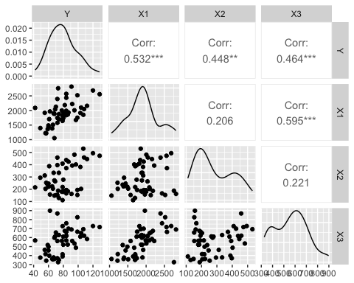
ggsave("ggpairs_matrix.pdf", plot = plot_ggpairs, width = 8, height = 6)
Found inspiration to chart the plot/graph like this via the ggplot2/GGally documentation on rdocumentation.org.
The relationships among Y, X1, X2, and X3 are displayed in the graph with the correlations. From the graph, you can see that X1, X2, and X3 each have a positive relationship with per capita shelter/housing expenditures (Y). The correlation between Y and X1, or personal income, has the strongest relationship with shelter expenditure data (r = 0.53), followed by X3/urbanization (r = 0.46) and financial insecurity (X2, r = 0.45). Each of these datasets represents states with higher income, more financially insecure residents, and/or more urban populations spending more per capita on housing assistance. Yet, none of these variables represents all of the variation in spending - the data in each panel resembles a moderate upward trend in spending.
However, among the variables, the strongest correlation in the matrix is between income (X1) and urbanization (X3), with a correlation of r = 0.60, meaning that states with more residents living in urban areas have a higher income per capita. As the relationship between X1 and X3 is stronger than either variable’s relationship with Y, it may be worth investigating multicollinearity, as a lot of the information about X1 and X3 may overlap. From the graph, the lower correlation scores between variables such as income and financial insecurity (X1-X2, r = 0.21), and urbanization and financial insecurity (X2-X3, r = 0.22), suggest that financial insecurity may be an umbrella term for complexities not represented well within the data, such as debt or higher cost of living, rather than immediately associating financial insecurity with lower income.
Overall, the matrix gives a plausible understanding of the states. For example, wealthier, more urban states may have higher tax bases that allocate more resources towards establishing social service infrastructure.

Housing expenditure by region
expenditure_labeled <- expenditure_data1
expenditure_labeled$Region <- factor(
expenditure$Region,
labels = c("Northeast", "North Central", "South", "West")
)
plot_boxplot <- ggplot(expenditure_labeled, aes(x = Region, y = Y)) +
geom_boxplot() +
geom_jitter(width = 0.1, alpha = 0.5) +
labs(title = "Housing Expenditure by Region",
x = "Region",
y = "Per capita housing expenditure")
print(plot_boxplot)
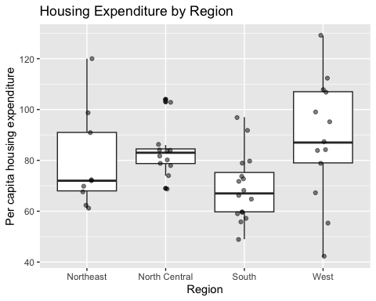
ggsave("boxplot_region.pdf", plot = plot_boxplot, width = 7, height = 5)
aggregate(Y ~ Region, data = expenditure_labeled, FUN = mean)
## Region Y
## 1 Northeast 79.44444
## 2 North Central 83.91667
## 3 South 69.18750
## 4 West 88.30769
According to the boxplots above, the region with the highest per capita expenditure on housing assistance is the West (Region 4). Its mean sits at 88.3, whereas the next highest is the North Central region (Region 2) with an average of 83.9. The boxplot lines show medians and the means come from aggregate(), but the West is also highest on the median, so the conclusion is the same.

Y vs X1
plot_y_x1 <- ggplot(expenditure, aes(x = X1, y = Y)) +
geom_point() +
labs(title = "Housing Expenditure vs Personal Income",
x = "Per capita personal income (X1)",
y = "Per capita housing expenditure (Y)")
print(plot_y_x1)
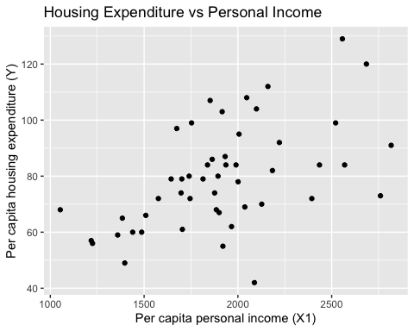
ggsave("scatter_Y_X1.pdf", plot = plot_y_x1, width = 7, height = 5)
The graph between Y and X1 shows a positive correlation. This was already established in the correlation matrix from question 2.a, which showed a moderately positive correlation (r = 0.53). Therefore, as income rises across various states and regions, housing expenditure tends to rise as well. However, the relationship isn’t too tight, as the points scatter somewhat upward rather than sitting on a straight line. This means income explains some, but not all, of the variation in housing spending across states.

Y vs X1 by region
plot_y_X1_regions <- ggplot(expenditure_labeled,
aes(x = X1, y = Y, color = factor(Region), shape = factor(Region))) +
geom_point(size = 3) +
labs(title = "Housing Expenditure vs Personal Income by Region",
x = "Per capita personal income (X1)",
y = "Per capita housing expenditure (Y)",
color = "Region",
shape = "Region")
print(plot_y_X1_regions)
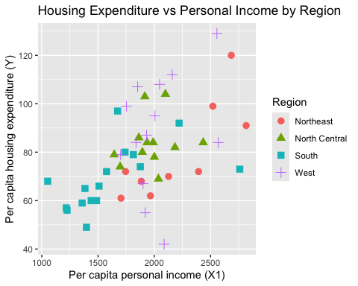
ggsave("scatter_Y_X1_regions.pdf", plot = plot_y_X1_regions, width = 7, height = 5)
The positive relationship between income and housing expenditure, as seen in the previous graph, holds when the states are split by region. The southern states (the blue squares) sit towards the bottom left of the graph; as a group they are clustered at the low-income, low-spending end, mostly below about 2000 in income and 80 in spending. Meanwhile, the northeastern states (red circles) include a few of the highest-income points, with spending having a large range from about 60 to 120. The north central states (green triangles) form a fairly tight cluster in the middle of both the spending and income variables. The western states (purple crosses) are the most spread out in spending, from about 42 to 129 at similar income levels, so income doesn’t explain their spending.
Part of the income and spending relationship reflects differences between the regions. There is still a lot of variation within each region that income doesn’t account for.

