Date: September 27, 2017

Dear Valued Metropolitan Financial Group Employee

Diversity and growth are not just integrated, but inseparable. This belief is at the heart of MFG's Value of "Diversity for growth and innovation."

Diversity puts more possibilities into play, and inclusion – going beyond prevailing, predominant or traditional perspectives – makes tapping into those possibilities more likely.

We anchor diversity in our Values and we embed it in our business, to improve our ability to connect and respond in a changing world.

Making the most of our diversity has always been the right thing and the smart think to do. We believe combining what we have in common with what each of us brings as unique individuals is a powerful recipe of success. By coming together and sharing our unique perspectives, we grow as an organization and as people. That leads to new insights and innovation.

Unified by our shared Vision and Values and enriched by individual diversity, MFG and its people are stronger. This helps us attract and retain the best. And it helps us better serve and meet the needs of our clients.

We’re proud of what we’ve achieved in our diversity journey and we’re motivated by a strong sense of purpose for what is still to come. We believe diversity and inclusion strengthens us and we are committed long term to progress in our company and the communities we serve.

Simply having diversity is interesting, doing something with it is powerful.

Sincerely,

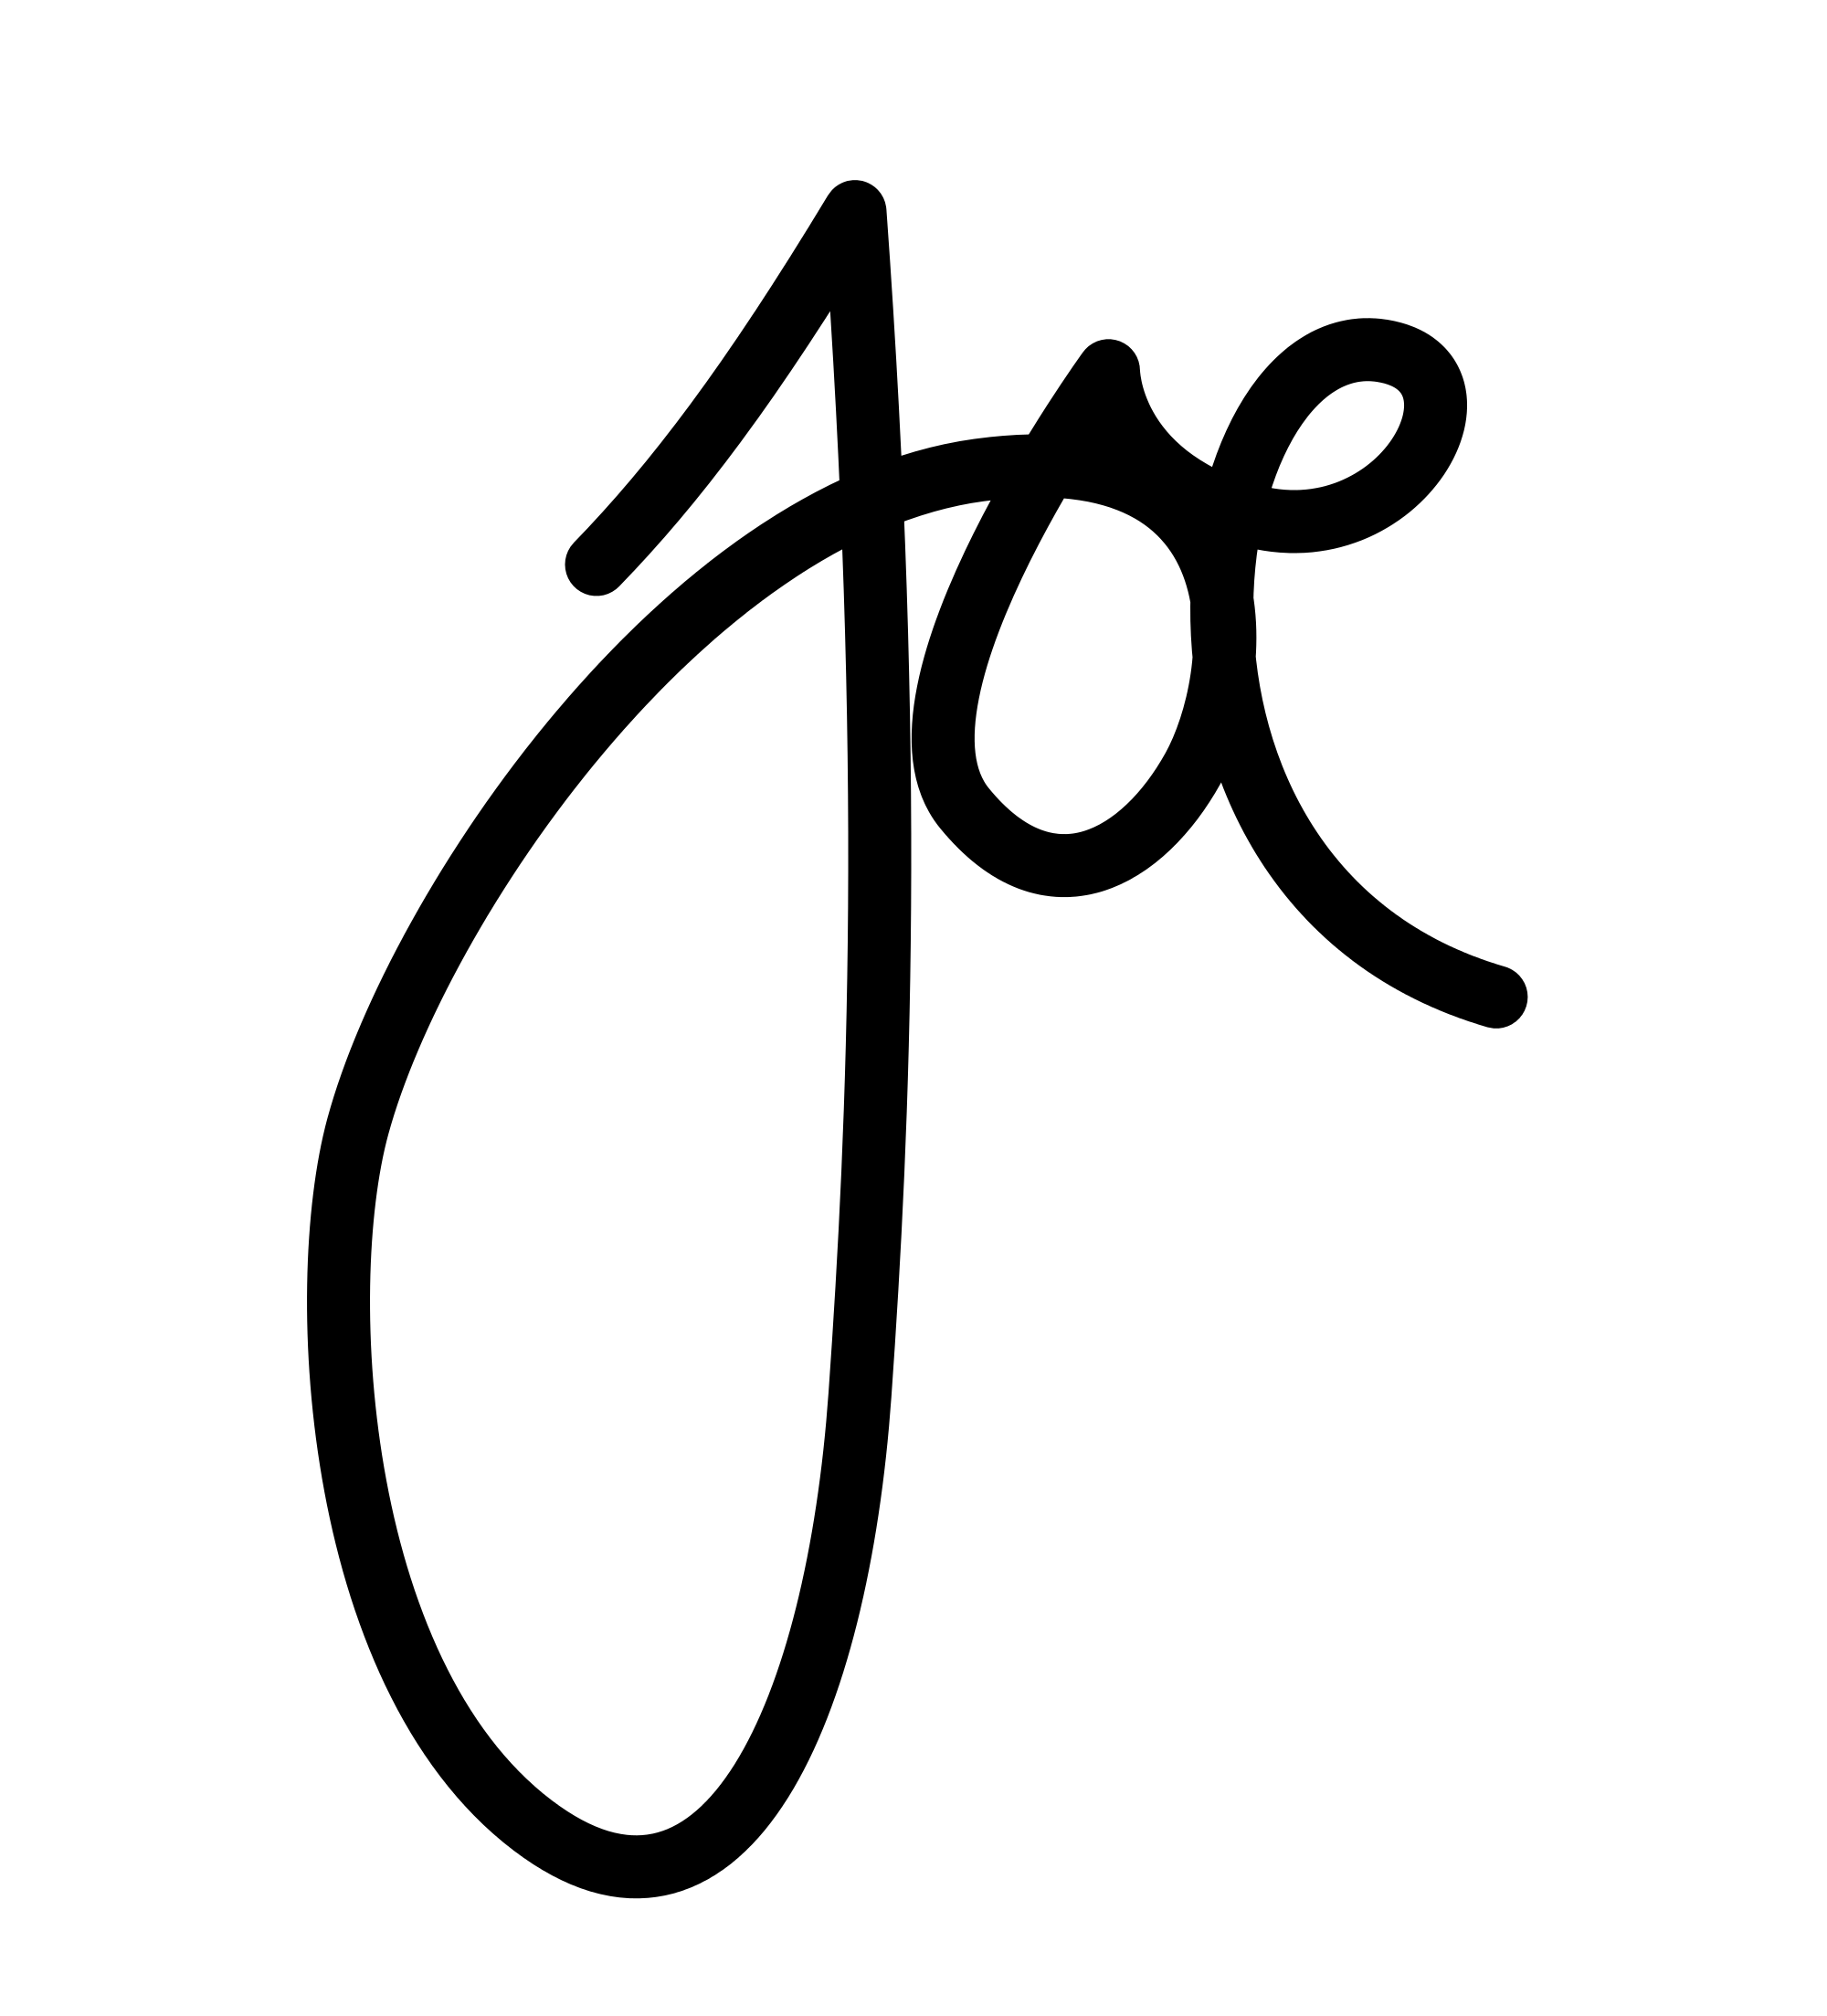

Joe Baker

President and CEO

Metropolitan Financial Group