Evo rescue Figures

July 1, 2025

## Load libraries and data

rm(list = ls())  
 root.dir = "C:/Users/mcu08001/Documents/1New Research/H23/Data"  
  
#load libraries  
library(dplyr); library(ggpubr); library(ggplot2);

## Parameters

#****************************************************************************************  
#Parameters  
N0 =1000 # starting pop size  
Ext.thres = 20  
tmax = 100 # maximum time  
Wmax = 2 # max fitness following Urban et al. 2008  
w= 1 # Gaussian fitness distribution width, but cancels out, just here to make initial equations match paper  
P = 0.1 * w # phenotype variance as a function of w, as per original paper and Urban el. 2008  
W.hat = Wmax * sqrt(w/(P + w))  
B0 = 2.5 # = initial maladaptation, Urban el. 2008 [1.3 is threshold with these values]  
h2 = 0.3  
d0 = sqrt(B0 * (w + P))  
k = (w + (1-h2)*P)/(w + P)

## Run equations - with and without heritability

#****************************************************************************************  
# starting conditions  
N = N0  
W0 = Wmax   
N <- rep(NA,tmax)  
time=seq(1,tmax+1,1)  
N[1] = N0  
  
#equations  
for(t in 1:tmax){  
 dt = d0 * k^t  
 Wt = W.hat* exp(-(dt^2)/(2 * (P + w)))  
 #N[t+1] = N[t] + Wt * N[t] * (1 - N[t]/K) #logistic  
 N[t+1] = Wt * N[t]   
 if(N[t+1] <Ext.thres){N[t+1] = 0}  
 if(N[t+1] > N0){N[t+1] = N0}  
}  
#N  
plot(time, N)

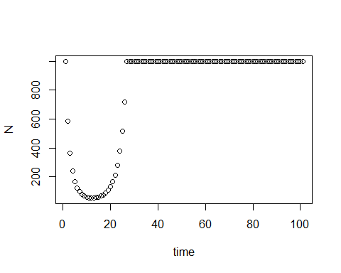

min(N)

## [1] 54.01967

N.h23 <- N  
#****************************************************************************************  
# starting conditions  
N = N0  
W0 = Wmax   
N <- rep(NA,tmax)  
time=seq(1,tmax+1,1)  
N[1] = N0  
h2 = 0  
k = (w + (1-h2)*P)/(w + P)  
#equations  
for(t in 1:tmax){  
 dt = d0 * k^t  
 Wt = W.hat* exp(-(dt^2)/(2 * (P + w)))  
 N[t+1] = Wt * N[t]   
 if(N[t+1] <Ext.thres){N[t+1] = 0}  
 if(N[t+1] > N0){N[t+1] = N0}  
}  
#N  
plot(time, N)

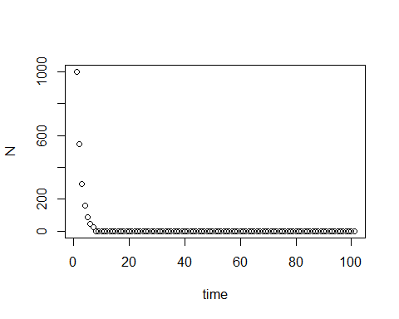

min(N)

## [1] 0

N.h20 <- N  
  
N_time <-data.frame(time = time, N.h23 = N.h23, N.h20 = N.h20)  
  
t.end = 27  
fig1a <- ggplot(data = N_time[1:t.end,]) +  
 geom_hline(yintercept = Ext.thres) +  
 geom_line(aes(x = time, y = N.h20),color = "#08A4BD", size = 3, alpha = 0.3) +   
 geom_line(aes(x = time, y = N.h23),color = "#FFA62B", size = 3, alpha = 0.3) +   
 geom_point(aes(x = time, y = N.h20),color = "#08A4BD", size = 3) +   
 geom_point(aes(x = time, y = N.h23),color = "#FFA62B", size = 3) +   
 xlab("Time") +  
 theme_classic() + ylab("Abundances") + ggtitle("(A) With and without heritability = 0.3") +  
 theme(axis.title.x = element_blank(), axis.title=element_text(size=14),axis.text = element_text(size=12),legend.position = "none")

## Warning: Using `size` aesthetic for lines was deprecated in ggplot2 3.4.0.  
## ℹ Please use `linewidth` instead.  
## This warning is displayed once every 8 hours.  
## Call `lifecycle::last_lifecycle_warnings()` to see where this warning was  
## generated.

fig1a

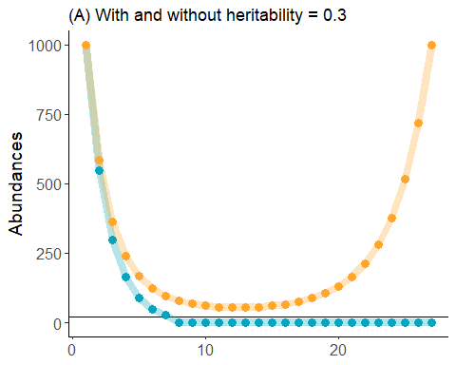

#save(N, file = "baseline.rds")

## Models varying initial population size

#****************************************************************************************  
#Parameters  
N0 =1000 # starting pop size  
Ext.thres = 20  
tmax = 100 # maximum time  
Wmax = 2 # max fitness = Urban el. 2008  
w= 1# Gaussian fitness distribution width, but cancels out, just here to make initial equations match paper  
P = 0.1 * w # phenotype variance as a function of w, as per original paper and Urban el. 2008  
W.hat = Wmax * sqrt(w/(P + w))  
B0 = 2.5 # = initial maladaptation, Urban el. 2008 [1.3 is threshold with these values]  
h2 = 0.3  
d0 = sqrt(B0 * (w + P))  
k = (w + (1-h2)*P)/(w + P)  
  
  
#****************************************************************************************  
#starting conditions  
N0 = N0  
W0 = Wmax   
#W[1] = W0  
N <- rep(NA,tmax)  
time=seq(1,tmax+1,1)  
N[1] = N0  
  
#equations  
for(t in 1:tmax){  
 dt = d0 * k^t  
 Wt = W.hat* exp(-(dt^2)/(2 * (P + w)))  
 #N[t+1] = N[t] + Wt * N[t] * (1 - N[t]/K) #logistic  
 N[t+1] = Wt * N[t]   
 if(N[t+1] <Ext.thres){N[t+1] = 0}  
 if(N[t+1] > N0){N[t+1] = N0}  
}  
#N  
plot(time, N)



min(N)

## [1] 54.01967

N.N1000 <- N  
#****************************************************************************************  
#starting conditions  
N0 = 500  
W0 = Wmax   
#W[1] = W0  
N <- rep(NA,tmax)  
time=seq(1,tmax+1,1)  
N[1] = N0  
#equations  
for(t in 1:tmax){  
 dt = d0 * k^t  
 Wt = W.hat* exp(-(dt^2)/(2 * (P + w)))  
 #N[t+1] = N[t] + Wt * N[t] * (1 - N[t]/K) #logistic  
 N[t+1] = Wt * N[t]   
 if(N[t+1] <Ext.thres){N[t+1] = 0}  
 if(N[t+1] > N0){N[t+1] = N0}  
}  
N

## [1] 500.00000 292.17480 181.94969 120.33967 84.25747 62.26141 48.41511  
## [8] 39.50958 33.74861 30.10054 27.96714 27.00984 27.05777 28.06100  
## [15] 30.07087 33.23953 37.83601 44.28043 53.20173 65.52897 82.63307  
## [22] 106.54619 140.30254 188.47110 257.99433 359.51853 500.00000 500.00000  
## [29] 500.00000 500.00000 500.00000 500.00000 500.00000 500.00000 500.00000  
## [36] 500.00000 500.00000 500.00000 500.00000 500.00000 500.00000 500.00000  
## [43] 500.00000 500.00000 500.00000 500.00000 500.00000 500.00000 500.00000  
## [50] 500.00000 500.00000 500.00000 500.00000 500.00000 500.00000 500.00000  
## [57] 500.00000 500.00000 500.00000 500.00000 500.00000 500.00000 500.00000  
## [64] 500.00000 500.00000 500.00000 500.00000 500.00000 500.00000 500.00000  
## [71] 500.00000 500.00000 500.00000 500.00000 500.00000 500.00000 500.00000  
## [78] 500.00000 500.00000 500.00000 500.00000 500.00000 500.00000 500.00000  
## [85] 500.00000 500.00000 500.00000 500.00000 500.00000 500.00000 500.00000  
## [92] 500.00000 500.00000 500.00000 500.00000 500.00000 500.00000 500.00000  
## [99] 500.00000 500.00000 500.00000

plot(time, N)

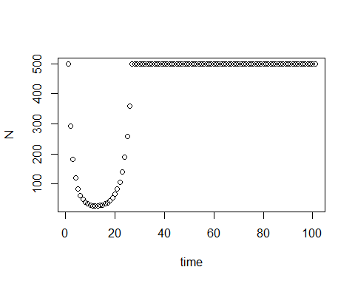

min(N)

## [1] 27.00984

N.N500 <- N  
  
#****************************************************************************************  
#starting conditions  
N0 = 100  
W0 = Wmax   
#W[1] = W0  
N <- rep(NA,tmax)  
time=seq(1,tmax+1,1)  
N[1] = N0  
#equations  
for(t in 1:tmax){  
 dt = d0 * k^t  
 Wt = W.hat* exp(-(dt^2)/(2 * (P + w)))  
 #N[t+1] = N[t] + Wt * N[t] * (1 - N[t]/K) #logistic  
 N[t+1] = Wt * N[t]   
 if(N[t+1] <Ext.thres){N[t+1] = 0}  
 if(N[t+1] > N0){N[t+1] = N0}  
}  
#N  
plot(time, N)

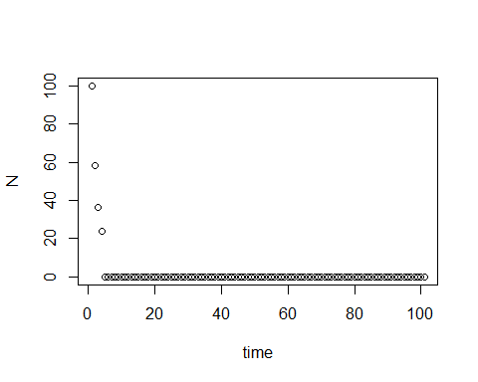

min(N)

## [1] 0

N.N100 <- N  
  
N_time <-data.frame(time = time, N.N1000 = N.N1000, N.N500 = N.N500, N.N100 = N.N100)  
  
t.end = 27  
fig1b <- ggplot(data = N_time[1:t.end,]) +  
 geom_hline(yintercept = Ext.thres) +  
 geom_line(aes(x = time, y = N.N1000),color = "#FFA62B", size = 3, alpha = 0.3) +   
 geom_line(aes(x = time, y = N.N500),color = "#DDA62B", size = 3, alpha = 0.3) +  
 geom_line(aes(x = time, y = N.N100),color = "#BBA62B", size = 3, alpha = 0.3) +   
 geom_point(aes(x = time, y = N.N1000),color = "#FFA62B", size = 3) +   
 geom_point(aes(x = time, y = N.N500),color = "#DDA62B", size = 3) +  
 geom_point(aes(x = time, y = N.N100),color = "#BBA62B", size = 3) +   
 xlab("Time") +  
 theme_classic() + ylab("Abundances") + ggtitle("(B) Initial size variation with heritability = 0.3") +  
 theme(axis.title.x = element_blank(), axis.title=element_text(size=14),axis.text = element_text(size=12),legend.position = "none")   
fig1b

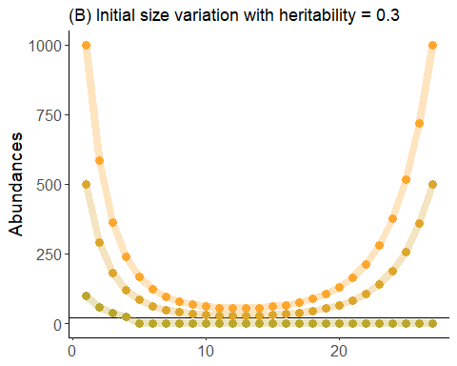

## Models with different extinction thresholds

#****************************************************************************************  
#Parameters  
N0 =100 # starting pop size  
Ext.thres = 20  
tmax = 100 # maximum time  
Wmax = 2 # max fitness = Urban el. 2008  
w= 1# Gaussian fitness distribution width, but cancels out, just here to make initial equations match paper  
P = 0.1 * w # phenotype variance as a function of w, as per original paper and Urban el. 2008  
W.hat = Wmax * sqrt(w/(P + w))  
B0 = 2.5 # = initial maladaptation, Urban el. 2008 [1.3 is threshold with these values]  
h2 = 0.3  
d0 = sqrt(B0 * (w + P))  
k = (w + (1-h2)*P)/(w + P)  
  
  
#****************************************************************************************  
#starting conditions  
N0 = N0  
W0 = Wmax   
#W[1] = W0  
N <- rep(NA,tmax)  
time=seq(1,tmax+1,1)  
N[1] = N0  
  
#equations  
for(t in 1:tmax){  
 dt = d0 * k^t  
 Wt = W.hat* exp(-(dt^2)/(2 * (P + w)))  
 #N[t+1] = N[t] + Wt * N[t] * (1 - N[t]/K) #logistic  
 N[t+1] = Wt * N[t]   
 if(N[t+1] <Ext.thres){N[t+1] = 0}  
 if(N[t+1] > N0){N[t+1] = N0}  
}  
#N  
plot(time, N)



min(N)

## [1] 0

N.ext20 <- N  
#****************************************************************************************  
#starting conditions  
Ext.thres = 10  
W0 = Wmax   
#W[1] = W0  
N <- rep(NA,tmax)  
time=seq(1,tmax+1,1)  
N[1] = N0  
#equations  
for(t in 1:tmax){  
 dt = d0 * k^t  
 Wt = W.hat* exp(-(dt^2)/(2 * (P + w)))  
 #N[t+1] = N[t] + Wt * N[t] * (1 - N[t]/K) #logistic  
 N[t+1] = Wt * N[t]   
 if(N[t+1] <Ext.thres){N[t+1] = 0}  
 if(N[t+1] > N0){N[t+1] = N0}  
}  
#N  
plot(time, N)

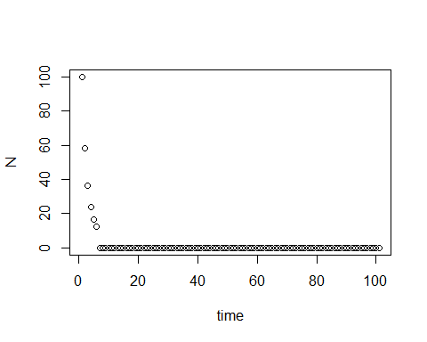

min(N)

## [1] 0

N.ext10 <- N  
  
#****************************************************************************************  
#starting conditions  
Ext.thres = 5  
W0 = Wmax   
#W[1] = W0  
N <- rep(NA,tmax)  
time=seq(1,tmax+1,1)  
N[1] = N0  
#equations  
for(t in 1:tmax){  
 dt = d0 * k^t  
 Wt = W.hat* exp(-(dt^2)/(2 * (P + w)))  
 #N[t+1] = N[t] + Wt * N[t] * (1 - N[t]/K) #logistic  
 N[t+1] = Wt * N[t]   
 if(N[t+1] <Ext.thres){N[t+1] = 0}  
 if(N[t+1] > N0){N[t+1] = N0}  
}  
#N  
plot(time, N)

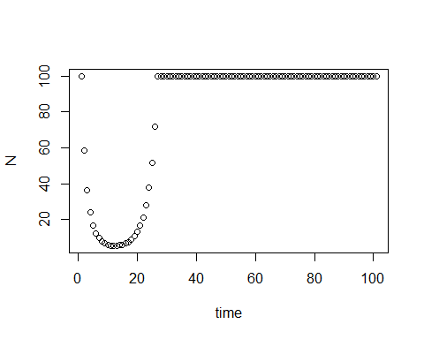

min(N)

## [1] 5.401967

N.ext5 <- N  
  
N_time <-data.frame(time = time, N.ext20 = N.ext20, N.ext10 = N.ext10, N.ext5 = N.ext5)  
  
t.end = 27  
fig1c <- ggplot(data = N_time[1:t.end,]) +  
 geom_hline(yintercept = 20, color = "#BBA62B") +  
 geom_hline(yintercept = 10, color = "#423B0B") +  
 geom_hline(yintercept = 5, color = "#62466B") +  
 geom_line(aes(x = time, y = N.ext20),color = "#BBA62B", size = 3) +   
 geom_point(aes(x = time, y = N.ext10),color = "#423B0B", size = 3) +  
 geom_point(aes(x = time, y = N.ext5),color = "#62466B", size = 3) +  
 geom_point(aes(x = time, y = N.ext20),color = "#BBA62B", size = 3, alpha = 0.3) +   
 geom_line(aes(x = time, y = N.ext10),color = "#423B0B", size = 3, alpha = 0.3) +  
 geom_line(aes(x = time, y = N.ext5),color = "#62466B", size = 3, alpha = 0.3) +  
 theme_classic() + ylab("Abundances") + ggtitle("(C) Variation in extinction thresholds\n with heritability = 0.3") +  
 xlab("Time") +  
 theme(axis.title=element_text(size=14),axis.text = element_text(size=12),legend.position = "none")   
fig1c

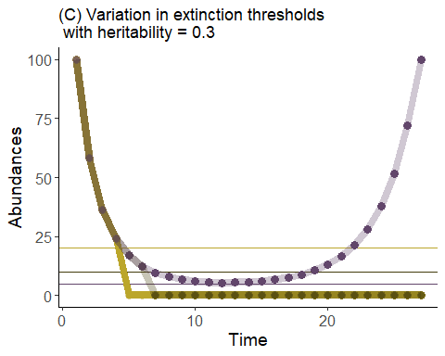

ggarrange(fig1a,NULL, fig1b, NULL, fig1c,nrow = 5, heights = c(3,.4, 3, .4, 3))

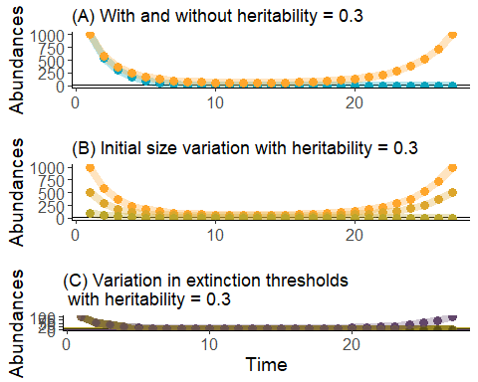

ggsave("h2 sim fig.png",width=5,height=12,unit="in",dpi=1200)