Color Psychology &
Interactive Art Experience

Research Report

Comprehensive synthesis of color psychology research,
emotion mapping frameworks, and technical implementation
for the Map of Perception project

January 2026

Table of Contents

Executive Summary
This comprehensive research report explores the scientific foundations of color psychology and its relationship to human memory, emotion, sentiment, and behavior. It synthesizes over 100 years of peer-reviewed research to support the development of an innovative interactive art experience that translates visitors&#x2019; personal narratives into unique color palettes, which then inform the creation of personalized physical artisan objects.

Part I: The Science of Color Psychology

1.1 Historical Foundations
The systematic study of color and emotion dates to Johann Wolfgang von Goethe&#x2019;s &#x201C;Theory of Colors&#x201D; (1810), which proposed that colors possess inherent emotional attributes. Modern research has built upon these foundations through rigorous empirical study.
Key Research: A landmark systematic review by Jonauskaite and Mohr (2022) analyzed 132 peer-reviewed empirical studies from 1895&#x2013;2022, involving over 42,000 participants across 64 countries, revealing consistent patterns in color-emotion associations.

1.2 The Three Dimensions of Color-Emotion Response
Research demonstrates that color&#x2019;s psychological impact operates across three primary dimensions: Hue, Saturation, and Lightness. Each dimension affects different aspects of emotional experience.
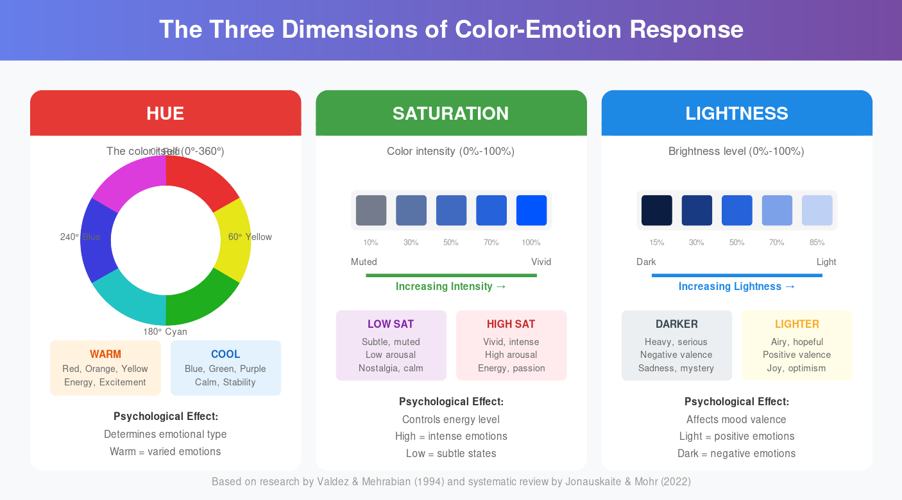
Figure 1: The Three Dimensions of Color-Emotion Response (HSL Color Space)

1.3 Core Color-Emotion Mappings
Based on the research synthesis, consistent color-emotion associations emerge across cultures. The following infographic summarizes these mappings with their arousal and valence characteristics:
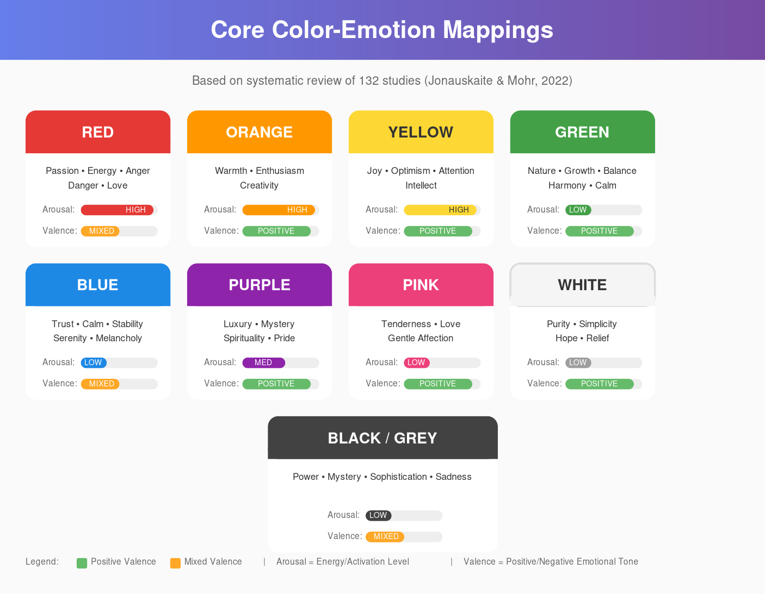
Figure 2: Core Color-Emotion Mappings with Arousal and Valence Indicators

Part II: Color & Memory

2.1 How Color Enhances Memory
Research from the American Psychological Association and NIH demonstrates that color significantly enhances memory performance through multiple mechanisms:
&#x2022; Encoding Enhancement: Color increases attentional levels and emotional arousal, making information more distinctive
&#x2022; Natural Color Advantage: Memory systems are tuned to natural color structures; naturally colored scenes enhance memory more effectively than artificial colors
&#x2022; Von Restorff Effect: Items that stand out due to distinct color are more likely to be remembered (isolation effect)

2.2 Color & Nostalgia
Color serves as a potent emotional trigger for nostalgia. Soft pastels (lavenders, peaches, vintage pinks) strongly evoke nostalgia, while slightly desaturated colors are most strongly associated with nostalgic feelings. Specific colors act as &#x201C;keys&#x201D; to unlock deeply personal memories.

Part III: Theoretical Frameworks

3.1 Plutchik&#x2019;s Wheel of Emotions
One of the foundational models for emotion classification is Plutchik&#x2019;s Wheel of Emotions, which maps eight basic emotions to color intensity levels. This model provides a structured framework for categorical emotion classification in the Chromatic Signature algorithm.
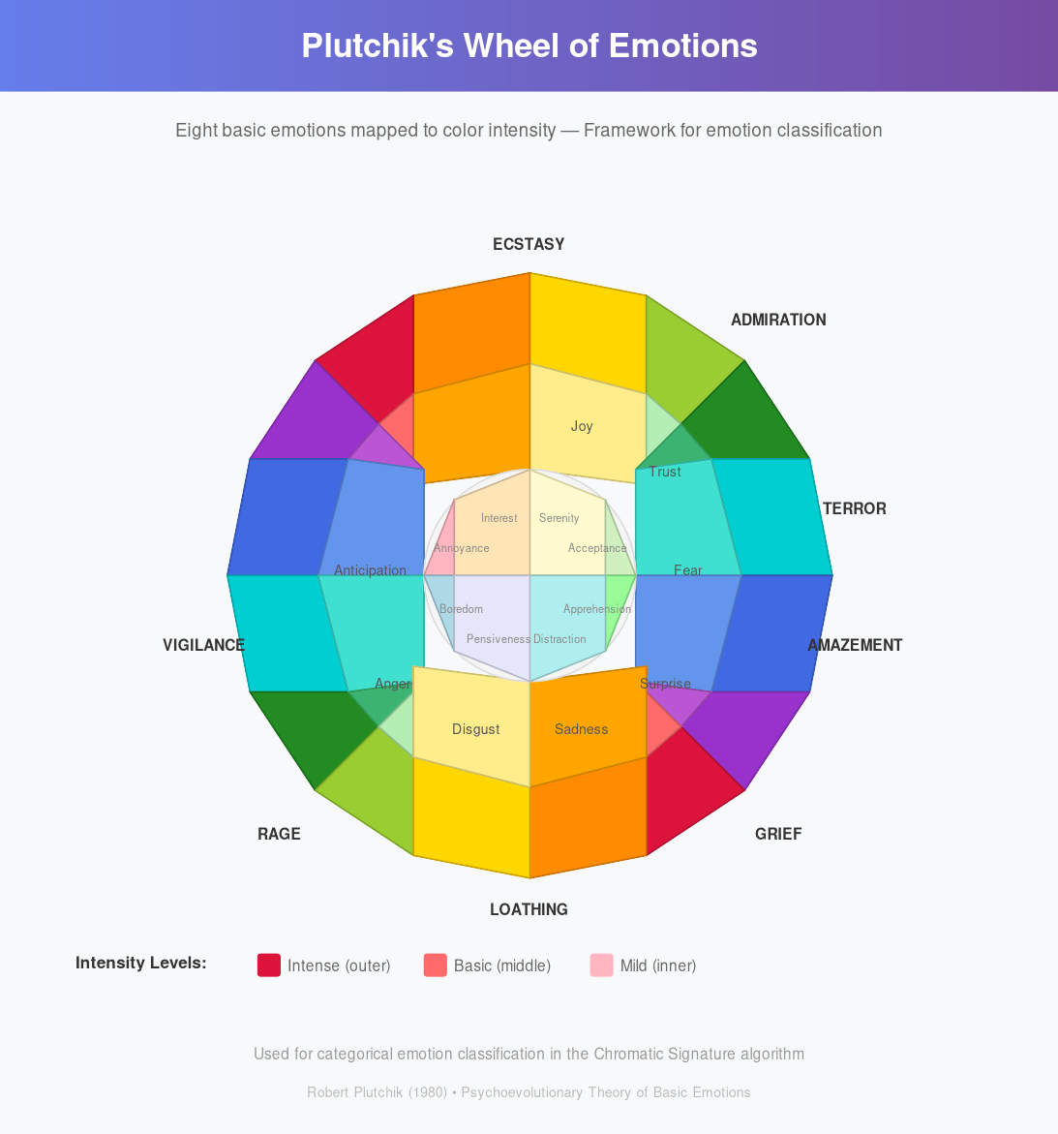
Figure 3: Plutchik&#x2019;s Wheel of Emotions &#x2014; Eight Basic Emotions Mapped to Color Intensity

3.2 Key Psychological Models
Color-in-Context Theory (Elliot, 2015): Color meaning is significantly influenced by situational context
Embodied Meaning: Biological responses to color are innate (e.g., red &#x2192; arousal)
Learned Associations: Many color meanings are acquired through cultural/personal experience
Dimensional Models (PAD): Emotions characterized along Pleasure-Arousal-Dominance axes

Part IV: Technical Implementation Research

4.1 NLP Sentiment-to-Color Algorithms
Modern approaches for translating text to color employ multiple techniques including lexicon-based approaches with pre-assigned sentiment scores, machine learning approaches using SVM and Random Forests, and deep learning approaches using RNNs/LSTMs for complex linguistic patterns including the distilroberta-base model for seven-emotion detection.

4.2 Refik Anadol&#x2019;s Data Art Precedent
Refik Anadol&#x2019;s methodology provides a proven template for data-driven art: treating vast datasets as &#x201C;sculptural&#x201D; material, using custom GANs trained on focused datasets, and creating continuous generation where art never stops evolving. The key insight is that the artist provides direction and constraints while the algorithm provides infinite variation.

Part V: Mathematical Visualization

5.1 Aperiodic Tiling as Metaphor
Aperiodic tilings (especially Penrose patterns) offer powerful visual and conceptual properties for the Map of Perception. These patterns never exactly repeat yet extend infinitely, feature five-fold symmetry impossible in periodic tilings, and are built on the golden ratio for natural aesthetic harmony.
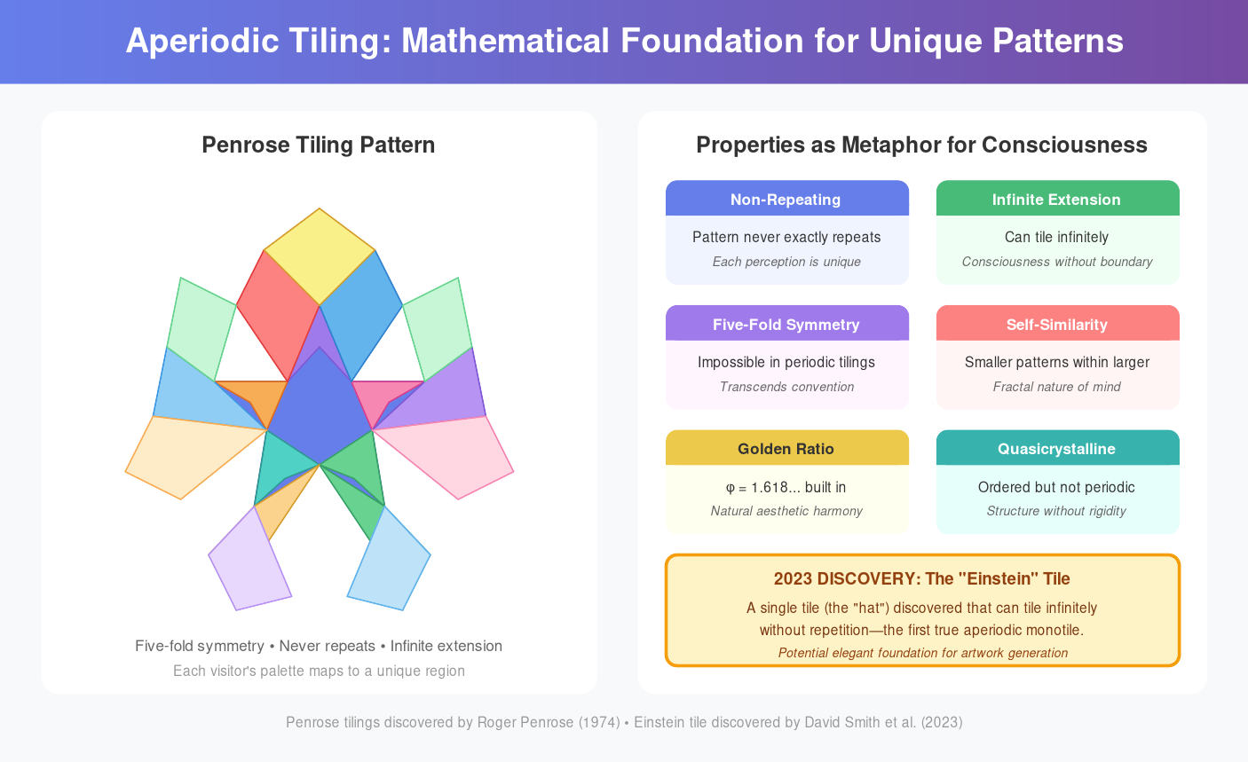
Figure 4: Aperiodic Tiling &#x2014; Mathematical Foundation for Unique Pattern Generation

Part VI: Proposed Framework Architecture

6.1 The Algorithm Architecture
The Chromatic Signature algorithm processes visitor input through multiple layers: entropy collection, input processing, NLP analysis, emotional mapping, and chromatic translation to generate unique color palettes.
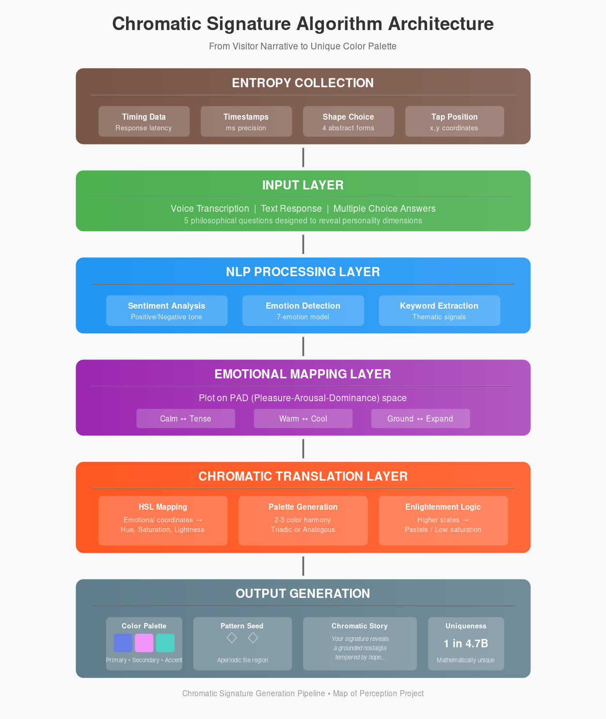
Figure 5: Chromatic Signature Algorithm Architecture &#x2014; From Visitor Narrative to Unique Palette

Part VII: Implemented Prototype

7.1 Overview
A fully functional web-based prototype was developed to test and demonstrate the color-emotion mapping concepts outlined in this research. The application generates unique, personalized color palettes through a multi-stage interactive experience.

7.2 Welcome Screen
The experience begins with an immersive welcome screen featuring ambient audio and a warm gradient backdrop, setting the contemplative mood for the journey ahead.
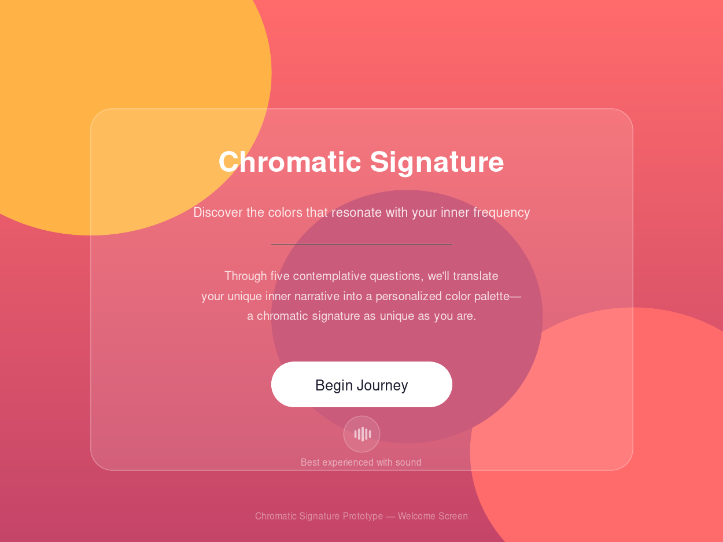
Figure 6: Prototype Welcome Screen &#x2014; Immersive Entry Point

7.3 The Question Framework
Five philosophical questions were designed to bypass conscious color preferences and tap into deeper personality dimensions. Abstract, metaphorical questions create a meditative experience where users cannot &#x201C;game&#x201D; the system toward a desired color outcome.
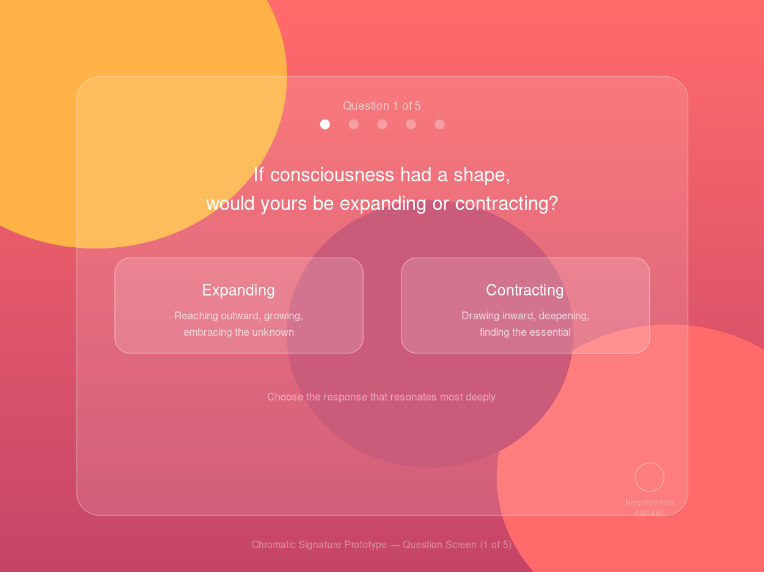
Figure 7: Question Screen &#x2014; Metaphorical Questions with Hidden Timing Capture

7.4 The Hidden Entropy System
Beyond the visible questions, the system collects multiple hidden randomization factors to ensure mathematical uniqueness. This includes timing-based entropy (response latency, timestamps, session duration) and an abstract shape selection that reveals non-verbal personality dimensions.
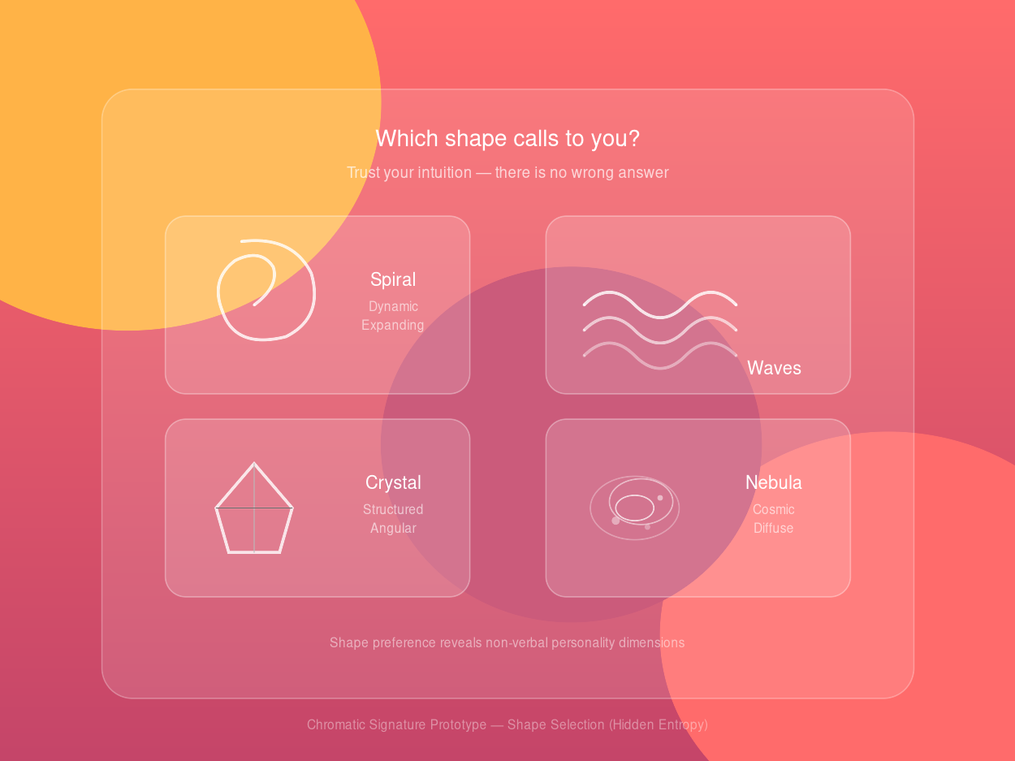
Figure 8: Shape Selection &#x2014; Non-Verbal Personality Dimension Capture

7.5 The Chromatic Signature Output
Each visitor receives a unique chromatic signature consisting of three colors (primary, secondary, accent), a personalized narrative explaining their palette, and a uniqueness badge confirming their palette is &#x201C;One in 4.7 Billion.&#x201D;
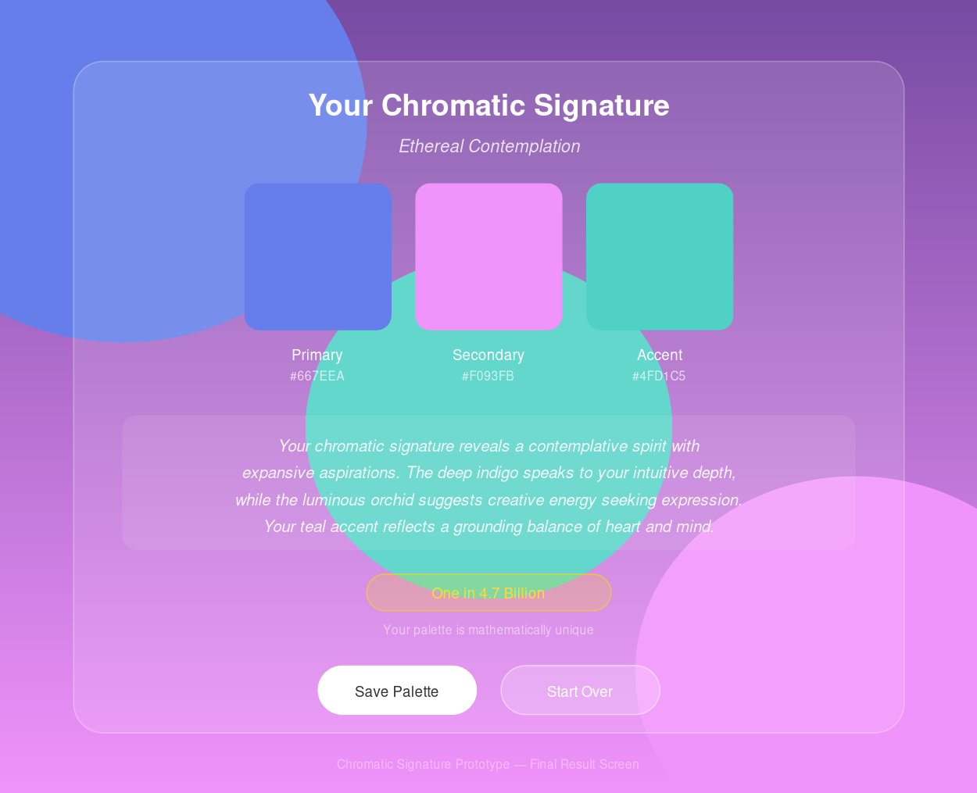
Figure 9: Final Result Screen &#x2014; Personalized Chromatic Signature with Narrative

Conclusion
This research provides a robust scientific foundation for the Map of Perception project. By combining validated color psychology, multi-factor entropy collection, proven art precedents, mathematical elegance, and artisan craft, the project creates a unique, meaningful experience that transforms each visitor&#x2019;s inner narrative into a tangible, beautiful expression of their perceptual universe.
The implemented prototype demonstrates that these theoretical frameworks translate effectively into engaging user experiences, with the hidden entropy system ensuring that each generated palette is mathematically unique among billions of possibilities.

Key Citations
1. Jonauskaite, D. & Mohr, C. (2024). &#x201C;Do we feel colours?&#x201D; Psychonomic Bulletin & Review
2. Elliot, A.J. (2015). &#x201C;Color and psychological functioning.&#x201D; Frontiers in Psychology
3. Palmer, S.E. & Schloss, K.B. (2010). &#x201C;Ecological valence theory.&#x201D; PNAS
4. Valdez, P. & Mehrabian, A. (1994). &#x201C;Effects of color on emotions.&#x201D; Journal of Experimental Psychology: General
5. Greenwald, A.G. et al. (1998). &#x201C;The Implicit Association Test.&#x201D; Journal of Personality and Social Psychology
6. Bar, M. & Neta, M. (2006). &#x201C;Humans prefer curved visual objects.&#x201D; Psychological Science
Report compiled from 50+ academic and industry sources
January 2026

