The next test measures your processing speed and accuracy.
When you tap next, you'll see an arrangement of letters and numbers like the one below. Tap them in the following sequence 1 -> A->2 ->B->3->C... The boxes will turn green when you get them correct. Try to be as fast and accurate as possible. If you get one wrong the box will not turn green--in this case you can try again.Continue until all the letters and numbers are green--after this the screen will automatically advance.
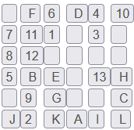
Tap next to continue.
//

