Guttersnipe (0.3)

Software Requirement  
Specifcations

Date Name

September 14, 2016 0.3

Description

Draft

Author

Mitchell Verter

Table of Contents

1. Introduction
   1. Proposal
   2. Technical Introduction
      1. Purpose
      2. Scope
      3. Acronyms and Abbreviations
      4. Summary
2. Overview
   1. Use Case Diagram

2.1.1.

* 1. Collaboration Diagrams
     1. SHAREABLE: READ
        1. ViewShareable
        2. SearchShareables
     2. ACCOUNT CONTROL: EXTERNAL
        1. Login
        2. Register
        3. RecoverPassword
     3. ACCOUNT CONTROL: INTERNAL

1. EditProfile
2. EditSchedule
3. RenewMembership
4. ChangePassword
5. Logout
6. DeleteAccount
   * 1. SHAREABLE: CREATE, UPDATE, DELETE
7. AddShareable
8. EditShareable
9. DeleteShareable
   * 1. SHAREABLE: ANNOTATE
        1. RateShareable
        2. CommentOnShareable
        3. DeleteComment
     2. COMMUNICATIONS
        1. SendMessage
        2. ReadMessage
        3. DeleteMessage
        4. BlockUser
10. Class Definitions and Diagrams
    1. User and Subclasses
       1. User and Subclasses Diagram
       2. User Definition
       3. Guttersnipe Definition
       4. Caretaker Definition
    2. Shareable and Parts
       1. Shareable and Parts
       2. Shareable Definition
       3. Time Definition,
       4. Thing Defintition
    3. 3.3.ER Class Diagram
11. Screenshots from 0.2 release and Future Wireframes
    1. Front Page
    2. Create Shareable Wizard
       1. CreateShareable: Start
       2. CreateShareable: Instructions
       3. CreateShareable: Describe
       4. CreateShareable: Classify (I)
       5. CreateShareable: Classify(2)
       6. CreateShareable: Map
       7. CreateShareable: Schedule (1)
       8. CreateShareable: Schedule (2)
       9. CreateShareable: Schedule (3)
    3. SearchShareable
       1. SearchShareable: ResultList
       2. SearchShareable: ResultCalendar
       3. SearchShareable: ResultMap
       4. SearchShareable: SearchByCategory
       5. SearchShareable: SearchByTag
       6. SearchSharable: SearchByLocation
       7. SearchShareable: SearchByTime
    4. Authentication
       1. SignIn
       2. SignUp
    5. Documentation
       1. Mission Page
       2. FAQ
       3. Presentation (2013)
          1. Start
          2. Objective
          3. Audience

Part 1: PROPOSAL

*PROPOSAL: GUTTERSNIPE*

1. What is the site/app?

Guttersnipe is a web portal and mobile app that caters to anarcho-communist street youth (and adults) who desire to subvert capitalism by sharing resources.

It will enable people to broadcast to each other locations of shareable resources, distributed among four main categories:

1. Housing: squats, abandoned buildings, punk houses, etc.
2. Food: dumpsters, Food Not Bombs, free meals, etc.
3. Healthcare: clinics, needles, condoms, etc.
4. Movement: rideshares, train maps

Eventually, other types of resource sharing will be integrated into the application.

Each Shareable will be characterized as a 1. Thing: Categorization and Tags 2 . Space: Geolocation 3. Time: Schedule

Further development will require a close study of the writings of Kropotkin and Fourier.

1. What need does this meet? or problem does it solve?

This application serves the urgent need to overthrow capitalism by helping people to self-organize outside and beyond the market of commerce.

The ultimate intention is to facilitate the creation of alternate avenues of exchange, freely organized by free individuals.

1. Who is going to go/use to this site/app?

In the current incarnation, it is mostly aimed towards the freegans gutterpunks, who live off of dumpstered food, live in squatted housing, and travel by hopping trains.

As we get a better sense on the needs of the anticapitalist community and possibilities for alternative organizing, we will expand the possibilities for anti-market resource sharing.

1. Why will they go to this site/app?

To find food, clothing, shelter, etc.

1. Why will they keep coming back to your site/app?

See above.

1. How is it different from other similar sites?

There are similar sites of various types, but many of them have certain faults.

There is a site called rideshare.com; there is a site named couchsurfer.com; there is freecycle.com, which allows the sharing of goods.

These are all laudable efforts. Some of these are marred by an underlying desire for profit. But some of them are motivated out of genuine desire to promote Mutual Aid.

The very mission of Guttersnipe.net will be to promote the organization of the lumpenproletariat and to create alternative exchanges outside of capitalism. This mission will enable Guttersnipe.net to be singularly focused on this goal.

It will thus be able to bring together whatever resources necessary for the undermining of capitalism: the various services— such as squatting, dumpster diving, hitchhiking, train hopping, resource sharing, etc — will be coordinated on a singular web portal.

In addition, there are several web portals that are dedicated towards the promotion of anarcho- communist goals..

Such sites are

* Freegan.info
* Picture the Homeless
* Squat.net
* Foodsharing (Germany)

Many of our initial design specifications will be taken from the freegan group and Picture the Homeless.

In addition, we intend Guttersnipe to be cross platform, available both via the web and as a mobile

app.

To my knowledge, there are not yet any apps dedicated with such a task.

1. What steps will a person go through interacting with the site/app?

Most of the various interactions will be handled using forms.

The various services offered by Guttersnipe all boil essentially boil down to two types of transaction:

1. information submission;
2. information retrieval.

One person posts about an abandoned building or a good dumpster; another person searches for such information.

** All Users can view a Shareable or search all Shareables.

Shareables can be searched and results will be shown with the following data:

1. Thing: Description, Categorization, Tags
2. Space: Map

1. Time: Calendar

** Registered Users (known as “Guttersnipes”) can add, edit, and delete Shareables. Guttersnipes may also rate Shareables, comment on Shareables, and erase these comments.

Guttersnipes can manage their profiles, which contains their availability schedules, names, account expiration date, optional email, optional password, optional location, and optional contact info.

All Guttersnipe user accounts expire after a certain date, but this date may be extended at any time.

Guttersnipes can communicate to each other messages that contain Schedules and Text in order to coordinate a meeting time.

** Caretakers

Caretakers are Guttersnipes with administrative capacities.

Practical Constraints Security

We will have to build in a security infrastructure in the project in order to guarantee anonymity of transactions.

Tor will be used to anonymize transactions.

Whisper will be used to encrypt communications and interactions.

The host server will have to be able to run Python/Flask.

The client will have to have an accessible webview for the deployment of Javascript.

We will have to design a User Interface that supports a 1.8 inch QQVGA (128x160) Display to support the phones provided by government assistance <http://newsroom.assurancewireless.com/> custom-page/product-information

01.02

Technical Introduction

1. Purpose

Guttersnipe promises to be a platform for individuals and groups to freely share resources such as food, shelter, and medicine.

This Document will detail the features of Guttersnipe, and will serve as a guide to developers, and as a legal document and users manual for prospective clients.

1. Scope.
2. Users
3. User

All System users can search the Shareables view a single Shareable, and read the rating and the comments ascribed to it.

1. Vagrant: This class represents all visitors to the site who has not yet signed in as a member.

The Vagrant class inherits all the properties and functionalities of the base class User.

All Vagrants may register to become a user, may login as a user, and may retrieve a lost username or password.

1. Guttersnipe: This class represents a user who has registered for an account in the system.

This class inherits all the properties and functionalities of the base class User.

In addition, the Guttersnipe can exercise control over its own account.

The Guttersnipe may edit its own profile, its own location and edit its own availability schedule.

It may renew its membership and change its password.

It may logout of its account.

The Guttersnipe may also create a new Shareable, and edit or

delete a Shareable that it has created.

The Guttersnipe may rate or comment on a Shareable and may delete a previous comment.

The Guttersnipe may send messages and send the schedules of other Guttersnipes. It may read messages and schedules as well. It may block any other Guttersnipe except for a Caretaker.

1.2.14. Caretaker: The Caretaker class represents the administrative users of the System.

Caretakers have all the same properties and functionality as the Guttersnipe, but their functionalities are unlimited in scope.

The Caretaker may edit or delete any Shareable, may delete any User, and may delete any comment.

1. Business Objects
2. Shareable: Each shareable is classified according to its categorization and description, its schedule, and its location.
3. Time: Each Shareable is available at a certain period of time (e.g. every Monday from 2PM-4PM). Time information provides these schedules as well as a note for further clarification.
4. Space: Each Shareable is located in a certain place (e.g.. Times Square). Space information provides longitude and latitude information, as well as textual information detailing the canonical and alternate information, and any additional notes
5. Thing: Each Shareable is characterized as a certain Type (food, shelter, medical, travel) and can have certain subtypes. Shareables can also be given “Tags” for further categorization. Textual information about how to acquire the shareable and other notes will also be included.
6. Shareable Annotations
7. Ratings: Guttersnipes will be able to rate shareables
8. Comments: Guttersnipes can add comments to shareables.
9. Communications

1.2.3.1.

* 1. Acronyms and Abbreviations
     1. V: Vagrant
     2. G: Guttersnipe [User]
     3. B: Caretaker
     4. SRS: Software Requirements Specification
     5. GUI: Graphical User Interface.
     6. FSM: Finite State Machine.
     7. 1 DB: Database.

1.3.8.1 ERCD: Entity-Relation Class Diagram.

* 1. Summary

The rest of this SRS is organized as follows:

Section 2: Gives the overall description of the Guttersnipe application. It contains the Use-Case diagram and descriptions for Guttersnipe. Section 2 also contains the assumptions and dependencies of the system.

Section 3: Gives specific software requirements and functionalities in the form of Mini Use- Case diagrams along with accompanying Collaboration diagrams, Finite State Machine of the system, and ER Class diagram of the system. This section also contains supplementary software requirements of the systems.

Section 4: GUI Components: The appendix contains user interface prototypes for the system, including many screenshots from the 0.2 release of the application.

02: Overview

02.01: Use Case Diagrams and Descriptions

02.02: Server/Client Assumptions and Dependencies

1. 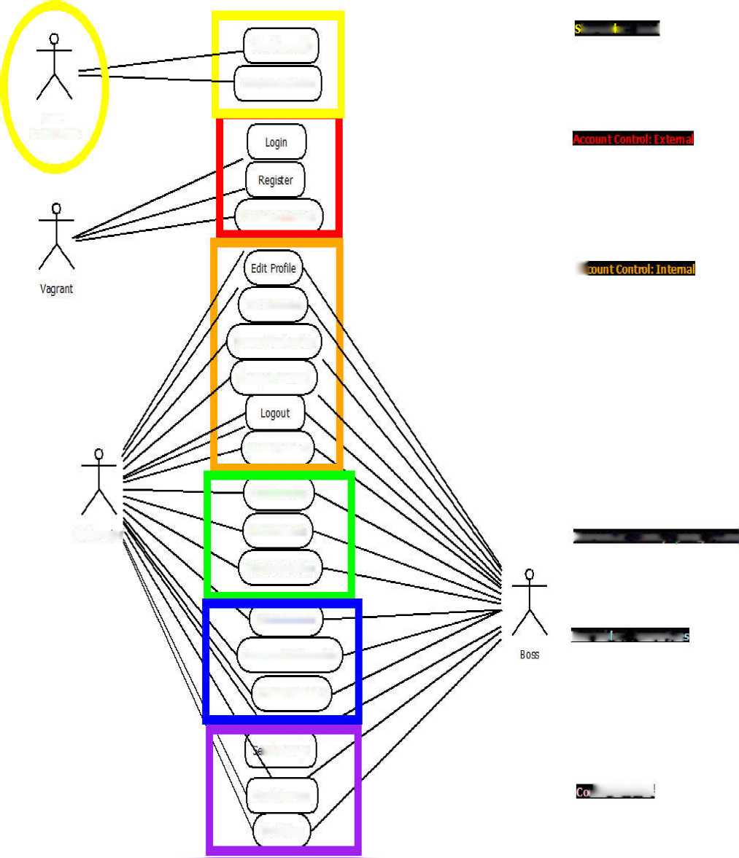Overview

2.1 User Case Diagram and Descriptions

**hareab es: Read**

**ViewShareable**

**SearchShareables**

**User;**

**BASECLASS**

**Guttersnpe'**

**RecoverPass/,'ordl**

**Edit Schedule**

**Renew Membership**

**Change Password**

**DeleteAccount**

**AddShareable**

**Edit Shareable**

**Delete Shareable**

RateShareable

**Co mmentOn Shareable**

**DeleteComment**

**mdMessage**

**Read Message**

**BlockUser**

a

Shareables: Create, U pdate, Delete

**Shareab es: Annotabon**

*iUmm*

A. 02.01.01

B. Usecases: USERS

1. User (U)
2. Shareables (Read)
3. View: Any U may view a search result.
4. SearchShareables: Any U may search for Shareable

by Thing (Categorization, Tags), Space (Geolocation), and Time (Schedule)

1. Vagrant (V)
2. Account Management (External)
3. Login: Any V can login to the system, which

transforms V into a G or B .

1. Register: Any V may register to become a G.
2. RetrieveUsername: Any V may request a username

reminder.

1. RecoverPassword: : Any V may request a password

reminder.

1. Guttersnipe (G)
2. Account Management (Internal)
3. EditProfile: Can edit information on own account.
4. EditSchedule: Can edit availability schedule.
5. RenewMembership: Can renew the terminal date of

membership

1. Logout: Can log out of own account.
2. ChangePassword: Can reset own password.
3. DeleteAccount: Can delete own account. Shareables (Create,

Update, Delete)

1. CreateShareable: Can add a Shareable resource.
2. UpdateShareable: Can update Shareable created by self.
3. DeleteShareable: Can delete Shareable created by

self.Shareables (Annotate)

1. RateShareable: Can rate any shareable
2. CommentOnShareable: Can comment on any shareable.
3. DeleteComment Can delete own comment.
4. Communications
5. SendMeetup: Can communicate message (schedule +

text) from other Guttersnipe.

1. ReadMessage: Can read message inbox.
2. SetSchedule: Can set availability calendar.
3. BlockUser: Can block any other user except Caretaker.
4. Caretaker (C)

Caretaker has same capabilities as Guttersnipe, but they are unrestricted to apply to all system users. The relevant overrides are as follows:

1. UpdateShareable: Can update Shareable created by any

user.

1. DeleteShareable: Can delete Shareable created by any

user.

* Deleting a Shareable account triggers DeleteAccount, DeleteComments and DeleteShareables for that User.

1. DeleteComment Can delete Comment written by any

user.

* Deleting a Comment triggers DeleteAccount, DeleteComments and DeleteShareables for that User.

1. DeleteAccount: Can delete the account of any user, except

for another Caretaker.

* Deleting a user account triggers DeleteComments and DeleteShareables for that User.

1. BlockUser: Triggers a DeleteAccount option for the

blocked user.

* Blocking a user account triggers DeleteAccount, DeleteComments and DeleteShareables for that User.

02.02.01

Client / Server

Assumptions and Dependencies

Previous release

The previous release (0.2.1.5) of Guttersnipe was a MEAN stack application, utilizing Mongo/Mongoose, Node, Express, and Angular 1.x.

The deployment of a node application requires a server or PAAS that supports a node engine. We find this constraint too restrictive because many servers do not have a node engine, including the servers where we hope to do our initial deployments.

Although Mongo/NoSql is a fine technology, we believe that rapid, optimized database queries can best be done with an SQL database, which will obviate the need for a lot of the “middle-tier” post-processing of results from a database query.

Current release

Client. The client requires a contemporary browser that supports standard HTML 5, CSS 3, and Javascript. It will use Angular 2.x as a front- end framework.

The application will be ported to mobile devices initially by taking advantage of libraries like phonegap which allow one to use the device webview to deploy web interfaces. Native Android/ iOS ports may be attempted as well.

For backend technologies, we sought a technology that could easily be ported to a variety of servers where no superuser access is required. We dislike bulky frameworks, preferring to add components as we need them. To this end, we have chosen the Flask / Python framework.

The most important platform to develop upon are the free phones given by government assistance (<http://newsroom.assurancewireless.com/> custom-page/product-information). Some of these have 1.8 inch screens. We are currently unsure of what toolkit we will need to use for the front end.

SPECIFIC

REQUIREMENTS

Class D&D

(diagrams && definitions)

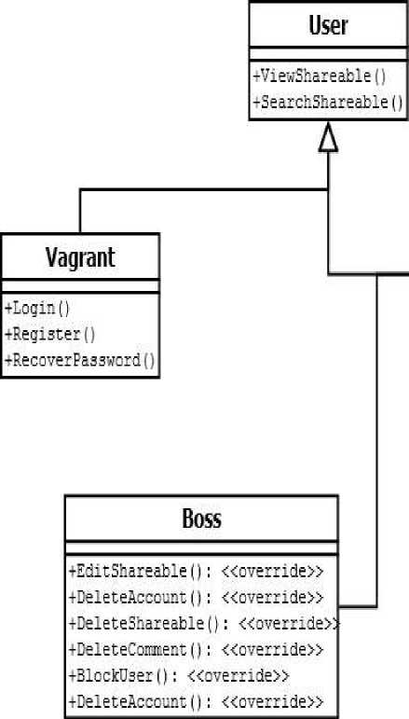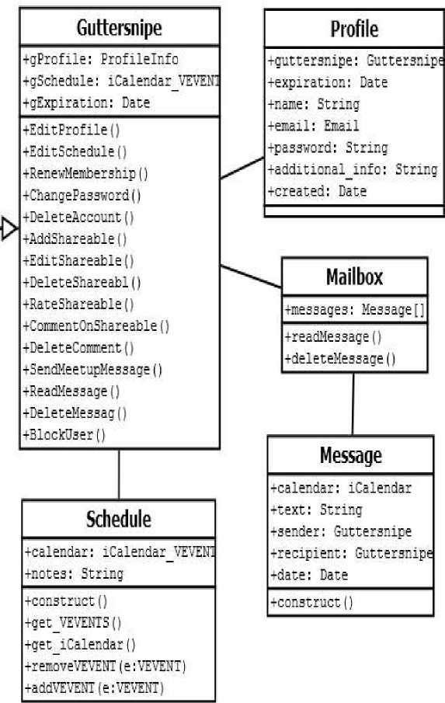User Class (A) Diagram

03.02.01 User Class Definitions User Class (abstract)

A User represents anyone using the application. It is an abstract class, so any actual user will be classified as a Vagrant, Guttersnipe, or Caretaker.

* Methods:

++ViewShareable(): Any User may view a shareable

++SearchShareable(): Any User may search through shareables by selecting filters for Thing, Space, and Time

Vagrant (extends the User Class)

A Vagrant represents someone who is browsing the site and has not yet logged in

* Methods:

++Login(): A Vagrant may log in to its own account ++Register() : A Vagrant may register to become a user ++RecoverUsername: A Vagrant may request to recover its Guttersnipe username

++RecoverPassword: :A Vagrant may request to recover its Guttersnipe username

Guttersnipe (extends the User Class)

A Guttersnipe represents a registered User who has logged into its own Account.

A

*Attributes:

++gProfile: Profilelnfo : Personal Information about the Guttersnipe. ++gSchedule: iCalendar_VEVENT: Availability information for the Guttersnipe

++gLocation: Space. The Guttersnipe’s registered location ++gExpiration: Date. A Guttersnipe’s account is a Temporary Autonomous Identification, which has an expiration date. This is done for security reasons. The expiration date may be extended at any time.

++ isAdmin: Identifies whether user is Guttersnipe or Caretaker.

* Methods:

++EditProfile(): A guttersnipe may edit its own profile ++EditSchedule(): A guttersnipe may edit its own schedule ++EditLocation: A Guttersnipe may edit its own location. ++RenewMembership(): A Guttersnipe may renew the termination date of its membership.

++ChangePassword(). A Guttersnipe may change its own password.

++DeleteAccount(): A Guttersnipe may delete its own account. ++AddShareable(): A Guttersnipe may add a Shareable.

++EditShareable(): A Guttersnipe may edit a Shareable that it has added. ++DeleteShareable(): A Guttersnipe may delete a Shareable that it has added. ++RateShareable(): A Guttersnipe may rate any Shareable ++CommentOnShareable(): A Guttersnipe may comment on any Shareable ++DeleteComment (): A Guttersnipe may delete any comment that it has written.

++SendMeetupMessage(): A Guttersnipe may send a message to another Guttersnipe. This message contains schedule and text. It will enable ++ReadMessage(): A Guttersnipe may read a message.

++DeleteMessage(): A Guttersnipe may delete a message.

++BlockUser(): A Guttersnipe may block another

Caretaker

A Caretaker is a registered user with administrative capacities. It has the same functionality as a Guttersnipe, but extends several of its methods. [1] 03.02.01 User-Associated Object Definitions

1. Profile

The Profile contains personal information about the Guttersnipe or Caretaker. Only username is a required attribute. All others are optional.

a. *Attributes:

1. username: The name user uses to log in
2. email (optional)
3. full_name (optional)
4. password (optional)
5. additional_info (optional): =Any additional details user wishes to add.
6. AvailabilitySchedule (optional)

A Guttersnipe may fill out a schedule to indicate it is most available for activities.

a. *Attributes:

1. availabilityCalendar: The user’s availability
2. notes; Any additional details
3. UserLocation (optional)

A Guttersnipe may indicate its location for participation in activities.

1. *Attributes:
2. Longditude
3. Latitude:
4. notes; Any additional details
5. Mailbox

A Guttersnipe has a mailbox where it can send and read messages a. *Attributes:

1. messages: collection of messages.
2. Message

A message is intended to communicate between Guttersnipes their availability for activities.

a. Attributes:

1. calendar: iCalendar: The user’s availability for a certain activity.
2. text = Text of the message
3. sender Guttersnipe who sent message
4. recipient = Guttersnipe who receives message
5. sendDate = Time Message was sent

03.02.01.05

Guttersnipe Component Classes

1. Message
2. Attributes:
3. calendar: iCalendar
4. text: String
5. sender: Guttersnipe
6. recipient: Guttersnipe []
7. date: Date
8. Functions
9. construct()
10. Profile
11. Attributes:
12. guttersnipe: Guttersnipe
13. expiration: Date
14. name: String
15. email: Email
16. password: String
17. additional_info: String
18. created: Date
19. Functions

i. __construct()

1. Schedule
2. Attributes:
3. calendar: sCalendar_VEVENT
4. notes: String
5. Functions
6. __construct()
7. get_VEVENTs() // Returns array of VEVENTs
8. get_iCalendar() // Returns iCalendar
9. removeF romSchedule(VEVENT) // Removes VEVENT

String>\rra*\

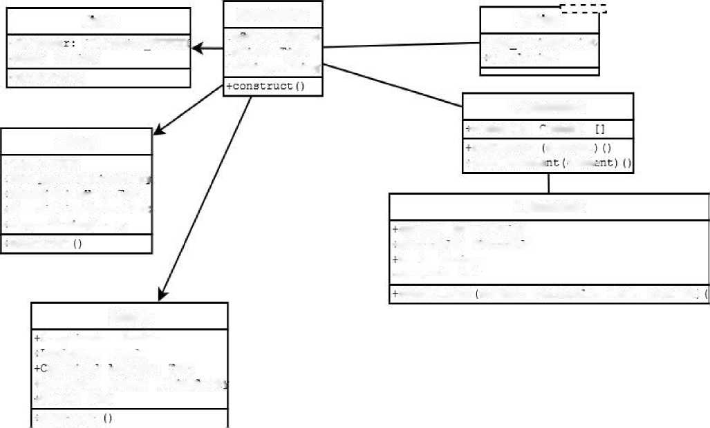Shareable Class (A) Diagram

iCalenda

Time

iCalenaar YEVENi

+name: String

+construct()

Thing

Shareable

Rating

isopace: Space

**+sTime: lime**

isThmg: Thing

+num ratings: mt

-total: mt

Comments

-comments: comment

addComment comment

**♦Type**:

ENDM

■^deleteCoirme

ccrrcr-

+5ubtvpes: StnngArrav

-Descnptionnow: lext

rDescriptionwhat: Text

Comment

-Tags: StnngArray

author: Guttersnipe

-construct

-shareable: Snareabie

text:

String

^created: Date

constructor author, shareable, text, created!

Space

Longditude: Double

-latitude:

Double

ar.or.icai address:

lext

♦Alternate Names:

rNotes:

Text

**-construct**

A. 03.02.02 Shareable Class and Parts

1. Shareable
2. *Attributes:
3. thing: Thing
4. space: Space
5. time: Time
6. Functions

i. construct(thing, space, time) // Constructor for the

Shareable class

1. Attributes:
2. type: ENUM

|  |  |
| --- | --- |
| ii. | subtypes: String [] |
| iii. | descriptionHow: String |
| iv. | descriptionWhat: String- |
| v.  b. Functions | tags: StringArray [] |

1. construct()
2. Space

a. *Attributes:

1. longditude: Double

|  |  |
| --- | --- |
| ii. | latitude: Double |
| iii. | canonical Address: String |
| iv. | alternate Names: String[] |
| v.  b. Functions | notes: String |

1. construct()
2. Time

a. *Attributes:

1. calendar: sCalendar_VEVENT
2. notes: String b. Functions
3. construct()””
4. Rating
5. Attributes:
6. num_rating: int
7. total: int
8. Functions
9. __construct()
10. getRating() : float””
11. Comments
12. Attributes:
13. comments: Comment []
14. Functions
15. __construct()
16. addComment()
17. deleteComment()
18. deleteByGuttersnipeID(int gsnipe_id)
19. Attributes:
20. author: Guttersnipe
21. shareable: Shareable
22. text: String
23. created: Date
24. Functions
25. function construct($commentID, $commentText,

$userName, $timestamp) // Constructor for the Comment class

B. Collaboration Diagrams, Database

8. Collaboration Diagram Obj ects:

1. Managers
2. (SearchManager, BrowseManager, MovieViewManager, LoginManager, RegisterManager, MovieRatingsInterface, MovieProcessor, CommentManager, CartManager, CheckoutManager, PasswordControl, LogoutControl, CommentControl, FlaggedCommentsManager, WarningSystem, DeleteManager)
3. GUI es

i. (SearchGUI, BrowseGUI, ViewMovieGUI, LoginGUI, MainCustomerPage, MainAdminPage, RegisterGUI, RegistrationSuccessGUI, MoviesBought, MoviePlayerInterface, CommentGUI, ViewCartGUI, CartGUI, CheckoutGUI, ConfirmationGUI, ResetPasswordGUI,

GUI COMPONENTS

Screenshots from 0.2 release and Future Wireframes

1. Front Page:

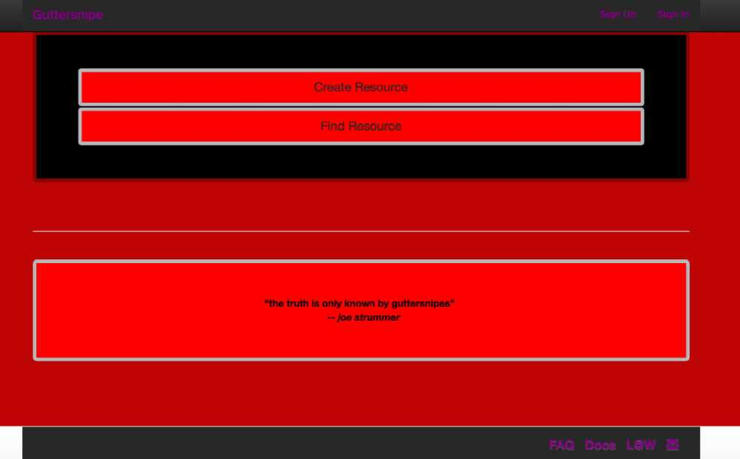Front Page shows

* Top Menu Links

o Home (here) o Sign Up o Sign In

* Body Links

o Create Resource o Find Resource

o “the truth is only known by guttersnipes” - joe strummer

* Bottom Menu Links

o FAQ

o Documentation o Legal o Contact

04.02.01

CreateShareable

Start

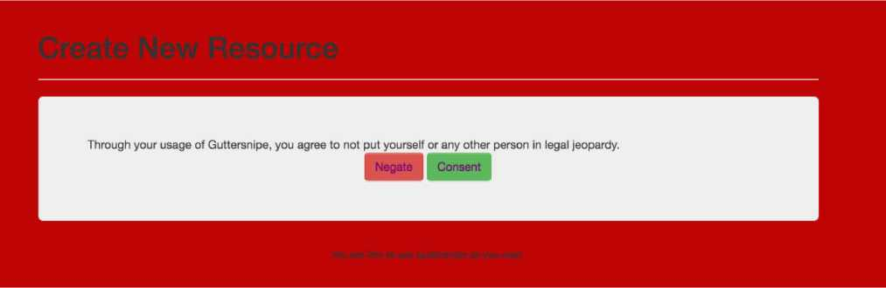

In order to add a Shareable to the System, the User can enter data in the following Wizard.

This represents the first step of that wizard.

It shows buttons for consent and negation.

Create New Resource

Through your usage of Guttersnipe, you agree to not put yourself or any other person in legal jeopardy.

Negate Consent

You are free to use Guttersnipe as you wish.

04.02.02

CreateShareable

Instructions

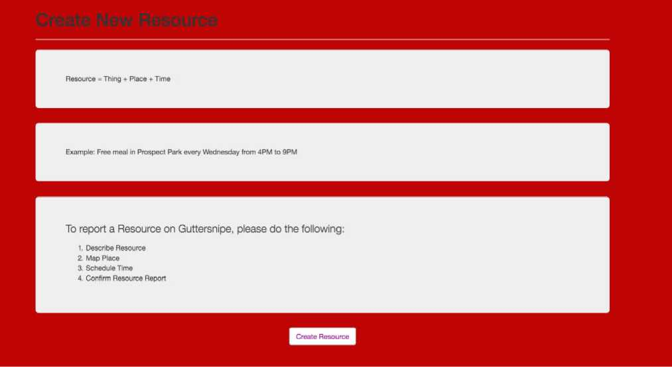

Instructions on how to create Shareable

Create New Resource Resource = Thing + Place + Time

Example: Free meal in Prospect Park every Wednesday from 4PM to 9PM To report a Resource on Guttersnipe, please do the following:

Describe Resource Map Place Schedule Time Confirm Resource Report

04.02.03

CreateShareable

Describe

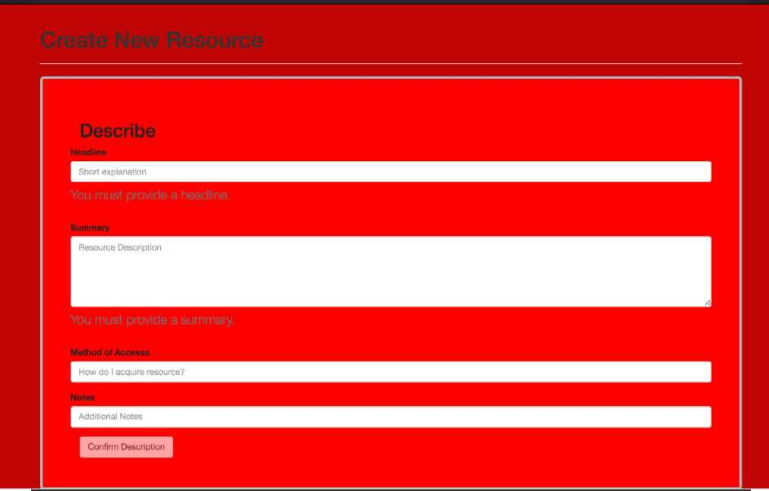Form for entering textual data about the Shareable

* Headline
* Summary
* Method of Access
* Additional Notes

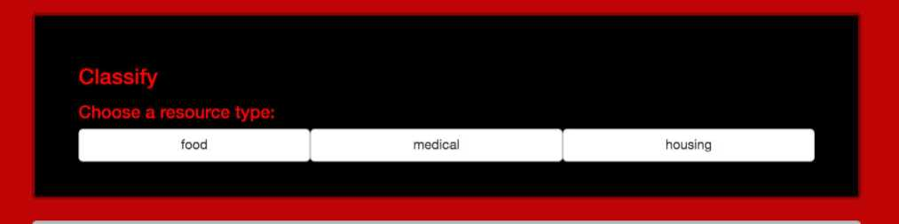Allows Guttersnipe to categorize Shareable as System-defined type

* Food
* Medical
* Housing
* Transport (new)

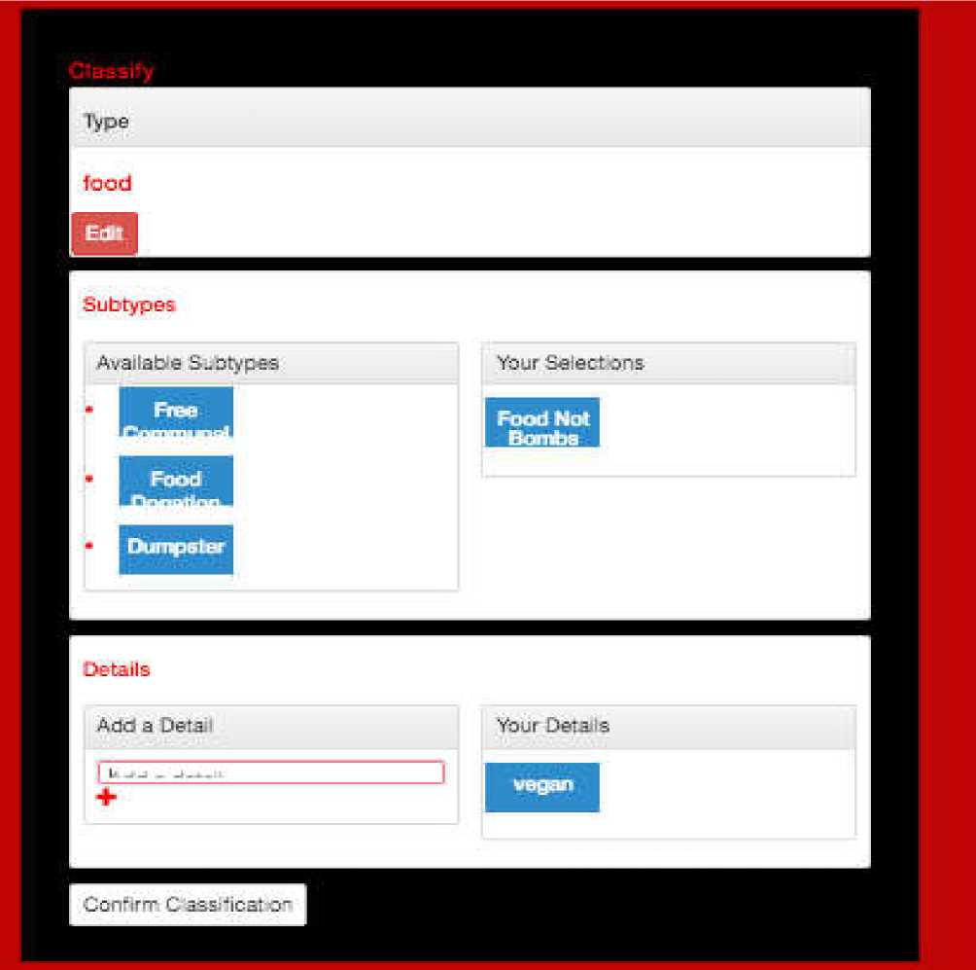

Allows Guttersnipe to add system-defined Subtypes and Guttersnipe-defined Tags to Shareable.

04.02.05fb)

C reateShareable Map Shareable Location

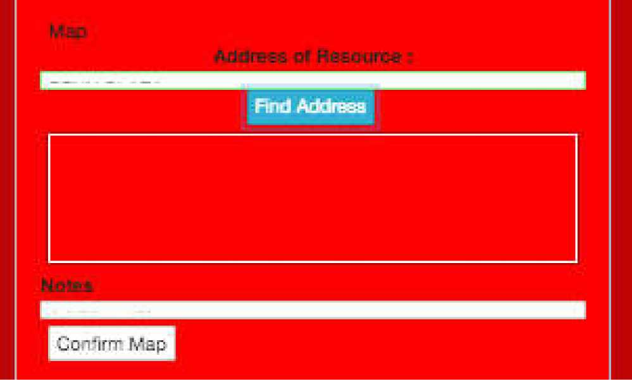

Shows Map centered on User’s current location or Times Square if location is unavailable. Allows user to specify address of the Shareable.

**04.02.0**6**faJ CreateShareable Sch**e**dul**e **(1J**

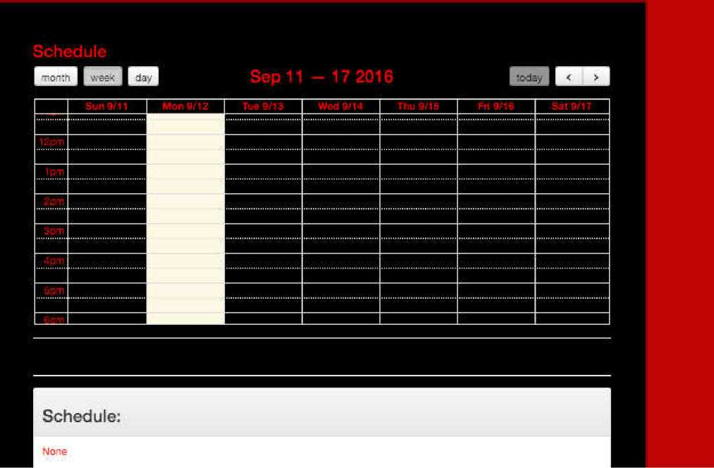

Shows blank calendar. When Guttersnipe clicks on a date, it will be shown popup in next Figure.

04.02.06Ca) CreateShareable: Schedule C1)

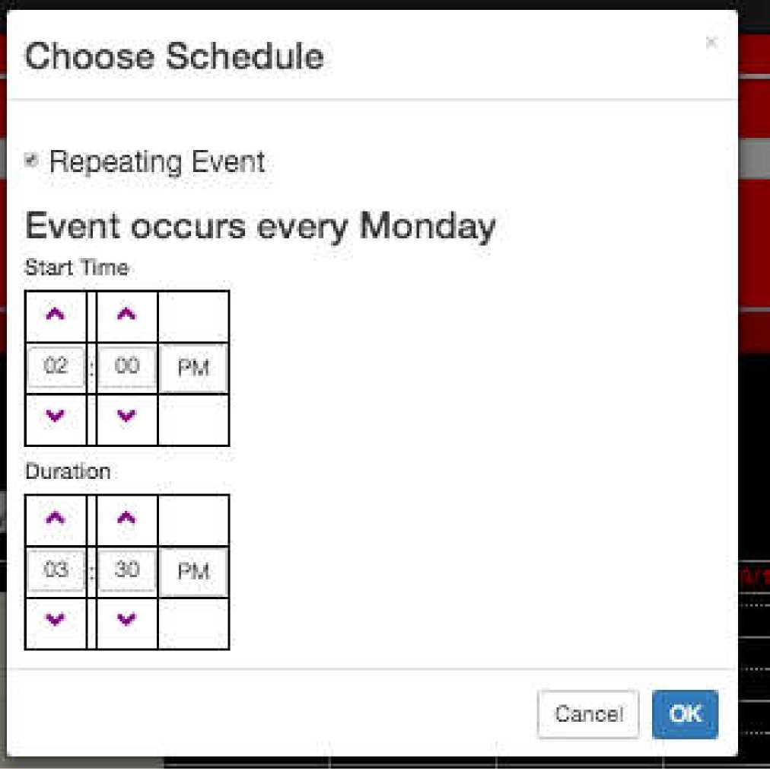

Shows blank calendar. When Guttersnipe clicks on a date, it will be shown popup in next Figure.

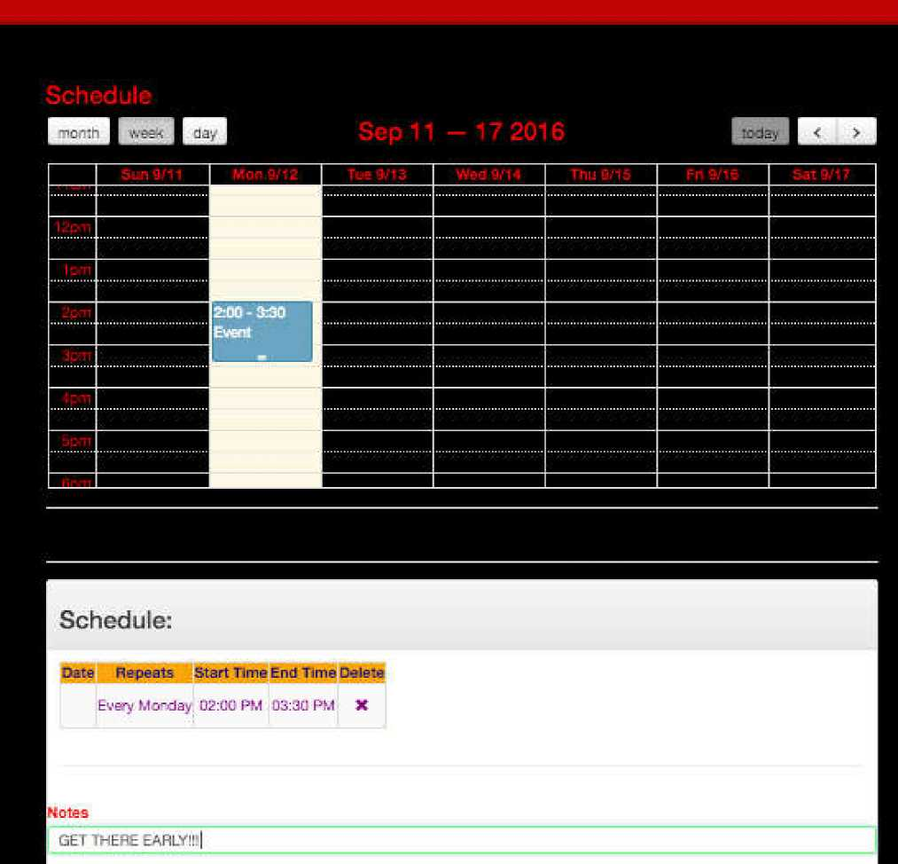

A calendar is shown once the user has selected a new schedule for the event. A list of schedules is show under the calendar.

The user can delete any schedules which are incorrect.

04.03. SearchShareable

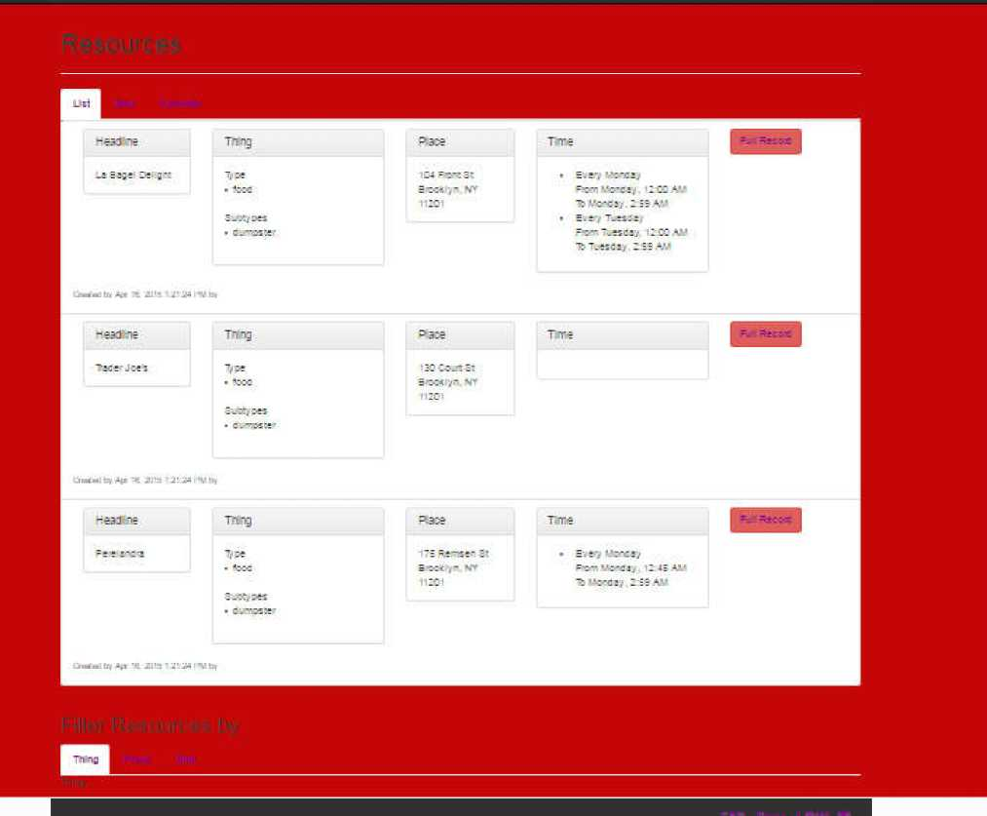Shows the results of the Shareable Search as a list. Columns for

* Headline
* Thing (Type && Subtype)
* Place
* Times
* Link to Full Record

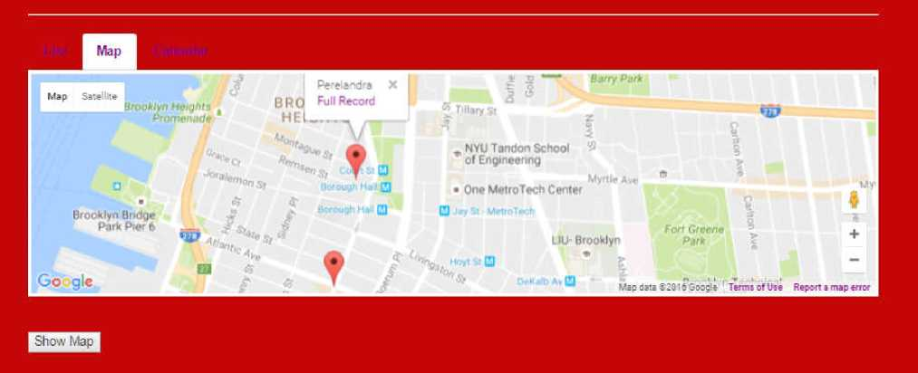

Shows Shareable Search Results as a Map.

Each point on the map has a tooltip that opens up a window with a Summary and a link to the Shareable.

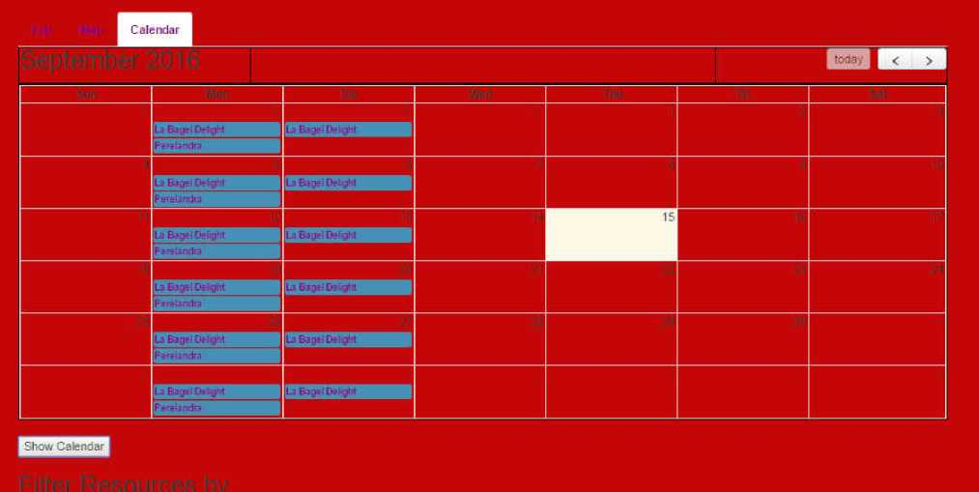Shows Shareable Search results as a Calendar.

Each entry on the calendar a link that can be clicked for the full record.

1. SearchShareable Search Filters



Search Interface will have 3 filters. These have not been designed yet

* Thing

o By Type and Subtype o By Tags

* Time

o By Date/Time

* Space

o Choose Map Location

User will be able to refine these 3 search filters and submit a search query when done.

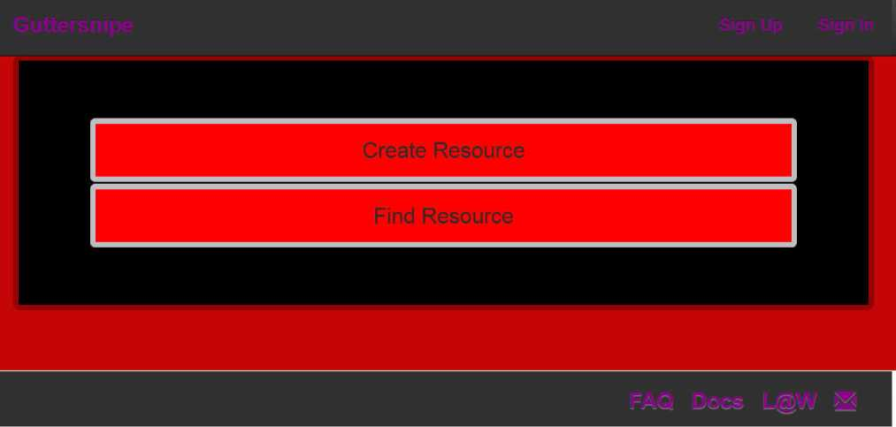

In the top right corner of the menu bar are buttons for “Sign Up” and “Sign In”

04.04.02

Account Management Smaller Screens

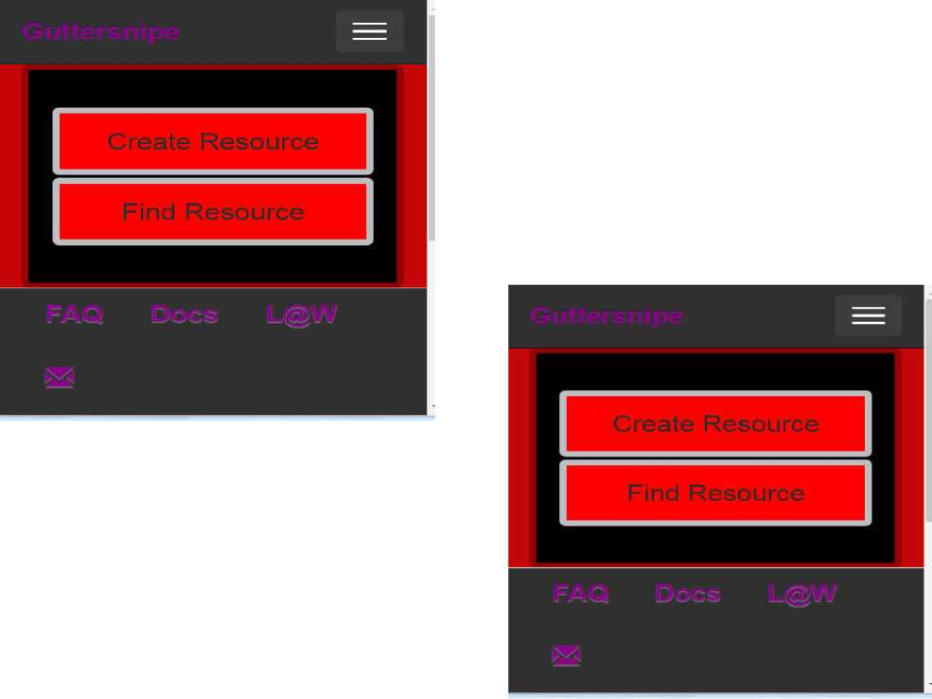

On Smaller Screens, users can click on the top right burger-shaped menu button to display the Sign Up and Sign In buttons

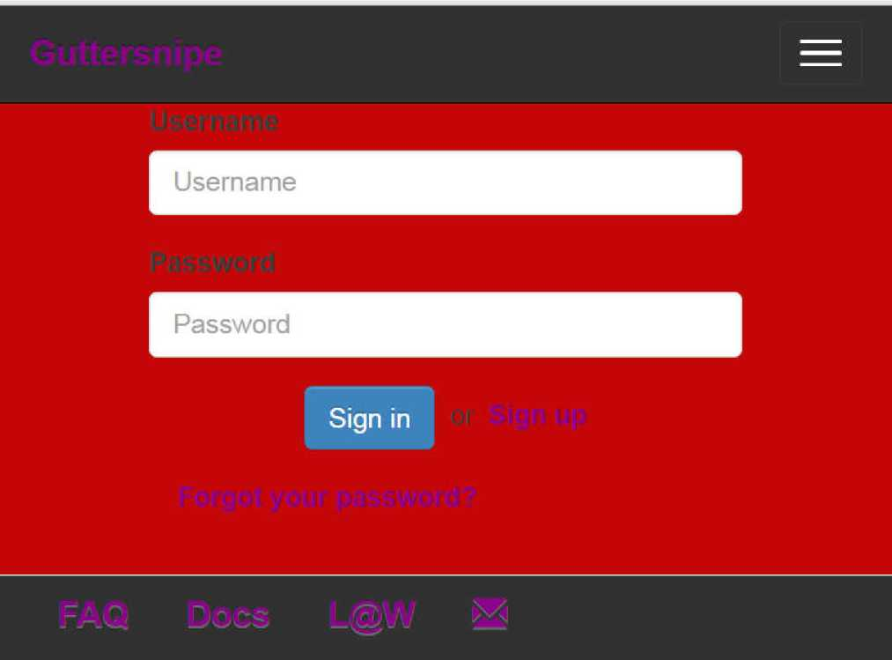

Shows form

* User
* Password
* Sign In Button

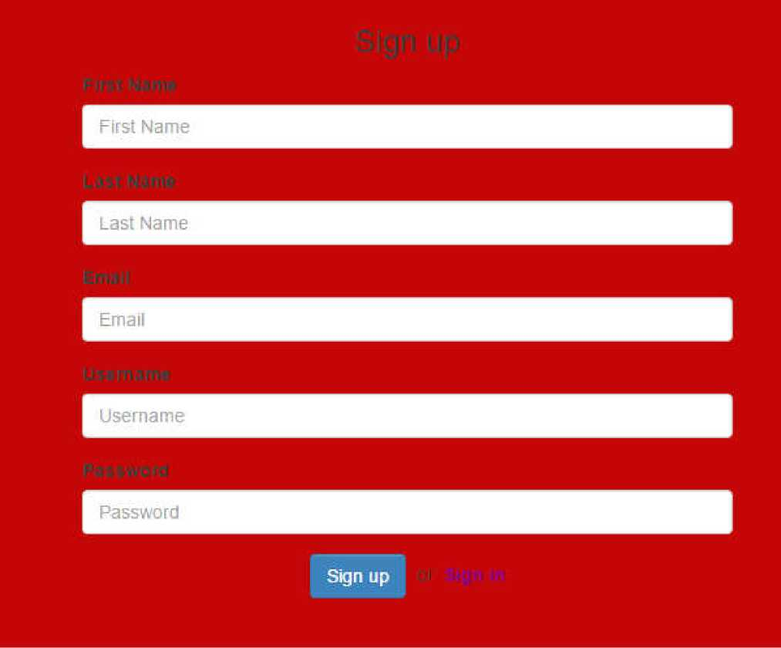Signup Page asks user to fill in form:

* Username:
* Expiration Date
* Email (optional)
* Password (optional)

04.04.05

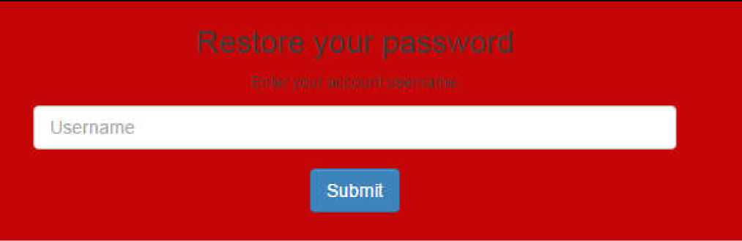Account Management Restore Password

Provides a button for asking system to send user a password reset form.

Documentation

DOCUMENTATION: GENERAL

04.05.01

Documentation: General Mission Page

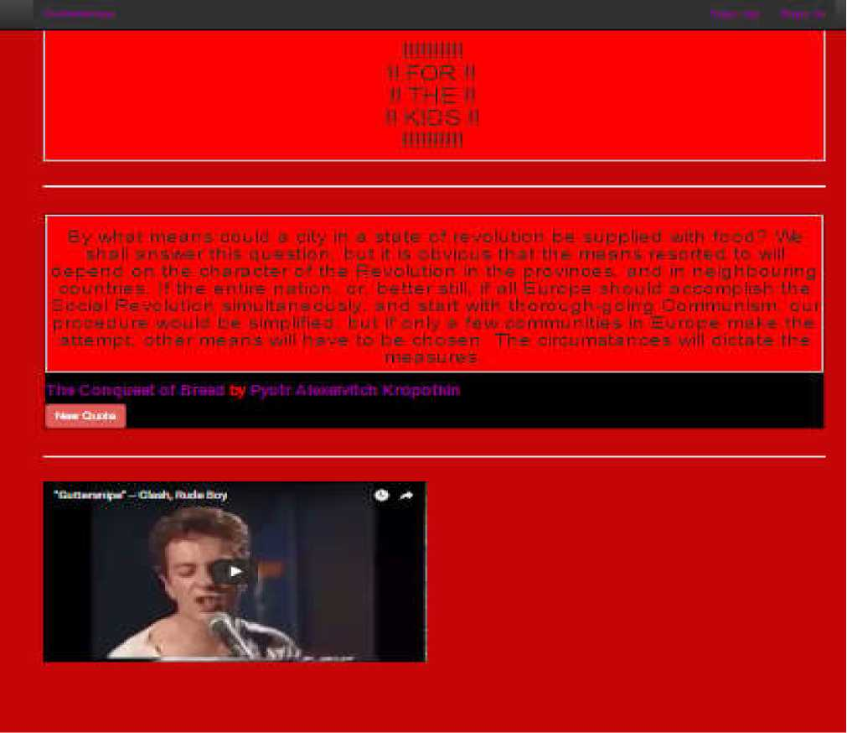Mission page shows

* “FOR THE KIDS!!!

■ Kropotkin Quotes Widget

* Joe Strummer “guttersnipe” video.

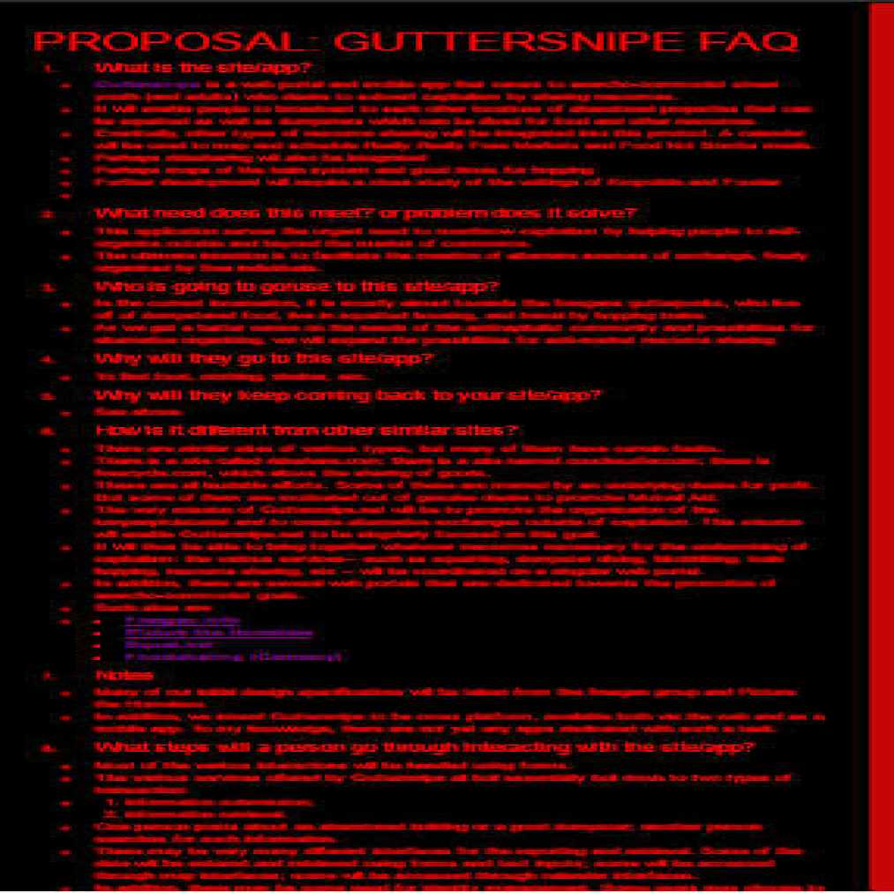

Displays a FAQ about the project.

This is same content as section “oi_oi: Proposal” of the current document.

DOCUMENTATION: 2013 Presentation

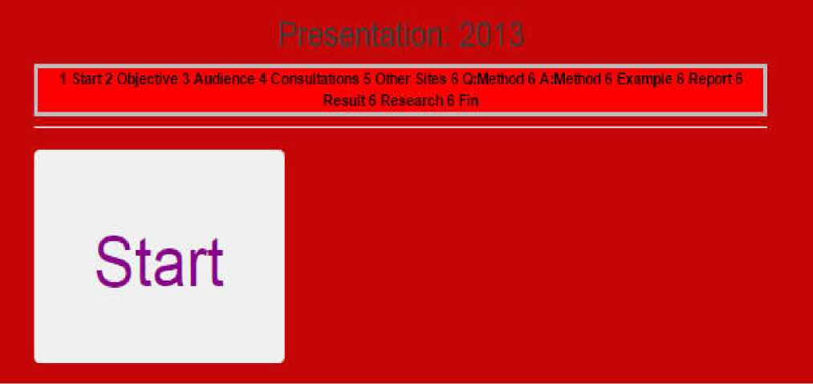

From 2013 Presentation:

Section 6:

STARTPAGE

The following slides are taken from my 2013 presentation prepared for what I intended to be my senior project at City College of New York

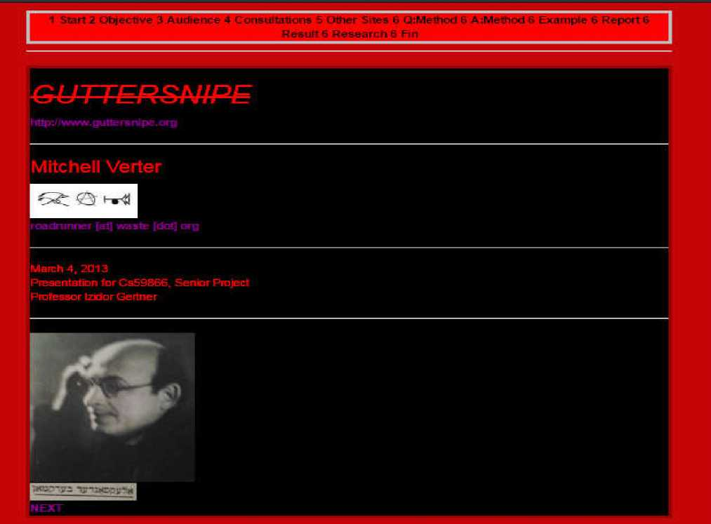

From 2013 Presentation: Section 6:

FRONTPAGE

GUTTERSNIPE <http://www.guttersnipe.org> Mitchell Verter

roadrunner [at] waste [dot] org March 4, 2013

Presentation for CS59866, Senior Project Professor Izidor Gertner <Picture of Alexander Berkman>

04.05.03.03

Documentation: 2013 Presentation Objective

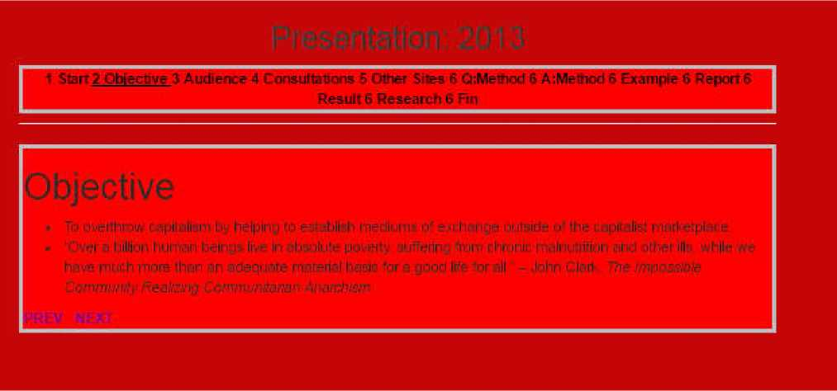

From 2013 Presentation: Section 6:

OBJECTIVE

* To overthrow capitalism by helping to establish mediums of exchange outside of the capitalist marketplace. [2]

04.05.03.04

Documentation: 2013 Presentation Audience

1 Start 2 Objective 3 Audience 4 Consuttn&ons 5 Other Sites 6 CcMetnod 6 AiMelbod 6 Example 6 Report 6

Result 6 Research 6 Fin

udience

**■ People who can not effort! Id Dr who choose not to participate in th**

**ie capitalist marketplace**

* The i/iclimese Majority p Poor

' DislQC-stsd!

**. Immigrants Street people Homeless**

* **Traveler punks**
* **Contingent/Precarious workers - Lumpenproletariat**

**PREV NEXT**

**04.05.03.05**

**Documentation: 2013 Presentation** Consulting Organizations

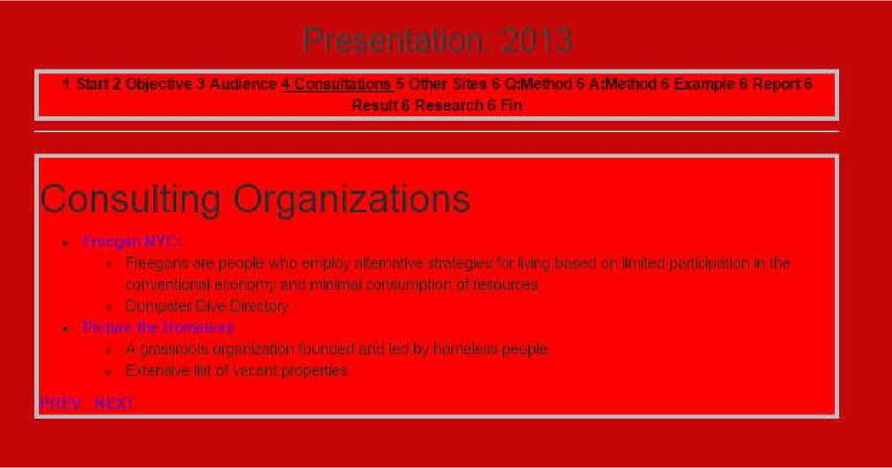

From 2013 Presentation:

Section 6:

CONSULTING ORGANIZATIONS [3]

04.05.03.06

Documentation: 2013 Presentation Other Sites

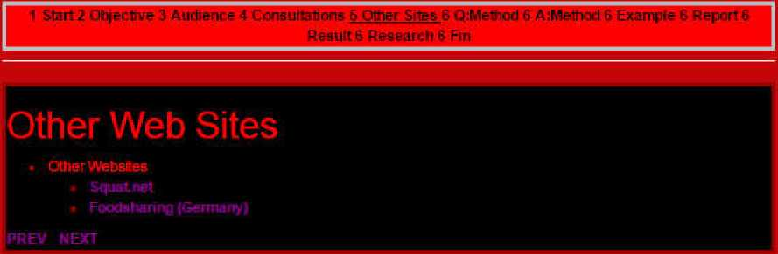From 2013 Presentation:

Section 6:

OTHER SITES

Other Web Sites

• Other Websites o Squat.net

o Foodsharing (Germany)

04.05.03.07

Documentation: 2013 Presentation Question of Method

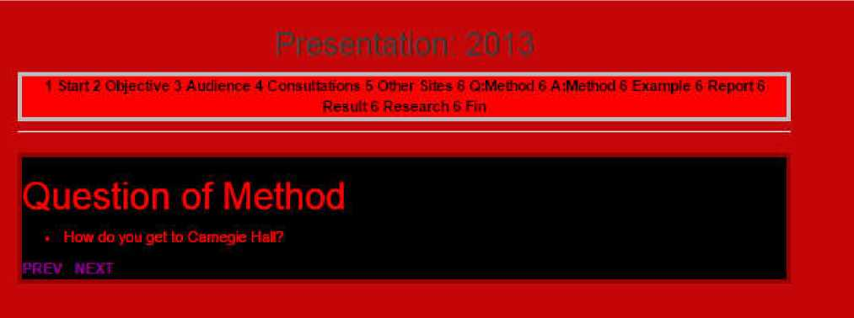From 2013 Presentation: Section 6:

QUESTION OF METHOD

Question of Method . How do you get to Camegie Hall?

04.05.03.08

Documentation: 2013 Presentation Answer of Method

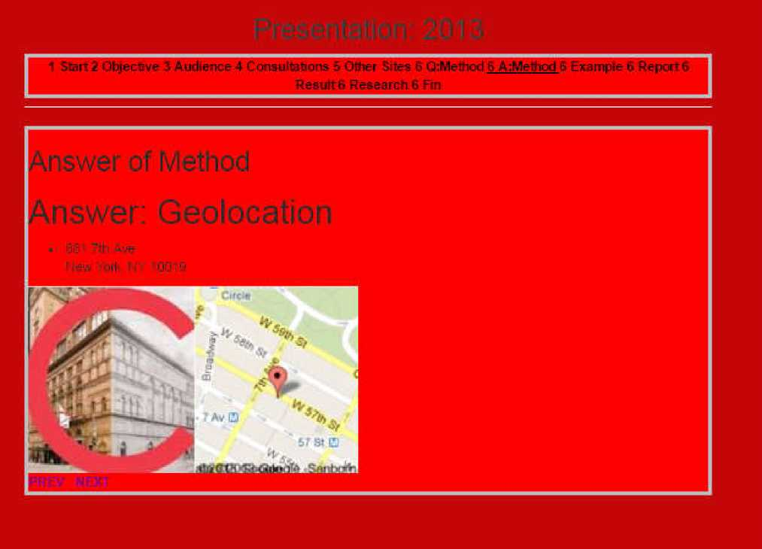From 2013 Presentation: Section 6:

ANSWER OF METHOD

Answer: Geolocation 881 7th Ave New York. NY 10019

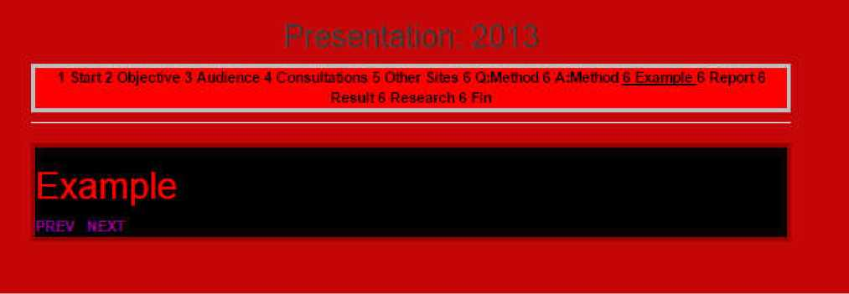

The following pages are taken from a previous incarnation of this project. Designed in 2002, these pages are still available at: <https://www.waste.org/~roadrunner/squat/>

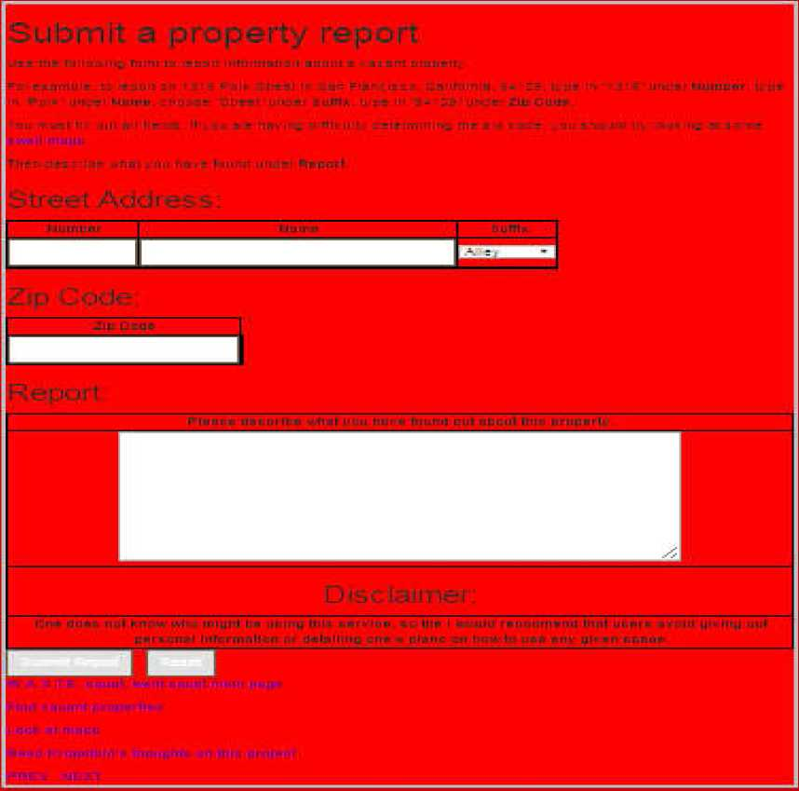C:\Users\mitchell\Documents\media\image35.jpeg

|  |  |  |
| --- | --- | --- |
| 1 3 1-rl Z ^Dinbvt J- z.11 | □ is-HD* - Ccneulteftcnc E CMTinr Ulls-» ; L:ki--IJicil 5- Ih zl E E m ^KDiilt ft tlFLFfri f- ft Fin | :i“ : FHftCL rl L |
|  | | |

Shows the Submit Property Report interface from the 2002 deployment.

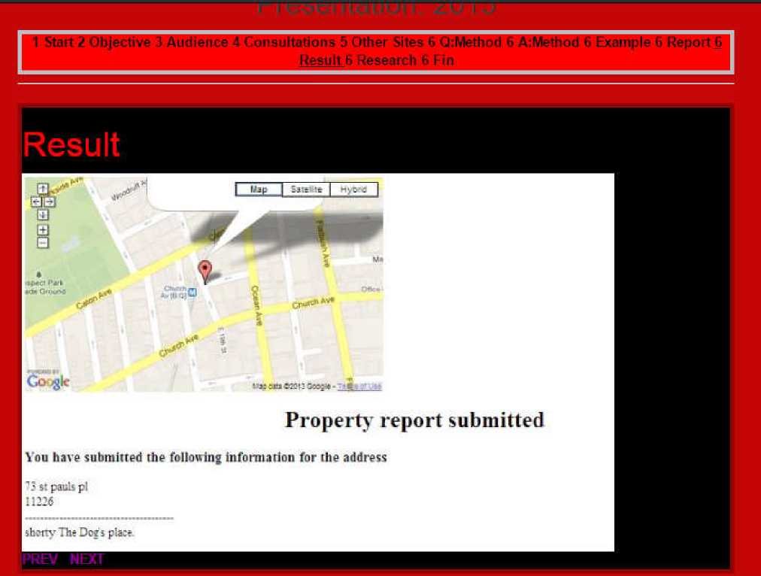

Shows a Resulting page for a Property Submission from the 2002 deployment.

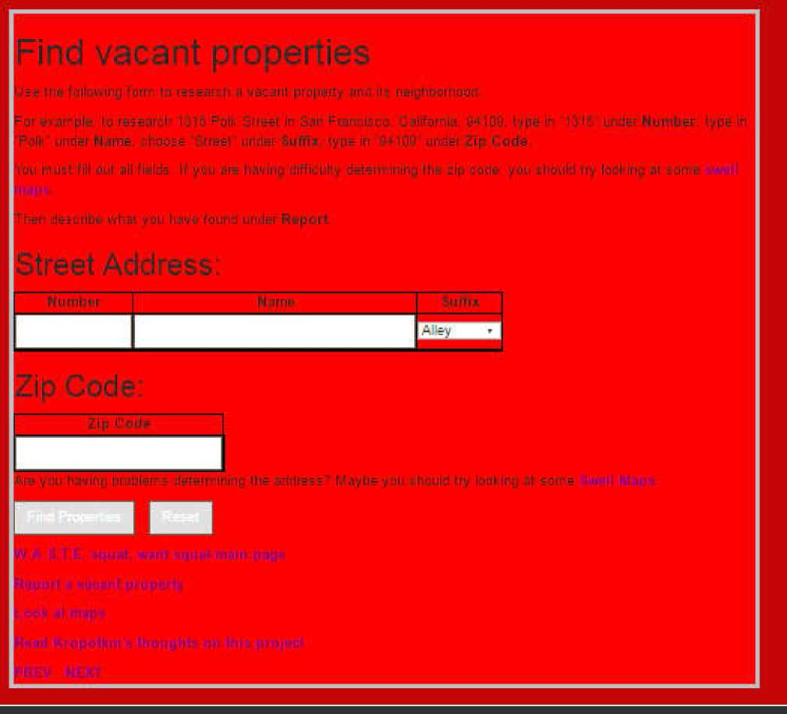

Shows the Property Search GUI from the 2002 deployment.

04.05.03.13

Documentation: 2013 Presentation FIN

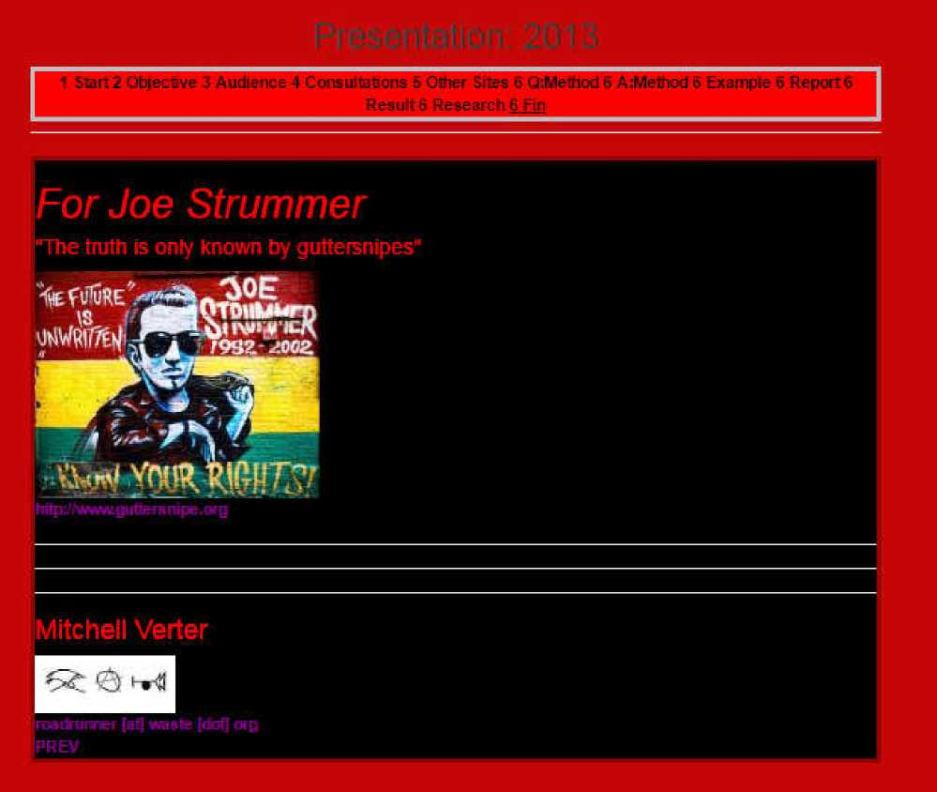Final Page from 2013 Presentation:

For Joe Strummer

“The truth is only known by guttersnipes”

<http://www.guttersnipe.org> Mitchell Verter

roadrunner [at] waste [dot] org

**DOCUMENTATION: ADMINISTRATIVE INFORMATION PAGES**

04.05.01

Documentation: Administrative L@W Page

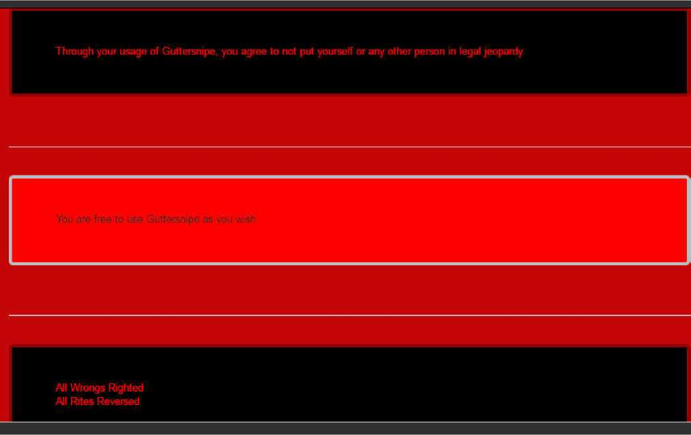Shows Legal Information

You are free to use Guttersnipe as you wish.

All Wrongs Righted All Rites Reversed

GNU General Public License

04.05.04.02

Documentation: Administrative Credits Page

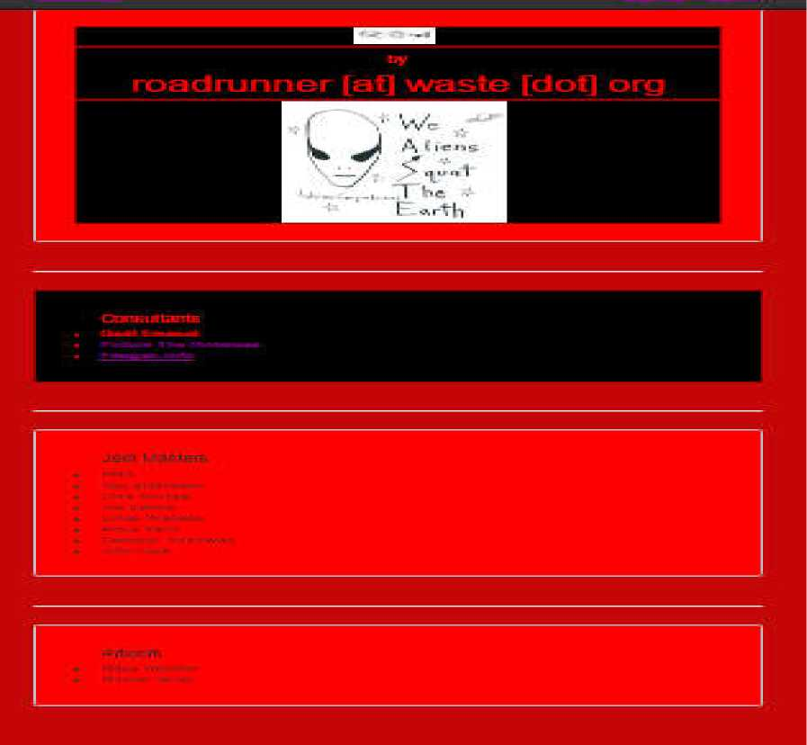

Shows creator and inspirations for the project.

04.05.04.03

Documentation: Administrative Contact Information

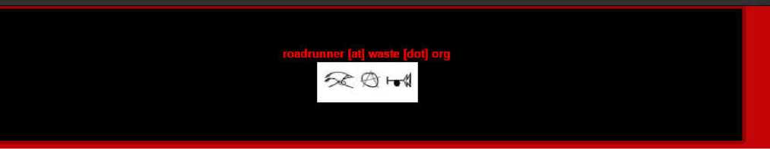Displays email address and a clickable picture to send mail.

**Kropotkin Quote Widget**

1. Kropotkin Quote

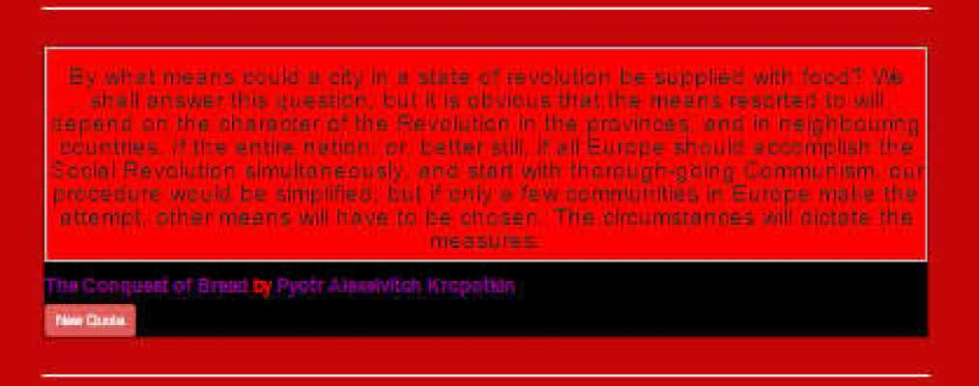

The Kropotkin widget displays quotes from “Conquest of Bread”

The “New Quote” button produces another randomly-chosen quote.

We intend to add another button that cycles through quotes every minute.

**RESPONSIVE WEB DESIGN**

04.04.07 Menu Dropdown

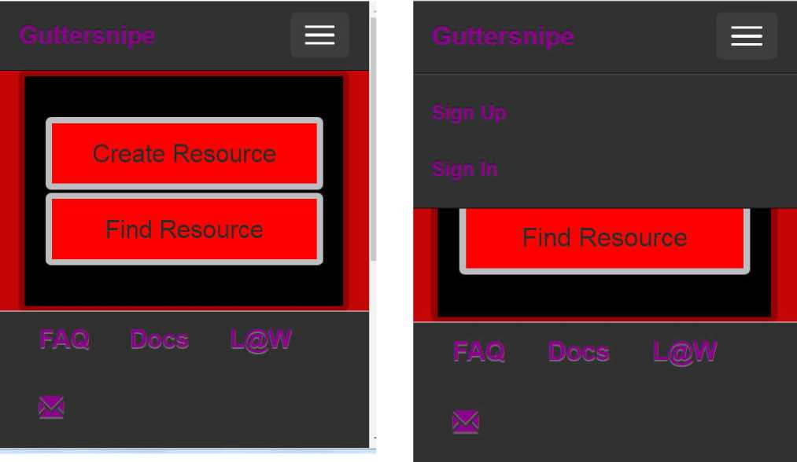

On smaller screens, the top toolbar is replaced with a button which displays a dropdown menu which reveals, when pressed, buttons for Sign In and Sign Up

**Collaboration**

**Diagrams**

Collaboration Diagram Stereotypes

Part 1: Control Objects Part 2: GUI Bound-

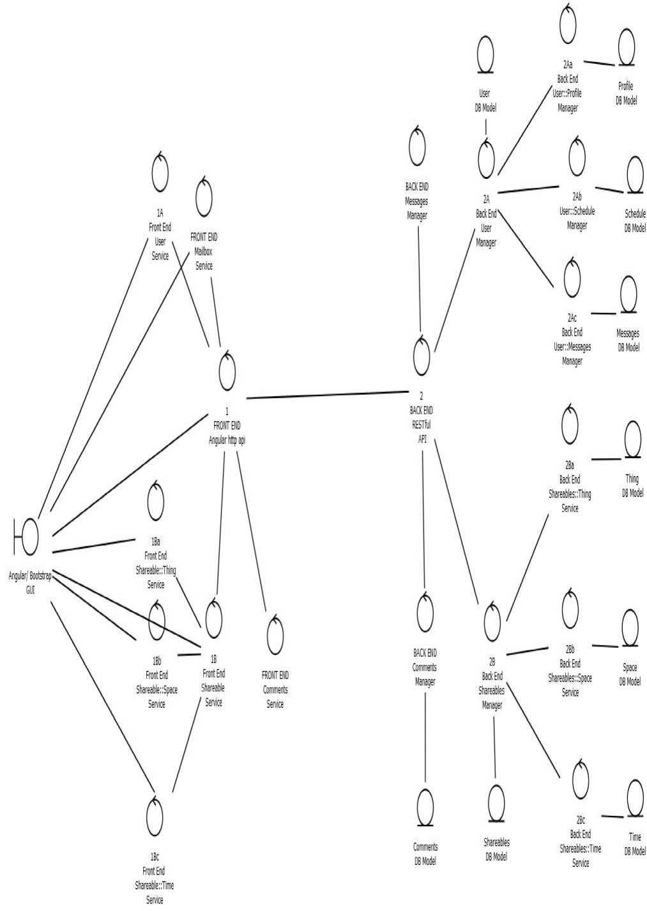

System Collaboration Diagram

FRONT END Boundary Classes :

The User interacts with the application through a Browser Interface. The pages below can be reached directly through the value entered in

* Browser Address Bar (GUI)
* Angular Components (GUI)

Control Classes:

The Front End is written in Angular/Ionic.

This allows us to impose a layer of control on the front end.

1. API/HTTP Service

1. User Services
2. Mailbox Service
3. Schedule Service
4. Profile Service
5. Shareables Service
6. Thing Service
7. Space Service
8. Time Service
9. Comments Service
10. Ratings Service

BACK END

The Back End is written in Python/Flask/SQLAlchemy.

It offers a Back End layer of Control Classes and a layer of Entity Classes.

Control Classes:

1. Flask

i. RESTful API

Entity Classes

1. /SQLAlchemy Models
2. User Models
3. Mailbox Model
4. Schedule Model
5. Profile Model
6. Shareables Model
7. Thing Model
8. Space Model
9. Time Model
10. Comments Model
11. Ratings Model

1. FRONT END: Angular HTTP API

An API Service wraps the native Angular $http Service

1. F/E User Service

A User Service maintains the User’s account.

The User can login and logout through this

It can be used together with the Messages and the Comments

Services

1. F/E Shareables Service

A Shareables Service maintains the array of Shareables and functions for each Shareable.

Shareables Service maintains CRUD functionality for the list of Shareables and for each individual Shareable.

1. F/E Shareables::Thing Service

The Thing Service maintains Tags, Type/Subtype, and Description data

1. F/E Shareables::Space Service

The Space Service maintains geolocation data.

1. F/E Shareables::Time Service

The Time Service maintains schedule data

c. Comments Service

The Comments Service maintains the comments that Guttersnipes put on Shareables.

CRUD functionality is available for the array and each member.

i. Messages Service

A Shareables Service maintains the array of Messages that Guttersnipes send to each other as well as each individual Message.

CRUD functionality is available for the array and each member

2. Back END: RESTful API API written with Flask/SQLalchemy

1. B/E User Model

A User Model maintains the User’s account.

The User can login and logout through this

It can be used together with the Messages and the Comments

Models

1. B/E Shareables Model

A Shareables Model maintains the array of Shareables and functions for each Shareable.

Shareables Model maintains CRUD functionality for the list of Shareables and for each individual Shareable.

1. B/E Shareables::Thing Model

The Thing Model maintains Tags, Type/Subtype, and Description data

1. B/E Shareables::Space Model

The Space Model maintains geolocation data.

1. B/E Shareables::Time Model

The Time Model maintains schedule data

1. Comments Model

The Comments Model maintains the comments that Guttersnipes put on Shareables.

CRUD functionality is available for the array and each member.

1. Messages Model

A Shareables Model maintains the array of Messages that Guttersnipes send to each other as well as each individual Message. CRUD functionality is available for the array and each member

DB Models (SQLalchemy/PostGIS

API written with Flask/SQLalchemy Database uses postgresql with PostGIS

1. B/E User DB Model

Stores

1. id
2. profile
3. schedule
4. is_admin
5. created_on
6. B/E Profile DB Model Stores
7. id
8. username
9. email
10. full_name
11. password
12. additional_info
13. B/E Schedule DB Model Stores
14. id
15. calendar = sCalendar_VEVENT
16. notes
17. Messages DB Model

Stores

1. calendar = sCalendar_VEVENT
2. text
3. sender
4. recipient
5. sent = db.Column(db.DateTime
6. Block User Join DB Table

Stores

i.blocker

|  |  |
| --- | --- |
| ii. | blocked |
| f. B/E Shareables DB Model  i. id | |
| ii. | thing_id |
| iii. | space_id |
| iv. | time_id |
| v. | comments |
| vi. | number_ratings |
| vii. | total_ratings |

1. B/E Shareables::Thing DB Model

The Thing DB Model maintains Tags

1. subtypes = String [] # Not a good choice.

*Rethink this*

1. descriptionHow
2. descriptionWhat
3. B/E Tag DB Model
4. id
5. tag
6. Tag Thing DB Join
7. tag_id
8. shareable_id
9. B/E Shareables::Space DB Model
10. The Space DB Model maintains geolocation data.
11. id
12. longditude
13. latitude
14. canonical_address
15. alternate_names
16. notes
17. B/E Shareables::Time DB Model
18. The Time DB Model maintains schedule data
19. id
20. calendar = sCalendar_VEVENT *#sCalendar_VEVENT will be defined soon* ...
21. notes

l. Comments DB Model

The Comments DB Model maintains the comments that Guttersnipes put on Shareables.

CRUD functionality is available for the array and each member.

|  |  |
| --- | --- |
| i. id |  |
| ii. | author |
| iii. | shareable |
| iv. | text |
| v. | created |

1. Angular GUI (Angular/Ionic/Bootstrap)

GUIs written with Angular/Ionic JS Frameworks.

CSS with Bootstrap

a. B/E User Entity

A User Entity maintains the User’s account.

The User can login and logout through this

It can be used together with the Messages and the Comments

Entitys

1. View Shareable

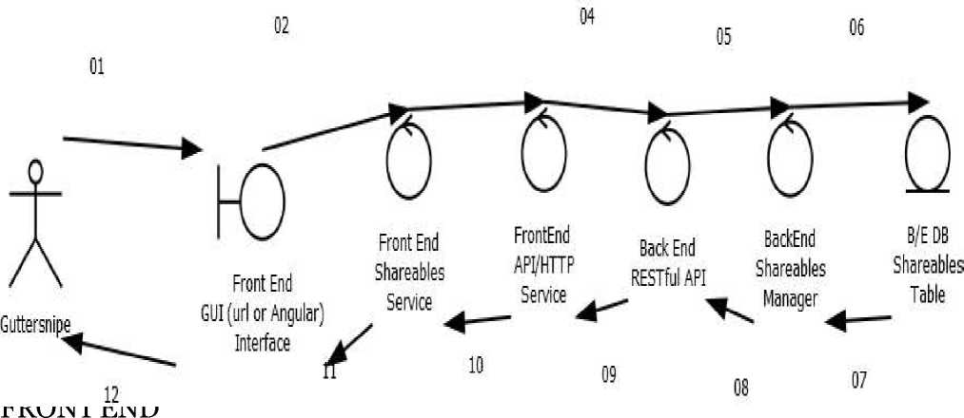

1. User Interacts With GUI via Angular Components or Browser Address
2. GUI sends message to Angular Service
3. Angular Service sends message to Angular $httpAPI Service

CLIENT-SERVER

1. Front End $httpAPI service sends message to RESTful API Back End BACK END
2. API sends message to Object Manager
3. Manager sends request to Database
4. Database returns object data to Object Manager
5. Object Manager returns formatted objects to RESTful API

SERVER CLIENT

1. RESTful API returns json data to Angular API Service FRONT END
2. $httpAPI returns data to Angular Service
3. Angular Service changes Angular Component GUI
4. Search Shareable

FRONT END

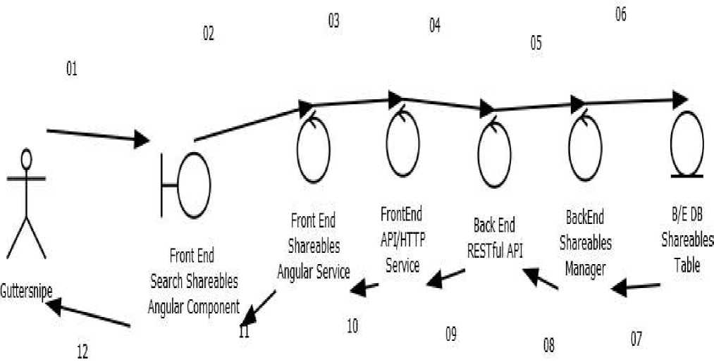

1. User Interacts With GUI via Angular Components or Browser Address
2. GUI sends message to Angular Service
3. Angular Service sends message to Angular $httpAPI Service

CLIENT-SERVER

1. Front End $httpAPI service sends message to RESTful API Back End BACK END
2. API sends message to Object Manager
3. Manager sends request to Database
4. Database returns object data to Object Manager
5. Object Manager returns formatted objects to RESTful API

SERVER CLIENT

1. RESTful API returns json data to Angular API Service FRONT END
2. $httpAPI returns data to Angular Service
3. Angular Service changes Angular Component GUI

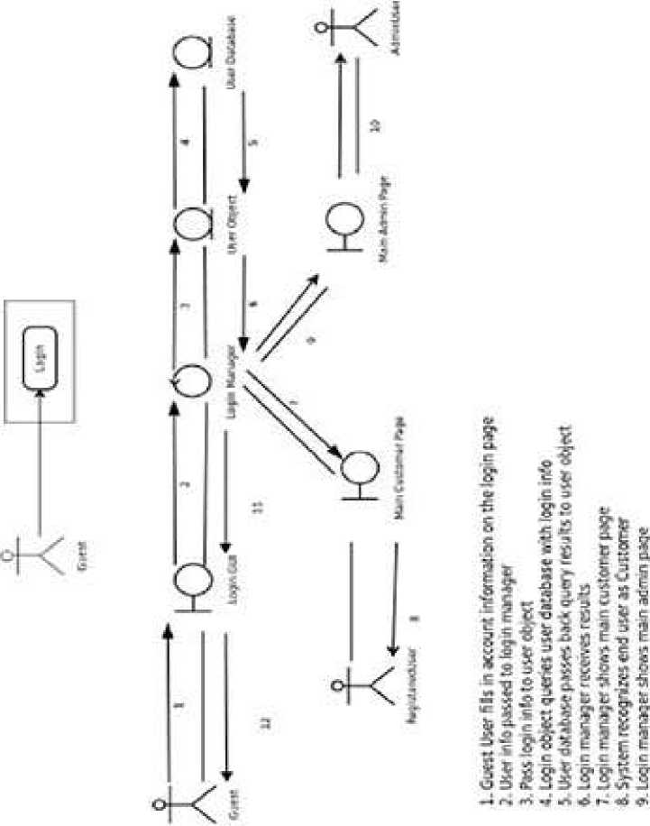

IQ iiMltfl’-ttog) Itr. P-Hf .n Mf -I

|  |  |
| --- | --- |
| tr  r*  t  S |  |
| ! |  |
| t  -& | & |
| LJ  i | ’5) |
| l | 0 |
| 1  g_ |  |
| 1 | ■ V  N |
| « | ca |
| SI | 9 |
| kr |
| || | 3 |
| cn |
| ■.■I r- | iZ |

J. IB cfrSf j?-.i iv lOJ -i Ob.cct fr fa we h*i; re logtT>

I ] un; ii rr-Ns^fl jireir Is rHut 'rev,-nr m & ■ 1J. Guest rKtivci ere 'rcissgi

^r

On

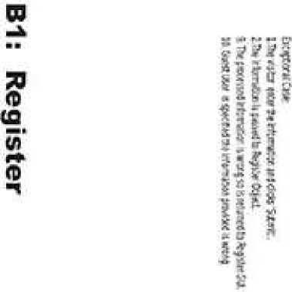

VO

U\

o

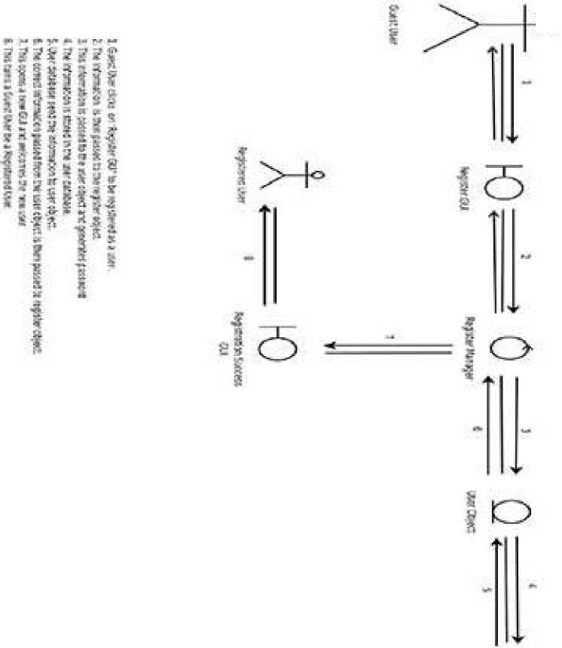

1. Recover Password

FRONT END

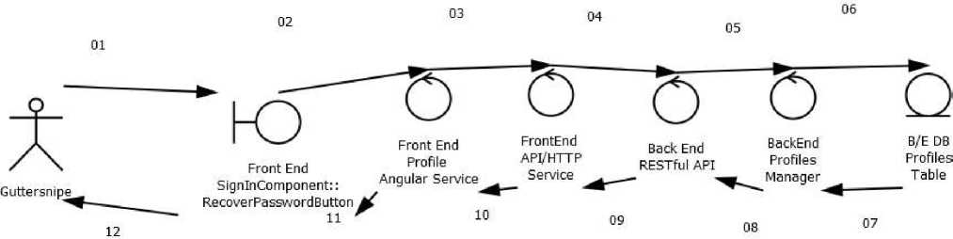

1. User Interacts With GUI via Angular Components or Browser Address
2. GUI sends message to Angular Service
3. Angular Service sends message to Angular $httpAPI Service

CLIENT-SERVER

1. Front End $httpAPI service sends message to RESTful API Back End BACK END
2. API sends message to Object Manager
3. Manager sends request to Database
4. Database returns object data to Object Manager
5. Object Manager returns formatted objects to RESTful API

SERVER CLIENT

1. RESTful API returns json data to Angular API Service FRONT END
2. $httpAPI returns data to Angular Service
3. Angular Service changes Angular Component GUI

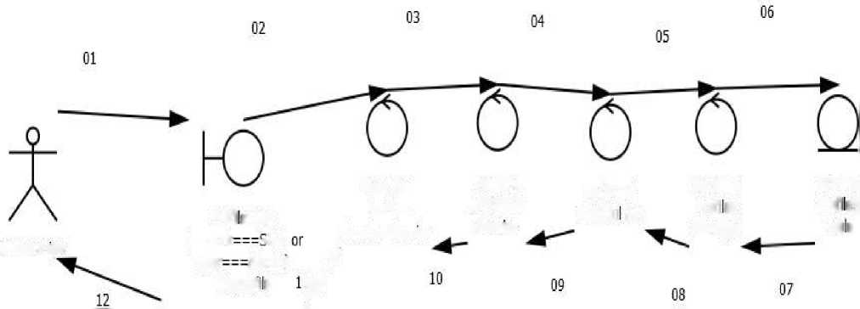03.01.03.01 Edit Profile

Front

End

FrontEnd

Back

End

BackEnd

B/E DB

Profi eView

Profiles

API/HTTP

RESTfu

API

Profies

Profies

Guttersnipe

(account

-ELF

Angular

Service

Semce

Manager

Tab e

user

Admin]

EditProfi e

**/**

FRONT END

1. User Interacts With GUI via Angular Components or Browser Address
2. GUI sends message to Angular Service
3. Angular Service sends message to Angular $httpAPI Service

CLIENT-SERVER

1. Front End $httpAPI service sends message to RESTful API Back End BACK END
2. API sends message to Object Manager
3. Manager sends request to Database
4. Database returns object data to Object Manager
5. Object Manager returns formatted objects to RESTful API

SERVER CLIENT

1. RESTful API returns json data to Angular API Service FRONT END
2. $httpAPI returns data to Angular Service
3. Angular Service changes Angular Component GUI

03.01.03.02 Edit Schedule

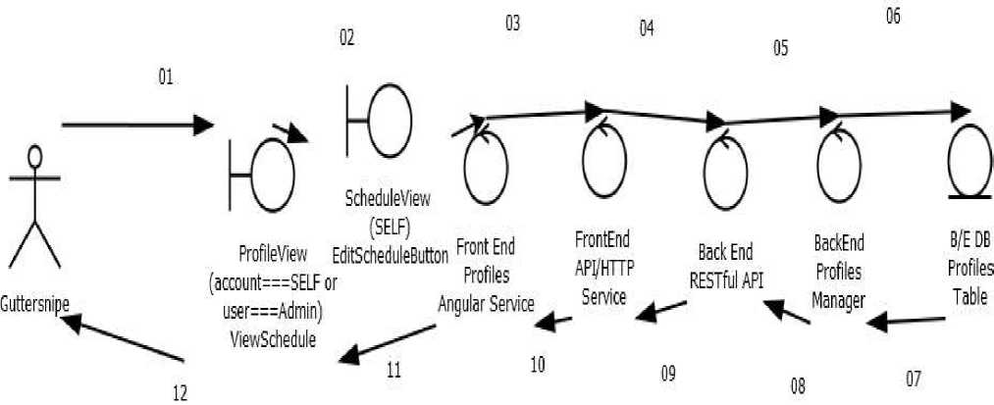

FRONT END

1. User Interacts With GUI via Angular Components or Browser Address
2. GUI sends message to Angular Service
3. Angular Service sends message to Angular $httpAPI Service

CLIENT-SERVER

1. Front End $httpAPI service sends message to RESTful API Back End BACK END
2. API sends message to Object Manager
3. Manager sends request to Database
4. Database returns object data to Object Manager
5. Object Manager returns formatted objects to RESTful API

SERVER CLIENT

1. RESTful API returns json data to Angular API Service FRONT END
2. $httpAPI returns data to Angular Service
3. Angular Service changes Angular Component GUI
4. Renew Account

FRONT END

1. User Interacts With GUI via Angular Components or Browser Address
2. GUI sends message to Angular Service
3. Angular Service sends message to Angular $httpAPI Service

CLIENT-SERVER

1. Front End $httpAPI service sends message to RESTful API Back End BACK END
2. API sends message to Object Manager
3. Manager sends request to Database
4. Database returns object data to Object Manager
5. Object Manager returns formatted objects to RESTful API

SERVER CLIENT

1. RESTful API returns json data to Angular API Service FRONT END
2. $httpAPI returns data to Angular Service
3. Angular Service changes Angular Component GUI
4. Change Password

FRONT END

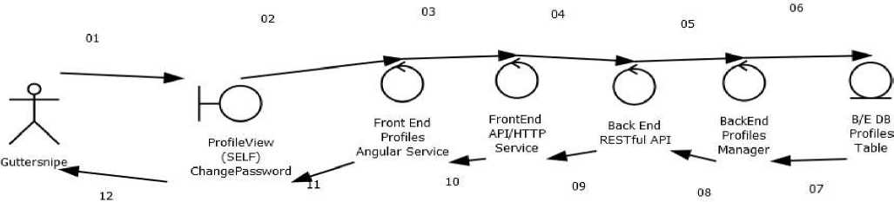

1. User Interacts With GUI via Angular Components or Browser Address
2. GUI sends message to Angular Service
3. Angular Service sends message to Angular $httpAPI Service

CLIENT-SERVER

1. Front End $httpAPI service sends message to RESTful API Back End BACK END
2. API sends message to Object Manager
3. Manager sends request to Database
4. Database returns object data to Object Manager
5. Object Manager returns formatted objects to RESTful API

SERVER CLIENT

1. RESTful API returns json data to Angular API Service

FRONT END

1. $httpAPI returns data to Angular Service
2. Angular Service changes Angular Component GUI

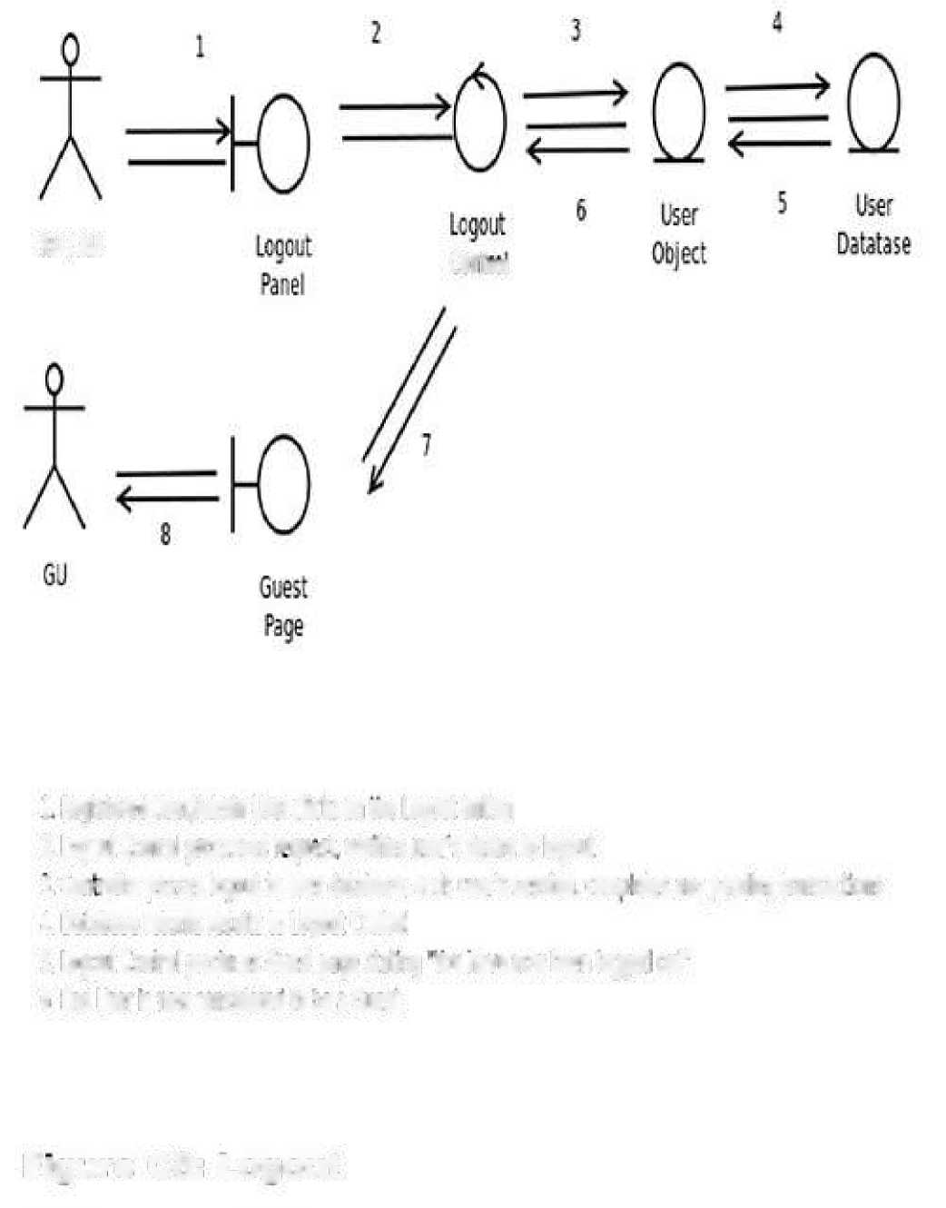W/AU

**1 Reglsterei Use rfAdmJn User dic£ on roe Logout button**

**tort™**

2. logout Control processes request- verifies users desire to logout 1 Con-roller passes logout to user database, ends users session, ccmo etesany pending transactions (. Database returns r^sLlti to Logout Control 5. Logout Control pm«s Guest page stating wave now been logged or 6 End Jier is now constoeifto ft be a Guest

Figure C3: Logout

1. Delete Account

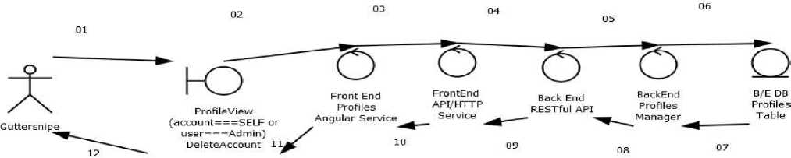

FRONT END

1. User Interacts With GUI via Angular Components or Browser Address
2. GUI sends message to Angular Service
3. Angular Service sends message to Angular $httpAPI Service

CLIENT-SERVER

1. Front End $httpAPI service sends message to RESTful API Back End BACK END
2. API sends message to Object Manager
3. Manager sends request to Database
4. Database returns object data to Object Manager
5. Object Manager returns formatted objects to RESTful API

SERVER CLIENT

1. RESTful API returns json data to Angular API Service FRONT END
2. $httpAPI returns data to Angular Service
3. Angular Service changes Angular Component GUI

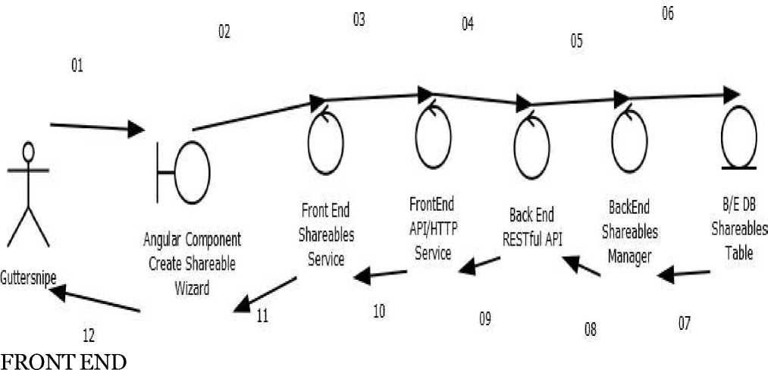

1. User Interacts With GUI via Angular Components or Browser Address
2. GUI sends message to Angular Service
3. Angular Service sends message to Angular $httpAPI Service

CLIENT-SERVER

1. Front End $httpAPI service sends message to RESTful API Back End BACK END
2. API sends message to Object Manager
3. Manager sends request to Database
4. Database returns object data to Object Manager
5. Object Manager returns formatted objects to RESTful API

SERVER CLIENT

1. RESTful API returns json data to Angular API Service FRONT END
2. $httpAPI returns data to Angular Service
3. Angular Service changes Angular Component GUI

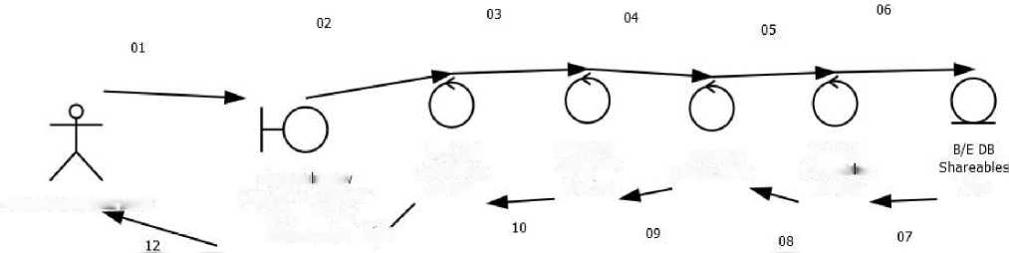FRONT END

Bhareab eViev

MahabharataGuttersnipe

(creator===SELF or user===Admin) EditShareable 1

Front End  
Shareables  
Service

FrontEnd

API/HTTP

Back End

BackEnd

Service

RESTful API

Shareab es

Manager

Table

1. User Interacts With GUI via Angular Components or Browser Address
2. GUI sends message to Angular Service
3. Angular Service sends message to Angular $httpAPI Service

CLIENT-SERVER

1. Front End $httpAPI service sends message to RESTful API Back End BACK END
2. API sends message to Object Manager
3. Manager sends request to Database
4. Database returns object data to Object Manager
5. Object Manager returns formatted objects to RESTful API

SERVER CLIENT

1. RESTful API returns json data to Angular API Service FRONT END
2. $httpAPI returns data to Angular Service
3. Angular Service changes Angular Component GUI

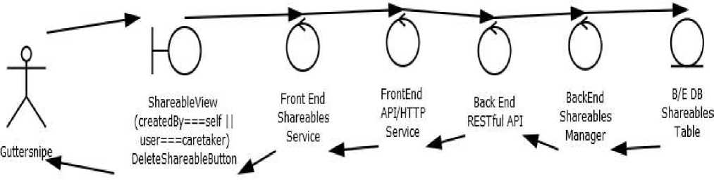

FRONT END

1. User Interacts With GUI via Angular Components or Browser Address
2. GUI sends message to Angular Service
3. Angular Service sends message to Angular $httpAPI Service

CLIENT-SERVER

1. Front End $httpAPI service sends message to RESTful API Back End BACK END
2. API sends message to Object Manager
3. Manager sends request to Database
4. Database returns object data to Object Manager
5. Object Manager returns formatted objects to RESTful API

SERVER CLIENT

1. RESTful API returns json data to Angular API Service FRONT END
2. $httpAPI returns data to Angular Service
3. Angular Service changes Angular Component GUI

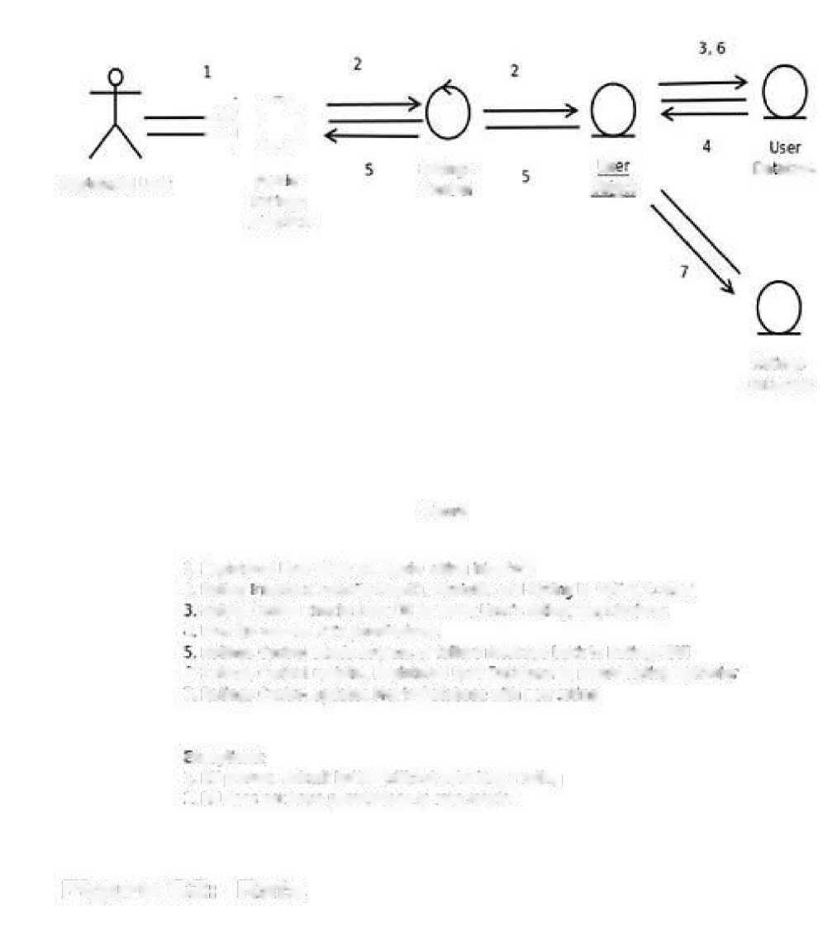

Reg.stored use;

Mov e

Ratings

Us

**□a atase**

Ratings

Centre1

Obigct

Snrerface

Ratings

Database

**Fig'.i it**

**1. Registered User cllcfcs on movie rating interlace** 2**. RaUrg rtejtsce Submits USeriD, MouelD, and Rabin to Rating Control**

**Rating Control chec'cs User EB to check users ratings permissions**

**t Lfser DS returns Ftds pt rrrd«ions**

**R^llr^s Cuntrcl seres success or rail ere rcessage oac< to Ratings GUI**

**o Ratings Control epoates Reg:stereti user Database to record Rating eenav:<;’** 7. Ratings Cfl-nfcI tpdates f-'evie database vntl new ’ating **1. RU presses sutmi: button without serening 3 rating** 2**. RU does rwr have permissions to rate itkjvI?**

Figure C2: Rate

Cutmwnt * 5 Guaranis

Hana$sr Database

1. 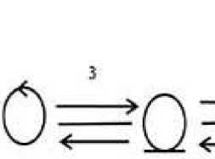**RU visits t*e coiwrant rierfaceo! a movie ps§e**

**A"**

Peg s!eped User

**COrrmant**

**ln:-arT=ce**

**?. RU submits comment to be nrecest ed by the corrmeii: manager**

**3 Toe Comreft Kaxgar atcesses Rsgl=terser otje-ct toj;w^-sthe qinwnwl ^;th a I'mesUirp**

1. The data is inserted to Comments database
2. **The corrm&n: infc rmal cr. is sent ts:fc tc- the Rag;=teoed Jser object**
3. **The tofTflieot information is passed ba-rk !□ cerrcvent nran**53**er**
4. **Tfe CcmP5ehT MaiigE' updates rn C&mmen interface frUli <i6w ccmsentfs)**

EK:ecti;jil.

1. **tianict^iTje-ivtis submitted**

7. The corrmeot ma nger dl sp'ays an error massage to the OLD EJtcestLoit i\

2. **A cotrinsfli that exceeds toe {tweeter lira t is S'jbra fled**

7. The conrirje,T manager displays an e-rrc-r message to toe GvJi

Figure C3: Comment

|  |  |  |  |  |  |
| --- | --- | --- | --- | --- | --- |
| _c | ) | l | 2 | 3  v A T | 4  \ » r\ |
|  |  |  | r\ | -> i . » | ( ) |
|  |  |  | —{ > | V J ^ V | J * ^ |
| /\ | |  | \j*—  „ . 7 | Ccmmerts 6 Admin 5 Comments | |
| Admin User | |  | Flagged  Comments  GUI | Control Object Datatase | |



**1 Admin User selects comments for deletion from Flagged Comments Panel**

1. ou sends deletion request fe Comments Control
2. **Comments to be oeletea are sent to Database**
3. **Comments are sent to comments database**
4. **Database returns remaining Flagged Comments from Database**
5. **The remaining flagged comments ate sent to comments control 7 The remaining Flagged Comments are displayed on &e GUI**

D1; Erase Comment

3. 2. 6. COMMUNICATIONS

03.01.06.01 Open Mailbox

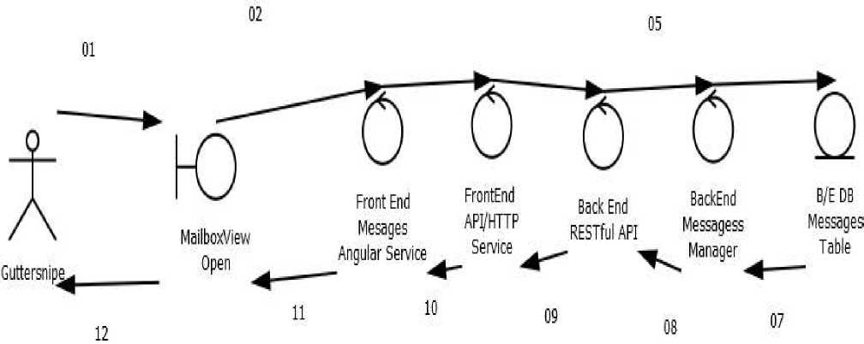

FRONT END

1. User Interacts With GUI via Angular Components or Browser Address
2. GUI sends message to Angular Service
3. Angular Service sends message to Angular $httpAPI Service

CLIENT-SERVER

1. Front End $httpAPI service sends message to RESTful API Back End BACK END
2. API sends message to Object Manager
3. Manager sends request to Database
4. Database returns object data to Object Manager
5. Object Manager returns formatted objects to RESTful API

SERVER CLIENT

1. RESTful API returns json data to Angular API Service FRONT END
2. $httpAPI returns data to Angular Service
3. Angular Service changes Angular Component GUI

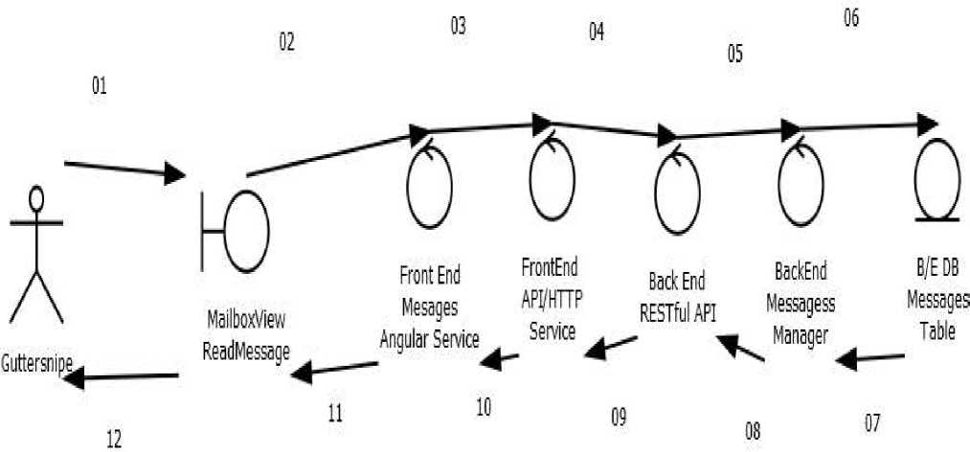

FRONT END

1. User Interacts With GUI via Angular Components or Browser Address
2. GUI sends message to Angular Service
3. Angular Service sends message to Angular $httpAPI Service

CLIENT-SERVER

1. Front End $httpAPI service sends message to RESTful API Back End BACK END
2. API sends message to Object Manager
3. Manager sends request to Database
4. Database returns object data to Object Manager
5. Object Manager returns formatted objects to RESTful API

SERVER CLIENT

1. RESTful API returns json data to Angular API Service FRONT END
2. $httpAPI returns data to Angular Service
3. Angular Service changes Angular Component GUI

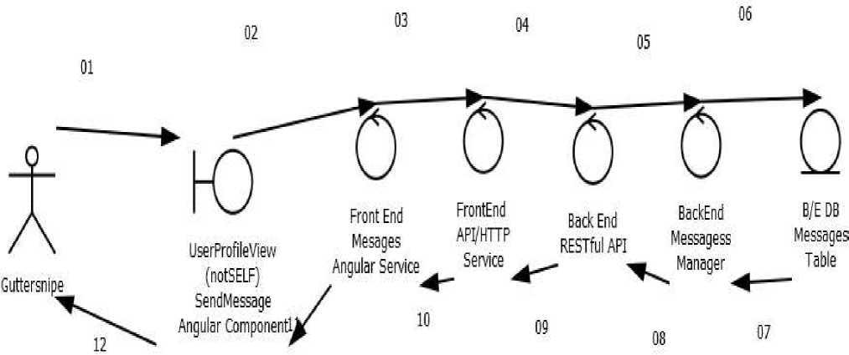

FRONT END

1. User Interacts With GUI via Angular Components or Browser Address
2. GUI sends message to Angular Service
3. Angular Service sends message to Angular $httpAPI Service

CLIENT-SERVER

1. Front End $httpAPI service sends message to RESTful API Back End BACK END
2. API sends message to Object Manager
3. Manager sends request to Database
4. Database returns object data to Object Manager
5. Object Manager returns formatted objects to RESTful API

SERVER CLIENT

1. RESTful API returns json data to Angular API Service FRONT END
2. $httpAPI returns data to Angular Service
3. Angular Service changes Angular Component GUI

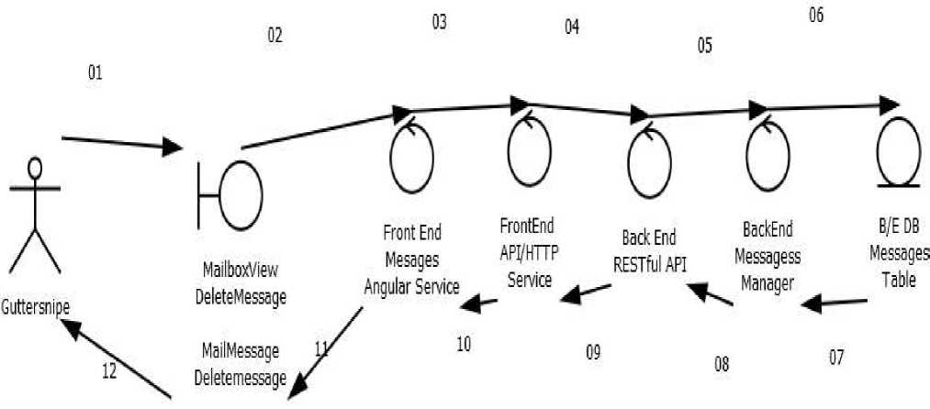

FRONT END

1. User Interacts With GUI via Angular Components or Browser Address
2. GUI sends message to Angular Service
3. Angular Service sends message to Angular $httpAPI Service

CLIENT-SERVER

1. Front End $httpAPI service sends message to RESTful API Back End BACK END
2. API sends message to Object Manager
3. Manager sends request to Database
4. Database returns object data to Object Manager
5. Object Manager returns formatted objects to RESTful API

SERVER CLIENT

1. RESTful API returns json data to Angular API Service FRONT END
2. $httpAPI returns data to Angular Service
3. Angular Service changes Angular Component GUI

03.01.06.05 Block User

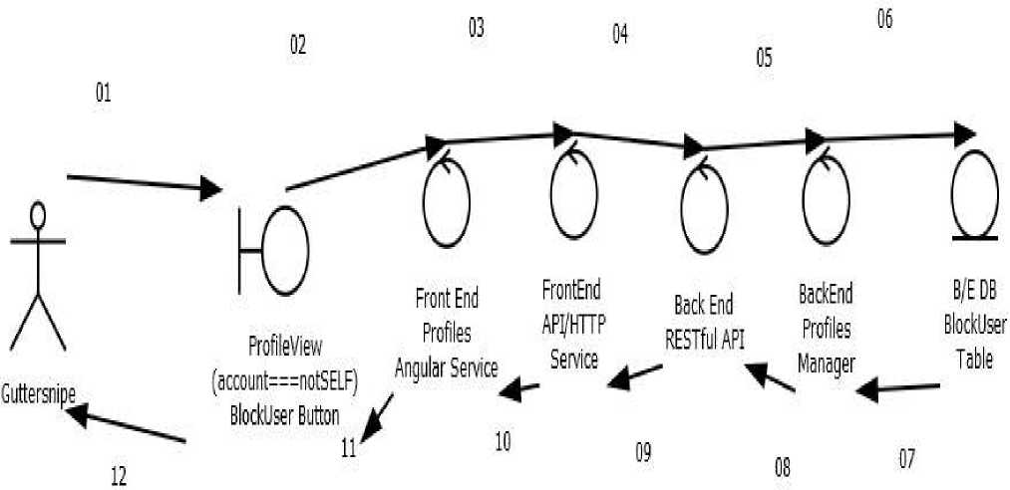

FRONT END

1. User Interacts With GUI via Angular Components or Browser Address
2. GUI sends message to Angular Service
3. Angular Service sends message to Angular $httpAPI Service

CLIENT-SERVER

1. Front End $httpAPI service sends message to RESTful API Back End BACK END
2. API sends message to Object Manager
3. Manager sends request to Database
4. Database returns object data to Object Manager
5. Object Manager returns formatted objects to RESTful API

SERVER CLIENT

1. RESTful API returns json data to Angular API Service FRONT END
2. $httpAPI returns data to Angular Service
3. Angular Service changes Angular Component GUI

118

• “Over a billion human beings live in absolute poverty, suffering from chronic malnutrition and other ills, while we have much more than an adequate material basis for a good life for all.” - John Clark,The Impossible Community Realizing Communitarian Anarchism

From 2013 Presentation: Section 6:

AUDIENCE

People who can not afford to or who choose not to participate in the capitalist marketplace

The Victimese Maj ority

Poor

Dislocated

Immigrants

Street people

Homeless

Traveler punks

Contingent/Precarious workers

Lumpenproletariat

1. Methods:

   ++EditShareable() : A Caretaker may edit any shareable.

   ++DeleteAccount(): A Caretaker may delete any Guttersnipe account ++DeleteShareable () : A Caretaker may delete any shareable ++DeleteComment () : A Caretaker may delete any comment ++BlockUser () : When a Caretaker blocks a Guttersnipe, it may also delete that Gutttersnipe’s account.
2. Consulting Organizations

   * Freegan NYC:

   o Freegans are people who employ alternative strategies for living based on limited participation in the conventional economy and minimal consumption of resources.

   o Dumpster Dive Directory
3. Picture the Homeless

   o A grassroots organization founded and led by homeless people. o Extensive list of vacant properties