

Software Requirement Specifications (1.0)

Revision History

Date | Version | Description | Author
10/17/2012 | 0.1 | Draft | Mitchell Verter
10/18/2012 | 0.3 | Draft | Mitchell Verter
10/19/2012 | 1.0 | 1.0 Release | Mitchell Verter

First Row Movies Founders

Name | Role
Mitchell Verter | Project Manager, coder
Jorge Yau | Chief Technology Officer, coder
Shamrat Basnet | Front-end Programmer, coder
Lovepreet Singh | Back-end Programmer, coder

Table of Contents

- Introduction 4
  - Purpose 4
  - Scope 4
  - Acronyms and Abbreviations 5
  - References 5
  - Summary 5
- Overview 6
  - Use-Case 6
    - Diagrams 6
    - Descriptions 7
  - Assumptions and Dependencies 8
- Specific Requirements 9
  - Collaboration Diagrams 9
    - User 9
    - Guest 14
    - Registered User 17
    - Customer 20
    - Admin 24
  - ECS System State Diagram 28
  - ER Class Diagram 29
  - Supplementary Software Requirements 30
- Supporting Information 31
  - Appendix A: User-Interface Prototypes 32

Software Requirements Specification
- Introduction
  - Purpose
First Row Movies (FRW) promises to be the premiere community for purchasing and sharing movies over the web.
This Document will detail the features of First Row Movies, and will serve as a guide to developers and as a legal document for prospective clients.
  - Scope.
    - User: This is the base class for all users of the system. All users of the System can search through all the movies, browse each movie, read comments and complain about inappropriate comments,
    - Guest User: The Guest User class inherits all the functionality of User. In addition, the Guest User has the capacity to register to become a user, to login as a user, and to retrieve a lost username.
    - Registered User: Registered User is an abstract base class that inherits all the functionality of User. In addition, the Registered user can watch a movie, reset a password, and logout from the system.
    - Customer User: Customer User inherits all the functionality of Registered User. In addition, the Customer User can rate movies, comment on movies, view a shopping cart, and checkout movies.
    - Admin User: Admin User inherits all the functionality of Registered User. In addition, the Admin User can erase comments, warn users, suspend users, and delete users.
    - Movie: Each movie is categorized according to its genre, director, actors, and date.
    - By keeping track of each user's history of movie purchases and by comparing the user's interests with other users with similar interests, First Row Movies will be able to recommend new purchases to customers.

  - Acronyms and Abbreviations
    - FRM: First Row Movies
    - U: User
    - GU: Guest User
    - RU: Registered User
    - CU: Customer User
    - AU: Admin User
    - SRS: Software Requirements Specification
    - GUI: Graphical User Interface.
    - FSM: Finite State Machine.
    - DB: Database.
    - ERCD: Entity-Relation Class Diagram.
  - References
Appendix A: User Interface Prototypes
  - Summary
The rest of this SRS is organized as follows:
    - Section 2: Gives the overall description of FRW. It contains the Use-Case diagram and descriptions for FRW. Section 2 also contains the assumptions and dependencies of the system.
    - Section 3: Gives specific software requirements and functionalities in the form of Mini Use-Case diagrams along with accompanying Collaboration diagrams, Finite State Machine of the system, and ER Class diagram of the system. This section also contains supplementary software requirements of the systems.
    - Appendix: The appendix contains user interface prototypes for the system.

2. Overview

2.1.1. Use Case Diagram

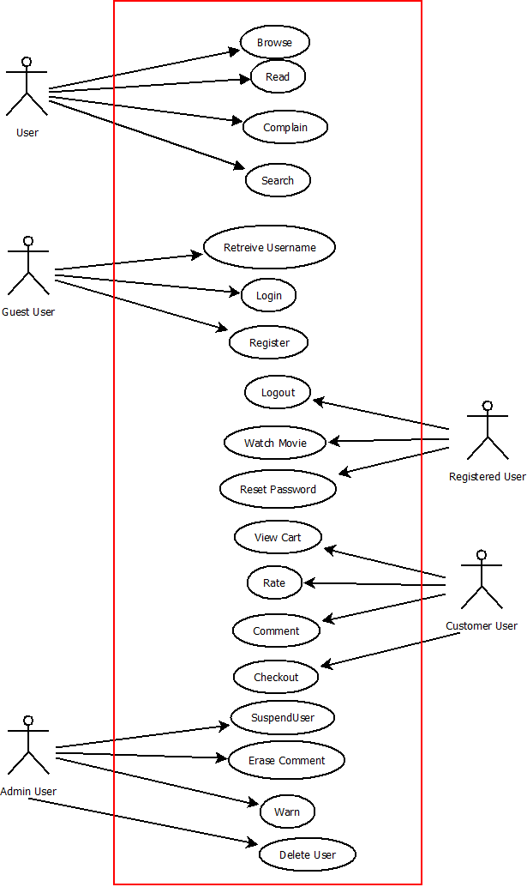

Figure 2.1.1: Use Case Diagram

2.1.2 Use Case Descriptions

- User (U)
  - Read Abstract: Any U may read the abstract (summary, id, title, stars, director, year, etc) of a movie.
  - Read Comments: Any U may read the comments made about a movie.
  - Complain: Any U may complain about a comment deemed to be inappropriate. Flagged comments will sent to AU for review.
  - Browse: Any U may browse a search result.
  - Search: Any U may search for movies using any combination of search vectors (id, title, starts, director, year, etc.)
- Guest User (GU)
  - Login: Any GU can login to the system, which transforms GU into a CU or AU .
  - Register: Any GU may register to become a CU.
  - Retrieve Username: Any CU who has forgotten her/his user name may request (as GU) that user information will be emailed to her/him.
- Registered User (RU)
  - Logout: Any RU (CU or AU) may log out of her or his account.
  - Watch Movie: Any RU (CU or AU) may watch movies online.
  - Reset Password: Any RU (CU or AU) may reset her or his password from the Account Settings page.
- Customer User (CU)
  - Rate: Any CU may give a rating to a movie (0.0 to 5.0, 0.5 increment.) Ratings will be evaluated according to user's history with Item and added to ratings DB.
  - Comment: Any CU may comment upon a movie.
  - Checkout: Any CU may checkout selected items for purchase.
  - View Cart: Any CU may review the items selected for purchase and deselect any of them.
- Admin User (AU)
  - Suspend User: Any AU may suspend any CU.
  - Erase Comment: Any AU may erase comment flagged for deletion.
  - Warn: Any AU may send warnings to customer.
  - Delete User: Any AU may delete customer from system.

2.2 Assumptions and Dependencies
a. The client can run on any contemporary web browser that supports standard HTML, CSS 2.0, JavaScript, and PHP 5.0. It should run well on any contemporary web browser, including the latest versions of Internet Explorer, Firefox, Chrome, Safari, and Opera..
b. The server must run a PHP 5.0 processing daemon and a MySQL database. Any LAMP/WAMP setup should suffice, as will any other server (IIS, etc) with PHP and mySQL modules installed.

3. Specific Requirements

3.1 Collaboration Diagrams

3.1.1 User Collaboration Diagrams

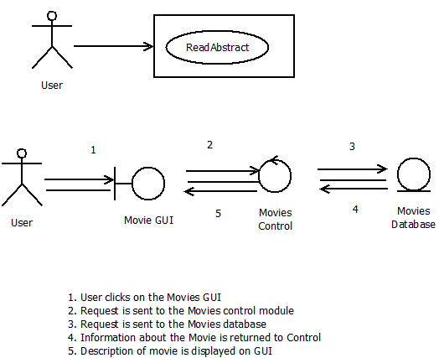

Figure A1 : Read Abstract

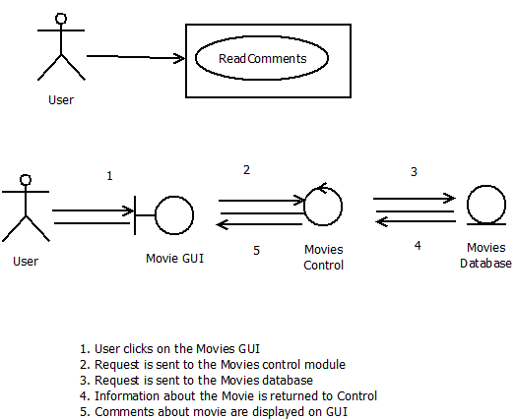

Figure A2: Read Comments

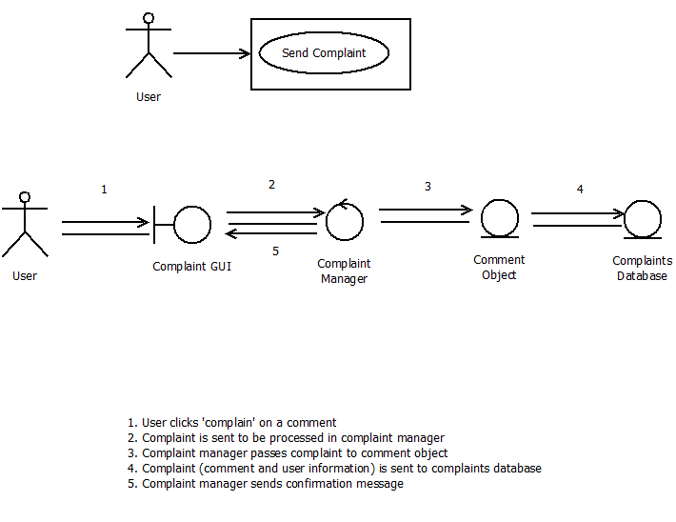

Figure A3 : Complain

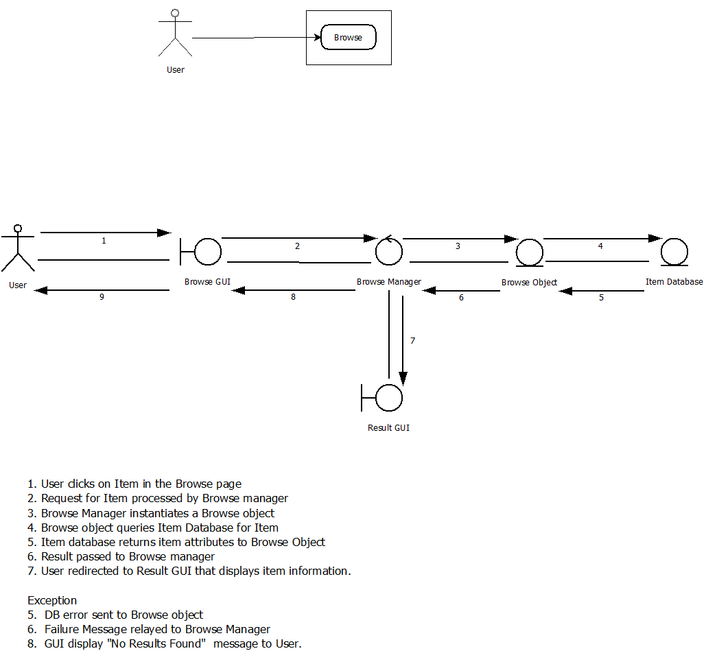

Figure A4: Browse

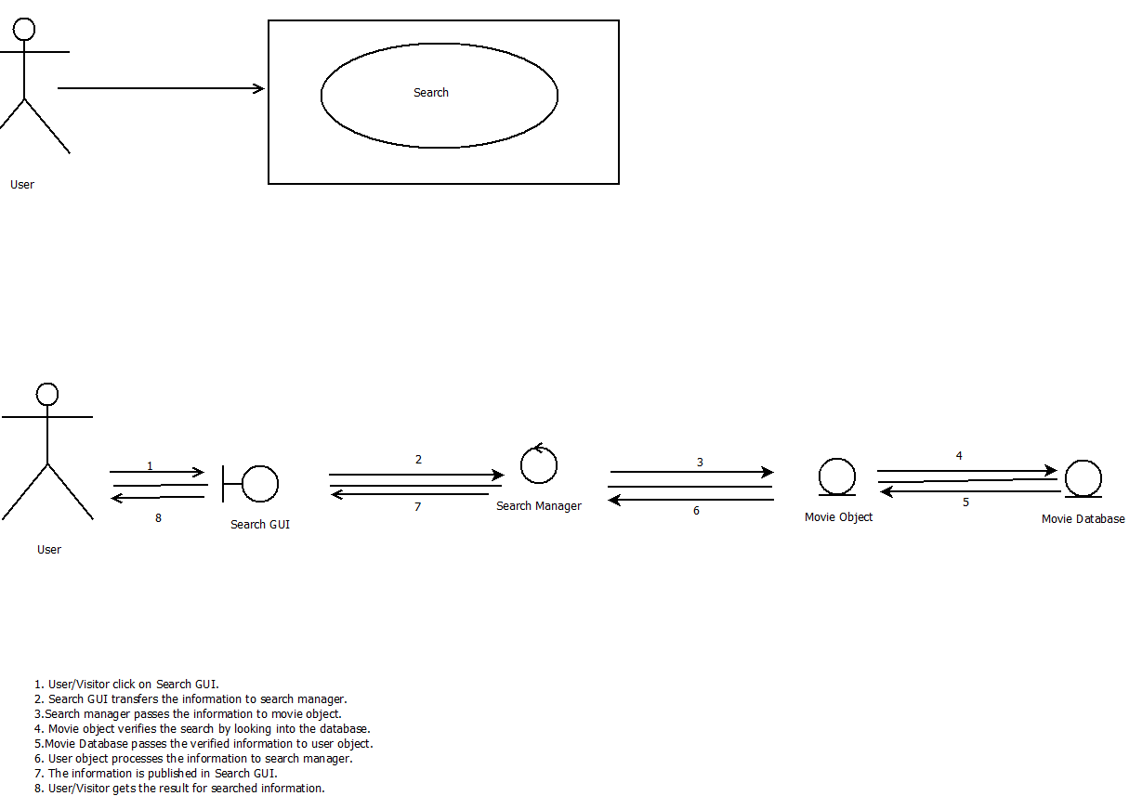

Figure A5: Search

3.1.2 Guest Collaboration Diagrams

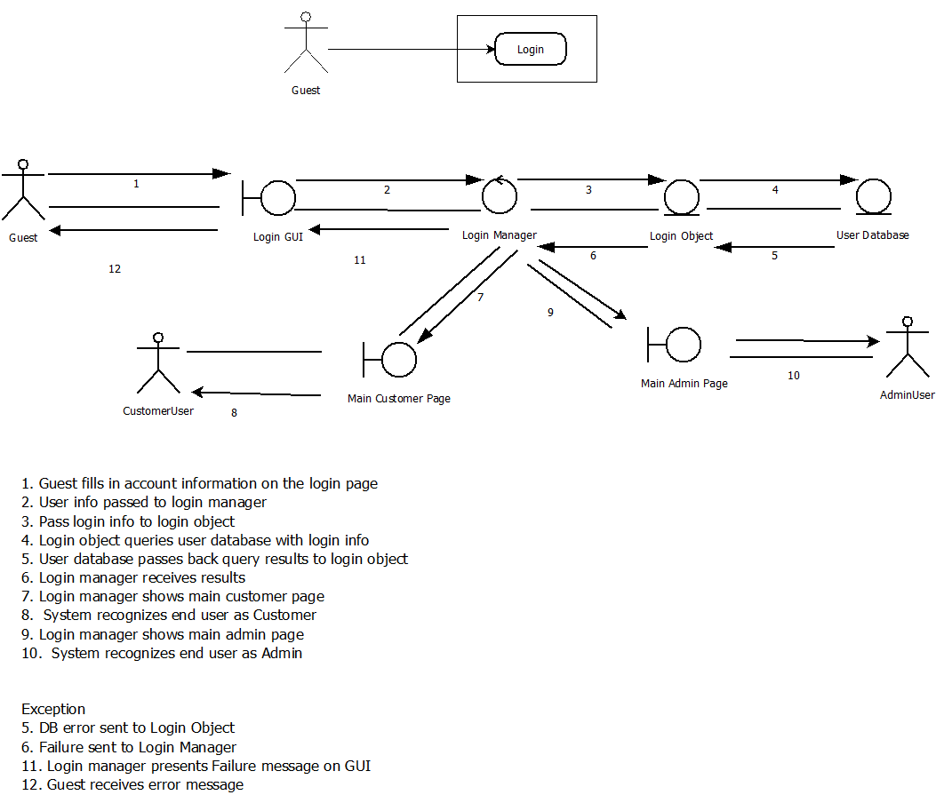

Figure B1: Login

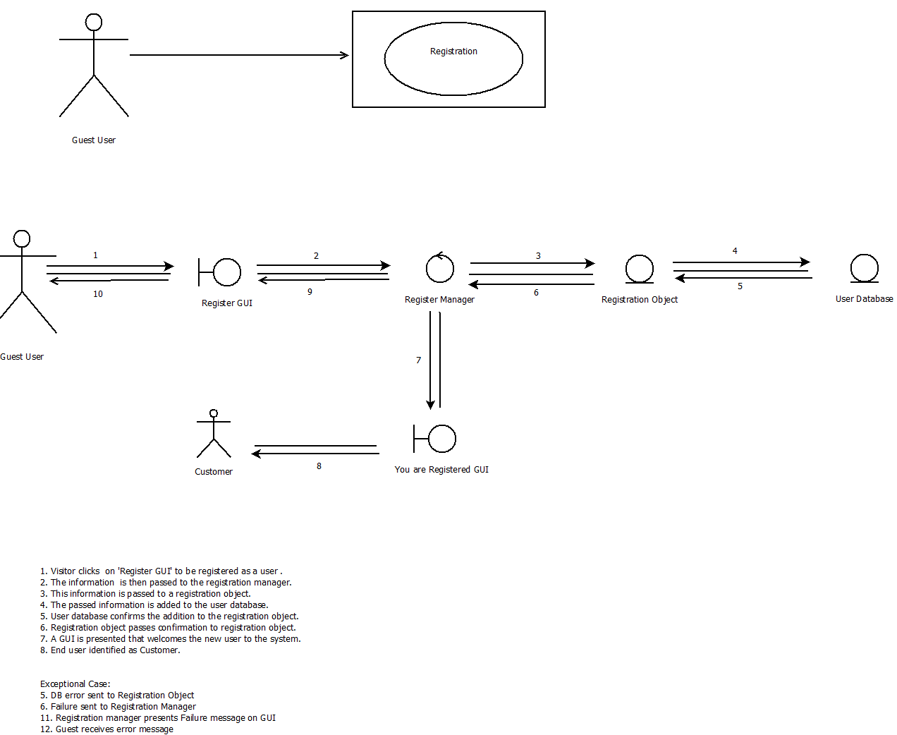

Figure B2: Register

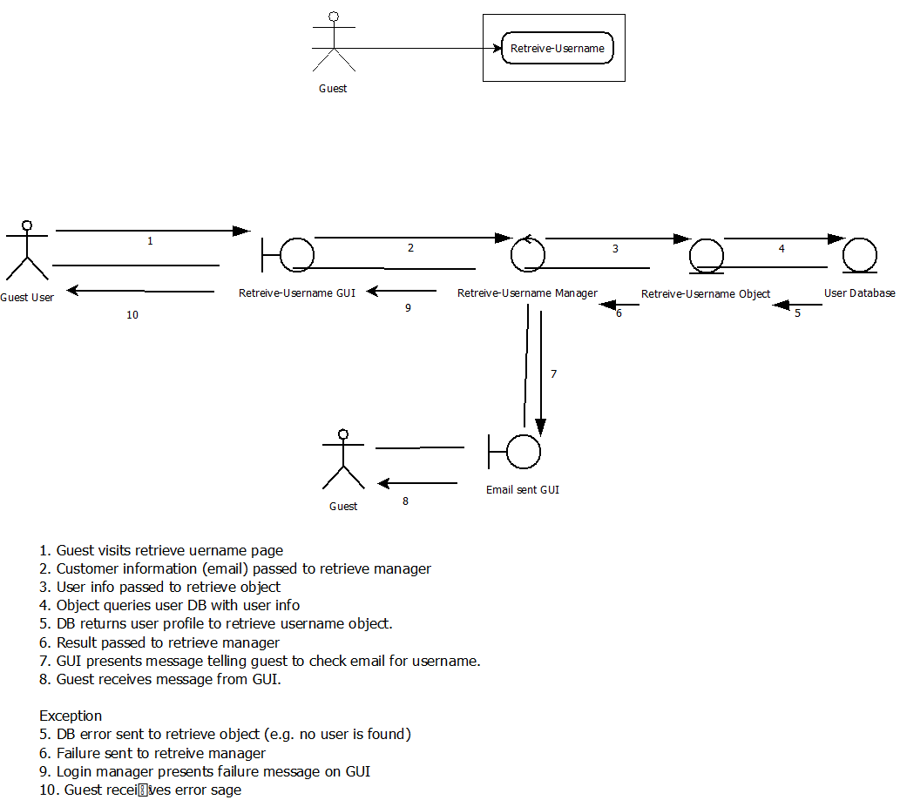

Figure B3: Retrieve Username

3.1.3 Registered User Collaboration Diagrams

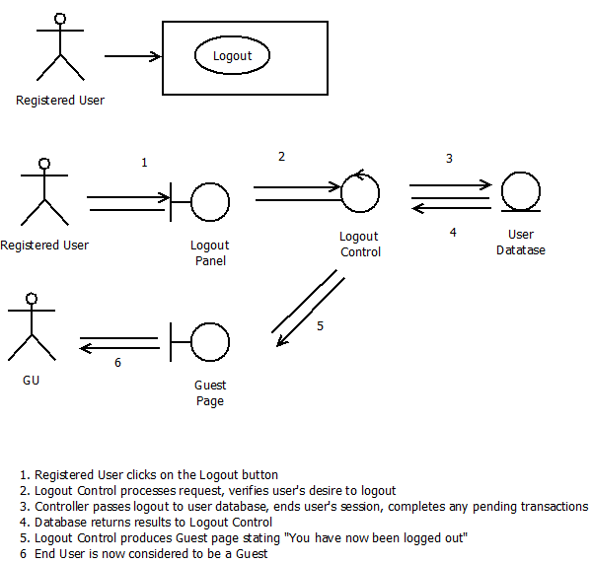

Figure C1: Logout

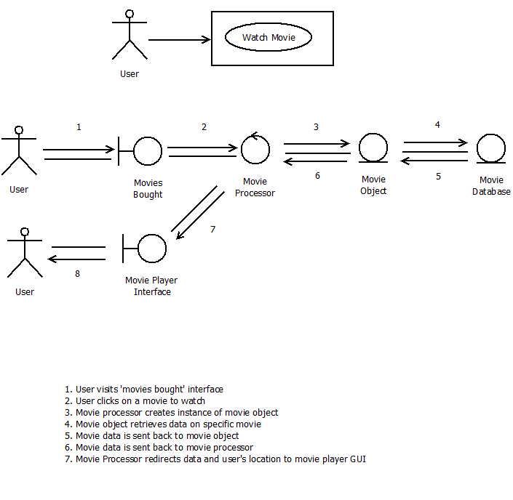

Figure C2: Watch Movie

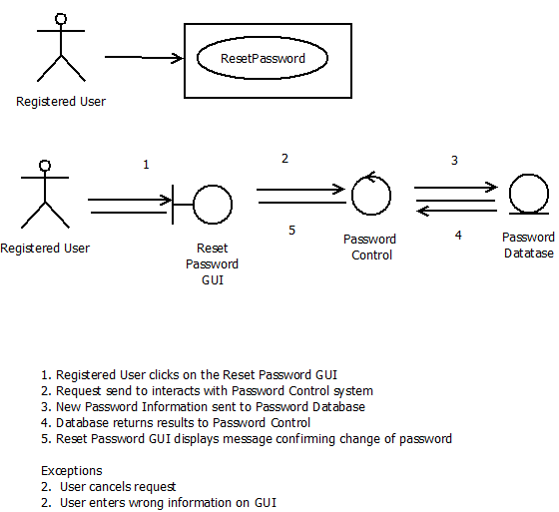

Figure C3: Reset Password

3.1.4 Customer Collaboration Diagrams

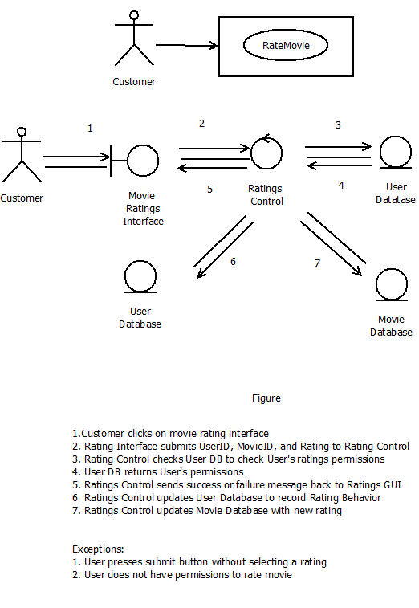
Figure D1: Rate

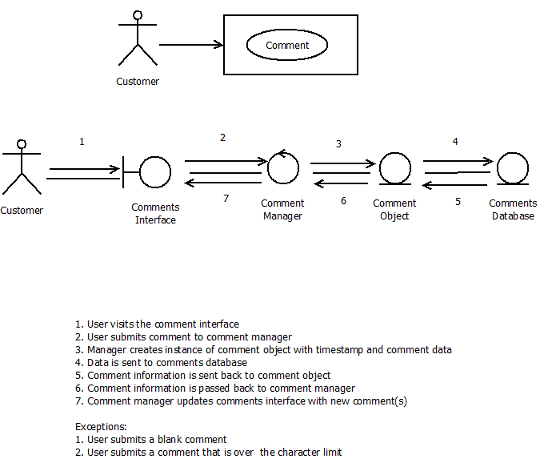

Figure D2: Comment

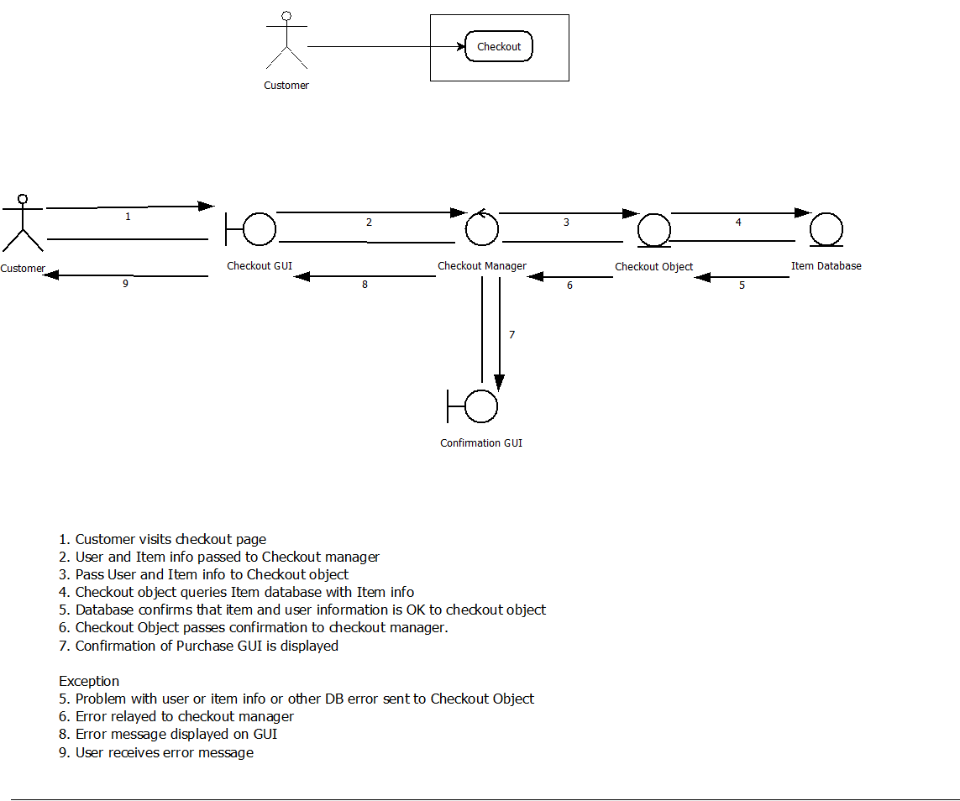

Figure D3: Checkout

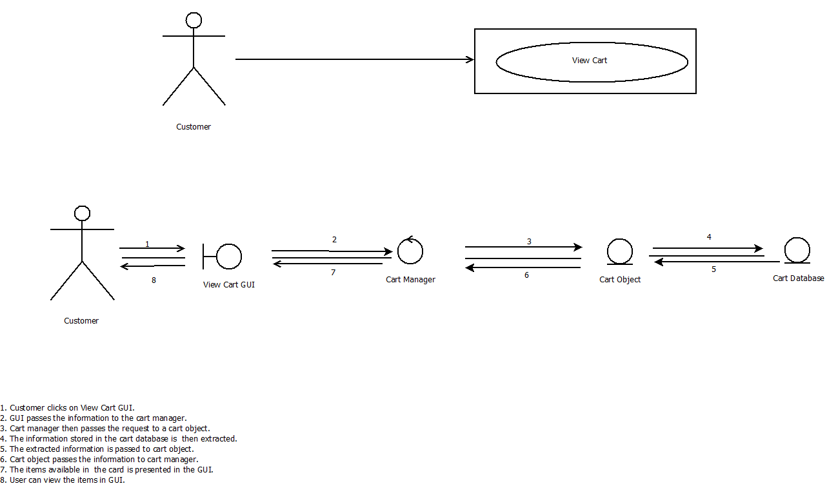

Figure D4: View Cart

3.1.5 Admin Collaboration Diagrams

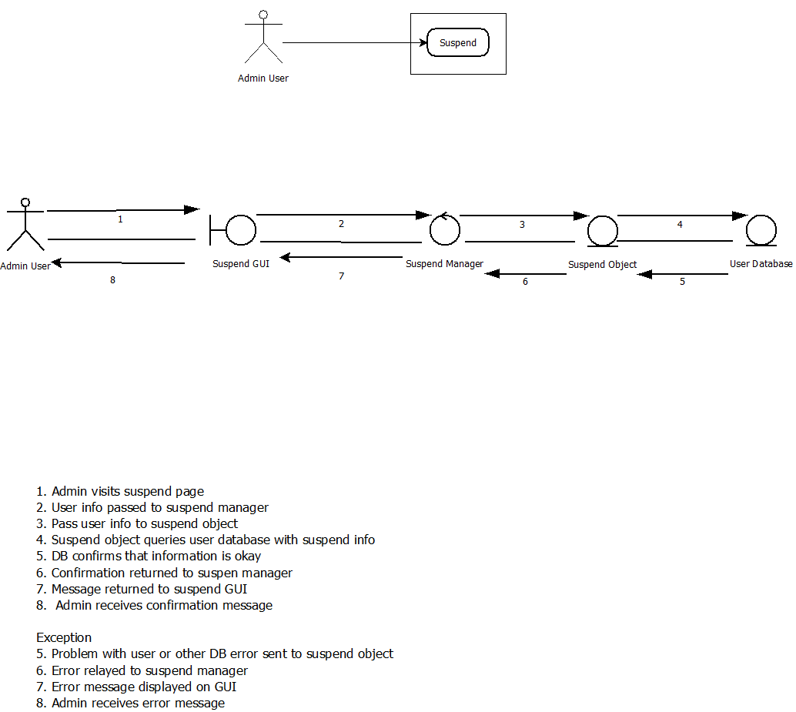

Figure E1: Suspend User

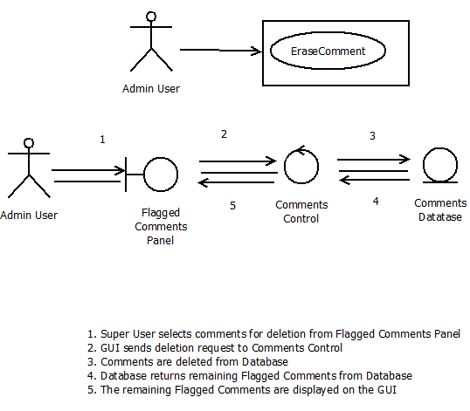

Figure E2: Erase Comment

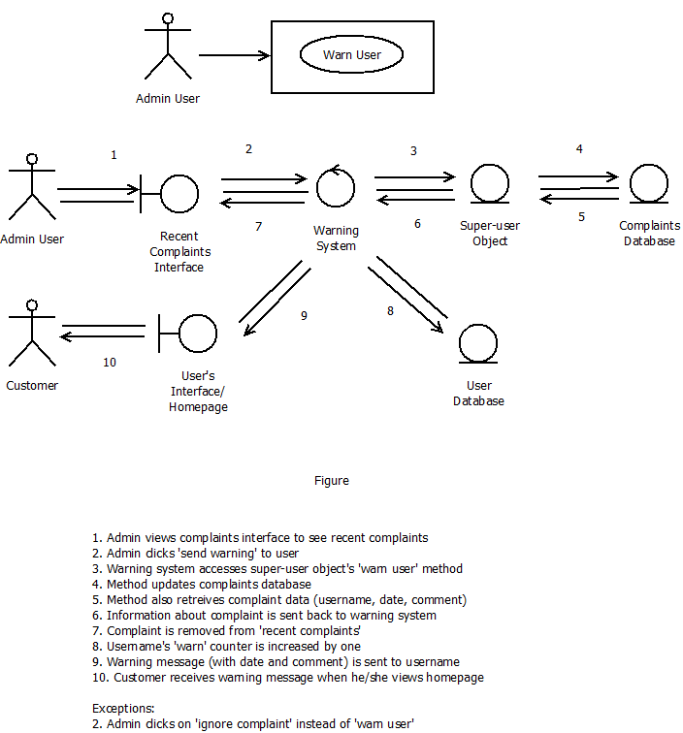

Figure E3: Warn User

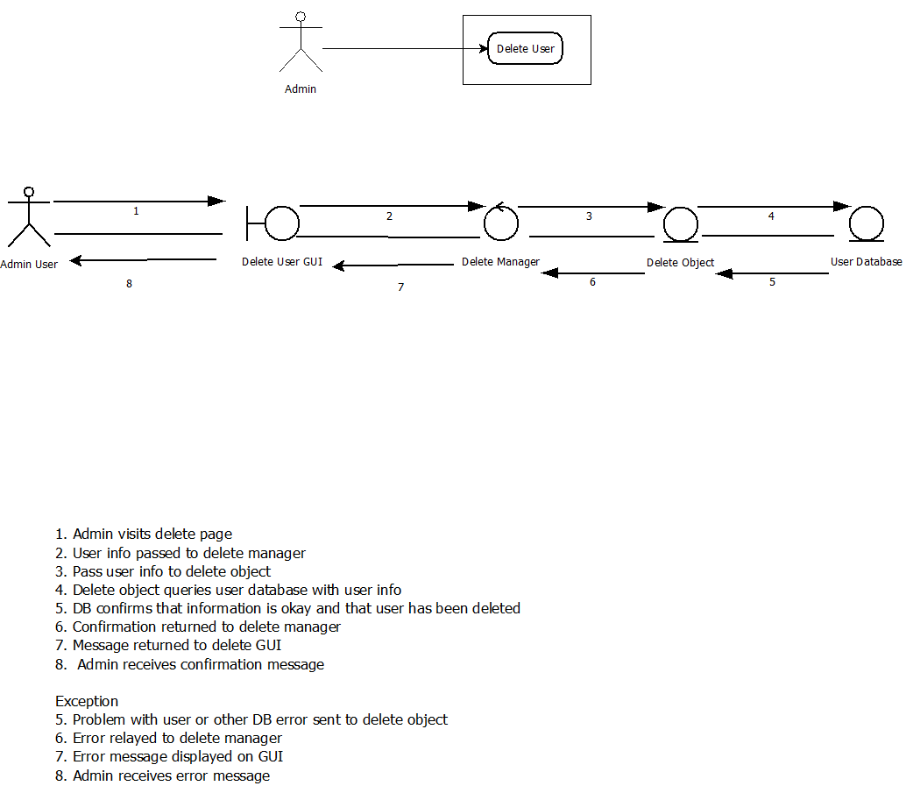

Figure E4: Delete User

3.2 System State Diagram

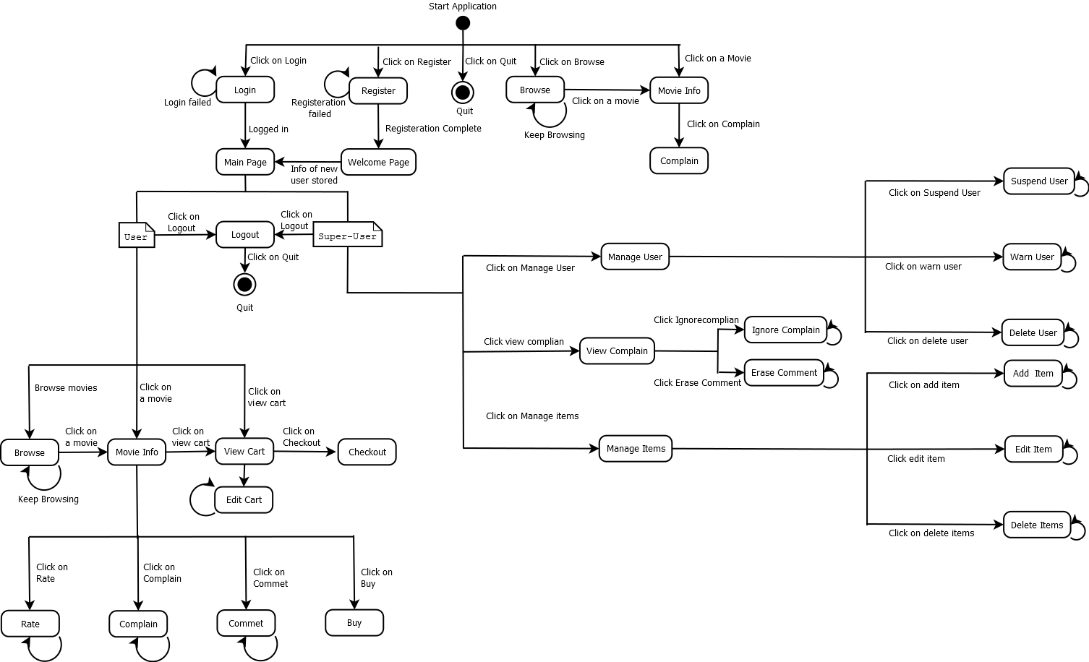

3.3 ER Class Diagram

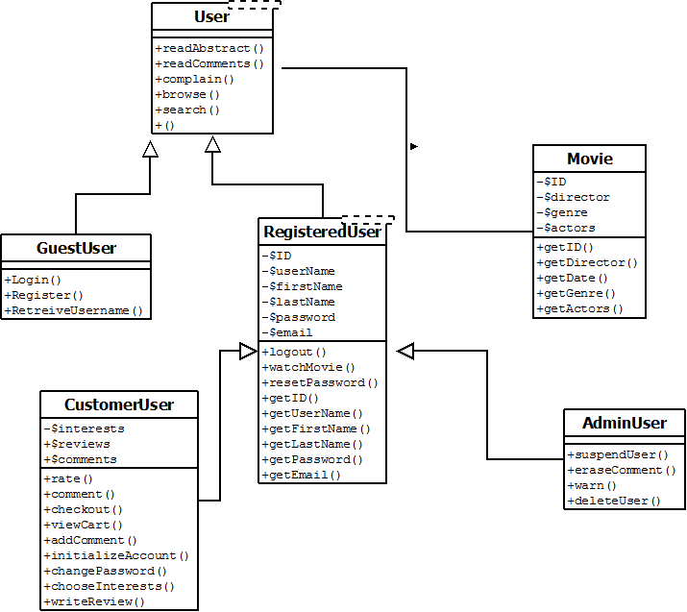

3.4 Supplementary Software Requirements

In order to run this web application properly, these software requirements must be met.

The client must have a web browser that supports the standard HTML, CSS 2.0, and JavaScript. It should run well on any contemporary web browser, including the latest versions of Internet Explorer, Firefox, Chrome, Safari, and Opera.

The server must run a PHP 5.0 processing daemon and a MySQL database. Any LAMP/WAMP setup should suffice, as will any other server (IIS, etc) with PHP and mySQL modules installed.

4. Supporting Information

4.1 Appendix A: User Interface Prototypes

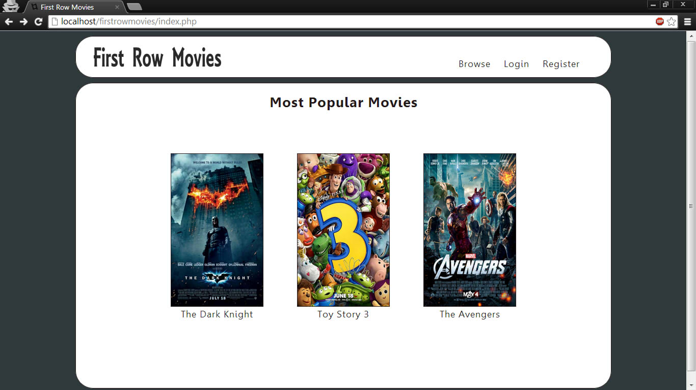

Figure 4.1.1: Homepage -- This is the default page that Guest Users see
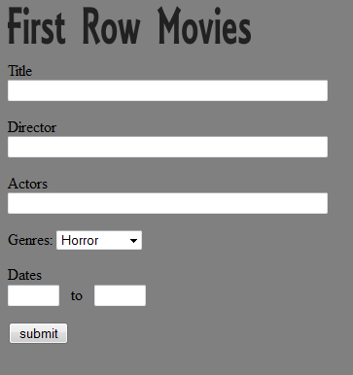

Figure 4.1.2: Search --
This is the interface all users interact with to search for movies

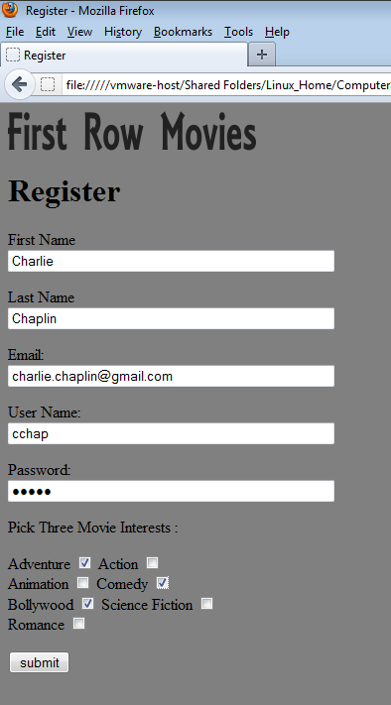

Figure 4.1.2: Register --
Guest Users can become new Customers through the register page

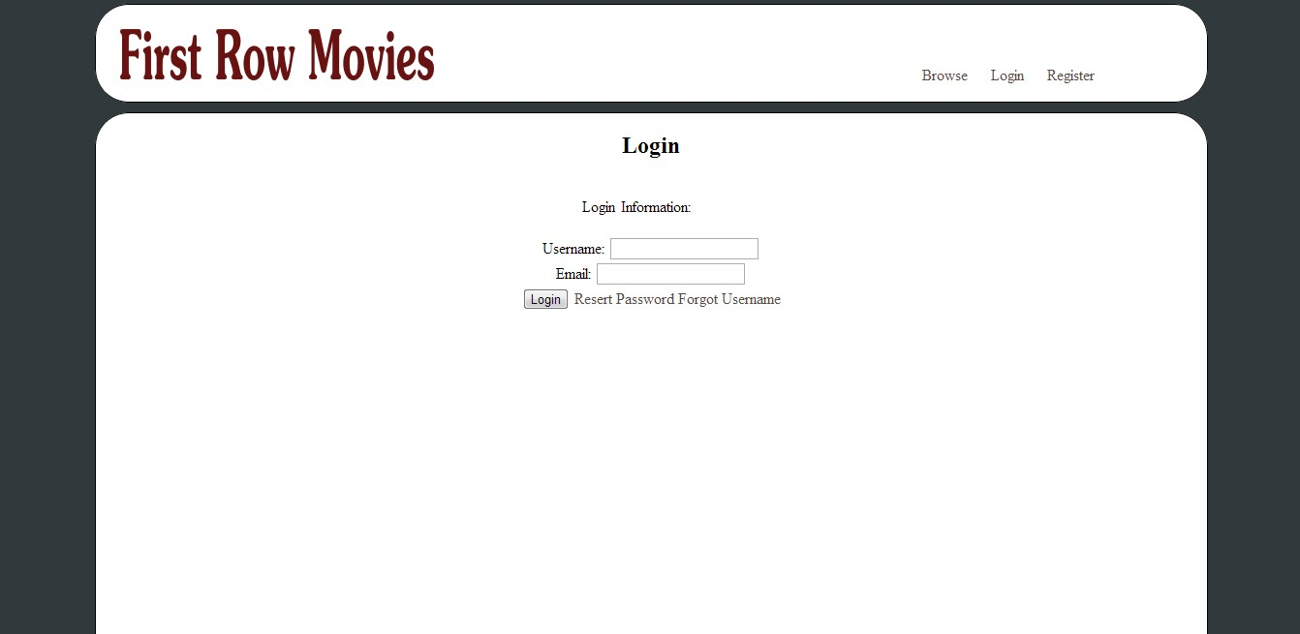

Figure 4.1.3: Login --
Guest Users can identify themselves as
Customers or Admins through the login page

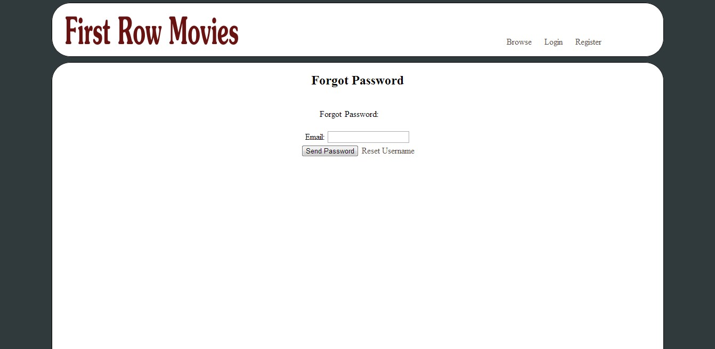

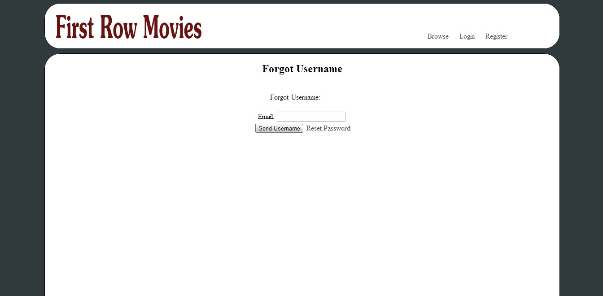

Figure 4.1.4: Retrieve Usernname / Password
Guest Users can request that their user information
be emailed to them if they have forgotten it.

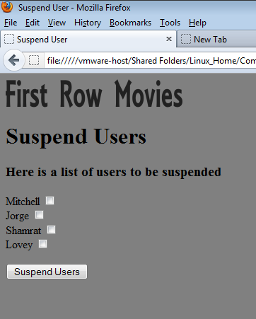

Figure 4.1.5: Suspend User
In this page, the Admin can review the users who may be suspended and can choose to suspend them

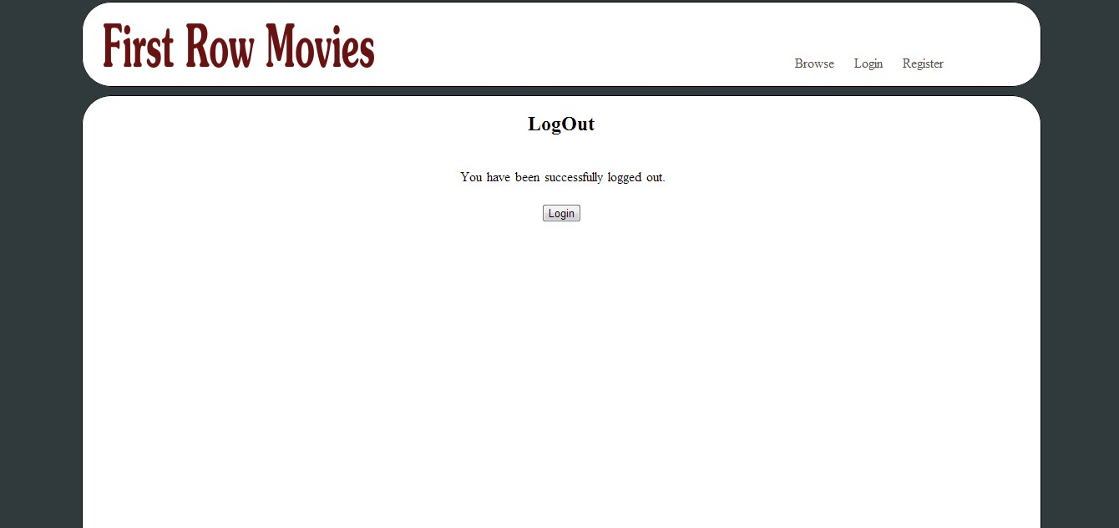

Figure 4.1.6: Logout
This is the GUI a Registered User sees after logging out.
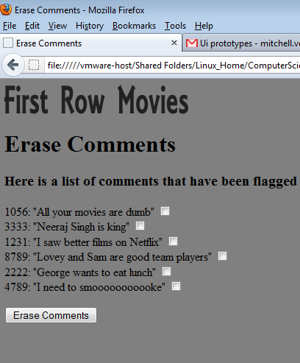

Figure 4.1.7: Erase Comments
In this page, the Admin can review the comments that have been flagged for deletion .
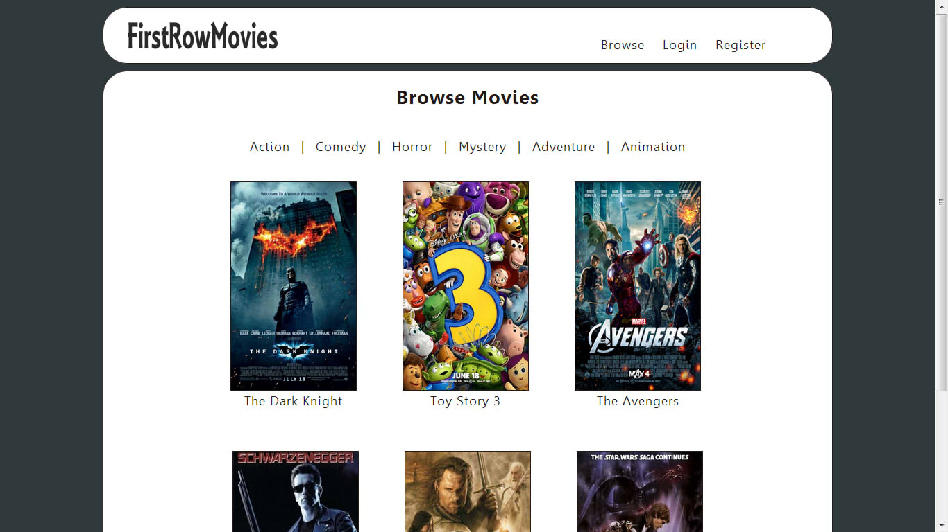

Figure 4.1.7: Browse Movies
In this page, a User can choose between search results

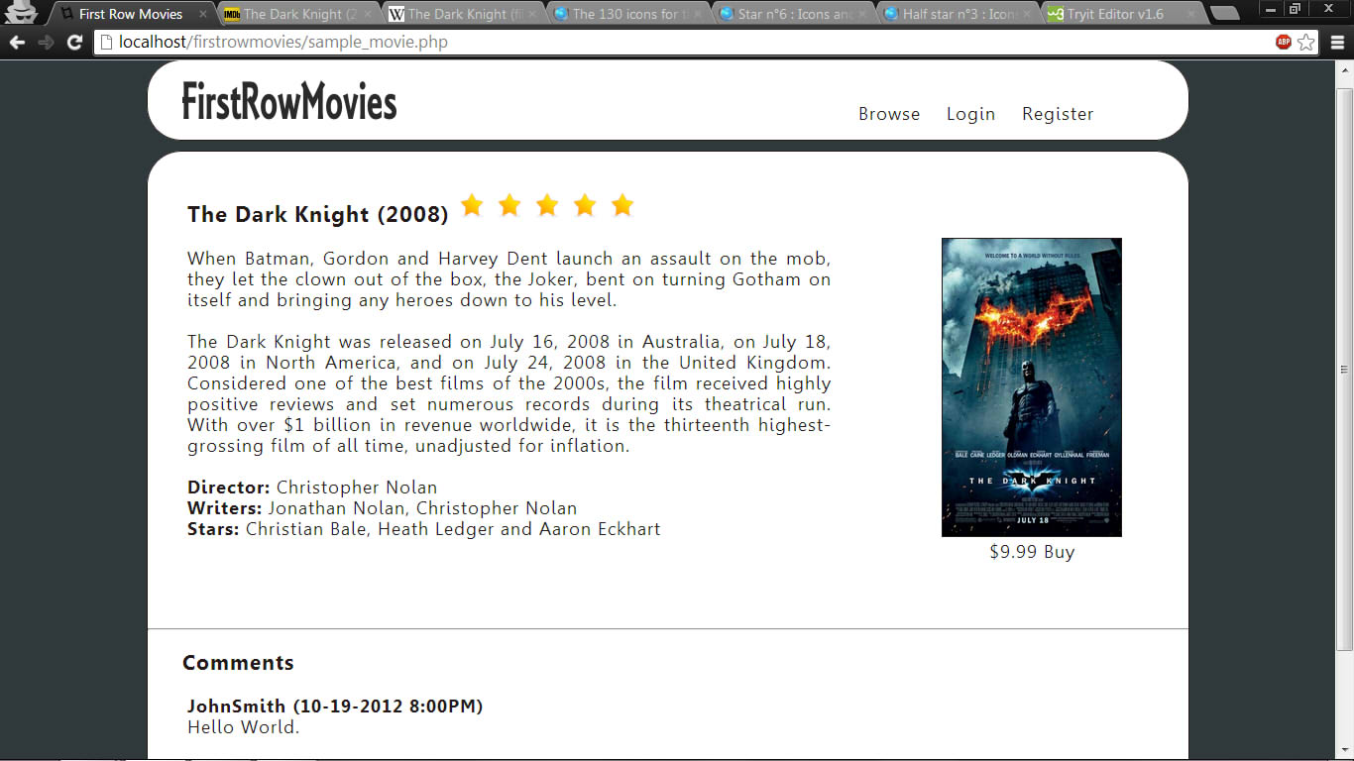

Figure 4.1.7: Movie Information
In this page, a User can browse the movie, read comments, reviews. Customers can buy movie.

