Neutron Experiment Results for VULCAN Instrument Using McStas

Notes:
- These results are obtained for VULCAN instrument using McStas package
- This experiment uses new SNSModerator (SNS_source4.comp)
* Written by: F. Gallmeier
* Date: August 2009
* Version: $Revision: 1.0 $
* Origin: SNS Oak Ridge National Laboratory

Here is the neutron profile for L_monitor (Intensity vs. wavelength (A)) and PSD_monitor

L_monitor 1
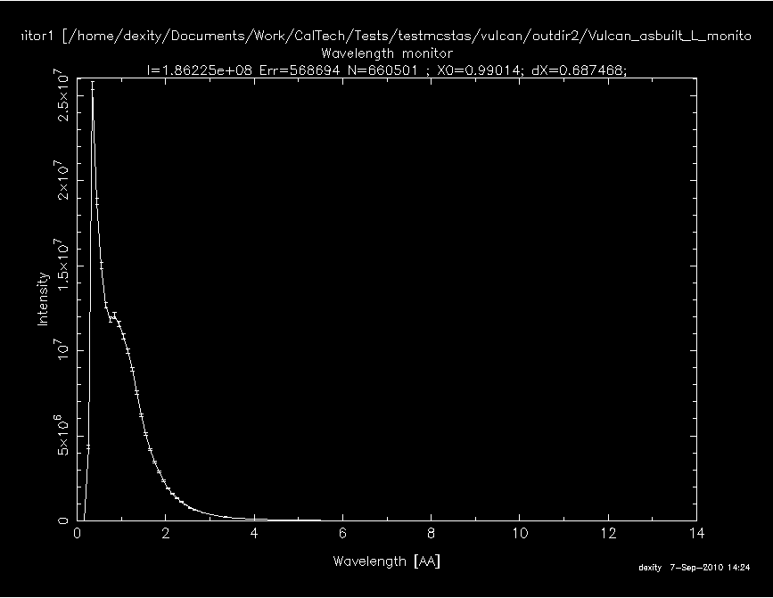
L_monitor 2
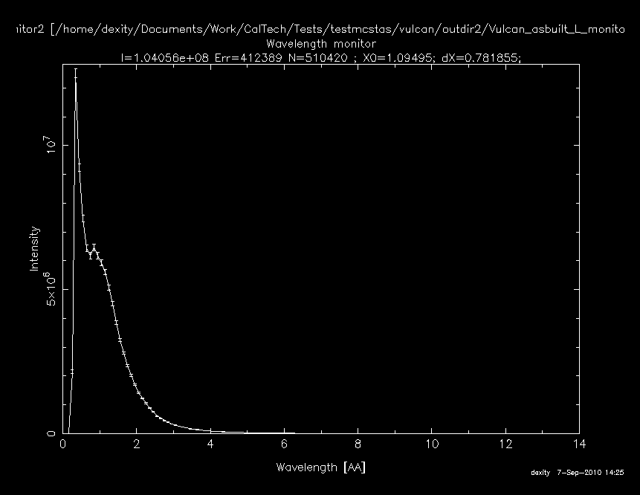
L_monitor 3
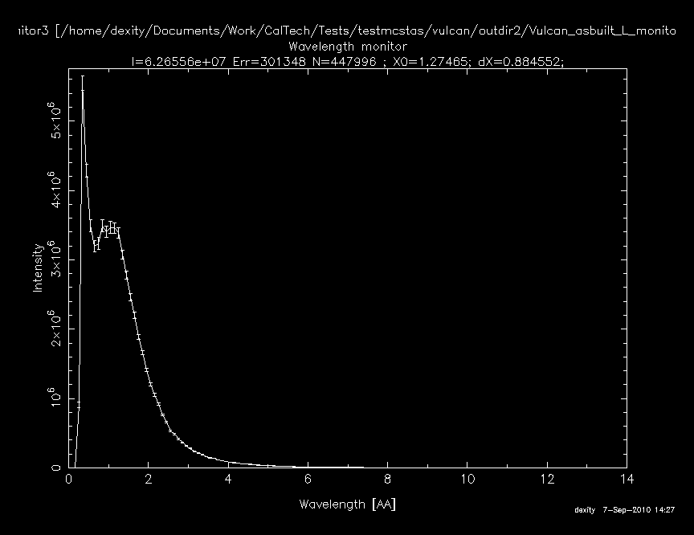
L_monitor 4
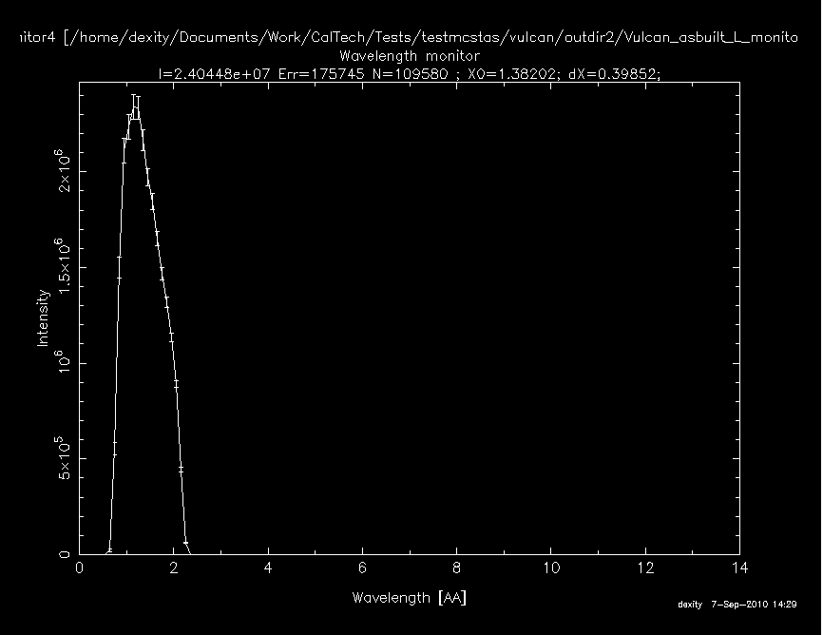
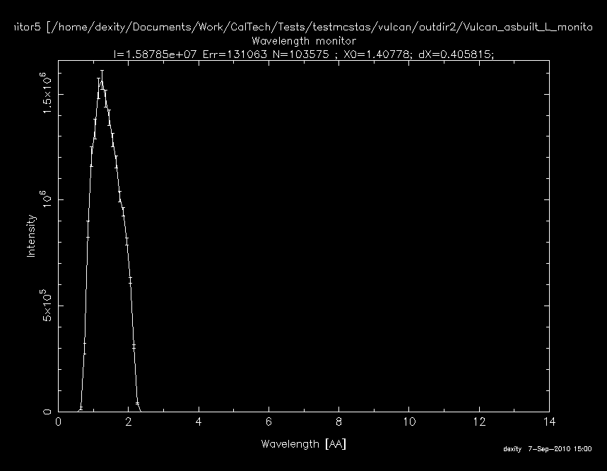
L_monitor 5
L_monitor 6
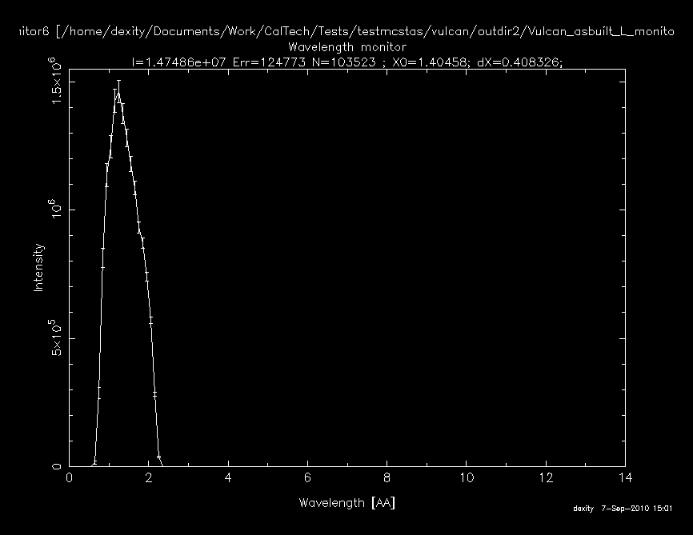
L_monitor 7
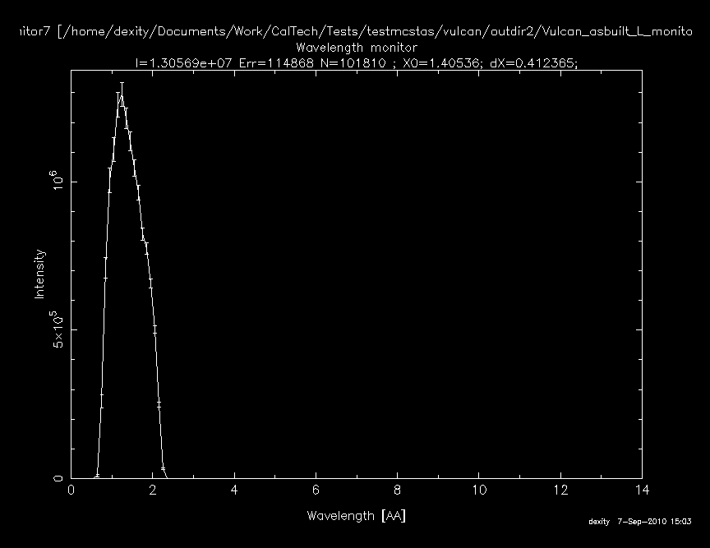
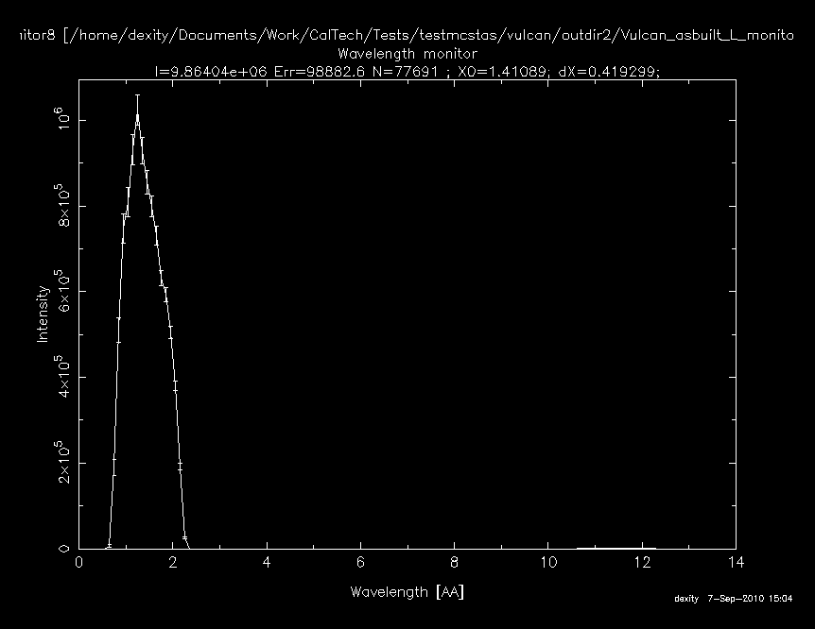
L_monitor 8
L_monitor 9
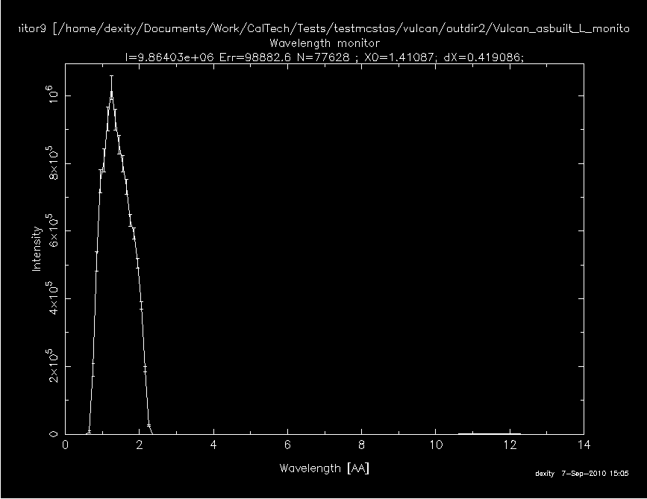
L_monitor 10
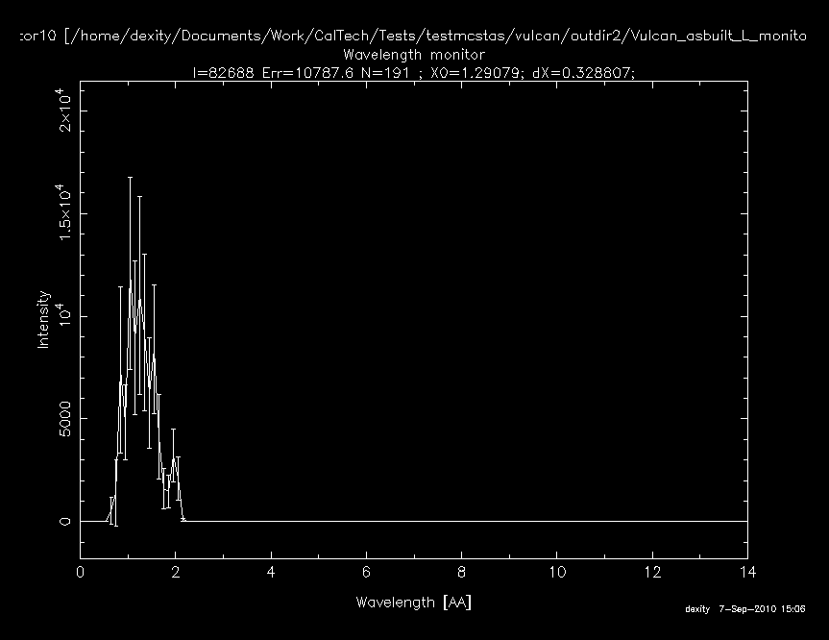
Monitor_nD 1
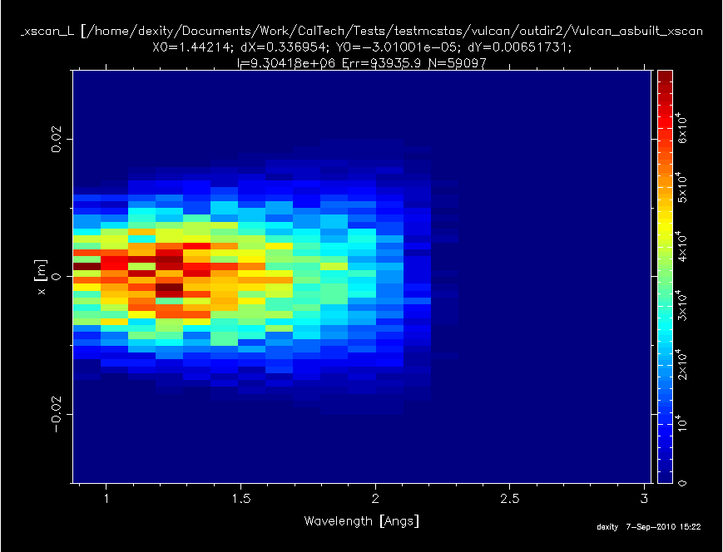
Monitor_nD 2
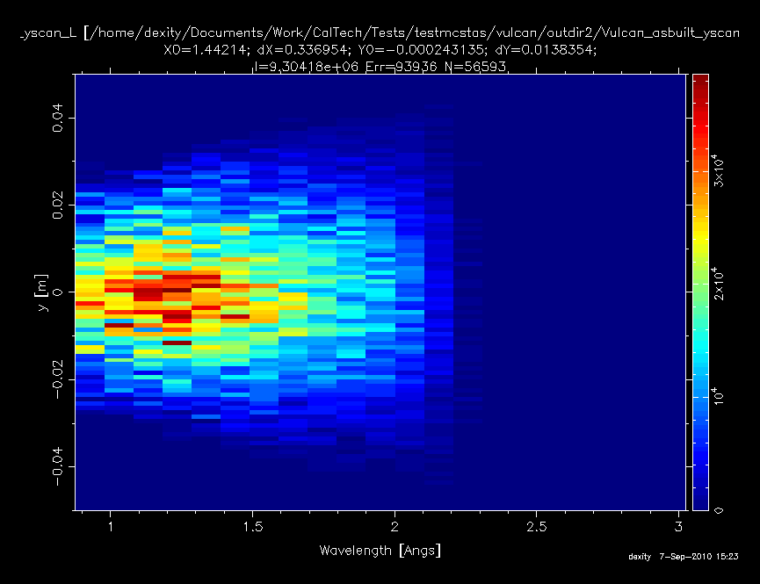
PSD_monitor
