Neutron Experiment Results for VULCAN Instrument using VNF

Notes:
- These are first results obtained for VULCAN instrument with VNF (well, with some hack).
- Current experiment uses old SNSModerator (SNS_source.comp) different from the one used in McStas simulations
* Written by: G. Granroth
* Date: March 2004
* Version: $Revision: 494 $
* Origin: SNS Project Oak Ridge National Laboratory

Here is the neutron profile for L_monitor (Intensity vs. wavelength (A)) and PSD_monitor

L_monitor 1
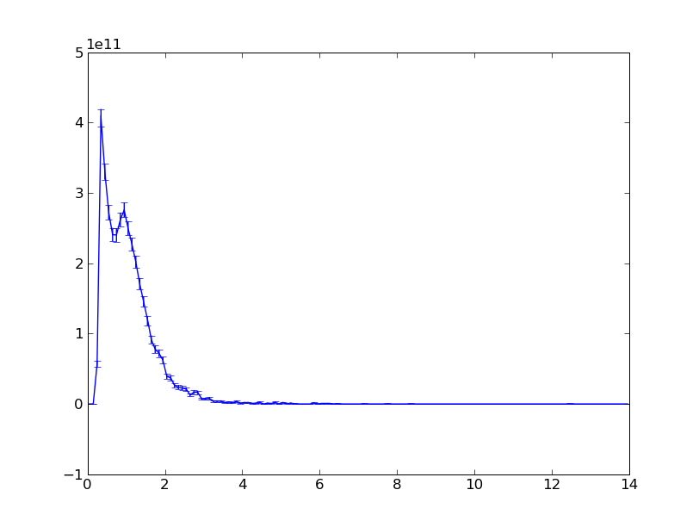
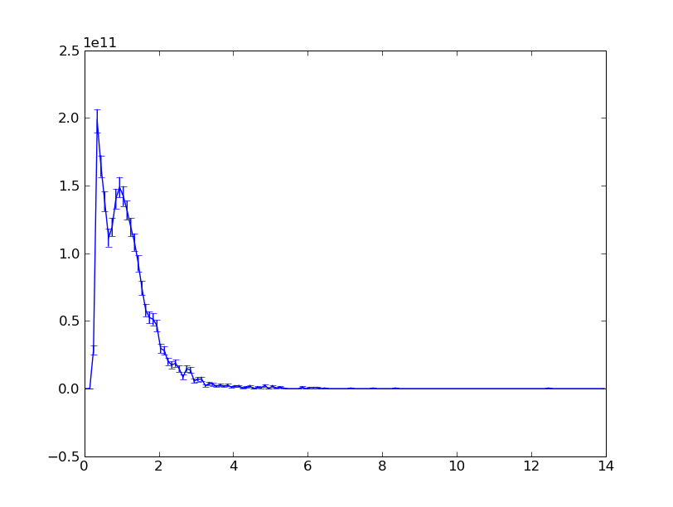
L_monitor 2
L_monitor 3
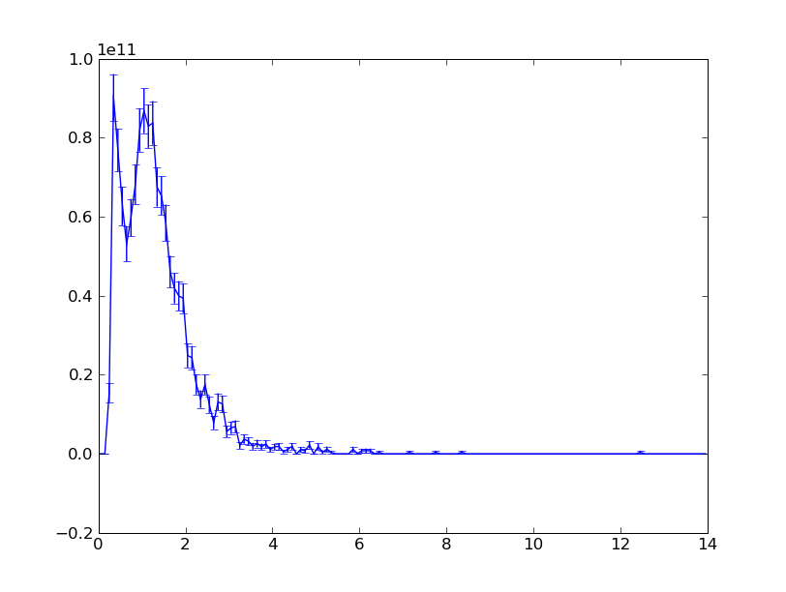
L_monitor 4
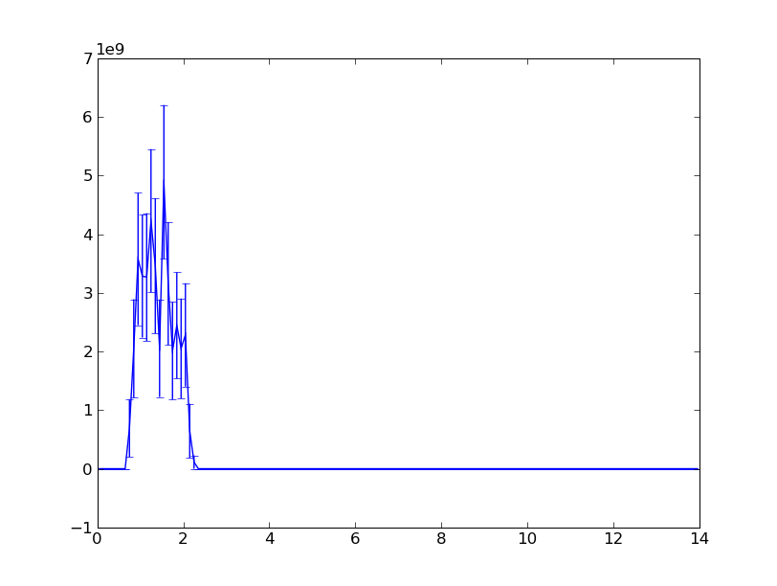
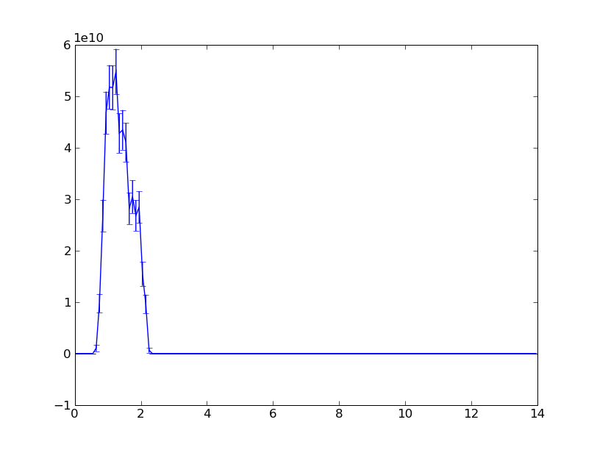
L_monitor 5
L_monitor 6
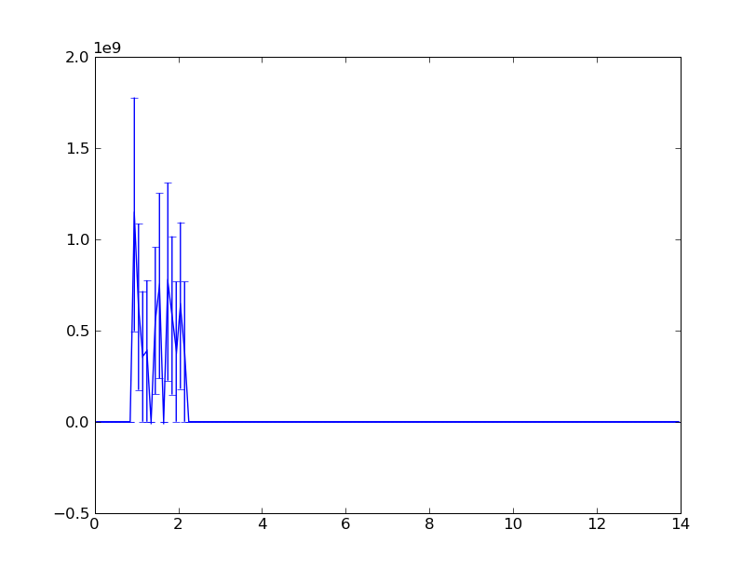
L_monitor 7
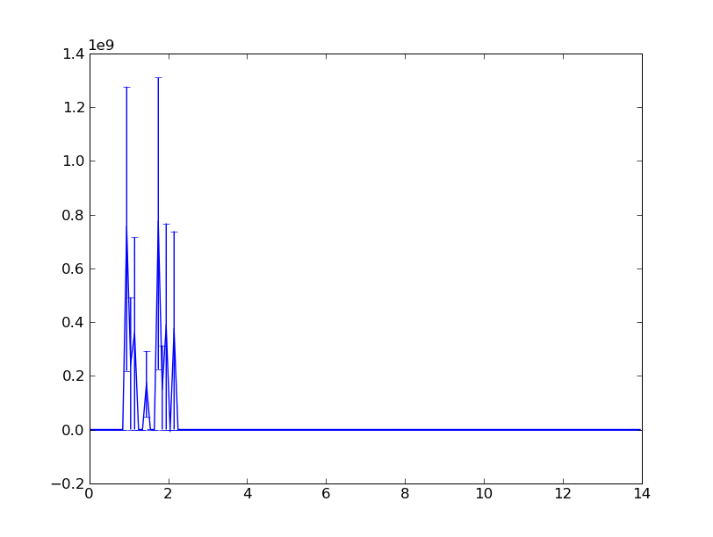
L_monitor 8
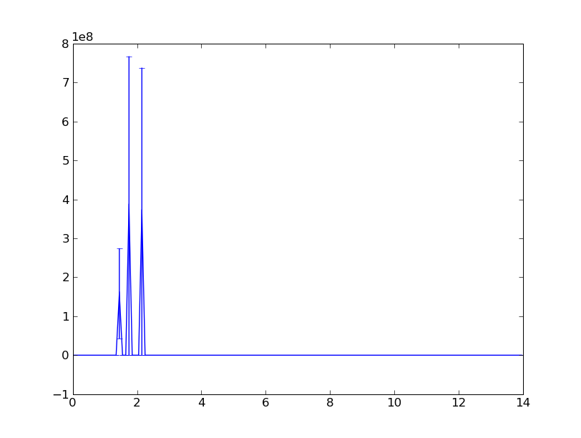
L_monitor 9
L_monitor 10
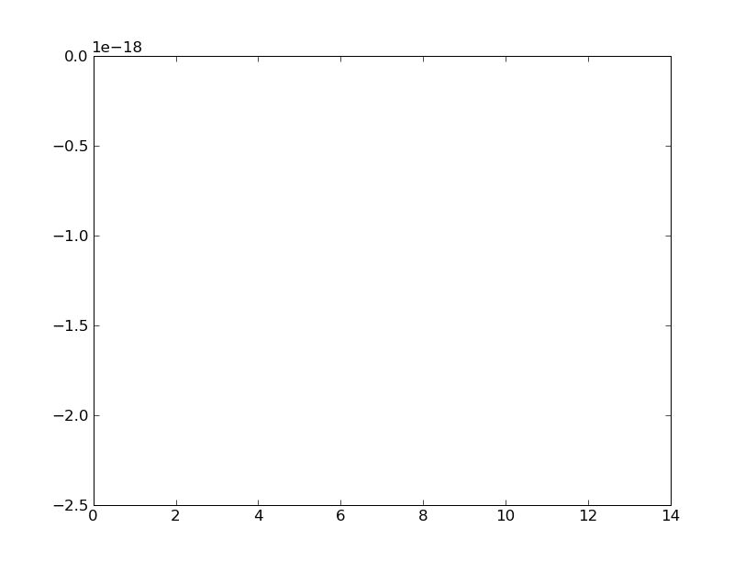
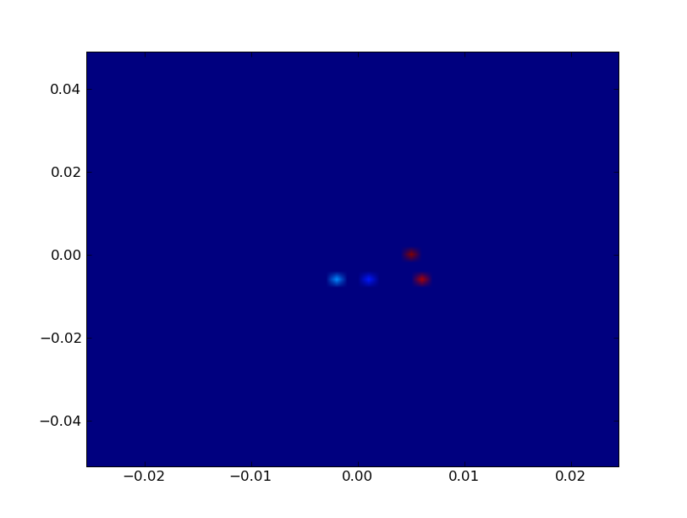
PSD_monitor

