Page 1

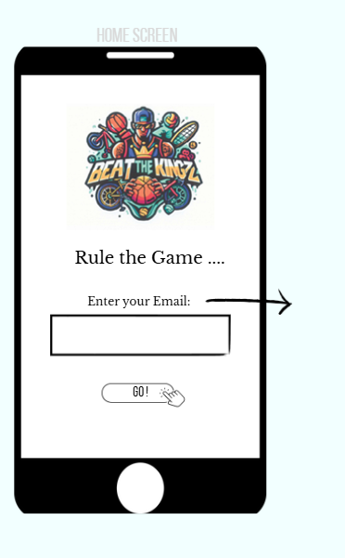

Welcome / Intro

- Background: Clean, minimal, with a soft gradient.
- Logo: Centered, pulsing (slight scale animation).
- Headline: “Rule the Game” with subtle fade-in.

Email Input:

- Field labeled “Enter your email”
- Placeholder: you@example.com
- Button: “GO” → validates email and sends a verification code.

Verification Flow
- Show message: “Sending verification code…”
- Display input field for verification code.
- Button: “Verify” → checks code.

“ Enter your email and your verification code. “

Page 2
Transition to Page 2
- Correct code → automatically move to Page 2.

Page 2
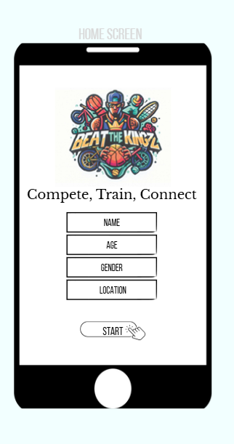

Page 2b
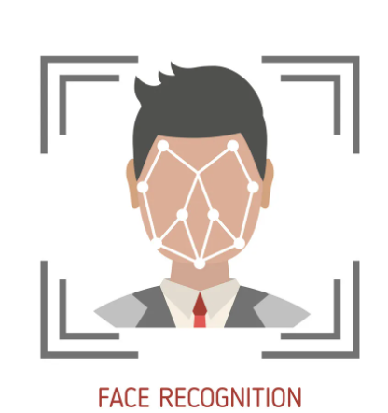

User Info

- Background: Clean, minimal, same style as Page 1.
- Logo: Centered, pulsing animation.
- Headline / Intro: “Compete, Train, Connect” below the logo.

User Input Fields:
- Name – text input
- Age – number input
- Gender – dropdown or radio buttons (Male / Female / Other)
- Location – text input or geolocation auto-fill

Button: “Start” → validates entries.
-------------------------------------------------------------------
Next Step / Transition:
After clicking Start → Page 2b:

Face Recognition OR Upload Profile Picture

- User can take a photo with camera or upload a profile picture
- Show preview with options to Retake / Replace / Confirm
- Smooth transition (fade or slide) to next page after confirmation.
- Once confirmed → automatically move to Page 3 (next part of app home)

Page 3

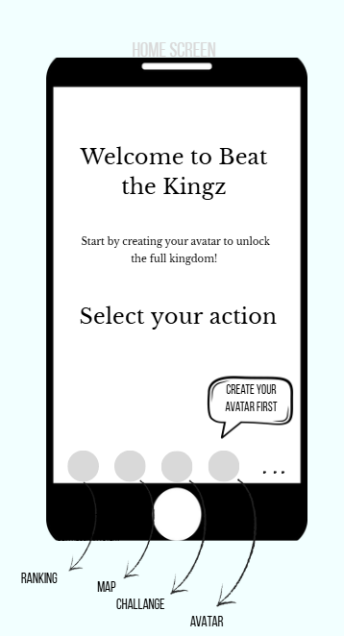

Welcome / Main Page

Background: Dynamic and immersive (animated particles or subtle motion).
- Headline: “Welcome, to beat the Kingz!”
- Subtext: “Start by creating your avatar to unlock the full kingdom (world).”
Buttons:
- Avatar – active, glowing, pulsing.
- Ranking / Map / Challenge – visible but dimmed/locked with tooltip “Unlock after creating your avatar.”
- Use game-style icons (trophy, map, lightning, avatar).

Interactions:
- Visual unlock effect (highlight animation) triggered once the avatar is created.

Page 4

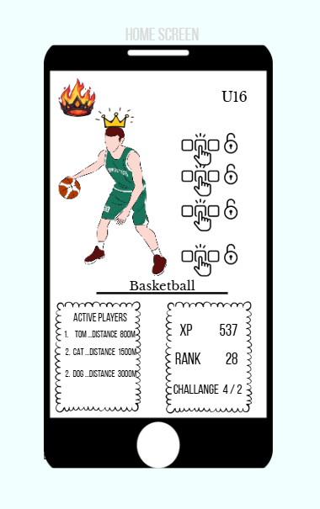

Trump/Avatar Card

This page features the player’s avatar, which can be customized with a full basketball outfit:
The avatar is displayed in the center of the screen.
- Head: Hair color and style
- Body: Shirt or jersey
- Legs: Trousers or shorts
- Feet: Basketball shoes
As players earn points through gameplay, they can unlock upgraded equipment and outfits for their avatar — improving both style and status within the game.

In the upper-left corner, a crown icon appears — visible only when the player is the current “King of the Court.”

In the upper-right corner, the player’s age group is shown.

Below the avatar are two main sections:
Right side: Player stats, including XP, Rank, and Challenge Status.
Left side: Active players nearby, showing live distance from the player’s current location to basketball playgrounds on the right side of the map.

Page 5

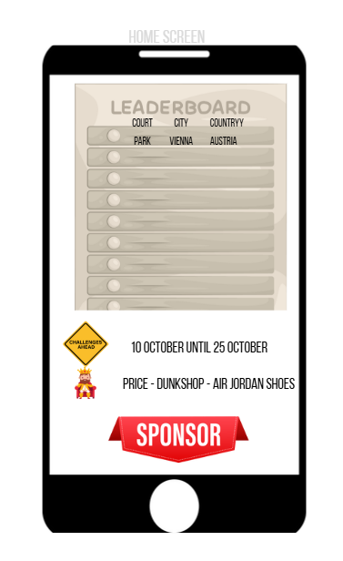

Ranking Page

The Ranking Page displays player rankings across three levels:
- Court
- City
- Country
Each of these appears as an inactive button. When a player clicks on one, it becomes active and shows the top 10 ranked players for that category.
For example:
Clicking on “Court” opens a map of all available courts.Selecting a specific court displays the top 10 players ranked on that ground.
If you click on any ranked player, a pop-up window appears showing that player’s avatar and detailed stats.

Additional Sections
Monthly Challenge:
Displays the challenge dates and the top 5 ranked players for the ongoing challenge.
Monthly Challenge Prize:
A separate section highlighting the reward or prize available for the current monthly challenge.
Sponsors Section:
Located at the bottom of the page, this area is reserved for sponsors and advertisements, offering visibility for partner brands

Page 6

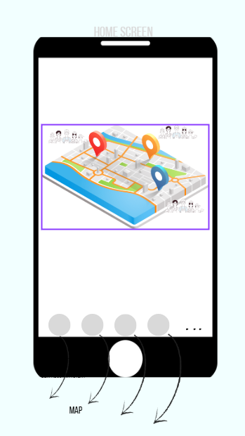

Map

The Map Page is an interactive interface that displays all available basketball courts in the user’s area and beyond.
Each court icon on the map shows:
- The number of active players currently playing.
- The location and name of the court.
Players can zoom in and out or tap on any court to view more detailed information.

When clicking on active player avatars, a pop-up window appears showing the player’s avatar, stats, and current status — including rank, XP, and ongoing challenges.
Additionally, users can easily identify the current “King of the Court” — their avatar is displayed wearing a crown, symbolizing their top ranking at that specific court.

This interactive map allows players to:
- Discover nearby courts and see where games are happening in real time.
- Spot the current Kings of the Court and other players - challenge them for the title.
- Connect with active players and plan challenges based on player activity and proximity.

Page 7

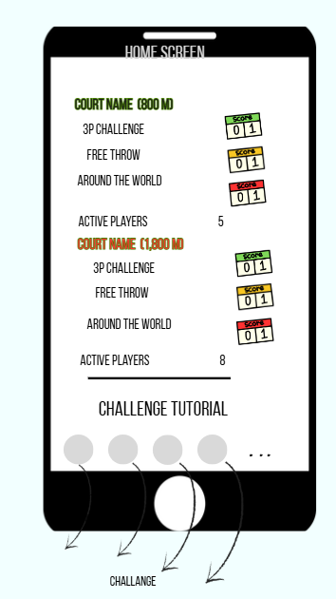

Courts and Challenges
This Page provides players with detailed information about nearby basketball courts and ongoing or completed challenges.
Includes:
- A list or map view of courts in your area, each showing:
- The number of active players currently on that court.
- Any active or completed challenges associated with that location.
Players can view:
- Challenges that need to be finalized (still in progress).
- Challenges already completed, along with results or rewards.
Below the main section, there is a dedicated area for tutorials, where players can access guides and instructions for all available challenges — helping them understand how to participate, earn points, and improve their rank.

This page serves as a hub for local activity and progression, allowing players to:
- Track nearby courts and current gameplay.
- Manage their ongoing and completed challenges.
- Learn new game mechanics and optimize their performance through tutorials.
Press Challenge -> Page 8

Page 8

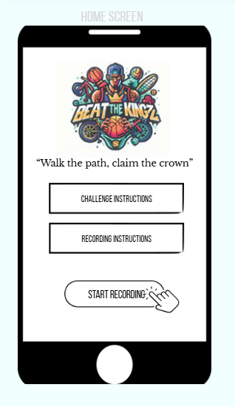

Challenge Overview / Instruction

Purpose: Introduce the challenge and guide players on how to participate successfully.
Instructions:
- Welcome players and set expectations for the challenge.
- Explain the task clearly, including goals and rules.
- Emphasize accuracy and honesty in completing the challenge.
- Highlight that only verified submissions count toward progress or rewards.
Challenge Recording Instructions
Purpose: Guide players on how to record and upload their challenge successfully.
Instructions:
- Set up the camera to capture the full movement or action.
- Ensure good lighting to make the player and environment visible.
- Use a stable surface or tripod to prevent shaking.
- Choose a clear background to focus on the action.
- Perform a verification gesture at the start (e.g., player ID, wave, or code word).
- Upload the video directly within the app to verify the challenge.

Page 9
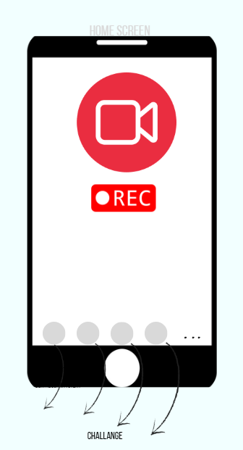

Page 9 a
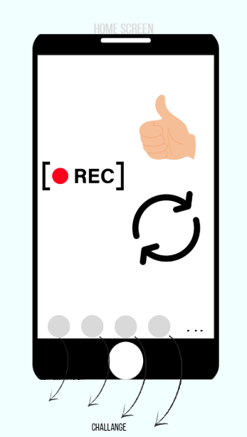
Video Camera & Countdown

Purpose: Show the camera setup and prepare the player for recording.
Instructions:
- When the player starts the challenge, the camera view appears on-screen.
- A countdown timer from 10 → 0 seconds is displayed before recording begins.
“Your recording will start in 10 seconds… 9… 8…”

Recording Completion & Options

Purpose: Allow players to review, retry, or submit their performance after finishing the challenge.
Instructions:
After completing the challenge, the player sees two options:
- Try Again – redo the challenge to improve performance.
- Upload Video – submit the recording for verification.

Page 10
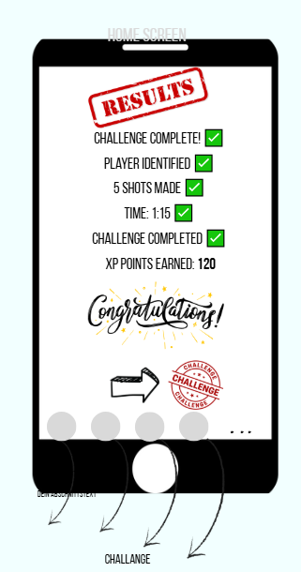

Challenge Results & Feedback
Purpose: Provide immediate feedback and show progress/rewards.
Information Displayed:
- Player Identified: ✅ Verification gesture or ID detected.
- Shots Made: ✅ Number of successful shots (e.g., 5/5).
- Time: ✅ Duration of the challenge (e.g., 1 min 15 sec).
- Challenge Completed: ✅ Status of completion.
- XP Points Earned: 🎉 Reward points displayed.

Next-Step Options:
- Next Challenge: Proceed to the next available challenge (if unlocked).
- Back to Avatar: Return to the player’s avatar or main profile screen.

