In firefox go to <http://mediaservicesqa.washpost.com/nms_training_tools/> and download “Large Photo” and “Thumbnail.” You’ll use these for the “Picture” and “Thumbnail” fields when creating a new product. There are also some shortcuts on this page that might be useful.

# Create a New Column/Feature

1. Log in to the site by visiting <http://mediaservicesqa.washpost.com/?q=user>
2. Log in with Username: Your first name Password: admin
3. Now you should see the administrative bar at the top of the screen 
4. To create a new column or feature click Content
5. You are now in the admin view. Click Add Content



1. Here you can choose what kind of content you want to add. Most of the content on the site belongs to one of these categories. 5 of these categories are for products:
   1. Column
   2. Comic
   3. Editorial Cartoon
   4. Feature
   5. Magazine

You’re going to select either Column or Feature

1. Now fill out the form to create a new column/feature. If there is any field that’s not self-evident please let me know and I’ll add help text for it. I’ll send you some filler images to use until we get the pretty ones back from creative services
2. For the Mugshot field in a new window go to <http://www.wpmediaservices.com/mugshots.htm> and find your artists name. click it and save the image to your desktop. Now return to the create a comic/editorial cartoon form and upload that picture as the mugshot.
3. For the RSS field, if this is a writer for the Washington Post, find their page on <http://www.wpmediaservices.com/features.htm> and click “View Recent Columns” in the right sidebar. (Otherwise ignore the RSS field and skip to step 12)
4. Now Look around the page for this button: 

or text like this: 

1. Once you click the button/text you will be on that author’s rss page. Now copy the url in your browser, return to the “create a column” form and paste that in the RSS feed.
2. For the links section you can create a link by typing the word you want to display, then highlighting the word and clicking on the hyperlink button in the toolbar above the text box

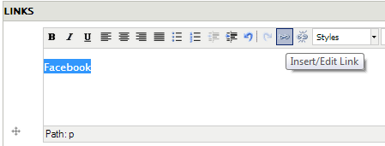

A popup will open with several options, but the only thing it really needs is Link URL:

Enter a URL and scroll down to click Insert when you’re finished.

1. Lastly, at the very bottom of the page click on URL Path Settings and type the name of the product as your url alias. No caps and replace spaces with a dash. example: esther-cepeda

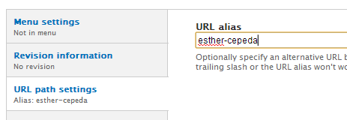

1. Now click Save. You’re finished!

# Create a New Comic/Editorial Cartoon

1. Log in to the site by visiting <http://mediaservicesqa.washpost.com/?q=user>
2. Log in with Username: Your first Name Password: admin
3. Now you should see the administrative bar at the top of the screen 
4. To create a new comic click Content
5. You are now in the admin view. Click Add Content



1. Here you can choose what kind of content you want to add. Most of the content on the site belongs to one of these categories. 5 of these categories are for products:
   1. Columns
   2. Comics
   3. Editorial Cartoons
   4. Features
   5. Magazines

You’re going to select Comic

1. Now fill out the form to create a new comic. If there is any field that’s not self-evident please let me know and I’ll add help text for it. I’ll send you some filler images to use until we get the pretty ones back from creative services
2. For the Mugshot field in a new window go to <http://www.wpmediaservices.com/mugshots.htm> and find your artists name. click it and save the image to your desktop. Now return to the create a comic/editorial cartoon form and upload that picture as the mugshot.
3. Ignore the rss feed field for Comics and editorial cartoons. I will put that in later.
4. For the links section you can create a link by typing the word you want to display, then highlighting the word and clicking on the hyperlink button in the toolbar above the text box

A popup will open with several options, but the only thing it really needs is Link URL:

Enter a URL and scroll down to click Insert when you’re finished.

1. If this item doesn’t have an RSS feed leave this blank. You can manually add content later.
2. Lastly, at the very bottom of the page click on URL Path Settings and type the name of the product as your url alias. No caps and replace spaces with a dash. example: esther-cepeda



1. Hit save at the bottom of the page and you’ve finished!

# Create the Meet the Characters section (Comics only)

1. Log in to the site by visiting <http://mediaservicesqa.washpost.com/?q=user>
2. Log in with Username: Your first Name Password: admin
3. Now you should see the administrative bar at the top of the screen 
4. To create a new comic click Content
5. You are now in the admin view. Click Add Content



1. Here you can choose what kind of content you want to add. You want to select “Comic Character”
2. Now fill out the form with the Name of your character, a picture of your character (You can use the thumbnail image you downloaded from mediaservicesqa.washpost.com/nms_training_tools) and a brief description of your character (1000 words is the limit but something more like 200 looks better on the page)
3. Finally, select the comic that this character belongs to. This is how the site knows where to put your character. If you don’t see your comic’s name then that comic hasn’t been created yet. Save this character for now and then follow the steps to create a comic. Once you’ve finished, return to this character and select the comic you just created and then Save
4. Click Save at the bottom and you’re finished!

# Edit Products you’ve already created.

1. Log in with Username: Your first Name Password: admin
2. Now you should see the administrative bar at the top of the screen 
3. To create a new comic click Content
4. In the Show Only Items Where section select the type of product you want to find from the Type dropdown menu and click filter

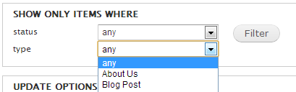

Now you should see a list of all products of type “Comic” or “Column” etc. Scroll down until you see the product you want to edit and click “edit” to the right of its name. Now you can make changes. Remember to hit save when you’re finished!