John Ure  
Mattias Guenther  
Maria Walshe

**Team #1 Project Proposal Abstract**

Description:

We are proposing to design, model, and build a speed reading trainer for those who might want to improve their reading speed. The splash screen on startup will allow the user to create a new user or access a previously stored user.

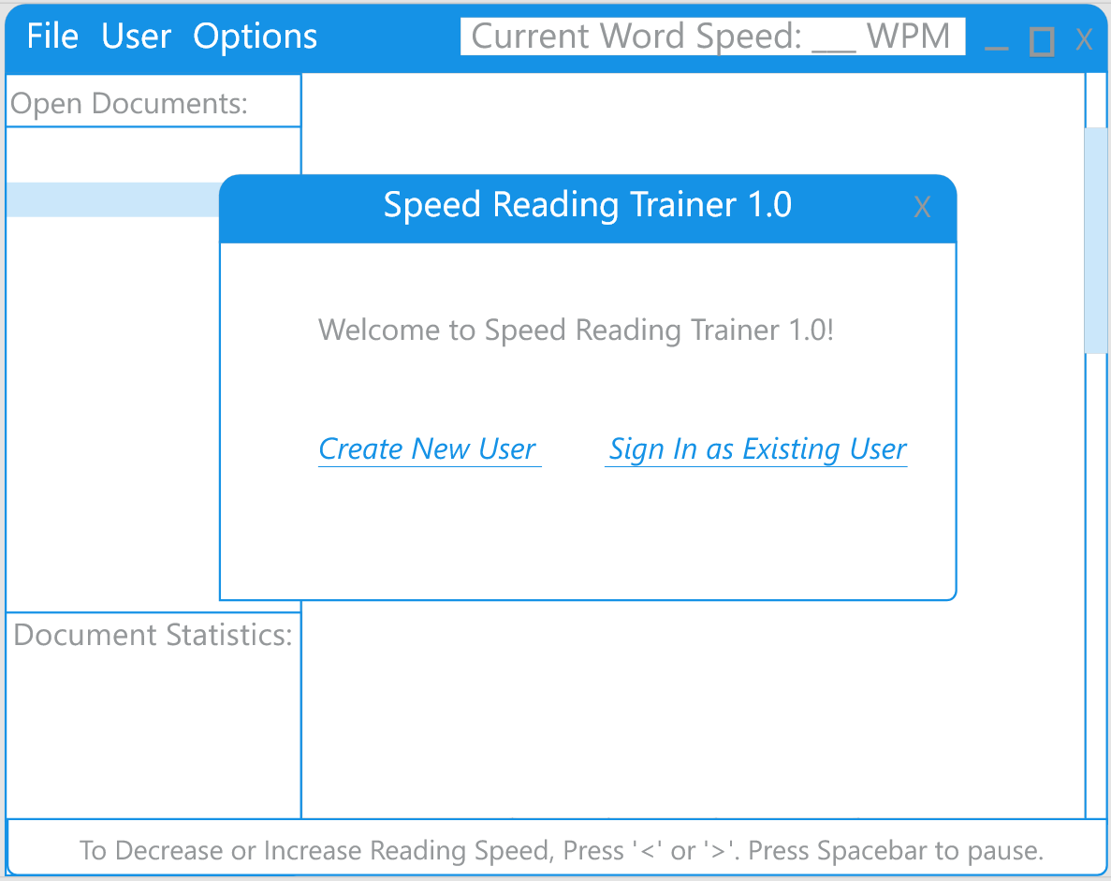

The software will contain profiles for multiple users. Each user will consist of a name, a list of documents which will contain the last 10 text documents they have opened, and an interface object that will contain their current UI options such as pointer type, preferred font, and speed setting in WPM.

Each user will have a unique catalog of files associated with them, and every document will contain its physical location on disk, as well as statistics to the user’s performance for that specific document. In the GUI, once the user profile is selected, document physical locations will show on the left of the panel. The interface will also open the text body of the document and display the current user statistics associated with that document.  
  
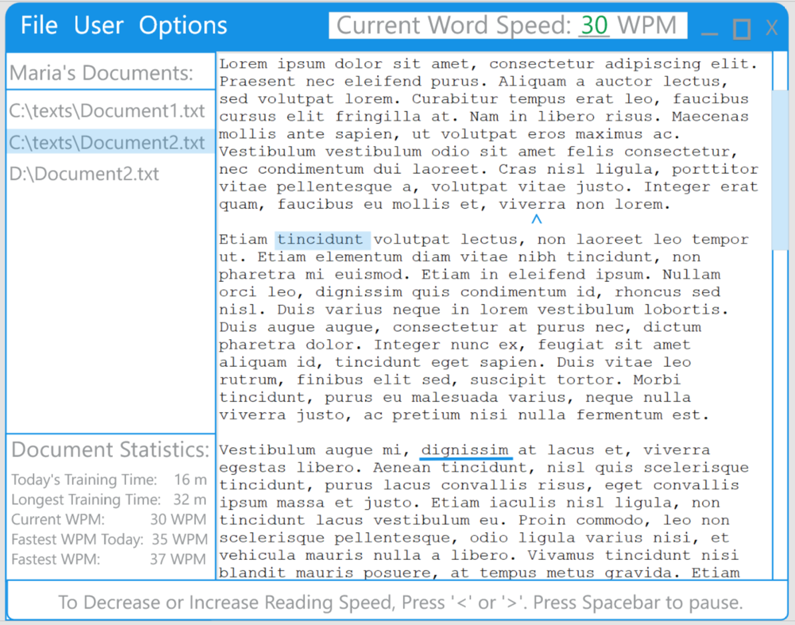

The user may either manually set a new bookmark location with the scroll bar and mouse click, or resume as the current location set. The word bookmarked will display with the pointer type selected by the user. The highlight block will be the default type, but the user may change this to either the underline or the caret symbol if they choose. Examples of all of these are shown above. Pressing ***spacebar*** will begin the reading at the selected speed, which the user may change at any time using ***‘<’*** or ***‘>’*** (or their lowercase equivalents).

Once the document is paused, the user may choose to save their place, open a new document, or reset their statistics for this document by Selecting the ***File*** menu item.  
  
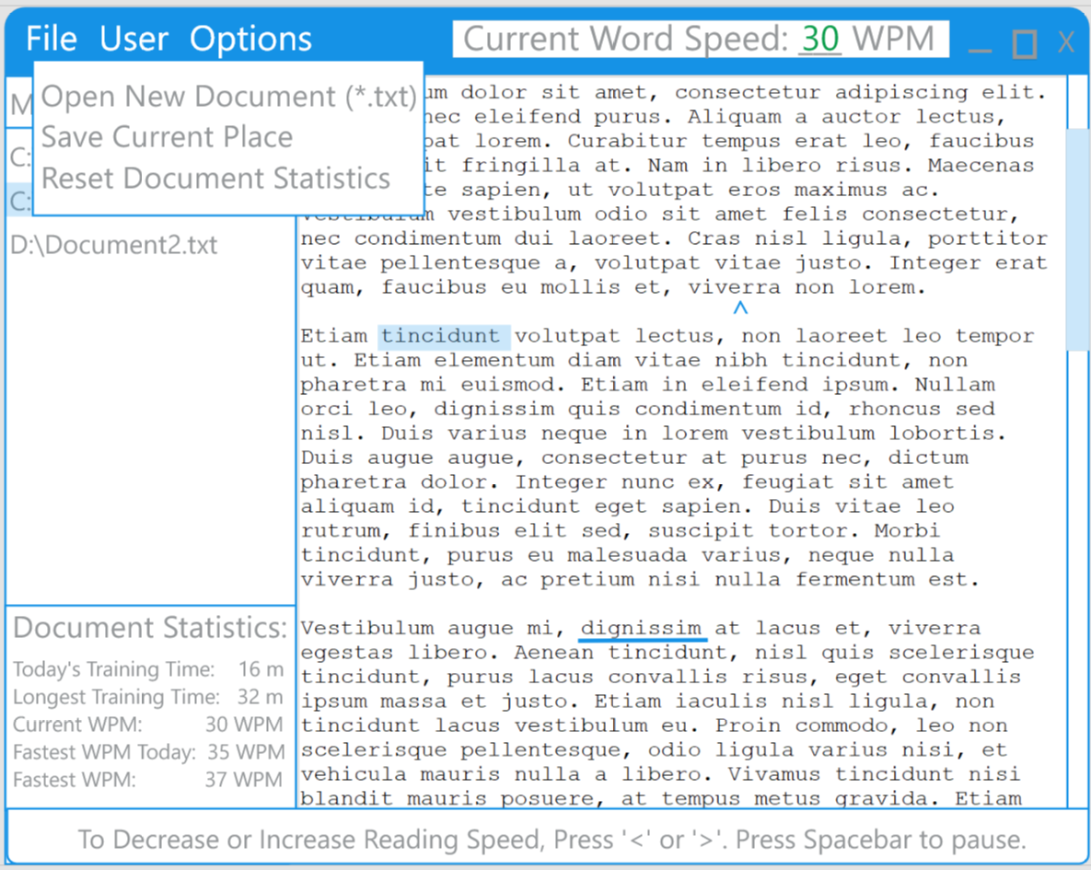

The User may also switch to another existing profile or create a new profile (and switch to that one) from the ***User*** menu item.

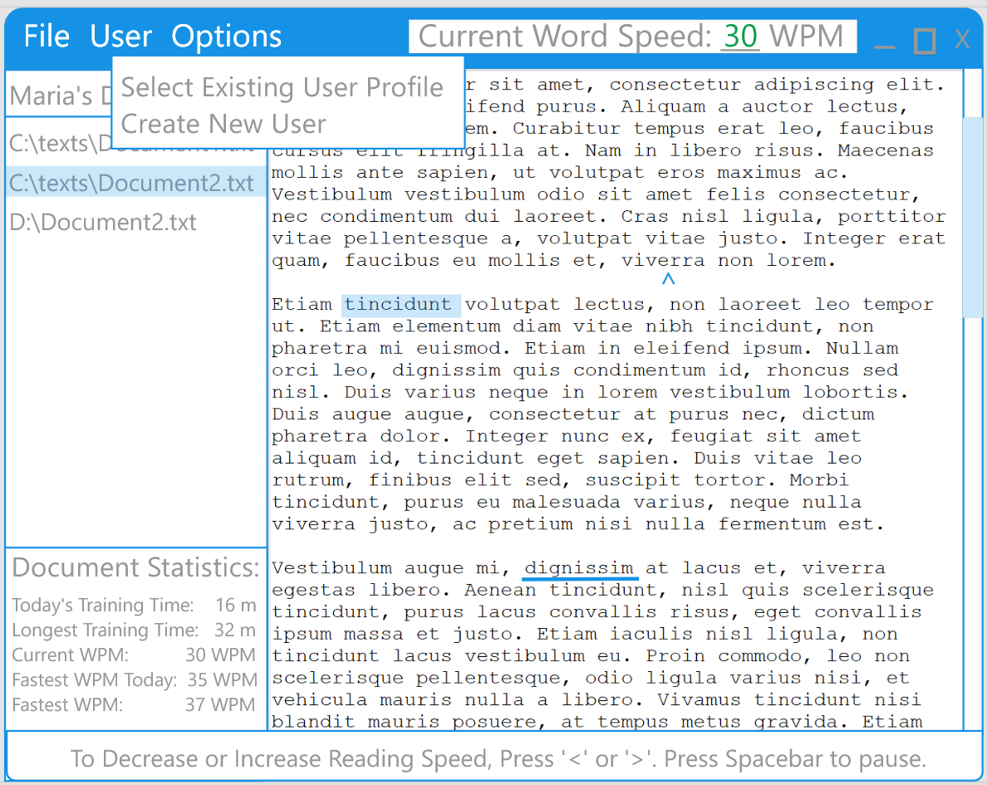

From the ***Options*** menu, the user may change their speed setting, display font, and pointer type (either word highlight, underline, or pointer arrow).

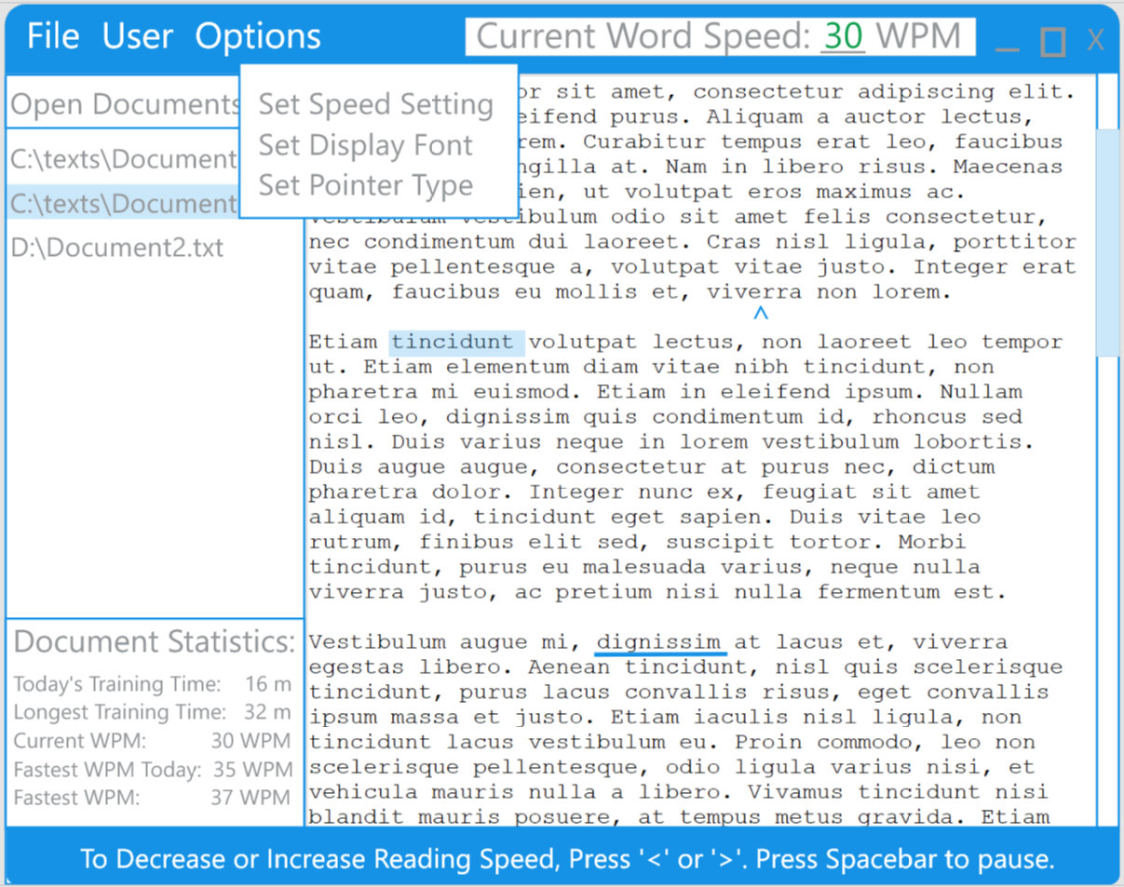

**User Behavior Model**

Although discussed above, below is the user behavior model that describes the various paths the user may take within the application:

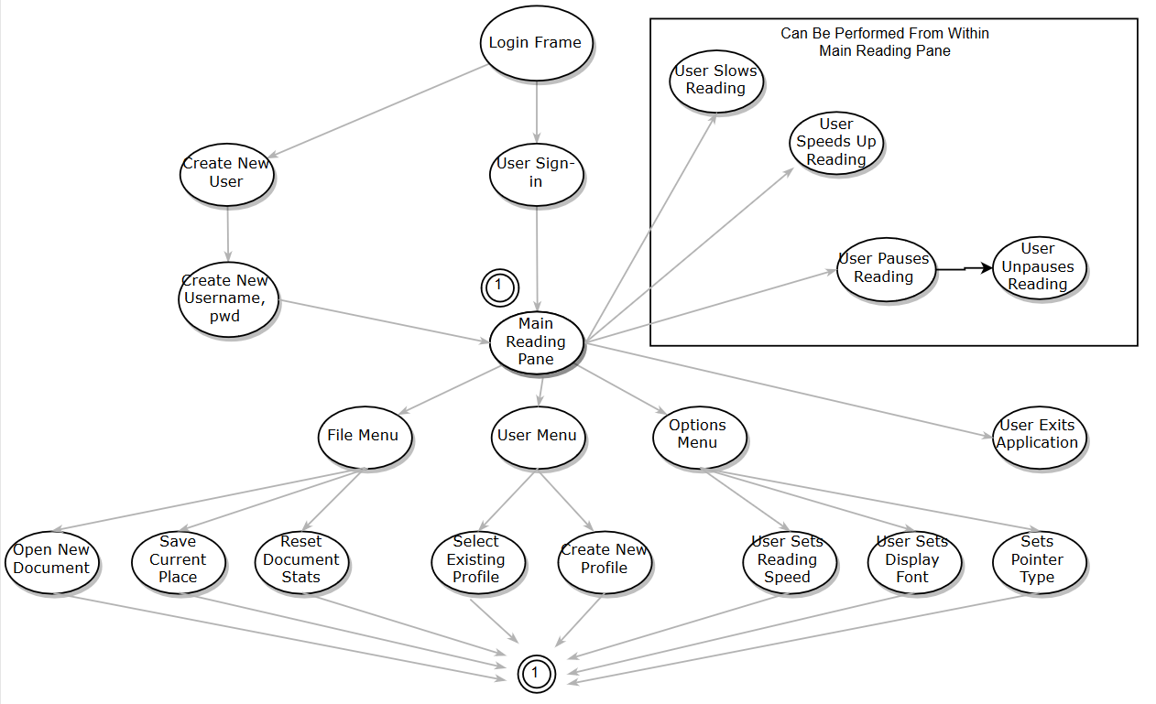

**UML Design:**

Below is the UML that is proposed at this point in the design. While I expect it to change, it is representative of what we intend to build.

