IOT Smart Mirror With News & Temperature

Smart mirrors are the mirrors of the future. A part of the connected world where we would be able to see news, temperature, weather and more just while looking and grooming in front of mirrors. Our proposed system allows to build such mirrors that allow for mirrors to receive news online and display it on the mirror screen along with other details including current temperature of the room for a futuristic and modern lifestyle. Our system uses a raspberry pi based processor board along with display and IOT based circuitry and temperature sensor interfaced together. We use a precisely modelled panel to construct the outer frame. Then we use specialized glass with a back frame to encase the system.
The frame cavity is now fitted with precisely positioned mounts for the display housing to be fitted in the mirror. This is necessary to achieve the desired effect. Now we use raspberry pi to connect with internet using IOT circuit through the use of a wifi module. This allows us to receive data through the IOT platform. We use IOTGecko in order to connect our system to the internet and get news feeds. The temperature interfaced on the circuit is used to display temperature and display it on the mirror fitted display. Thus we demonstrate a futuristic IOT smart mirror with news and temperature display.

Block Diagram:

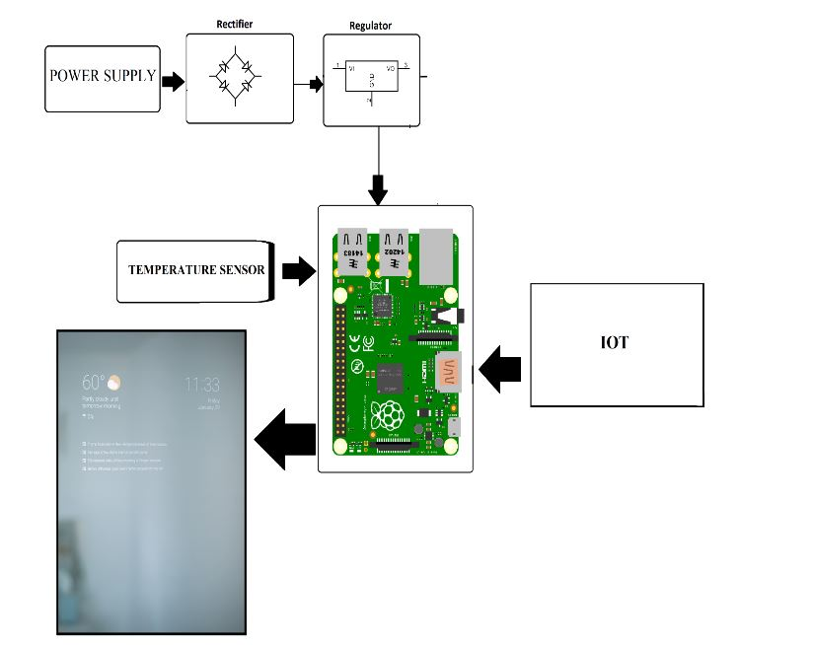

Hardware Specifications
- Raspberry Pi
- Temperature Sensor
- Wifi Module
- Display Panel
- Resistors
- Capacitors
- Diodes
- Adapter
- Mirror frame
- Mirror Panels
- Supporting Frame
- Mounts
- Joints & Screws

Software Specifications
- Python 3 compiler
- Programming Language: Python
- IOTGecko

