Replication Template

Note: This document provides the broad strokes of what might go into your replication. You are welcome to deviate from this pattern.
Title:
Repeating the Original Title + (Author, Year)

Abstract
One sentence describing the purpose of the original study. One sentence that reports them main findings from the original study. Report the results of your reproduction. If it fails, highlight the main reason or the revised reproduction process. Discuss the robustness reproduction performed. What do the results state about internal validity for the study? At a high-level, what is the impact this has for the PES literature?

Keywords + JEL Codes: Same as the original paper (assists with finding appropriate referees)

Introduction:
- Start with motivation about the placement of this study within the PES literature.
- Very briefly (1 paragraph) describe the original study – research question, design, result.
- In the next few paragraphs describe the reproduction/replication process performed.
- What are the main highlights from this exercise?
- Finally, does this change the confidence in the internal validity of the study? How?
  - You should perform a simple literature review exploring the articles that cite this study on Google Scholar.
  - Note any (1) major studies that dispute the findings, or (2) any replication or reproduction studies of this study.
  - Your replication will fit directly within this small literature focused on evaluating the results of this particular study.
- In the last paragraph, discuss the implications of this replication in the broader PES literature. Does the success or failure of this replication change our understanding of the evidence in any meaningful way?
- Throughout, you may note that this replication falls within the contributions of the ongoing replication effort in economics
  - Brodeur, Abel, D Mikola, N Cook, R McWay, and et al., “Reproducibility and Robustness of Economics and Political Science Research,” Nature, 2026a, 652 (8108), 151–156. [Link]
  - Brodeur, Abel, D Valenta, A Marocci, R McWay, and et al., “AI-assisted Teams Outperform AI-led teams but not human-only teams in assessing research reproducibility in quantitative social science,” Proceedings of the National Academy of Sciences, 2026b, 123 (22). [Link]
Reproducibility:
- There are two major distinctions of analysis that may be performed. These are reproductions and replications. For details on definitions, please refer to “Definitions of reproducibility and replicability in political science” by Brodeur et al. (2024) [Link]
  - Another important citation: Dreber, A. and M. Johannesson (2023). A Framework for Evaluating Reproducibility and Replicability in Economics. Economic Inquiry, 63.2 (2025) 338-356 [Link]
- In this section, you will take the provided data and code and you may perform the following:
  - Computational reproducibility tests the extent to which results in original studies can be reproduced using the data and code from the original studies.
  - Recreate reproducibility tests to what extent results in original studies can be reproduced using the information in the original studies without access to the processed data set and/or the analysis code
- State the source of the replication package and the state of public access.
- Note the original software used and the state of the software used in your reproduction.
- Report on the meta data provided – does this study provide a README with directions, is there clear documentation, is there supplementary material to reference, does the data have clear labels, is the code well commented?
  - What you are describing is the quality of the replication material you are starting with. Are the authors conforming to replication packet standards:
    - https://www.aeaweb.org/journals/data
- Report on the success or failure to reproduce the main tables and figures of the study
  - Do not worry about appendix material.
  - If you fail to push-button replicate, attempt and document to troubleshoot the issue.
  - Additionally, you want to identify the core table or figures that presents the highlighted result (what is reported in the abstract or introduction). This is the main result to reproduce. If others do not, it is not as big of a deal. This should not be more than 2 or 3 tables/figures. Make clear to reader this is the core results you are reproducing.
- After completing the reproduction, provide an assessment using the BITSS ACRe
  - Guide for Advancing Computational Reproducibility in the Social Sciences (ACRe) established by the Berkeley Initiative for Transparency in the Social Sciences (BITSS) (Bogdanoski et al., 2020).
  - Bogdanoski, A., C. Christiano, J. Ferguson, F. H. Guardia, K. Hoeberling, E. Miguel, E. Ng, and L. Vilhuber (2020). Guide for Advancing Computational Reproducibility in the Social Sciences. Berkeley Initiative for Transparency in the Social Sciences. [Link]
- Summarize the data and code provided as they relate to the final result using a version of the following summary table:
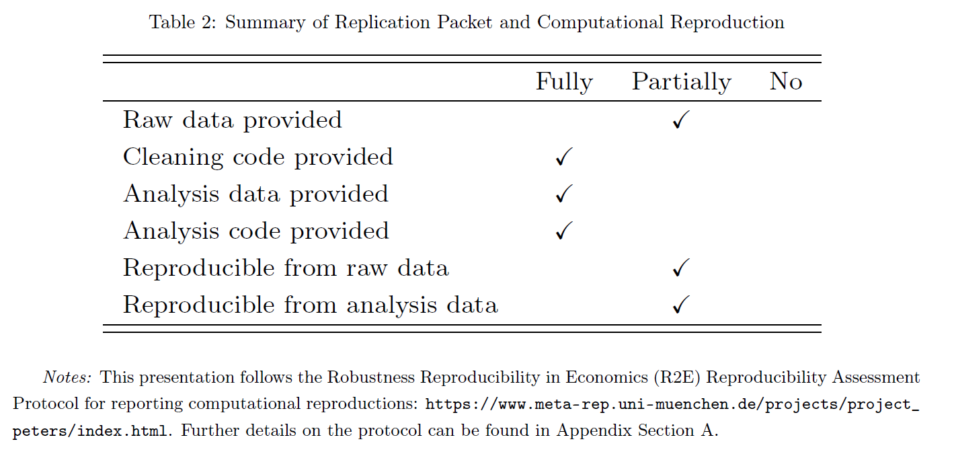
- Additionally, for the main results table/figure that is identified you will want to produce a table that compares the original estimates to the reproduced estimates. Even if they exactly reproduce.
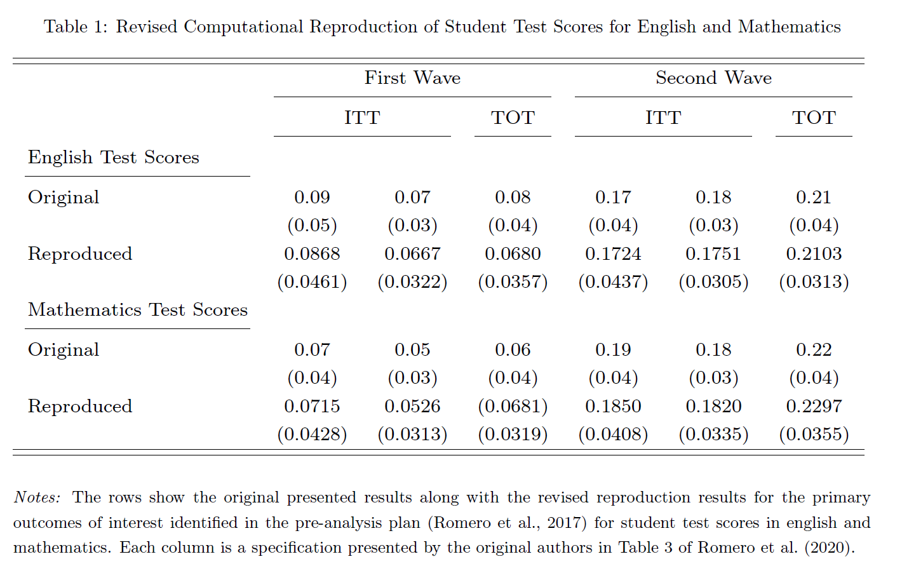
Replication:
- This is an optional section.
- An alternative approach is to completely replicate the study from scratch. This is a higher bar to pass. There are two potential definitions of replication you may pursue:
  - Direct replicability tests to what extent results in original studies can be repeated on new data using the original studies’ research design and analysis (with three further sub-categories depending on if data are from the same population, a similar population, or a different population is used).
  - Conceptual replicability also uses new data to test to what extent results in original studies can be repeated, but for this type of replication an alternative research design and/or alternative analysis is used to test the same hypothesis as in the original study
Robustness Reproduction:
- Conditional on having code and data that allows you to recreate the original results with some small margin of error, you may perform a robustness reproduction.
- Robustness reproducibility tests to what extent results in original studies are robust to alternative plausible analytical decisions using the same data as in the original studies.
- If you pre-registered an analysis plan, this is the section to report that.
- State clearly the outcomes of interest you will test and the specification you are comparing against. Before showing new results, it is should be clear to the reader what was the original analytical decisions the author made.
- Justify the alternative specification decisions that you make. Either this is theoretically justified or it is a reasonable alternative in implementation that the authors did not select.
- In general, challenge at least two analytical or theoretical assumptions/decisions that the authors make. Within these challenges, you may have several alternative pathways to choose from.
- In reporting, you are mainly describing the sensitivity of the results to these decisions. An important consideration (after reading the original study) is what are the justifications by the original authors to make that decision. Perhaps they have a very good reason for doing so. If so, your alternative decision must also have a very good reasoning to defy the original authors decision which passed peer review for publication.
- This section would be a good place to present a specification curve highlighting the original estimate against all the estimated effects that you have replicated.
  - Stata: https://github.com/martin-andresen/speccurve
  - Python: https://aeturrell.github.io/specification_curve/
  - R: https://masurp.github.io/specr/
    - Documentation for specr: https://github.com/masurp/specr/blob/master/R/specr.R
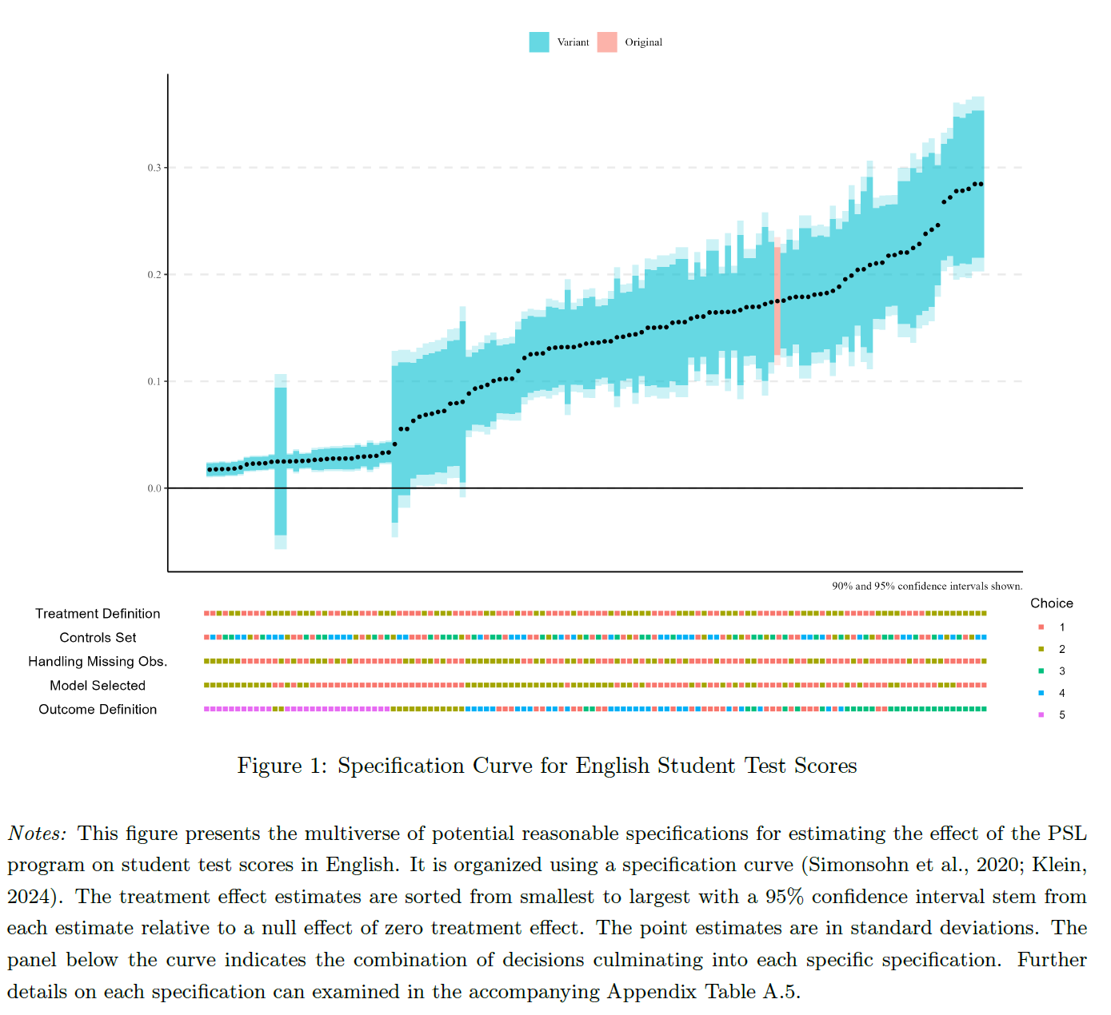
- You may also wisht to report your overall findings using the reproducibility indicators as described by:
  - Bensch, G., J. Rose, A. Brodeur, and J. Ankel-Peters (2025). The Robustness Dashboard. I4R Discussion Paper (234). [Link]
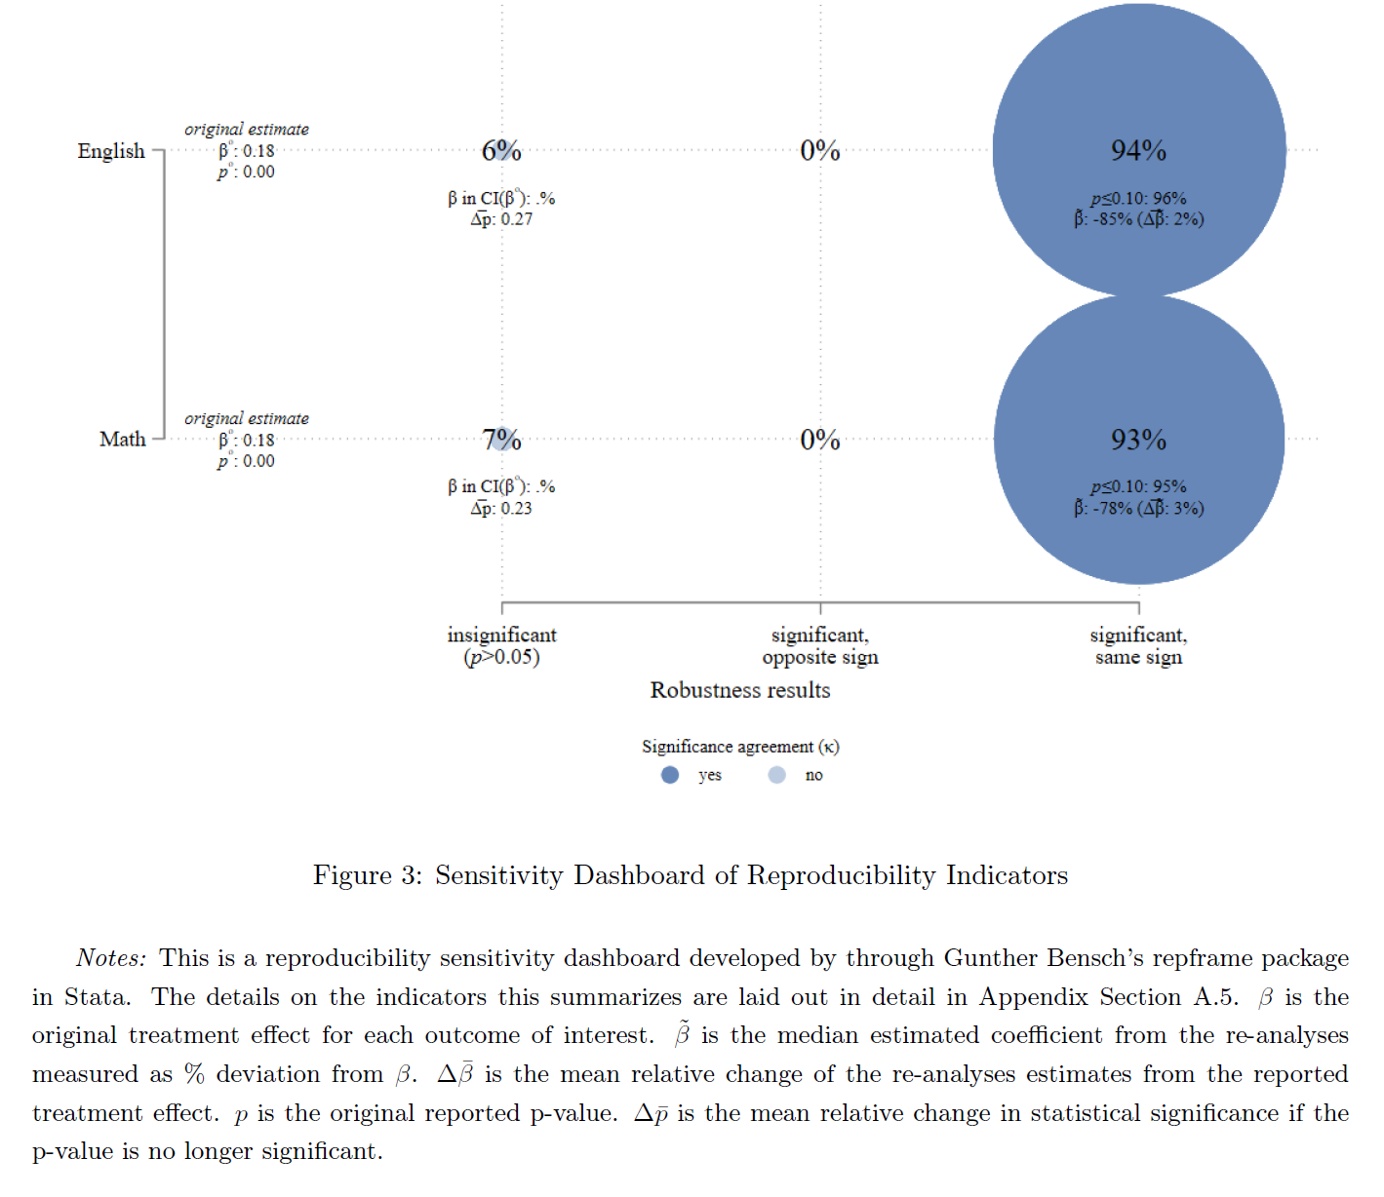
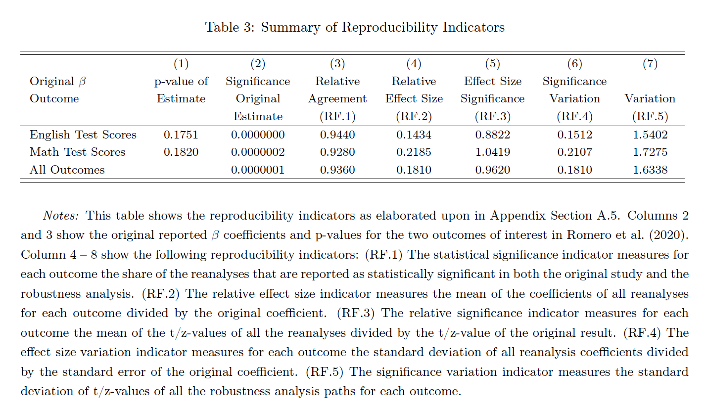

Conclusion:
- This should be very brief – maybe 1 or 2 paragraphs.
- Provide a high overview of what was replicated and the results.
- Make any final claims about the implication of this replication in the broader context of (1) the PES literature and/or (2) replications in economics.

