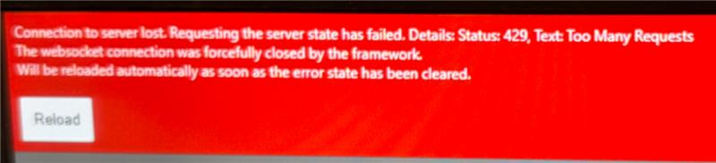
I saw this error when someone had their event grid set to 0ms update rate

