Weston Evans

IS 345-54

Project 3 Final Draft

March 4, 2023

**Project 3: Weather Analysis V3**

My source code was too large to paste with proper formatting, so I’ve provided links to my GitHub. The followings link will take you directly to the source code for each form. Full operating instructions are included in the header of form1.cs. Feel free to explore the project in general from there if you wish. A video link is included on page 2 of me creating a new database, adding records, and filtering the database based on my input. Thank you.

**Source Code: Form1.cs**

<https://github.com/mcworkaholic/IS345-WeatherApp/blob/PC/Form1.cs>

**Source Code: Form2.cs**

<https://github.com/mcworkaholic/IS345-WeatherApp/blob/PC/Form2.cs>

**Source Code: Form3.cs**

<https://github.com/mcworkaholic/IS345-WeatherApp/blob/PC/Form3.cs>

**Source Code: Form4.cs**

<https://github.com/mcworkaholic/IS345-WeatherApp/blob/PC/Form4.cs>

**Source Code: Form5.cs**

<https://github.com/mcworkaholic/IS345-WeatherApp/blob/PC/Form5.cs>

**Video link**

<https://mnscu-my.sharepoint.com/:v:/g/personal/km1133yg_go_minnstate_edu/EV3PrUie9klIkkPEedfyaGwB6tJsmG1T3oHB_FPn0NU8Hg?e=WGIyoJ>

**Runtime Screenshots(Next Pages)**

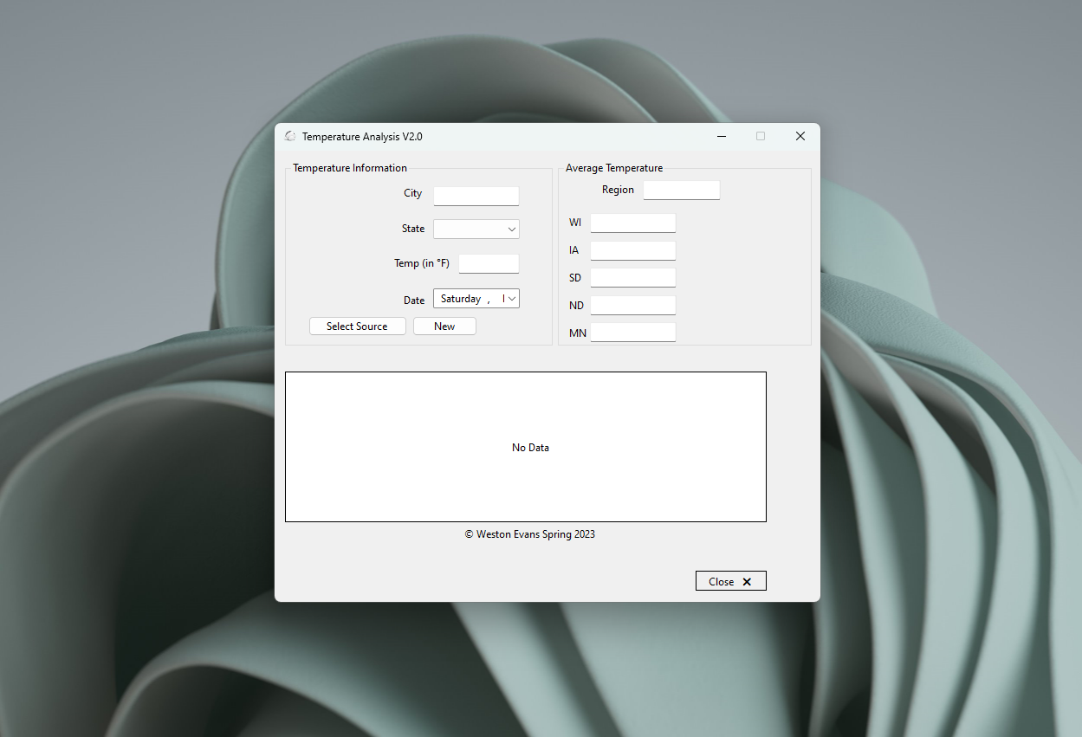

Form 1 load

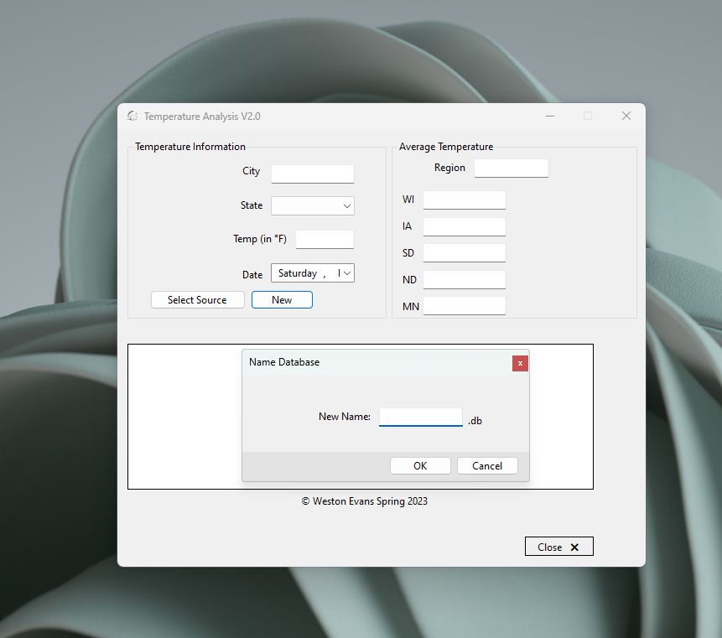

Database creation after clicking “new” button

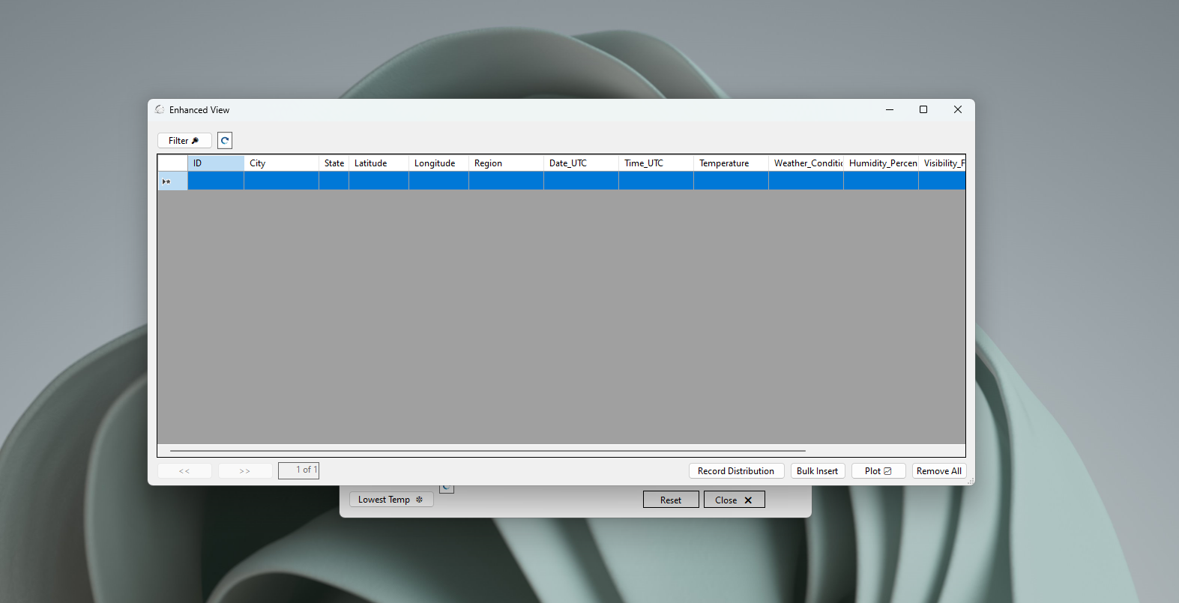

Showing empty database after clicking “more” button

Showing empty map after clicking “record distribution” button

Showing filtering after clicking on “filter” button, fully expanded options