上传文件

hadoop fs -put /root/class_students_utf8.csv /

hadoop fs -put /root/ddf-data.csv /

hadoop fs -put /root/destination.csv /

执行jar包

hadoop jar task1.jar com.example.MainClass /class_students.csv /task1ans

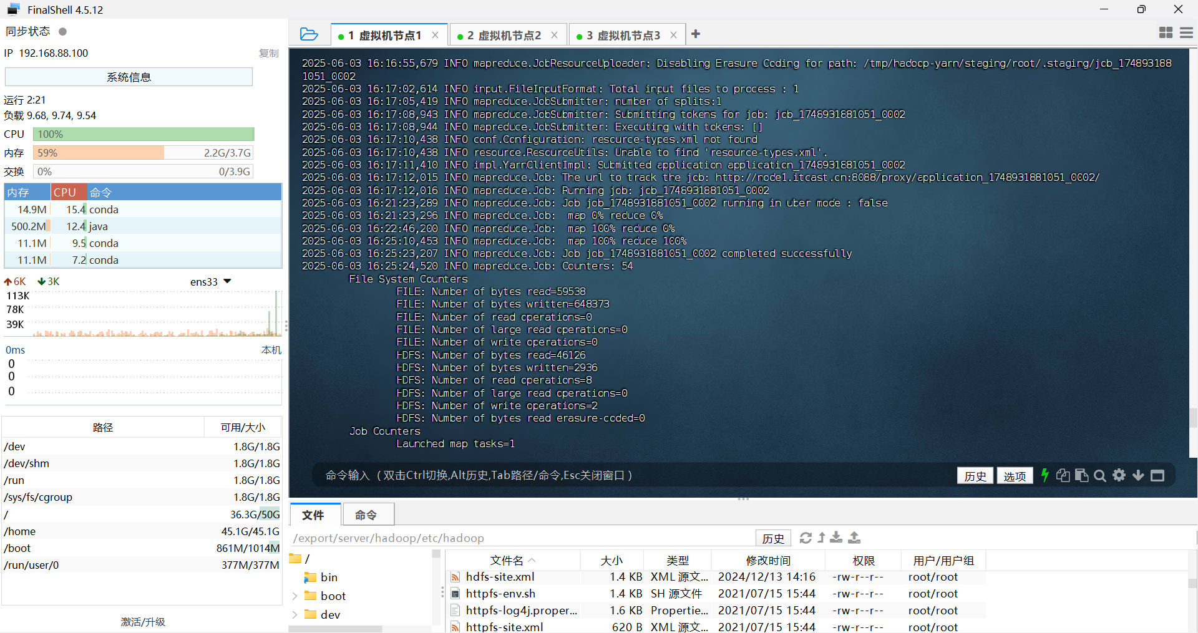

hadoop jar task2.jar com.example.MainClass /ddf-data.csv /task2ans

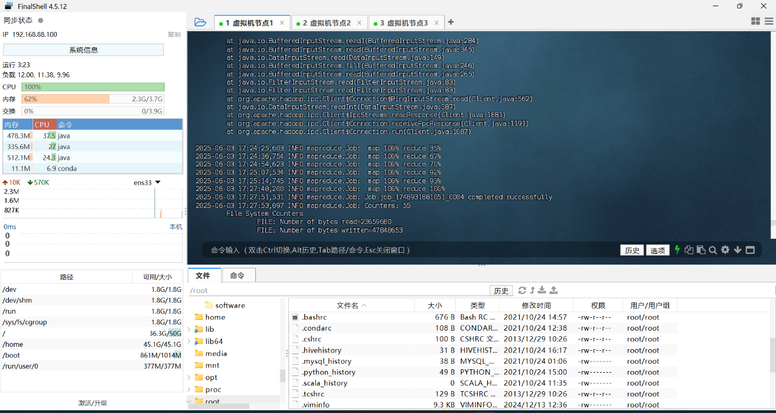

hadoop jar task3.jar com.example.MainClass /ddf-data.csv /destination.csv /task3ans

