Prepared by
Alan Richardson, AuditCo
Prepared For
Matt M Matthew McCarthy
Robertson’s Remedial and Painting Pty Ltd
10/ 56 Buffalo Road, GLADESVILLE 2111

Audit Report
Site Safet Audit
[Site Address]
[Insert Current Date]

Robertson's Remedial and Painting – Site Safety Audit Report
[Insert Site Address]
Part A
Executive Summary
[Insert Executive Summary]
Example….An inspection of the Robertson’s Remedial and Painting site at 56–58 Fraters Ave, Sans Souci was completed on 26 November 2025. The site showed solid compliance in areas such as signage, scaffold safety, emergency planning, amenities and hazardous-chemical management. However, nine items were flagged, mainly relating to powered mobile plant verification, respirable crystalline silica (RCS) controls, PPE compliance, and electrical plant record-keeping. Several issues stemmed from subcontractor practices and lack of engineering controls during tile and render removal.

Score
[Insert Score]
Example 26 / 35 (74.29%)

Open Actions Register
[Insert line items from Open Actions Register linked to the site address]

Findings
[Insert Summary of Findings from the Flagged Items in dot points]
Example below
- Powered mobile plant introduced without RPD verification. No daily pre-starts or OEM maintenance documentation.
- Workers removing tiles/render were not initially wearing P2 respirators.
- Silica controls for tile/bed removal non-compliant – no wet suppression used. Under WHS Regulation 529B(1), this activity requires at least one engineering control—wet suppression, on-tool extraction, or local exhaust ventilation—before Respiratory Protective Equipment (RPE) is used. Relying on P2 masks alone is non-compliant and only satisfies 529B(c).
- Required RCS danger signage not displayed during demolition-hammer activities.
- Electrical equipment lacked supporting inspection/maintenance records.

Part B

Example format below

RPD - Site Safety Inspections
Alan Richardson | Complete

Score | 26 / 35 (74.29%) | Flagged items | 9 | Actions | 0

Site conducted | 56-58 Fraters Ave Sans Souci

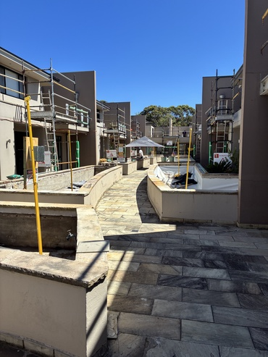
Photo 1

Prepared by | Alan Richardson

Date of inspection | 26 Nov 2025 10:30 AEDT

Flagged items | 9 flagged

Site Inspection / Planning and risk management (project value >$250K)
Is there continual review, and if necessary revision of control measures to ensure they remain effective, including when:  - a control measure is not effectively controlling the risk?  - a new hazard or risk is identified?  - a change at the workplace or in the way work is carried out gives rise to a new or different health and safety risk?  (WHS Reg 38 and WHS Regs 299–303 SWMS non-compliance) | Non-Compliant

A motorised ride-on tracked wheelbarrow dumper (powered mobile plant) was introduced to the project at 56–58 Fraters Ave, Sans Souci by a subcontractor, not RPD. The Project Manager identified the risk and issued a site alert through 1Breadcrumb, notifying workers of the new plant and the associated traffic and pedestrian interaction risks.
This action satisfies part of RPD’s WHS duties—specifically the requirement to inform workers about new hazards (WHS Reg 39) and to communicate interaction risks involving powered mobile plant (WHS Reg 214–215).
However, issuing a site alert alone does not fully meet RPD’s obligations for managing risks associated with powered mobile plant brought onto site by subcontractors. The following duties continue to apply:
1. Verify the plant is safe to use (WHS Reg 203–215)
RPD must ensure the plant is suitable and safe before use. This includes verifying that: periodic maintenance has been completed and recorded in accordance with the OEM requirements, and daily pre-start inspections are being completed and documented by the subcontractor’s workers.
2. Verify operator competency (WHS Act s.19, WHS Reg 39)
RPD must ensure the subcontractor identifies the specific workers who will operate the dumper.
RPD must record evidence of competency through one of the following: toolbox talk record, induction note and SWMS sign-off identifying the operator(s)
3. Add the plant to the site’s Plant Register (WHS Reg 213)
The dumper must be recorded in the 1Breadcrumb Plant Register, demonstrating that RPD is monitoring inspection status, maintenance records, and plant condition as required under the plant maintenance provisions.
4. Ensure the plant is included in the relevant SWMS (WHS Reg 291–299)
Operation of the motorised dumper must be incorporated into the SWMS for the activity underway (e.g., balcony works, demolition, or material handling).
Recommendations:
Re-induct the subcontractor and their workers into the updated SWMS, including specific controls for the use of the motorised dumper on site.
Add the statement:
“The motorised ride-on tracked wheelbarrow dumper must be included in the Plant Register, operated only by nominated competent workers, and subject to documented daily pre-start checks and ongoing OEM maintenance verification.”
Record the re-induction and sign-off at the next toolbox talk.
If required, assist the subcontractor by issuing a plant inspection form, template, or digital checklist in 1Breadcrumb to ensure correct maintenance and pre-start records are captured.

Site Inspection / Planning and risk management (project value >$250K)
Clear warning signage as an administrative control is used to manage the residual risk after higher-level controls have been applied posted at all entry points (WHS Act S19 (Primary Duty) | Non-Compliant

Required RCS danger poster not displayed while demolition hammers were used on tiles/render. As this produces respirable crystalline silica (RCS), RPD must provide clear warning signage to inform workers and prevent unprotected entry, as required under WHS Reg 39 and Reg 51.
Recommendation:
Display RCS danger signage at main site entry.
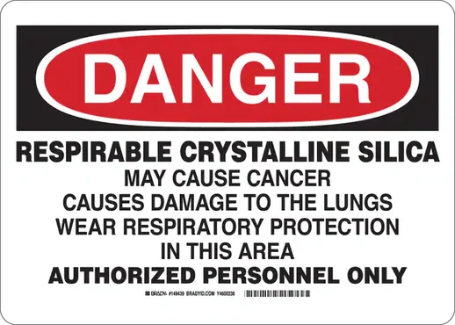 | 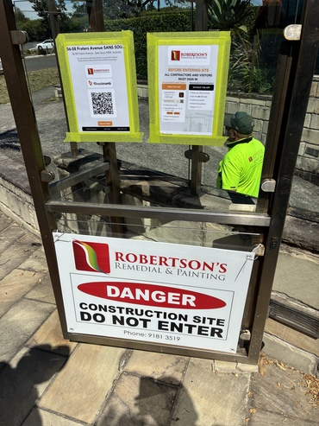  Photo 9 | 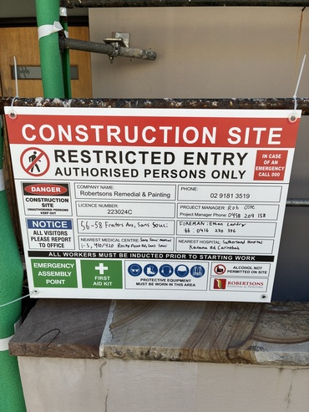  Photo 10

Site Inspection / Worker competency and PPE
All workers using PPE – long sleeve Hi-Viz shirt, safety gloves, eye protection, hearing protection, safety shoes | Non-Compliant

At the time of the audit sub-contract workers removing tiles with demolition hammers weren't wearing P2 masks. Subsequently the supervisor of sub-contract workers obtained and issued P2 masks to workers.

Site Inspection / Plant and equipment safety
Electrical equipment inspected, tested, and tagged (WHS Reg cl.150) | Non-Compliant

The test tag alone does not meet WHS record-keeping duties. To be fully compliant you must have a tag on the item (Reg. 150) and a documented register/log that records inspections, testing, maintenance, and repairs (Reg. 213 + Plant CoP)
SafeWork NSW inspectors consistently expect a test tag is a compliance indicator only and the register is evidence of compliance. If an incident occurs (shock, arc fault, damaged cord, RCD failure), a tag is not legally defensible on its own.
Temporary electrical switchboards are considered plant, same as an excavator or EWP, and Reg. 213 requires PCBUs to retain records of all inspections, maintenance and testing/repairs.
Additionally, electrical leads had tags but did not display dates.
Recommendations:
Provide register including temporary electrical switchboards and all electrical equipment. Tags to display dates.
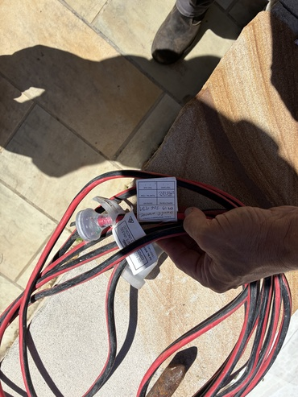  Photo 17 | 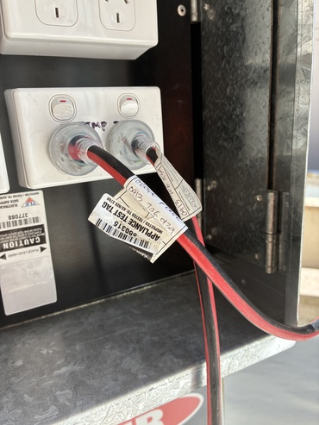  Photo 18

Site Inspection / Plant and equipment safety
Plant (e.g. swing stage scaffold / EWP / excavator) – Daily pre-start completed by operators who hold relevant HRW licence or VOC (WHS Reg Part 4.5) | Non-Compliant

A motorised ride-on tracked wheelbarrow dumper (classed as powered mobile plant) without daily pre-start.
Recommendations:
Motorised ride-on tracked wheelbarrow dumper must be included in the Plant Register and document daily pre-start checks and ongoing OEM maintenance verification.

Site Inspection / Plant and equipment safety
Periodic maintenance inspections recorded as per OEM (Original Equipment Manufacturer) (WHS Reg Part 4.5 cls 213–215 (Plant maintenance); CoP: Managing risks of plant) | Non-Compliant

A motorised ride-on tracked wheelbarrow dumper (classed as powered mobile plant) without any visible record of periodic maintenance inspection.
Recommendations:
Motorised ride-on tracked wheelbarrow dumper must be included in the Plant Register and document daily pre-start checks and ongoing OEM maintenance verification.

Site Inspection / Plant and equipment safety
Are all high-risk records readily accessible and digitally auditable at the time of audit? (WHS Reg s. 317) | Non-Compliant

Site Inspection / Hazardous substances and silica control
Control measures for silica – minimum expected controls for grinders for compliance in NSW:  -Grinder with Local Exhaust Ventilation (LEV), grinder attachment/hose, to M-class (HEPA-filtered) vacuum to trap respirable dust  -P2 respirator disposable ok (fit-tested)  -Exclusion zone  -SWMS covering silica controls  (SafeWork NSW Respirable Crystalline Silica Code of Practice 2025) | Non-Compliant

During the audit, subcontract workers removing tiles, tile beds and render with demolition hammers were not wearing P2 respirators. Although P2 masks were later issued, P2 respirators are the last line of defence and cannot be used as the primary control for silica dust.
This work meets the definition of processing a crystalline silica substance (CSS) because demolition hammers crush and break tiles and render, generating respirable crystalline silica (RCS). Under WHS Regulation 529B(1), this activity requires at least one engineering control—wet suppression, on-tool extraction, or local exhaust ventilation—before RPE is used. Relying on P2 masks alone only satisfies 529B(c) and is therefore non-compliant.
SafeWork NSW considers wet or extraction methods to be reasonably practicable in almost all circumstances, and arguments against using them are unlikely to be accepted. Arguments such as: “Wet suppression creates a slip hazard,” or “we did not instruct the subcontractor on dust-control equipment” will not be accepted by SafeWork NSW.
For the Sans Souci project, wet methods are clearly the most practicable and effective control if the subcontractor’s demolition hammers lack extraction capability. The subcontractor must be instructed to use a pump sprayer, hose with mist nozzle, or portable water-spray system to pre-wet surfaces and apply water continuously (or intermittently where appropriate) to suppress dust effectively.
Recommendations
Re-induct the subcontractor and their workers into the relevant SWMS and add the explicit control measure: “Use a pump sprayer, hose with mist nozzle, or portable water-spray system to pre-wet surfaces and maintain effective wet suppression during all demolition-hammer tile and render removal activities.”
Record the re-induction and sign-off at the next toolbox talk.
Where required, issue portable pump sprayer units to subcontractor workers to ensure the control can be implemented.

Photo 19

Site Inspection / Hazardous substances and silica control
Respiratory protection – Fit-for-purpose respirators (e.g., P2 for silica), fit-tested, issued, maintained; program complies with AS/NZS 1715 and 1716. | Non-Compliant

At the time of the audit sub-contract workers removing tiles with demolition hammers weren't wearing P2 masks. Subsequently the supervisor of sub-contract workers obtained and issued P2 masks to workers.
Recommendations:
Update the SWMS and site instructions to require wet suppression during all demolition-hammer tile removal. Re-train and re-induct subcontract workers and supervisors and verify compliance through supervision and daily checks.

Site Inspection | 9 flagged, 26 / 35 (74.29%)

Planning and risk management (project value >$250K) | 1 flagged, 12 / 13 (92.31%)

For projects > $250,000 in contract value site sign includes the required warnings company name, company phone, company licence number, emergency contact name and mobile, address of the job or project, name and address of nearest medical centre and name and address of nearest hospital | Compliant

  Photo 2 |   Photo 3

Project risk assessment completed (WHS Reg cl.34–38) | Compliant

SSMP available for project work or contract value >$250K (WHS Reg cl.309) | Compliant

QR Code displayed | Compliant

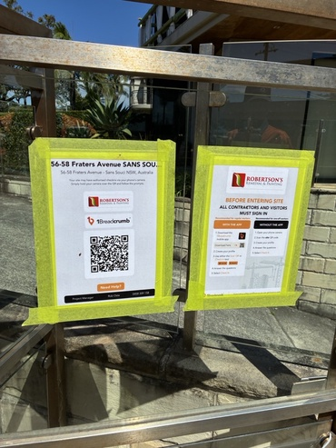  Photo 4 | 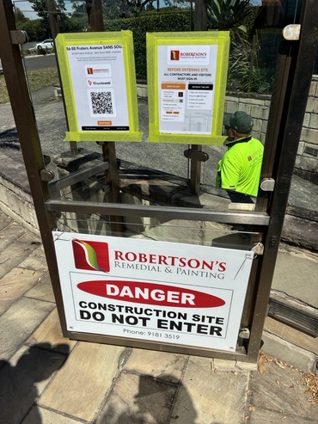  Photo 5

General site emergency plan - documented and displayed at site with nearest medical hospitality listed (WHS Reg cl.43 & 80) | Compliant

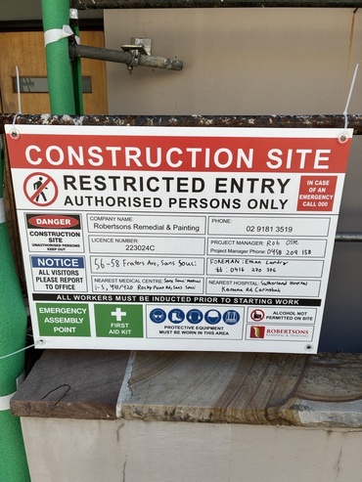
Photo 6

First aid kits - stocked and accessible; eye-wash available (WHS Reg cl.42) | Compliant

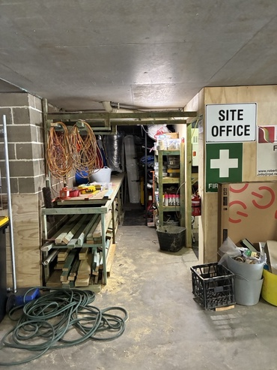
Photo 7

Neighbour and occupant notifications issued | Compliant

Worker’s amenities available for toilets and handwashing (WHS Reg cl.41) | Compliant

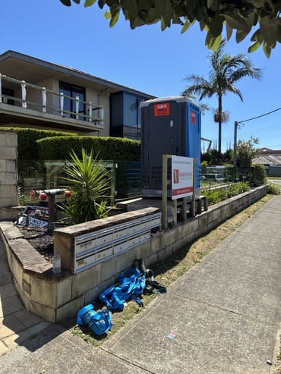
Photo 8

Clear warning signage as an administrative control is used to manage the residual risk after higher-level controls have been applied posted at all entry points (WHS Act S19 (Primary Duty) and WHS Regulation Cl. 78 & 79 (Risk of Falls)) |  |  |  |  | Non-Compliant
Required RCS danger poster not displayed while demolition hammers were used on tiles/render. As this produces respirable crystalline silica (RCS), RPD must provide clear warning signage to inform workers and prevent unprotected entry, as required under WHS Reg 39 and Reg 51.
Recommendation:
Display RCS danger signage at main site entry.
 |   Photo 9 |   Photo 10

Penetrations and balcony openings – Covered, guarded or fitted with secure covers rated for load (WHS Reg cl.78). | Compliant

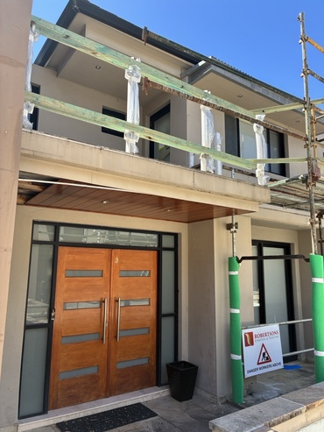
Photo 11

Is there continual review, and if necessary revision of control measures to ensure they remain effective, including when:  - a control measure is not effectively controlling the risk?  - a new hazard or risk is identified?  - a change at the workplace or in the way work is carried out gives rise to a new or different health and safety risk?  (WHS Reg 38 and WHS Regs 299–303 SWMS non-compliance) | Non-Compliant

A motorised ride-on tracked wheelbarrow dumper (powered mobile plant) was introduced to the project at 56–58 Fraters Ave, Sans Souci by a subcontractor, not RPD. The Project Manager identified the risk and issued a site alert through 1Breadcrumb, notifying workers of the new plant and the associated traffic and pedestrian interaction risks.
This action satisfies part of RPD’s WHS duties—specifically the requirement to inform workers about new hazards (WHS Reg 39) and to communicate interaction risks involving powered mobile plant (WHS Reg 214–215).
However, issuing a site alert alone does not fully meet RPD’s obligations for managing risks associated with powered mobile plant brought onto site by subcontractors. The following duties continue to apply:
1. Verify the plant is safe to use (WHS Reg 203–215)
RPD must ensure the plant is suitable and safe before use. This includes verifying that: periodic maintenance has been completed and recorded in accordance with the OEM requirements, and daily pre-start inspections are being completed and documented by the subcontractor’s workers.
2. Verify operator competency (WHS Act s.19, WHS Reg 39)
RPD must ensure the subcontractor identifies the specific workers who will operate the dumper.
RPD must record evidence of competency through one of the following: toolbox talk record, induction note and SWMS sign-off identifying the operator(s)
3. Add the plant to the site’s Plant Register (WHS Reg 213)
The dumper must be recorded in the 1Breadcrumb Plant Register, demonstrating that RPD is monitoring inspection status, maintenance records, and plant condition as required under the plant maintenance provisions.
4. Ensure the plant is included in the relevant SWMS (WHS Reg 291–299)
Operation of the motorised dumper must be incorporated into the SWMS for the activity underway (e.g., balcony works, demolition, or material handling).
Recommendations
Re-induct the subcontractor and their workers into the updated SWMS, including specific controls for the use of the motorised dumper on site.
Add the statement:
“The motorised ride-on tracked wheelbarrow dumper must be included in the Plant Register, operated only by nominated competent workers, and subject to documented daily pre-start checks and ongoing OEM maintenance verification.”
Record the re-induction and sign-off at the next toolbox talk.
If required, assist the subcontractor by issuing a plant inspection form, template, or digital checklist in 1Breadcrumb to ensure correct maintenance and pre-start records are captured.

Has a safe system been implemented for the collection, storage, and disposal of waste? | Compliant

Are all high-risk records readily accessible and digitally auditable (WHS Reg s. 317) | Compliant

Worker competency and PPE | 1 flagged, 3 / 4 (75%)

Have all workers completed a: site induction (copy of White Card retained and verified), SWMS induction, toolbox talk and been approved to commence work on site (WHS Act s.19 PCBU must ensure only authorised persons undertake work on site. WHS Reg cl. 39 and 299) | Compliant

Operators of powered mobile plant are competent (SOA or VOC) to operate the specific type of plant being used? (WHS Act s.19, WHS Reg cl 39 (Information, training & instruction); CoP: Managing risks of plant) | Compliant

All workers using PPE – long sleeve Hi-Viz shirt, safety gloves, eye protection, hearing protection, safety shoes | Non-Compliant

At the time of the audit sub-contract workers removing tiles with demolition hammers weren't wearing P2 masks. Subsequently the supervisor of sub-contract workers obtained and issued P2 masks to workers.

Are all high-risk records readily accessible and digitally auditable at the time of audit? (WHS Reg s. 317) | Compliant

General work at height | 7 / 7 (100%)

Is a Work at Height Risk Assessment / SWMS in place for all activities above 2 mt? | Compliant

Is the work at height hierarchy of controls applied (eliminate > prevent > position > arrest)? | Compliant

Are guardrails installed 900–1100 mm above surface with midrail & toeboard/screen? | Compliant

Has scaffolding been erected by a HRW lic. person, certified/tagged (green) after inspection in accordance with AS/NZS 1576 and AS 4576 and re-inspected within the last 30 days? Are all high-risk records readily accessible and digitally auditable at the time of audit? (WHS Reg s. 317) | Compliant

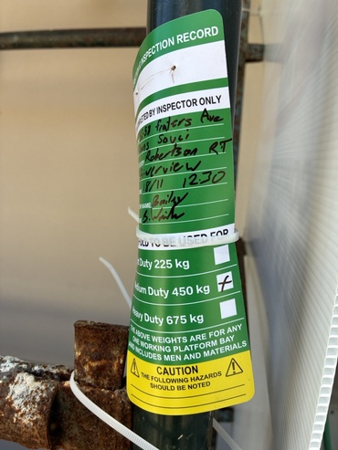  Photo 15 | 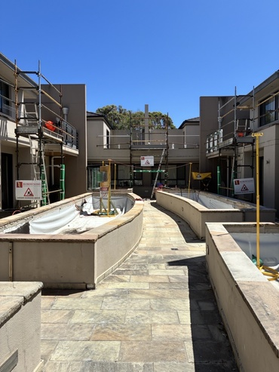  Photo 16

Scaffold assessment:  - Appropriately supported on ground  - Working decks complete, with no missing ledgers, planks or hop-ups  - Handrails and mid-rails installed  - Toe boards/brick guards installed  - Ties vertically: every 4 mt or 3mt for heavy-duty scaffolds  - Tie horizontally: minimum every second bay  - Adequate diagonal bracing  - Safe access/egress to scaffold decks  - Gaps between working the deck and building edges less than 225mm  - Materials or debris kept ≥2 mt from unprotected edges to avoid trip-and-fall hazards  - Loads placed on the scaffold within its rated capacity  - Has the scaffold ONLY been altered by HRW licenced scaffolder | Compliant

Access ladders / stairs secured, extend 1 m above landing, set on firm base; and not within 2 m of edge/void? (WHS Reg cl.78). | Compliant

Are all high-risk records readily accessible and digitally auditable at the time of audit? (WHS Reg s. 317) | Compliant

Plant and equipment safety | 4 flagged, 1 / 5 (20%)

Electrical equipment inspected, tested, and tagged (WHS Reg cl.150) | Non-Compliant

The test tag alone does not meet WHS record-keeping duties. To be fully compliant you must have a tag on the item (Reg. 150) and a documented register/log that records inspections, testing, maintenance, and repairs (Reg. 213 + Plant CoP)
SafeWork NSW inspectors consistently expect a test tag is a compliance indicator only and the register is evidence of compliance. If an incident occurs (shock, arc fault, damaged cord, RCD failure), a tag is not legally defensible on its own.
Temporary electrical switchboards are considered plant, same as an excavator or EWP, and Reg. 213 requires PCBUs to retain records of all inspections, maintenance and testing/repairs.
Additionally, electrical leads had tags but did not display dates.
Recommendation:
Provide register including temporary electrical switchboards and all electrical equipment. Tags to display dates.
  Photo 17 |   Photo 18

Guards on machinery or tools where there is risk of injury (WHS Regulation: Part 3.1 - Plant and CoP Managing the Risks of Plant in the Workplace) | Compliant

Plant (e.g. swing stage scaffold / EWP / excavator) – Daily pre-start completed by operators who hold relevant HRW licence or VOC (WHS Reg Part 4.5) | Non-Compliant

A motorised ride-on tracked wheelbarrow dumper (classed as powered mobile plant) without daily pre-start.
Recommendations
Motorised ride-on tracked wheelbarrow dumper must be included in the Plant Register and document daily pre-start checks and ongoing OEM maintenance verification.

Periodic maintenance inspections recorded as per OEM (Original Equipment Manufacturer) (WHS Reg Part 4.5 cls 213–215 (Plant maintenance); CoP: Managing risks of plant) | Non-Compliant

A motorised ride-on tracked wheelbarrow dumper (classed as powered mobile plant) without any visible record of periodic maintenance inspection.
Recommendations
Motorised ride-on tracked wheelbarrow dumper must be included in the Plant Register and document daily pre-start checks and ongoing OEM maintenance verification.

Are all high-risk records readily accessible and digitally auditable at the time of audit? (WHS Reg s. 317) | Non-Compliant

Hazardous substances and silica control | 2 flagged, 3 / 5 (60%)

Hazard identification – All hazardous products on site (primers, membranes, adhesives, sealants, cleaners) identified and recorded in a register (WHS Reg cl.346). | Compliant

Safety Data Sheets (SDS) – Current (≤5 yrs old), readily accessible for each chemical inc. water-based paint or membranes (WHS Reg cl.344). | Compliant

Control measures for silica – minimum expected controls for grinders for compliance in NSW:  -Grinder with Local Exhaust Ventilation (LEV), grinder attachment/hose, to M-class (HEPA-filtered) vacuum to trap respirable dust  -P2 respirator disposable ok (fit-tested)  -Exclusion zone  -SWMS covering silica controls  (SafeWork NSW Respirable Crystalline Silica Code of Practice 2025) | Non-Compliant

During the audit, subcontract workers removing tiles, tile beds and render with demolition hammers were not wearing P2 respirators. Although P2 masks were later issued, P2 respirators are the last line of defence and cannot be used as the primary control for silica dust.
This work meets the definition of processing a crystalline silica substance (CSS) because demolition hammers crush and break tiles and render, generating respirable crystalline silica (RCS). Under WHS Regulation 529B(1), this activity requires at least one engineering control—wet suppression, on-tool extraction, or local exhaust ventilation—before RPE is used. Relying on P2 masks alone only satisfies 529B(c) and is therefore non-compliant.
SafeWork NSW considers wet or extraction methods to be reasonably practicable in almost all circumstances, and arguments against using them are unlikely to be accepted. Arguments such as: “Wet suppression creates a slip hazard,” or “we did not instruct the subcontractor on dust-control equipment” will not be accepted by SafeWork NSW.
For the Sans Souci project, wet methods are clearly the most practicable and effective control if the subcontractor’s demolition hammers lack extraction capability. The subcontractor must be instructed to use a pump sprayer, hose with mist nozzle, or portable water-spray system to pre-wet surfaces and apply water continuously (or intermittently where appropriate) to suppress dust effectively.
Recommendations
Re-induct the subcontractor and their workers into the relevant SWMS and add the explicit control measure: “Use a pump sprayer, hose with mist nozzle, or portable water-spray system to pre-wet surfaces and maintain effective wet suppression during all demolition-hammer tile and render removal activities.”
Record the re-induction and sign-off at the next toolbox talk.
Where required, issue portable pump sprayer units to subcontractor workers to ensure the control can be implemented.

Photo 19

Respiratory protection – Fit-for-purpose respirators (e.g., P2 for silica), fit-tested, issued, maintained; program complies with AS/NZS 1715 and 1716. | Non-Compliant

At the time of the audit sub-contract workers removing tiles with demolition hammers weren't wearing P2 masks. Subsequently the supervisor of sub-contract workers obtained and issued P2 masks to workers.

Are all high-risk records readily accessible and digitally auditable at the time of audit? (WHS Reg s. 317) | Compliant

Offices in Sydney, Melbourne, Brisbane and Newcastle

Auditors located across 20+ locations Australia-wide
Connect with us anytime via these contact details:

1300 706 491

www.auditco.com

info@auditco.com

