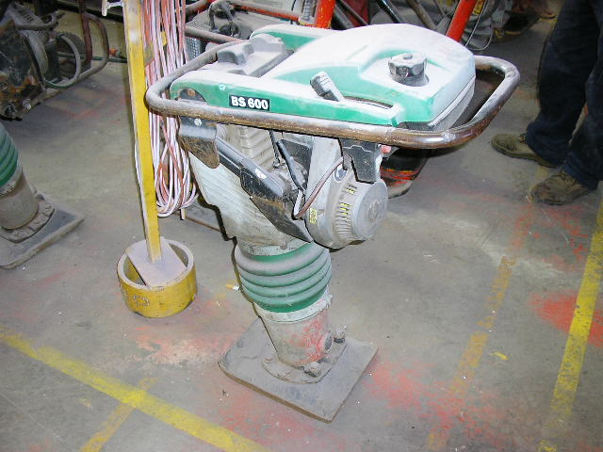 | Hazard Information Sheet
  Equipment: | Compaction
 | Equip Type: | Wackers - Rammers
 | Generic Description or  Specific Make / Model: | Rammers
 | Type: | Petrol/Diesel
 | Other Details

Operator Requirements: | Operators must be trained and competent to use this equipment safely.
Purpose For Which This Equip Is Designed: | A pedestrian operated machine designed to compact soil in narrow trenches and around obstacles such as columns

Hazards & Risks:
Control Measures:
Striking (Hitting):  If not held firmly, equip can move and hit toes or feet of operator or bystanders. | (i) When in use, hold equip firmly with both hands and keep feet clear of ‘stamping foot’ on machine.  (ii) Operator to wear appropriate protective footwear. (iii) Keep work area clear of bystanders.
High Temperature or Fire:  Refuelling: When refuelling, sparks, flames, hot engine can ignite fuel. | Before refuelling, operator to shut down engine. When refuelling ensure that there are no naked flames in the area.  DO NOT SMOKE. Avoid spilling fuel and collect any fuel run off.
Manual Handling:  Body strain if equip requires manual lifting. | Ask for assistance to lift or carry the machine. Keep a straight back when lifting and use leg muscles to take weight of machine.
Noise:  Exposure to noise. | Personnel working with or in the vicinity of this equipment to wear suitable hearing protection.
Suffocation:  Use in a confined space can cause asphyxiation. | Operator/user responsible to use machine in well ventilated area.

Disclaimer: In fulfilment of its statutory obligations, (ARS) & John Holland has taken what it considers to be all reasonable precautions and exercised due diligence to ensure that it has provided all relevant information on the safe use of the plant. However, except as required by law and only to the extent so required, (ARS) & John Holland does not make any representation, warranty or undertaking, express or implied, as to, or accept any responsibility or liability for, the accuracy or completeness of, or any errors in or omissions from, this Hazard Information Sheet. Except as required by law and only to the extent so required, neither (ARS) & John Holland nor any of its respective directors, officers, agents, or employees shall in any way be liable directly or indirectly to any person or body for any loss or damages, costs or expenses whatever arising out of or in connection with the information contained in this Hazard Information Sheet. | Date: 19/06/06

