nresult ：0 表示成功

result：1 表示失败

根目录：

<http://localhost:8888/inspection/web/webAction>

例如对于登陆接口的测试：

<http://localhost:8888/inspection/web/webAction!interlogin.action?iuname=zhangsan&iupwd=123>

1.登陆接口

方法名称：interlogin

参数：iuname，iupwd

备注：用户名字： iuname

用户密码： iupwd

响应值：

成功，返回值如下

{

"inspectUserVo": {

"entid": 0,

"groupid": "2",

"groupname": "第一班组",

"id": 2,

"iudesc": "",

"iumobile": "13543456765",

"iuname": "李四",

"iunumber": "00002",

"iupwd": "123",

"iusex": "男",

"page": 0,

"rows": 0

},

"result": 0

}

解释：此为一个InspectUserVo对象，

id //主键

entid; // 企业ID

iunumber;//编号

iuname;//名称

iupwd;//密码

iusex;//性别

iumobile;//手机

iudesc;//描述

tgroupid;//所属班组id

groupname//所属班组名称

page;// 当前页

rows;// 每页显示记录数

失败：

{

"result": 1

}

2．注销

方法名称interloginOut

参数puid

备注：puid为巡检对象主键id

id（主键）

响应

成功：

{

"result": 0

}

失败：

{

"result": 1

}

3修改密码

方法名称 intereditTerminalPassword

参数：puid ，iupwd

备注：puid为巡检对象主键id

响应：

成功：

{

"result": 0

}

失败：

{

"result": 1

}

4．任务查询

方法名称：interfindTask

参数：puid

备注：巡检对象主键id

响应

成功：

{

"TPlanTaskVoList": [

{

"entid": 0,

"id": 133,

"lineVoList": [

{

"entid": 0,

"id": 1,

"ldesc": "",

"lname": "地铁8号线",

"lnumber": "L8",

"lorder": 0,

"page": 0,

"pointList": [

{

"elist": [],

"entid": 0,

"equipmentList": [

{

"eaddress": "",

"efactory": "苹果",

"ename": "管线",

"entid": 0,

"enumber": "gx001",

"eposx": 0,

"eposy": 0,

"erfid": "",

"etwocodeid": "",

"etype": "进口",

"id": 2,

"page": 0,

"projectList": [

{

"entid": 0,

"id": 1,

"page": 0,

"pdesc": "记录管线温度222222",

"pmaxvalue": "2",

"pminvalue": "2",

"pname": "管线温度",

"pstatus": "异常",

"ptype": "记录类",

"pvalue": "dd",

"rows": 0

}

],

"rows": 0,

"sdesc": ""

}

],

"id": 4,

"page": 0,

"poaddress": "江浦路2号口",

"podesc": "",

"poname": "江浦路",

"ponumber": "L002",

"poposx": 121.466849,

"poposy": 31.231249,

"rows": 0

},

{

"elist": [],

"entid": 0,

"equipmentList": [

{

"eaddress": "上海铁岭路32号",

"efactory": "电信",

"ename": "变压器",

"entid": 0,

"enumber": "by001",

"eposx": 0,

"eposy": 0,

"erfid": "",

"etwocodeid": "1",

"etype": "国产",

"id": 1,

"page": 0,

"projectList": [],

"rows": 0,

"sdesc": ""

},

{

"eaddress": "",

"efactory": "苹果",

"ename": "管线",

"entid": 0,

"enumber": "gx001",

"eposx": 0,

"eposy": 0,

"erfid": "",

"etwocodeid": "",

"etype": "进口",

"id": 2,

"page": 0,

"projectList": [

{

"entid": 0,

"id": 1,

"page": 0,

"pdesc": "记录管线温度222222",

"pmaxvalue": "2",

"pminvalue": "2",

"pname": "管线温度",

"pstatus": "异常",

"ptype": "记录类",

"pvalue": "dd",

"rows": 0

}

],

"rows": 0,

"sdesc": ""

}

],

"id": 3,

"page": 0,

"poaddress": "南京东路300号",

"podesc": "融入",

"poname": "南京路步行街",

"ponumber": "XL003",

"poposx": 121.489845,

"poposy": 31.228408,

"rows": 0

},

{

"elist": [],

"entid": 0,

"equipmentList": [],

"id": 2,

"page": 0,

"poaddress": "铁岭路32号",

"podesc": "死东风公司饭店",

"poname": "同业大厦",

"ponumber": "XL002",

"poposx": 121.483485,

"poposy": 31.22708,

"rows": 0

}

],

"rows": 0

}

],

"pdesc": "sSs",

"penddate": "2013-07-02",

"pendtime": "16:42:30",

"pgid": 0,

"plineid": 1,

"pname": "abc",

"pstartdate": "2013-07-02",

"pstarttime": "00:00:00",

"pstatus": 0,

"ptype": 0,

"puid": 2

},

{

"entid": 0,

"id": 134,

"lineVoList": [

{

"entid": 0,

"id": 1,

"ldesc": "",

"lname": "地铁8号线",

"lnumber": "L8",

"lorder": 0,

"page": 0,

"pointList": [

{

"elist": [],

"entid": 0,

"equipmentList": [

{

"eaddress": "",

"efactory": "苹果",

"ename": "管线",

"entid": 0,

"enumber": "gx001",

"eposx": 0,

"eposy": 0,

"erfid": "",

"etwocodeid": "",

"etype": "进口",

"id": 2,

"page": 0,

"projectList": [

{

"entid": 0,

"id": 1,

"page": 0,

"pdesc": "记录管线温度222222",

"pmaxvalue": "2",

"pminvalue": "2",

"pname": "管线温度",

"pstatus": "异常",

"ptype": "记录类",

"pvalue": "dd",

"rows": 0

}

],

"rows": 0,

"sdesc": ""

}

],

"id": 4,

"page": 0,

"poaddress": "江浦路2号口",

"podesc": "",

"poname": "江浦路",

"ponumber": "L002",

"poposx": 121.466849,

"poposy": 31.231249,

"rows": 0

},

{

"elist": [],

"entid": 0,

"equipmentList": [

{

"eaddress": "上海铁岭路32号",

"efactory": "电信",

"ename": "变压器",

"entid": 0,

"enumber": "by001",

"eposx": 0,

"eposy": 0,

"erfid": "",

"etwocodeid": "1",

"etype": "国产",

"id": 1,

"page": 0,

"projectList": [],

"rows": 0,

"sdesc": ""

},

{

"eaddress": "",

"efactory": "苹果",

"ename": "管线",

"entid": 0,

"enumber": "gx001",

"eposx": 0,

"eposy": 0,

"erfid": "",

"etwocodeid": "",

"etype": "进口",

"id": 2,

"page": 0,

"projectList": [

{

"entid": 0,

"id": 1,

"page": 0,

"pdesc": "记录管线温度222222",

"pmaxvalue": "2",

"pminvalue": "2",

"pname": "管线温度",

"pstatus": "异常",

"ptype": "记录类",

"pvalue": "dd",

"rows": 0

}

],

"rows": 0,

"sdesc": ""

}

],

"id": 3,

"page": 0,

"poaddress": "南京东路300号",

"podesc": "融入",

"poname": "南京路步行街",

"ponumber": "XL003",

"poposx": 121.489845,

"poposy": 31.228408,

"rows": 0

},

{

"elist": [],

"entid": 0,

"equipmentList": [],

"id": 2,

"page": 0,

"poaddress": "铁岭路32号",

"podesc": "死东风公司饭店",

"poname": "同业大厦",

"ponumber": "XL002",

"poposx": 121.483485,

"poposy": 31.22708,

"rows": 0

}

],

"rows": 0

}

],

"pdesc": "sSs",

"penddate": "2013-07-03",

"pendtime": "16:42:30",

"pgid": 0,

"plineid": 1,

"pname": "abc",

"pstartdate": "2013-07-03",

"pstarttime": "00:00:00",

"pstatus": 0,

"ptype": 0,

"puid": 2

},

{

"entid": 0,

"id": 135,

"lineVoList": [

{

"entid": 0,

"id": 1,

"ldesc": "",

"lname": "地铁8号线",

"lnumber": "L8",

"lorder": 0,

"page": 0,

"pointList": [

{

"elist": [],

"entid": 0,

"equipmentList": [

{

"eaddress": "",

"efactory": "苹果",

"ename": "管线",

"entid": 0,

"enumber": "gx001",

"eposx": 0,

"eposy": 0,

"erfid": "",

"etwocodeid": "",

"etype": "进口",

"id": 2,

"page": 0,

"projectList": [

{

"entid": 0,

"id": 1,

"page": 0,

"pdesc": "记录管线温度222222",

"pmaxvalue": "2",

"pminvalue": "2",

"pname": "管线温度",

"pstatus": "异常",

"ptype": "记录类",

"pvalue": "dd",

"rows": 0

}

],

"rows": 0,

"sdesc": ""

}

],

"id": 4,

"page": 0,

"poaddress": "江浦路2号口",

"podesc": "",

"poname": "江浦路",

"ponumber": "L002",

"poposx": 121.466849,

"poposy": 31.231249,

"rows": 0

},

{

"elist": [],

"entid": 0,

"equipmentList": [

{

"eaddress": "上海铁岭路32号",

"efactory": "电信",

"ename": "变压器",

"entid": 0,

"enumber": "by001",

"eposx": 0,

"eposy": 0,

"erfid": "",

"etwocodeid": "1",

"etype": "国产",

"id": 1,

"page": 0,

"projectList": [],

"rows": 0,

"sdesc": ""

},

{

"eaddress": "",

"efactory": "苹果",

"ename": "管线",

"entid": 0,

"enumber": "gx001",

"eposx": 0,

"eposy": 0,

"erfid": "",

"etwocodeid": "",

"etype": "进口",

"id": 2,

"page": 0,

"projectList": [

{

"entid": 0,

"id": 1,

"page": 0,

"pdesc": "记录管线温度222222",

"pmaxvalue": "2",

"pminvalue": "2",

"pname": "管线温度",

"pstatus": "异常",

"ptype": "记录类",

"pvalue": "dd",

"rows": 0

}

],

"rows": 0,

"sdesc": ""

}

],

"id": 3,

"page": 0,

"poaddress": "南京东路300号",

"podesc": "融入",

"poname": "南京路步行街",

"ponumber": "XL003",

"poposx": 121.489845,

"poposy": 31.228408,

"rows": 0

},

{

"elist": [],

"entid": 0,

"equipmentList": [],

"id": 2,

"page": 0,

"poaddress": "铁岭路32号",

"podesc": "死东风公司饭店",

"poname": "同业大厦",

"ponumber": "XL002",

"poposx": 121.483485,

"poposy": 31.22708,

"rows": 0

}

],

"rows": 0

}

],

"pdesc": "sSs",

"penddate": "2013-07-04",

"pendtime": "16:42:30",

"pgid": 0,

"plineid": 1,

"pname": "abc",

"pstartdate": "2013-07-04",

"pstarttime": "00:00:00",

"pstatus": 0,

"ptype": 0,

"puid": 2

},

{

"entid": 0,

"id": 136,

"lineVoList": [

{

"entid": 0,

"id": 1,

"ldesc": "",

"lname": "地铁8号线",

"lnumber": "L8",

"lorder": 0,

"page": 0,

"pointList": [

{

"elist": [],

"entid": 0,

"equipmentList": [

{

"eaddress": "",

"efactory": "苹果",

"ename": "管线",

"entid": 0,

"enumber": "gx001",

"eposx": 0,

"eposy": 0,

"erfid": "",

"etwocodeid": "",

"etype": "进口",

"id": 2,

"page": 0,

"projectList": [

{

"entid": 0,

"id": 1,

"page": 0,

"pdesc": "记录管线温度222222",

"pmaxvalue": "2",

"pminvalue": "2",

"pname": "管线温度",

"pstatus": "异常",

"ptype": "记录类",

"pvalue": "dd",

"rows": 0

}

],

"rows": 0,

"sdesc": ""

}

],

"id": 4,

"page": 0,

"poaddress": "江浦路2号口",

"podesc": "",

"poname": "江浦路",

"ponumber": "L002",

"poposx": 121.466849,

"poposy": 31.231249,

"rows": 0

},

{

"elist": [],

"entid": 0,

"equipmentList": [

{

"eaddress": "上海铁岭路32号",

"efactory": "电信",

"ename": "变压器",

"entid": 0,

"enumber": "by001",

"eposx": 0,

"eposy": 0,

"erfid": "",

"etwocodeid": "1",

"etype": "国产",

"id": 1,

"page": 0,

"projectList": [],

"rows": 0,

"sdesc": ""

},

{

"eaddress": "",

"efactory": "苹果",

"ename": "管线",

"entid": 0,

"enumber": "gx001",

"eposx": 0,

"eposy": 0,

"erfid": "",

"etwocodeid": "",

"etype": "进口",

"id": 2,

"page": 0,

"projectList": [

{

"entid": 0,

"id": 1,

"page": 0,

"pdesc": "记录管线温度222222",

"pmaxvalue": "2",

"pminvalue": "2",

"pname": "管线温度",

"pstatus": "异常",

"ptype": "记录类",

"pvalue": "dd",

"rows": 0

}

],

"rows": 0,

"sdesc": ""

}

],

"id": 3,

"page": 0,

"poaddress": "南京东路300号",

"podesc": "融入",

"poname": "南京路步行街",

"ponumber": "XL003",

"poposx": 121.489845,

"poposy": 31.228408,

"rows": 0

},

{

"elist": [],

"entid": 0,

"equipmentList": [],

"id": 2,

"page": 0,

"poaddress": "铁岭路32号",

"podesc": "死东风公司饭店",

"poname": "同业大厦",

"ponumber": "XL002",

"poposx": 121.483485,

"poposy": 31.22708,

"rows": 0

}

],

"rows": 0

}

],

"pdesc": "sSs",

"penddate": "2013-07-05",

"pendtime": "16:42:30",

"pgid": 0,

"plineid": 1,

"pname": "abc",

"pstartdate": "2013-07-05",

"pstarttime": "00:00:00",

"pstatus": 0,

"ptype": 0,

"puid": 2

},

{

"entid": 0,

"id": 137,

"lineVoList": [

{

"entid": 0,

"id": 1,

"ldesc": "",

"lname": "地铁8号线",

"lnumber": "L8",

"lorder": 0,

"page": 0,

"pointList": [

{

"elist": [],

"entid": 0,

"equipmentList": [

{

"eaddress": "",

"efactory": "苹果",

"ename": "管线",

"entid": 0,

"enumber": "gx001",

"eposx": 0,

"eposy": 0,

"erfid": "",

"etwocodeid": "",

"etype": "进口",

"id": 2,

"page": 0,

"projectList": [

{

"entid": 0,

"id": 1,

"page": 0,

"pdesc": "记录管线温度222222",

"pmaxvalue": "2",

"pminvalue": "2",

"pname": "管线温度",

"pstatus": "异常",

"ptype": "记录类",

"pvalue": "dd",

"rows": 0

}

],

"rows": 0,

"sdesc": ""

}

],

"id": 4,

"page": 0,

"poaddress": "江浦路2号口",

"podesc": "",

"poname": "江浦路",

"ponumber": "L002",

"poposx": 121.466849,

"poposy": 31.231249,

"rows": 0

},

{

"elist": [],

"entid": 0,

"equipmentList": [

{

"eaddress": "上海铁岭路32号",

"efactory": "电信",

"ename": "变压器",

"entid": 0,

"enumber": "by001",

"eposx": 0,

"eposy": 0,

"erfid": "",

"etwocodeid": "1",

"etype": "国产",

"id": 1,

"page": 0,

"projectList": [],

"rows": 0,

"sdesc": ""

},

{

"eaddress": "",

"efactory": "苹果",

"ename": "管线",

"entid": 0,

"enumber": "gx001",

"eposx": 0,

"eposy": 0,

"erfid": "",

"etwocodeid": "",

"etype": "进口",

"id": 2,

"page": 0,

"projectList": [

{

"entid": 0,

"id": 1,

"page": 0,

"pdesc": "记录管线温度222222",

"pmaxvalue": "2",

"pminvalue": "2",

"pname": "管线温度",

"pstatus": "异常",

"ptype": "记录类",

"pvalue": "dd",

"rows": 0

}

],

"rows": 0,

"sdesc": ""

}

],

"id": 3,

"page": 0,

"poaddress": "南京东路300号",

"podesc": "融入",

"poname": "南京路步行街",

"ponumber": "XL003",

"poposx": 121.489845,

"poposy": 31.228408,

"rows": 0

},

{

"elist": [],

"entid": 0,

"equipmentList": [],

"id": 2,

"page": 0,

"poaddress": "铁岭路32号",

"podesc": "死东风公司饭店",

"poname": "同业大厦",

"ponumber": "XL002",

"poposx": 121.483485,

"poposy": 31.22708,

"rows": 0

}

],

"rows": 0

}

],

"pdesc": "sSs",

"penddate": "2013-07-06",

"pendtime": "16:42:30",

"pgid": 0,

"plineid": 1,

"pname": "abc",

"pstartdate": "2013-07-06",

"pstarttime": "00:00:00",

"pstatus": 0,

"ptype": 0,

"puid": 2

},

{

"entid": 0,

"id": 138,

"lineVoList": [

{

"entid": 0,

"id": 1,

"ldesc": "",

"lname": "地铁8号线",

"lnumber": "L8",

"lorder": 0,

"page": 0,

"pointList": [

{

"elist": [],

"entid": 0,

"equipmentList": [

{

"eaddress": "",

"efactory": "苹果",

"ename": "管线",

"entid": 0,

"enumber": "gx001",

"eposx": 0,

"eposy": 0,

"erfid": "",

"etwocodeid": "",

"etype": "进口",

"id": 2,

"page": 0,

"projectList": [

{

"entid": 0,

"id": 1,

"page": 0,

"pdesc": "记录管线温度222222",

"pmaxvalue": "2",

"pminvalue": "2",

"pname": "管线温度",

"pstatus": "异常",

"ptype": "记录类",

"pvalue": "dd",

"rows": 0

}

],

"rows": 0,

"sdesc": ""

}

],

"id": 4,

"page": 0,

"poaddress": "江浦路2号口",

"podesc": "",

"poname": "江浦路",

"ponumber": "L002",

"poposx": 121.466849,

"poposy": 31.231249,

"rows": 0

},

{

"elist": [],

"entid": 0,

"equipmentList": [

{

"eaddress": "上海铁岭路32号",

"efactory": "电信",

"ename": "变压器",

"entid": 0,

"enumber": "by001",

"eposx": 0,

"eposy": 0,

"erfid": "",

"etwocodeid": "1",

"etype": "国产",

"id": 1,

"page": 0,

"projectList": [],

"rows": 0,

"sdesc": ""

},

{

"eaddress": "",

"efactory": "苹果",

"ename": "管线",

"entid": 0,

"enumber": "gx001",

"eposx": 0,

"eposy": 0,

"erfid": "",

"etwocodeid": "",

"etype": "进口",

"id": 2,

"page": 0,

"projectList": [

{

"entid": 0,

"id": 1,

"page": 0,

"pdesc": "记录管线温度222222",

"pmaxvalue": "2",

"pminvalue": "2",

"pname": "管线温度",

"pstatus": "异常",

"ptype": "记录类",

"pvalue": "dd",

"rows": 0

}

],

"rows": 0,

"sdesc": ""

}

],

"id": 3,

"page": 0,

"poaddress": "南京东路300号",

"podesc": "融入",

"poname": "南京路步行街",

"ponumber": "XL003",

"poposx": 121.489845,

"poposy": 31.228408,

"rows": 0

},

{

"elist": [],

"entid": 0,

"equipmentList": [],

"id": 2,

"page": 0,

"poaddress": "铁岭路32号",

"podesc": "死东风公司饭店",

"poname": "同业大厦",

"ponumber": "XL002",

"poposx": 121.483485,

"poposy": 31.22708,

"rows": 0

}

],

"rows": 0

}

],

"pdesc": "sSs",

"penddate": "2013-07-07",

"pendtime": "16:42:30",

"pgid": 0,

"plineid": 1,

"pname": "abc",

"pstartdate": "2013-07-07",

"pstarttime": "00:00:00",

"pstatus": 0,

"ptype": 0,

"puid": 2

}

],

"result": 0

}

备注：返回的是一个TPlanTaskVo的list对象TPlanTaskVoList，对象如下图所示

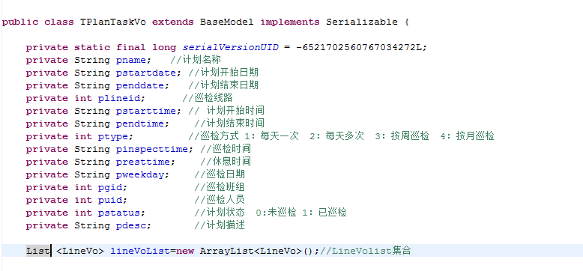

其父类BaseModel对象如下图所示：

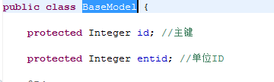

LineVo队对象如下所示

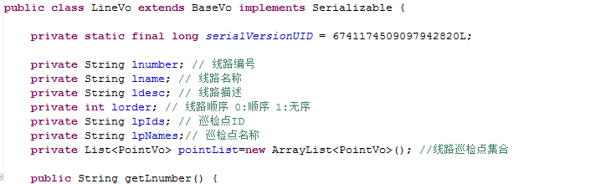

Base对象如下

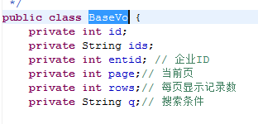

上图中的PointVo对象如下图所示：

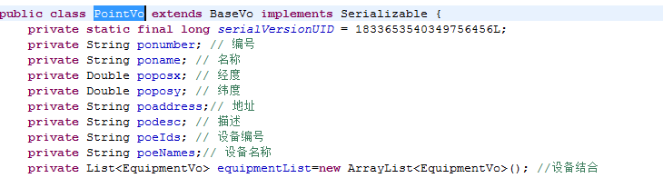

上图中的EquipmentVo如下图所示

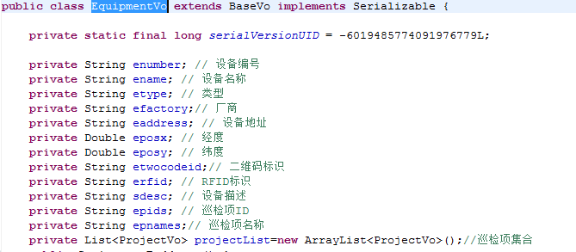

上图中的ProjectVo如下图所示

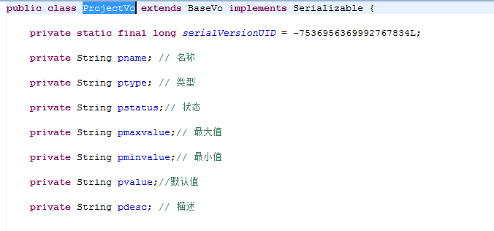

失败：

{

"result": 1

}

5. 终端巡检数据提交

方法名称interterminalData

参数：xlid，xuid，xpid，xequtnum，xterid，xproid，xmaxvalue，xminvalue，xvalue，xdesc，

备注： xlid//巡检线路id

xpid//巡检点id

xuid//巡检员id

xequtnum//设备编号

xterid//巡检终端编号

xproid// 巡检项Id

xmaxvalue;// 最大值

xminvalue; // 最小值

xvalue // 默认值

xdesc // 描述

xequtnum//状态

响应

成功：

{

"result:": 0

}

失败：

{

"result": 1

}

6终端拍照上传

方法名：interterminalPicture

参数：File对象

xproid //项目Id

xequtnum //设备编号

xterid //巡检终端编号

xuid //巡检员id

xlid //巡检线路id

响应

成功：

{

"result:": 0

}

失败：

{

"result": 1

}

7 设备信息初始化

方法名称：interequipmentInit

参数：

enumber //设备编号

twoDimensionCodeId //二维码id

响应

成功：

{

"result:": 0

}

失败：

{

"result": 1

}

8.gps数据提交

方法名称：interterminalGPS

参数：

rpterminalid 终端id

rplineid 线路id

rpposx 纬度

rpposy 经度

rpuserid 用户id

rpgroupid 组id

响应

成功：

{

"result:": 0

}

失败：

{

"result": 1

}