QAQC of the CINP ASSP 1994 - 2018 CPUE data

EKelsey

4/10/2020

Load libraries

library(dplyr)

## Warning: package 'dplyr' was built under R version 3.6.1

##   
## Attaching package: 'dplyr'

## The following objects are masked from 'package:stats':  
##   
## filter, lag

## The following objects are masked from 'package:base':  
##   
## intersect, setdiff, setequal, union

library(ggplot2)

## Warning: package 'ggplot2' was built under R version 3.6.1

Load data and add columns neccessary for QAQC:

metadata <- read.csv('~/WERC-SC/ASSP_share/ASSP_4_metadata_CPUE_20200325.csv') %>%   
 mutate_at(c("App_sunset", "std_ending"), .funs = ~as.POSIXct(., format="%m/%d/%Y %H:%M")) %>%   
 mutate_at(c("net_open_1", "net_close_1", "net_open_2", "net_close_2", "net_open_3",  
 "net_close_3", "net_open_4", "net_close_4", "net_open_5", "net_close_5"),  
 .funs = ~as.POSIXct(., format="%Y-%m-%d %H:%M:%S")) %>%  
 mutate_at(c("App_sunset", "std_ending", "net_open_1", "net_close_1"),   
 .funs = list(time = ~ hms::as_hms(.))) %>%   
 mutate(CPUE_ratio = CPUEstd/CPUEraw) %>%   
 filter(TRUE)

## Graphical check of App_sunset

### Plotted by month

ggplot(metadata, aes(month, App_sunset_time)) +  
 geom_point(aes(color = year)) +  
 scale_color_gradient(low="purple", high="orange") +  
 theme_bw()

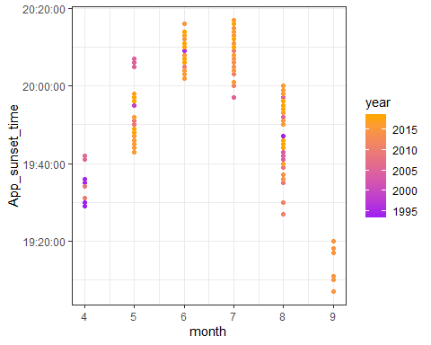

## Graphical check of Std_ending

### Plotted by month

ggplot(metadata, aes(month, std_ending_time)) +  
 geom_point(aes(color = year)) +  
 scale_color_gradient(low="black", high="light blue") +  
 theme_bw()

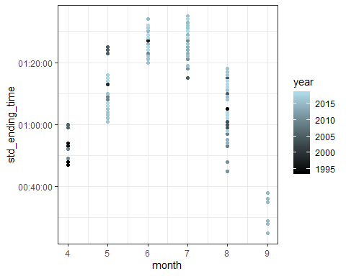

Summarize net_open and net_close (not perfect because don’t account for next-day effort)

# first (and usually only) net open time  
summary(as.POSIXct(metadata$net_open_1_time))

## Min. 1st Qu. Median   
## "1970-01-01 00:00:00" "1970-01-01 20:45:00" "1970-01-01 21:02:30"   
## Mean 3rd Qu. Max.   
## "1970-01-01 20:33:23" "1970-01-01 21:36:00" "1970-01-01 23:35:00"   
## NA's   
## "22"

# first (and usually only) net close time  
summary(as.POSIXct(metadata$net_close_1_time))

## Min. 1st Qu. Median   
## "1970-01-01 00:00:00" "1970-01-01 01:24:00" "1970-01-01 02:00:00"   
## Mean 3rd Qu. Max.   
## "1970-01-01 03:37:47" "1970-01-01 02:17:30" "1970-01-01 23:59:00"   
## NA's   
## "21"

# —

## Total mistnetting minutes per session

library(ggplot2)  
ggplot(metadata, aes(min)) +  
 geom_histogram(binwidth = 10) +  
 theme_bw()

## Warning: Removed 22 rows containing non-finite values (stat_bin).

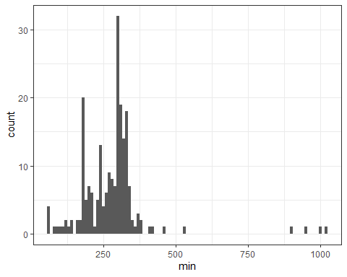

# summary of total mistnetting minutes  
summary(metadata$min)

## Min. 1st Qu. Median Mean 3rd Qu. Max. NA's   
## 56.0 214.0 293.0 280.3 316.0 1022.0 22

## Total mistnetting standard minutes per session

### from start until end or standard ending, whichever came first

ggplot(metadata, aes(min_std)) +  
 geom_histogram(binwidth = 10) +  
 theme_bw()

## Warning: Removed 22 rows containing non-finite values (stat_bin).

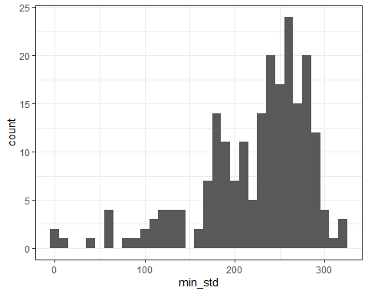

# summary of mistnetting minutes cut to standard ending time  
summary(metadata$min_std)

## Min. 1st Qu. Median Mean 3rd Qu. Max. NA's   
## 0.0 189.0 239.6 223.0 267.3 317.1 22

## Compare min vs. min_std for each session

library(ggplot2)  
ggplot(metadata, aes(min, min_std)) +  
 geom_point() +  
 theme_bw()

## Warning: Removed 22 rows containing missing values (geom_point).

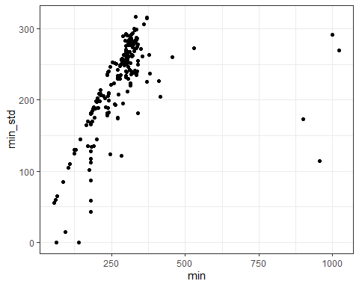

# —

## Histogram of total ASSP caught per session

ggplot(metadata, aes(ASSP)) +  
 geom_histogram(binwidth = 1) +  
 theme_bw()

## Warning: Removed 27 rows containing non-finite values (stat_bin).

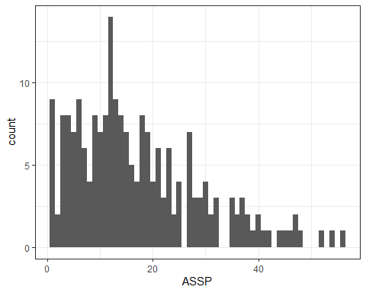

# summary of ASSP catches  
summary(metadata$ASSP)

## Min. 1st Qu. Median Mean 3rd Qu. Max. NA's   
## 1.00 8.00 14.00 17.18 23.00 56.00 27

## Histogram of total ASSP caught per standardized session

ggplot(metadata, aes(ASSPstd)) +  
 geom_histogram(binwidth = 1) +  
 theme_bw()

## Warning: Removed 27 rows containing non-finite values (stat_bin).

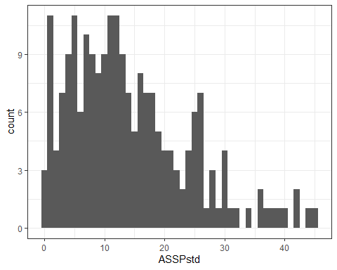

# summary of standardized ASSP catches  
summary(metadata$ASSPstd)

## Min. 1st Qu. Median Mean 3rd Qu. Max. NA's   
## 0.00 7.00 12.00 14.08 19.00 45.00 27

## comparison of ASSP vs ASSPstd

ggplot(metadata, aes(ASSP, ASSPstd)) +  
 geom_point() +  
 theme_bw()

## Warning: Removed 27 rows containing missing values (geom_point).

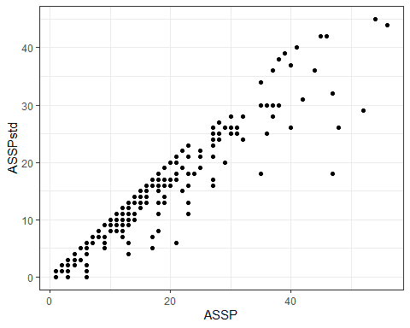

# —

## visualization of CPUE per session

ggplot(metadata, aes(CPUEraw)) +  
 geom_histogram(binwidth = 0.01) +  
 theme_bw()

## Warning: Removed 46 rows containing non-finite values (stat_bin).

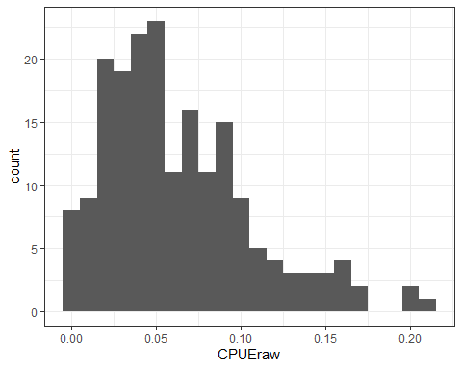

# summary of CPUE per session  
summary(metadata$CPUEraw)

## Min. 1st Qu. Median Mean 3rd Qu. Max. NA's   
## 0.00282 0.03245 0.05298 0.06270 0.08795 0.20779 46

## visualization of CPUE per standardized session

ggplot(metadata, aes(CPUEstd)) +  
 geom_histogram(binwidth = 0.01) +  
 theme_bw()

## Warning: Removed 47 rows containing non-finite values (stat_bin).

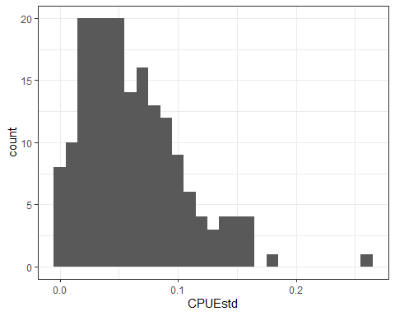

# summary of CPUE per standardized session  
summary(metadata$CPUEstd)

## Min. 1st Qu. Median Mean 3rd Qu. Max. NA's   
## 0.00000 0.02858 0.05351 0.06166 0.08511 0.25810 47

## comparision of CPUE vs CPUEstd

ggplot(metadata, aes(CPUEraw, CPUEstd)) +  
 geom_point() +  
 theme_bw()

## Warning: Removed 47 rows containing missing values (geom_point).

