

CSE400: Network Security and Forensics
Assignment1

Instructor: Dr. Deepa Suresh

1 | Student name | Salih Samir
 | ID | 1087965
2 | Student name | Mohamed Idris
 | ID | 1075626
3 | Student name
 | ID

Introduction
Evil Twin attack is a wireless network attack whereby an attacker establishes a rogue access point that mimics an authentic Wi-Fi hot spot. The aim is to deceive the users to connect to this rogue access point thinking they are part of a legitimate network. After being connected, the attacker is able to intercept network traffic, steal sensitive data like login credentials and financial data, or even perform man-in-the-middle attacks [1]. The title of the Evil Twin is based on the fact that the fake hotspot appears almost the same as the original one and it is sometimes using the same SSID and even stronger signal strength to attract users [2]. This kind of attack is classified as a spoofing and interception attacks because it is a type of attack that uses an authentic service to intercept data [3]. The threat is in the fact that users can be easily cheated, as many people do not check the validity of Wi-Fi networks, particularly in open areas like airports, hotels, and cafes [4]. Evil Twin attacks are still very typical nowadays when mobile connectivity and the use of wireless networks are becoming increasingly popular and are a good target for attackers who rely on user trust and convenience [5].

History
Evil Twin attacks have a long history dating back to the early 2000s when Wi-Fi networks began to be made accessible to the general population [6]. Security measures were either lax or non-existent at the time since most networks were unsecured and unencrypted. Hackers found out that they could attract unsuspecting users by creating a fake hotspot with the same network name as a legitimate one and spy on their actions [7]. In 2004 and 2005, security researchers started to document the Evil Twin technique as a severe weakness in wireless networks [8]. They demonstrated that the attack was accessible and feasible because attackers could easily develop rogue access points with ordinary Wi-Fi cards and laptops.
With the advent of smartphones and the growth of free Wi-Fi in public places, the Evil Twin attack became even more efficient in the 2010s [9]. Airbase-ng and hostapd were tools that enabled attackers to automate the process of creating convincing rogue hotspots, reducing the technical barrier to such attacks. About the same period, penetration testers and ethical hackers started to employ dedicated tools like the Wi-Fi Pineapple, which offered a convenient and powerful platform to use in the Evil Twin attacks when performing security tests [10]. The KRACK vulnerability in WPA2 encryption in 2017 brought back the issue of wireless security and demonstrated how attackers can use a combination of vulnerabilities in cryptographic protocols and Evil Twin configurations to access user data [11].
Evil Twin attacks are one of the most common threats to Wi-Fi users today [12]. They are frequently used together with phishing methods, including counterfeit login portals or malicious captive portals, in which the victims are requested to re-enter their credentials [13]. Other methods used by attackers include the use of the technique of stripping of the SSL to avoid encryption and collect plain text data [14]. The current forms of this attack are more difficult to detect, particularly in places where there are numerous overlapping networks, like in an airport, shopping mall or a corporate office [15]. The continued success of the Evil Twin attack underscores the fact that attackers can use not only technological vulnerabilities but also human trust, which is a major issue in cybersecurity studies and practical defense measures [16].

Methodology — How Evil Twin Attacks Are Carried Out
An evil twin attack is a multi-phase operation that combines social engineering, wireless protocol manipulation, and conventional MITM techniques rather than a single exploit. This is an outline of how it usually goes in the field:
1. Reconnaissance
Attackers start by looking for possible targets in the wireless environment, which are usually open or SSIDs with inadequate security (e.g., WPA2-PSK). SSID and BSSID, channel utilisation, beacon period, client activity, the security protocols are among the important data collected. Tools: Bettercap, Kismet, Wireshark, and airodump-ng.
2. Rogue AP Setup
The attacker creates a phoney AP using the same SSID and frequently a spoof BSSID using commodity hardware (such as a Raspberry Pi running hostapd or a laptop with a USB Wi-Fi adaptor). Captive portals could spread malware or collect login credentials.
3. Client Coercion Techniques
Attackers employ proximity, deauthentication techniques, 802.11 channel change announcements, or beacon flooding to make sure client devices connect to the rogue AP.
4. Traffic Interception and Exploitation
After gaining access, the attacker can manipulate DNS resolution and routing to steal credentials, remove SSL, spoof DNS, take over sessions, or introduce malware.
5. Data Exfiltration and Persistence
Harvested data might be transferred to C2 servers, retained for cracking, resold, or used to pivot into corporate networks. Rogue APs may continue to exist in cafés or airports while wearing hardware disguises.

Impact — Real-World Consequences and Case Studies
Credential Theft at Scale
At cafes or airports, victims input their credentials into rogue captive portals. comprises banking, corporate, and email credentials. For instance, the Paris airport situation in 2023 (AFP).
Enterprise Security Breach Vector
used to obtain SSO or VPN credentials and take over cloud sessions during red team evaluations. If certificates are not validated, WPA2-Enterprise remains susceptible (IBM X-Force, 2024).
Low Barrier, High ROI
Due to the low cost of tools and equipment, fraudsters, pen-testers, and threat actors frequently launch assaults. In 2024, Kaspersky reports an increase in rogue AP detections.
.
Regulatory and Legal Impact
Governments have taken legal action against attackers and issued Wi-Fi safety advice. But without direct access to rogue devices, enforcement is challenging.

Attack Simulation & Traffic Analyse
To simulate how an evil twin attack should take place in a controlled lab environment, we utilized Kali Linux running inside a VirtualBox virtual machine and configured it with Bridged adapter network. This way we allow the virtual machine to behave like a separate device on the local network. Unfortunately, due to hardware limitations and the requirement of a Wi-fi adapter that supports wlan0 for monitoring and packet injections we conducted the attack over a wired ethernet interface instead of using a wireless one.
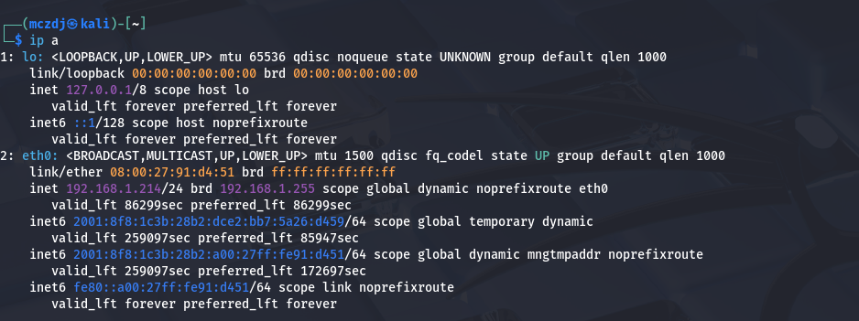
Firstly, we began by assigning a static Ip address to the attack interface.

This has now configured our attack machine with a predictable Ip for the victim to connect to.
Next, we created our malicious phishing page that acts as the fake portal that the victim would be greeted with when trying to connect to our fake access point. We created an HTMl page that was saved to /var/www/html/index.html and included a basic form that POSTed login credentials such as username and password to a file named log.txt on the attacker’s machine
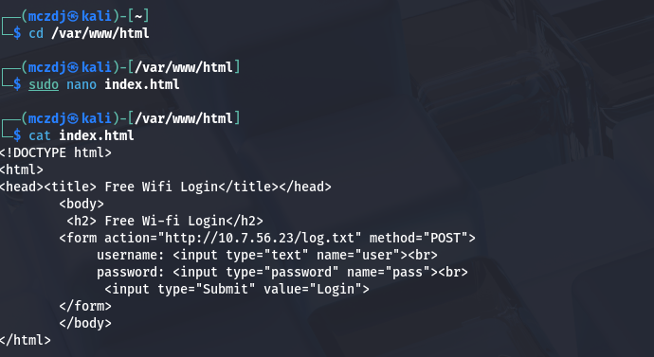
We configured dnsmasq to serve two main roles: assign IP addresses to connected victims (DHCP) and redirect all DNS queries to our fake access point. This meant that any domain the victim attempts to visit like google.com or facebook.com would resolve to our attack machine’s IP address.
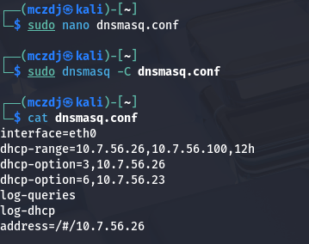
To host the phishing page, we have used Apache2 HTTP server. Where we verified that the phishing portal was being hosted correctly by using the curl command to fetch the page locally and being rendered correctly.

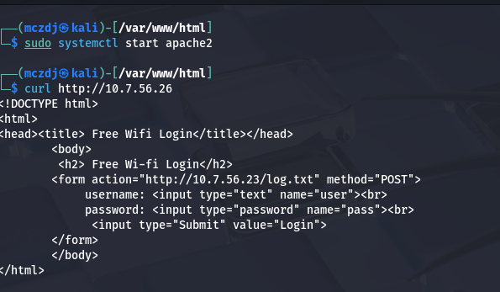

On a separate laptop (the simulated victim device), we manually configured the network settings to use the attacker’s IP as both the default gateway & DNS server. When visiting any website, the DNS queries were resolved by the attacker machine and redirected to the fake login portal we set up earlier. When credentials were submitted through the page these credentials are later sent to the log.txt file in the attacker machine.
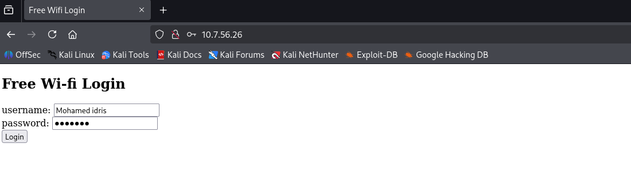
We used tcpdump on the attacker machine to capture all the traffic on the eth0 interface and saved it to a .pcap file for later inspection on the attacker machine. This included DNS queries from the victim, HTTP POST requests to submit credentials, and general network activity. The .pcap file was opened in Wireshark, where we filtered by IP to observe detailed interactions between the victim device and the attacker.
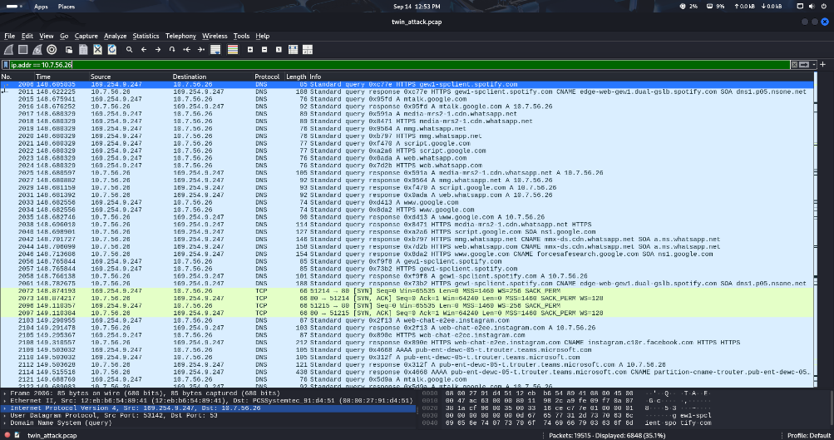
This simulation successfully demonstrated the core mechanics of an Evil Twin attack, even without wireless deauthentication or automatic victim association. We covered:
- Credential Phishing
- DNS spoofing and redirection
- Traffic interception and analysis
- Configuration of rogue services ( DNS, DHCP, HTTP)
Although limitation of hardware caused a bit of sit back we were able to simulate evil twin attack safely by replicating and studying the logic of the impact of an Evil twin attack in the lab environment.

Mitigation — Defensive Tools and Techniques

Defending against Evil Twin attacks requires a multi-layered approach that addresses both user behavior and technical safeguards.

- User Awareness and Hygiene: People should refrain from using unconfirmed connections to public Wi-Fi networks. Disable automatic connections to known networks and always verify the SSID with the location (such as the airport or café). A trustworthy VPN should be used to encrypt all traffic when utilizing public Wi-Fi.

- Enterprise Network Security: Organizations ought to implement WPA2-Enterprise and WPA3 with 802.1X certificate validation and authentication. By doing this, impersonation is avoided, and customers are guaranteed to be able to confirm the authenticity of the access point.

- Systems for preventing wireless intrusions (WIPS): Install WIPS software with rogue AP detection enabled, such as Cisco Aironet, Aruba RFProtect, or open-source alternatives like Kismet. These systems look for management frame spoofing, anomalous signal behavior, and duplicate SSIDs.

- Management Frame Protection: Protecting against deauthentication and disassociation attacks can be achieved by turning on 802.11w (Protected Management Frames). This is a crucial layer for more recent systems, although not all outdated devices support it.

- TLS Everywhere: Verify that all services use HSTS and certificate pinning to enforce HTTPS whenever feasible. Most attacks, including SSL stripping and credential harvesting, are prevented by good TLS hygiene, even if traffic is intercepted by a rogue AP.

- Device Hardening and Posture Control: Set up endpoint security policies to prevent connections to open or untrusted networks and routinely remove stored SSIDs from device memory. Wi-Fi connection regulations can be enforced via mobile device management (MDM) systems.

Refrences
[1] A. K. Jain and R. B. Patel, “Evil Twin attack detection in wireless networks,” 2016 International Conference on Computing, Communication and Automation (ICCCA), Greater Noida, India, 2016, pp. 1004–1009. doi: 10.1109/CCAA.2016.7813887. [Online]. Available: https://doi.org/10.1109/CCAA.2016.7813887

[2] J. Wright, Kali Linux Wireless Penetration Testing. Birmingham, UK: Packt Publishing, 2014. [Online]. Available: https://www.packtpub.com/product/kali-linux-wireless-penetration-testing/9781783280414

[3] N. Gruschka, L. L. Iacono, and M. Jensen, “Spoofing and phishing in wireless networks: Attacks and defenses,” IEEE Communications Surveys & Tutorials, vol. 15, no. 4, pp. 1967–1987, 2013. doi: 10.1109/SURV.2013.013013.00034. [Online]. Available: https://doi.org/10.1109/SURV.2013.013013.00034

[4] A. Doupé, L. Cavedon, C. Kruegel, and G. Vigna, “Enemy at the gate: Evading web application firewalls using HTTP parameter pollution,” Proceedings of the 19th ACM Conference on Computer and Communications Security, 2012, pp. 49–60. doi: 10.1145/2382196.2382204. [Online]. Available: https://doi.org/10.1145/2382196.2382204

[5] S. K. Singh and S. Sharma, “Cyber security risks in public Wi-Fi networks: An analysis of Evil Twin attacks,” International Journal of Computer Applications, vol. 180, no. 23, pp. 25–30, 2018. doi: 10.5120/ijca2018916454. [Online]. Available: https://doi.org/10.5120/ijca2018916454

[6] J. Edney and W. A. Arbaugh, Real 802.11 Security: Wi-Fi Protected Access and 802.11i. Boston, MA: Addison-Wesley, 2003. [Online]. Available: https://dl.acm.org/doi/book/10.5555/1205487

[7] E. Tews and M. Beck, “Practical attacks against WEP and WPA,” Proceedings of the Second ACM Conference on Wireless Network Security (WiSec), 2009, pp. 79–86. doi: 10.1145/1514274.1514286. [Online]. Available: https://doi.org/10.1145/1514274.1514286

[8] F. Callegati, W. Cerroni, and M. Ramilli, “Man-in-the-Middle Attack to the HTTPS Protocol,” IEEE Security & Privacy, vol. 7, no. 1, pp. 78–81, 2009. doi: 10.1109/MSP.2009.12. [Online]. Available: https://doi.org/10.1109/MSP.2009.12

[9] O. Whitehouse, “Evil Twin attacks in the age of smartphones,” Symantec Security Response Blog, 2010. [Online]. Available: https://www.symantec.com/connect/blogs/evil-twin-attacks-age-smartphones

[10] Hak5, “WiFi Pineapple – wireless auditing and penetration testing,” 2015. [Online]. Available: https://shop.hak5.org/products/wifi-pineapple

[11] M. Vanhoef and F. Piessens, “Key Reinstallation Attacks: Forcing nonce reuse in WPA2,” Proceedings of the 24th ACM Conference on Computer and Communications Security (CCS), Dallas, TX, 2017, pp. 1313–1328. doi: 10.1145/3133956.3134027. [Online]. Available: https://www.krackattacks.com

[12] Cisco, “Wireless security report: Common threats in enterprise Wi-Fi,” Cisco Systems, White Paper, 2019. [Online]. Available: https://www.cisco.com/c/en/us/products/security/white-papers.html

[13] A. Bansal and R. Malhotra, “Phishing over Wi-Fi networks: Evil Twin and captive portal threats,” International Journal of Computer Applications, vol. 975, pp. 8887–8891, 2020. [Online]. Available: https://www.ijcaonline.org/archives/volume175/number23/31315-2020920504

[14] M. Marlinspike, “sslstrip: HTTPS stripping attacks,” 2009. [Online]. Available: https://moxie.org/software/sslstrip

[15] Kaspersky, “Evil Twin Wi-Fi: Fake hotspots and how to protect yourself,” 2021. [Online]. Available: https://www.kaspersky.com/resource-center/threats/evil-twin

[16] R. Anderson, Security Engineering: A Guide to Building Dependable Distributed Systems, 3rd ed. Wiley, 2020. [Online]. Available: https://www.wiley.com/en-us/Security+Engineering%3A+A+Guide+to+Building+Dependable+Distributed+Systems%2C+3rd+Edition-p-9781119642787

[17] B. Sangster et al., “A Practical Evil Twin Attack for WPA2 Enterprise Networks,” ACM WiSec, 2021. Academic Paper. Demonstrates real-world Evil Twin attack on WPA2-Enterprise with certificate bypass. Technical foundation for advanced attacks in enterprise settings.

[18] M. Momeni et al., “Effectiveness of Evil Twin Attacks in Modern Wi-Fi Networks,” Elsevier, 2023. Academic Paper. Analysis of coercion techniques using 802.11h/v and beacon flooding. Supports client-coercion stage in methodology.

[19] US-CERT TA18-074A, “Cyber Threats to Wireless Networks,” Department of Homeland Security, 2024. Government Alert. Overview of MITM threats, Evil Twin methodology, and public guidance. Credible public sector acknowledgment of the threat.

[20] AFP News Report, “Paris Airport Wi-Fi Scam Foiled,” Agence France-Presse, 2023. News Article. Reports arrest of cybercriminals using fake Wi-Fi in airports. Validates real-world impact and law enforcement actions.

[21] IBM X-Force, “Wireless Attack Paths in Corporate Environments,” IBM Security Report, 2024. Industry Report. Identifies Evil Twin use in enterprise red teaming and credential theft. Ties attacks to business risk and professional audits.

[22] Kaspersky Labs, “Wi-Fi Threats & Rogue AP Detection Trends,” Kaspersky Threat Intelligence, 2024. Vendor Report. Annual stats on growth of Evil Twin incidents and malware delivery. Establishes attack prevalence and evolution.
https://www.kaspersky.com/resource-center/preemptive-safety/evil-twin-attacks
[23] StationX, “Red Team Field Guide: Wi-Fi MITM Attacks,” StationX Cyber Training, 2025. Practitioner Guide. Step-by-step tool usage for Evil Twin, including hostapd, sslstrip, dnsmasq. Informs real-world attacker methodology.

[24] “Review of Evil Twin Attacks in the Age of Wi-Fi 6 and WPA3,” 2025. Academic Review. Survey of Evil Twin variants, countermeasures, and detection frameworks. Consolidated reference for modern implementations.
https://www.irejournals.com/formatedpaper/1708514.pdf
[25] Varonis, “How Evil Twin Attacks Work,” Blog & Whitepaper, 2024. Technical Guide. Explains attack stages with diagrams and user-level protections. Good for visualization and awareness content. https://www.varonis.com/blog/evil-twin-attack
[26] Wireshark Foundation, Wireshark User Guide, [Online]. Available: https://www.wireshark.org/docs/wsug_html/
[27] The Tcpdump Group, Tcpdump and Libpcap Documentation, [Online]. Available: https://www.tcpdump.org/manpages/
[28] Offensive Security, Kali Linux Documentation, 2025. [Online]. Available: https://www.kali.org/docs/
[29] Oracle, VirtualBox User Manual, 2025. [Online]. Available: https://www.virtualbox.org/manual/UserManual.html

